Supplementary material

1 Descriptive Statistics:

Table 1- Descriptive statistics of the quality variables (at 0.3 m depth).
Variable | Unity | Points | Coefficient of variation | Variance | Mean | Standard deviation | Number of observations | Median
Total phosphorus | mgL⁻¹ | Point #3 | 0.522 | 0.003 | 0.112 | 0.059 | 32 | 0.092
Total phosphorus | mgL⁻¹ | Point #4 | 0.492 | 0.003 | 0.116 | 0.057 | 32 | 0.105
Total phosphorus | mgL⁻¹ | Point #6 | 0.492 | 0.003 | 0.113 | 0.056 | 31 | 0.093
Total nitrogen | mgL⁻¹ | Point #3 | 0.441 | 0.472 | 1.558 | 0.687 | 32 | 1.3125
Total nitrogen | mgL⁻¹ | Point #4 | 0.375 | 0.269 | 1.381 | 0.518 | 32 | 1.419
Total nitrogen | mgL⁻¹ | Point #6 | 0.482 | 0.460 | 1.407 | 0.678 | 31 | 1.15
Cyanobacteria | cellsmL⁻¹ | Point #3 | 0.739 | 3.89E+10 | 2.67E+05 | 1.97E+05 | 32 | 2.54E+05
Cyanobacteria | cellsmL⁻¹ | Point #4 | 0.863 | 4.51E+10 | 2.46E+05 | 2.12E+05 | 31 | 1.75E+05
Cyanobacteria | cellsmL⁻¹ | Point #6 | 0.871 | 2.29E+10 | 1.74E+05 | 1.51E+05 | 33 | 9.40E+04
Chlorophyll a | µgL⁻¹ | Point #3 | 0.628 | 1067.818 | 52.043 | 32.677 | 31 | 38.49
Chlorophyll a | µgL⁻¹ | Point #4 | 0.592 | 497.751 | 37.706 | 22.310 | 31 | 31.47
Chlorophyll a | µgL⁻¹ | Point #6 | 0.664 | 435.443 | 31.416 | 20.867 | 30 | 24.915

2 Water sampling and general characteristics of the reservoir:

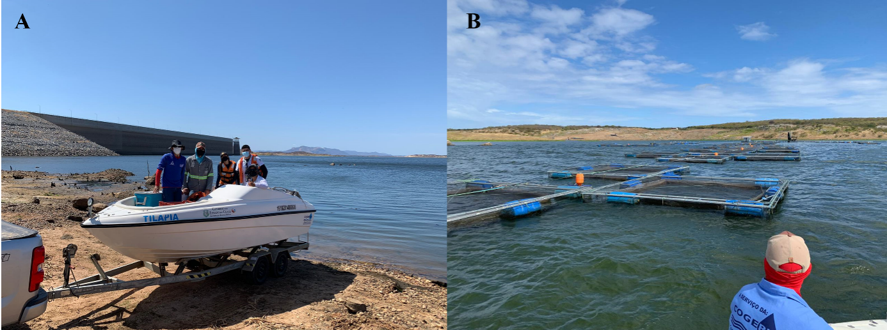
Figure S1 – Water quality monitoring performed by the State’s water management company. A) Shows the monitoring team at the boat used to collect the samples in the reservoir and B) Shows part of the fish farming area in the reservoir.

Table 2- Formula to calculate the 5 depths in which water samples would be collected in order to be analyze water quality parameters in the laboratory. Where MD states for the maximum depth of the water column (m); T is transparency; AZ is the depth where the DO started to be < 1 mg/L.
Depth | Formula
1 | 0.3 m
2 | $${\left(T x3\right)}/2$$
3 | $${\left(MD+\left(T x 3\right)\right)}/2$$
4 | $${\left(MD+AZ\right)}/2$$
5 | $$MD−0.5$$
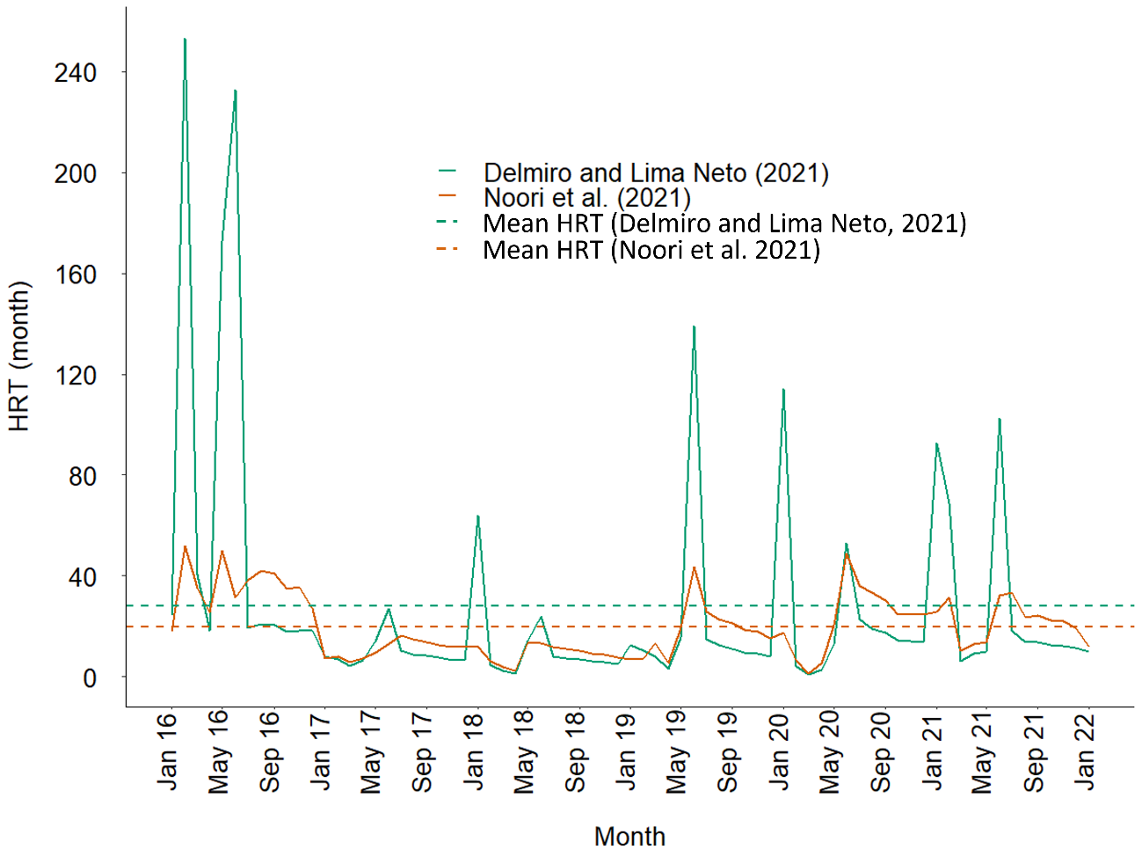
Figure S2 – Hydraulic residence time of Castanhão reservoir calculated using two different methods.

3 Thermal and Chemical stratification-DO

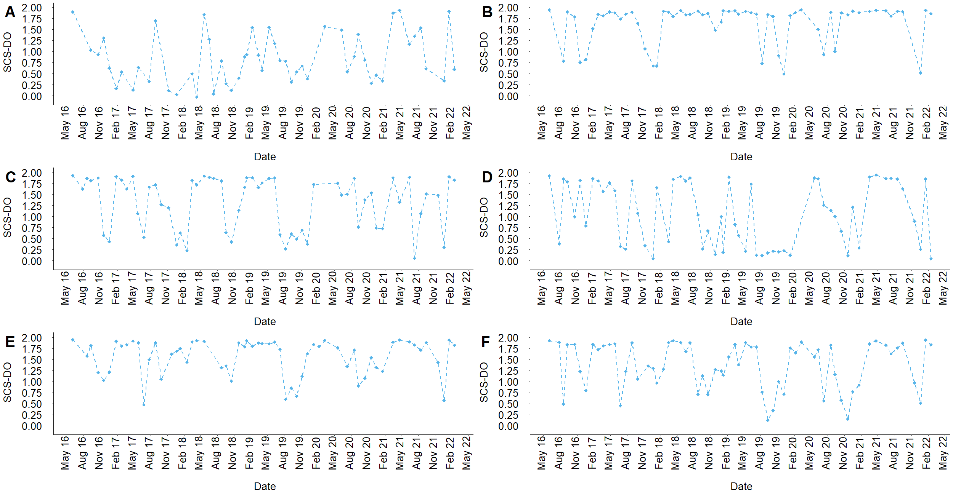
Figure S3 – Time series of the strength of chemical stratification for dissolved oxygen (SCS-DO). A SCS-DO of value zero indicates no stratification. A) Is sampling point P1, B) P2, C) P3, D) P4, E) P5, F) P6.

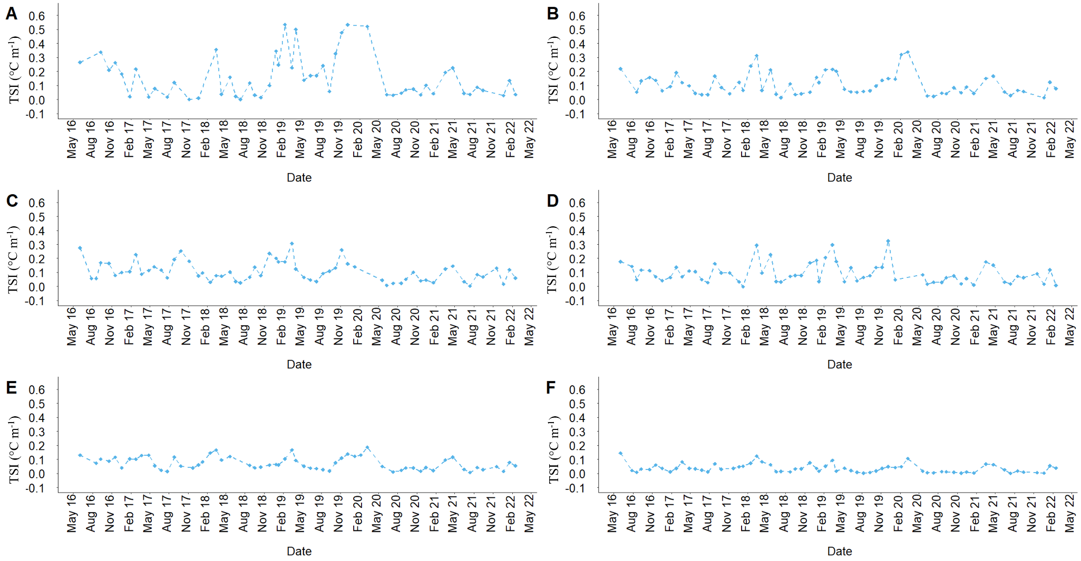Figure S4 – Thermocline strength index (TSI). A TSI of value zero indicates no stratification. A) Is sampling point P1, B) P2, C) P3, D) P4, E) P5, F) P6.

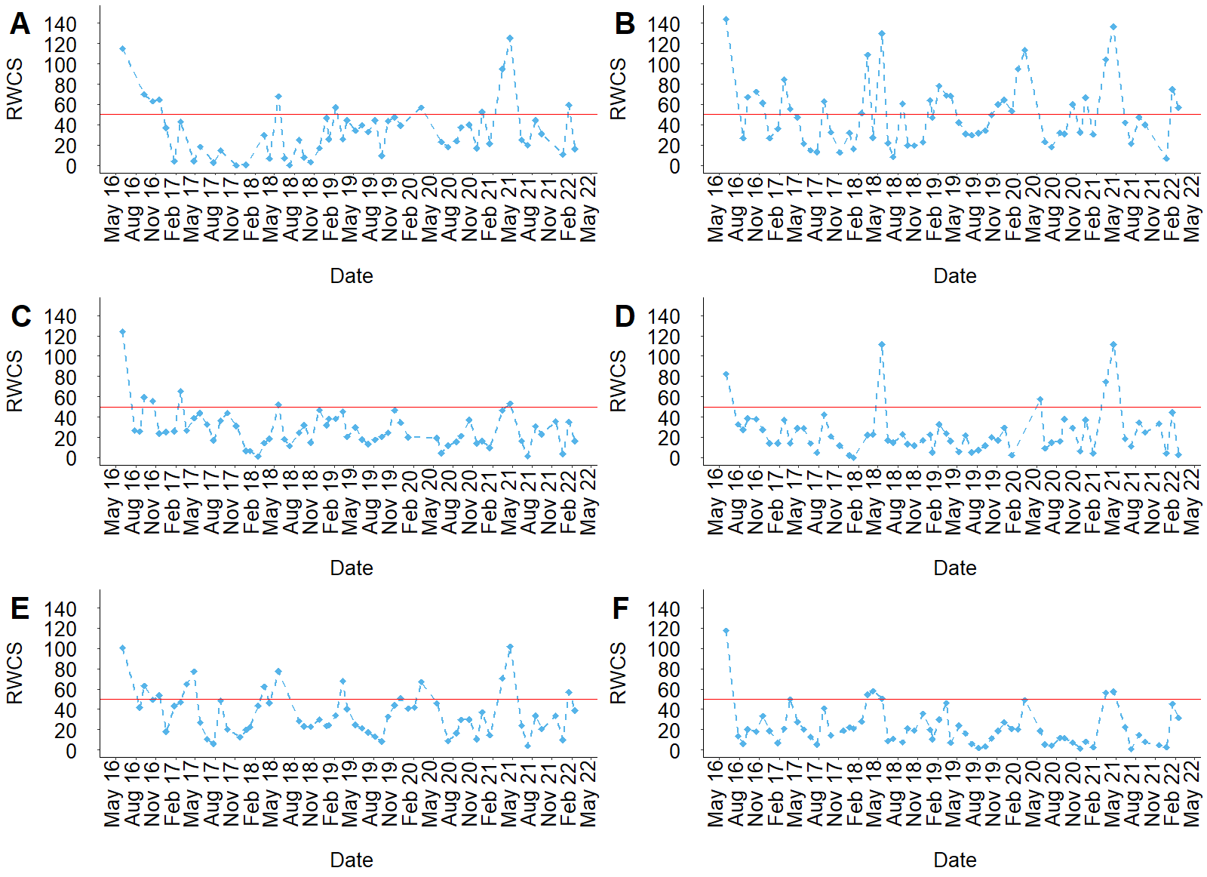
Figure S5 – Time series of the Relative Water Column Stability (RWCS). The red line represents the the limiting condition of RWCS ≥50 considered as a reference to characterize the thermal stratification in the water column. A) Is sampling point P1, B) P2, C) P3, D) P4, E) P5, F) P6
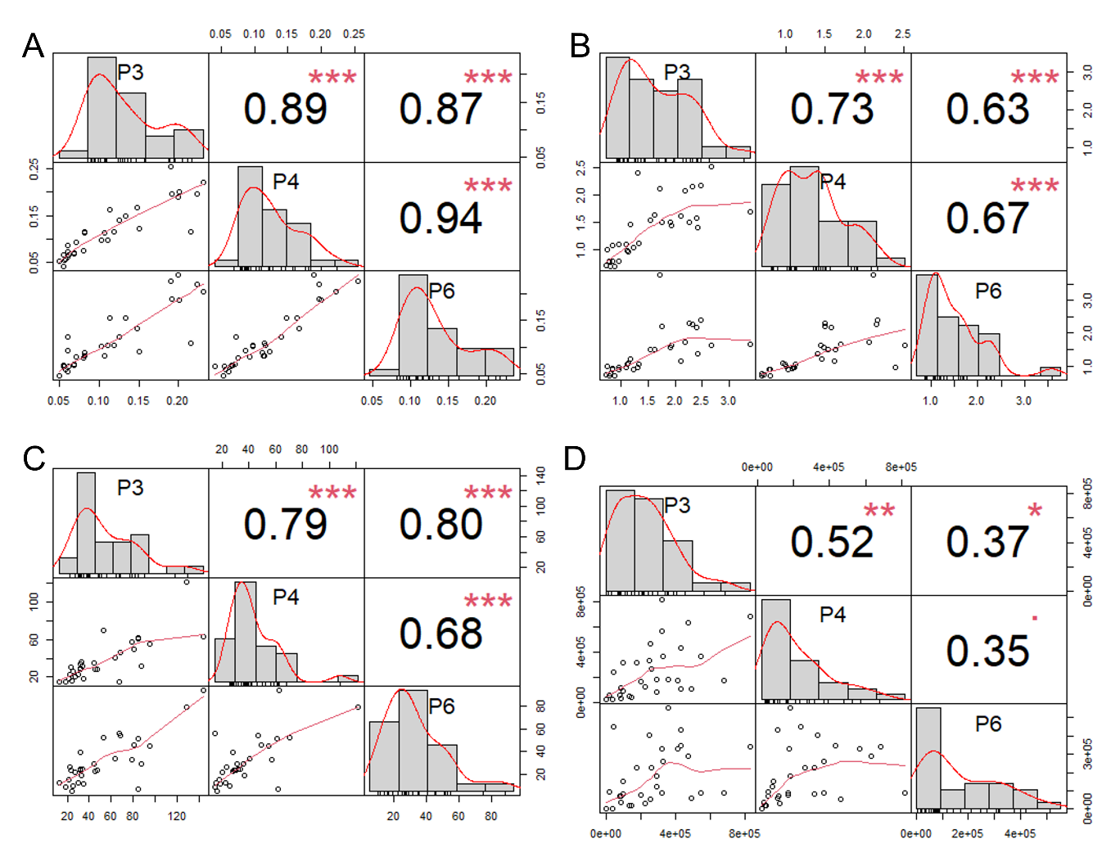
Figure S6 - Pearson’s correlation of water quality values between the surface samples (0.3 m depth) of points 3, 4 and 6. A) Represents the correlation values for total phosphorus, B) for total nitrogen, C) for chlorophyll a concentration, and D) for cyanobacteria cell density.

4 Pearson’s correlation analysis
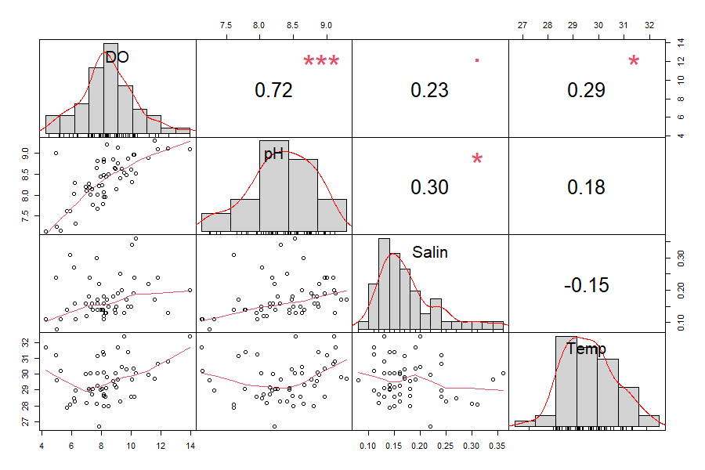
Figure S7 – Pearson's correlation analysis of profiling variables in point P1 (0.3 m depth). The distribution of each variable is shown on the diagonal. On the bottom of the diagonal the bivariate scatter plots with a fitted line are displayed. On the top of the diagonal, the value of the correlation plus the significance level as stars. Each significance level is associated to a symbol: the p-values 0, 0.001, 0.01, 0.05, 0.1, 1 correspond to the symbols “***”, “**”, “*”, “.”, “ ”, respectively.
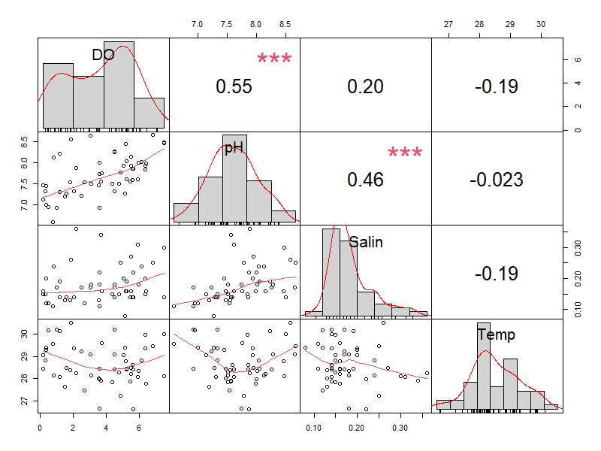
Figure S8 – Pearson's correlation analysis of profiling variables in point P1 (0.5 m above sediment layer). The distribution of each variable is shown on the diagonal. On the bottom of the diagonal the bivariate scatter plots with a fitted line are displayed. On the top of the diagonal, the value of the correlation plus the significance level as stars. Each significance level is associated to a symbol: the p-values 0, 0.001, 0.01, 0.05, 0.1, 1 correspond to the symbols “***”, “**”, “*”, “.”, “ ”, respectively.
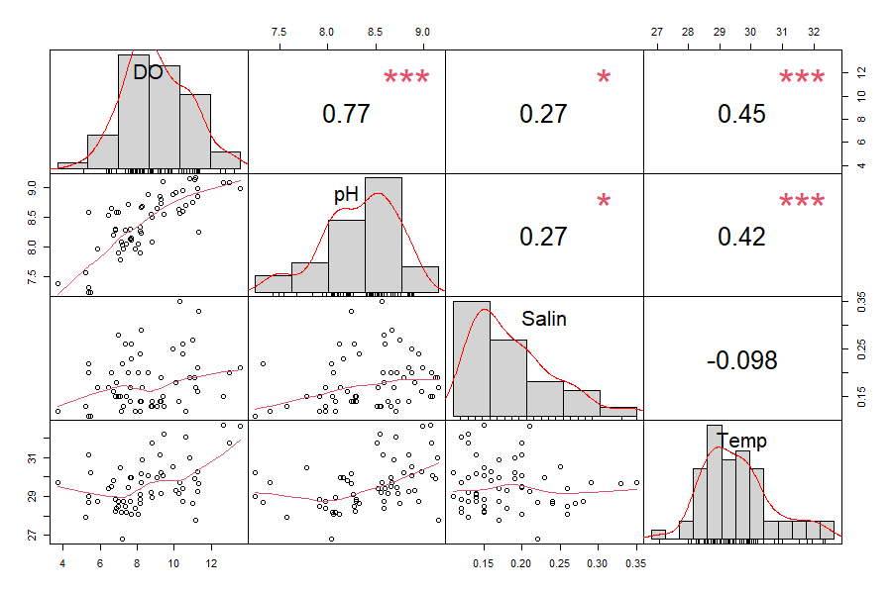
Figure S9 – Pearson's correlation analysis of profiling variables in point P2 (0.3 m depth). The distribution of each variable is shown on the diagonal. On the bottom of the diagonal the bivariate scatter plots with a fitted line are displayed. On the top of the diagonal, the value of the correlation plus the significance level as stars. Each significance level is associated to a symbol: the p-values 0, 0.001, 0.01, 0.05, 0.1, 1 correspond to the symbols “***”, “**”, “*”, “.”, “ ”, respectively.

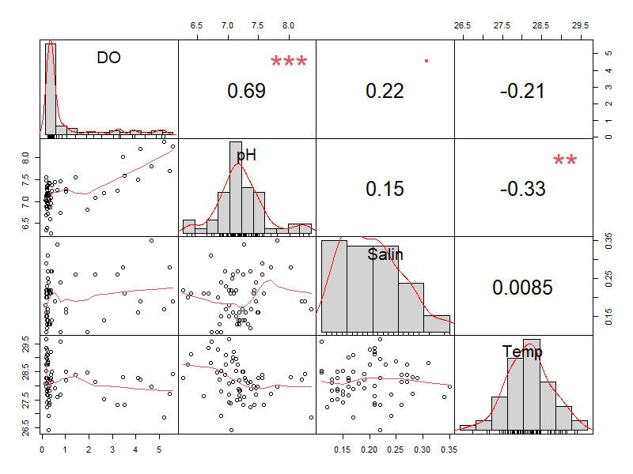
Figure S10 – Pearson's correlation analysis of profiling variables in point P2(0.5 m above sediment layer). The distribution of each variable is shown on the diagonal. On the bottom of the diagonal the bivariate scatter plots with a fitted line are displayed. On the top of the diagonal, the value of the correlation plus the significance level as stars. Each significance level is associated to a symbol: the p-values 0, 0.001, 0.01, 0.05, 0.1, 1 correspond to the symbols “***”, “**”, “*”, “.”, “ ”, respectively.
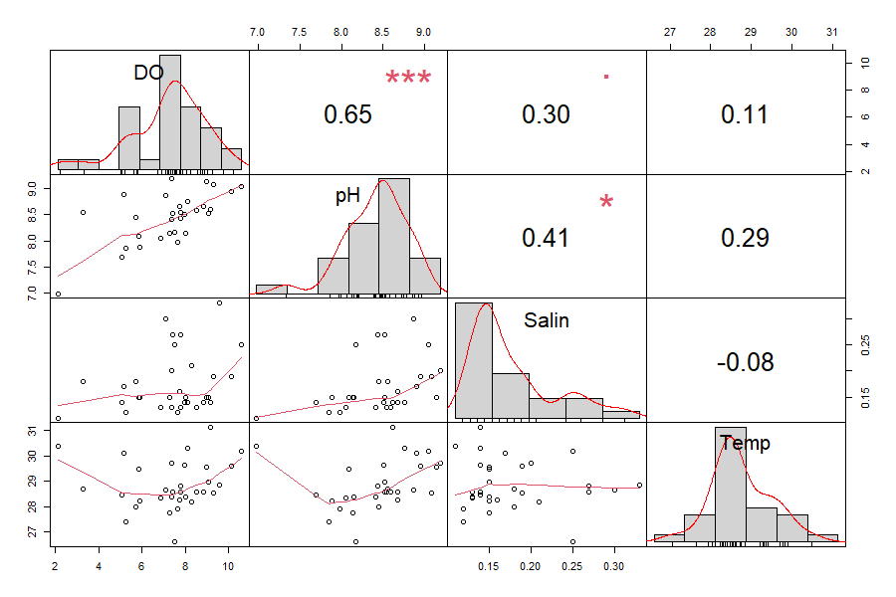
Figure S11 – Pearson's correlation analysis of profiling variables in point P3 (0.3 m depth). The distribution of each variable is shown on the diagonal. On the bottom of the diagonal the bivariate scatter plots with a fitted line are displayed. On the top of the diagonal, the value of the correlation plus the significance level as stars. Each significance level is associated to a symbol: the p-values 0, 0.001, 0.01, 0.05, 0.1, 1 correspond to the symbols “***”, “**”, “*”, “.”, “ ”, respectively.
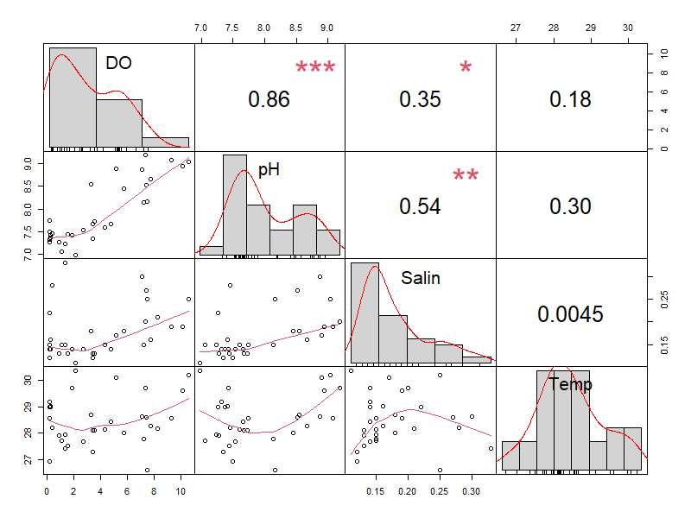
Figure S12 – Pearson's correlation analysis of profiling variables in point P3(0.5 m above sediment layer). The distribution of each variable is shown on the diagonal. On the bottom of the diagonal the bivariate scatter plots with a fitted line are displayed. On the top of the diagonal, the value of the correlation plus the significance level as stars. Each significance level is associated to a symbol: the p-values 0, 0.001, 0.01, 0.05, 0.1, 1 correspond to the symbols “***”, “**”, “*”, “.”, “ ”, respectively.
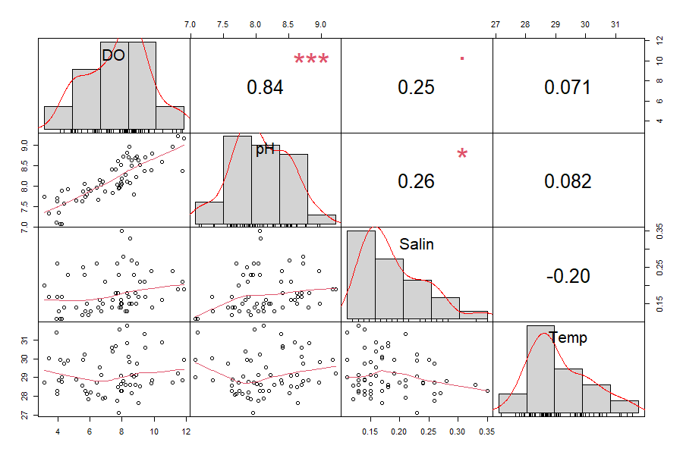
Figure S13 – Pearson's correlation analysis of profiling variables in point P4 (0.3 m depth). The distribution of each variable is shown on the diagonal. On the bottom of the diagonal the bivariate scatter plots with a fitted line are displayed. On the top of the diagonal, the value of the correlation plus the significance level as stars. Each significance level is associated to a symbol: the p-values 0, 0.001, 0.01, 0.05, 0.1, 1 correspond to the symbols “***”, “**”, “*”, “.”, “ ”, respectively.
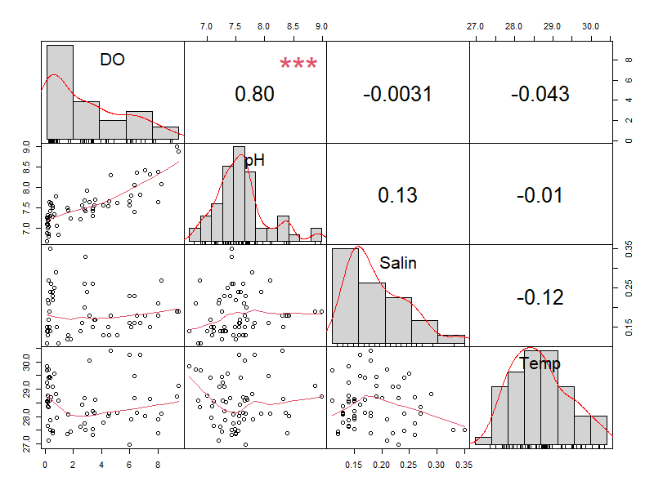
Figure S14 – Pearson's correlation analysis of profiling variables in point P4(0.5 m above sediment layer). The distribution of each variable is shown on the diagonal. On the bottom of the diagonal the bivariate scatter plots with a fitted line are displayed. On the top of the diagonal, the value of the correlation plus the significance level as stars. Each significance level is associated to a symbol: the p-values 0, 0.001, 0.01, 0.05, 0.1, 1 correspond to the symbols “***”, “**”, “*”, “.”, “ ”, respectively.
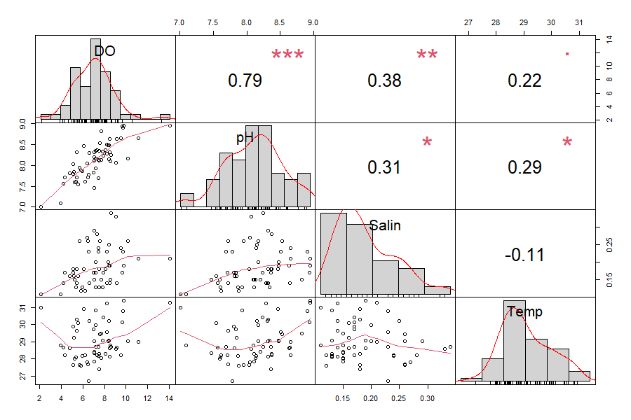
Figure S15 – Pearson's correlation analysis of profiling variables in point P5 (0.3 m depth). The distribution of each variable is shown on the diagonal. On the bottom of the diagonal the bivariate scatter plots with a fitted line are displayed. On the top of the diagonal, the value of the correlation plus the significance level as stars. Each significance level is associated to a symbol: the p-values 0, 0.001, 0.01, 0.05, 0.1, 1 correspond to the symbols “***”, “**”, “*”, “.”, “ ”, respectively.
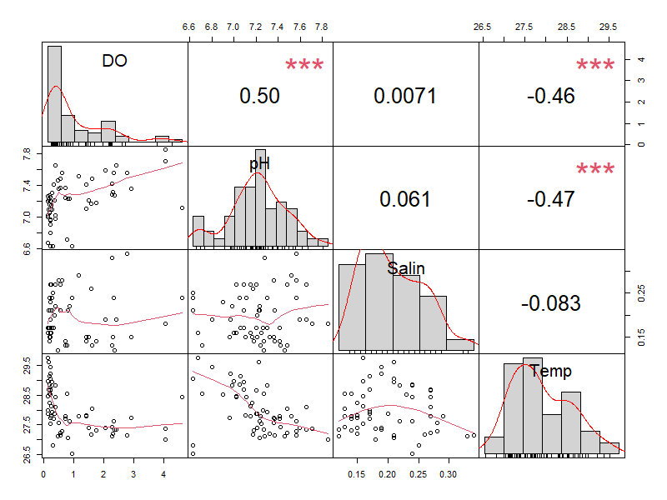
Figure S16 – Pearson's correlation analysis of profiling variables in point P5 (0.5 m above sediment layer). The distribution of each variable is shown on the diagonal. On the bottom of the diagonal the bivariate scatter plots with a fitted line are displayed. On the top of the diagonal, the value of the correlation plus the significance level as stars. Each significance level is associated to a symbol: the p-values 0, 0.001, 0.01, 0.05, 0.1, 1 correspond to the symbols “***”, “**”, “*”, “.”, “ ”, respectively.
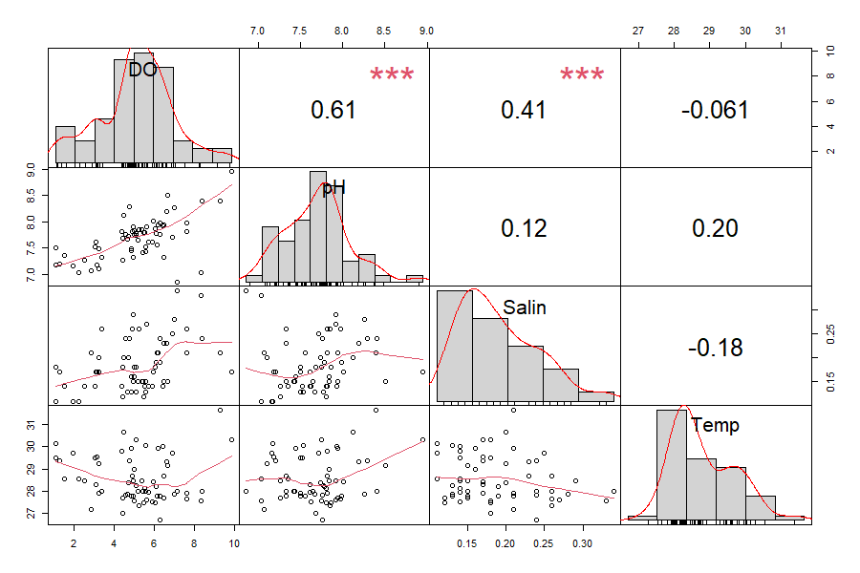
Figure S17 – Pearson's correlation analysis of profiling variables in point P6 (0.3 m depth). The distribution of each variable is shown on the diagonal. On the bottom of the diagonal the bivariate scatter plots with a fitted line are displayed. On the top of the diagonal, the value of the correlation plus the significance level as stars. Each significance level is associated to a symbol: the p-values 0, 0.001, 0.01, 0.05, 0.1, 1 correspond to the symbols “***”, “**”, “*”, “.”, “ ”, respectively.
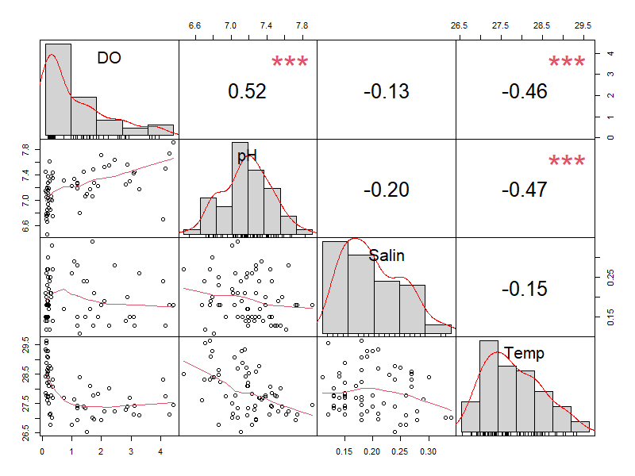
Figure S18 – Pearson's correlation analysis of profiling variables in point P6(0.5 m above sediment layer). The distribution of each variable is shown on the diagonal. On the bottom of the diagonal the bivariate scatter plots with a fitted line are displayed. On the top of the diagonal, the value of the correlation plus the significance level as stars. Each significance level is associated to a symbol: the p-values 0, 0.001, 0.01, 0.05, 0.1, 1 correspond to the symbols “***”, “**”, “*”, “.”, “ ”, respectively.
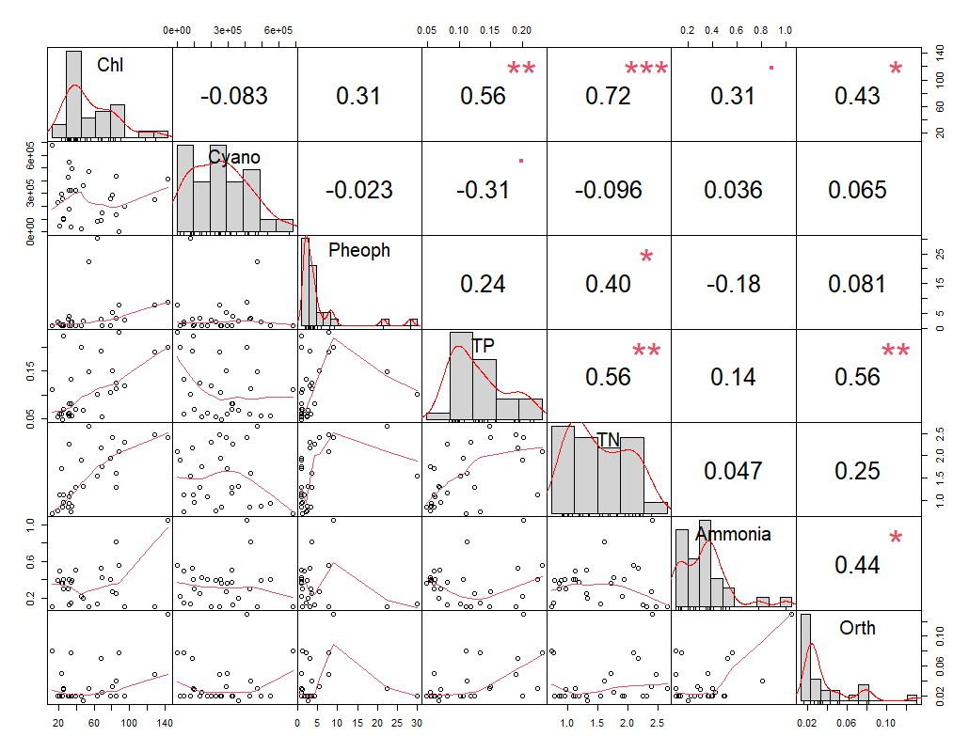
Figure S19 - Pearson's correlation analysis of water quality variables at the sampling point P3 (0.3 m depth). The distribution of each variable is shown on the diagonal. On the bottom of the diagonal the bivariate scatter plots with a fitted line are displayed. On the top of the diagonal, the value of the correlation plus the significance level as stars. Each significance level is associated to a symbol: the p-values 0, 0.001, 0.01, 0.05, 0.1, 1 correspond to the symbols “***”, “**”, “*”, “.”, “ ”, respectively.

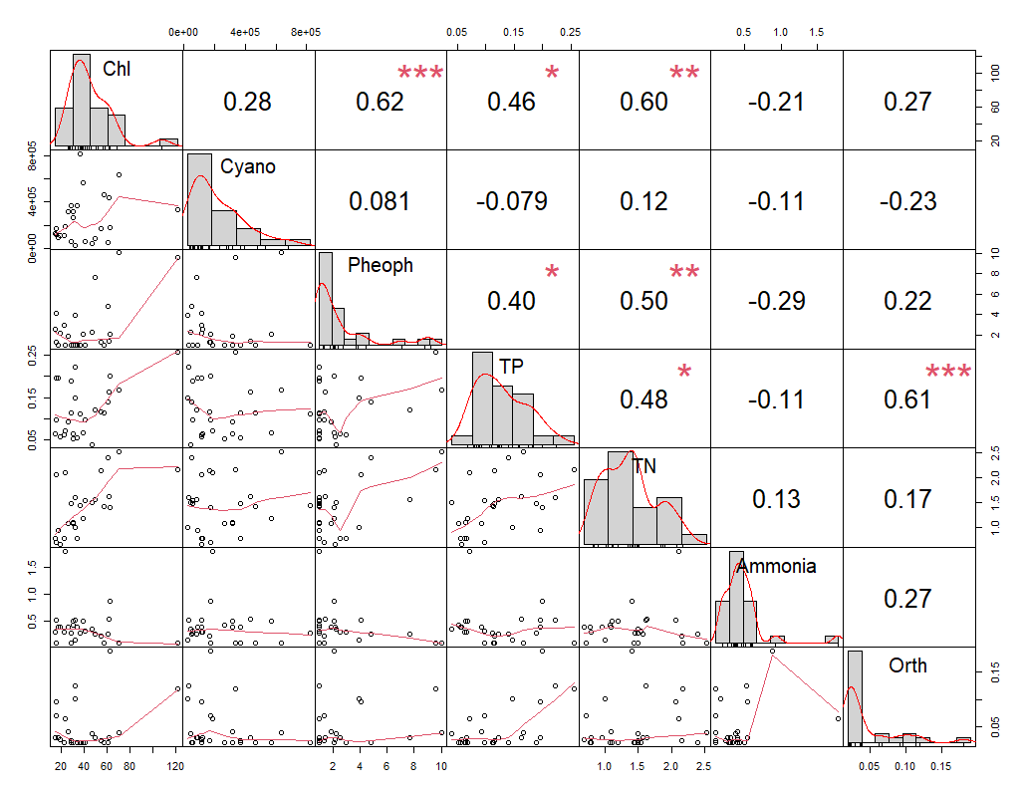
Figure S20 - Pearson's correlation analysis of water quality variables at the sampling point P4 (0.3 m depth). The distribution of each variable is shown on the diagonal. On the bottom of the diagonal the bivariate scatter plots with a fitted line are displayed. On the top of the diagonal, the value of the correlation plus the significance level as stars. Each significance level is associated to a symbol: the p-values 0, 0.001, 0.01, 0.05, 0.1, 1 correspond to the symbols “***”, “**”, “*”, “.”, “ ”, respectively.

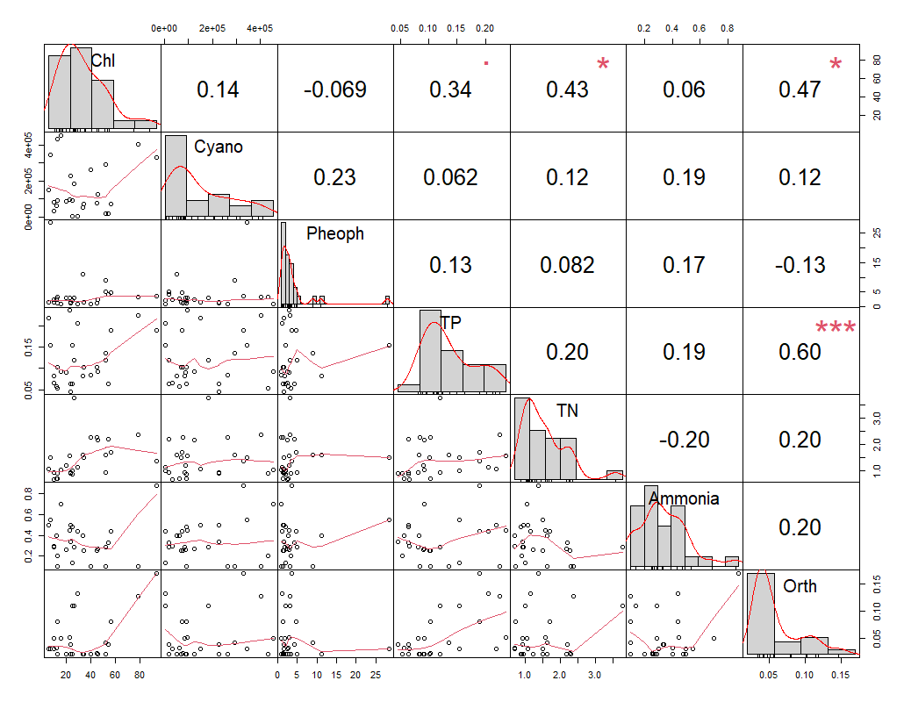
Figure S21 - Pearson's correlation analysis of water quality variables at the sampling point P6 (0.3 m depth). The distribution of each variable is shown on the diagonal. On the bottom of the diagonal the bivariate scatter plots with a fitted line are displayed. On the top of the diagonal, the value of the correlation plus the significance level as stars. Each significance level is associated to a symbol: the p-values 0, 0.001, 0.01, 0.05, 0.1, 1 correspond to the symbols “***”, “**”, “*”, “.”, “ ”, respectively

4 Boxplot analysis:
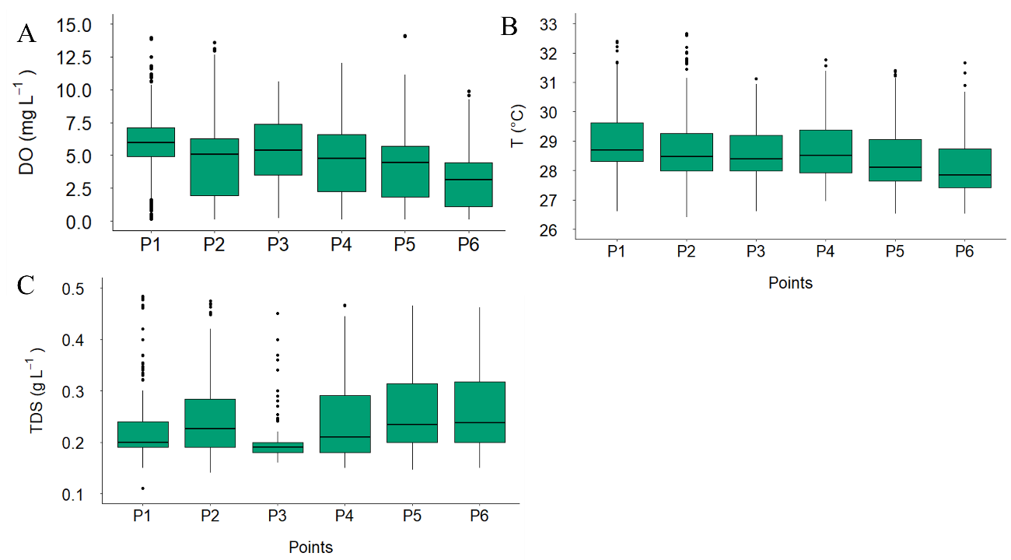
Figure S22 – Boxplots comparing variables of the profiling monitoring differences between the points, with sampling depths ranging from 0.3 m under the water surface to 0.5 m above sediment layer. A) dissolved oxygen concentrations, B) temperatures, C) Total dissolved solids.

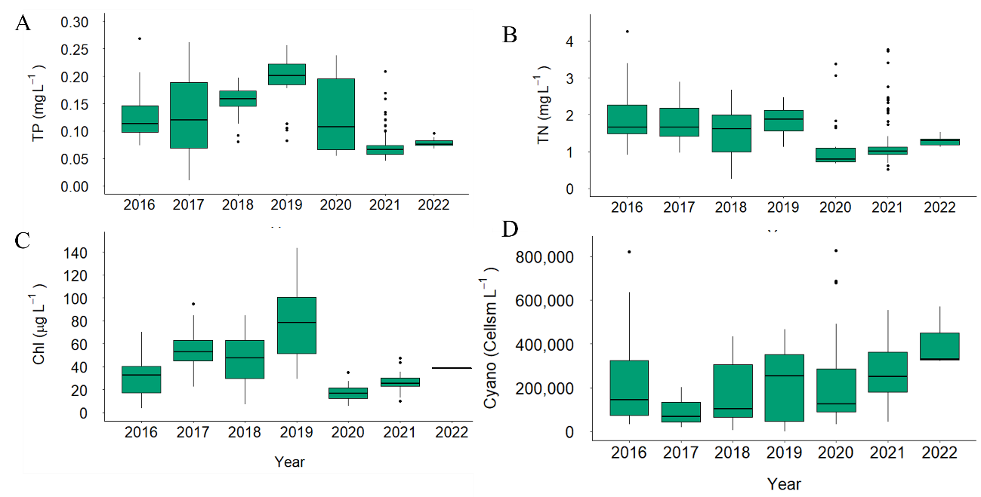
Figure S23 – Boxplots comparing the interannual changes of water quality parameters, with sampling depths ranging from 0.3 to 24.6 m. A) presents total phosphorus concentrations, B) total nitrogen, C) chlorophyll a and D) cyanobacteria cell density.

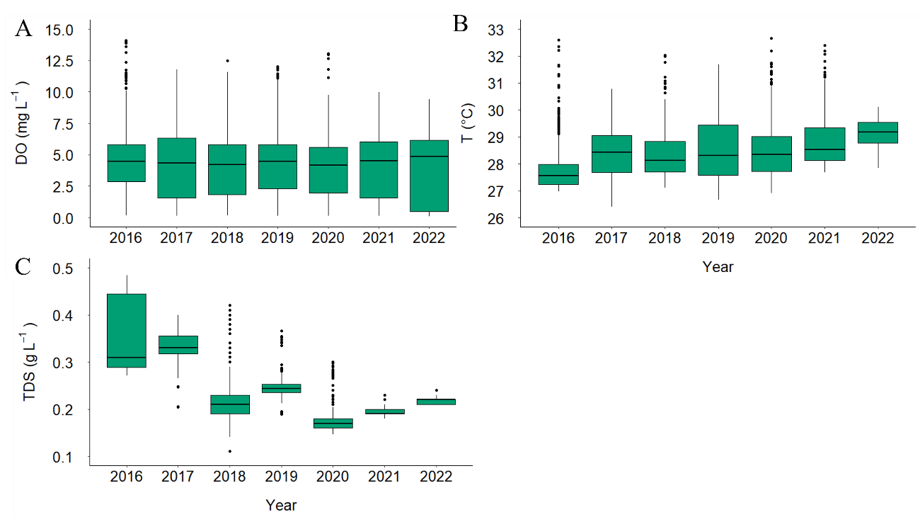
Figure S24 – Boxplots comparing profiling monitoring variables interannual changes, with sampling depths ranging from 0.3 m under the water surface to 0.5 m above sediment layer. A) presents dissolved oxygen concentrations, B) temperatures, C) Total dissolved solids.

5 Time series with boxplots:
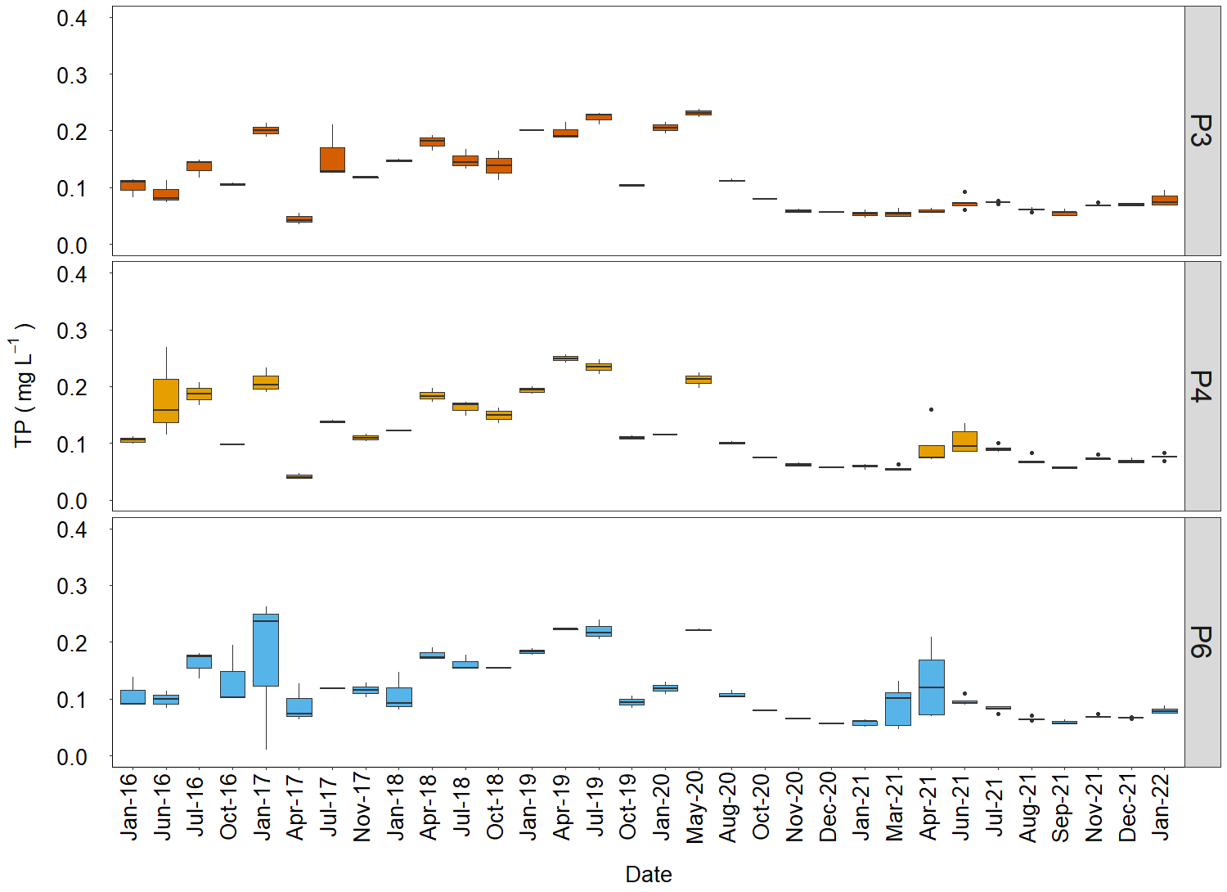
Figure S25 –Time series of total phosphorus concentration.

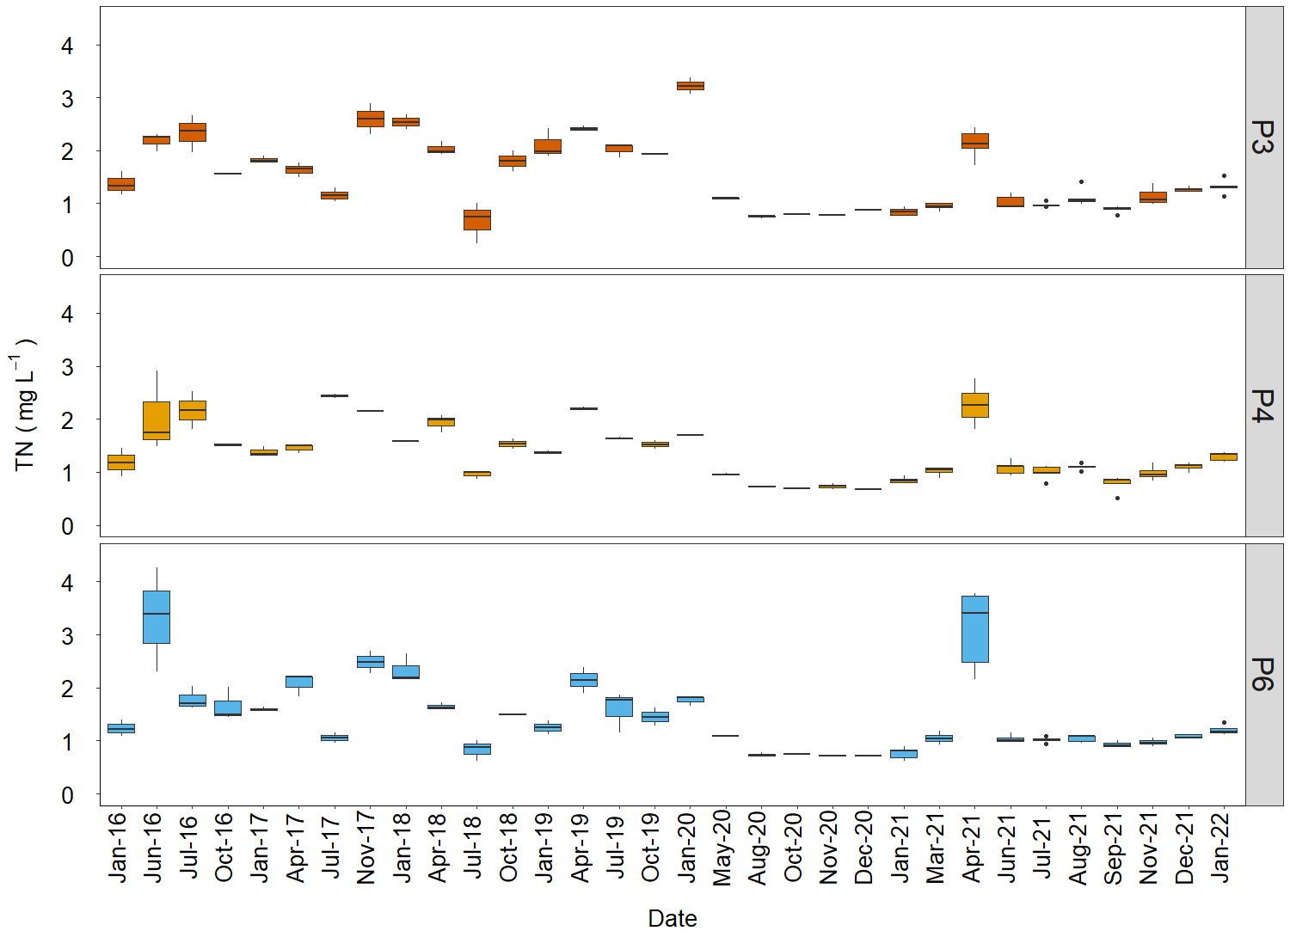
Figure S26 – Time series of total nitrogen concentration.
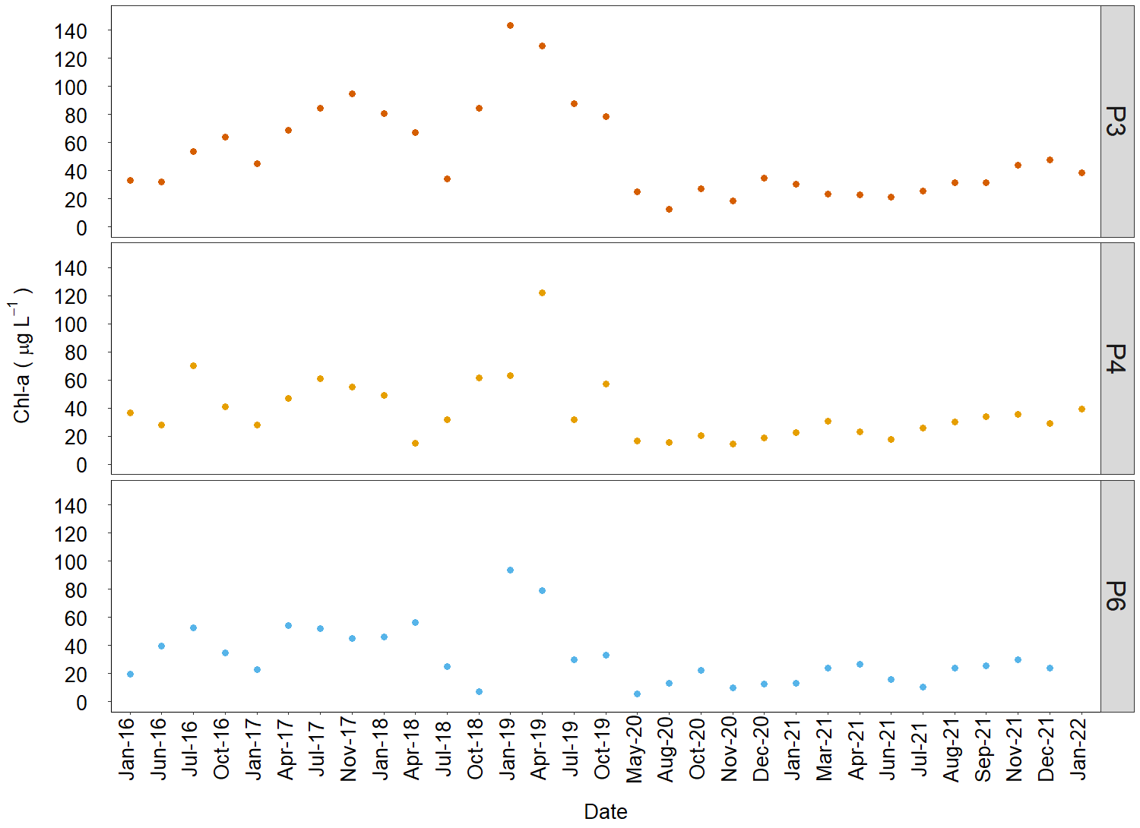
Figure S27 – Time series of chlorophyll a concentration at 0.3 m depth.

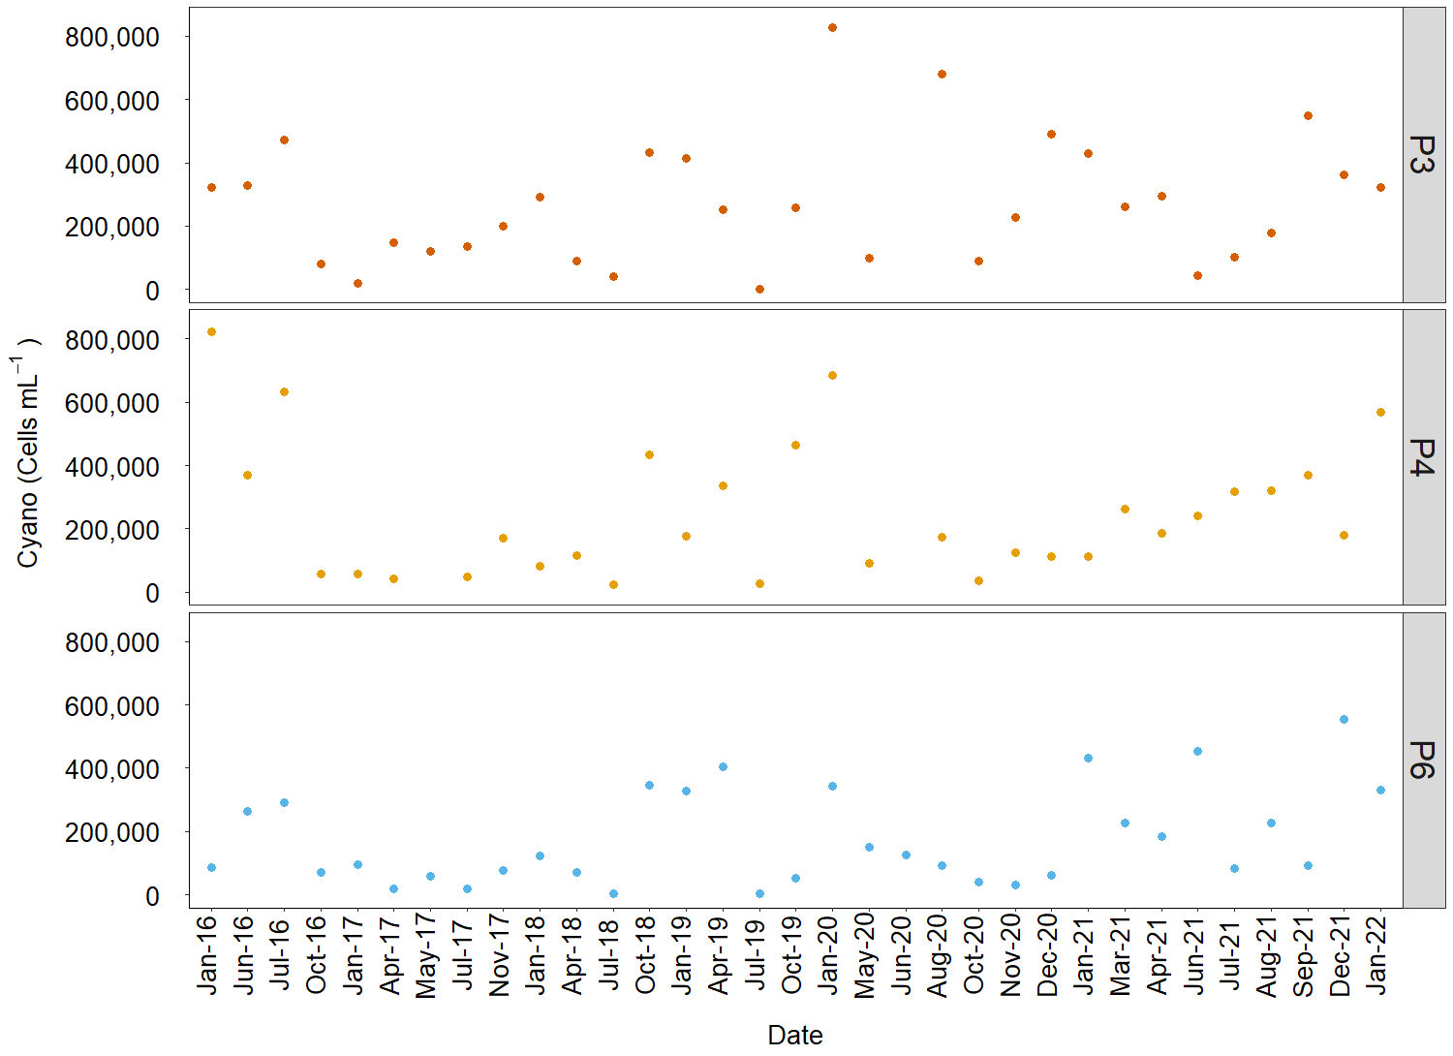
Figure S28 – Time series of cyanobacteria cell density at 0.3 m depth.

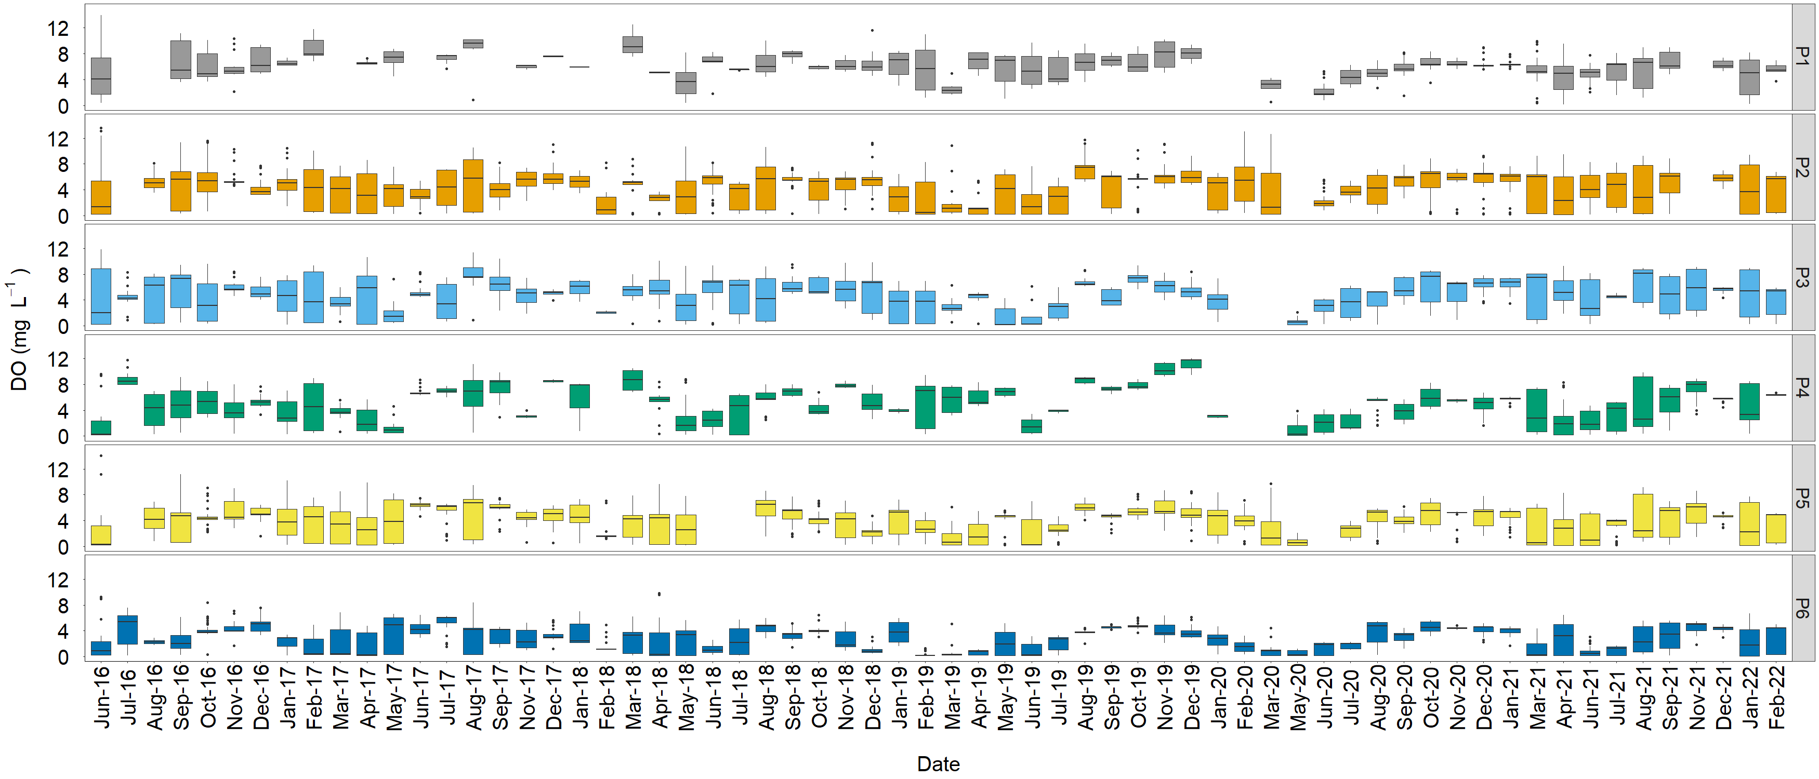
Figure S29 – Time series of dissolved oxygen concentration.
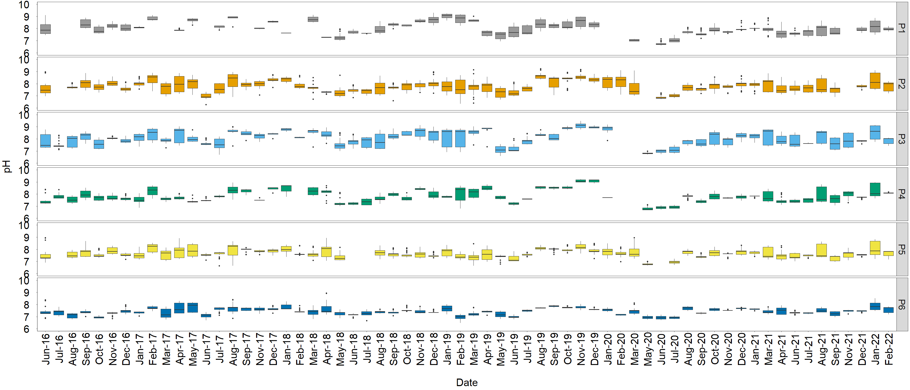
Figure S30 – Time series of pH concentration.

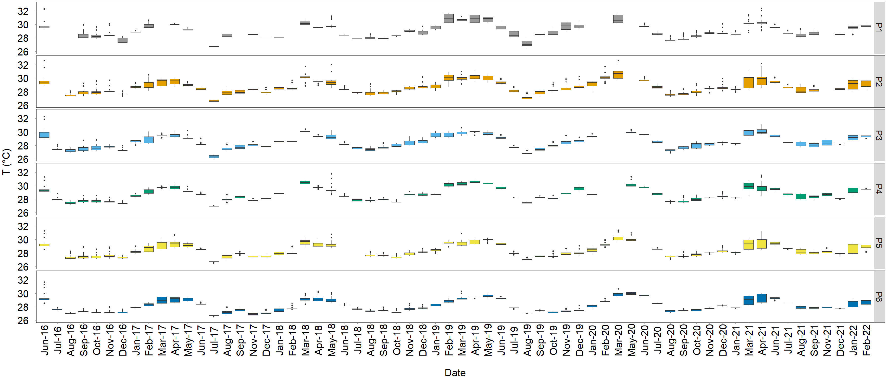
Figure S31 – Time series of temperature.
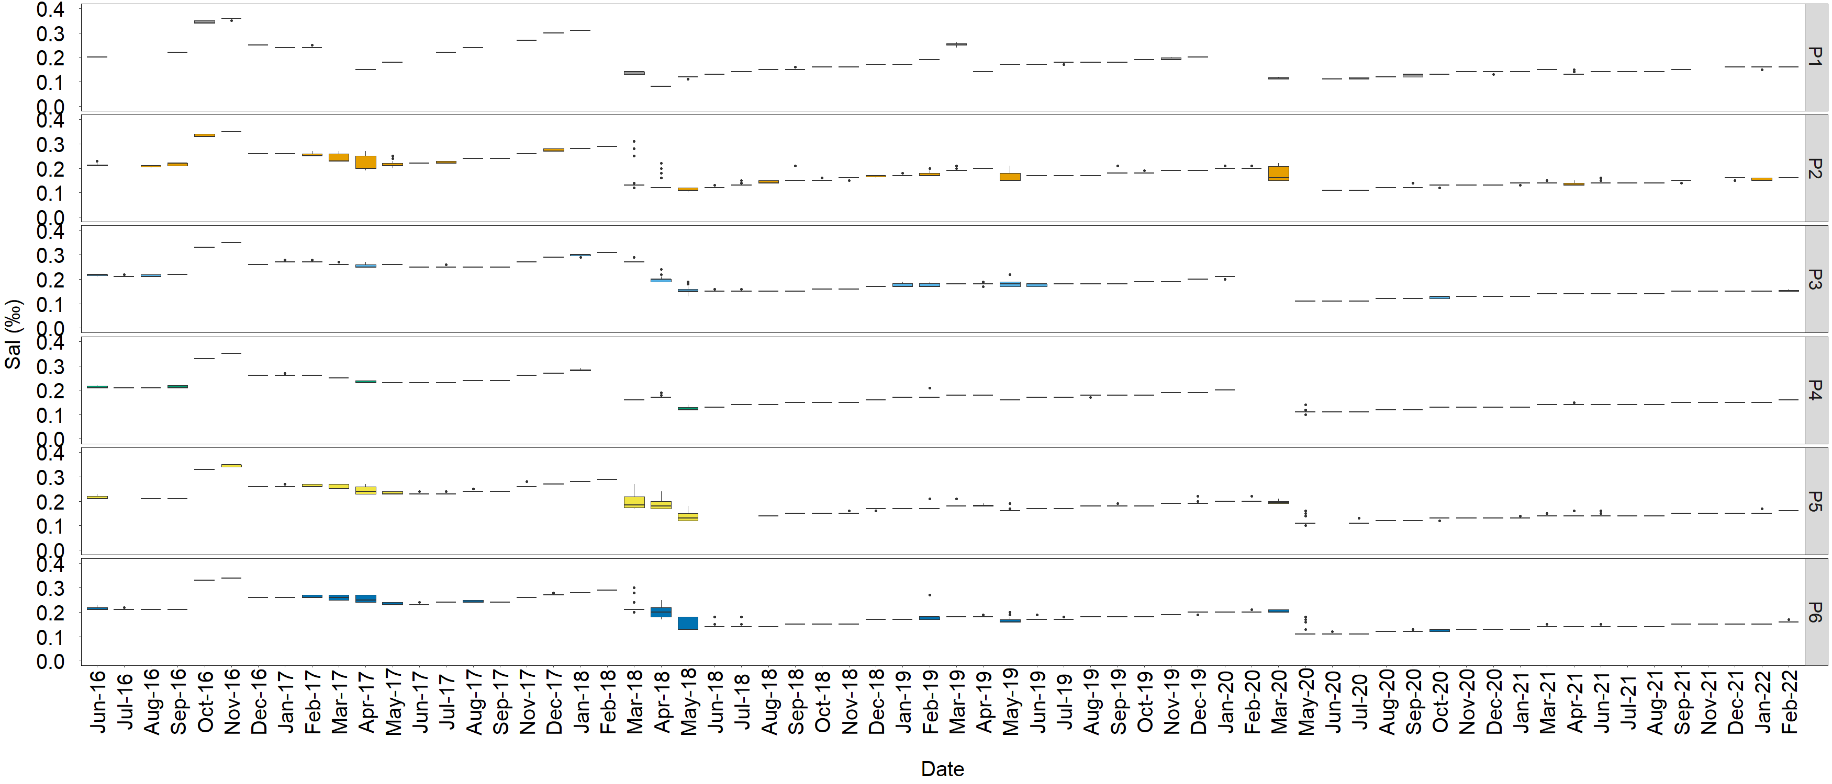
Figure S32 – Time series of salinity.
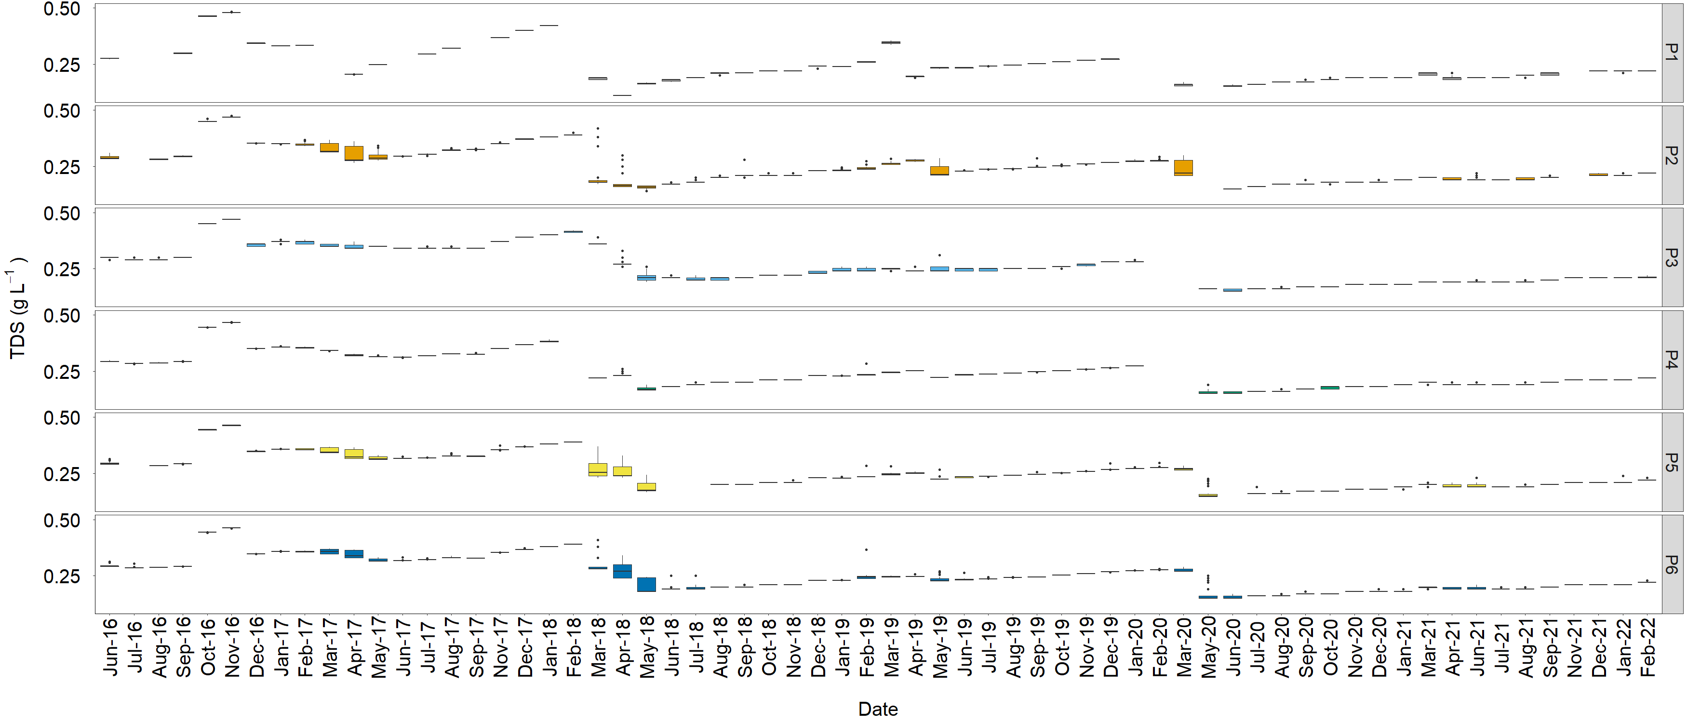
Figure S33 – Time series of total dissolved solids concentration.

