Supporting Information

Fractal Chiral Organic Molecular Cages

Zhen Wang,*^{, 1,2, #} Qing-Pu Zhang,^{1, #} Fei Guo, ^{2,#} Zi-Hui Liang, ² Chang-Hai Yi,² Chun Zhang*^{, 1} and Chuan-Feng Chen *^{,3}

¹ College of Life Science and Technology, National Engineering Research Center for Nanomedicine, Huazhong University of Science and Technology, Wuhan, 430074, China.
² National Engineering Laboratory for Advanced Yarn and Fabric Formation and Clean Production, Technology Institute, Wuhan Textile University, Wuhan, Hubei 430200, China.
³Institute of Chemistry, Chinese Academy of Sciences, Beijing 100190, China.

Corresponding Author
E-mail: chunzhang@hust.edu.cn;
E-mail: wz@wtu.edu.cn;
E-mail: cchen@iccas.ac.cn;

Contents
1. General information. S1
2. Experimental details S1
3. ¹H and ¹³C NMR spectra S6
4. 2D ¹H,¹H-COSY, ¹H,¹H-NOESY, ¹H,¹³C-HSQC and ¹H,¹³C-HMBC NMR spectra S10
5. X-ray single crystal diffraction structures. S16
6. Computational calculation. S20
7. Circular dichroism (CD) spectra. S20
8. SEM and TEM. S21
References S24

General information.
All materials obtained commercially were used without further purification. ¹H NMR, ¹³C NMR, ¹H,¹H-COSY NMR, ¹H,¹H-NOESY NMR, ¹H,¹³C-HSQC NMR and ¹H,¹³C-HMBC NMR spectra were recorded on a DMX600 NMR. MALDI-TOF mass spectra were obtained on a BIFLEXIII mass spectrometer. CD spectra were recorded on J-810 Jasco Japan. SEM studies were conducted on JSM6510LV. TEM studies were conducted on a Tecnai G220 electron microscope. The X-ray intensity data were collected on a standard Bruker SMART-1000 CCD Area Detector System equipped with a normal-focus molybdenum-target X-ray tube (λ = 0.71073 Å) operated at 2.0 kW (50 kV, 40 mA) and a graphite monochromator. The structures were solved by using direct methods and were refined by employing full-matrix least-squares cycles on F² (Bruker, SHELXTL-97).

Experimental details

2.1 Synthesis of 1,3,5-TPB based [2+3] molecular cage (CHO-TMC).
Scheme S1 Synthesis of 1,3,5-TPB based [2+3] molecular cage (CHO-TMC).

1,3,5-TPB based [2+3] molecular cage TMC was synthesized according to the reported literature.^{[1]}
TMC (100 mg, 0.096 mmol) and 4-hydroxybenzaldehyde 3 (47 mg, 0.383 mmol) were dissolved 10 mL N,N-dimethylformamide (DMF), N,N-diisopropylethylamine (DIPEA) (67 μL, 0.383 mmol) was added, and then stirred vigorously at room temperature for 1 h. The reaction was monitored by TLC. When the raw materials were consumed, water (50 mL) was added to quench the reaction, and then filtered. The precipitate was dispersed in MeOH, ultrasonicated for 5 min and subsequently filtered, the obtained precipitate was the pure product of TPB based [2+3] molecular cage CHO-TMC (110 mg, 89%). ¹H NMR (600 MHz, CDCl₃), δ (ppm) = 10.087 (s, 3H), 8.06–8.07 (d, J = 8.40 Hz, 6H); 7.50–7.51 (d, J = 8.40 Hz, 6H), 7.48 (s, 6H), 7.38–7.40 (d, J = 8.40 Hz, 12H), 6.95–6.96 (d, J = 8.40 Hz, 12H); ¹³C (150 MHz, CDCl₃): δ (ppm) = 190.83, 174.13, 173.80, 156.11, 151.57, 140.99, 138.53, 134.48, 131.59, 127.31, 123.93, 122.50., 122.30.
Crystallographic data for CHO-TMC: Mr = 1459.09, Monoclinic, Space group C2/c, a = 37.8044(14), b = 17.6961(5) Å, c = 32.1933(14) Å, α = 90°, β = 127.004(6)°, γ = 90°, V = 17199.3(15) Å³, Z = 8, ρ_{calcd}. = 1.127 Mg/m³, μ = 0.691 mm^{–1}, reflections collected 62563, data/restraints/parameters 17018/110/838, GOF on F² 2.648, final R₁ = 0.2742, wR₂ = 0.6104, R indices (all data): R₁ = 0.3109, wR₂ = 0.6411, largest diff. peak and hole: 1.980 and -0.714 e/Å⁻³, CCDC - 2180996.

2.2 Synthesis of [2[2+3]+3] higher-level molecular cage 4P-HTMC, 4M-HTMC and 4MP-HTMC.
Scheme S2 Synthesis of [2[2+3]+3] higher-level chiral molecular cage 4P-HTMC.

CHO-TMC (100 mg, 0.077 mmol) and (R,R)-diaminocyclohexane (CHDA) (13.2 mg, 0.115 mmol) were dissolved in DCM (10 mL) and added to round bottom flask. Then, a catalysis amount of trifluoroacetic acid (TFA) (0.3 μL, 5% mmol) were added in. The combined mixture was stirred vigorously at room temperature for overnight. After that, the reaction was monitored by TLC with additional a small amount of (R,R)-diaminocyclohexane (CHDA). When the raw materials were consumed, the mixture was precipitated by MeOH 50 mL. The formed white precipitate was filtered and dried in vacuum to afford dry white solid molecular cage 4P-HTMC. (103 mg, 94%). ¹H NMR (600 MHz, CDCl₃), δ (ppm) = 8.36 (s, 6H), 7.79–7.81 (d, J = 8.40 Hz, 12H); 7.23–7.24 (d, J = 8.40 Hz, 12H), 7.19 (s, 6H), 7.15–7.16 (d, J = 8.40 Hz, 12H), 6.81–6.82 (t, 18H), 6.72–6.73 (d, J = 8.40 Hz, 12H), 6.35–6.36 (d, J = 8.40 Hz, 12H), 3.51–5.53 (m, 6H), 1.29–1.91 (m, 24H); ¹³C (150 MHz, CDCl₃), δ (ppm) = 174.29, 174.09, 173.71, 159.10, 152.99, 151.64, 151.25, 141.04, 140.69, 138.59, 138.19, 134.64, 129.64, 127.23, 126.78, 124.04, 123.59, 122.37, 121.55, 121.39, 74.36, 33.21, 24.50. MALDI TOF-MS, m/z = 2835.96.
Crystallographic data for 4P-HTMC: Mr = 1459.09, Orthorhombic, Space group P 2₁ 2₁ 2₁, a = 20.2221(18), b = 29.288(3) Å, c = 40.606(4) Å, α = 90°, β = 90°, γ = 90°, V = 24049(4) Å³, Z = 8, ρ_{calcd}. = 0.981 Mg/m³, μ = 0.256 mm^{–1}, reflections collected 116327, data/restraints/parameters 34559/166/2161, GOF on F² 1.021, final R₁ = 0.0826, wR₂ = 0.2285, R indices (all data): R₁ = 0.1303, wR₂ = 0.2700, largest diff. peak and hole: 0.475 and -0.358 e/Å⁻³, CCDC - 2181020.
Scheme S3 Synthesis of [2[2+3]+3] higher-level chiral molecular cage 4M-HTMC.
CHO-TMC (100 mg, 0.077 mmol) and (R,R)-diaminocyclohexane (CHDA) (13.2 mg, 0.115 mmol) were dissolved in DCM (10 mL) and added to round bottom flask. Then, a catalysis amount of trifluoroacetic acid (TFA) (0.3 μL, 5% mmol) were added in. The combined mixture was stirred vigorously at room temperature for overnight. After that, the reaction was monitored by TLC with additional a small amount of (S,S)-diaminocyclohexane (CHDA). When the raw materials were consumed, the mixture was precipitated by MeOH 50 mL. The formed white precipitate was filtered and dried in vacuum to afford dry white solid molecular cage 4M-HTMC. (100 mg, 91%). ¹H NMR (600 MHz, CDCl₃), δ (ppm) = 8.36 (s, 6H), 7.79–7.81 (d, J = 8.40 Hz, 12H); 7.23–7.24 (d, J = 8.40 Hz, 12H), 7.19 (s, 6H), 7.15–7.16 (d, J = 8.40 Hz, 12H), 6.81–6.82 (t, 18H), 6.72–6.73 (d, J = 8.40 Hz, 12H), 6.35–6.36 (d, J = 8.40 Hz, 12H), 3.52–5.54 (m, 6H), 1.29–1.91 (m, 24H); ¹³C (150 MHz, CDCl₃), δ (ppm) = 174.29, 174.10, 173.72, 159.08, 152.99, 151.65, 151.25, 141.04, 140.69, 138.59, 138.19, 134.65, 129.64, 127.23, 126.78, 124.04, 123.58, 122.37, 121.55, 121.40, 74.36, 33.21, 24.50. MALDI TOF-MS, m/z = 2835.96. MALDI TOF-MS, m/z = 2835.93.
Crystallographic data for 4M-HTMC: Mr = 3551.14, Orthorhombic, Space group P 2₁ 2₁ 2₁, a = 19.6795(9), b = 29.1198(14) Å, c = 40.2573(18) Å, α = 90°, β = 90°, γ = 90°, V = 23070.0(18) Å³, Z = 8, ρ_{calcd}. = 0.918 Mg/m³, μ = 1.148 mm^{–1}, reflections collected 172380, data/restraints/parameters 40238/0/2144, GOF on F² 2.459, final R₁ = 0.2446, wR₂ = 0.5244, R indices (all data): R₁ = 0.2547, wR₂ = 0.5385, largest diff. peak and hole: 2.712 and -2.212 e/Å⁻³, CCDC - 2181024.
Scheme S4 Synthesis of [2[2+3]+3] higher-level chiral molecular cage 4MP-HTMC.
CHO-TMC (100 mg, 0.077 mmol) and racemic diaminocyclohexane (CHDA) (13.2 mg, 0.115 mmol) were dissolved in DCM (10 mL) and added to round bottom flask. Then, a catalysis amount of trifluoroacetic acid (TFA) (0.3 μL, 5% mmol) were added in. The combined mixture was stirred vigorously at room temperature for overnight. After that, the reaction was monitored by TLC with additional a small amount of racemic diaminocyclohexane (CHDA). When the raw materials were consumed, the mixture was precipitated by MeOH 50 mL. The formed white precipitate was filtered and dried in vacuum to afford dry white solid molecular cage 4MP-HTMC. (100 mg, 91%). ¹H NMR (600 MHz, CDCl₃), δ (ppm) = 8.36 (s, 6H), 7.79–7.81 (d, J = 8.40 Hz, 12H); 7.23–7.23 (d, J = 8.40 Hz, 12H), 7.19 (s, 6H), 7.15–7.16 (d, J = 8.40 Hz, 12H), 6.81–6.82 (t, 18H), 6.72–6.73 (d, J = 8.40 Hz, 12H), 6.35–6.36 (d, J = 8.40 Hz, 12H), 3.51–5.53 (m, 6H), 1.29–1.91 (m, 24H); ¹³C (150 MHz, CDCl₃), δ (ppm) = 174.29, 174.09, 173.71, 159.08, 152.99, 151.65, 151.25, 141.04, 140.69, 138.58, 138.19, 134.64, 129.64, 127.23, 126.78, 124.04, 123.58, 122.37, 121.55, 121.39, 74.36, 33.20, 24.51.

¹H and ¹³C NMR spectra
Fig. S1 The ¹H NMR spectra of 1,3,5-TPB based [2+3] molecular cage CHO-TMC in CDCl₃.
Fig. S2 The ¹³C NMR spectra of 1,3,5-TPB based [2+3] molecular cage CHO-TMC in CDCl₃.
Fig. S3 The ¹H NMR spectra of [2[2+3]+3] higher-level chiral molecular cage 4P-HTMC in CDCl₃.
Fig. S4 The ¹³C NMR spectra of [2[2+3]+3] higher-level chiral molecular cage 4P-HTMC in CDCl₃.
Fig. S5 The ¹H NMR spectra of [2[2+3]+3] higher-level chiral molecular cage 4M-HTMC in CDCl₃.
Fig. S6 The ¹³C NMR spectra of [2[2+3]+3] higher-level chiral molecular cage 4M-HTMC in CDCl₃.
Fig. S7 The ¹H NMR spectra of [2[2+3]+3] higher-level racemic molecular cage 4MP-HTMC in CDCl₃.

Fig. S8 The ¹³C NMR spectra of [2[2+3]+3] higher-level racemic molecular cage 4MP-HTMC in CDCl₃.

4. 2D ¹H,¹H-COSY, ¹H,¹H-NOESY, ¹H,¹³C-HSQC and ¹H,¹³C-HMBC NMR spectra
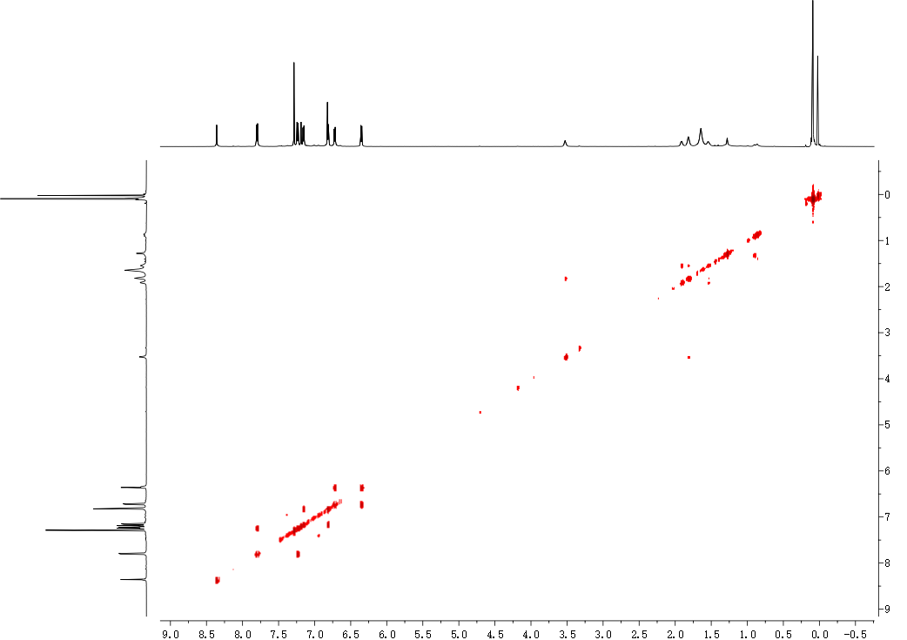
Fig. S9 The ¹H,¹H-COSY spectra of [2[2+3]+3] higher-level chiral molecular cage 4P-HTMC in CDCl₃.
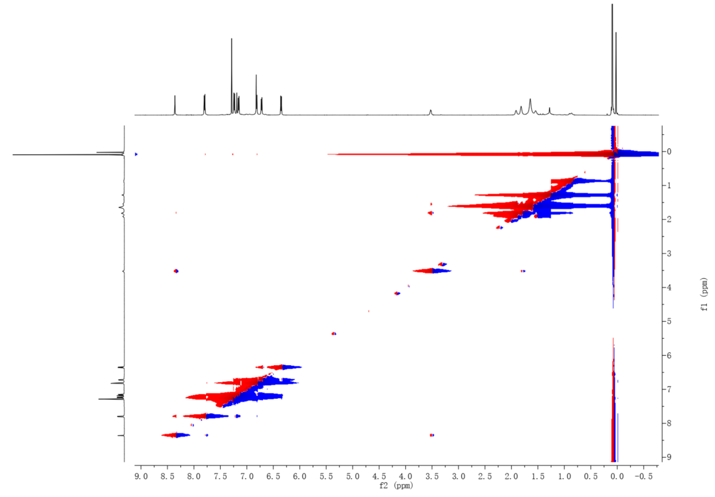
Fig. S10 The ¹H,¹H- NOESY spectra of [2[2+3]+3] higher-level chiral molecular cage 4P-HTMC in CDCl₃.
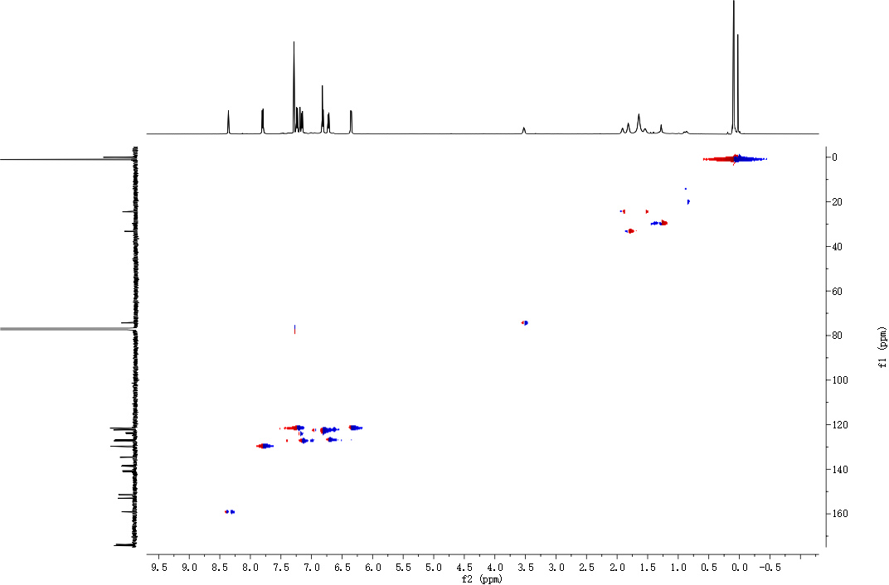
Fig. S11 The ¹H,¹³C- HSQC spectra of [2[2+3]+3] higher-level chiral molecular cage 4P-HTMC in CDCl₃.
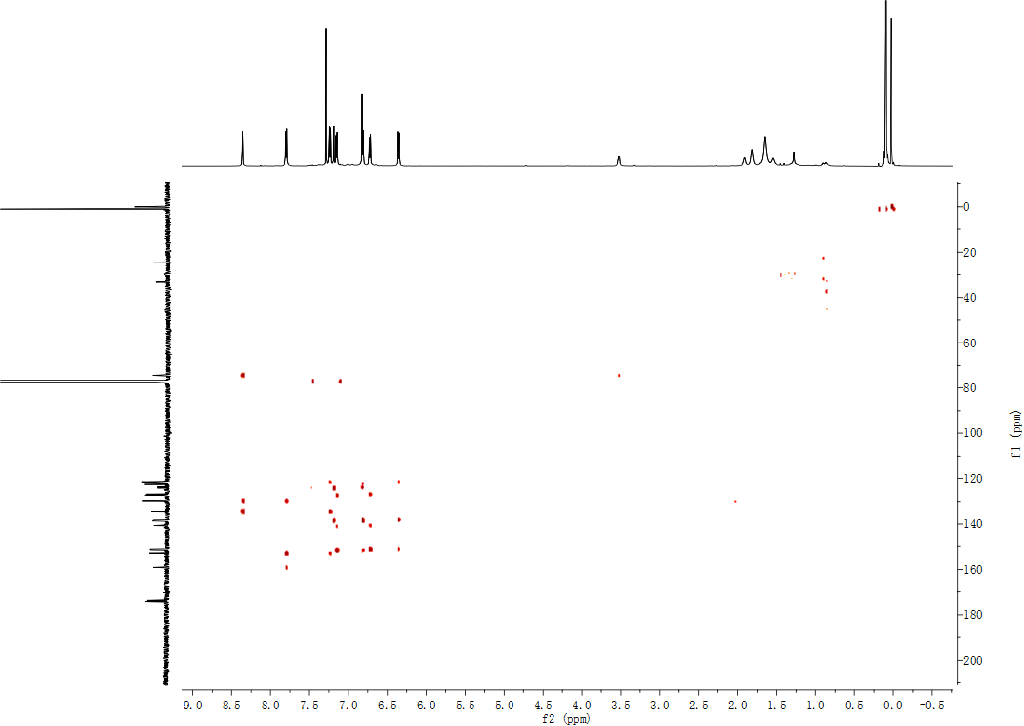
Fig. S12 The ¹H,¹³C-HMBC spectra of [2[2+3]+3] higher-level chiral molecular cage 4P-HTMC in CDCl₃.
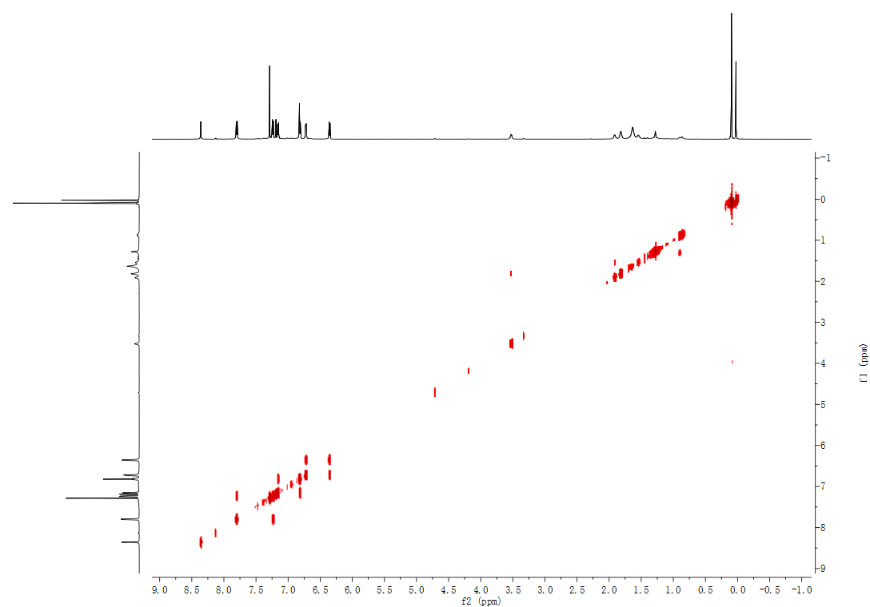
Fig. S13 The ¹H,¹H-COSY spectra of [2[2+3]+3] higher-level chiral molecular cage 4M-HTMC in CDCl₃.
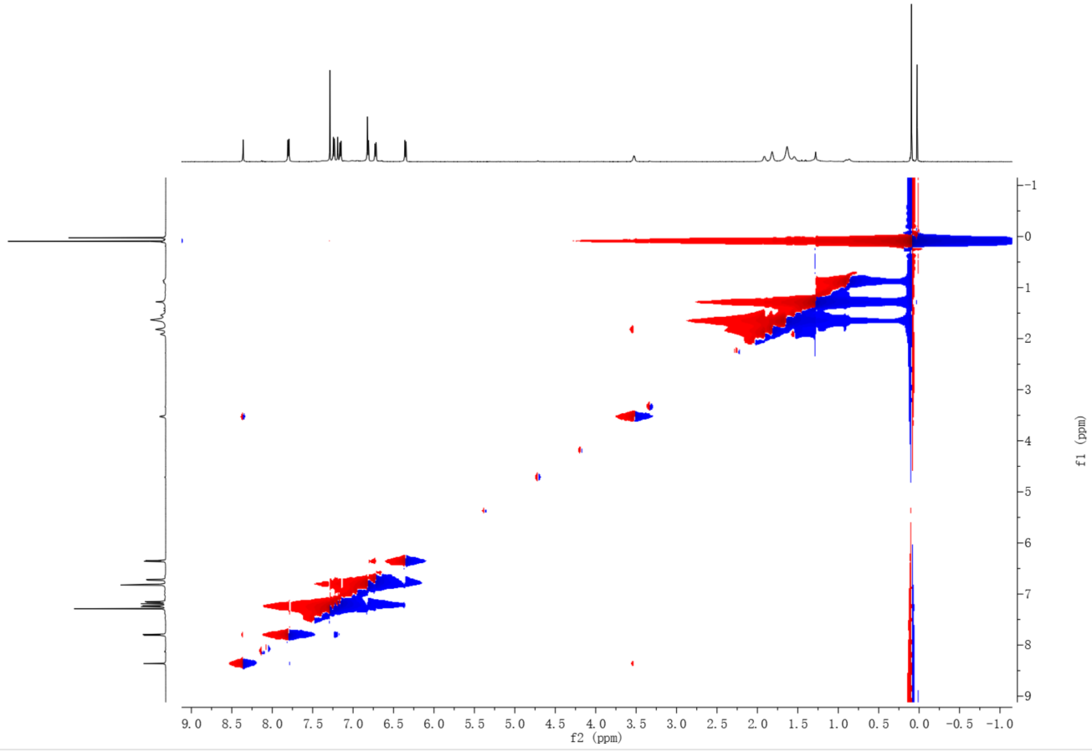
Fig. S14 The ¹H,¹H- NOESY spectra of [2[2+3]+3] higher-level chiral molecular cage 4M-HTMC in CDCl₃.
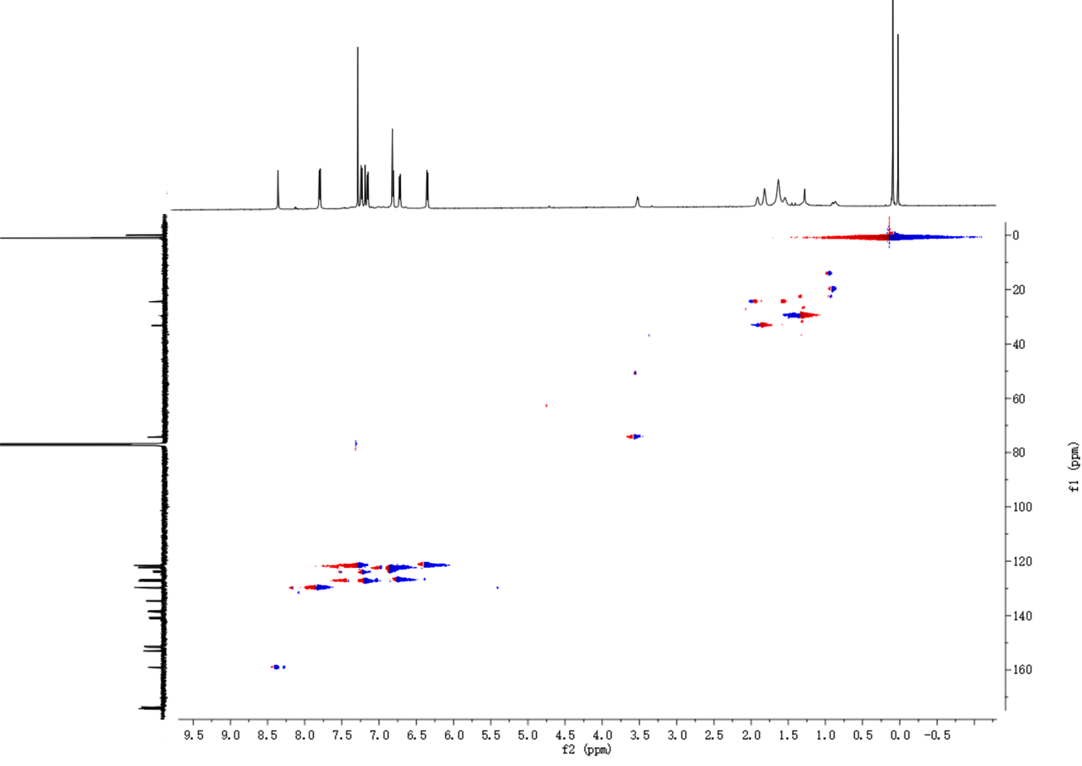
Fig. S15 The ¹H,¹³C- HSQC spectra of [2[2+3]+3] higher-level chiral molecular cage 4M-HTMC in CDCl₃.
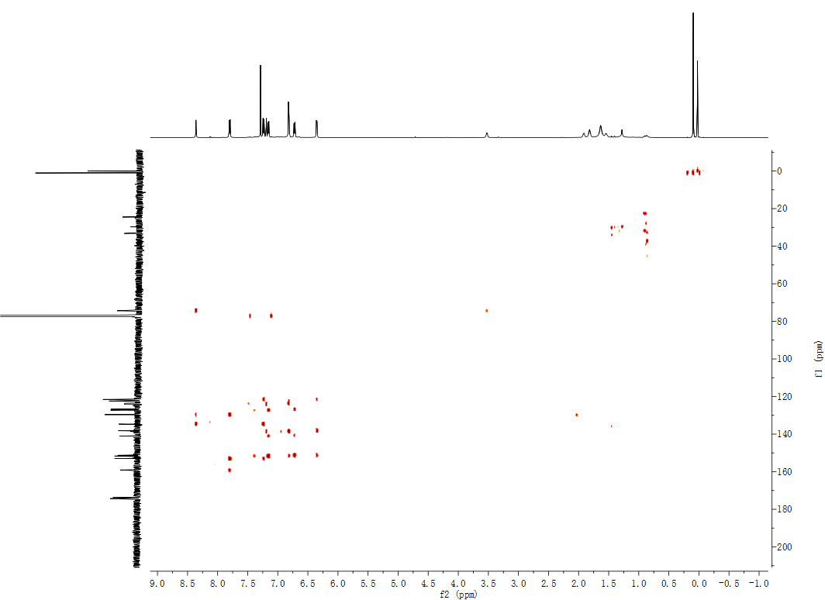
Fig. S16 The ¹H,¹³C-HMBC spectra of [2[2+3]+3] higher-level chiral molecular cage 4M-HTMC in CDCl₃.
Fig. S17 The ¹H,¹H-COSY spectra of [2[2+3]+3] higher-level racemic molecular cage 4MP-HTMC in CDCl₃.
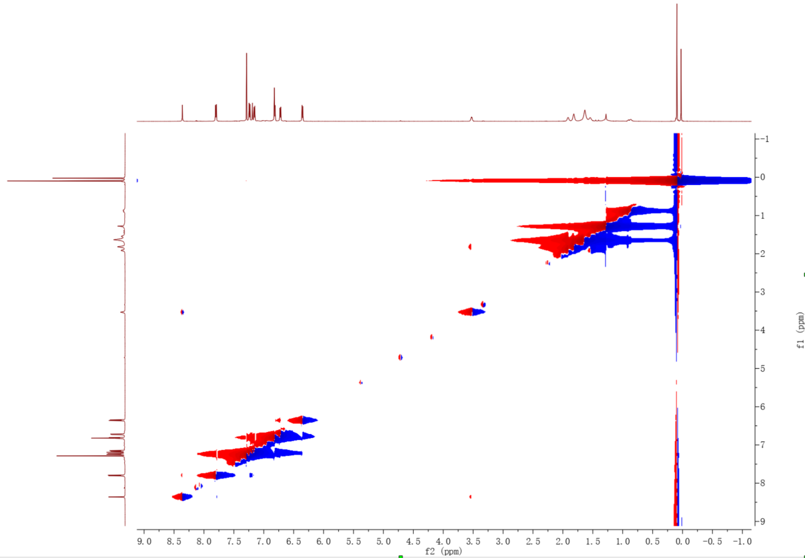
Fig. S18 The ¹H,¹H- NOESY spectra of [2[2+3]+3] higher-level racemic molecular cage 4MP-HTMC in CDCl₃.
Fig. S19 The ¹H,¹³C- HSQC spectra of [2[2+3]+3] higher-level racemic molecular cage 4MP-HTMC in CDCl₃.
Fig. S20 The ¹H,¹³C-HMBC spectra of [2[2+3]+3] higher-level racemic molecular cage 4MP-HTMC in CDCl₃.

5. X-ray single crystal diffraction structures.
Fig. S21 The chemical structure and X-ray single crystal structures from side view (a and b) and top view (c and d) molecular cages 2P-CHO-TMC and 2M-CHO-TMC, respectively. The cavity size of them was around 4.1 Å determined by the distance of central phenyl rings. The non-coplanar helical propeller conformation of TPB shows a rotation angle of approximately 37° (Hydrogen atom was omitted for clarity).
Fig. S22 The assemble structures of molecular cages 2P-CHO-TMC (blue) and 2M-CHO-TMC (red) analyzed by the X-ray single crystal structures of CHO-TMC. The enantiomers molecular cages 2P-CHO-TMC (blue) and 2M-CHO-TMC coexist in equal proportions with intertwined network structures. (Hydrogen atom was omitted for clarity).
Fig. S23 The X-ray single crystal structures of molecular cage CHO-TMC shows similar C-O-C bonds.

Fig. S24 The X-ray single crystal structures of molecular cages 4P-HTMC (left) and 4M-HTMC (right) from side view (a and b) show cavities size was around 3.9 Å determined by the distance of central phenyl rings. The top view shows the hetero-pores around 10 Å (c and d) and the molecular size of 4P-HTMC and 4M-HTMC, the building blocks CHO-TMC () and building blocks’ building blocks TPB are about 30-34 Å, 16 Å and 10 Å, determined by the vertices distance of the tri-bladed propeller structures (e and f). (Hydrogen atom was omitted for clarity).
Fig. S25 The X-ray single crystal structures of molecular cages 4P-HTMC (a) and 4M-HTMC (b) that assemble into dimers by intermolecular C−H···N interactions occur between the aromatic protons and the nitrogen atom of the triazine ring, and the π-π stacking interactions take place between the triazine ring moieties of adjacent molecular cages.
Fig. S26 The assemble structures of molecular cages 4P-HTMC (blue) and 4M-HTMC (red) analyzed by the X-ray single crystal structures of CHO-TMC. Through intermolecular interactions, the formed neighboring helices of molecular cages 4P-HTMC (blue) and 4M-HTMC (red) align and stack together, resulting in the formation of 2D layered structures. (Hydrogen atom was omitted for clarity).

6. Computational calculation.
The total energy calculation all four possible isomers HTMC with different ratio of (R,R)-(CHDA)/(S,S)-(CHDA) (R₃, S₃, R₂S and RS₂) were performed with Material Studio 8.0 using DMol3 model. The task was set to Geometry Optimization with Quality of Medium and Functional of GGA and BLYP.
Fig. S27 The chemical structure and their total energy of four possible isomers HTMC with different ratio of (R,R)-(CHDA)/(S,S)-(CHDA) (3R, 3S, 2R+S and 2S+R) after Geometry Optmization. (Hydrogen atom was omitted for clarity).

7. Circular dichroism (CD) spectra.
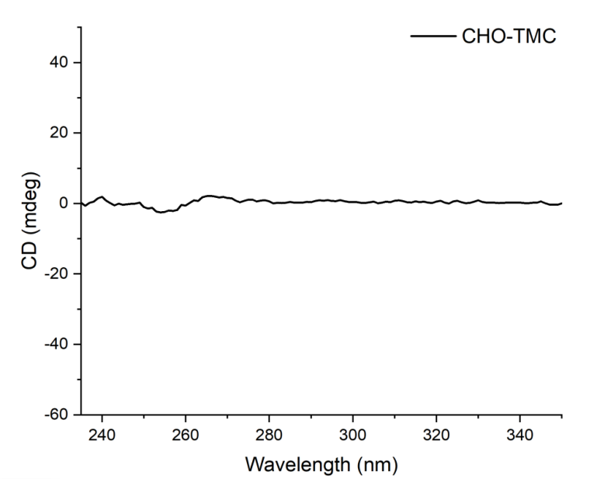
Fig. S28 The CD spectra of molecular cage CHO-TMC in DCM (c = 0.5 mM).
Fig. S29 The CD spectra of molecular cage 4P-HTMC (blue) and 4M-HTMC (red) in DCM (c = 0.5 mM) and in solid state.

8. SEM and TEM.
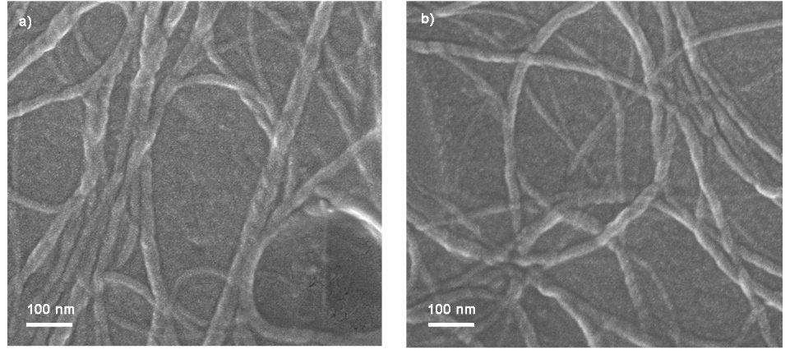
Fig. S30 The SEM images of d) 4P-HTMC and f) 4M-HTMC assembled L-helical or D-helical nanofibers.
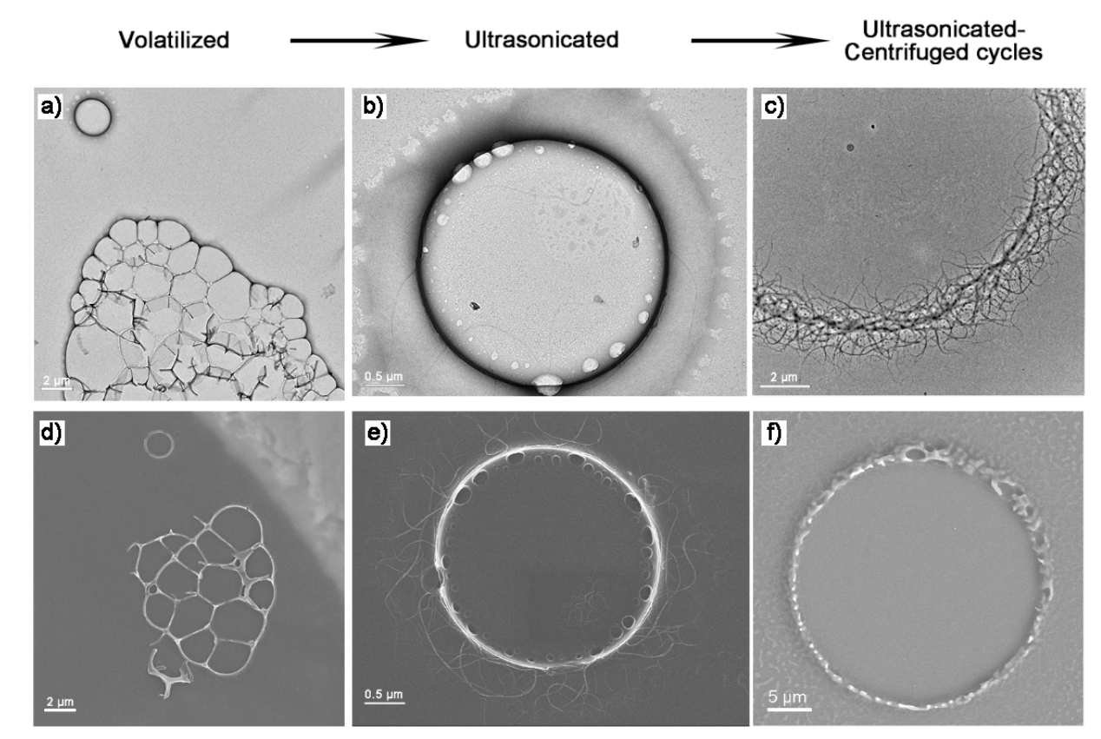
Fig. S31 The TEM (a-c) and SEM (d-f) images of 4P-HTMC in different morphology of tissue-like assemble structures (a, d), flagellatas-shaped like vesicles (b, e), and micro-scaled nanofiber rings (c. f).
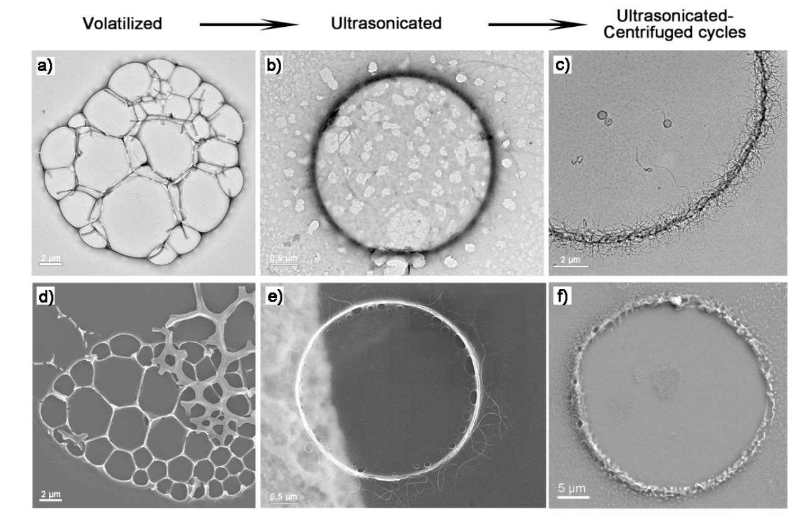
Fig. S32 The TEM (a-c) and SEM (d-f) images of 4M-HTMC in different morphology of tissue-like assemble structures (a, d), flagellatas-shaped like vesicles (b, e), and micro-scaled nanofiber rings (c. f).
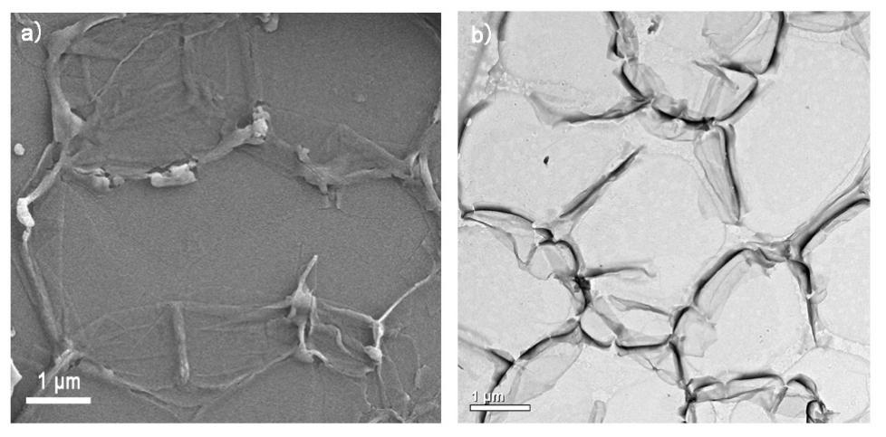
Fig. S33 The SEM images and TEM images of 4P-HTMC assemble into micro-scaled networks.
Fig. S34 The SEM (a-c) images and TEM (d-f) images of 4P-HTMC formed micro-vesicles in merging process and the nanofibers formed form the membrane.
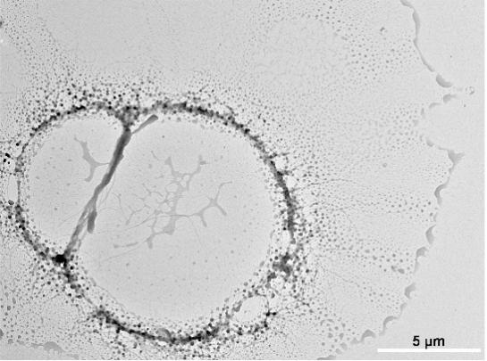
Fig. S35 The TEM images of 4P-HTMC formed huge ring structure in merging process.

References
- Naseer, M. M.; Wang, D.-X.; Zhao, L.; Huang, Z.-T.; Wang, M.-X. Synthesis and Functionalization of Heteroatom-Bridged Bicyclocalixaromatics, Large Molecular Triangular Prisms with Electron-Rich and -Deficient Aromatic Interiors. J. Org. Chem. 2011, 76, 1804–1813.

