Supplementary Material for
A theoretical study on toluene oxidization by OH radical
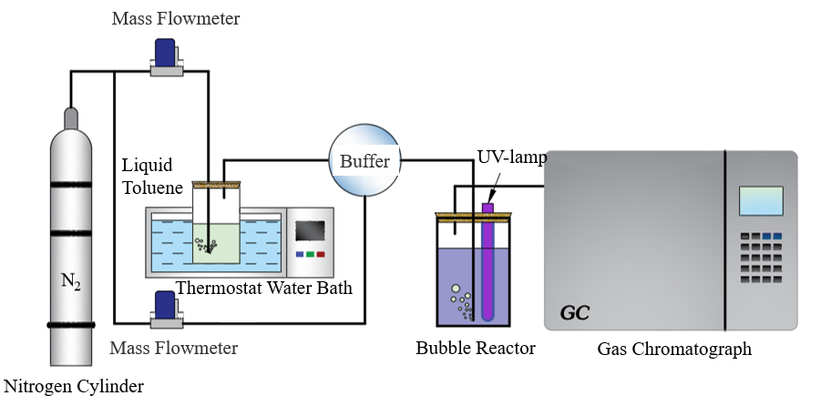
S1 Flow chart of experimental reaction of toluene degradation
Number | Instrument Name | Instrument Model | Instrument Manufacturer
1 | Gas chromatograph | GC 9570 | Zhejiang Fuli Analytical Instrument Co., Ltd
2 | pH meter | PHS-3C | Shanghai INESA Scientific Instrument Co., Ltd
3 | Electric constant temperature water bath | DK-98-1 | Tianjin Teste Instrument Co., Ltd
4 | Electronic balance | FR124CN | Shanghai OHAUS Instrument Co., Ltd
5 | Hydrogen generator | HGZ-300 | Shandong Huifen Instrument Co., Ltd
6 | Gas Flow Indicator | D08-4F | Beijing Qixing Huachuang Flow Meter Co., Ltd
7 | Gas Flow Meter | D07 | Beijing Qixing Huachuang Flow Meter Co., Ltd
8 | Electron Paramagnetic Resonance | MS-5000 | Magnettech
9 | UV lamp | ZW10D | Yiwu Jiacheng lighting appliances
S2(a) Experimental instrument for degradation of toluene and model thereof

Number | Reagent name | Molecular formula | Molecular weight | specification | supplier
1 | Potassium bisulfate | K₅H₃S₄O₁₈ | 614.76 | 42%~46% KHSO₅ | McLean chemical reagent
2 | Sodium persulfate | Na₂S₂O₈ | 238.1 | ≥99%，Analytically pure | McLean chemical reagent
3 | Phosphoric acid | H₃PO₄ | 98.00 | ≥85%，Analytically pure | Tianjin Beichen Fangzheng reagent
4 | Sodium hydroxide | NaOH | 40 | ≥95%，Analytically pure | McLean chemical reagent
5 | Hydrogen peroxide | H₂O₂ | 34.01 | 30%，Analytically pure | Tianjin Beichen Fangzheng reagent
6 | Sodium hypochlorite | NaClO | 74.44 | Available chlorine≥30% | McLean chemical reagent
7 | Toluene | C₇H₈ | 92.14 | ≥99.5%，Analytically pure | Sinopharm Group chemical reagents
8 | Tert-butanol | C₄H₁₀O | 74.12 | ≥99.5%，Analytically pure | Tianjin City Damao chemical reagent
9 | Anhydrous ethanol | C₂H₆O | 46.07 | ≥99.5%，Analytically pure | Tianjin City Damao chemical reagent
10 | Furfuryl alcohol | C₅H₆O₂ | 98.10 | ≥98%，Analytically pure | McLean chemical reagent
S2(b) Experimental Reagent specifications and supplier for degradation of toluene

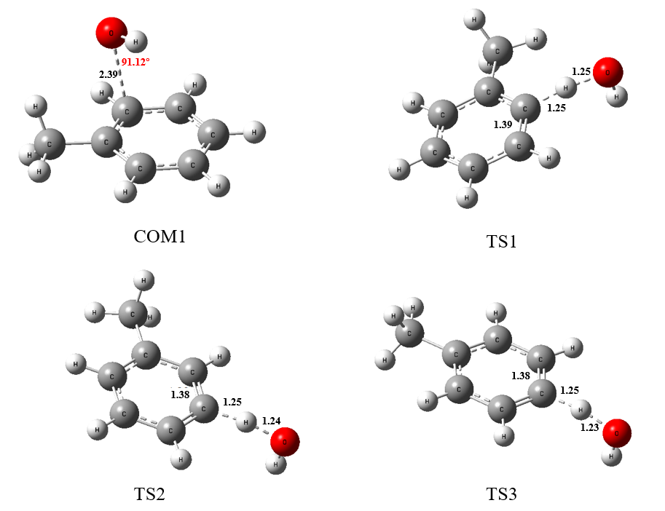
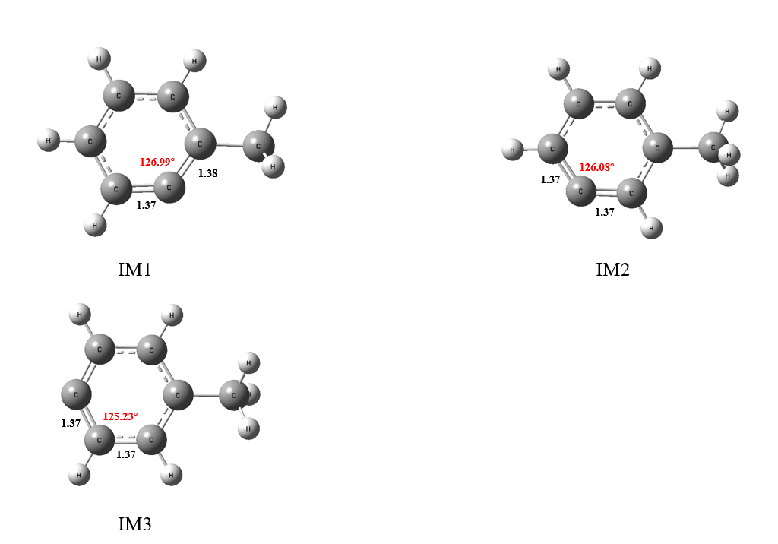
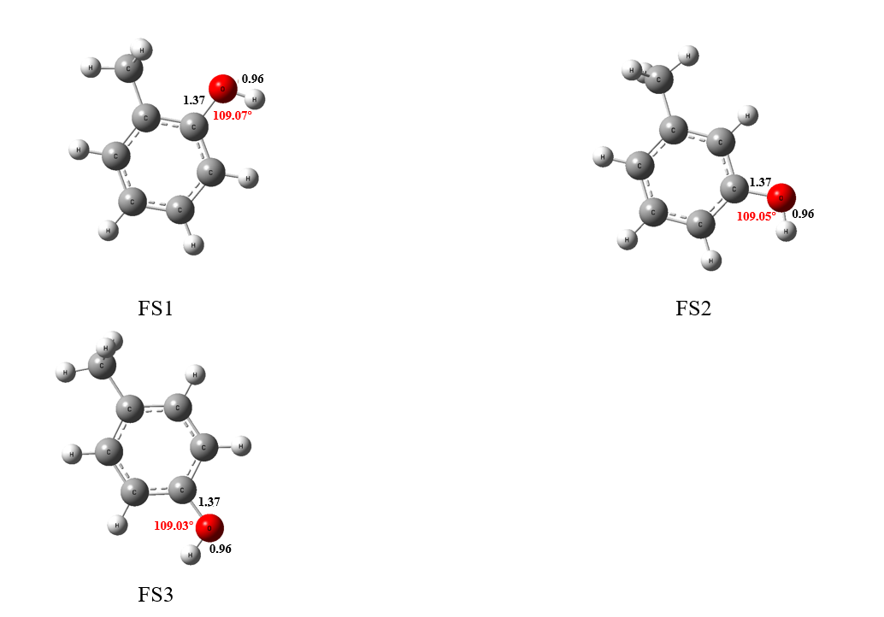
S3-1Geometric optimization results of toluene-OH complexes (COM1) and path1 transition states (TS1, TS2, TS3), intermediate products (IM1, IM2, IM3), and final products (FS1, FS2, FS3).

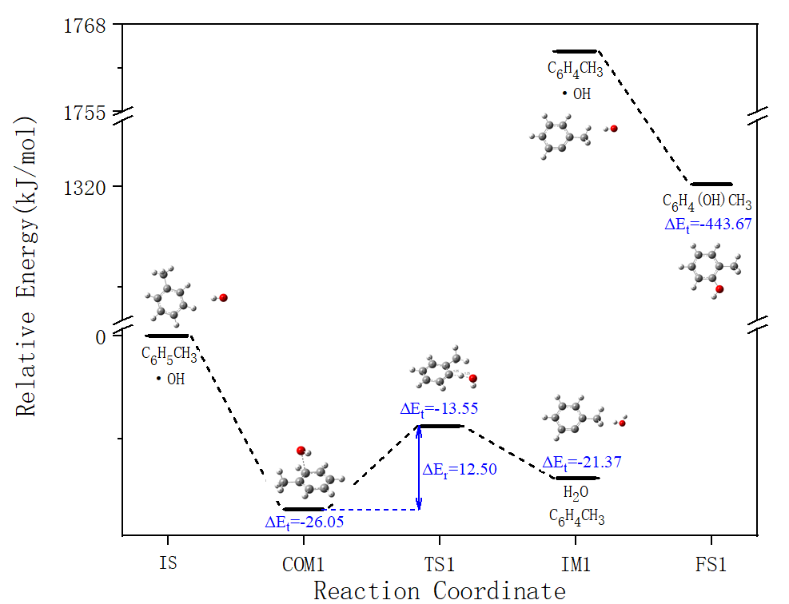
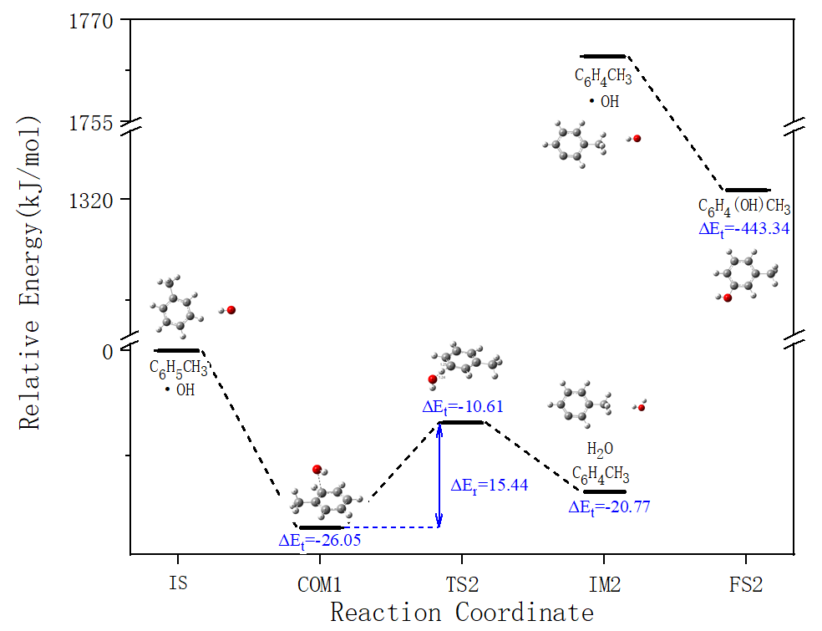
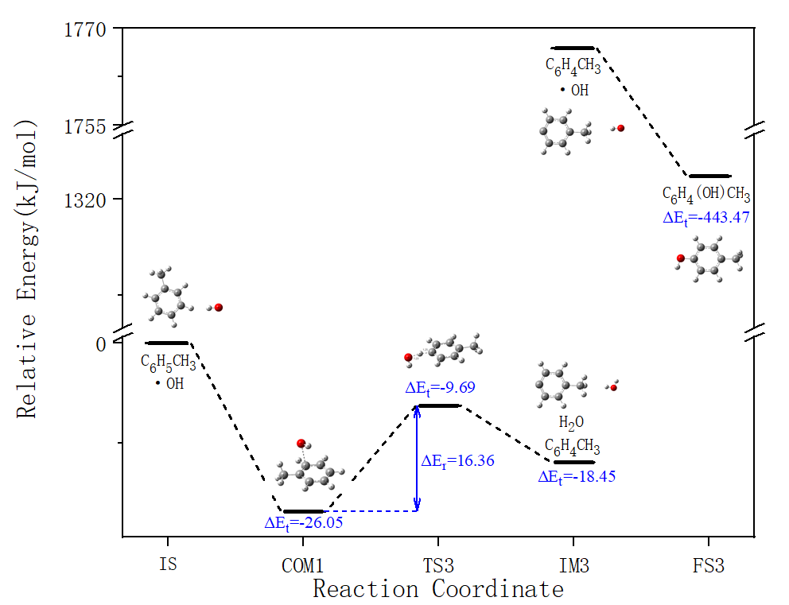
S3-2 Path 1Energy change graph
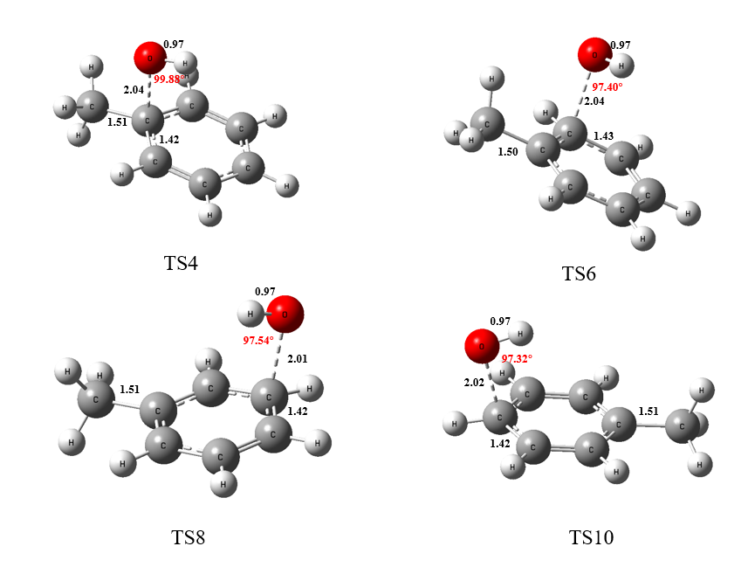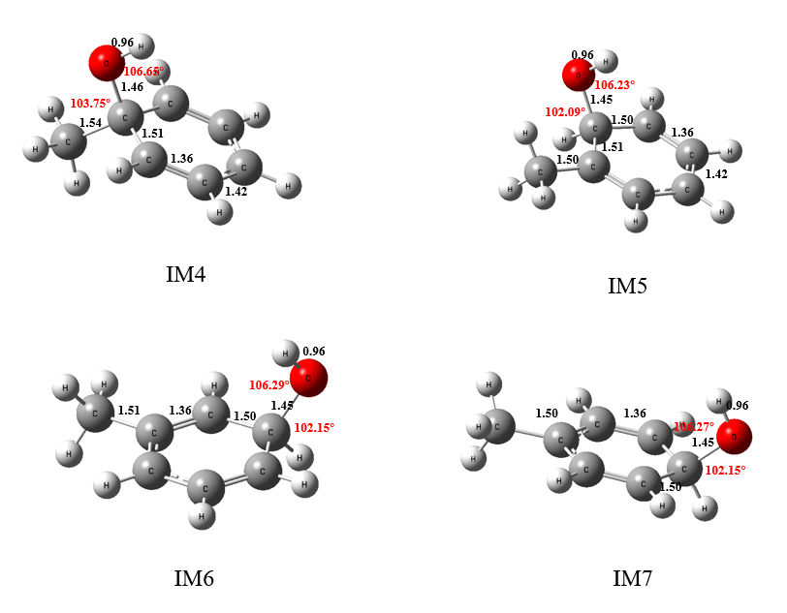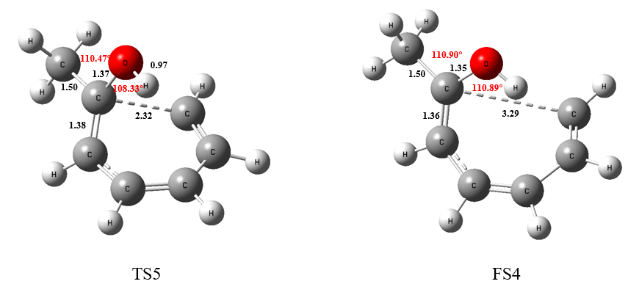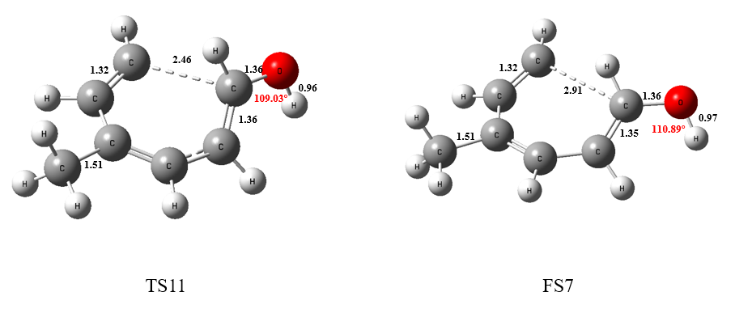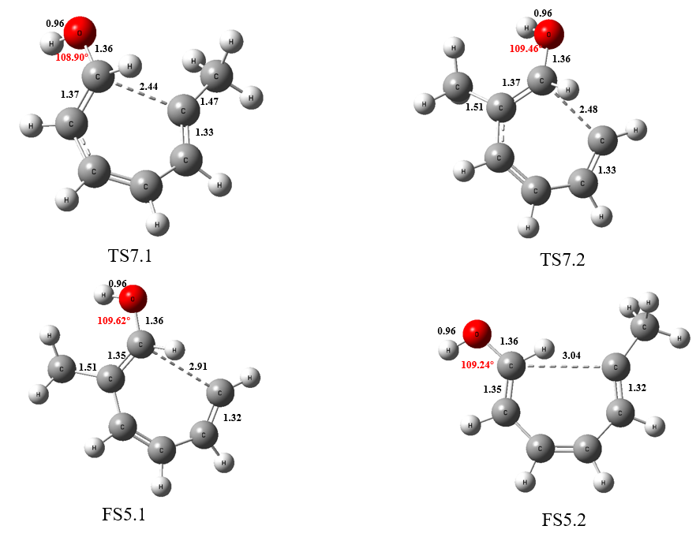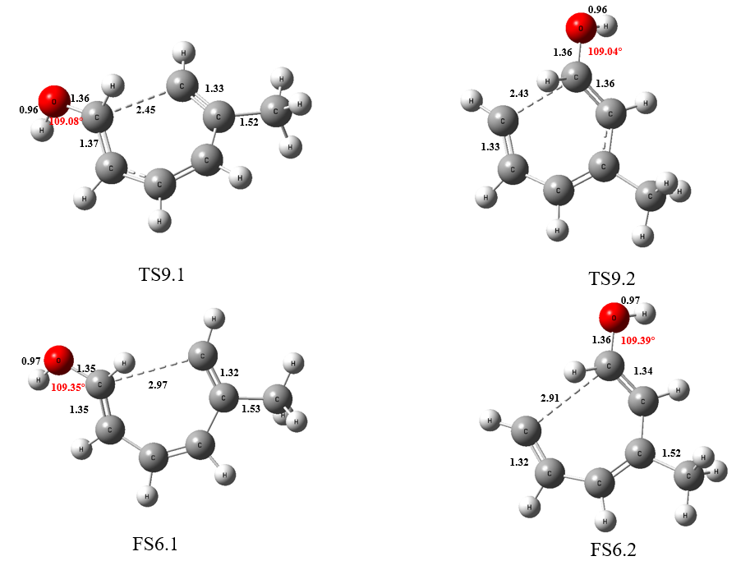
S4-1 Path2 Geometric optimization results of transition states (TS4-11), intermediate products (IM1-4) and end products (FS4-7).
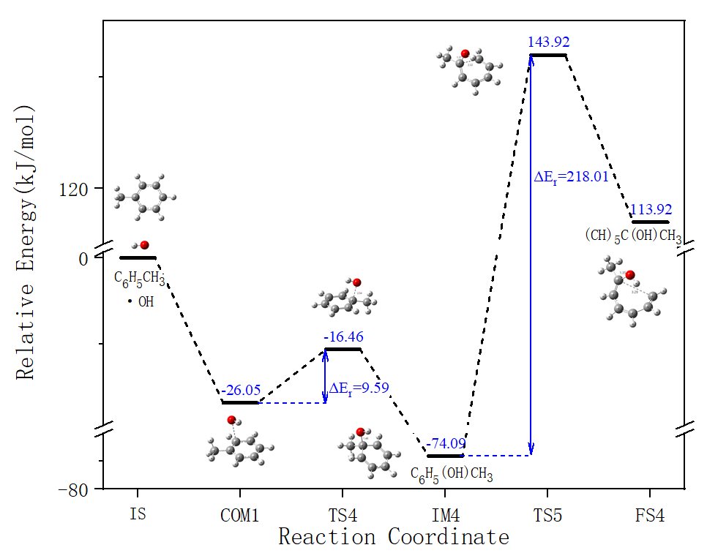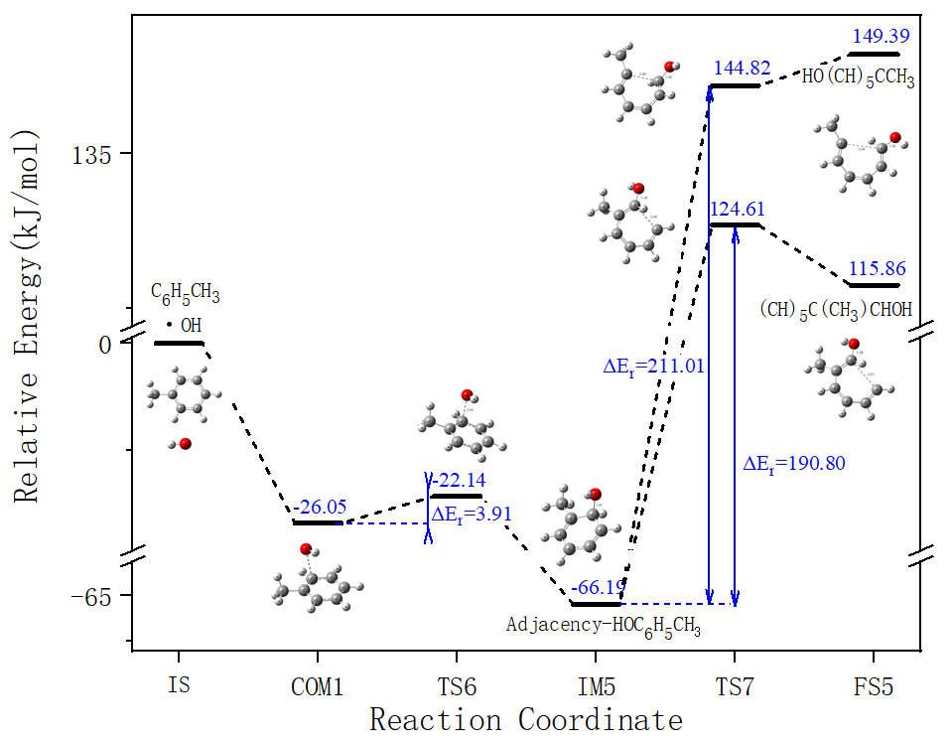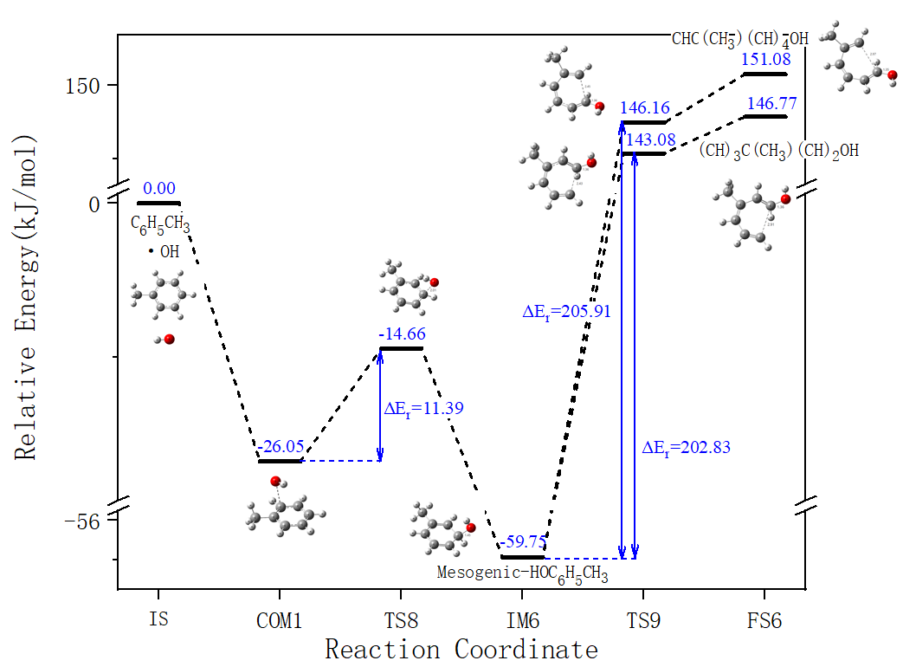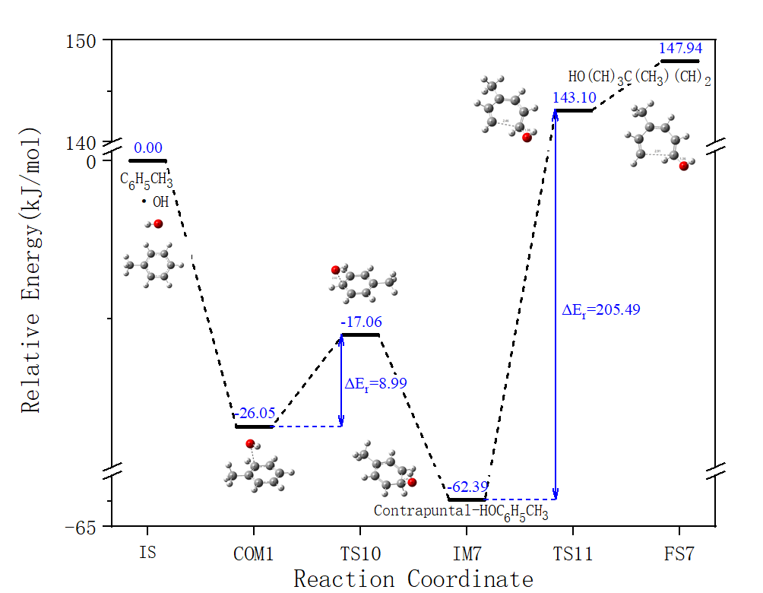
S4-2 Path 2 Energy change graph
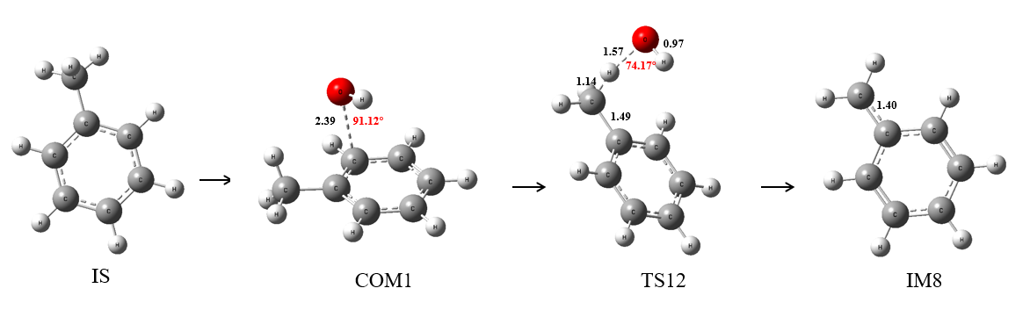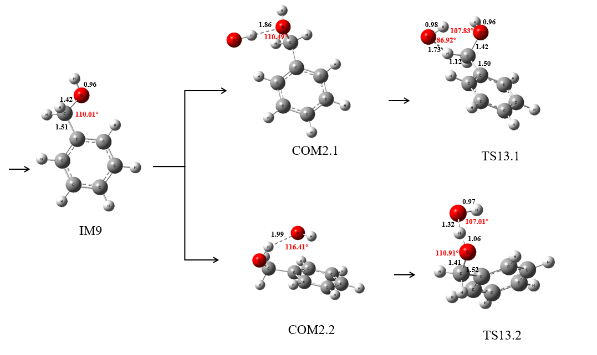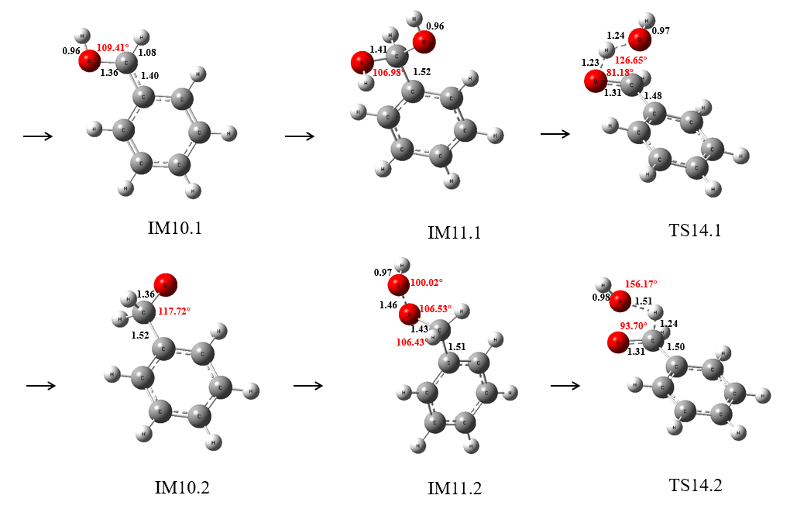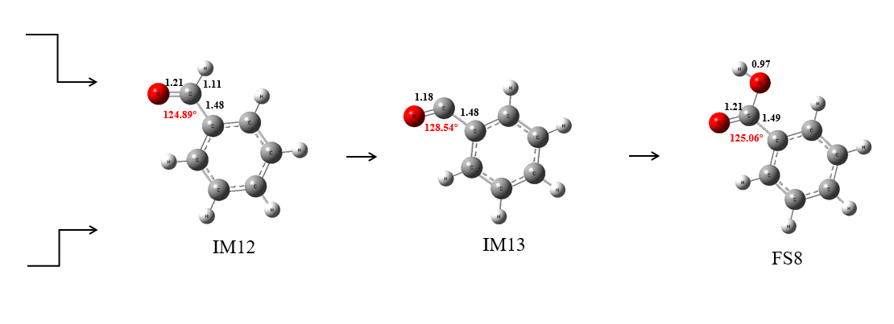
S5-1 Path3 Geometric optimization results of complexes (COM2), transition states (TS12-14), intermediate products (IM5-13), and end products (FS8).
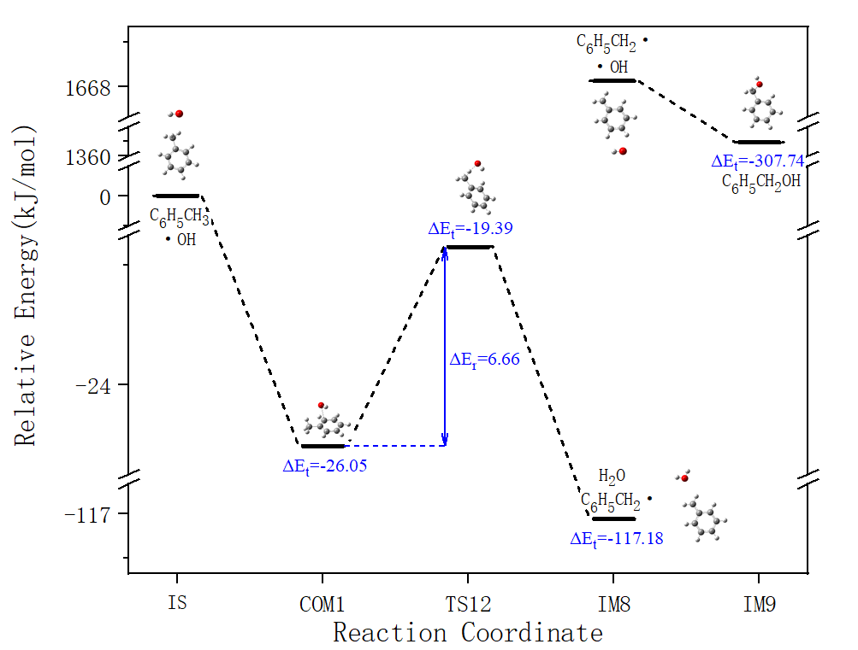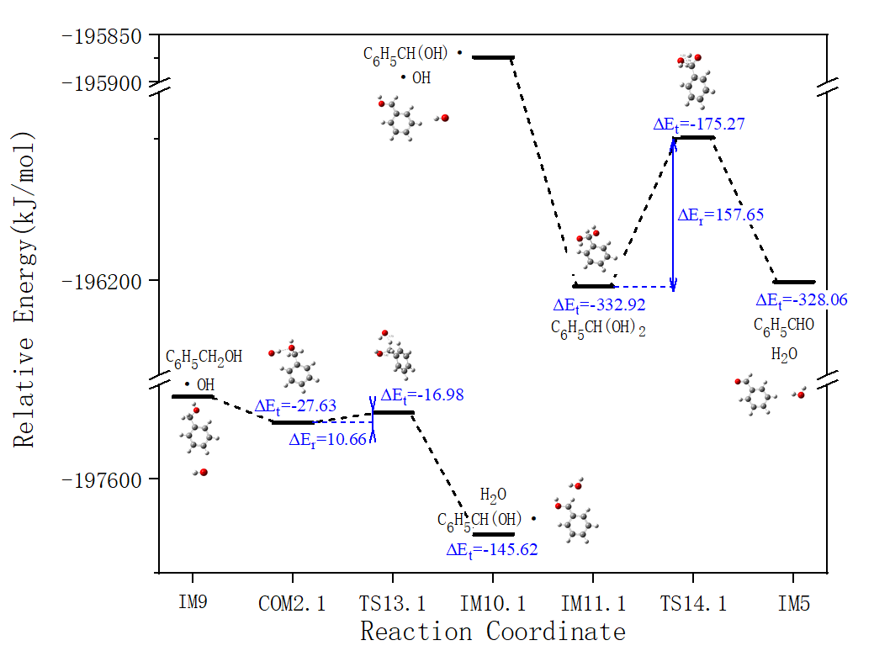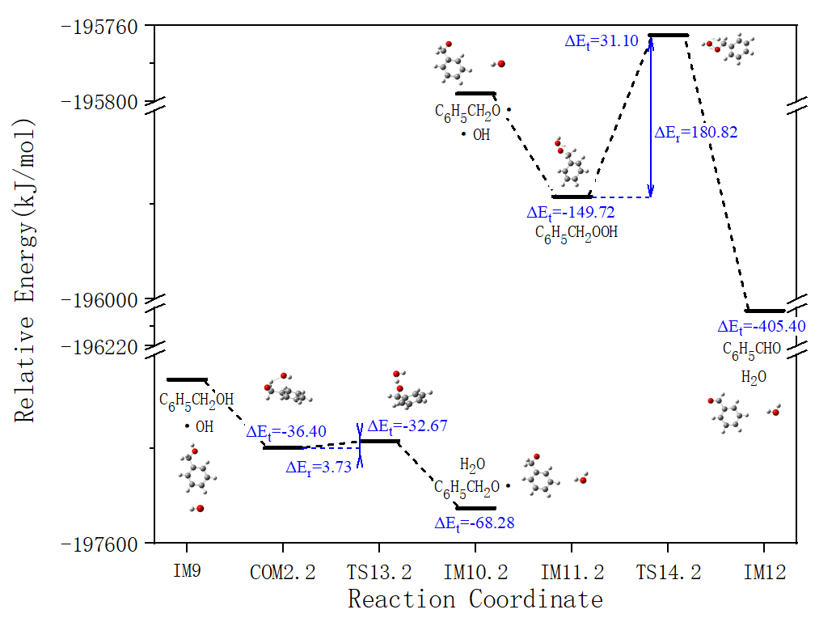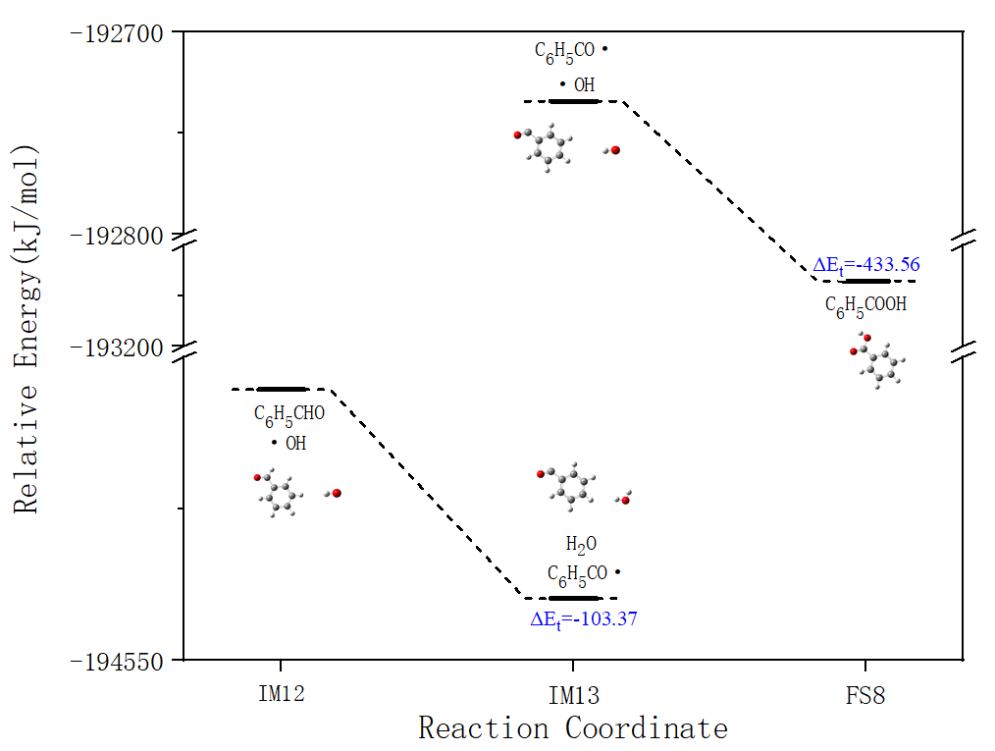
S5-2 Path 3Energy change graph
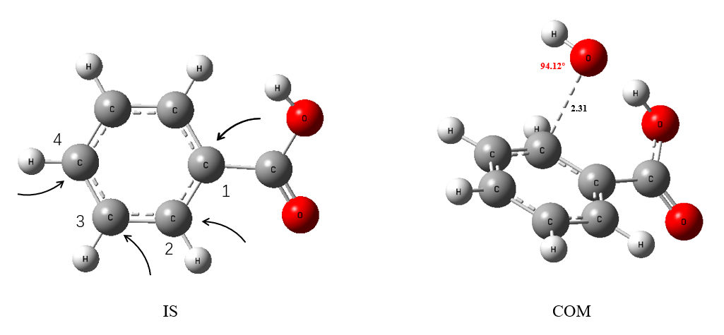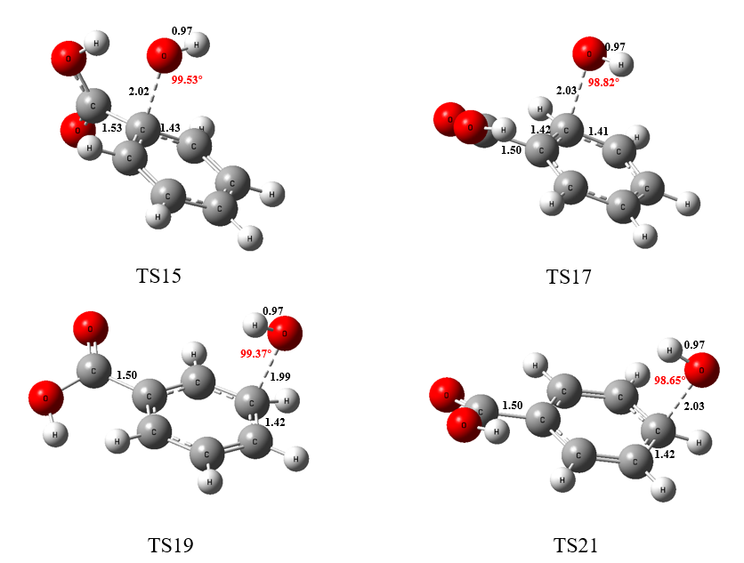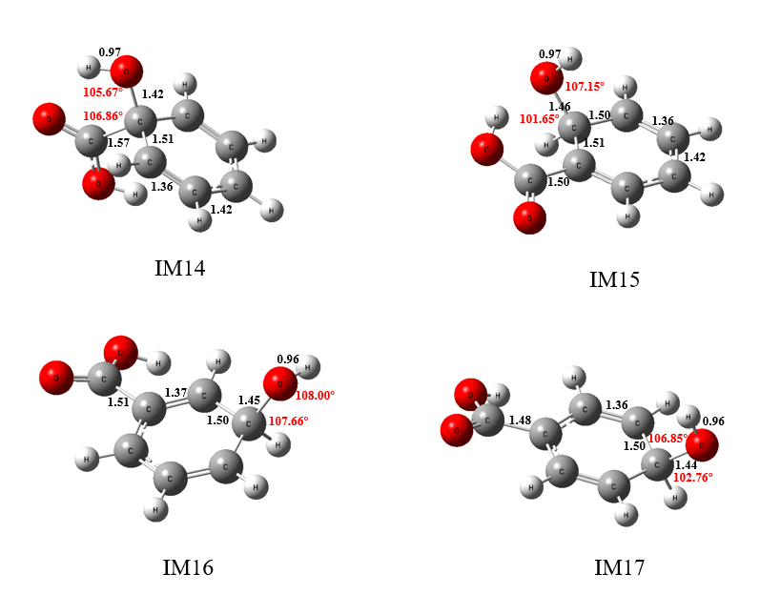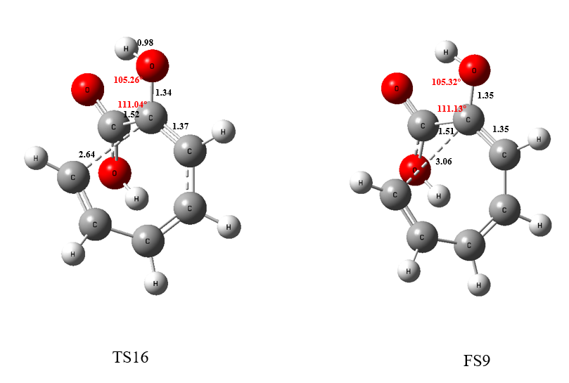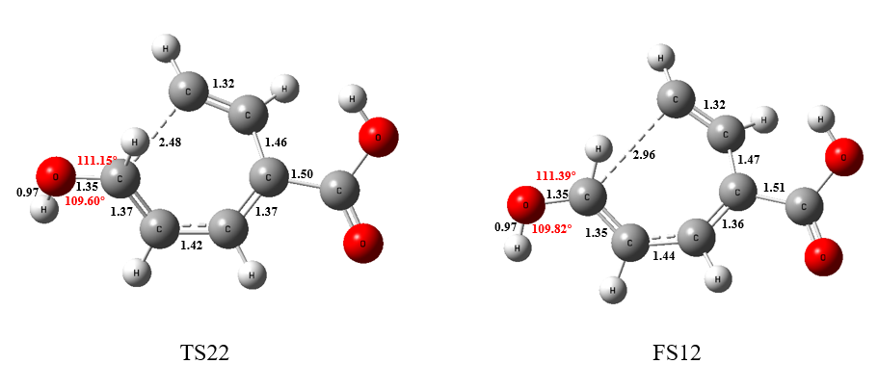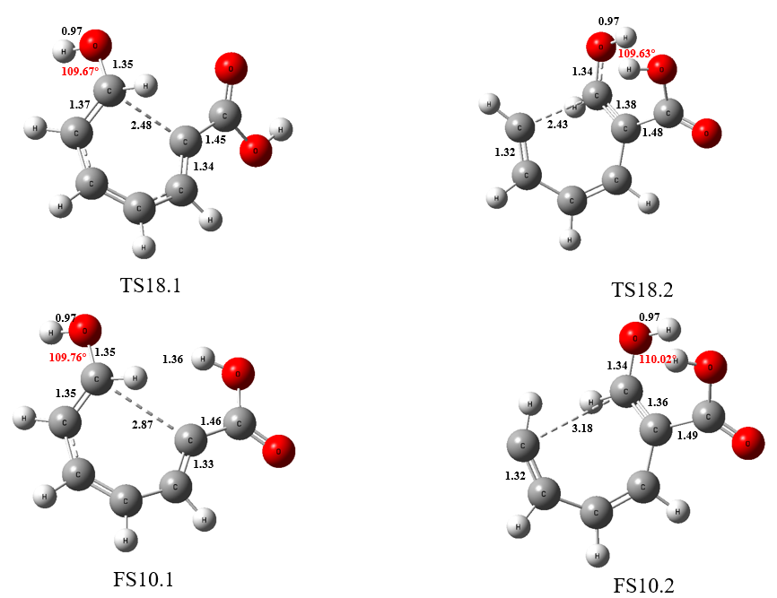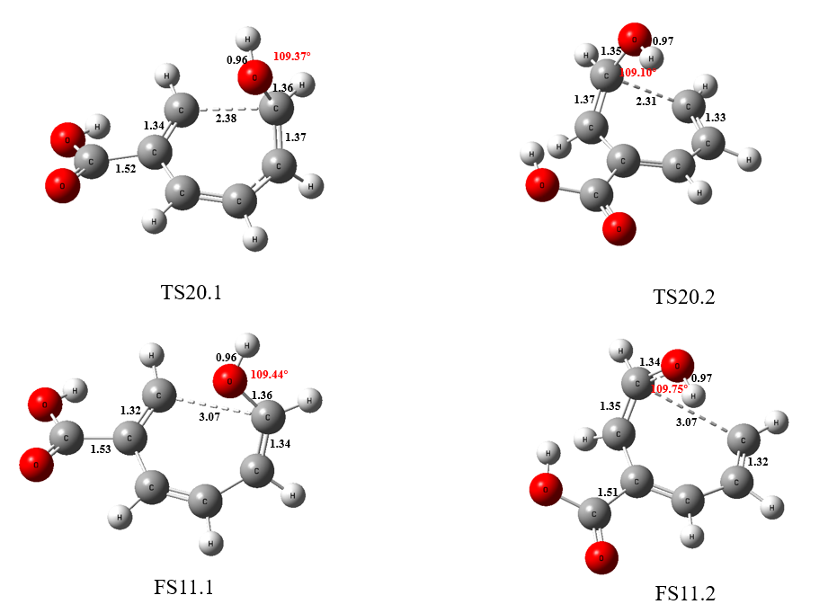
S6-1 Path4Geometric optimization results of complexes (COM3), transition states (TS15-22), intermediate products (IM14-17), and end products (FS9-12).
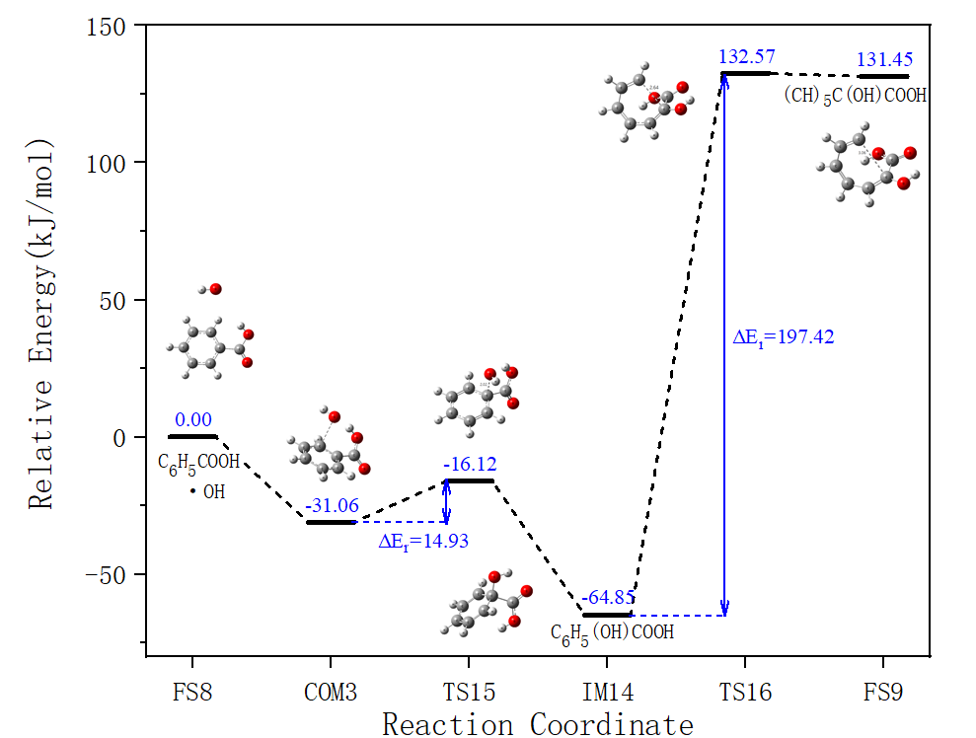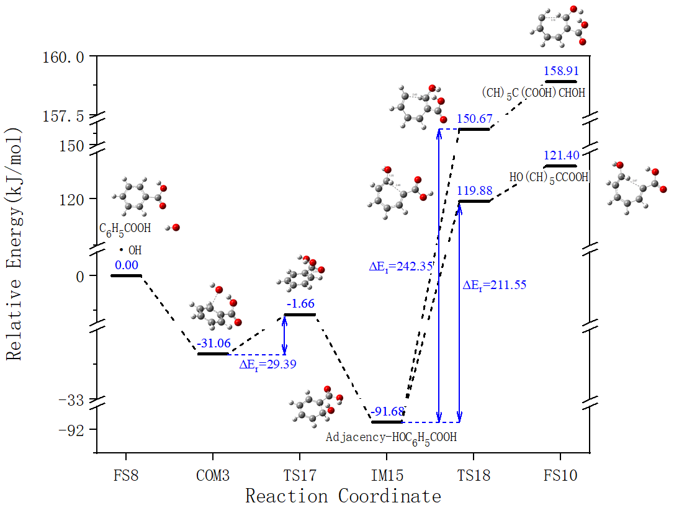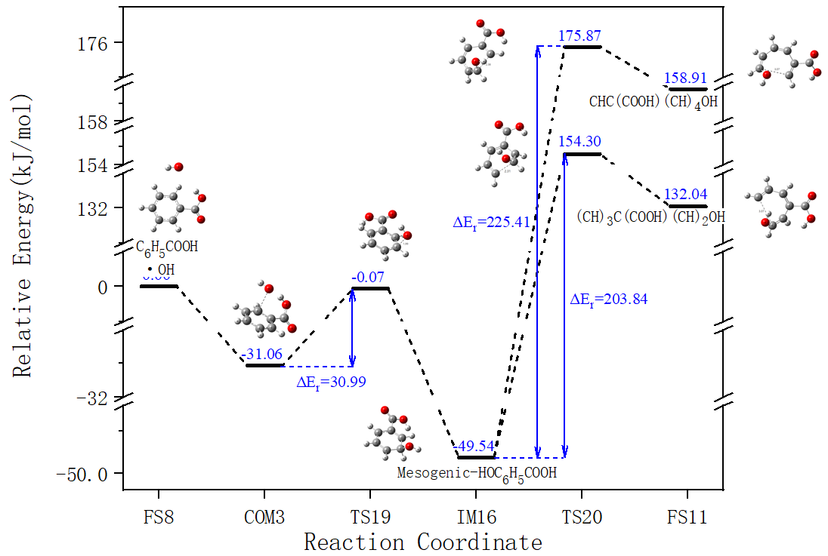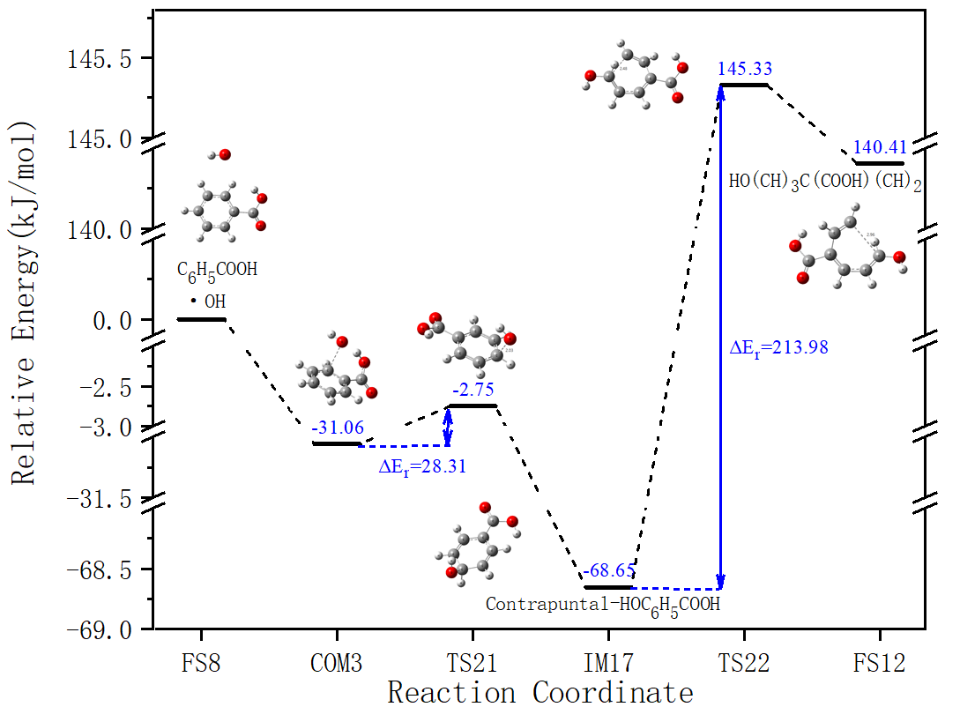
S6-2 Path 4 Energy change graph

