Definition of urban parks provided to survey participants

Following Torreani Ovelar et al. (2022) classification, urban parks in Asuncion, Fernando de la Mora, and Luque include parks and pocket parks (in the neighbourhood including football pitches); larger parks, such as Parque Caballero, Mburicao, Del Rio, Bicentenario; metropolitan parks (these are very large parks: Jardin Botánico, Parque Guasú, Ñu Guasú, Cerro Lambaré, Parque de la Salud); and sensitive areas (waterfronts, railway tracks, etc.).

Ref: Torreani Ovelar, C. P., Fernandez Balmaceda, S. G. & Stanley de Cuppens, K. P. Dinámicas del Espacio Público en Asunción y el Área Metropolitana. 185 https://espaciopublicodelama.com/ (2022).

Table 1. Land cover classes of European Space Agency WorldCover imagery (https://esa-worldcover.org/en)

Value | Description | Included in residential greenness variable
10 | Tree cover | Yes
20 | Shrubland | Yes
30 | Grassland | Yes
40 | Cropland | Yes
50 | Built-up | No
60 | Bare / sparse vegetation | No
70 | Snow and ice | NA
80 | Permanent water bodies | Yes
90 | Herbaceous wetland | Yes
95 | Mangroves | Yes
100 | Moss and lichen | Yes

Table 2. Correlation matrix for continuous variables.

Variable | Age | Social cohesion | Life satisfaction | Residential greenness | Nature relatedness | Park visits
Age | 1.000 | -0.109 | -0.098 | 0.014 | -0.086 | -0.121
Social cohesion | -0.109 | 1.000 | 0.069 | -0.021 | 0.149 | -0.002
Life satisfaction | -0.098 | 0.069 | 1.000 | 0.027 | 0.149 | 0.173
Residential greenness | -0.010 | -0.021 | -0.027 | 1.000 | -0.034 | -0.002
Nature relatedness | -0.086 | -0.119 | 0.149 | -0.346 | 1.000 | 0.157
Park visits | -0.121 | -0.092 | 1.173 | -0.002 | 0.157 | 1.000

Table 3. Variance inflation factor (VIF) matrix from model coefficients estimates

 | VIF
Variable | Model 1 | Model 2 | Model 3 | Model 4 | Model 5 | Model 6 | Model 7 | Model 8
Gender | 1.00 | 1.02 | 1.02 | 1.02 | 1.00 | 1.02 | 1.02 | 1.02
Age | 1.08 | 1.12 | 1.12 | 1.15 | 1.08 | 1.12 | 1.12 | 1.12
Income | 1.08 | 1.13 | 1.14 | 1.14 | 1.08 | 1.12 | 1.14 | 1.13
Living conditions |  | 1.15 | 1.12 | 1.22 |  | 1.16 | 1.43 | 1.15
Social cohesion |  | 1.05 | 1.06 | 1.05 |  | 1.05 | 1.06 | 1.06
Residential greenness |  | 1.09 | 1.12 | 1.09 |  | 1.09 | 1.40 | 1.09
Nature relatedness |  | 1.05 | 1.05 | 1.22 |  | 1.05 | 1.05 | 1.25
Park visits |  | 1.07 | 1.07 | 1.07 |  | 1.08 | 1.08 | 1.07
Living conditions * Residential greenness |  |  |  |  |  |  | 1.72
Living conditions * Nature relatedness |  |  |  |  |  |  |  | 1.21

Table 4. Shapiro-Wilk test for normality of residuals

Model | Statistic | p-value
Model 1 | 0.928 | 0.00
Model 2 | 0.924 | 0.00
Model 3 | 0.928 | 0.00
Model 4 | 0.923 | 0.00

Model 1
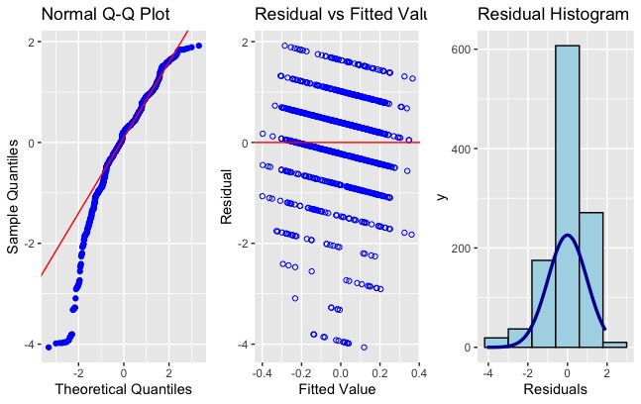
Model 2
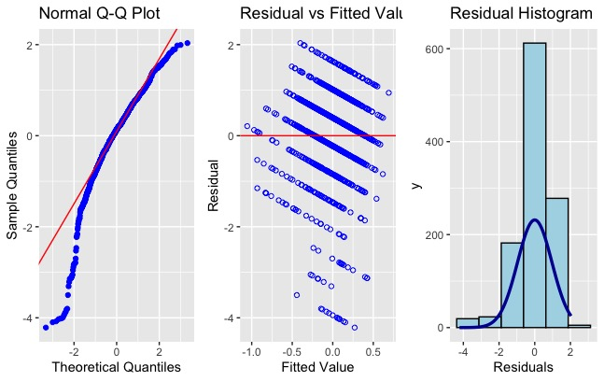
Model 3
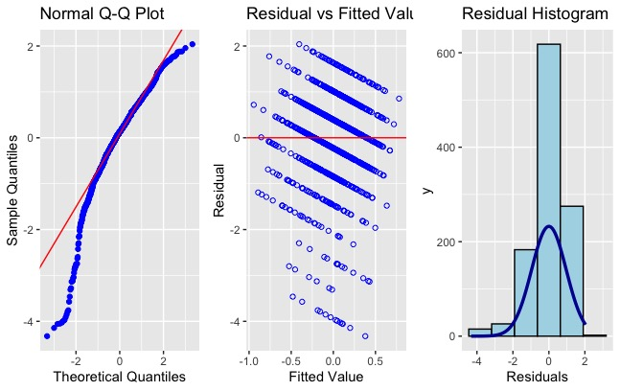
Model 4
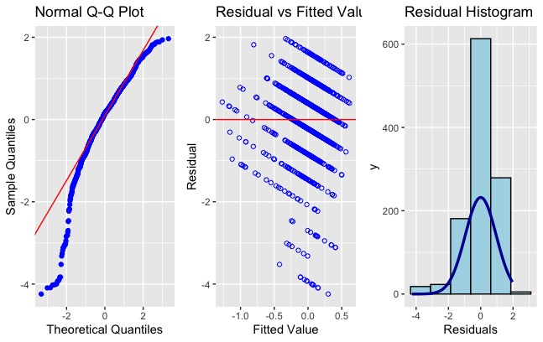

Model 5
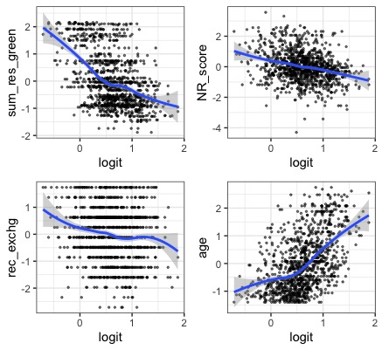

Model 6
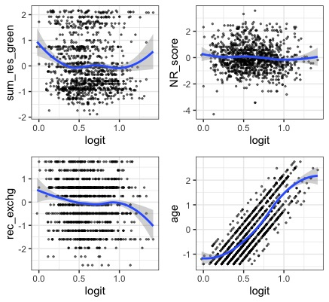
Model 7
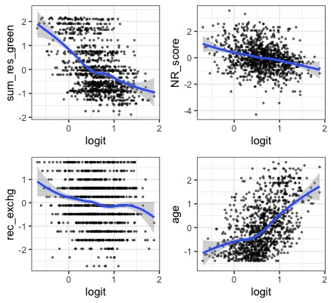
Model 8
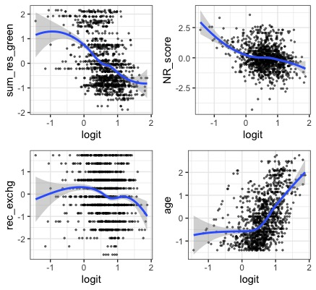
Fig. S1. Residual diagnostic tests for models on life satisfaction (Models 1, 2, 3, 4) and b) mental health (Models 5, 6, 7, 8).

Survey delivered to Asuncion residents

Thank you for participating in this survey. Your responses will help us to better understand your views on public green spaces and wellbeing.

Section 1. General wellbeing

We will first ask you about your general wellbeing.
Q1. Please rate your own health.
☐Very good
☐Good
☐Average
☐Poor
☐Very poor

Q2. On a scale of 0-10, where zero means not at all satisfied and 10 means completely satisfied.
Overall, how satisfied are you with life these days?

☐1 Not satisfied at all
☐2
☐3
☐4
☐5
☐6
☐7
☐8
☐9
☐10 Completely satisfied

Section 2. Use and value of green spaces

We are going to ask you some questions about the green spaces in Asuncion and how you interact with them. Here, we define green spaces as any natural and semi-natural land within the city including, for example, parks, beaches, national parks, the Asuncion River Walkway, the zoo and Botanic gardens.

Q3. In the last week, did you spend more or less time in a green space than you usually do? Please also think about places you may have passed through when travelling to or from places or exercising.
☐About the same
☐Less time
☐More time
☐I don’t spend time in green spaces

Q4. About how often do you usually visit or pass through a green space for any reason? Please tick one.
☐Never
☐Once a year
☐Once every three months
☐Once a month
☐2-3 times a month
☐Once a week
☐2-3 days a week
☐3-5 days a week
☐6-7 days a week

Q5. How far is the closest public green space to your home?
Number of blocks:__________________________________________
Name of green space:_______________________________________
Street/Suburb:_____________________________________
☐I don’t know

Q6. Do you visit the closest public green space to home?
☐Yes
☐No

Q7. Over the last week, what green spaces did you visit or pass through? Can you estimate the total time you spent there? Please list up to three of the places you visited for the longest time period.
Name of green space | 1-29 minutes | 30 minutes to 1 hour | 1-2 hours | 2-3 hours | 3-4 hours | 4+ hours

Q8. Please indicate how strongly you agree or disagree with the extent of each of these statements. Please select the box that indicates how you really feel, rather than how you think “most people” feel.
 | Strongly agree | Agree | Neither agree nor disagree | Disagree | Strongly disagree
I enjoy being outdoors, even in unpleasant weather.
Some species are just meant to die out or become extinct.
Humans have the right to use natural resources any way we want.
My ideal vacation spot would be a remote wilderness area.
I always think about how my actions affect the environment.
I enjoy digging in the earth and getting dirt on my hands.
My connection to nature and the environment is a part of my spirituality.
I am very aware of environmental issues.
I take notice of wildlife wherever I am.
I don’t often go out in nature.
Nothing I do will change problems in other places on the planet.
I am not separate from nature, but a part of nature.
The thought of being deep in the bush, away from civilisation, is frightening.
My feelings about nature do not affect how I live my life.
Animals, birds and plants should have fewer rights than humans.
Even in the middle of the city, I notice nature around me.
My relationship to nature is an important part of who I am.
Conservation is unnecessary because nature is strong enough to recover from any human impact.
The state of non-human species is an indicator of the future for humans.
I think a lot about the suffering of animals.
I feel very connected to all living things and the earth.

Section 3: Demographics

We would like to collect some demographic information about you.

Q9. How old are you?

Q10. Please state your gender?
☐Male ☐Prefer to self-describe. Describe:
☐Female ☐Prefer not to say

Q11. Is your current residence:
☐Owned ☐Prefer not to say
☐Rented ☐Informal settlement
☐Live with my parents ☐Other: Describe:

Q12. What is your address or the closest street intersection to your home?
___________________________________________________________________________

Q13. Did you live in the same residence two years ago?
☐Yes
☐No
☐Prefer not to say

Q14. What is your household monthly income?
☐Negative income
☐Nil
☐Minimum wage
☐Two times minimum wage
☐Four times minimum wage
☐Six times minimum wage
☐Eight times minimum wage
☐Ten times minimum wage
☐More than ten times minimum wage
☐Prefer not to say

Q15. Education
☐Primary school ☐Postgraduate degree
☐Secondary school ☐Never went to school
☐College degree ☐Prefer not to say
☐Diploma

Q16. What is your employment status?
☐Work full time (35+ hours per week) - formal employment
☐Work part time - formal employment
☐Work full time (35+ hours per week) - informal employment
☐Work part time - informal employment
☐Student
☐Home duties
☐Unemployed
☐Seeking work
☐Other. Describe:

Q17. How many people live in your household?
Number of people_____

Q18. How many dependent children (under 18) live in your household?
☐Number of children __
☐No children
☐Prefer not to say

Q19. Please select the main method you use to commute.
☐Walk
☐Bike
☐Motorbike (owned)
☐Automobile (owned)
☐Public transport
☐Electric vehicle (owned)

Section 4: Wellbeing

The next few questions are about aspects of your health.

Q20. In the last month, how often did you feel any of the emotions stated below? Please tick only one.

Emotions | None of the time | A little of the time | Some of the time | Most of the time | All of the time
Nervous
Hopeless
Restless or fidgety
So depressed that nothing could cheer you up
That everything was an effort
Worthless
Lonely

Q21 Are you currently being treated for any of the following conditions (yes/no):
 | Yes | No
High blood pressure
Heart disease
Diabetes
Depression

Q22. Do you have any other comments regarding your experiences in green spaces in Asuncion?

