Supplementary Data
Table S1 The flow rates of eight tested light-duty vehicle
No | flow rate (m3/min) | No | flow rate (m3/min)
No.1 | 8.92 | No.5 | 8.95
No.2 | 8.92 | No.6 | 8.98
No.3 | 8.96 | No.7 | 8.64
No.4 | 8.95 | No.8 | 8.77
Table S2 The ratio of four conditions under WLTC and CLTC-P
No | Test cycle | WLTC |  |  |  | CLTC-P
No | Characteristic | Idle Ratio | Acceleration Ratio | Deceleration Ratio | Cruise Ratio | Idle Ratio | Acceleration Ratio | Deceleration Ratio | Cruise Ratio
No | Unit | % | % | % | % | % | % | % | %
No.1 | Total | 0.12 | 0.33 | 0.34 | 0.21 | 0.22 | 0.33 | 0.31 | 0.14
No.1 | Low Speed | 0.24 | 0.29 | 0.37 | 0.10 | 0.35 | 0.27 | 0.24 | 0.13
No.1 | Medium Speed | 0.11 | 0.37 | 0.34 | 0.19 | 0.19 | 0.34 | 0.32 | 0.14
No.1 | High Speed | 0.06 | 0.32 | 0.29 | 0.33 | 0.05 | 0.41 | 0.37 | 0.17
No.2 | Total | 0.13 | 0.34 | 0.33 | 0.20 | 0.21 | 0.32 | 0.31 | 0.16
No.2 | Low Speed | 0.25 | 0.28 | 0.35 | 0.11 | 0.34 | 0.24 | 0.23 | 0.18
No.2 | Medium Speed | 0.11 | 0.40 | 0.34 | 0.15 | 0.19 | 0.34 | 0.34 | 0.12
No.2 | High Speed | 0.06 | 0.31 | 0.31 | 0.32 | 0.05 | 0.42 | 0.36 | 0.17
No.3 | Total | 0.13 | 0.33 | 0.33 | 0.21 | 0.22 | 0.33 | 0.29 | 0.16
No.3 | Low Speed | 0.25 | 0.29 | 0.35 | 0.11 | 0.35 | 0.26 | 0.23 | 0.15
No.3 | Medium Speed | 0.11 | 0.40 | 0.33 | 0.16 | 0.19 | 0.34 | 0.32 | 0.15
No.3 | High Speed | 0.07 | 0.31 | 0.31 | 0.32 | 0.06 | 0.42 | 0.34 | 0.18
No.4 | Total | 0.13 | 0.33 | 0.35 | 0.19 | 0.24 | 0.31 | 0.28 | 0.17
No.4 | Low Speed | 0.25 | 0.30 | 0.34 | 0.11 | 0.38 | 0.26 | 0.21 | 0.15
No.4 | Medium Speed | 0.11 | 0.39 | 0.34 | 0.16 | 0.20 | 0.32 | 0.31 | 0.16
No.4 | High Speed | 0.07 | 0.29 | 0.32 | 0.33 | 0.06 | 0.39 | 0.36 | 0.20
No.5 | Total | 0.13 | 0.33 | 0.35 | 0.19 | 0.23 | 0.32 | 0.29 | 0.16
No.5 | Low Speed | 0.26 | 0.28 | 0.34 | 0.12 | 0.37 | 0.25 | 0.23 | 0.15
No.5 | Medium Speed | 0.11 | 0.38 | 0.36 | 0.15 | 0.20 | 0.32 | 0.32 | 0.16
No.5 | High Speed | 0.07 | 0.33 | 0.34 | 0.27 | 0.06 | 0.43 | 0.36 | 0.16
No.6 | Total | 0.13 | 0.34 | 0.36 | 0.18 | 0.22 | 0.33 | 0.30 | 0.15
No.6 | Low Speed | 0.25 | 0.30 | 0.35 | 0.10 | 0.36 | 0.28 | 0.22 | 0.14
No.6 | Medium Speed | 0.11 | 0.37 | 0.36 | 0.17 | 0.20 | 0.33 | 0.33 | 0.14
No.6 | High Speed | 0.06 | 0.31 | 0.35 | 0.27 | 0.06 | 0.41 | 0.36 | 0.17
No.7 | Total | 0.13 | 0.35 | 0.33 | 0.19 | 0.22 | 0.32 | 0.28 | 0.18
No.7 | Low Speed | 0.26 | 0.30 | 0.33 | 0.11 | 0.35 | 0.25 | 0.21 | 0.19
No.7 | Medium Speed | 0.11 | 0.39 | 0.32 | 0.18 | 0.20 | 0.32 | 0.31 | 0.17
No.7 | High Speed | 0.06 | 0.34 | 0.34 | 0.25 | 0.06 | 0.43 | 0.35 | 0.17
No.8 | Total | 0.12 | 0.34 | 0.33 | 0.21 | 0.22 | 0.32 | 0.27 | 0.19
No.8 | Low Speed | 0.23 | 0.29 | 0.34 | 0.13 | 0.35 | 0.23 | 0.18 | 0.24
No.8 | Medium Speed | 0.11 | 0.40 | 0.32 | 0.17 | 0.20 | 0.34 | 0.32 | 0.14
No.8 | High Speed | 0.06 | 0.32 | 0.32 | 0.30 | 0.05 | 0.42 | 0.33 | 0.20
Table S3 The ratio of four conditions under RDE test
No | Characteristic | Idle Ratio | Acceleration Ratio | Deceleration Ratio | Cruise Ratio
No | Unit | % | % | % | %
No.1 | Total | 0.03 | 0.35 | 0.33 | 0.28
No.1 | Low Speed | 0.05 | 0.37 | 0.36 | 0.22
No.1 | Medium Speed | 0.02 | 0.34 | 0.29 | 0.35
No.1 | High Speed | 0.01 | 0.33 | 0.27 | 0.38
No.2 | Total | 0.08 | 0.31 | 0.31 | 0.31
No.2 | Low Speed | 0.09 | 0.32 | 0.33 | 0.27
No.2 | Medium Speed | 0.06 | 0.26 | 0.26 | 0.41
No.2 | High Speed | 0.03 | 0.34 | 0.28 | 0.34
No.3 | Total | 0.10 | 0.30 | 0.34 | 0.26
No.3 | Low Speed | 0.11 | 0.31 | 0.34 | 0.24
No.3 | Medium Speed | 0.14 | 0.24 | 0.31 | 0.32
No.3 | High Speed | 0.03 | 0.33 | 0.36 | 0.28
No.4 | Total | 0.05 | 0.33 | 0.30 | 0.31
No.4 | Low Speed | 0.07 | 0.35 | 0.32 | 0.25
No.4 | Medium Speed | 0.03 | 0.31 | 0.28 | 0.39
No.4 | High Speed | 0.01 | 0.30 | 0.26 | 0.43
No.5 | Total | 0.05 | 0.34 | 0.30 | 0.30
No.5 | Low Speed | 0.07 | 0.36 | 0.31 | 0.26
No.5 | Medium Speed | 0.04 | 0.27 | 0.26 | 0.43
No.5 | High Speed | 0.03 | 0.35 | 0.30 | 0.32
No.6 | Total | 0.05 | 0.35 | 0.31 | 0.29
No.6 | Low Speed | 0.07 | 0.36 | 0.33 | 0.24
No.6 | Medium Speed | 0.02 | 0.32 | 0.30 | 0.35
No.6 | High Speed | 0.02 | 0.32 | 0.28 | 0.38
No.7 | Total | 0.03 | 0.35 | 0.32 | 0.30
No.7 | Low Speed | 0.04 | 0.36 | 0.33 | 0.26
No.7 | Medium Speed | 0.02 | 0.32 | 0.31 | 0.35
No.7 | High Speed | 0.02 | 0.32 | 0.30 | 0.37
No.8 | Total | 0.06 | 0.37 | 0.29 | 0.28
No.8 | Low Speed | 0.09 | 0.39 | 0.31 | 0.21
No.8 | Medium Speed | 0.03 | 0.29 | 0.26 | 0.42
No.8 | High Speed | 0.01 | 0.35 | 0.25 | 0.40

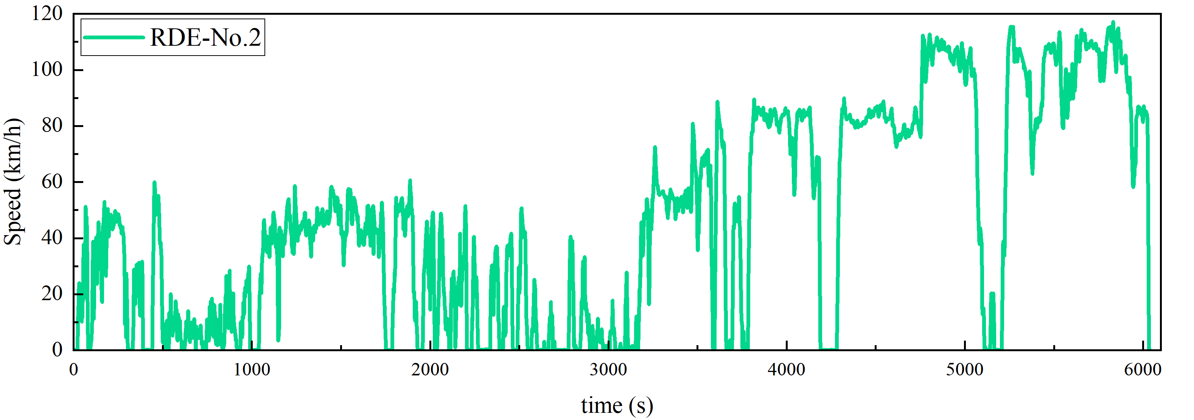
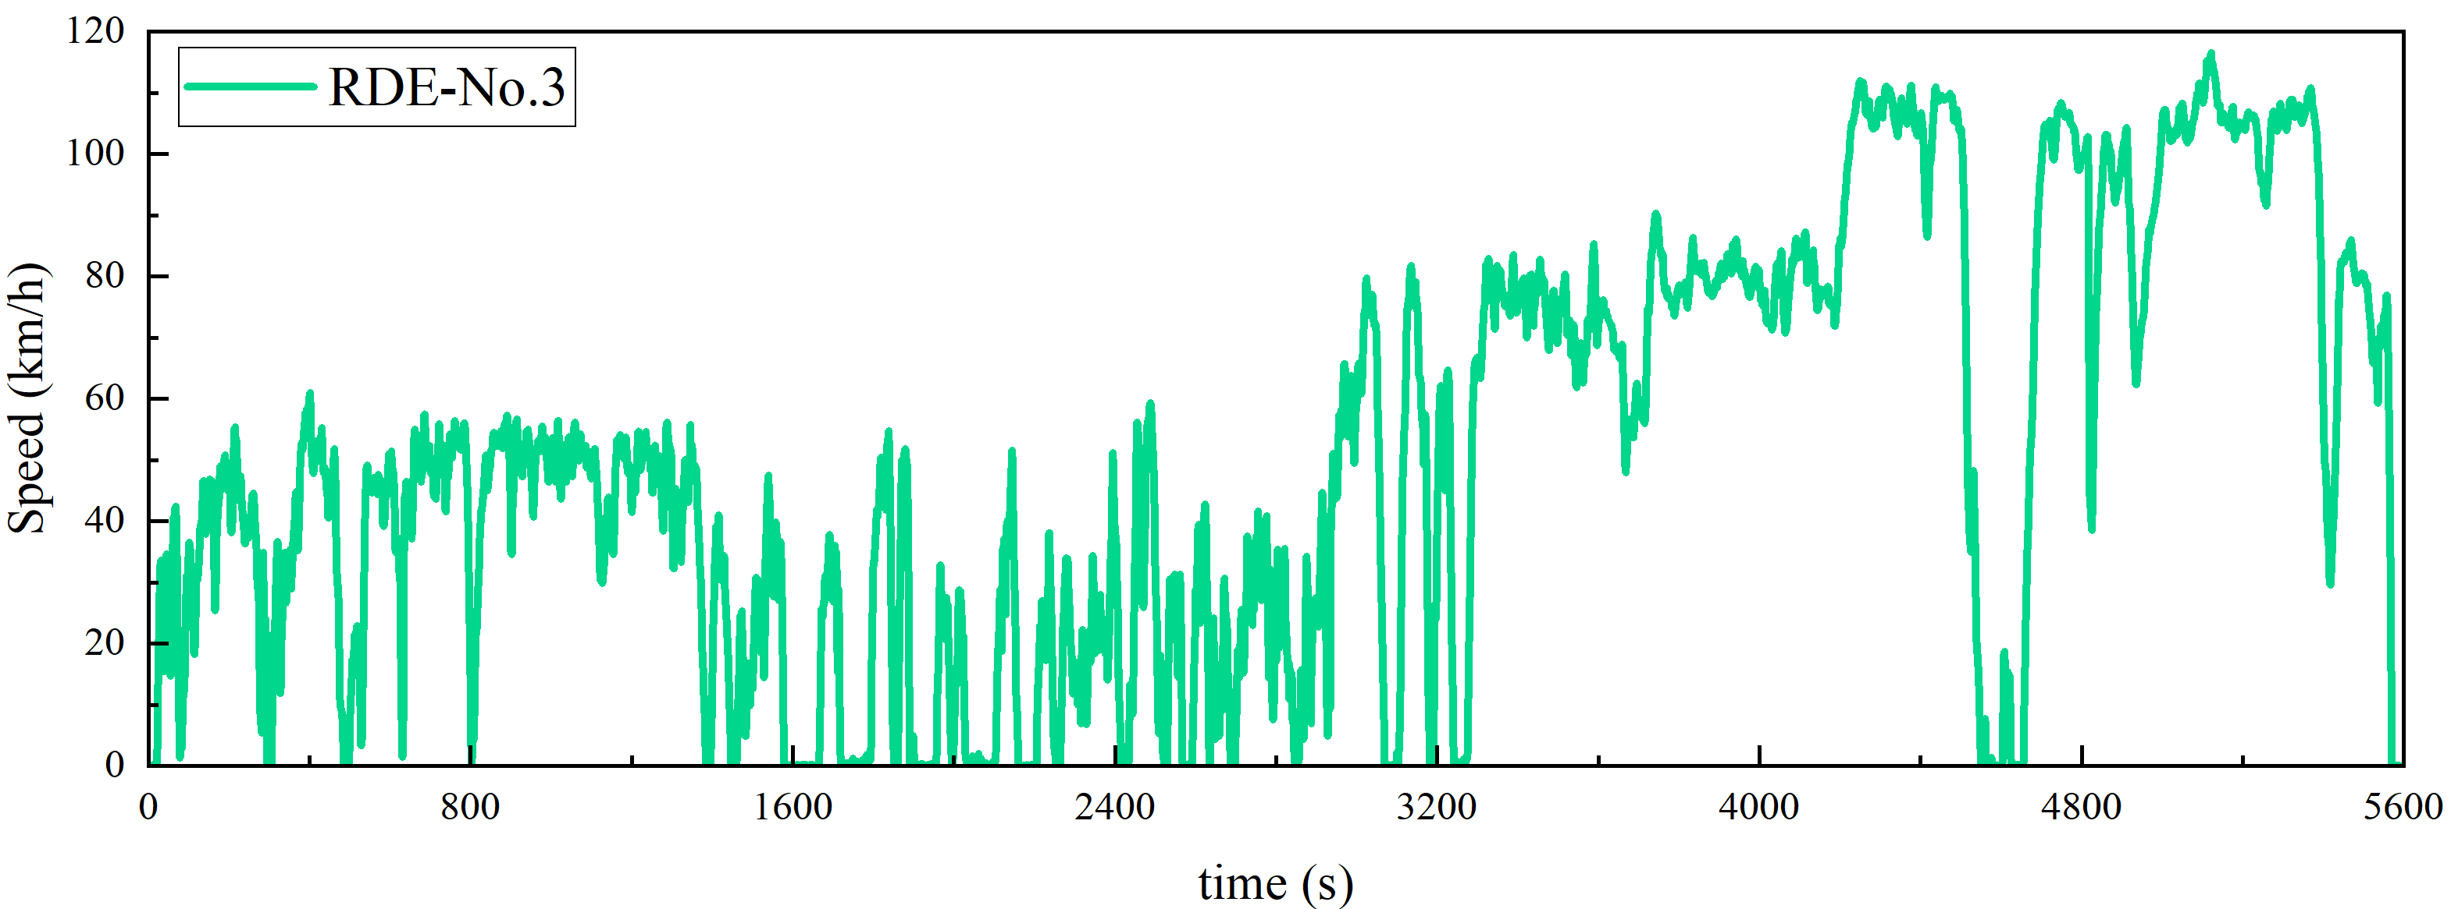
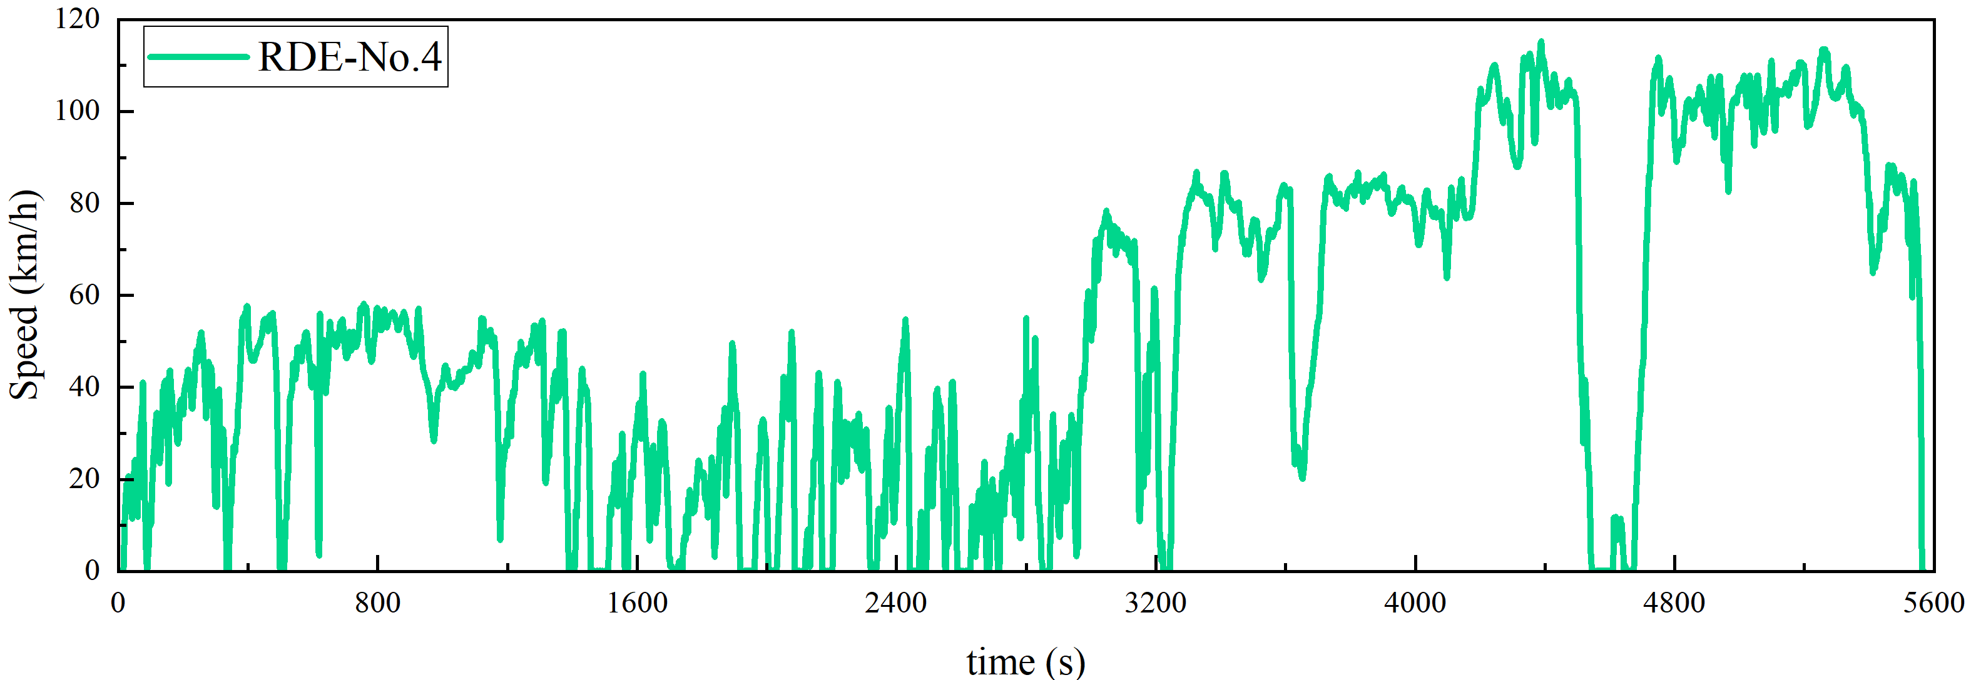
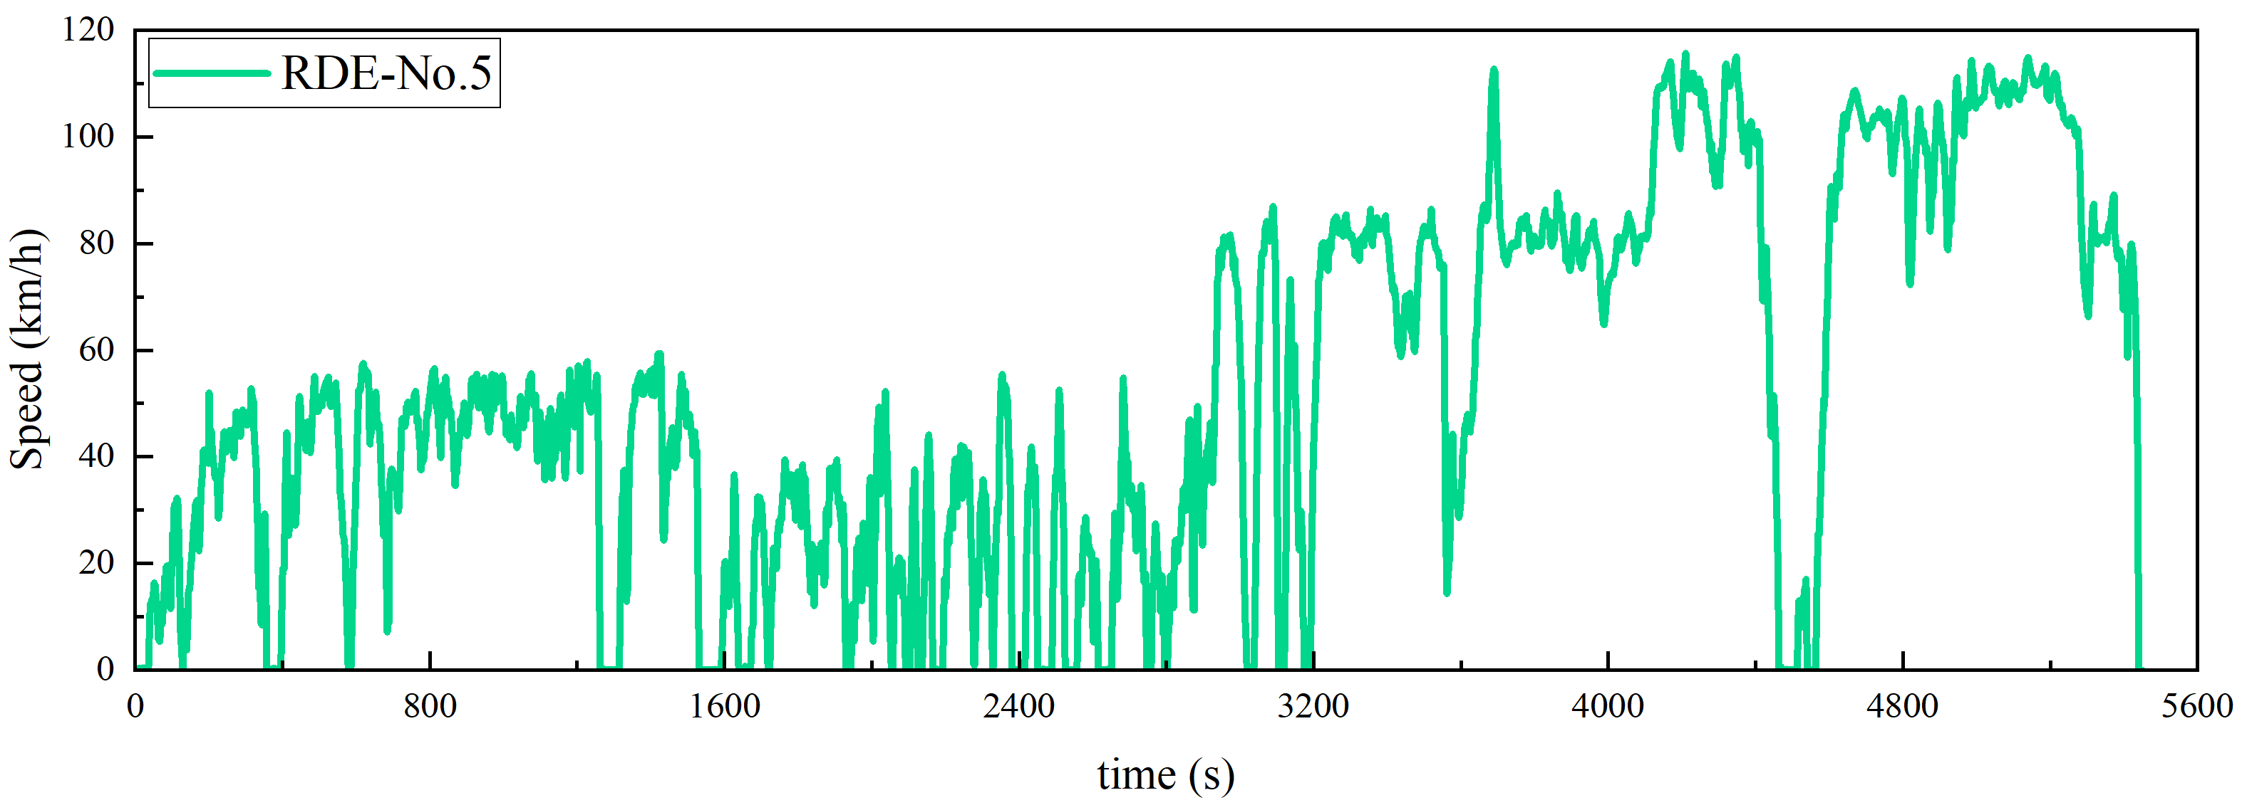
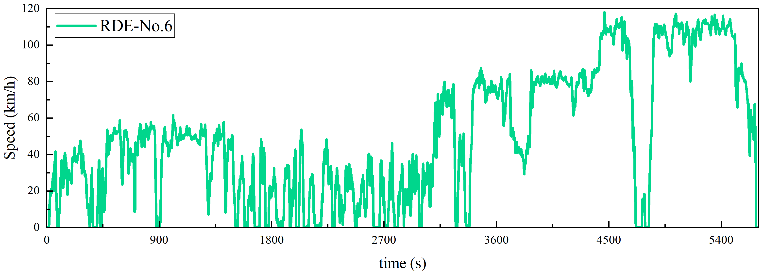
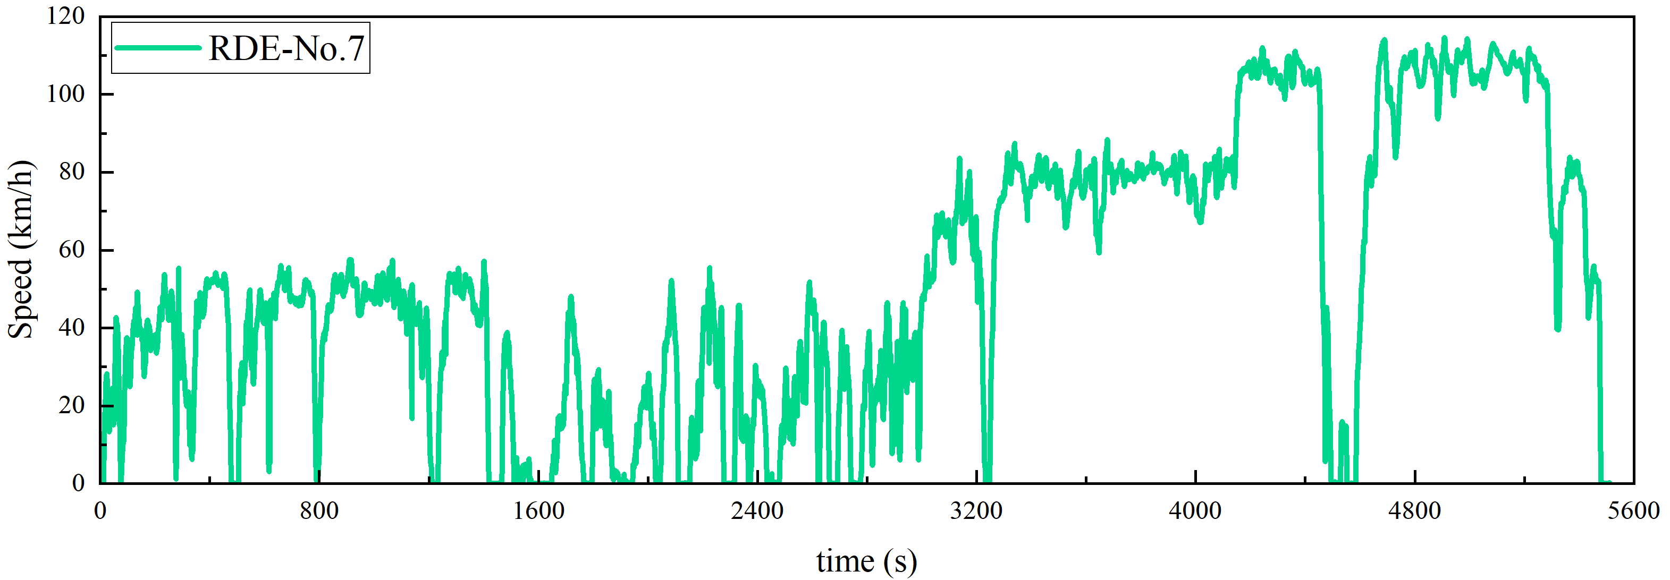
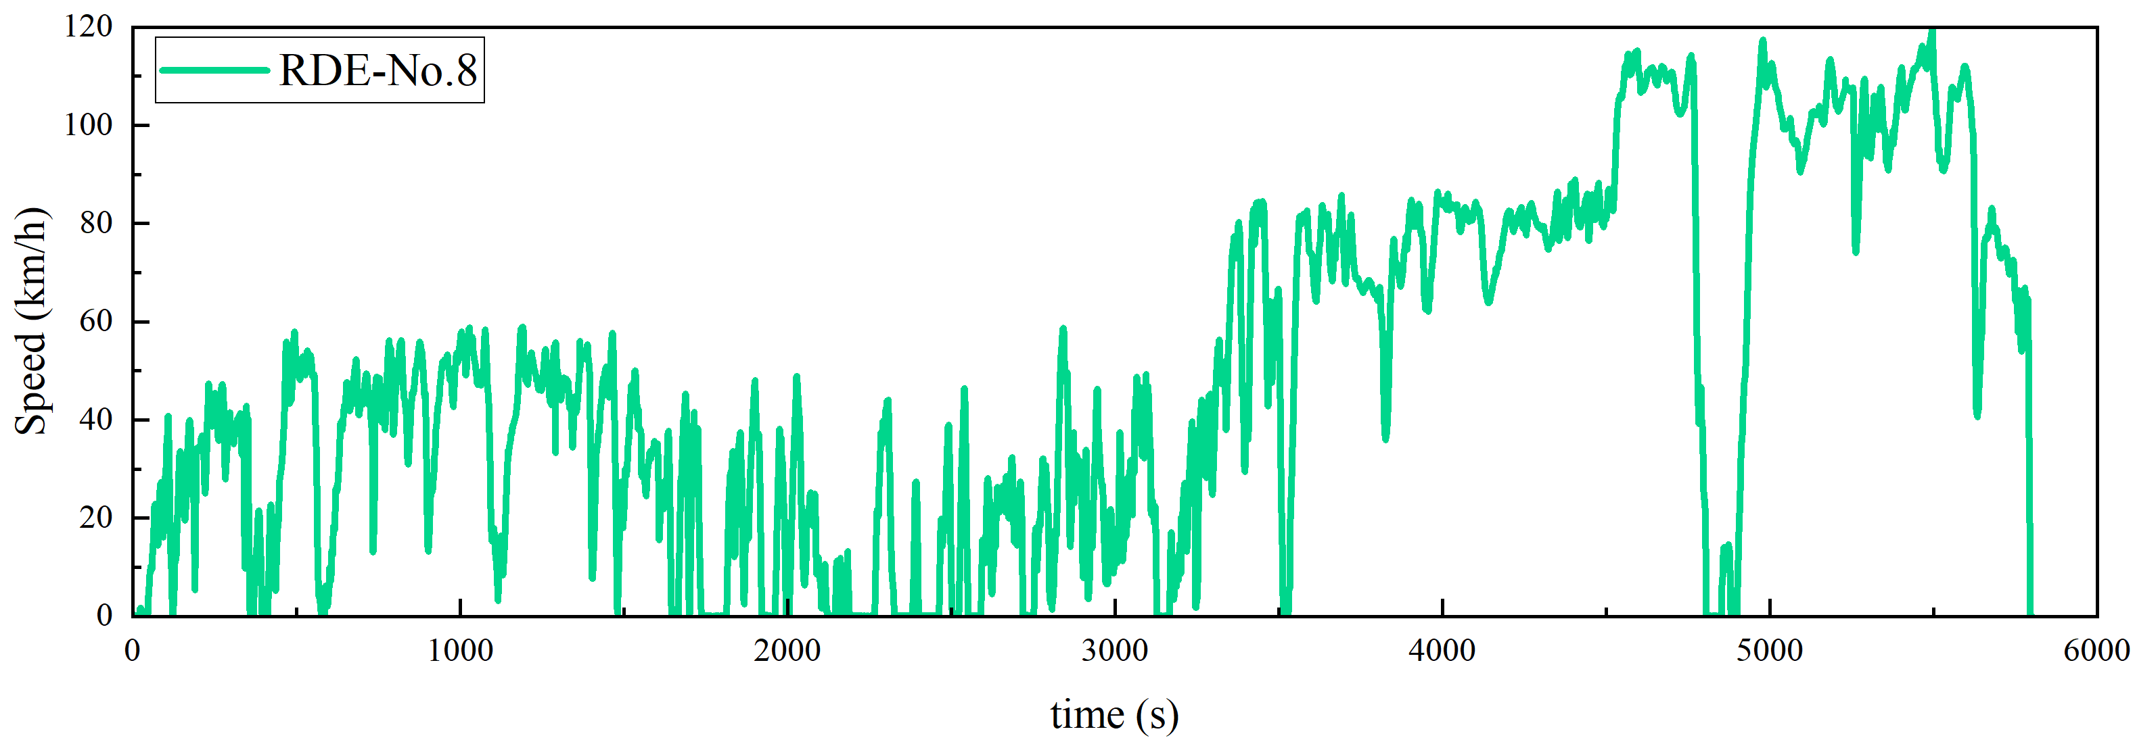
Fig S1. the velocity profiles for the RDE tests

