Supporting Information

Green synthesis of novel pyrazole carbonitrile and aryl methylene-pyrazole derivatives using 2-aminopyridine-Functionalized Silica-Coated Fe₃O₄ Nanoparticles as a highly-efficient and magnetically Separable Catalyst (Fe₃O₄@SiO₂/NH/CC/2APy/CuII)

Abdulqader Liwal ª, Tahereh Akbarpour ^{a*}, Ardeshir Khazaei ª and Amir Ghanbarpour ª
ª Faculty of Chemistry, Bu-Ali Sina University, Hamedan, 6517838683, Iran

*Corresponding authors:
Phone office: +98 811 8282807 E. Mail: T_Akbarpoor@yahoo.com

Characterization of the catalyst:

S. 1 FT-IR spectra for the intermediate and the final catalyst (Fe₃O₄@SiO₂/NH/CC/2APy/CuII).
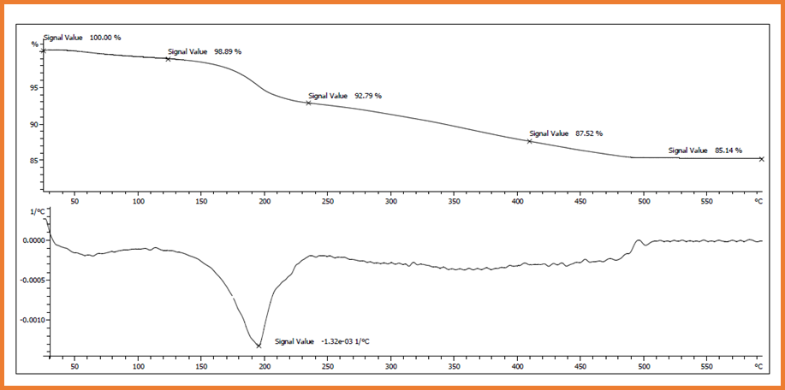
S. 2 TGA/DTG of the Fe₃O₄@SiO₂/NH/CC/2APy/CuII catalyst.
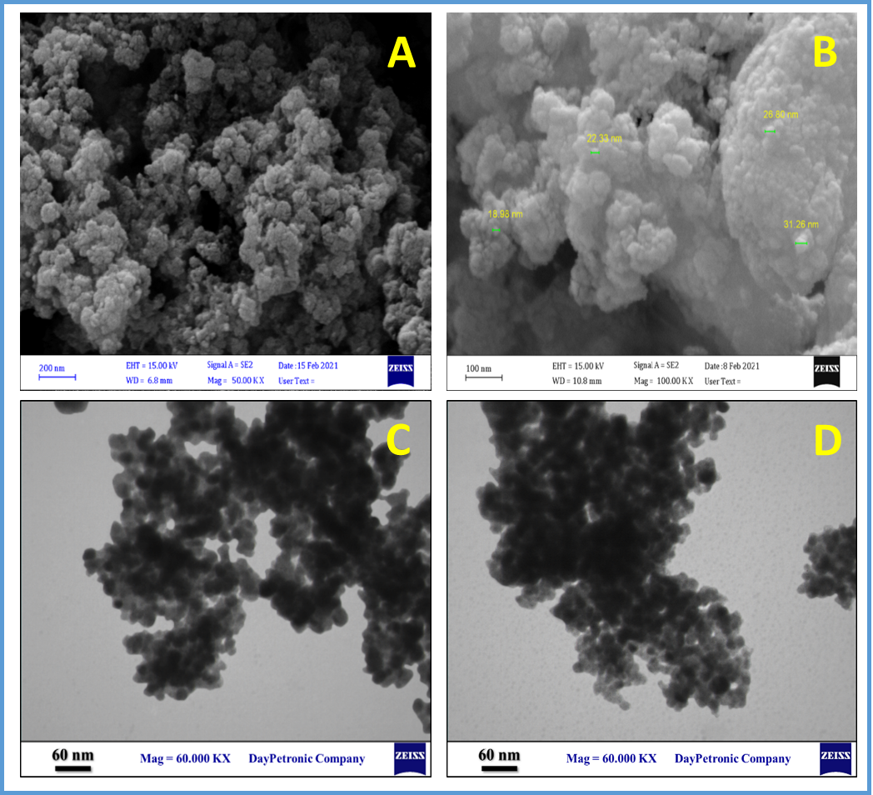
S. 3 Field Emission Scanning Electron Microscopy (FESEM) (A and B) and Transmission electron microscopy (TEM) (C and D) of the copper-based nano-magnetic catalyst.
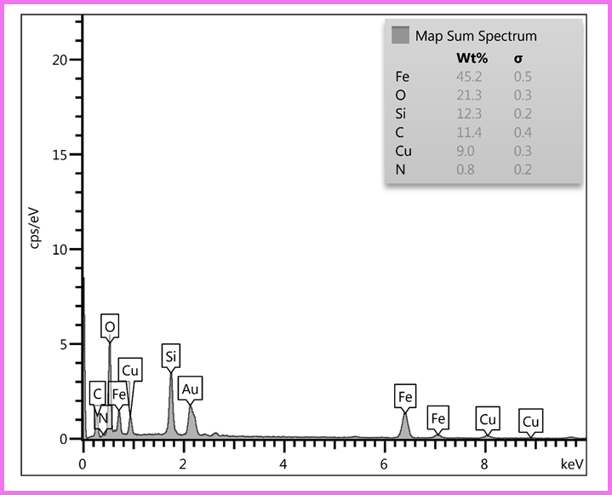
S. 4 The energy-dispersive X-ray spectroscopy (EDX) of Fe₃O₄@SiO₂/NH/CC/2APy/CuII MNPs.

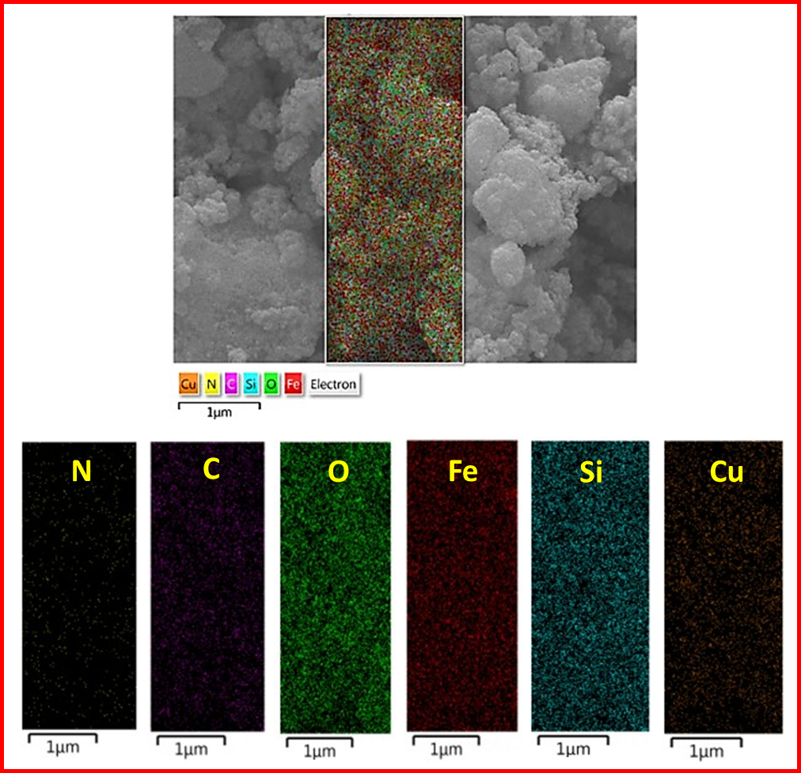
S. 5 The EDX elemental mapping of the copper-based nano-magnetic catalyst.

S. 6 Magnetization curves of the Fe₃O₄@SiO₂/NH/CC/2APy/CuII catalyst.

S. 7 Comparison of reduction in efficiency with number of cycles in optimal conditions using Fe₃O₄@SiO₂/NH/CC/2APy/CuII catalyst

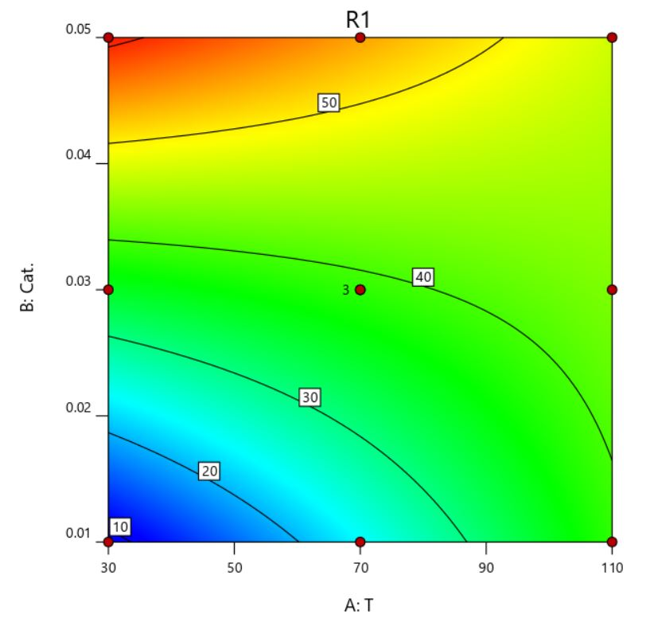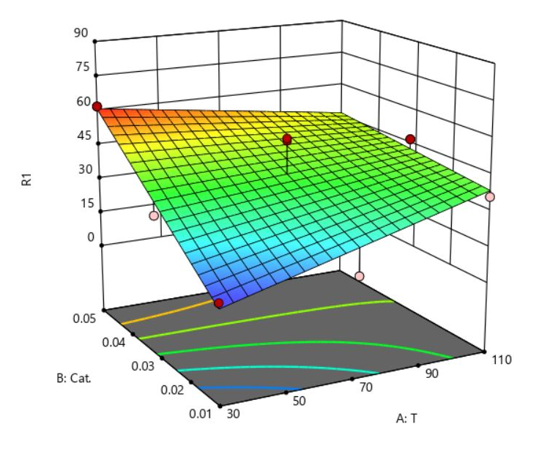
S. 8 2D and 3D graphs for yield versus temperature and the amount of the catalyst.

S. 9 Comparison of reduction in efficiency with number of cycles in optimal conditions using copper-based nano-magnetic catalyst

¹HNMR and ¹³CNMR Spectral Data:

5-Amino pyrazole carbonitrile:
5-Amino-1,3-diphenyl-1H-pyrazole-4-carbonitrile (1)
Yield: 90%, m. p: 158-160 °C. IR (KBr): 3310, 2923, 1602, 1522, 1494, 1251, 1136, 750 cm⁻¹.
5-Amino-3-(4-chloro-phenyl)-1-phenyl-1H-pyrazole-4-carbonitrile (2)
Yield: 65%, m. p: 130-133 °C. IR (KBr): 3311, 3057, 1936, 1599, 1518, 1467, 1134, 749cm⁻¹; ¹H NMR (250 MHz, DMSO-d₆) δ 6.90-7.59 (m, 8H), 6.87 (s, 2H); ¹³C NMR (101 -MHz, DMSO) δ 144.40, 135.83, 133.94, 129.36, 128.83, 127.27, 120.36, 112.79, 77.59, 77.05, 76.54.
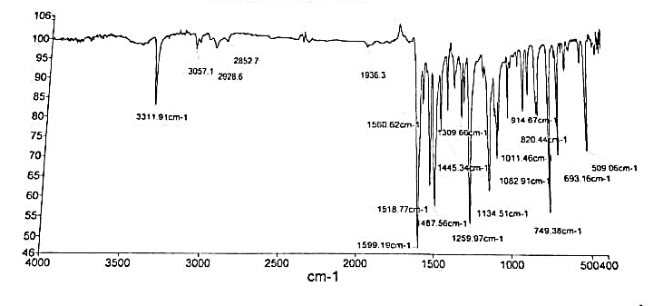
S 10. IR of 5-amino-3-(4-chloro-phenyl)-1-phenyl-1H-pyrazole-4-carbonitrile

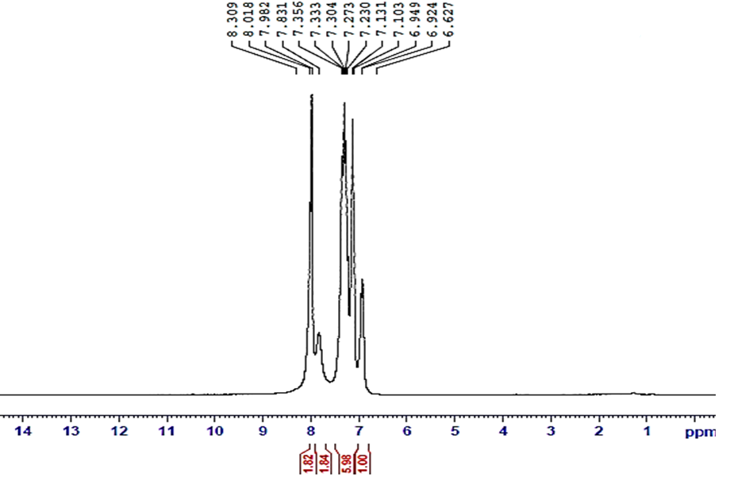
S 11. ¹HNMR of 5-amino-3-(4-chloro-phenyl)-1-phenyl-1H-pyrazole-4-carbonitrile
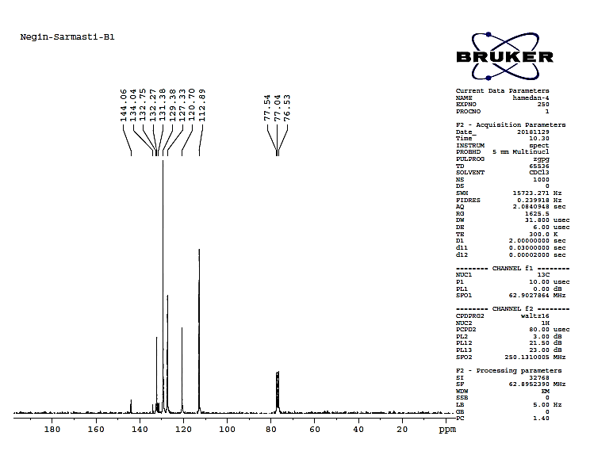
S 12. ¹³CNMR of 5-amino-3-(4-chloro-phenyl)-1-phenyl-1H-pyrazole-4-carbonitrile
5-Amino-3-(2-chloro-phenyl)-1-phenyl-1H-pyrazole-4-carbonitrile (3)
Yield: 74 %, m. p: Semi-solid. IR (KBr): 3301, 2926, 1556, 1256, 111256, 1146, 694 cm⁻¹.
5-Amino-3-(4-nitro-phenyl)-1-phenyl-1H-pyrazole-4-carbonitrile (4)
Yield: 65%, mp: 157-159 °C. IR (KBr): 3301, 2421, 1595, 1558, 1324, 1256, 1106, 749 cm⁻¹.
5-Amino-3-(3-nitro-phenyl)-1-phenyl-1H-pyrazole-4-carbonitrile (5)
Yield: 55%, m. p: 126-128 °C. IR (KBr): 3276, 3210, 1707, 1490, 1376, 1106, 1070, 764 cm⁻¹
5-Amino-3-(4-bromo-phenyl)-1-phenyl-1H-pyrazole-4-carbonitrile (6)
Yield: 78%, m. p: 156-159 °C. IR (KBr): 3302, 1557, 1519, 1484, 1260, 750cm⁻¹; ¹H NMR (250 MHz, DMSO-d₆) δ 6.94-7.53 (m, 8H), 6.91 (s, 2H); ¹³C NMR (101 -MHz, DMSO) δ 144.38, 135.88, 134.31, 131.76, 129.37, 127.56, 122.16, 120.39, 112.83, 77.57, 77.07, 76.56.
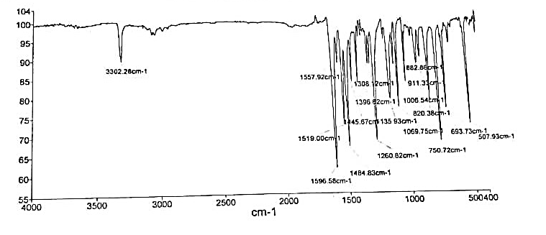
S 13. IR of 5-amino-3-(4-bromo-phenyl)-1-phenyl-1H-pyrazole-4-carbonitrile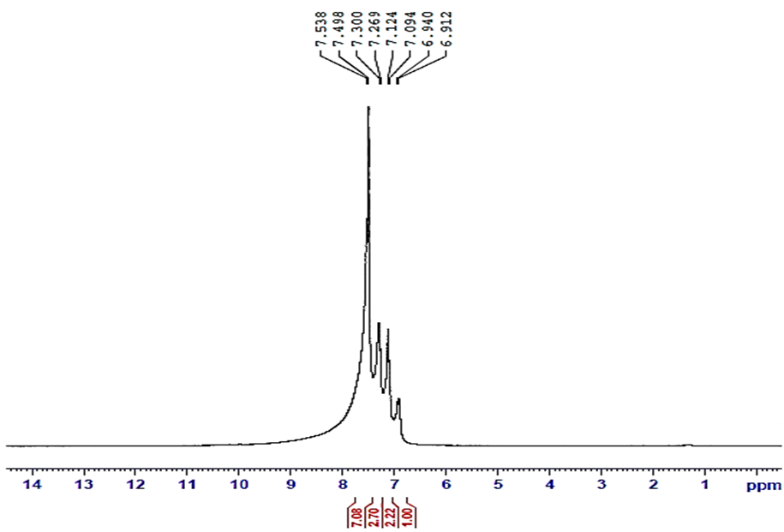
S 14. ¹HNMR of 5-amino-3-(4-bromo-phenyl)-1-phenyl-1H-pyrazole-4-carbonitrile
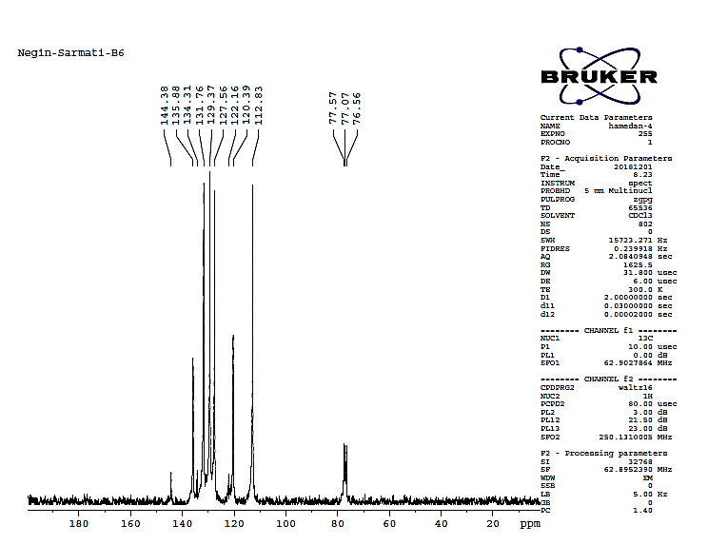
S 15. ¹³CNMR of 5-amino-3-(4-bromo-phenyl)-1-phenyl-1H-pyrazole-4-carbonitrile
5-Amino-1-phenyl-3-p-tolyl-1H-pyrazole-4-carbonitrile (7)
Yield: 87%, m. p: 115-117°C. IR (KBr):3309, 2919, 1596, 1507, 1295, 747 cm⁻¹; ¹H NMR (250 MHz, DMSO-d₆) δ 6.89-7.89 (m, 8H), 6.87 (s, 2H), 2.37 (s, 3H); 13C NMR (101 -MHz, DMSO-d6) δ 137.57, 129.30, 126.15, 119.93, 112.71, 77.53, 77.02, 76.51, 21.37.
5-Amino-3-(4-methoxy-phenyl)-1-phenyl-1H-pyrazole-4-carbonitrile (8)
Yield: 92 %, m. p: 119-121 °C. IR (KBr): 3314, 2954, 1596, 1507, 1295, 1027, 745cm⁻¹.
5-Amino-3-(3-hydroxy-phenyl)-1-phenyl-1H-pyrazole-4-carbonitrile (9)
Yield: 78 %, m. p: 128-130 °C. IR (KBr): 3316, 3049, 1622, 1601, 1495, 1203, 1157, 743cm⁻¹; ¹H NMR (250 MHz, DMSO) δ 9.95 (s, 1H), 6.80-7.63 (m, 9H), 6.77 (s, 2H); ¹³C NMR (101 -MHz, DMSO) δ 157.69, 136.80, 129.86, 129.31, 120.22, 119.35, 115.63, 112.79, 112.17, 77.50.
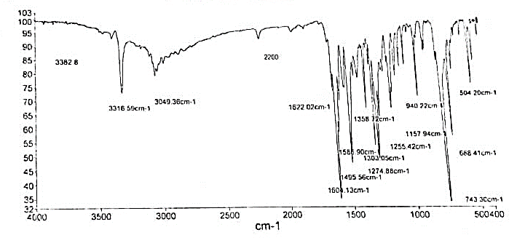
S 16. IR of 5-amino-3-(3-hydroxy-phenyl)-1-phenyl-1H-pyrazole-4-carbonitrile

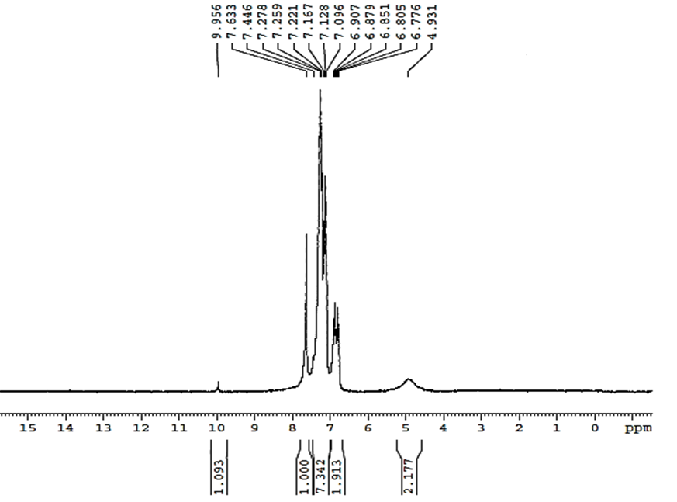
S 17. ¹HNMR of 5-amino-3-(3-hydroxy-phenyl)-1-phenyl-1H-pyrazole-4-carbonitrile

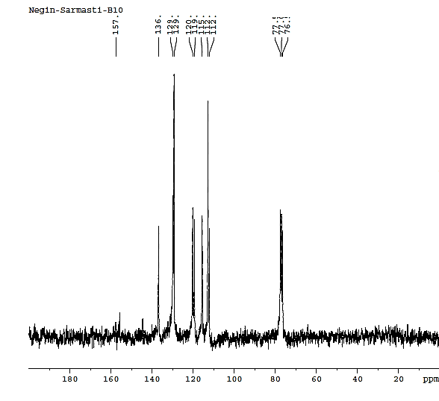
S 18. ¹³CNMR of 5-amino-3-(3-hydroxy-phenyl)-1-phenyl-1H-pyrazole-4-carbonitrile
5-Amino-1-phenyl-3-thiophen-2-yl-1H-pyrazole-4-carbonitrile (10)
Yield: 75%, m. p: 146-148 °C. IR (KBr): 3325, 3100, 1603, 1563, 1448, 1139, 751cm⁻¹;
5-Amino-3-furan-2-yl-1-phenyl-1H-pyrazole-4-carbonitrile (11)
Yield: 55%, m. p: 208-211 °C. IR (KBr): 3319, 1605, 1517, 1263, 1130, 1009, 745cm⁻¹.
5-Amino-3-(4-dimethylamino-phenyl)-1-phenyl-1H-pyrazole-4-carbonitrile (12)
Yield: 66 %, m. p: 109-110 °C. IR (KBr): 3315, 1601, 1510. 1363, 1261, 1134, 749; ¹H NMR (250 MHz, DMSO) δ 6.82-7.63 (m, 9H), 6.74 (s, 2H), 2.99 (s, 6H); ¹³C NMR (101 -MHz, DMSO) δ 138.44, 131.97, 129.20, 127.46, 122.64, 119.46, 112.56, 110.99, 77.50, 76.99, 76.48, 40.57.
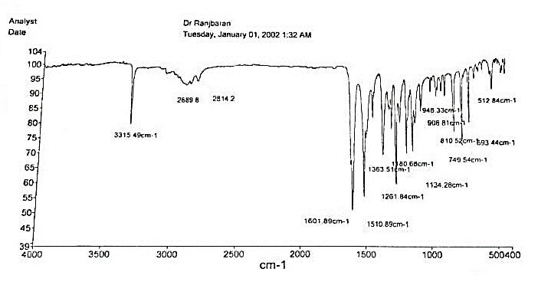
S 19. IR of 5-amino-3-(4-dimethylamino-phenyl)-1-phenyl-1H-pyrazole-4-carbonitrile

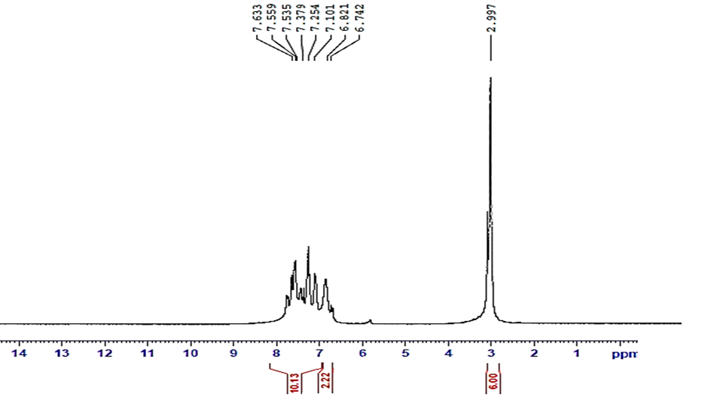
S 20. ¹HNMR of 5-amino-3-(4-dimethylamino-phenyl)-1-phenyl-1H-pyrazole-4-carbonitrile

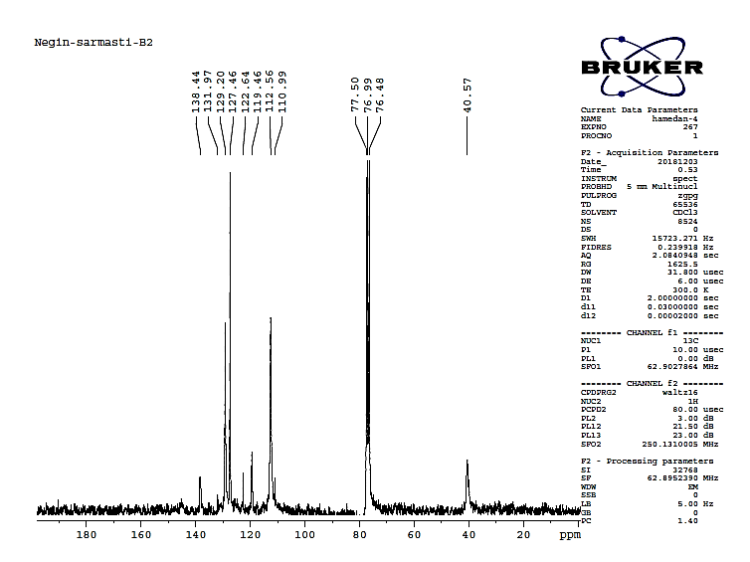
S 21. ¹³CNMR of 5-amino-3-(4-dimethylamino-phenyl)-1-phenyl-1H-pyrazole-4-carbonitrile

methylene-pyrazol:
4,4'-(Phenylmethylene)bis(3-methyl-1-phenyl-1H-pyrazol-5-ol) (1)
Yield: 60%, m. p: 166-168 °C. IR (KBr): 3063, 2928, 1781, 1609, 1415, 1290, 927 cm⁻¹ ;¹HNMR (250 MHz, DMSO‐d₆): δ (ppm) 2.23-2.32 (s, 6H), 4.97 (s, 1H), 7.22-7.74 (m, 15H), 13.9 (s, 2H) ; ¹³CNMR (250 MHz, DMSO‐d₆): δ (ppm) 12.04, 18.97, 33.59, 39.22, 39.54, 39.88, 40.21, 40.54, 56.53, 105.20, 120.96, 126, 126.35, 127.63, 128.57, 129.34, 137.78, 142.63, 146.77, 157.72.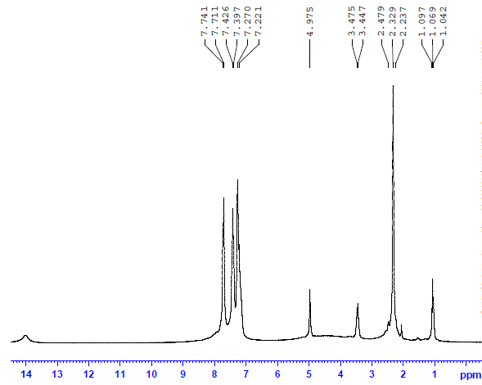
S 22. ¹HNMR of 4,4'-(Phenylmethylene)bis(3-methyl-1-phenyl-1H-pyrazol-5-ol)
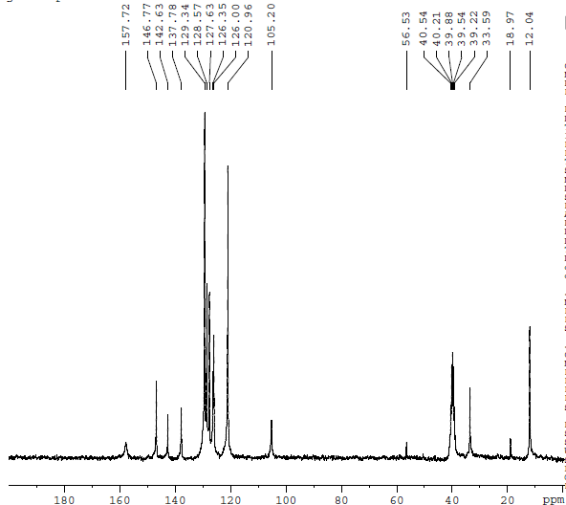
S 23. ¹³CNMR of 4,4'-(Phenylmethylene)bis(3-methyl-1-phenyl-1H-pyrazol-5-ol)
4,4'-((3-Bromo phenyl)methylene)bis(3-methyl-1-phenyl-1H-pyrazol-5-ol) (2)
Yield: 65 %, m. p: 167-170 °C. IR (KBr): 3075, 2973, 2918, 1605, 1579, 1473, 1373, 1054, 763cm⁻¹.
4,4'-((4-Bromo phenyl)methylene)bis(3-methyl-1-phenyl-1H-pyrazol-5-ol) (3)
Yield: 78%, m. p: 205-209 °C. IR (KBr): 3431, 3045, 2978, 1609, 1376, 1106, 1070, 690cm⁻¹.
4,4'-((2,4-Dichlorophenyl)methylene)bis(3-methyl-1-phenyl-1H-pyrazol-5-ol) (4)
Yield: 68%, m. p: 218-220 °C. IR (KBr): 3438, 3060, 2914, 1604, 1578, 1498, 1422, 1291, 888, 754 cm⁻¹ ;¹HNMR (250 MHz, DMSO‐d₆): δ (ppm) 2.25-2.47 (d, 6H), 5.05 (s, 1H), 7.22-7.65 (m, 13H), 13.96 (s, 2H) ; ¹³CNMR (250MHz, DMSO‐d₆): δ (ppm) 12.20, 31.74, 40.17, 103.72, 121.05, 126.11, 127.46, 129.35, 131.95, 137.46, 146.39, 160.76.
4,4'-((2-Chlorophenyl)methylene)bis(3-methyl-1-phenyl-1H-pyrazol-5-ol) (5)
Yield: 76%, m. p: 224-226°C. IR (KBr): 3448, 3062, 2909, 1614, 1560, 1368, 747 cm⁻¹; ¹HNMR (250 MHz, DMSO‐d₆): δ (ppm) 2.25-2.47 (d, 6H), 5.10 (s, 1H), 7.21-7.75 (m, 13H), 13.96 (s, 2H); ¹³CNMR (250MHz, DMSO‐d₆): δ (ppm) 12.28, 32.05, 38.91, 39.23, 39.57, 39.90, 40.23, 40.56, 40.89, 104.09, 121.08, 126.09, 127.34, 128.49, 129.36, 129.89, 130.65, 132.30, 137.65, 139.92, 146.42, 158.21.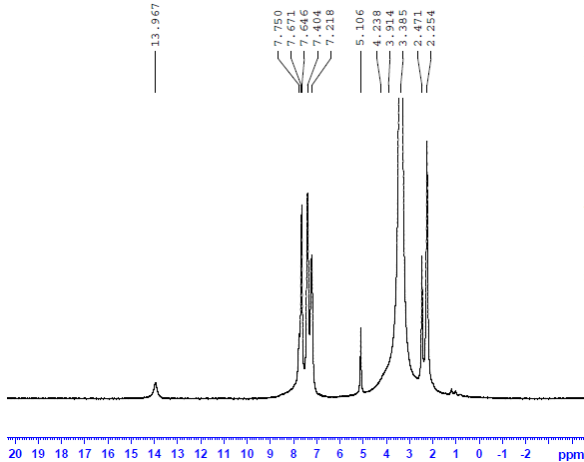
S 24. ¹HNMR of 4,4'-((2-Chlorophenyl)methylene)bis(3-methyl-1-phenyl-1H-pyrazol-5-ol)
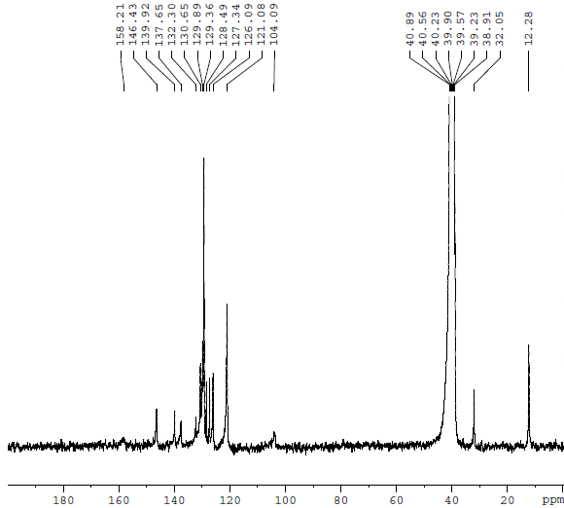
S 25. ¹³CNMR of 4,4'-((2-Chlorophenyl)methylene)bis(3-methyl-1-phenyl-1H-pyrazol-5-ol)
4,4'-((4-Chlorophenyl)methylene)bis(3-methyl-1-phenyl-1H-pyrazol-5-ol) (6)
Yield: 74%, m. p: 196-199°C. IR (KBr): 3428, 3067, 2923, 1601, 1579, 1413, 1219, 750 cm⁻¹; ¹HNMR (250 MHz, DMSO‐d₆): δ (ppm) 2.24-2.47 (d, 6H), 5.05 (s, 1H) 7.22- 7.65 (m, 14H), 13.94 (s, 2H); ¹³CNMR (250 MHz, DMSO‐d₆): δ (ppm) 12.20, 31.47, 40.12, 103.72, 121.05, 126.11, 127.46, 129.35, 131.95, 137.46, 146.39, 160.76.
4,4'-((p-toylmethylene)bis(3-methyl-1-phenyl-1H-pyrazol-5-ol) (7)
Yield: 59%, m. p: 101-105 °C. IR (KBr): 3478, 3047, 2919, 1601, 1502, 1407, 1297, 1024, 803 cm⁻¹ ¹HNMR (250 MHz, DMSO‐d₆): δ (ppm) 2.21-2.28 (d, 6H), 3.42(s, 3H) 4.89 (s, 1H), 7.06-7.68 (m, 14H), 13.94 (s, 2H). ¹³CNMR (250 MHz, DMSO‐d₆): δ (ppm) 12.06, 20.95, 33.20, 39.26, 39.59, 39.92, 40.25, 40.58, 105.37, 120.94, 125.98, 127.52, 129.14, 129.35, 132.58, 135.27, 137.78, 139.57, 146.71, 157.57.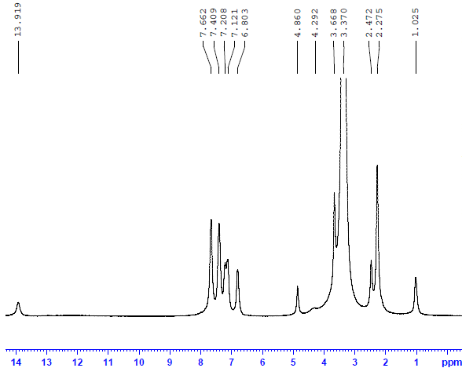
S 26. ¹HNMR of 4,4'-((p-toylmethylene)bis(3-methyl-1-phenyl-1H-pyrazol-5-ol
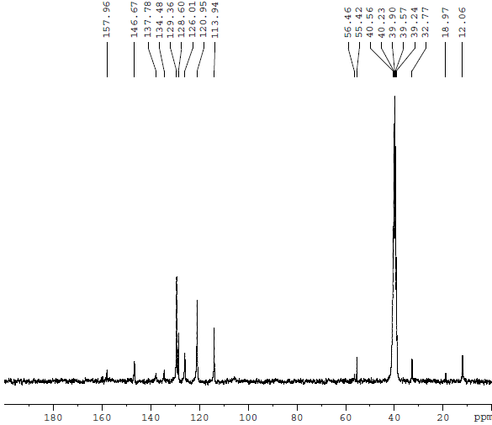
S 27. ¹³CNMR of 4,4'-((p-toylmethylene)bis(3-methyl-1-phenyl-1H-pyrazol-5-ol
4,4'-((3-ethoxy-4-hydroxyphenyl)methylene)bis(3-methyl-1-phenyl-1H-pyrazol-5-ol) (8)
Yield: 62%, m. p: 210-212 °C. IR (KBr): 3318, 3068, 1688, 1490, 1376, 1120, 1033, 764 cm⁻¹.
4,4'-((2-Hydroxyphenyl)methylene)bis(3-methyl-1-phenyl-1H-pyrazol-5-ol) (9)
Yield: 88%, m. p: 215-219 °C. IR (KBr): 3066, 2931, 1702, 1505, 1495, 1456, 1278, 1100, 753 cm⁻¹.
4,4'-((3-Hydroxyphenyl)methylene)bis(3-methyl-1-phenyl-1H-pyrazol-5-ol) (10)
Yield: 76%, m. p: 162-164 °C. IR (KBr): 3061, 2925, 1598, 1489, 1455, 1414, 1371, 1106, 752 cm⁻¹.
4,4'-((2-Methoxyphenyl)methylene)bis(3-methyl-1-phenyl-1H-pyrazol-5-ol) (11)
Yield: 85%, m. p: 205-210 °C. IR (KBr): 3311, 3087, 2978, 1707, 1579, 1376, 1108, 1070, 738 cm⁻¹.
4,4'-((3-Methoxyphenyl)methylene)bis(3-methyl-1-phenyl-1H-pyrazol-5-ol) (12)
Yield: 73%, m. p: 182-185 °C. IR (KBr): 3047, 2919, 1602, 1581, 1501, 1432, 1042, 752 cm⁻¹; ¹HNMR (250 MHz, DMSO‐d₆): δ (ppm) 2.28-2.45 (s, 6H), 3.65 (s, 3H), 4.88 (s, 1H), 6.79-7.67 (m, 14H), 14 (s, 2H) ;¹³CNMR (250 MHz, DMSO‐d₆): δ (ppm) 12.08, 33.63, 39.28, 39.60, 39.92, 40.25, 40.56, 55.26, 104.95, 110.82, 114.25, 120.08, 121.07, 126.05, 129.36, 137.75, 144.47, 146.79, 157.59, 159.61.
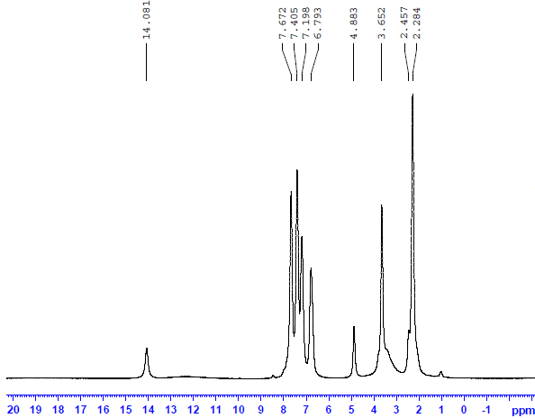
S 28. ¹HNMR of 4,4'-((3-Methoxyphenyl)methylene)bis(3-methyl-1-phenyl-1H-pyrazol-5-ol)

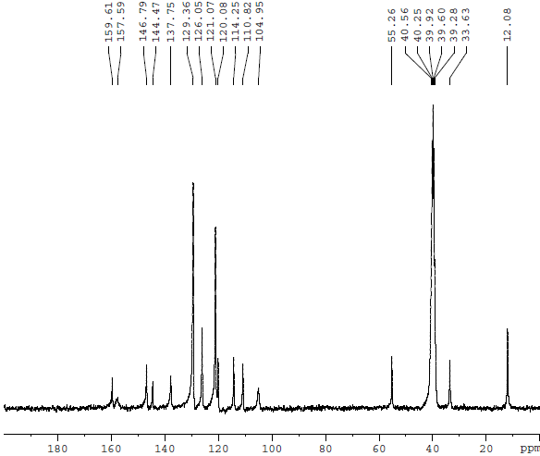
S 29. ¹³CNMR of 4,4'-((3-Methoxyphenyl)methylene)bis(3-methyl-1-phenyl-1H-pyrazol-5-ol).
4,4'-((4-Methoxyphenyl)methylene)bis(3-methyl-1-phenyl-1H-pyrazol-5-ol) (13)
Yield: 70%, m. p: 155-159 °C. IR (KBr):3217, 2966, 1577, 1518, 1498, 1373, 1275, 1126, 1043, 753 cm⁻¹; ¹HNMR (250 MHz, DMSO‐d₆): δ (ppm) 2.27-2.47 (d, 6H), 3.66 (s, 3H), 4.86 (s, 1H), 6.80-7.66 (m, 15H), 13.91 (s, 2H) ;¹³CNMR (250 MHz, DMSO‐d₆): δ (ppm) 12.06, 18.97, 32.77, 39.24, 39.57, 39.90, 40.23, 40.56, 55.42, 56.46, 113.94, 120.95, 126.01, 128.60, 129.36, 134.48, 137.78, 146.67, 157.96.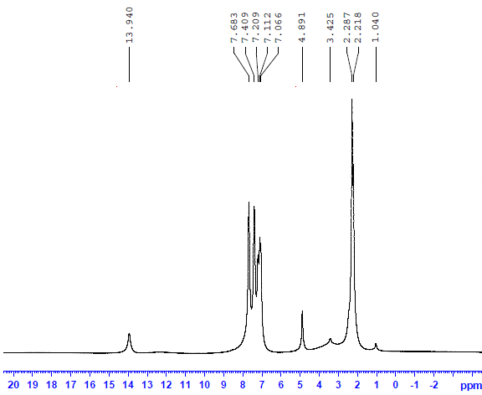
S 30. ¹HNMR of 4,4'-((4-Methylphenyl)methylene)bis(3-methyl-1-phenyl-1H-pyrazol-5-ol)
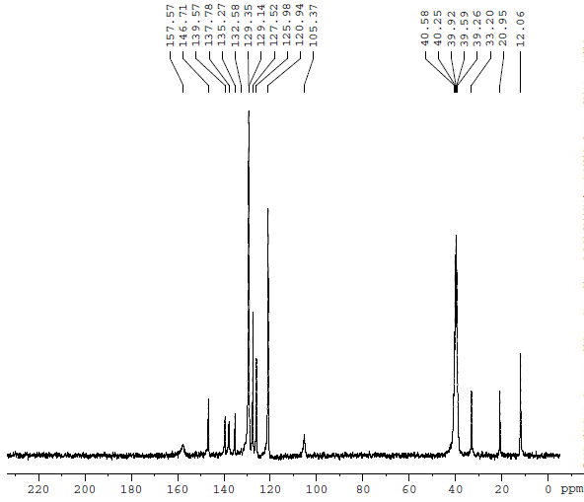
S 31. ¹³CNMR of 4,4'-((4-Methylphenyl)methylene)bis(3-methyl-1-phenyl-1H-pyrazol-5-ol)
4,4'-((3-Nitrophenyl)methylene)bis(3-methyl-1-phenyl-1H-pyrazol-5-ol) (14)
Yield: 75%, m. p: 203-209 °C. IR (KBr): 3456, 2975, 2928, 1600, 1579, 1500, 1403, 1373, 747 cm⁻¹; ¹HNMR (250 MHz, DMSO‐d₆): δ (ppm) 1.03 (s, 6H), 5.12 (s, 1H), 7.22-8.06 (m, 14H), 13.93(s, 2H) ; ¹³CNMR (250 MHz, DMSO‐d₆): δ (ppm) 12.04, 18.98, 33.30, 38.95, 39.28, 39.61, 39.94, 40.27, 40.61, 40.93, 56.47, 104.46, 121.10, 121.64, 122.19, 126.20, 129.40, 130.13, 134.79, 137.61, 145.09, 146.77, 148.21, 158.11.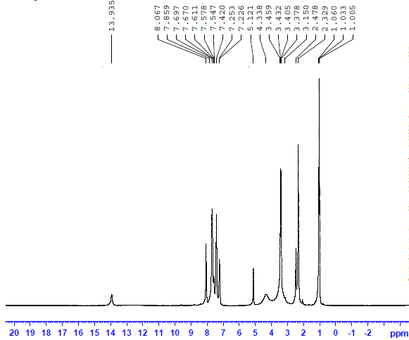
S 32. ¹HNMR of 4,4'-((3-Nitrophenyl)methylene)bis(3-methyl-1-phenyl-1H-pyrazol-5-ol)

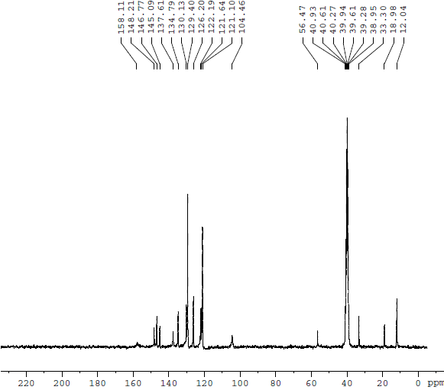
S 33. ¹³CNMR of 4,4'-((3-Nitrophenyl)methylene)bis(3-methyl-1-phenyl-1H-pyrazol-5-ol)

