Kaistella yananensis sp. nov., a novel indoleacetic acid producing bacterium isolated from the root nodules of Sophora davidii (Franch.) Skeels

The GenBank/EMBL/DDBJ accession number for the 16S rRNA gene sequence of strain BT6-1-3^{T} is ON115017. The strain BT6-1-3^{T} genome sequence was deposited in GenBank (JAPCHZ000000000).

Jiamin Ai ^{a,#}, Xiaolong He ^{a,#}, Mingxia Ren ª, Tianfei Yu ª, Xiaodong Liu ª, Yingying Jiang ª, Zhenshan Deng ^{a,}*

ª College of Life Sciences, Yan’an University, Yan’an 716000, China

# These authors have contributed equally to this work.
*Correspondence: zhenshandeng214@163.com

Table S1. ANIb, ANIm and dDDH value (%) of strain BT6-1-3^{T} with its phylogenetically related species.
Strains: Kaistella yananensis BT6-1-3^{T}; 2, Kaistella anthropi CCUG 52764; 3, Kaistella montana LZ 2022a; 4, Kaistella haifensis DSM 19056^{T}.
Speces name |  | ANIb |  | ANIm |  | dDDH
 |  | 1 |  | 1 |  | 1
1 |  | * |  | * |  | 100
2 |  | 79.27 |  | 86.89 |  | 23.3
3 |  | 78.19 |  | 84.76 |  | 21.5
4 |  | 80.04 |  | 87.43 |  | 24.2

Table S2. Regression model analysis of variance.
Source | Sum of Squares | df | Mean Square | F-value | p-value
Model | 6718.89 | 9 | 746.54 | 5.80 | 0.0152
A-T | 565.42 | 1 | 565.42 | 4.39 | 0.0744
B-pH | 0.1941 | 1 | 0.1941 | 0.0015 | 0.9701
C-rpm | 106.70 | 1 | 106.70 | 0.8287 | 0.3929
AB | 0.3452 | 1 | 0.3452 | 0.0027 | 0.9602
AC | 23.02 | 1 | 23.02 | 0.1788 | 0.6851
BC | 0.0021 | 1 | 0.0021 | 0.0000 | 0.9969
A² | 257.92 | 1 | 257.92 | 2.00 | 0.1999
B² | 5184.46 | 1 | 5184.46 | 40.27 | 0.0004
C² | 259.51 | 1 | 259.51 | 2.02 | 0.1987
Residual | 901.29 | 7 | 128.76
Lack of Fit | 708.47 | 3 | 236.16 | 4.90 | 0.0794
Pure Error | 192.82 | 4 | 48.20
Cor Total | 7620.18 | 16

Figure S1. Phylogenetic trees showing the relationship between strain BT6-1-3^{T} and near neighbors inferred from 16S rRNA gene sequences. The trees were established by maximum-likelihood (a) and maximum-parsimony (b) methods from calculated evolutionary distances. Numbers at nodes indicate levels of bootstrap values (%) based on 1000 resampled datasets. Bar, 0.02 nucleotide substitutions per site.

Figure S2. Scanning electron micrograph of strain BT6-1-3^{T} on PYG plate at 30 °C for 4 days. Bar, (a): 5 µm; (b): 1 µm.

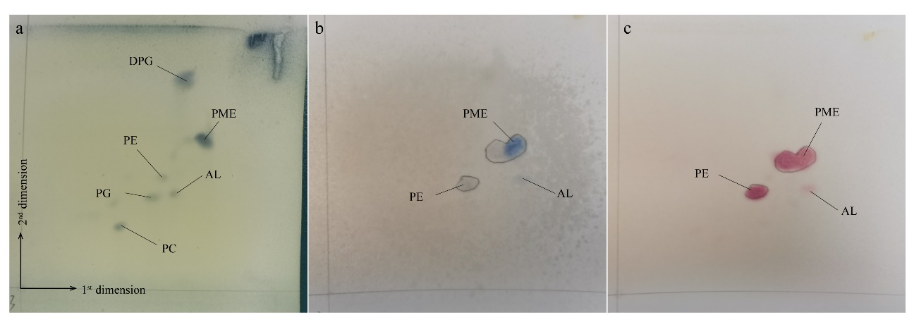
Figure S3. Two-dimensinal TLC of polar lipids of strain BT6-1-3^{T} and detected with phosphomolybdate ethanol (a), a-naphthol and sulfuric acid ethanol (b), ninhydrin (c). diphosphatidylglycerol (DPG), phosphatidylcholine (PC), phosphatidylethanolamine (PE), phosphoglyceride (PG) methylethanolamine (PME) and one unknown aminolipid (AL).

