Supplementary Table 1. Baseline characteristics.
 | ITT |  |  | PP
 | Total | Target intervention | Control intervention | Total | Target intervention | Control intervention
N [female] | 46 (18) | 21 (8) | 25 (10) | 39 (15) | 16 (6) | 23 (9)
Age [years] | 69.8 (5.1) | 70.2 (5.6) | 69.7 (4.7) | 70.0 (5.2) | 70.2 (6.2) | 69.8 (4.6)
Education [years] | 15.3 (2.4) | 15.4 (2.6) | 15.2 (2.2) | 14.9 (2.3) | 14.6 (2.3) | 15.2 (2.2)
APOE e4 [N/N_{total}] | 19 / 34 | 8 / 14 | 11 / 20 | 17 / 30 | 7 / 11 | 10 / 19
Depression [GDS score] | 2.1 (1.0) | 2.3 (1.1) | 2.0 (0.8) | 2.3 (1.0) | 2.6 (1.1) | 2.0 (0.8)
CERAD
Verbal Fluency [N] | 14.2 (4.0) | 14.6 (3.9) | 13.8 (4.2) | 13.8 (3.9) | 13.7 (3.9) | 13.8 (4.0)
BNT [N] | 14.2 (0.9) | 14.1 (0.8) | 14.2 (0.9) | 14.2 (0.9) | 14.2 (0.8) | 14.2 (1.0)
Constructional Praxis (Recall) [N] | 8.5 (2.3) | 8.5 (2.1) | 8.5 (2.6) | 8.4 (2.4) | 8.2 (2.1) | 8.5 (2.7)
Word List Learning [N] | 17.7 (4.2) | 17.5 (4.2) | 17.9 (4.3) | 17.8 (4.1) | 17.2 (4.6) | 18.2 (3.8)
Word List Recall [N] | 5.5 (2.1) | 5.4 (2.0) | 5.6 (2.1) | 5.6 (2.1) | 5.3 (2.2) | 5.7 (2.0)
Word List Recognition [N] | 8.1 (4.4) | 8.4 (4.3) | 7.8 (4.6) | 7.9 (4.8) | 8.1 (4.9) | 7.8 (4.8)
Total Score | 69.0 (9.3) | 69.0 (8.3) | 69.0 (10.4) | 68.7 (8.6) | 67.3 (8.7) | 69.6 (8.6)
Note. APOE, Apolipoprotein E. GDS, Geriatric depression scale (max. score: 15 points (cut off 6 points)). CERAD, Consortium to Establish a Registry for Alzheimer’s Disease. Verbal Fluency with maximal score 24. BNT. Boston Naming Test with maximal score 15, Constructional Praxis (Recall) with maximal score 11. Word List Learning with maximal score 30. Word List Recall with maximal score 10. Word List Recognition, calculated by subtracting false positives from true positives with maximal score of 10. Total score as addition of above measures with max 100 points based on Chandler, M. J., et al. (2005)

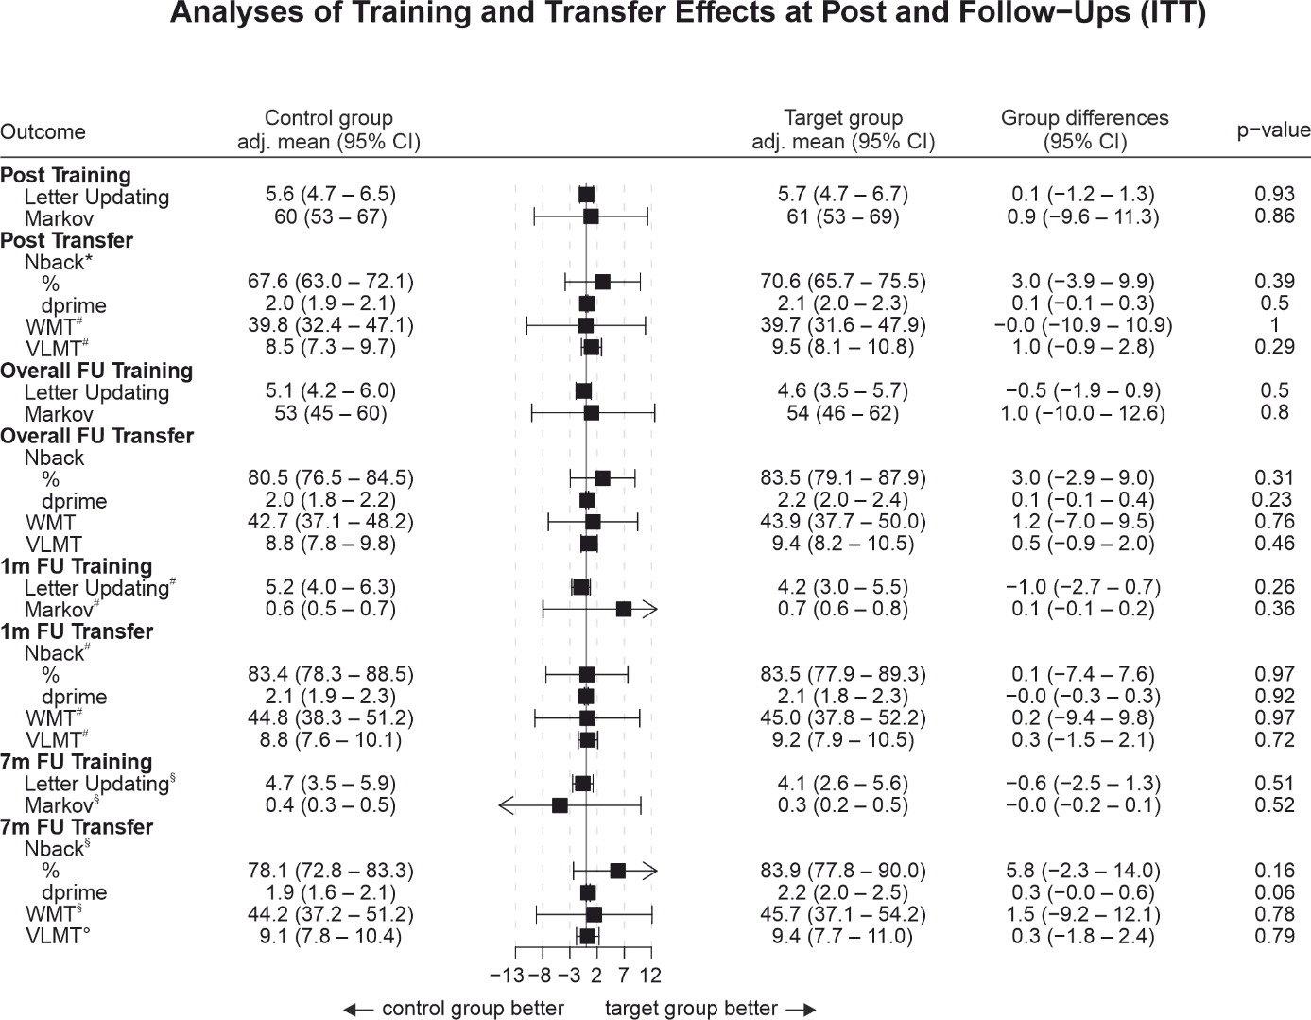
Supplementary Figure 1. Forest plot for performance outcomes (intention-to-treat sample). Intention-to-treat analyses of training and transfer effects at post and follow-ups. Abbreviations and units: Letter Updating # correct. Markov %, optimal actions. Nback % correct and dprime. WMT %correct. VLMT (German version of the AVLT) # words recalled. Separate linear mixed model analyses were conducted for post assessment and follow-up time points, for each task (ie, 1/7mFU values are derived from the same models as for the corresponding overall FU scores). In case of missing data, results are based on multiple imputation. For separate time points: N = 46 if not indicated otherwise. *n = 45. #n = 44. §n = 34. °n = 33. AVLT, Auditory Verbal Learning Test; CI, confidence interval; FU, follow-up; WMT, Wiener Matrices Test.

Supplementary Table 2. Microstructure and volumes (MRI sample).
 | Target intervention |  | Control intervention
 | Pre | FUII | Pre | FUII
White matter pathways (mean/SD)
FA | 0.309 (0.027) | 0.312 (0.026) | 0.312 (0.026) | 0.315 (0.030)
Volume [mm³] | 4127.000 (698.762) | 4018.400 (713.437) | 4099.235 (699.538) | 4011.176 (551.031)
Grey matter (mean/SD)
MD (x 10³) | 1.099 (0.069) | 1.089 x 10³ (0.084) | 1.087 (0.096) | 1.132 (0.1436)
Volume [mm³] | 1.224 x 10² (1.185 x 10³) | 1.210 x 10² (9.164 x 10⁴) | 1.214 x 10² (6.895 x 10⁴) | 1.188 x 10² (7.427 x 10⁴)
Note. FA. Fractional anisotropy. MD. Mean diffusivity.
Supplementary Table 3. Self-reported incidence of adverse events (at least moderate symptoms) by group during intervention.
 |  | ITT |  |  |  | PP
 |  | Total  N=46 | Target intervention  n = 21 | Control intervention  n = 25 | Incidence rate ratio for group differences  (95 % CI) | Total  N=39 | Target intervention  n = 16 | Control intervention  n = 23 | Incidence rate ratio for group differences  (95 % CI)
Observation time in days, mean (SD) |  | 8.7 (0.8) | 8.7 (0.9) | 8.8 (0.7) |  | 9 (0) | 9 (0) | 9 (0)
Total number of adverse events |  | 31/ 7.9 (5.4-11.0) | 15/ 8.2 (4.7-13.1) | 16/ 7.6 (4.5-12.0) | 1.1  (0.5-2.2) | 27/ 7.9 (5.3-11.3) | 15/ 9.8 (5.6-15.6) | 12/ 6.3 (3.4-10.6) | 1.5  (0.7-3.4)
 | Itching | 7/ 1.8  (0.8-3.5) | 4/ 2.2  (0.7-5.1) | 3/ 1.4  (0.4-3.7) | 1.5  (0.3-7.8) | 7/ 2  (0.9-4.0) | 4/ 2.6  (0.8-6.1) | 3/ 1.6  (0.4-4.1) | 1.6  (0.4-8.4)
 | Pain | 2/ 0.5  (0.1-1.6) | 2/ 1.1  (0.2-3.4) | 0 | .. | 2/  (0.1-1.8) | 2/ 1.3  (0.2-4.0) | 0 | ..
 | Burning | 5/ 1.3  (0.5-2.7) | 4/ 2.2  (0.7-5.1) | 1/ 0.5  (0.0-2.1) | 4.6  (0.7-89.8) | 5/ 1.5  (0.5-3.1) | 4/ 2.6  (0.8-6.1) | 1/ 0.5  (0.0-2.3) | 4.9  (0.7-96.7)
 | Warmth/heat | 5/ 1.3  (0.5-2.7) | 2/ 1.1 (0.2-3.4) | 3/ 1.4  (0.4-3.7) | 0.8  (0.1-4.6) | 4/ 1.2  (0.4-2.7) | 2/ 1.3  (0.2-4.0) | 2/ 1.1  (0.2-3.3) | 1.2  (0.1-10.3)
 | Metallic/iron taste | 0 | 0 | 0 | .. | 0 | 0 | 0 | ..
 | Fatigue/decreased alertness | 11/ 2.8 (1.5-4.8) | 2/ 1.1  (0.2-3.4) | 9/ 4.3  (2.1-7.7) | 0.3  (0.0-1.0) | 8/ 2.3  (1.1-4.4) | 2/ 1.3  (0.2-4.0) | 6/ 3.2  (1.3 – 6.4) | 0.4  (0.1-1.8)
 | Other | 1/ 0.3  (0.0-1.1) | 1/ 0.5  (0.0-2.4) | 0 | .. | 1/ 0.3  (0.0-1.3) | 1/ 0.7  (0.0-2.9) | 0 | ..
Reported values are absolute frequency of the respective AEs / incidence rate per 100 patient days (95 % CI).
For the ITT 15 adverse events were self-reported by 4 participants in the target group and 16 adverse events were self-reported by 7 participants in the control intervention group. For the PP 15 adverse events were self-reported by 4 participants in the target group and 12 adverse events were self-reported by 6 participants in the control intervention group.

Supplementary Table 4. Number of participants by group assignment and guess.
ITT |  |  |  |  |  | PP
Assignment |  | Response |  |  |  | Response
 |  | Target | Control | DK | Total | Target | Control | DK | Total
 | Target | 7 | 2 | 8 | 17 | 7 | 1 | 7 | 15
 | Control | 6 | 4 | 13 | 23 | 6 | 3 | 12 | 21
 | Total | 13 | 6 | 21 | 40 | 13 | 4 | 19 | 36
ITT, Intention to treat. PP, per protocol. Note: DK denotes “Don’t know”.

