SUPPLEMENTARY MATERIALS
Associations between serum levels of liver function biomarkers and all-cause and cause-specific mortality: A prospective cohort study

Contents
Box 1. The processed procedures of six liver function biomarkers in the NHANES. 3
Box 2. The mathematical details of additive Cox model. 4
Box 3. Details for smoothing hazard ratio curves 4
Box 4. Details of the calculation of liver function risk score 4
Table S1. Associations of mortality with serum levels of liver function biomarkers across adulthood in NHANES 1988-2014. 5
Figure S1. The distributions of serum liver of liver function biomarkers by sex. 6
Figure S2. The associations of serum levels of six liver function biomarkers with all-cause related deaths in males. 7
Figure S3. The associations of serum levels of six liver function biomarkers with all-cause related deaths in females. 8
Figure S4. The associations of serum levels of six liver function biomarkers with heart and cerebrovascular diseases related deaths in NHANES population. 8
Figure S5. The associations of serum levels of six liver function biomarkers with cancer related deaths in NHANES population. 9
Figure S6. The associations of serum levels of six liver function biomarkers with other causes related deaths in NHANES population. 9
Figure S7. The effect estimates of discrete levels of liver function biomarkers on all-cause mortality (A) and the relative importance of the six biomarkers for all-cause mortality (B). 10
Figure S8. The distribution of risk scores at log scale among heart and cerebrovascular diseases related deaths and alive people (A) and the survival curves of people with high and low risk scores (B). 11
Figure S9. The distribution of risk scores at log scale among cancer related deaths and alive people (A) and the survival curves of people with high and low risk scores (B). 11
Figure S10. The distribution of risk scores at log scale among other causes related deaths and alive people (A) and the survival curves of people with high and low risk scores (B). 12
Figure S11. The areas under ROC curves of LFRSs, by cause of mortality. 12
Figure S12. Result of the first sensitivity analysis: associations of serum level of liver function biomarker with all-cause mortality among participants who were followed up ≥ 36 months. 13
Figure S13. Result of the second sensitivity analysis: associations of serum level of liver function biomarker with all-cause mortality among participants who were free of diabetes, cancer, heart diseases at the baseline. 13
Figure S14. Result of the third sensitivity analysis: associations of serum level of liver function biomarker with all-cause mortality among participants from NHANES III. 14
Figure S15. Result of the third sensitivity analysis: associations of serum level of liver function biomarker with all-cause mortality among participants from NHANES 1999-2014. 14
Figure S16. Result of the fourth sensitivity analysis: associations of serum level of liver function biomarker with all-cause mortality based on complete models. 15
Figure S17. Result of the fifth sensitivity analysis: associations of serum level of liver function biomarker with all-cause mortality among participants aged < 60 years. 15
Figure S18. Result of the fifth sensitivity analysis: associations of serum level of liver function biomarker with all-cause mortality among participants aged >= 60 years. 16
Figure S19. Result of the sixth sensitivity analysis: associations of serum level of liver function biomarker with all-cause mortality among participants whose serum level of biomarkers were within 1-99% quantile. 16

Box 1. The processed procedures of six liver function biomarkers in the NHANES.
Description of Laboratory Methodology
Serum specimens were processed, stored, and shipped to the Collaborative Laboratory Services for analysis. Detailed specimen collection and processing instructions are discussed in the NHANES Laboratory/Medical Technologists Procedures Manual (LPM). Vials were stored under appropriate frozen (–30°C) conditions until they were shipped to the National Center for Environmental Health for testing. For routine biochemistry profiling, the analyses were performed using a Beckman Synchron LX20 and Beckman UniCel® DxC800 Synchron.

1. Alanine Aminotransferase (ALT)
The DxC800 uses a kinetic rate method to measure ALT activity in serum or plasma. In the reaction, ALT catalyzes the reversible transamination of L-alanine and a-ketoglutarate to pyruvate and L-glutamate. The pyruvate is then reduced to lactate in the presence of lactate dehydrogenase (LDH) with the concurrent oxidation of NADH to NAD. The system monitors the rate of change in absorbance at 340 nm over a fixed-time interval. The rate of change in absorbance is directly proportional to the ALT activity in the sample.

2. Aspartate Aminotransferase (AST)
The DxC800 uses an enzymatic rate method to measure the AST activity in serum or plasma. In the reaction, the AST catalyzes the reversible transamination of L-aspartate and a-ketoglutarate to oxaloacetate and L-glutamate. The oxaloacetate is then reduced to malate in the presence of malate dehydrogenase with the concurrent oxidation of NADH to NAD. The system monitors the rate of change in absorbance at 340 nm over a fixed-time interval. The rate of change in absorbance is directly proportional to the AST activity in the sample.

3. Gammaglutamyl Transaminase (GGT)
The DxC800 uses an enzymatic rate method to determine the GGT activity in serum or plasma. In the reaction, the GGT catalyzes the transfer of a gamma-glutamyl group from the colorless substrate, gamma-glutamyl-p-nitroaniline, to the acceptor, glycylglycine with production of the colored product, p-nitroaniline. The system monitors the rate of change in absorbance at 410 nm over a fixed-time interval. The rate of change in absorbance is directly proportional to the activity of GGT in the sample.

4. Alkaline Phosphatase (ALP)
The DxC800 system uses a kinetic rate method using a 2-Amino-2-Methyl-1-Propanol (AMP) buffer to measure ALP activity in serum or plasma. In the reaction, the ALP catalyzes the hydrolysis of the colorless organic phosphate ester substrate, p-Nitrophenylphosphate, to the yellow colored product p-Nitrophenol and phosphate. This reaction occurs at an alkaline pH of 10.3. The system monitors the rate of change in absorbance at 410 nm over a fixed-time interval. This rate of change in absorbance is directly proportional to the ALP activity in the serum.

5. Total Bilirubin
The DxC800 uses a timed-endpoint Diazo method (Jendrassik-Grof) to measure the concentration of total bilirubin in serum or plasma. In the reaction, bilirubin reacts with diazo reagent in the presence of caffeine, benzoate, and acetate as accelerators to form azobilirubin. The system monitors the change in absorbance at 520 nm at a fixed-time interval. This change in absorbance is directly proportional to the concentration of total bilirubin in the sample.

6. Albumin
The DcX800 method is used to measure the albumin concentration as a bichromatic digital endpoint method. In the reaction, the albumin combines with Bromcresol Purple (BCP) reagent to form a complex. The system monitors the change in absorbance at 600 nm. The change in absorbance is directly proportional to the concentration of albumin in the sample.

Box 2. The mathematical details of additive Cox model.
Traditionally, the Cox model assumes that the hazard function can be written as:
$α\left(t;Z\right)= α_{0}(t)exp\left(β^{T}Z\right)$,
where 𝑡 is time, $Z={(Z_{1},⋯,Z_{p})}^{T}$ is a 𝑝-dimensional vector of time-fixed covariates, 𝛽 is the associated vector of unknown regression parameters, and $α_{0}\left(t\right)$ a nonnegative baseline hazard function. The effect of covariates estimated by any proportional hazards model can thus be reported as hazard ratios (HRs). The logarithm of the hazard ratio curve is then reduced to a straight line, indicating that the expected change in risk for a $(Z_{i}-z_{i,ref})$ change in 𝑍𝑖 is a constant value (the well-known proportional hazards assumption). However, there are many nonlinear associations existed between the outcome and covariates. One possible approach to incorporate nonlinear effects into the Cox model is to express the log hazard as an additive function:
$α\left(t;Z\right)= α_{0}(t)exp\left(\sum_{i=1}^{q}{f_{i}\left(Z_{i}\right)+\sum_{i=q+1}^{p}{β_{i}Z_{i}}}\right)$,
where the first 𝑞 covariates are continuous and introduced nonlinearly through (unknown) smooth functions, 𝑓𝑖, and the remaining ones are covariates introduced parametrically in the model.

Box 3. Details for smoothing hazard ratio curves
The HR curve for a continuous predictor $Z_{i}$ in the additive Cox model can be written as:
$HR\left(Z_{i},z_{i,ref}\right)=exp\left(f_{i}\left(Z_{i}\right)-f_{i}\left(z_{i,ref}\right)\right)$, where $z_{i,ref}$ means the specific value of the predictor taken as the reference. A natural estimate of the adjusted HR curve can be calculated as $\hat{{HR}_{i}}\left(Z_{i},z_{i,ref}\right)=exp⁡\{\hat{f_{i}}\left(Z_{i}\right)-\hat{f_{i}}\left(z_{i,ref}\right)\}$ by replacing $f_{i}(∙)$ with the corresponding natural-spline estimate $\hat{f_{i}}(∙)$(or any other smoother).¹

Reference
1, Meira-Machado L, Cadarso-Suárez C, Gude F, et al. smoothHR: An R Package for Pointwise Nonparametric Estimation of Hazard Ratio Curves of Continuous Predictors. Comput Math Methods Med. 2013; 2013: 745742.

Box 4. Details of the calculation of liver function risk score
We calculated the relative importance of each liver function biomarker as measured by the increasing R² values of the models, and we tested the consistency of the results by calculating the explainable log-likelihood that was attributable to each analyte. We also categorized the serum level of the biomarker into five non-overlapping groups with consideration of the sample size in each group, the points located in HR curves, and the shapes of HR curves, rather than in terms of the quartiles or deciles exclusively. For example, the cut-off points of the ALT level were 15, 30, 40, and 60, which denote the mid-value between 0 and the valley point in the HR curve, the valley point, the upper limit of medical reference interval, and the approximate median value of the remaining interval, respectively. The intervals between valley points and the upper limits of the medical reference were defined as the references. Since a nearly linear relation was observed between GGT level and mortality, we discretized the GGT levels in terms of sample size in each group and defined the first group as the reference. The HRs of each group could then be calculated by additive Cox models. We constructed an integrated index, referred to as the liver function risk score (LFRS), using the following formula:
$$LFRS= \sum_{j}^{6}{\sum_{i}^{5}{\left(\left|x_{j}-x_{min,j}\right|×R_{j}^{2}×{HR}_{ij}\right)}}$$
where i denotes the five groups of each biomarker and j denotes the six biomarkers. $x_{j}$ denotes the serum levels of the j^{th} biomarker at the individual level. $x_{min,j}$ indicates the valley points of each biomarker on the HR curve. $R_{j}^{2}$ and ${HR}_{ij}$ represent the relative importance of the j^{th} biomarker and the HR values of the i^{th} group of the j^{th} biomarker, respectively. For the referents and groups with P values > 0.05, HR values were set to 1. We then split the LFRSs into two independent groups, namely, high and low, with the median value as the cut-off.

Table S1. Associations of mortality with serum levels of liver function biomarkers across adulthood in NHANES 1988-2014.
 | All causes |  | Heart & cerebrovascular diseases |  | Cancer |  | Others
Serum level | HR (95% CI) | Serum level | HR (95% CI) | Serum level | HR (95% CI) | Serum level | HR (95% CI)
ALT (U/L)
0-14 | 1.27(1.14,1.41) | 0-11 | 2.04(1.78,2.33) | 0-14 | 2.17(1.74,2.70) | 0-14 | 1.22(1.06,1.40)
15-30 | 1.07(0.96,1.18) | 12-23 | 1.14(1.01,1.29) | 15-30 | 1.23(0.99,1.52) | 15-30 | 1.02(0.89,1.17)
31-40 | Ref. | 24-40 | Ref. | 31-40 | Ref. | 31-40 | Ref.
41-60 | 1.24(1.06,1.45) | 41-60 | 0.96(0.70,1.32) | 41-60 | 1.45(1.05,2.01) | 41-60 | 1.35(1.09,1.66)
61-99 | 1.70(1.38,2.10) | 61-99 | 2.12(1.48,3.04) | 61-99 | 1.80(1.13,2.87) | 61-99 | 1.71(1.27,2.29)
AST (U/L)
0-10 | 1.54(1.31,1.83) | 0-15 | 1.43(1.14,1.80) | 0-15 | 1.73(1.33,2.24) | 0-11 | 1.54(1.15,2.07)
11-21 | 1.07(1.02,1.12) | 16-32 | 0.99(0.80,1.22) | 16-32 | 1.10(0.86,1.40) | 12-23 | 1.06(0.99,1.13)
22-40 | Ref. | 33-40 | Ref. | 33-40 | Ref. | 24-40 | Ref.
41-60 | 1.42(1.26,1.61) | 41-60 | 1.21(0.88,1.68) | 41-60 | 1.46(1.03,2.06) | 41-60 | 1.54(1.31,1.81)
61-99 | 1.99(1.61,2.44) | 61-99 | 1.76(1.14,2.73) | 61-99 | 1.72(1.03,2.89) | 61-99 | 2.34(1.84,2.99)
GGT (U/L)
0-13 | Ref. | 0-10 | Ref. | 0-10 | Ref. | 0-10 | Ref.
14-25 | 1.01(0.91,1.12) | 11-25 | 1.14(0.91,1.42) | 11-25 | 1.10(0.91,1.38) | 11-25 | 1.06(0.92,1.22)
26-50 | 1.13(1.01,1.26) | 26-50 | 1.30(1.03,1.63) | 26-50 | 1.11(1.03,1.50) | 26-50 | 1.35(1.13,1.61)
51-80 | 1.26(1.11,1.44) | 51-80 | 1.35(1.03,1.78) | 51-80 | 1.78(1.03,2.54) | 51-80 | 1.79(1.43,2.23)
81-299 | 1.77(1.54,2.03) | 81-299 | 2.34(1.77,3.10) | 81-299 | 2.16(1.77,3.14) | 81-299 | 2.12(1.69,2.67)
ALP (U/L)
0-24 | 0.95(0.61,1.47) | 0-49 | 0.65(0.53,0.80) | 0-49 | 0.97(0.81,1.16) | 0-49 | 0.94(0.83,1.07)
25-50 | Ref. | 50-75 | Ref. | 50-75 | Ref. | 50-75 | Ref.
51-100 | 1.16(1.09,1.23) | 76-100 | 1.39(1.26,1.53) | 76-100 | 1.33(1.19,1.48) | 76-100 | 1.19(1.11,1.28)
101-150 | 1.32(1.23,1.42) | 101-150 | 1.63(1.45,1.82) | 101-150 | 1.42(1.25,1.63) | 101-150 | 1.35(1.25,1.47)
151-199 | 2.08(1.81,2.40) | 151-199 | 3.57(2.80,4.54) | 151-199 | 2.98(2.21,4.03) | 151-199 | 2.11(1.75,2.54)
TB (mg/dL)
0-0.3 | 1.16(1.07,1.25) | 0-0.4 | 1.55(1.36,1.78) | 0-0.4 | 1.76(1.51,2.06) | 0-0.4 | 1.09(0.99,1.19)
0.4-0.5 | 1.05(1.01,1.10) | 0.5-0.7 | 1.14(1.01,1.28) | 0.5-0.7 | 1.18(1.03,1.35) | 0.5-0.7 | 1.03(0.96,1.11)
0.6-1.0 | Ref. | 0.8-1.3 | Ref. | 0.8-1.3 | Ref. | 0.8-1.3 | Ref.
1.1-1.5 | 1.08(1.01,1.17) | 1.4-2.0 | 1.10(0.82,1.48) | 1.4-2.0 | 1.22(0.88,1.69) | 1.4-2.0 | 1.23(1.02,1.49)
1.6-2.9 | 1.23(1.04,1.45) | 2.1-2.9 | 1.11(0.55,2.23) | 2.1-2.9 | 0.66(0.21,2.06) | 2.1-2.9 | 1.90(1.29,2.82)
ALB (g/dL)
1.5-3.0 | 3.14(2.42,4.09) | 1.5-3.0 | 3.96(2.41,6.53) | 1.5-3.0 | 2.55(1.21,5.38) | 1.5-3.0 | 3.74(2.70,5.20)
3.1-4.0 | 1.40(1.30,1.52) | 3.1-4.0 | 1.43(1.31,1.56) | 3.1-4.0 | 1.41(1.28,1.56) | 3.1-4.0 | 1.32(1.25,1.41)
4.1-4.4 | 1.10(1.02,1.19) | 4.1-4.4 | Ref. | 4.1-4.4 | Ref. | 4.1-4.4 | Ref.
4.5-5.3 | Ref. | 4.5-5.0 | 0.94(0.81,1.09) | 4.5-5.0 | 0.78(0.66,0.96) | 4.5-5.3 | 0.89(0.80,0.99)
5.4-7.0 | 0.92(0.38,2.24) | 5.1-7.0 | 1.72(0.43,6.92) | 5.1-7.0 | 0.93(0.50,1.78) | 5.1-7.0 | 0.72(0.45,1.17)
All estimates accounted for complex survey designs of NHANES.
Abbreviations: HR, hazard ratio; ALT, alanine aminotransferase; AST, aspartate aminotransferase; GGT, gamma-glutamyl transferase; ALP, alkaline phosphatase; TB, total bilirubin; ALB: Albumin; CI, confidence interval. Ref., reference.

Figure S1. The distributions of serum liver of liver function biomarkers by sex.
ALT, alanine aminotransferase; AST, aspartate aminotransferase; GGT, gamma-glutamyl transferase; ALP, alkaline phosphatase; TB, total bilirubin; ALB: Albumin.
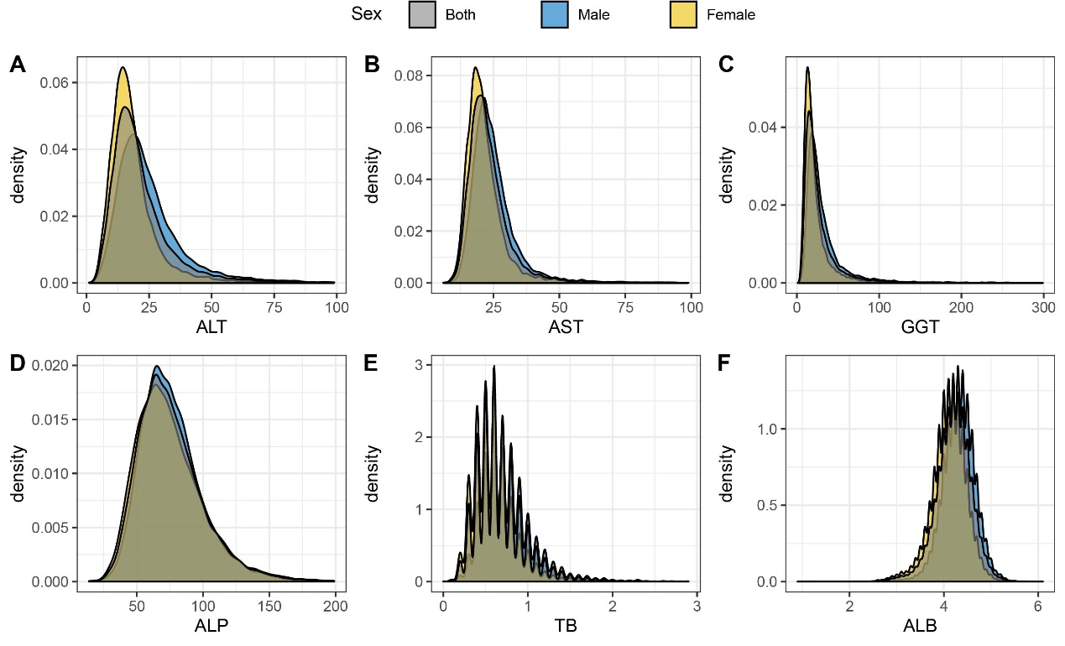

Figure S2. The associations of serum levels of six liver function biomarkers with all-cause related deaths in males.
The degrees of freedom of ALT, AST, GGT, ALP, TB, and ALB was 3, 3, 3, 6, 2, and 2, respectively.
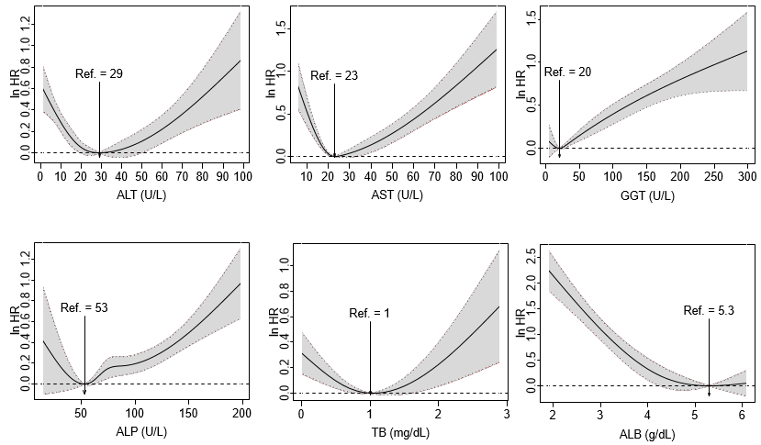

Figure S3. The associations of serum levels of six liver function biomarkers with all-cause related deaths in females.
The degrees of freedom of ALT, AST, GGT, ALP, TB, and ALB was 3, 3, 1, 5, 3, and 2, respectively.
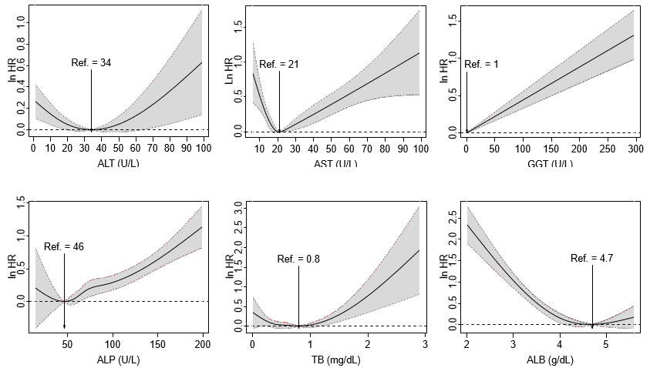

Figure S4. The associations of serum levels of six liver function biomarkers with heart and cerebrovascular diseases related deaths in NHANES population.
The degrees of freedom of ALT, AST, GGT, ALP, TB, and ALB was 4, 3, 2, 12, 3, and 2, respectively.
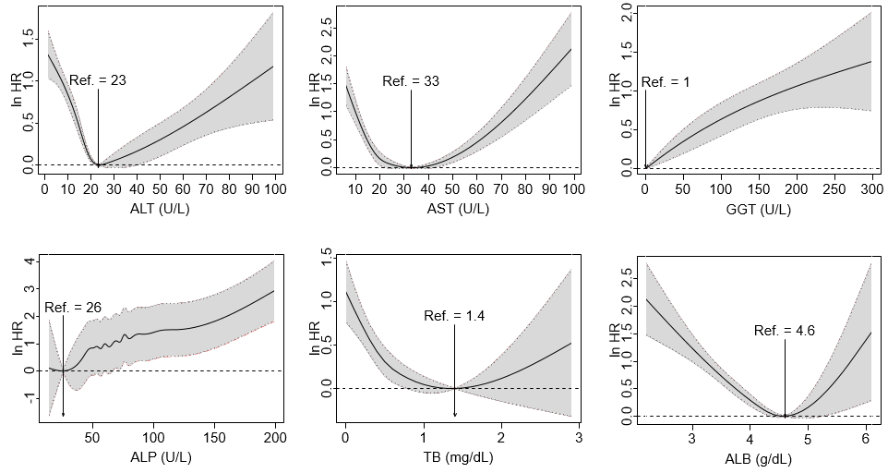

Figure S5. The associations of serum levels of six liver function biomarkers with cancer related deaths in NHANES population.
The degrees of freedom of ALT, AST, GGT, ALP, TB, and ALB was 3, 3, 2, 5, 3, and 2, respectively.
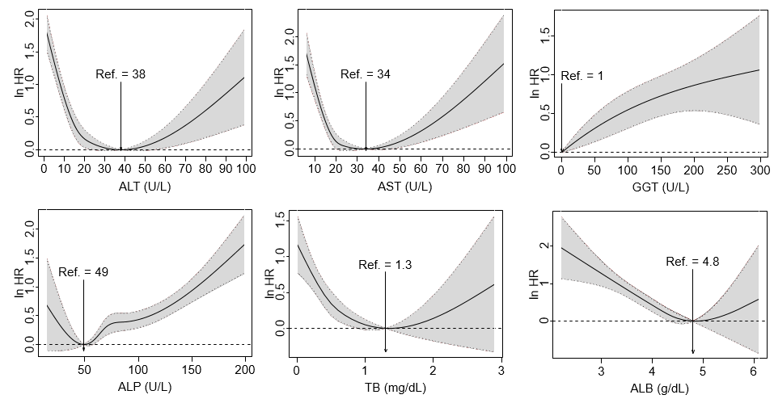

Figure S6. The associations of serum levels of six liver function biomarkers with other causes related deaths in NHANES population.
The degrees of freedom of ALT, AST, GGT, ALP, TB, and ALB was 3, 3, 2, 5, 2, and 2, respectively.
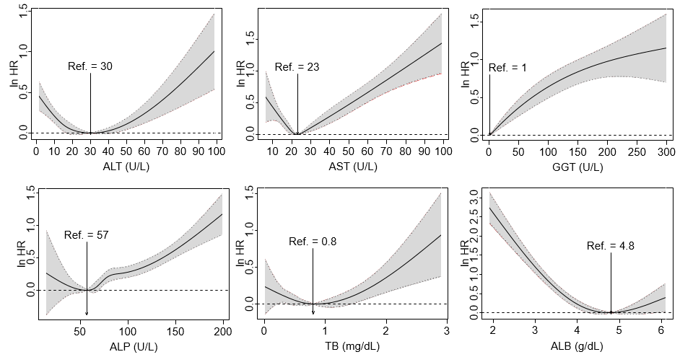

Figure S7. The effect estimates of discrete levels of liver function biomarkers on all-cause mortality (A) and the relative importance of the six biomarkers for all-cause mortality (B).
The dots represent the point estimates and the error bars means the corresponding 95% confidence intervals. The squares denote the reference group.
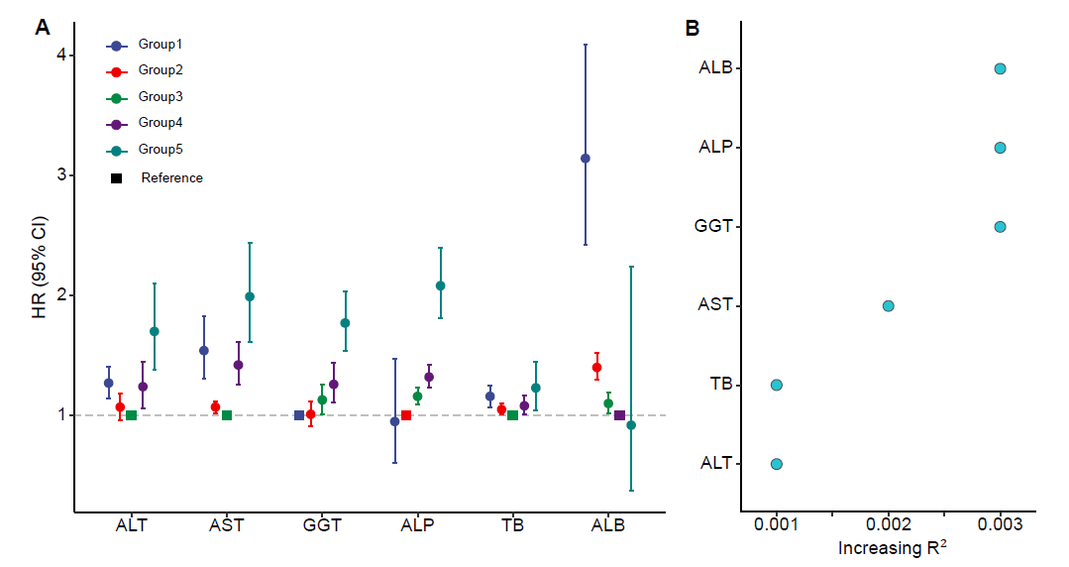

Figure S8. The distribution of risk scores at log scale among heart and cerebrovascular diseases related deaths and alive people (A) and the survival curves of people with high and low risk scores (B).
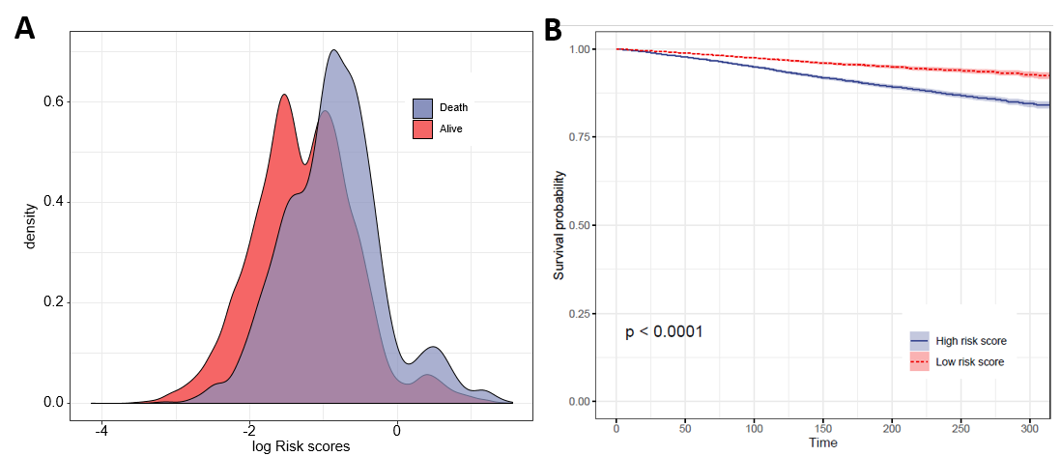

Figure S9. The distribution of risk scores at log scale among cancer related deaths and alive people (A) and the survival curves of people with high and low risk scores (B).
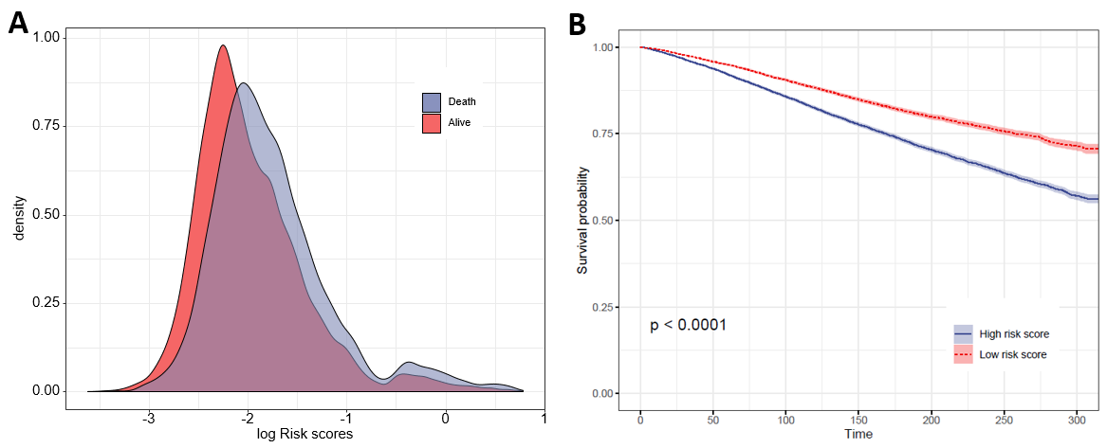

Figure S10. The distribution of risk scores at log scale among other causes related deaths and alive people (A) and the survival curves of people with high and low risk scores (B).
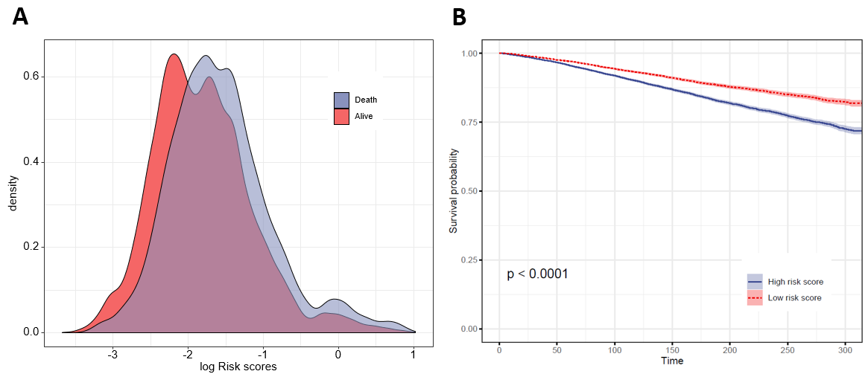

Figure S11. The areas under ROC curves of LFRSs, by cause of mortality.
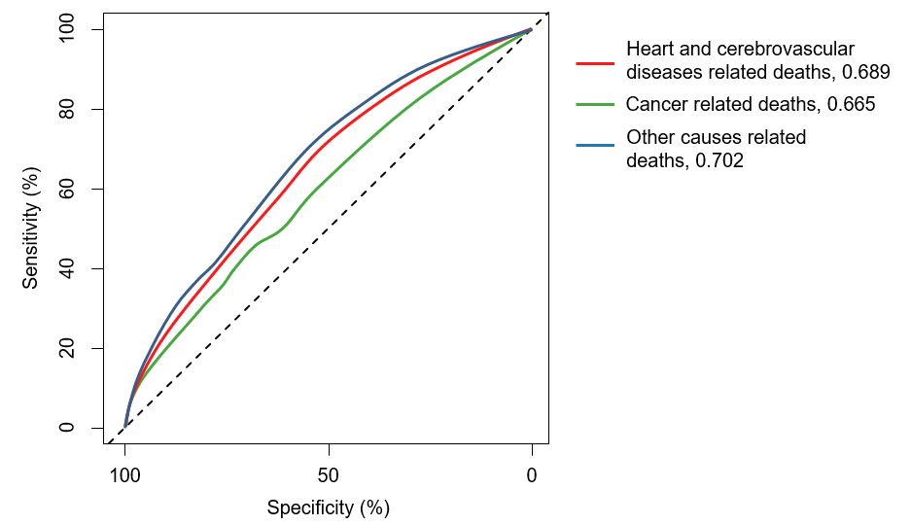

Figure S12. Result of the first sensitivity analysis: associations of serum level of liver function biomarker with all-cause mortality among participants who were followed up ≥ 36 months.
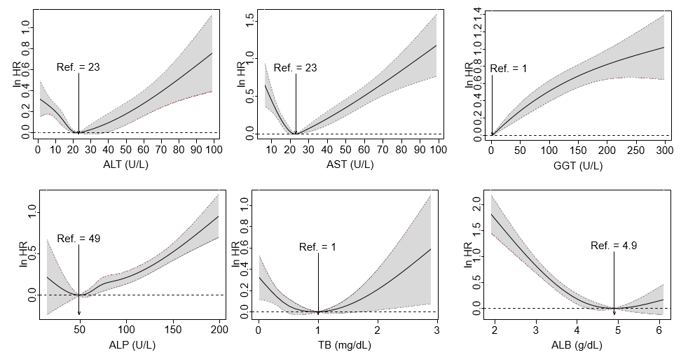

Figure S13. Result of the second sensitivity analysis: associations of serum level of liver function biomarker with all-cause mortality among participants who were free of diabetes, cancer, heart diseases at the baseline.
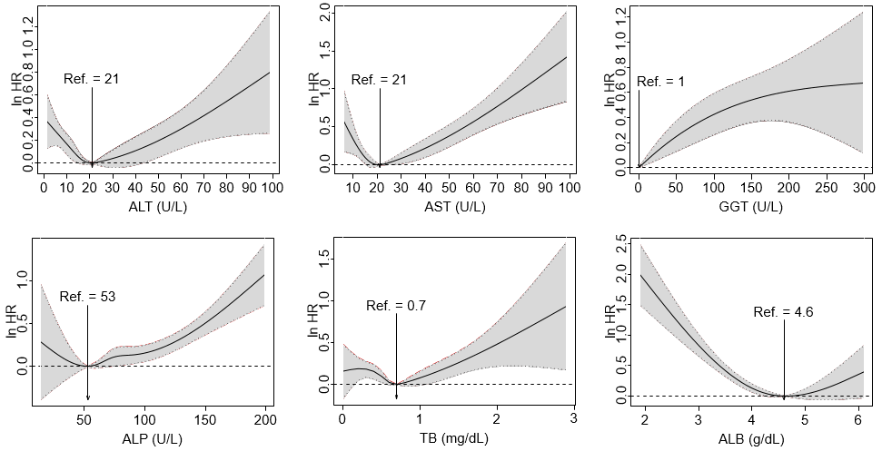

Figure S14. Result of the third sensitivity analysis: associations of serum level of liver function biomarker with all-cause mortality among participants from NHANES III.
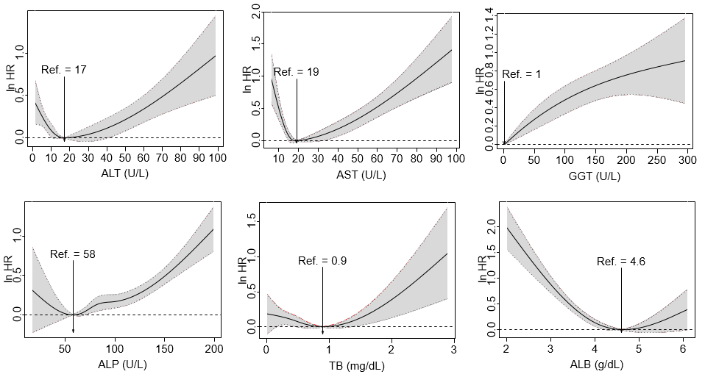

Figure S15. Result of the third sensitivity analysis: associations of serum level of liver function biomarker with all-cause mortality among participants from NHANES 1999-2014.
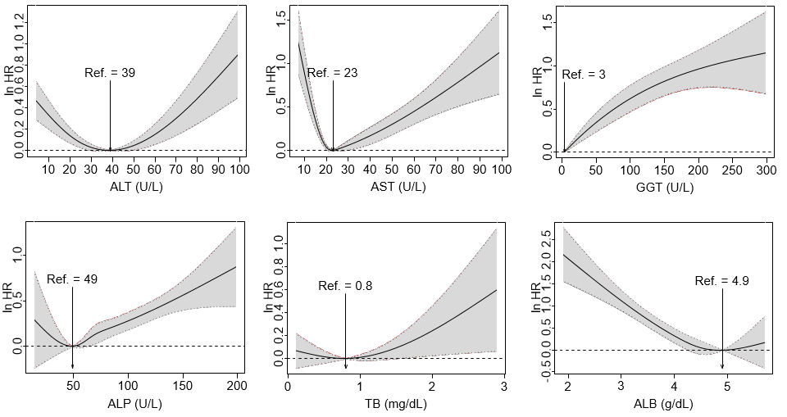

Figure S16. Result of the fourth sensitivity analysis: associations of serum level of liver function biomarker with all-cause mortality based on complete models.
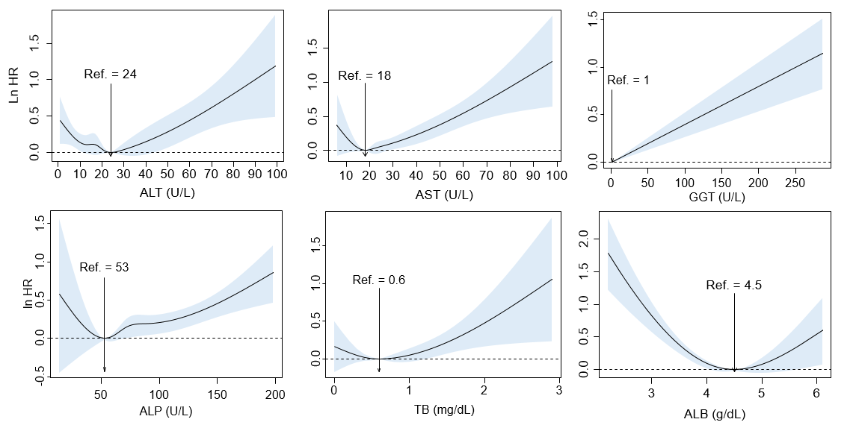

Figure S17. Result of the fifth sensitivity analysis: associations of serum level of liver function biomarker with all-cause mortality among participants aged < 60 years.
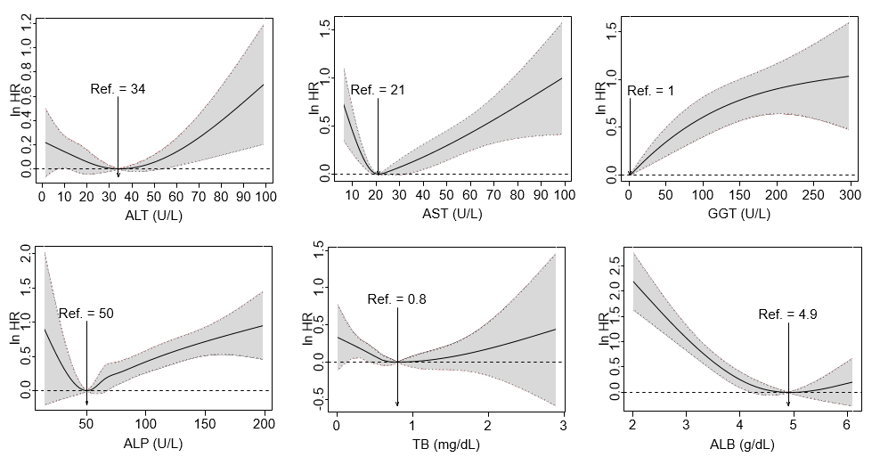

Figure S18. Result of the fifth sensitivity analysis: associations of serum level of liver function biomarker with all-cause mortality among participants aged >= 60 years.
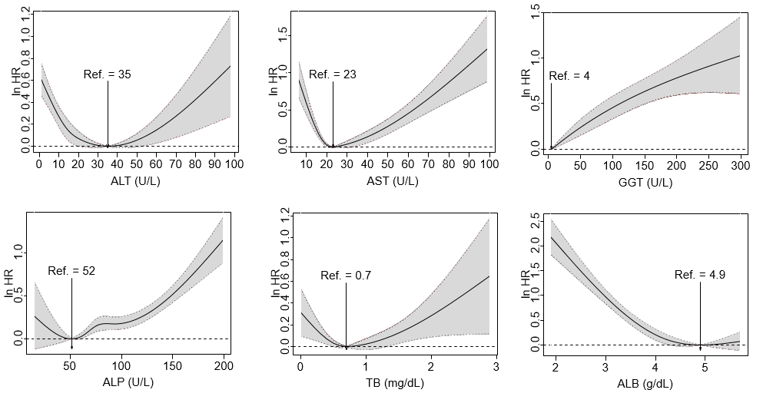

Figure S19. Result of the sixth sensitivity analysis: associations of serum level of liver function biomarker with all-cause mortality among participants whose serum level of biomarkers were within 1-99% quantile.
