Supplementary material
Approval of the Research Ethics Committee (REC) No. (397/2021), Faculty of Dentistry, Suez Canal University
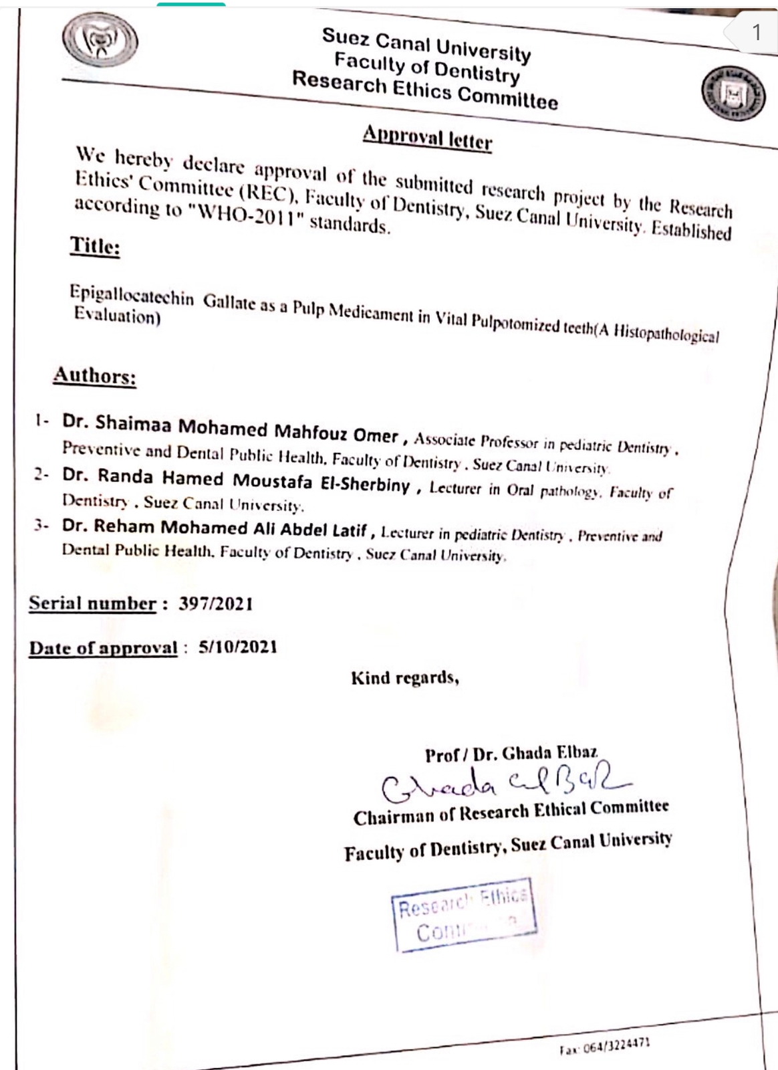

Statistical analysis results:
Comparison between different periods in Formocresol group:
Variables | Groups | Range |  | Mean | ±SD | Paired.  T-test | P. value
Variables | Groups | Min | Max
1.Inflammatory cell response | 4weeks | 2 | 3 | 2.83 | 0.41 | 6.71 | <0.001**
1.Inflammatory cell response | 9 weeks | 1 | 2 | 1.33 | 0.52 | 6.71 | <0.001**
2.Vasodilatation | 4weeks | 2 | 3 | 2.50 | 0.55 | 7.0 | <0.001**
2.Vasodilatation | 9 weeks | 1 | 2 | 1.33 | 0.52 | 7.0 | <0.001**
3.Pulp fibrosis | 4weeks | 1 | 3 | 2.0 | 0.63 | 5.00 | 0.004**
3.Pulp fibrosis | 9 weeks | 2 | 3 | 2.83 | 0.41 | 5.00 | 0.004**
4.Necrosis | 4weeks | 0 | 3 | 1.67 | 1.21 | 2.74 | 0.041**
4.Necrosis | 9 weeks | 2 | 3 | 2.67 | 0.52 | 2.74 | 0.041**
5.Odontoblastic layer | 4weeks | 0 | 1 | 0.67 | 0.52 | 1.0 | 0.363
5.Odontoblastic layer | 9 weeks | 0 | 1.0 | 0.83 | 0.41 | 1.0 | 0.363
Test used: Paired T-test
**: significant difference
SD: Standard Deviation

Comparison between Formocresol groups’ result at 4 and 9 weeks

Comparison between different periods in EGCG groups:
Variables | Groups | Range |  | Mean | ±SD | Paired.  T-test | P. value
Variables | Groups | Min | Max
1.Inflammatory cell response | 4weeks | 1 | 2 | 1.50 | 0.55 | 2.24 | 0.076^{ns}
1.Inflammatory cell response | 9 weeks | 1 | 1 | 1.00 | 0.00 | 2.24 | 0.076^{ns}
2.Vasodilatation | 4weeks | 1 | 2 | 1.33 | 0.52 | 1.46 | 0.203 ^{ns}
2.Vasodilatation | 9 weeks | 0 | 1 | 0.83 | 0.41 | 1.46 | 0.203 ^{ns}
3.Pulp fibrosis | 4weeks | 1 | 2 | 1.33 | 0.52 | 1.00 | 0.363 ^{ns}
3.Pulp fibrosis | 9 weeks | 1 | 2 | 1.17 | 0.41 | 1.00 | 0.363 ^{ns}
4.Necrosis | 4weeks | 0 | 1 | 0.17 | 0.41 | 1.00 | 1.00 ^{ns}
4.Necrosis | 9 weeks | 0 | 1 | 0.17 | 0.41 | 1.00 | 1.00 ^{ns}
5.Odontoblastic layer | 4weeks | 0 | 1 | 0.17 | 0.41 | 1.00 | 0.363 ^{ns}
5.Odontoblastic layer | 9 weeks | 0 | 0 | 0.0 | 0.0 | 1.00 | 0.363 ^{ns}
Test used: Paired T-test
^{ns}: non-significant
SD: Standard Deviation

Comparison between Epigallocatechin gallate (EGCG) groups’ result at 4 and 9 weeks.

Comparison between Formocresol (FC) and Epigallocatechin gallate (EGCG) groups at 4 weeks:
variables | Groups | Range |  | Mean | ±SD | Indep.  T-test | P. value
variables | Groups | Min | Max
1.Inflammatory cell response | FC | 2 | 3 | 2.83 | 0.41 | 4.78 | <0.001**
1.Inflammatory cell response | EGCG | 1 | 2 | 1.50 | 0.55 | 4.78 | <0.001**
2.Vasodilatation | FC | 2 | 3 | 2.50 | 0.55 | 3.79 | <0.001**
2.Vasodilatation | EGCG | 1 | 2 | 1.33 | 0.52 | 3.79 | <0.001**
3.Pulp fibrosis | FC | 1 | 3 | 2.0 | 0.63 | 2.00 | 0.073
3.Pulp fibrosis | EGCG | 1 | 2 | 1.33 | 0.52 | 2.00 | 0.073
4.Necrosis | FC | 0 | 3 | 1.67 | 1.21 | 2.87 | 0.017**
4.Necrosis | EGCG | 0 | 1 | 0.17 | 0.41 | 2.87 | 0.017**
5.Odontoblastic layer | FC | 0 | 1 | 0.67 | 0.52 | 1.86 | 0.092
5.Odontoblastic layer | EGCG | 0 | 1 | 0.17 | 0.41 | 1.86 | 0.092
Test used: independent T-test
**: significant difference
SD: Standard Deviation

Formocresol (FC), Epigallocatechin gallate (EGCG)
Comparison between Formocresol and Epigallocatechin gallate groups’ result at 4 weeks.

Comparison between Formocresol (FC) and Epigallocatechin gallate (EGCG) groups at 9 weeks:
Variables | Groups | Range |  | Mean | ±SD | Indep.  T-test | P. value
Variables | Groups | Min | Max
1.Inflammatory cell response | FC | 1 | 2 | 1.33 | 0.52 | 1.58 | 0.145
1.Inflammatory cell response | EGCG | 1 | 1 | 1.0 | 0.0 | 1.58 | 0.145
2.Vasodilatation | FC | 1 | 2 | 1.33 | 0.52 | 1.86 | 0.092
2.Vasodilatation | EGCG | 0 | 1 | 0.83 | 0.41 | 1.86 | 0.092
3.Pulp fibrosis | FC | 2 | 3 | 2.83 | 0.41 | 7.07 | <0.001**
3.Pulp fibrosis | EGCG | 1 | 2 | 1.17 | 0.41 | 7.07 | <0.001**
4.Necrosis | FC | 2 | 3 | 2.67 | 0.52 | 9.30 | <0.001**
4.Necrosis | EGCG | 0 | 1 | 0.17 | 0.41 | 9.30 | <0.001**
5.Odontoblastic layer | FC | 0 | 1 | 0.83 | 0.41 | 5.00 | <0.001**
5.Odontoblastic layer | EGCG | 0 | 0 | 0 | 0 | 5.00 | <0.001**
Test used: independent T-test
**: significant difference
SD: Standard Deviation

Comparison between Formocresol and Epigallocatechin gallate groups’ result at 9 weeks.

Quantitative analysis of degree of Fibrosis “Area percentage” by using Masson Trichrome stain:
Groups | 4 Weeks |  | 9 Weeks |  | Paired T-test | P value
Groups | Mean | SD | Mean | SD | Paired T-test | P value
EGCG | 2.767 | 0.639 | 3.360 | 0.221 | 1.347 | 0.236
FC | 30.952 | 1.588 | 68.207 | 0.588 | 32.52 | <0.001**
Indep. T test | 40.31 |  | 103.22
P value | <0.001** |  | <0.001**
**; means significant difference at P<0.05
SD: Standard Deviation, FC: Formocresol, EGCG: Epigallocatechin gallate

