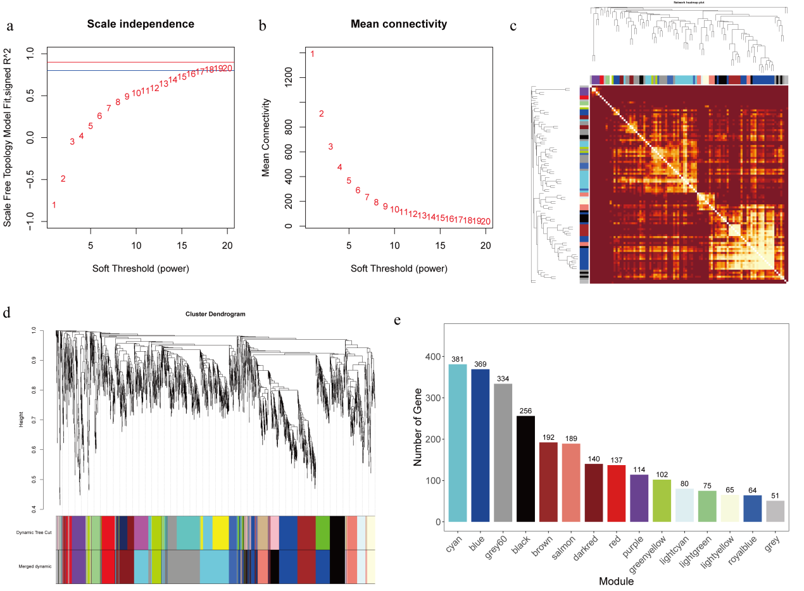

Fig.S1. Determination of soft thresholdβ and the number of differentially expressed genes (DEGs) for each module. a: The ordinate represents the index of scale free network model. The red line represents that R² is equal to 0.9. The blue line represents that R² is equal to 0.8. b: The ordinate represents the average link degree of each's oft threshold. The abscissa represents the soft thresholdβ. c. Module gene correlation analysis. Each row and column represents a gene, and the darker the color of each dot (white, yellow, red) represents the stronger the connectivity between the two genes corresponding to the row and column, that is, the stronger the Pearson correlation (Student's t test). d. Cluster dendrogram and gene modules after WGCNA analysis. Different colors represent different modules. e. Histogram of gene number of each module. The abscissa represents each module and the ordinate represents the number of genes.

Table S1. Summary of RNA-seq data for each sample.
Sample | Clean reads | Clean bases | GC content(%) | Q30(%)
4C-1  4C-2  4C-3  8C-1  8C-2  8C-3  4S-1  4S-2  4S-3  8S-1  8S-2  8S-3 | 48864640  52930496  43798104  53149976  46716486  46821928  47914230  41159720  46623136  48224972  44192820  49588996 | 7302935308  7902801056  6541085834  7937966826  6981044564  6992288683  7160991120  6137278361  6959197821  7207399485  6603142118  7405835663 | 52.00  52.08  52.32  51.71  51.86  51.85  52.17  52.15  52.79  52.23  52.46  52.55 | 92.70  92.69  93.03  92.95  93.49  93.22  93.23  93.22  93.54  92.96  93.03  93.09
(4C: tetraploid under the control condition; 8C: octoploid under the control condition; 4S: tetraploid under salt stress; 8S: octoploid under salt stress. -1, -2, and -3 represent three replicate individuals.)

Table S2 Sequence comparison results between the sample RNA-seq data and the switchgrass reference genome.
Sample | Mapped Reads | Uniquely  Mapped Reads | Multiple  Mapped Reads
4C-1  4C-2  4C-3  8C-1  8C-2  8C-3  4S-1  4S-2  4S-3  8S-1  8S-2  8S-3 | 92.16%  91.09%  92.42%  92.40%  93.06%  93.17%  92.86%  93.20%  92.76%  93.26%  92.83%  92.55% | 88.38%  87.23%  88.71%  88.55%  89.16%  89.32%  89.07%  89.46%  89.11%  89.52%  89.18%  88.85% | 3.79%  3.86%  3.71%  3.84%  3.90%  3.85%  3.79%  3.75%  3.65%  3.74%  3.64%  3.70%
(4C: tetraploid under the control condition; 8C: octoploid under the control condition; 4S: tetraploid under salt stress; 8S: octoploid under salt stress. -1, -2, and -3 represent three replicate individuals.)

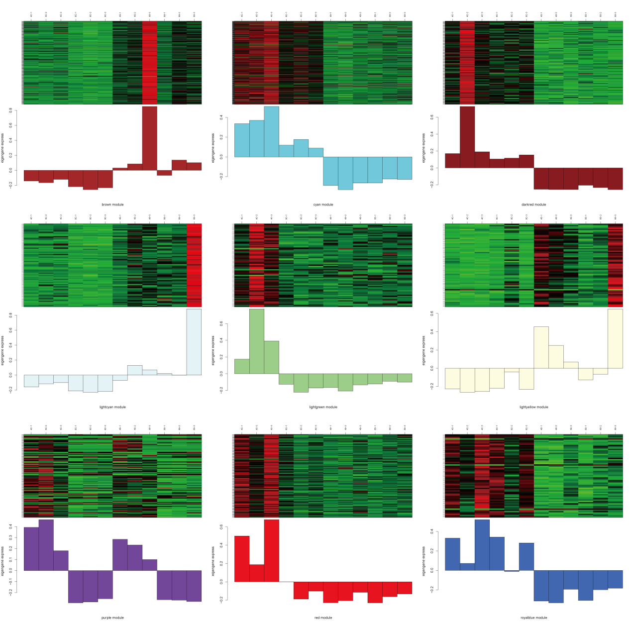
Fig.S2. Heatmaps of gene expression patterns of each module. The upper part of the figure is aheat map of gene expression in different samples: red indicates up-regulation; green indicates down-regulation; the lower part of the figure is the eigengene value of the gene in different samples. The x-axis represents samples (4C, 4S，8C and 8S) and y-axis represents the eigengene value of the gene in different samples.

