Extended Figures

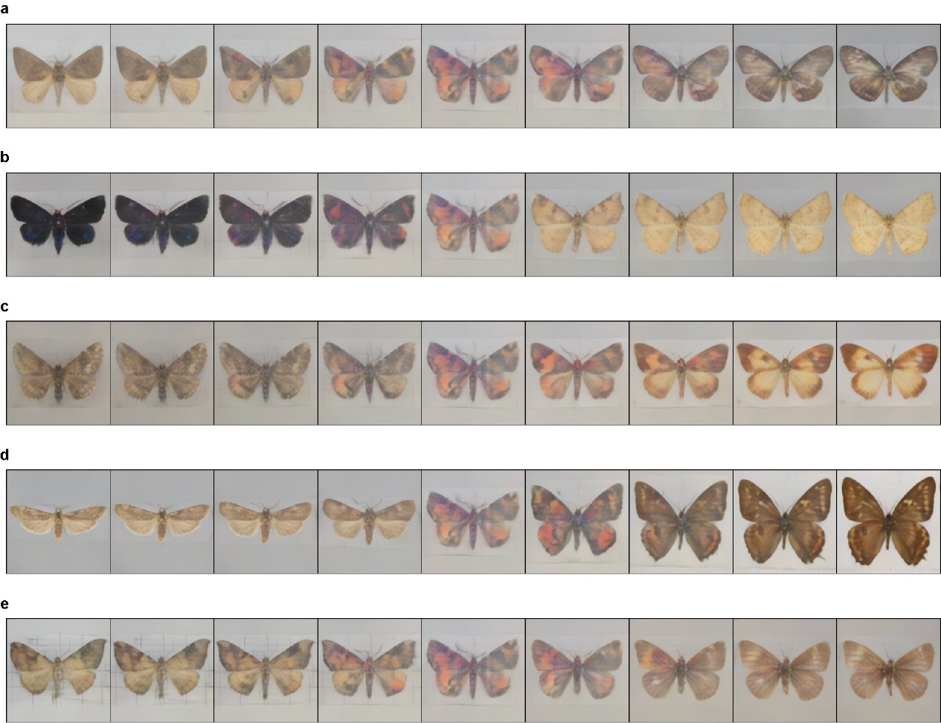

Extended Fig. 1. Visualization examples generated with extracted features by our trained decoder. These are five visualization examples from all extracted 512 features. The image at the middle of each row represents a mean form of Lepidoptera (all feature values are set to zero). The images from the middle to the left are generated with fixed-step values from 0 to the minimum of a single feature dimension of interest (the non-negative feature id of a: 543, b: 550, c:582, d: 619, e: 620), and the images from the middle to the right area generated with values from 0 to the maximum (the non-negative feature id of a: 31, b: 38, c: 70, d: 107, e: 108).
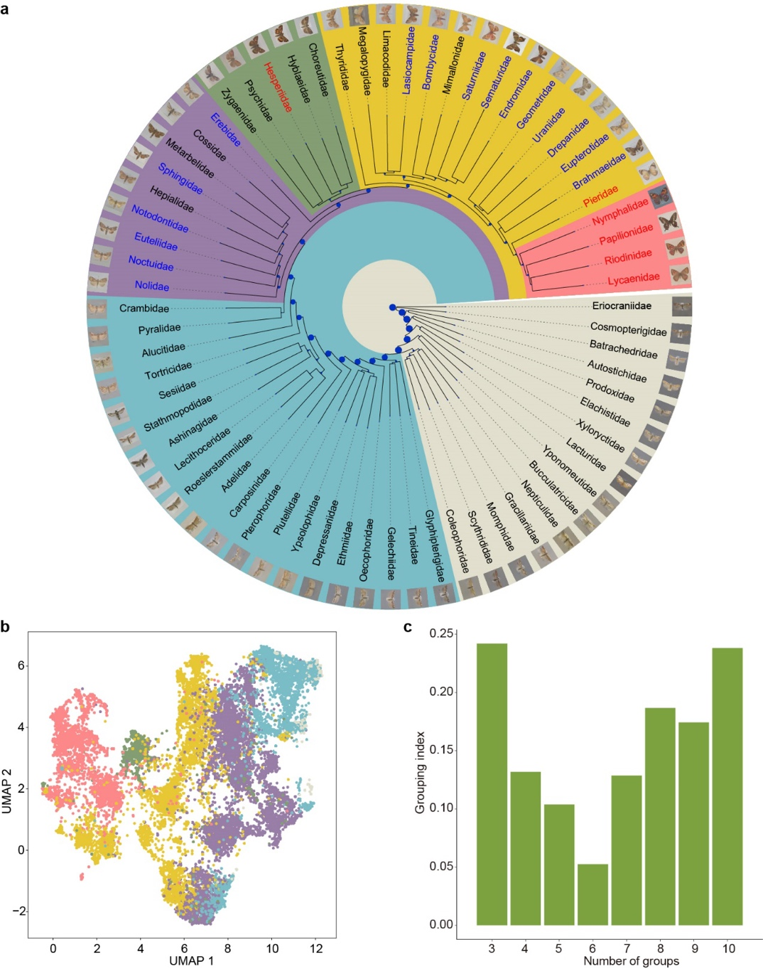

Extended Fig. 2. The morphological dendrogram, morphogroup distributions in the morphospace, and the grouping performance according to the number of groups. a, A dendrogram rooted at Eriocraniidae presented with the neighbor-joining method. Specimen images on the tips represent typical forms generated from each family's mean key features. Family names in blue and red denote macro-moths and butterflies, respectively, and different background colors represent different morphogroups. b, The distributions of the six morphogroups are visualized in different colors (coinciding with the colors in Figure 1c) on a UMAP scatter plot. c, The grouping index, calculated with varying numbers of morphogroups, indicates better performance with lower values.
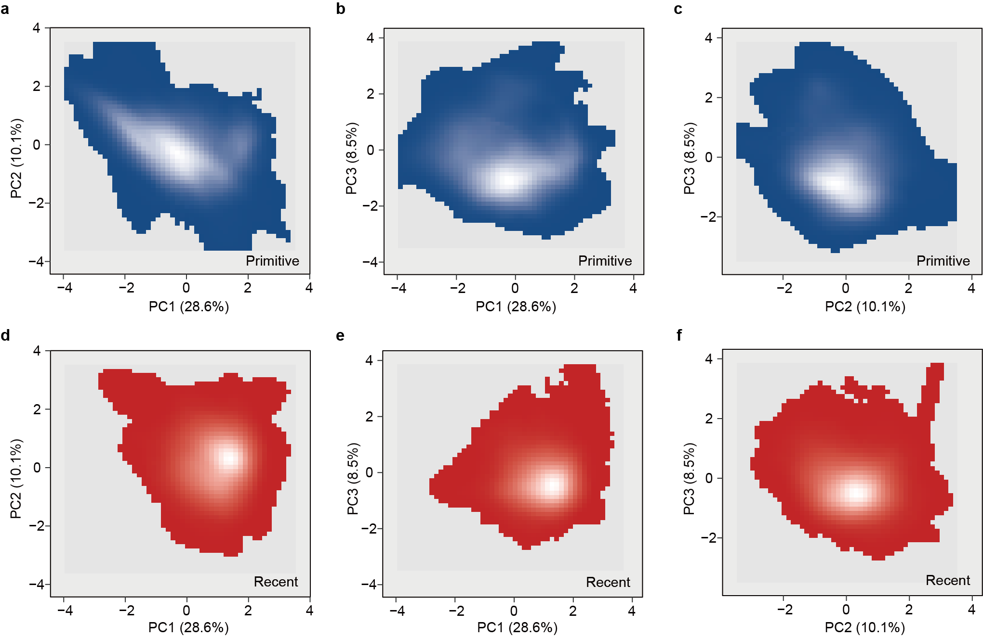
Extended Fig. 3. The trait probability densities (TPD) of assemblages of Lepidoptera families on the principle component (PC) axes. a- c, The blue grids represent the TPD of the families belonging to the primitive morphogroups. d-f, The red grids represent the families belonging to the recent morphogroups. The lighter hues indicate higher relative probability densities, and the recent morphogroups exhibit higher trait redundancy (55.2% compared to 30.0% in the primitive morphogroups), resulting in a higher degree of morphological similarity.
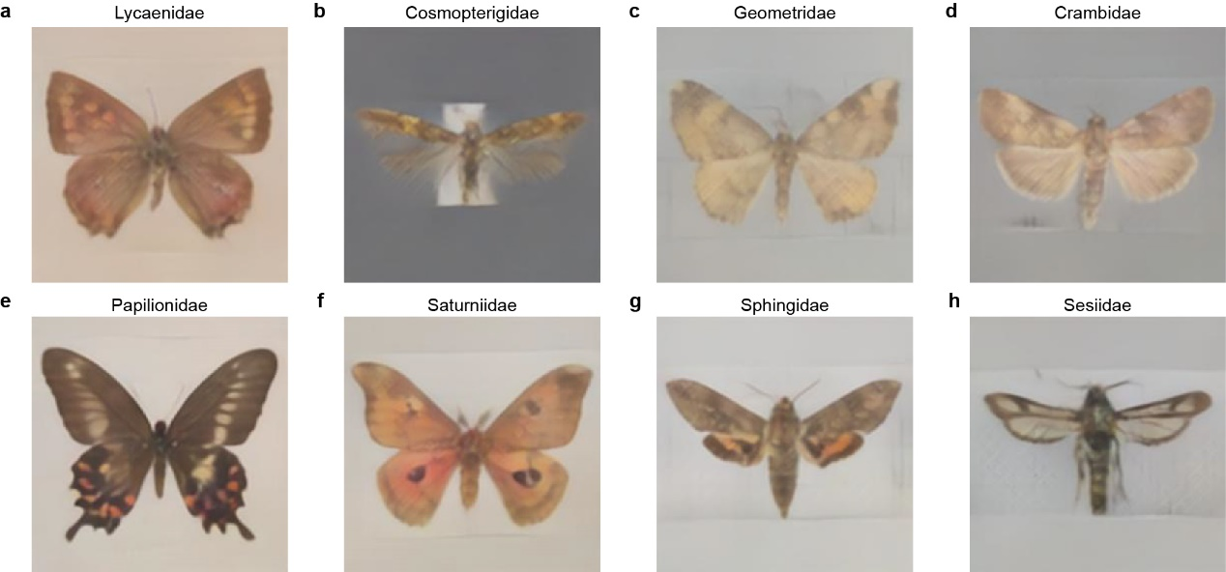

Extended Fig. 4. Generated typical forms of Lepidopteran families with higher number of species sampled. a, The family with the minimum aspect ratio (AR); b, The family with the maximum AR; c, The family with the minimum second moment of area (2nd MoA); d, The family with the maximum 2nd MoA. Additionally, e, f, g, h, show typical forms arbitrarily selected for their unique wing shapes or color patterns of four families.
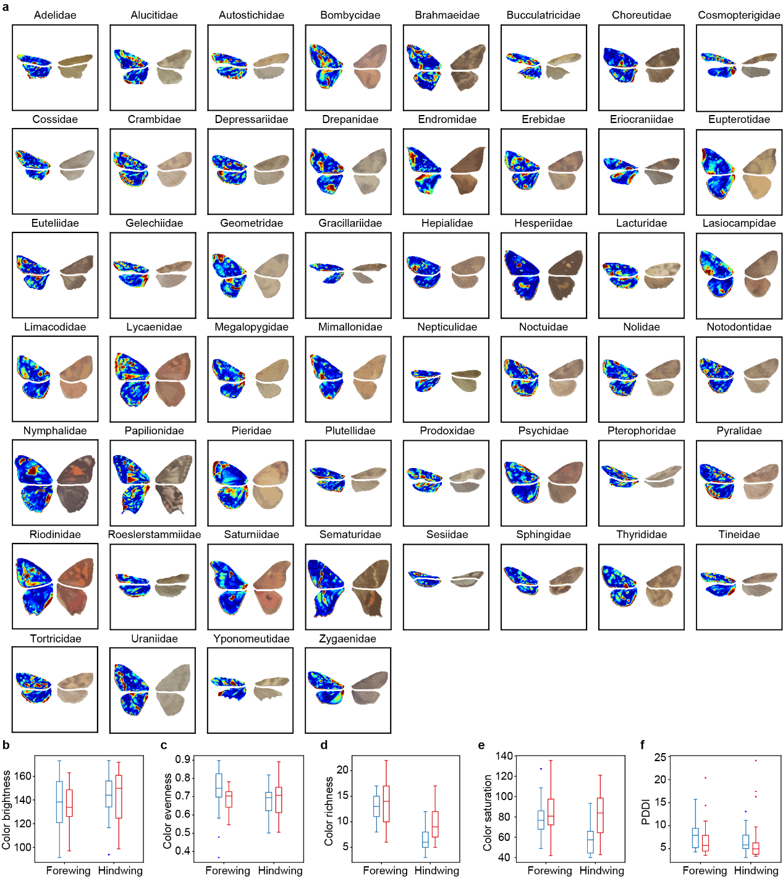

Extended Fig. 5. The color patterning of Lepidoptera fore- and hindwings. a, The color patterning of each family of Lepidoptera with phylogeny information. The typical form of a family generated with the mean morpho features is depicted on the right, and the relative distinctiveness of wings is on the left. The distinctiveness of each wing is calculated independently. b-f, The comparison of color patterning between the primitive morphogroups (blue) and the recently evolved (red) groups. Statistical details are presented in Extended Table 4.
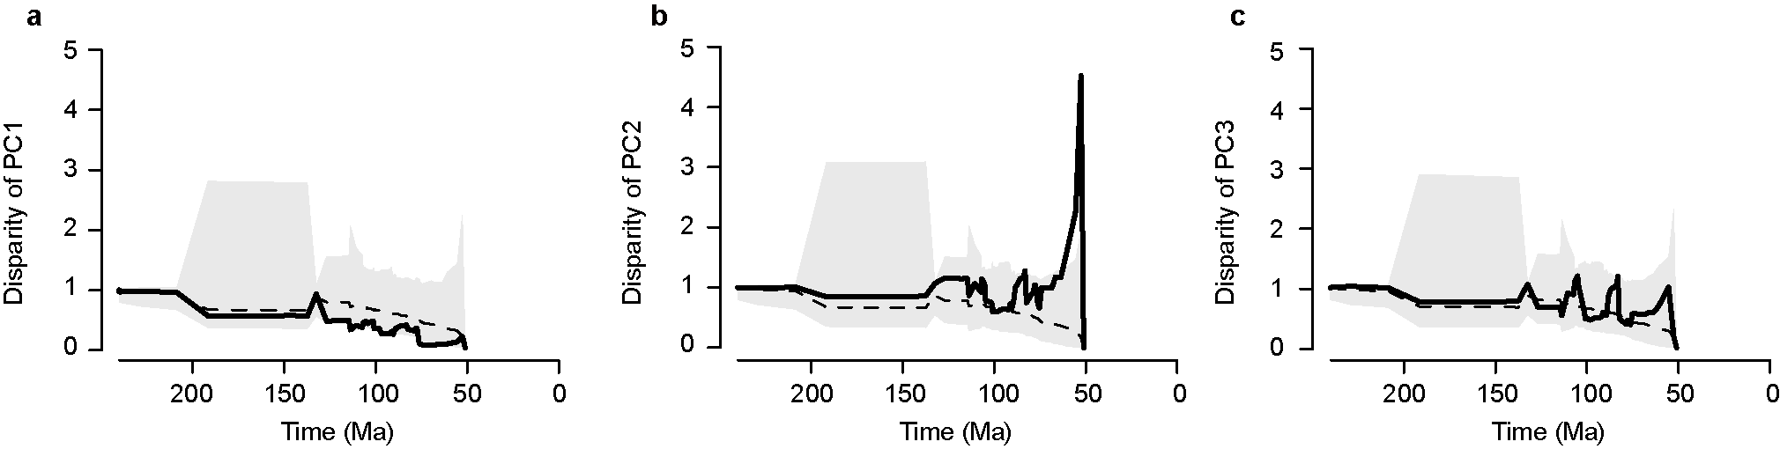
Extended Fig. 6. Evolutionary dynamics of lineage diversification and morphological evolution in Lepidopterans. The morphological disparity through time based on a, PC1, b, PC2, and c, PC3 of the mean key features of families. The expected morphological disparity, estimated using a Brownian motion model, is shown by the shaded areas, while the empirical estimates of disparity through time are indicated by the solid lines.
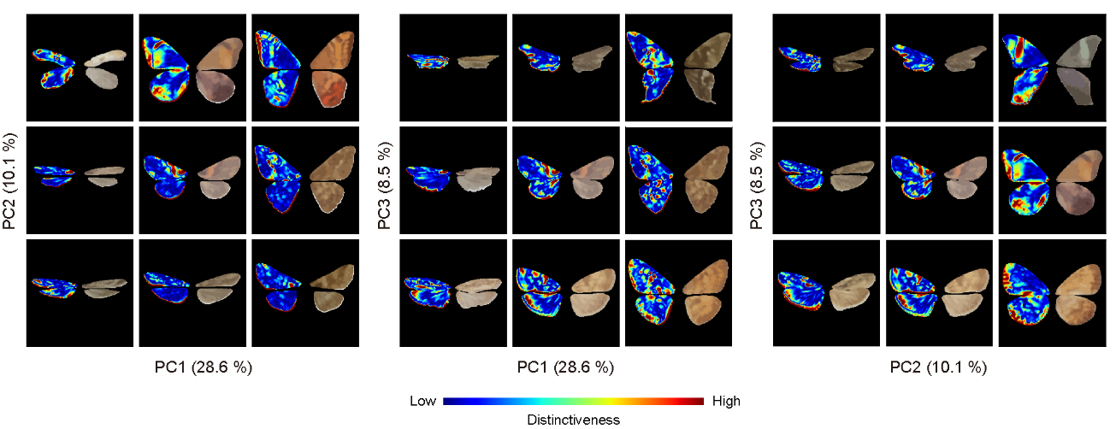

Extended Fig. 7. Distinctive color patches and their locations in Lepidopterans. The right wings represent the clustered color patches, whereas the left wings represent the distinctiveness of the patches. The images were generated with equidistantly sampled points from the principal component (PC) planes, with each panel showing the effects of different PC axis combinations.
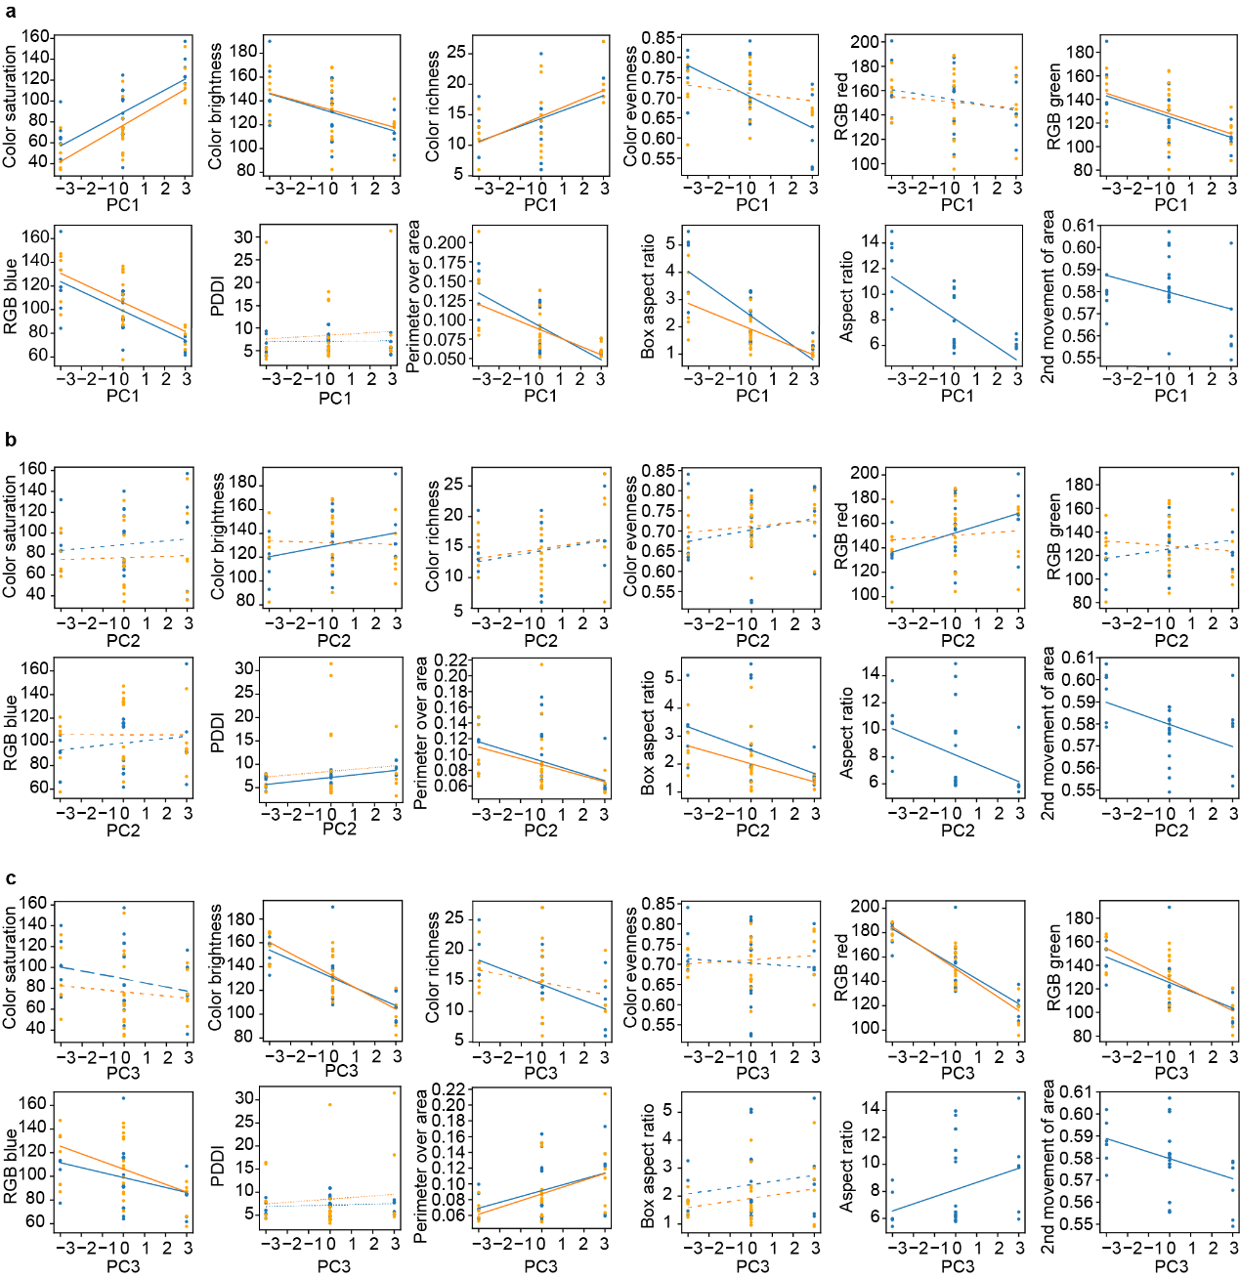

Extended Fig. 8. Relationships between wing characters and principle component (PC) axes of the morphospace (see Fig. 3). a, PC1. b, PC2. c, PC3. The blue circles represent the forewings (N=18), and the yellow circles represent the hindwings (N=18). The significance of the correlations is indicated by the lines: solid lines indicate significant correlations (p < 0.05), dashed lines indicate correlations that are marginally significant (p < 0.1), and dotted lines indicate non-significant correlations (p ≥ 0.1).
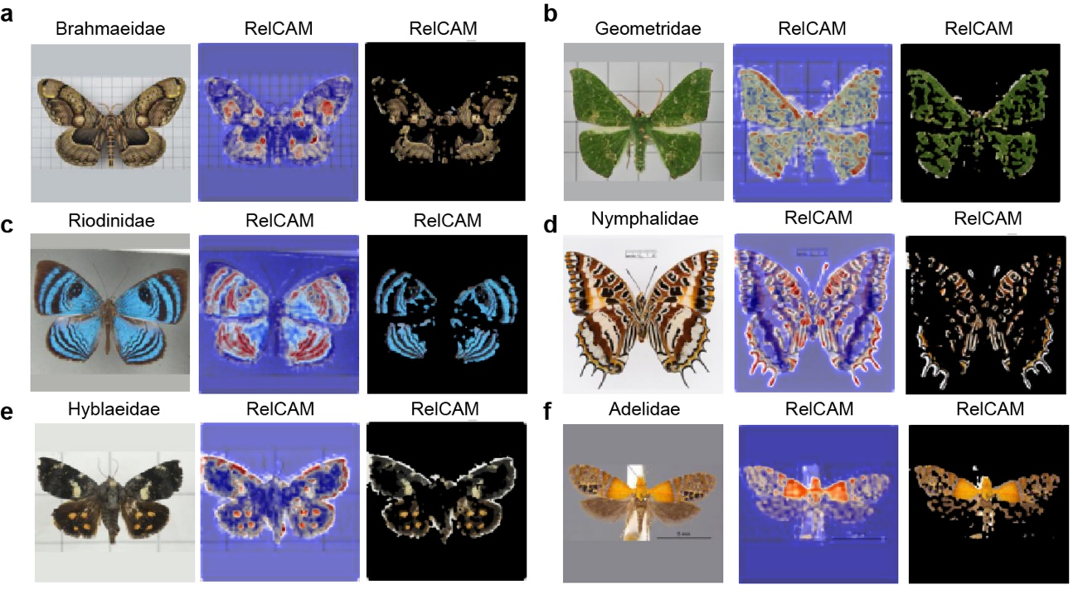

Extended Fig. 9. The Relevance-CAM results of our pre-trained DFC module. The saliency maps produced by Relevance-CAM and images masked with relevance, highlight the regions of the images that the DFC module focuses on most. a-f, Results sampled from a variety of families and backgrounds (a with small grid, b slightly shaded, with large grid, c shaded and tilt with apparent background boundary, d with a specimen label between forewings, e off center with large grids, f with a scale bar and an overlaid specimen label), revealing that the DFC module primarily focuses on the foreground specimen regardless of the background. Labels above the first image of each panel indicate the family name of the specimen image, and “RelCAM” labels on the second and third images indicate those masked by Relevance-CAM.
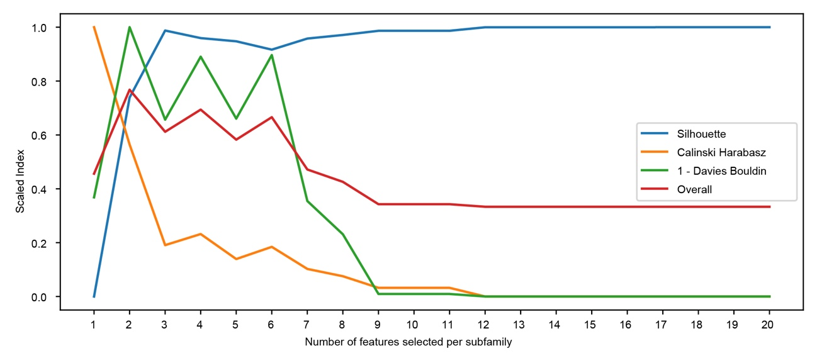

Extended Fig. 10. Evaluation of clustering performance based on selected key features. We evaluated the clustering performance targeting subfamilies on the feature spaces constructed with the combination of the selected key features of each subfamily. The x-axis represents the number of selected key features (N = 1 to 20), while the y-axis represents the clustering indices: Silhouette (blue line), Calinski Harabasz (orange line), and 1 - Davies Bouldin (green line). The sum of these indices represents the overall performance (red line).
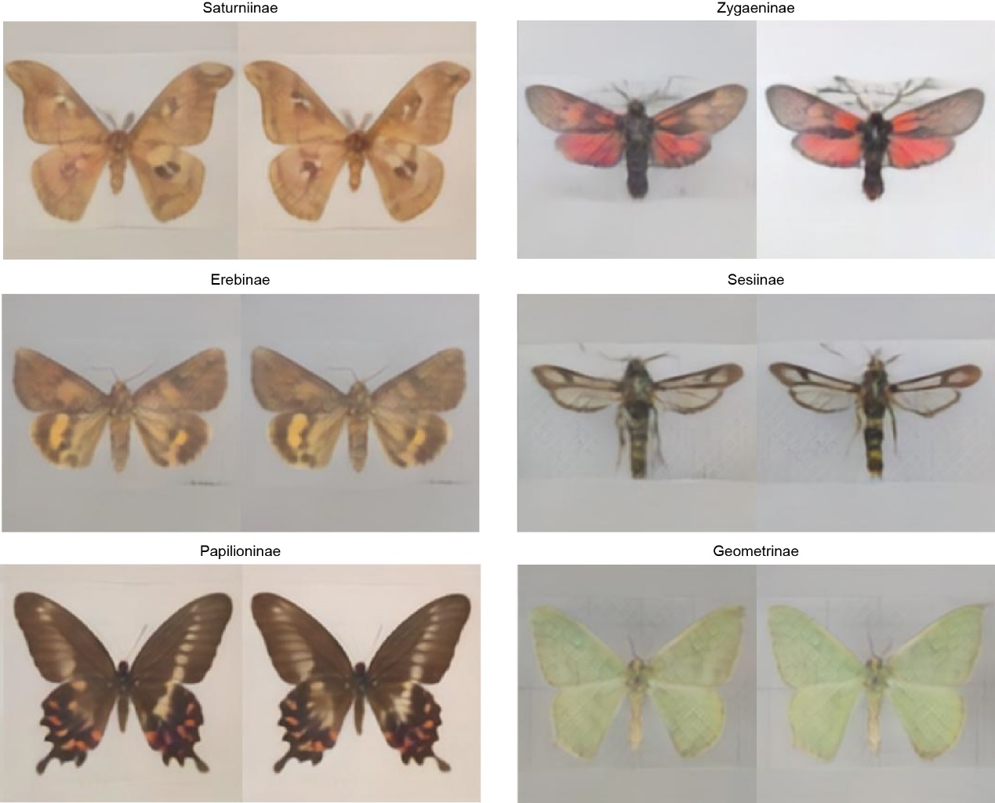

Extended Fig. 11. Typical forms generated with selected key features or all features in six subfamilies of Lepidopterans. The Figure presents images of six subfamilies arbitrarily selected for their distinctive shapes, colors, spots, or stripes. For each subfamily, the image on the left was generated using 40 key features, and the image of on the right was generated using all 512 features.
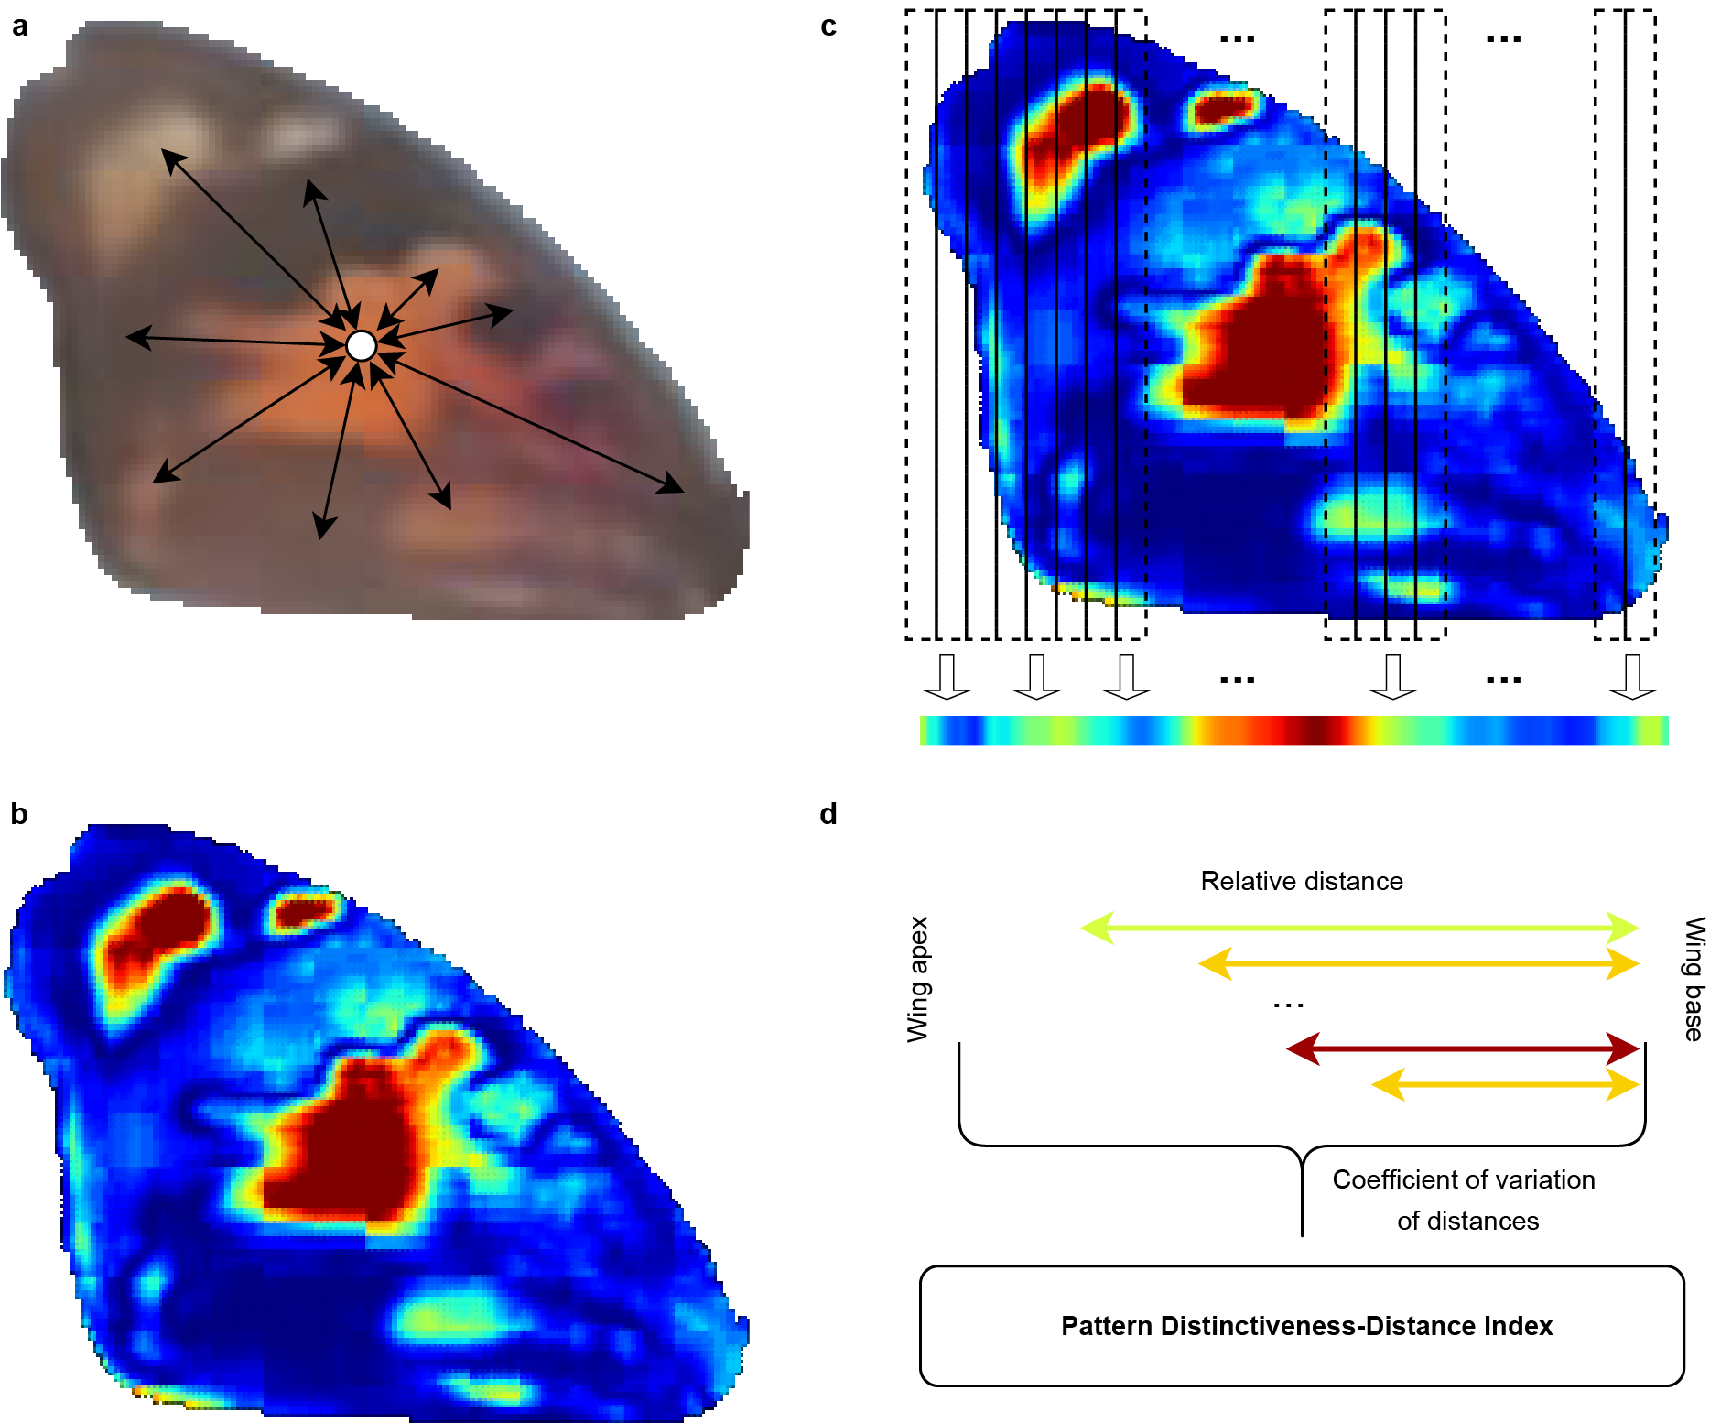

Extended Fig. 12. The Pattern Distinctiveness-Distance Index (PDDI) calculation process. a, For each pixel of a wing, we calculated the mean pairwise pixel RGB distance as the relative color distinctiveness. b, The heatmap of the color distinctiveness. The warmer color indicates higher distinctiveness. c, We then aggregated the pixel columns by taking their mean of the highest 50% distinctiveness to reduce the 2-dimensional distinctiveness map into the 1-dimensional horizontal axis. d, Finally, we took the relative horizontal distance from the wing base with the highest 50% aggregated distinctiveness and calculated the mean distance normalized by the variance as the PDDI. A greater value signifies that more distinctive color patterns occur at a greater distance from the wing base on the horizontal direction.
Extended Tables

Extended Table 1 | The principle component (PC) loadings for the principle component analysis (PCA). Each of the first five PCs explained more than 5% of the variance. Their loadings of the most contributing non-negative features (see Methods). Note that a negative loading in PCA means that the feature is negatively correlated with the principal component. Thus, even if all the features have non-negative values, we could still have negative loadings in our PCA result.

Non-negative Feature ID | PC1  (28.6%) | PC2  (10.1%) | PC3  (8.5%) | PC4  (6.3%) | PC5  (5.3%)
31 | -0.01 | 0.01 | -0.08 | 0.01 | 0.01
38 | 0.06 | 0.04 | -0.05 | 0.02 | -0.01
70 | -0.03 | 0.02 | -0.02 | 0.01 | 0.00
107 | 0.09 | 0.08 | 0.03 | -0.01 | -0.03
108 | -0.07 | 0.04 | 0.03 | -0.04 | -0.03
129 | 0.01 | 0.04 | 0.07 | 0.02 | 0.00
138 | -0.04 | 0.02 | -0.02 | 0.01 | -0.03
143 | 0.05 | -0.03 | -0.04 | -0.03 | -0.01
151 | -0.04 | 0.02 | -0.07 | -0.03 | 0.03
200 | 0.07 | 0.04 | 0.02 | -0.01 | 0.01
204 | -0.18 | -0.02 | 0.03 | 0.11 | 0.02
230 | 0.04 | 0.04 | 0.01 | 0.05 | 0.01
234 | 0.05 | -0.02 | -0.07 | 0.02 | 0.04
257 | 0.01 | -0.08 | -0.01 | -0.01 | -0.02
346 | 0.04 | 0.01 | -0.01 | -0.01 | 0.03
347 | 0.03 | 0.01 | -0.02 | 0.00 | 0.02
348 | -0.17 | 0.02 | -0.04 | -0.04 | 0.05
380 | -0.02 | -0.01 | 0.00 | -0.05 | 0.00
383 | -0.08 | 0.03 | -0.02 | 0.00 | 0.00
392 | -0.02 | -0.03 | 0.01 | -0.07 | 0.05
400 | -0.13 | 0.09 | -0.04 | 0.00 | -0.04
451 | -0.02 | -0.04 | -0.01 | 0.01 | -0.06
454 | 0.02 | 0.01 | 0.01 | 0.00 | 0.02
480 | 0.04 | 0.02 | -0.03 | 0.01 | 0.05
504 | -0.10 | 0.09 | 0.06 | -0.01 | 0.08
506 | -0.05 | -0.02 | 0.02 | -0.01 | 0.01
543 | 0.02 | 0.02 | 0.10 | -0.04 | -0.02
550 | -0.06 | -0.09 | 0.09 | -0.08 | 0.02
582 | 0.06 | -0.02 | -0.01 | -0.03 | 0.02
619 | -0.29 | -0.05 | 0.02 | -0.02 | -0.01
620 | 0.06 | -0.04 | -0.01 | 0.04 | 0.01
633 | -0.02 | 0.02 | 0.02 | 0.05 | 0.01
650 | 0.01 | -0.03 | 0.00 | -0.02 | 0.03
655 | -0.11 | 0.06 | 0.02 | 0.07 | -0.01
663 | 0.05 | -0.01 | 0.03 | 0.02 | -0.01
712 | -0.07 | -0.04 | -0.02 | 0.01 | -0.03
716 | 0.10 | 0.05 | -0.01 | -0.05 | 0.00
743 | -0.02 | -0.01 | 0.02 | 0.02 | 0.00
746 | -0.01 | 0.01 | 0.06 | -0.02 | -0.02
763 | 0.04 | 0.06 | 0.06 | 0.00 | 0.06
769 | 0.03 | 0.05 | 0.00 | -0.01 | 0.01
892 | 0.04 | 0.00 | 0.03 | 0.05 | -0.01
899 | 0.01 | -0.01 | -0.04 | -0.02 | 0.00
912 | 0.10 | -0.13 | 0.08 | 0.08 | 0.05
963 | 0.01 | 0.03 | 0.03 | -0.03 | 0.07
966 | -0.01 | -0.01 | -0.01 | 0.00 | -0.02
992 | 0.01 | 0.04 | 0.08 | -0.03 | -0.09
1016 | 0.04 | -0.05 | -0.04 | 0.00 | -0.03
1018 | 0.08 | 0.05 | 0.03 | 0.01 | -0.01

Extended Table 2 | The trait probability density (TPD) results. The richness, evenness, and divergence indices, as well as the number of families, redundancies, and relative redundancies of the primitive and recent morphogroups. To calculate these indices with the TPD package in R, families with less than required number of species (four) were either removed (values inside the parentheses) or filled with dummy species to bring the number of species to four (values outside the parentheses). The traits of the dummy species were imputed with the median traits of the real species in the corresponding families.

Trait probability density | Assemblage
 | Primitive | Recent
Richness | 95.53 (93.63) | 71.50 (70.52)
Evenness | 0.449 (0.454) | 0.368 (0.371)
Divergence | 0.540 (0.544) | 0.434 (0.439)
Number of families | 25 (21) | 27 (26)
Redundancy | 7.21 (7.03) | 14.35 (14.36)
Relative redundancy | 0.300 (0.352) | 0.552 (0.574)

Extended Table 3 | Model selection for evolutionary models of PC1, PC2 and PC3 evolution in Lepidoptera. The models included were Brownian Motion (BM), rate trend (trend), early burst (EB), diversity dependent (DD), single regime OU (OU), and multi-regime OU (OUM and OU2). Note that in the OU model tests (OU and OUM), we used the discrete trait state (0~5 = 6 states) determined by artificial elligence to test for different regimes for the OUM model but with two morphogroups assignment (primitive morphogroup 0 = morphogroups 0, 1, 3; recent morphogroup 1 = morphogroups 2, 4, 5). AICc: Akaike information criterion c.

Trait | Model | lnL | AIC | AICc | Sigma sq | Parameter estimates | AIC weight
PC1 | BM | -69.95 | 145.89 | 146.39 | 0.73 |  | 0.00
 | trend | -66.21 | 138.42 | 138.92 | 4.29 | slope = -0.45 | 0.00
 | EB | -68.24 | 142.48 | 142.98 | 7.38 | a = -1.35 | 0.00
 | DD | -69.27 | 142.54 | 142.99 | 1.35 | psi = -0.02 | 0.00
 | OU | -69.95 | 145.89 | 146.39 | 0.73 | alpha = 0.00 | 0.00
 | OUM | -30.15 | 76.31 | 79.66 | 8.19 | alpha = 21.95 | 1.00
 | OU2 | -60.77 | 129.55 | 130.40 | 0.51 | alpha = 0.00 | 0.00
PC2 | BM | -54.76 | 115.51 | 116.01 | 0.00 |  | 0.00
 | trend | -56.55 | 119.09 | 119.59 | 0.00 | slope = 100.00 | 0.00
 | EB | -58.12 | 122.24 | 122.74 | 0.46 | a = -0.00 | 0.00
 | DD | -56.62 | 117.24 | 117.84 | 0.29 | psi = 0.01 | 0.00
 | OU | -54.75 | 115.50 | 116.00 | 2.83 | alpha = 2.94 | 0.00
 | OUM | -36.49 | 88.99 | 92.34 | 4.20 | alpha = 8.81 | 1.00
 | OU2 | -53.54 | 115.08 | 115.93 | 91.50 | alpha = 99.49 | 0.00
PC3 | BM | -53.17 | 112.34 | 112.84 | 0.00 |  | 0.35
 | trend | -54.73 | 115.46 | 115.96 | 0.00 | slope = 100.00 | 0.07
 | EB | -56.08 | 118.16 | 118.66 | 0.43 | a = -0.00 | 0.02
 | DD | -55.90 | 115.80 | 116.10 | 0.28 | psi = 0.01 | 0.06
 | OU | -53.16 | 112.32 | 112.82 | 3.24 | alpha = 3.58 | 0.35
 | OUM | -51.74 | 119.48 | 122.82 | 1.96 | alpha = 2.28 | 0.01
 | OU2 | -53.13 | 114.25 | 115.10 | 90.34 | alpha = 100.00 | 0.13

Extended Table 4 | Comparisons of wing coloration between the primitive and recent morphogroup. The means and the variances were estimated using bootstrapping (R=10000, sampling with replacement). The null hypothesis is that the primitive morphogroup has a greater mean and variance than the recent morphogroup. The symbols indicating statistical significance are interpreted as follows: ***: p < 0.001, *: p < 0.05.

Part | Character | Estimate | Bootstrap p
Fore wing | Brightness | Mean | 0.67
 |  | Variance | 0.88
 | Evenness | Mean | 0.94
 |  | Variance | 0.99
 | Richness | Mean | 0.20
 |  | Variance | 0.00***
 | Saturation | Mean | 0.10
 |  | Variance | 0.11
 | PDDI | Mean | 0.82
 |  | Variance | 0.21
Hind wing | Brightness | Mean | 0.58
 |  | Variance | 0.09
 | Evenness | Mean | 0.30
 |  | Variance | 0.25
 | Richness | Mean | 0.00***
 |  | Variance | 0.01*
 | Saturation | Mean | 0.00***
 |  | Variance | 0.04*
 | PDDI | Mean | 0.52
 |  | Variance | 0.07

