Supplementary Information
Observation of Non-Hermitian Skin Effect in Thermal Diffusion
Yun-Kai Liu ^{1,*}, Pei-Chao Cao ^{2,3,4,5,*}, Minghong Qi^{2,3,4,5}, Qiang-Kai-Lai Huang^{2,3,4,5}, Yu-Gui Peng^{1,†}, Ying Li^{2,3,4,5,†}, Xue-Feng Zhu^{1,†}
¹School of Physics and Innovation Institute, Huazhong University of Science and Technology, Wuhan 430074, China
²Interdisciplinary Center for Quantum Information, State Key Laboratory of Extreme Photonics and Instrumentation, ZJU-Hangzhou Global Scientific and Technological Innovation Center, Zhejiang University, Hangzhou 310027, China.
³International Joint Innovation Center, The Electromagnetics Academy at Zhejiang University, Zhejiang University, Haining 314400, China
⁴Key Lab. of Advanced Micro/Nano Electronic Devices & Smart Systems of Zhejiang, Jinhua Institute of Zhejiang University, Zhejiang University, Jinhua 321099, China
⁵Shaoxing Institute of Zhejiang University, Zhejiang University, Shaoxing 312000, China
* These authors contributed equally to this work.
†Corresponding authors: ygpeng@hust.edu.cn (Y.-G. P.); eleying@zju.edu.cn (Y. L.); xfzhu@hust.edu.cn (X.-F. Z.)

Supplementary Note 1. Generalized Brillouin zone
The eigenvalues of the anti-Hermitian SSH model with OBC are purely imaginary, for which the modal profiles of bulk states exhibit extended field distributions, as shown in Supplementary Fig. 1a. These characteristics are consistent in the anti-Hermitian SSH models with PBC and OBC. However, for the non-Hermitian SSH models, the eigenspectra and eigenmodes under OBC are very different from the ones under PBC (see Supplementary Figs. 1b and 1c), where the conventional bulk-boundary correspondence based on the Bloch Hamiltonian will fail. Therefore, it is necessary to introduce a new concept of generalized Brillouin zone (GBZ) to characterize the differences between the non-Hermitian systems of PBC and OBC.
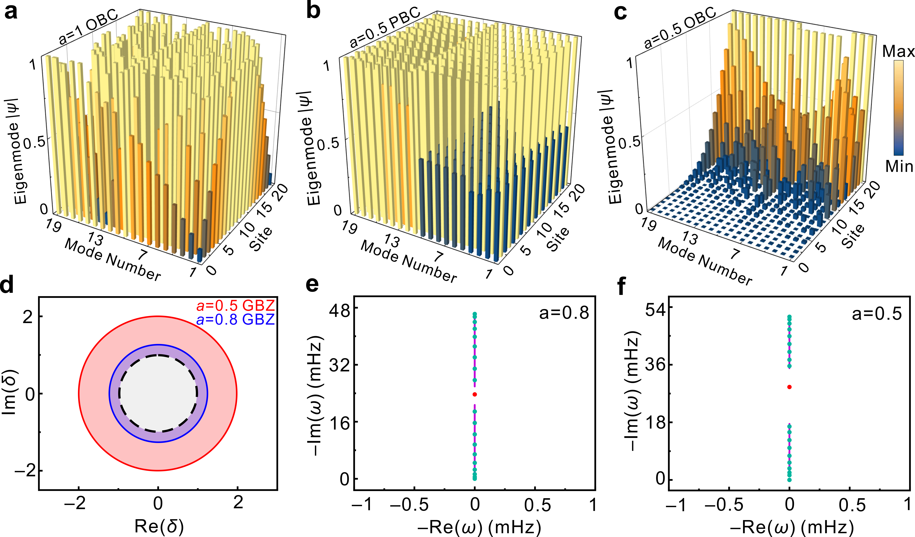
Supplementary Fig. 1 | Eigenfield and eigenspectra. a The calculated eigenfield distributions of the eigenstates at $a=1$. b, c, The eigenfield distributions of the eigenstates at $a=0.5$ under the PBC and OBC, respectively. d The calculated GBZ with the asymmetry factor $a$ being 0.8 and 0.5. The dashed circle here indicates the conventional Brillouin zone. e, f, The complex plane energy spectra calculated by the GBZ at $a=0.8$ and $a=0.5$, which agree well with the spectra calculated by the real-space Hamiltonian. The isolated eigenvalue denotes the edge state of the system, as shown by the red dot.
Under OBC, the eigenmodes of the non-Hermitian SSH model are localized on the right boundary and decay exponentially to the left boundary, as shown in Fig. 2e of the main text or Supplementary Fig. 1c. We assume that the eigenfunctions of Hamiltonian can be expressed as $ψ={(T_{A_{1}}, T_{B_{1}}, T_{A_{2}}, …, T_{B_{N-1}}, T_{A_{N}}, T_{B_{N}})}^{T}$. The eigenstates in the mth period are $ϕ_{A}=δ^{m}ϕ_{A_{m}}, ϕ_{B}=δ^{m}ϕ_{B_{m}}$. Moreover, the Bloch phase factor is changed to $δ=re^{ik}$, i.e., the Bloch wave number is modified to be a complex number $k→k-ilnr$¹.
Considering the nearest neighbor coupling, the following relation can be obtained by
$\begin{matrix}i\left({aD}_{2}+\frac{D_{1}}{δ}\right)ϕ_{B}=ωϕ_{A} \\ i\left(\frac{D_{2}}{a}+D_{1}δ\right)ϕ_{A}=ωϕ_{B}\end{matrix},$ (S1)
According to Eq. (S1), we obtain
$ω^{2}=-\left({aD}_{2}+\frac{D_{1}}{δ}\right)\left(\frac{D_{2}}{a}+D_{1}δ\right),$ (S2)
where the phase factor is
$δ_{±}=\frac{-P±\sqrt{P^{2}-4{D_{1}}^{2}{D_{2}}^{2}}}{2aD_{1}D_{2}},$ (S3)
with $P={D_{2}}^{2}+D_{1}D_{2}+{ω^{'}}^{2}$ and $δ_{+}δ_{-}=\frac{1}{a^{2}}$. According to the non-Bloch band theory^{1,2}, we can derive
$\left|δ_{+}\left(ω\right)\right|=\left|δ_{-}\left(ω\right)\right|=r≡\frac{1}{a}$. (S4)
This parameter r is the radius of the GBZ of the non-Hermitian SSH model. In Supplementary Fig. 1d, we show the GBZs for different asymmetry factors $a$, and the unit circle shown by the dashed line represents the typical Brillouin zone. We can find out that the GBZ does not coincide with the Brillouin zone when $a$ is less than 1. The deviation of the GBZ from the Brillouin zone indicates the existence of the NHSE. When GBZ is located outside the unit circle, the eigenstates are localized on the right boundary under OBC. In addition, in combination with Eq. (5), the eigenspectra over the GBZ can be calculated, for which the result is consistent with the spectra obtained directly from the real space Hamiltonian under the open boundary condition, as shown in Supplementary Figs. 1e and 1f. It should be noted that the system has a topological edge state under the open boundary condition, and its temperature field is also localized at the right boundary of the structure. However, the GBZ only defines the continuum spectrum in the bulk eigenstates, so that the energy of edge state is not included in the GBZ.

Supplementary Note 2. Differences between diffusive and wave systems
For non-Hermitian Hamiltonians, a line gap exists when its complex spectrum is separated by a reference line on the complex energy plane. Here we show that the non-Hermitian system that we construct naturally has a line gap, which is different from acoustic and optic wave systems.
According to Eq. (5) in the main text, we assume that ${D_{1}=D}_{2}=D_{0}$. The equation can be simplified into
$ω_{1}(k)=±\frac{iD_{0}\sqrt{{\left(a+\frac{1}{a}+2\right)}^{2}-4\left(a\left(1-cosk-isink\right)+\frac{1-cosk+isink}{a}\right)}}{2}$, (S5)
where $ω_{1}\left(k\right)=ω\left(k\right)+\frac{iD_{0}\left(a+\frac{1}{a}+2\right)}{2}$. For $k=π$, i.e., $cosk=-1, sink=0$, Eq. (S5) can be expressed into
$$ω_{1}=±\frac{iD_{0}\sqrt{{\left(a+\frac{1}{a}-2\right)}^{2}}}{2},$$
where $0<a<1$, so we always have $a+\frac{1}{a}>2 and ω_{1}≠0$. Therefore, for the as-constructed diffusive system, under the non-Hermitian condition of $a≠1$, the band gap is always opened. The corresponding spectrum in the case of $a≠1$ is shown in Supplementary Fig. 2a, where we can clearly find the existence of the line gap.
For acoustic and optic wave systems, the Hamiltonian of a SSH lattice corresponding to the same form of coupling is expressed as follows
$H\left(k\right)=\left(\begin{matrix}0 & {aD}_{0}+D_{0}e^{-ik} \\ {D_{0}}/a+D_{0}e^{ik} & 0\end{matrix}\right)$. (S6)
Thus, the corresponding spectrum of wave systems is
$ω\left(k\right)=±D_{0}\sqrt{2+a\left(cosk+isink\right)+\frac{cosk-isink}{a}}$. (S7)
We can find that when $a$ is not equal to 1, the real part $Re(ω)$ of spectrum is closed, otherwise the wave system will have a point gap, as shown in Supplementary Fig. 2b.
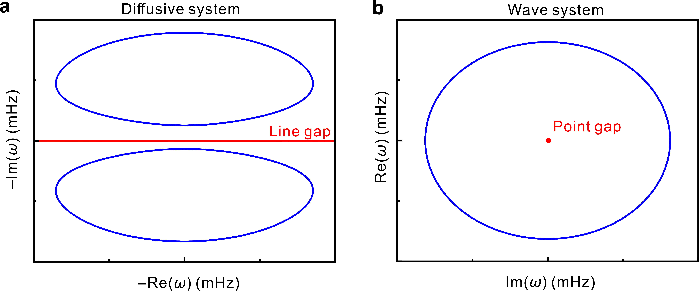
Supplementary Fig. 2 | The complex eigenfrequency spectra of the diffusive system and the non-Hermitian wave system. a The eigenfrequency spectra for the non-Hermitian diffusive system. b The eigenfrequency spectra for the non-Hermitian wave system. The analytical model is shown in Fig. 2a of the main text.

Supplementary Note 3. Complex spectral windings of the diffusive NHSE
Under the periodic boundary condition, the complex spectrum of the NHSE forms two mutually disjoint elliptical rings. The spectrum under OBC is surrounded by the complex spectrum of PBC. In order to describe this relation, the winding number^{3,4}
$W=\int_{-π}^{π}{\frac{1}{2πi}\frac{{∂ω(k)}/{∂k}}{ω(k)-ω_{0}}dk}$ (S8)
is proposed for the characterization of topological invariant, where $ω(k)$ is the eigenspectrum over the Brillouin zone with PBC, and $ω_{0}$ is the reference frequency given arbitrarily. Here $W$ represents the number of times that the complex eigenspectrum encircles the reference point $ω_{0}$. The winding number $W=-1(+1)$ indicates that the temperature eigenfield is localized on the right (left) boundary of the system. In our case, the winding number is $-1$ when $ω_{0}$ is the reference frequency within the complex spectrum loop for the as-proposed non-Hermitian diffusive model. In Supplementary Fig. 3, we show the results of the winding number changing with the imaginary part $Im(ω)$ of the eigenvalue, where we set the real part $Re\left(ω\right)=0$. Supplementary Figs. 3a-3i show the change of corresponding winding numbers for different $a$, respectively. The frequency range between the two blue dashed lines represents the bandgap region, and the calculation results can be mutually confirmed by Fig. 2 of the main text.
Supplementary Fig. 3 | Theoretical calculation of winding number. a-i The winding number corresponding to different asymmetry factors ranging from 0.9 to 0.1. Here the winding number $W=-1$, which indicates that the diffusion thermal lattice exhibits skin modes and the temperature fields of eigenstates are localized at the right boundary of the system. The two blue dashed lines mark the frequency range of band gap.

Supplementary Note 4. Hamiltonian and Eigenvalue in the 1D cavity chain
In the diffusive model described by Fig. 3a of the main content, a cavity chain of N periods has 2N sites. Here we show the derivation of the temperature field evolution in the 1D thermal lattice. The two adjacent sites n, n+1 with volume specific heat capacity ${{ρc}_{p}}_{n}{{,ρc}_{p}}_{n+1}$ will affect each other through an intermediate coupling stick with the thermal conductivity $κ_{n}$. We consider that the temperature field$T_{A_{N}}(t){ (T}_{B_{N}}(t))$ at the site $A (B)$ in the nth period can be regarded as being uniform. According to the Fourier’s law in heat conduction, the heat flow can be expressed in the following differential form of $q\left(x, t\right)=-κS∇T(x,t).$ Therefore, in the as-designed structure, the heat flow is$q_{n,n+1}\left(t\right)=-κ_{n}S_{n}\frac{T_{n+1}-T_{n}}{d}$, where $S_{n}$ is the the cross-section area of the coupling stick and $d$ is its length. On the other hand, the heat exchange rate on site n is$∂_{t}Q\left(x, t\right)=ρ{c_{p}}_{n}{V_{n}∂}_{t}T\left(x, t\right)=q_{in}-q_{out},$ for which the evolution of temperature field is ${∂_{t}T}_{n}=\frac{q_{n-1,n}-q_{n,n+1}}{ρ{c_{p}}_{n}V_{n}}$. Furthermore, the temperature evolution can be expressed as
${∂_{t}T}_{n}=\frac{1}{ρ{c_{p}}_{n}V_{n}}(κ_{n-1}S_{n-1}\frac{T_{n-1}-T_{n}}{d}-κ_{n}S_{n}\frac{T_{n}-T_{n+1}}{d})$, (S9)
where $V_{n}$is the volume of site rod. We express the coupling coefficient between the sites n and n+1 into $D_{n,n+1}= \frac{κ_{n}S_{n}}{ρ{c_{p}}_{n+1}V_{n+1}d}$and $D_{n+1,n}= \frac{κ_{n}S_{n}}{ρ{c_{p}}_{n}V_{n}d}$. For a thermal lattice with N periods, performing the above calculation for all sites, we will obtain the following equations governing the temperature field evolution
⋮$${∂_{t}T}_{A_{N-1}}={D_{B_{N-2},A_{N-1}}(T}_{B_{N-2}}-T_{A_{N-1}})+{D_{B_{N-1},A_{N-1}}(T}_{B_{N-1}}-T_{A_{N-1}}),$$
$${∂_{t}T}_{B_{N-1}}={D_{A_{N-1},B_{N-1}}(T}_{A_{N-1}}-T_{B_{N-1}})+{D_{A_{N},B_{N-1}}(T}_{A_{N}}-T_{B_{N-1}}),$$
$${∂_{t}T}_{A_{N}}={D_{B_{N-1},A_{N}}(T}_{B_{N-1}}-T_{A_{N}})+{D_{B_{N},A_{N}}(T}_{B_{N}}-T_{A_{N}}),$$
$${∂_{t}T}_{B_{N}}={D_{A_{N},B_{N}}(T}_{A_{N}}-T_{B_{N}})+{D_{A_{N+1},B_{N}}(T}_{A_{N+1}}-T_{B_{N}}),$$
⋮
According to the governing equation group, the Hamiltonian in real space can be written as
$H=-i\left(\begin{matrix}D_{B_{1},A_{1}} & -D_{B_{1},A_{1}} & \begin{matrix}⋯ & 0 & 0 \end{matrix} \\ \begin{matrix}{-D}_{A_{1},B_{1}} \\ ⋮ \\ 0\end{matrix} & \begin{matrix}D_{A_{1},B_{1}}+D_{A_{2},B_{1}} \\ ⋮ \\ 0\end{matrix} & \begin{matrix}\begin{matrix}⋯ \\ ⋱ \\ ⋯\end{matrix} & \begin{matrix}0 \\ ⋮ \\ {D_{B_{N-1},A_{N}}+D}_{A_{N},B_{N}}\end{matrix} & \begin{matrix}0 \\ ⋮ \\ {-D}_{A_{N},B_{N}}\end{matrix}\end{matrix} \\ 0 & 0 & \begin{matrix}⋯ & {-D}_{A_{N},B_{N }} & { D}_{A_{N},B_{N }}\end{matrix}\end{matrix}\right).$ (S10)
Here we define the initial coupling coefficient $D_{0}=\frac{κ_{0}S_{0}}{ρ{c_{p}}_{0}V_{0}d}$. The geometric parameters of $S_{n}$ and $V_{n}$ are set to be constants $S_{n}=S_{0},$ $V_{n}=V_{0}.$ By introducing an asymmetric factor a, we can express the parameters $ρ{c_{p}}_{n}$ and $κ_{n}$ of the thermal lattice into
$ρ{c_{p}}_{n}=\left\{\begin{matrix}a^{n-1}ρ{c_{p}}_{0}, n=1, 3, 5,⋯ \\ a^{n}ρ{c_{p}}_{0}, n=2, 4, 6,⋯ \end{matrix}\right., κ_{n}=a^{n}κ_{0}, n=1,2,3,⋯,$ (S11)
where a is greater than zero and less than unitary. With the parameters set above, we will finally construct the asymmetric intracell coupling coefficients as well as symmetric intercell coupling coefficients as follows
$\left\{\begin{matrix}D_{A_{N},B_{N}}=\frac{D_{0}}{a} \\ D_{B_{N},A_{N}}=aD_{0}\end{matrix}\right.$, $\left\{\begin{matrix}D_{B_{N},A_{N+1}}=D_{0} \\ D_{A_{N+1},B_{N}}{=D}_{0}\end{matrix}\right.$. (S12)
The governing equation of temperature evolution can thus be rewritten into
⋮
$${∂_{t}T}_{A_{N}}={D_{0}(T}_{B_{N-1}}-T_{A_{N}})+{aD_{0}(T}_{B_{N}}-T_{A_{N}}),$$
$${∂_{t}T}_{B_{N}}={\frac{D_{0}}{a}(T}_{A_{N}}-T_{B_{N}})+{D_{0}(T}_{A_{N+1}}-T_{B_{N}}),$$
⋮
We can readily express the Hamiltonian of the thermal lattice with periodicity as follows
$H\left(k\right)=-i\left(\begin{matrix}{aD}_{0}+D_{0} & -{aD}_{0}-D_{0}e^{-ik} \\ -{D_{0}}/a-D_{0}e^{ik} & {D_{0}}/a+D_{0}\end{matrix}\right)$. (S13)
In the end, the corresponding spectrum of the system can be obtained as
$ω(k)=\frac{-iD_{0}\left(a+\frac{1}{a}+2\right)}{2}±\frac{iD_{0}\sqrt{{\left(a+\frac{1}{a}+2\right)}^{2}-4\left(a\left(1-cosk-isink\right)+\frac{1-cosk+isink}{a}\right)}}{2}$. (S14)
Since we utilize the tight-binding model and assume the temperature distribution $T_{n}$ on arbitrary sites is uniform in the theoretical analysis. The as-constructed Hamiltonian for heat transport is discrete. However, in the numerical simulation, affected by the finite size of the structure, the on-site temperature distribution is non-uniform. In the heat transfer process, the temperature field is continuous. In most cases, the temperatures at the left and right ends of the coupling stick are not consistent with the temperature of the site rods connected to the coupling stick. It is therefore necessary to correct the length of the coupling stick $d$to obtain a closer result to the actual heat transfer process. Here we introduce a correction factor $α$, which imposes correction to the stick length $d$. The temperature evolution is then expressed as
${∂_{t}T}_{n}=\frac{1}{ρ{c_{p}}_{n}V_{n}}(κ_{n-1}S_{n-1}\frac{T_{n-1}-T_{n}}{αd}-κ_{n}S_{n}\frac{T_{n}-T_{n+1}}{αd})$. (S15)
The modified eigenvalues can be derived as
$ω'(k)=\frac{-i{αD}_{0}\left(a+\frac{1}{a}+2\right)}{2}±\frac{iαD_{0}\sqrt{{\left(a+\frac{1}{a}+2\right)}^{2}-4\left(a\left(1-cosk-isink\right)+\frac{1-cosk+isink}{a}\right)}}{2}$. (S16)
The eigenspectra of this system, calculated by the Equation (S16) and by simulations, are shown in Fig. 3b of the main text. It should be noted that the higher frequency band in the simulation deviates much from the theoretically calculated values. The main reason for this difference is that, with the increase of $-Im(ω)$, the stick length correction fails and the tight-binding model of 1D thermal lattice can no longer accurately predict the continuous thermal diffusion process.

Supplementary Note 5. Experimental details
In the experiments, we chose Aluminium Alloy (AlSi10Mg) instead of steel in the selection of materials. Compared with steel, Aluminium Alloy have a much higher thermal conductivity of $κ=180 W/m·K$. For Aluminium Alloy, the density $ρ=2700 kg/m^{3}$ and the heat capacity $c=900 J/kg·K$. 3D printing selective laser melting technology was utilized to fabricate our sample, which can provide the precise parameter control. The manufacturing accuracy of the structure can reach up to ± 0.1 mm/100 mm. The as-fabricated structure is composed of eight rods connected by coupling sticks. The sample surface was sprayed with the matte black paint to keep the emissivity of material surface consistent for accurate temperature measurements. The experiments were carried out under vacuum conditions. In the experiment, the pressure in the chamber dropped below $1×{10}^{-4}$ Pa. Here we suspended the sample in a vacuum chamber by using two plastic stands, shown in Supplementary Fig. 4. The thermal conductivity of plastic stand is poor, so it can hardly absorb the heat on the sample and does not affect the temperature transfer inside the sample. A long resistance wire, tightly intertwined around the site rod, was used to heat the structure. In order to improve the heat transfer efficiency, we smeared silicone grease on the resistance wire to increase the contact between the resistance wire and the sample. The external power supply provided the current (~6 amperes) to heat the sample in a short time (~5 seconds) in the vacuum chamber, as shown in Supplementary Figure 4. After the short heating process, the power supply was cut off, and then we started to use the infrared camera to observe temperature field evolution on the sample through the glass window on the vacuum chamber.
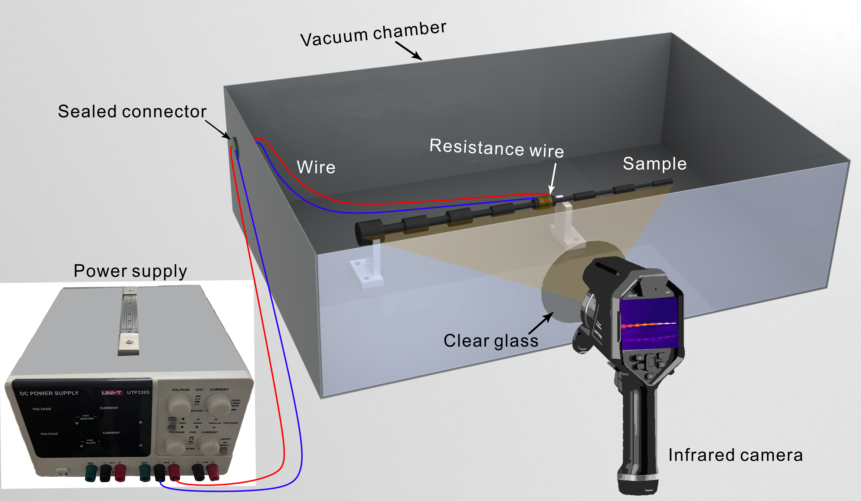
Supplementary Fig. 4 | A sketch of the experimental setup. The sample was placed in a vacuum chamber and suspended on a plastic stand of poor thermal conductivity. The resistance wire wrapped on one rod served as the heat source, and was connected to the power supply outside the vacuum chamber. The infrared camera was placed in front of the glass window of the vacuum chamber for observing the temperature field evolution on the sample.

In the proof-of-concept experiment, we have shown that the diffusive NHSE is indeed immune to the defects. Here we used the ring-shaped defects, which are either a pair of bulge loops or notch rings, as the introduced defects. The defects are schematically shown in Supplementary Fig. 5a, where the sizes of the two rings are exactly the same. The ratio of the inner radius of the ring to the radius of the site rod, viz., $\frac{r_{i}}{R}$ is employed to characterize the size of defects. It needs to be mentioned that the influence of the ring-shaped defects on the coupling coefficient between the site rods is different from the coupling sticks. In Supplementary Fig. 5b, we show the relation between the inner radius $r_{i}$ of the ring-shaped defect and the coupling coefficient $D_{7,6}$ between the site rods 6 and 7, where the rod radius $R_{6}$ is 2.74 mm, the inner radius of the ring defect $r_{6}$ is 1.37 mm, and the length $d$ is 16 mm. This result indicates that coupling coefficient between the rod sites can be effectively modified by adjusting the inner radius of the ring-shaped defect $r_{i}$. In this way, the NHSE model introduced with random defects is established in Supplementary Fig. 5c, with the details of the defects shown in the illustration.
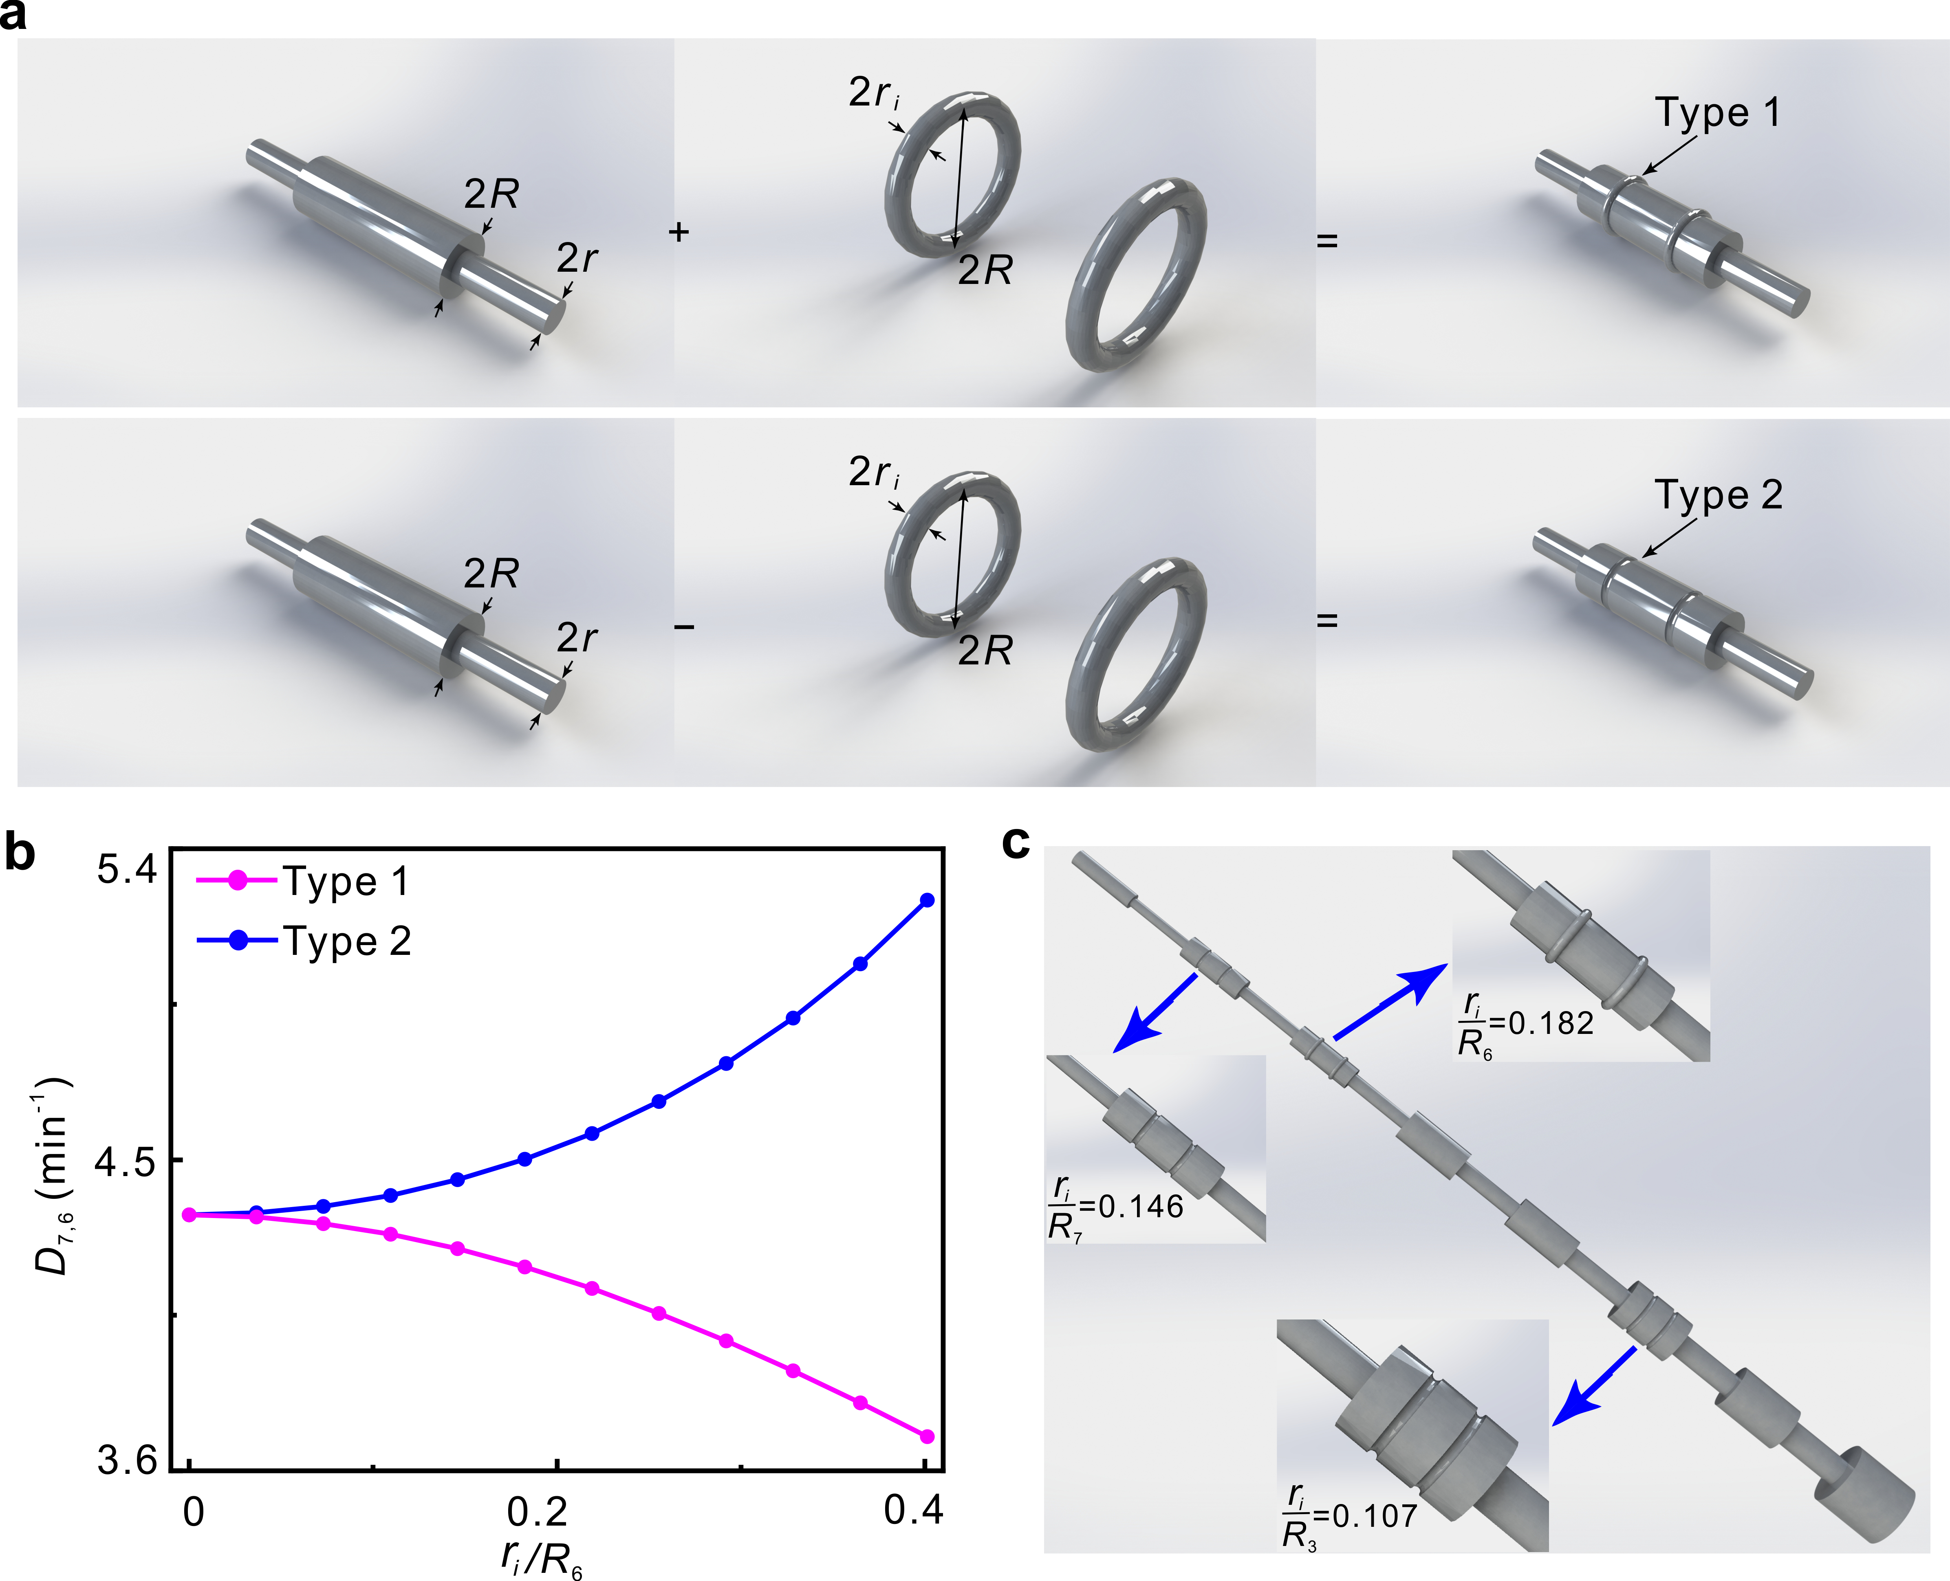
Supplementary Fig. 5 | Construction of a thermal lattice with defects. a The construction of two different types of defects. A pair of bulged (Type 1) or notched (Type 2) ring-shaped defects were introduced on a site rod. The inner diameter of the ring-shaped defect is $2r_{i}$. b The influence of the inner radius$r_{i}$ of ring-shaped defects on the coupling coefficient $D_{7,6}$ between site rods 6 and 7. c Detailed defect parameters for the sample used in the experiment for verification of the robustness of diffusive NHSE. Other structural parameters are the same with the ones of a perfect sample.

References
- Yao, S. & Wang, Z. Edge States and Topological Invariants of Non-Hermitian Systems. Phys. Rev. Lett. 121, 086803 (2018).
- Hu, Y.-M., Song, F. & Wang, Z. Generalized Brillouin zone and non-Hermitian band theory. Acta Phys. Sin. 70, 230307(2021).
- Zhang, K., Yang, Z. & Fang, C. Correspondence between winding numbers and skin modes in non-Hermitian systems. Phys. Rev. Lett. 125, 126402 (2020).
- Zhang, L. et al. Acoustic non-Hermitian skin effect from twisted winding topology. Nat. Commun. 12, 6297 (2021).

