Bradyrhizobium ottawaense efficiently reduces nitrous oxide through high nosZ gene expression

Supplementary information
Sawa Wasai-Hara^{1, 2}, Manabu Itakura², Arthur Fernandes Siqueira², Daisaku Takemoto¹, Masayuki Sugawara², Hisayuki Mitsui², Shusei Sato² , Noritoshi Inagaki¹, Toshimasa Yamazaki¹, Haruko Imaizumi-Anraku¹, Yoshikazu Shimoda^{1*}, and Kiwamu Minamisawa^{2*}

¹National Agriculture and Food Research Organization (NARO), Tsukuba, Ibaraki 305-8604, Japan
²Graduate School of Life Sciences, Tohoku University, Katahira, Aoba-ku, Sendai 980-8577, Japan

*Corresponding author: Y.S., yshimoda@affrc.go.jp, K.M., kiwamu.minamisawa.e6@tohoku.ac.jp

Methods
Phylogenic analysis (Supplementary Fig. 1)
Thirty-one genes belong to AMPHORA were extracted from the information annotated by DFAST, combined, and aligned. A phylogenetic tree was generated using MEGAX (ver 10.2.6; https://www.megasoftware.net/, [1]) using the neighbor-joining method.
Protein quantification (Supplementary Fig. 2)
To calculate the N₂O-reducing activity per total protein, calibration curves for protein content at each optical density (OD) were developed for both Bradyrhizobium ottawaense and B. diazoefficiens. The total protein content was calculated from the measured OD. Protein content in the supernatants was measured using a protein assay kit (Bio-Rad Laboratories, Hercules, CA, USA).
Growth experiment (Supplementary Fig. 3)
B. ottawaense SG09 and OO99^{T} and B. diazoefficiens USDA110^{T} were cultured under N₂O-respiring conditions. The strains were cultured HM liquid medium and initial N₂O concentration was adjusted to 30%.
Comparison of gene cluster (Supplementary Fig. 5)
Comparison of gene cluster organization and homology was performed using GenomeMatcher (ver 3.04, [2]).

Supplementary Fig. 1. Phylogenic tree based on AMPHORA genes. Parentheses after the strain name indicate nodule-forming ability. R = nodule-forming strain (rhizobia), N = non-nodulation and non-diazotroph.

Supplementary Fig. 2. N₂O-reducing activity of B. ottawaense isolates, type strain OO99^{T}, B. diazoefficiens stain USDA110^{T}, and the nosZ-deficient strain (ΔnosZ) normalized by the amount of total protein. Different letters above the bars represent significant differences between inoculation treatments analyzed using Tukey’s test after analysis of variance (ANOVA; p < 0.05). Parentheses after the strain name indicate nodule-forming ability. R = nodule forming strain (rhizobia), N = non-nodulation and non-diazotroph.

Supplementary Fig. 3. Growth curve of Bradyrhizobium ottawaense SG09, OO99^{T}, SG09ΔnosZ, and B. diazoefficiens USDA110^{T} under N₂O-respiring conditions. Error bars denote standard deviation (n = 3).

Supplementary Fig. 4. Full-length gel image of Fig. 3. Coomassie brilliant blue staining(a) and NosZ-specific activity staining (DOC-PAGE, b) protein extracted from B. ottawaense SG09 and B. diazoefficiens USDA110^{T}. The numbers in each lane indicate the concentration (x) rate of extracted protein samples. ‘M’ indicates the protein size marker (60, 120, and 240 kDa were indicated).

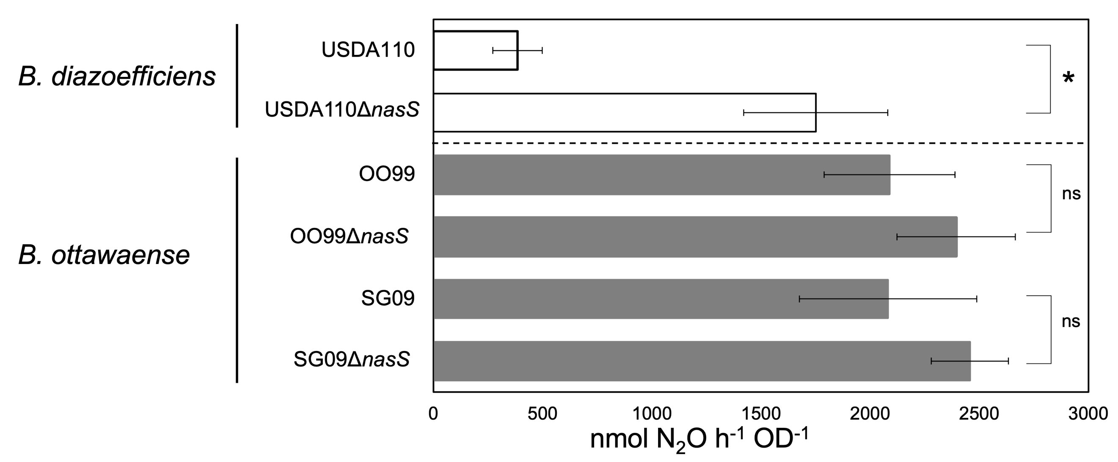
Supplementary Fig. 5. N₂O-reducing activity of the ΔnasS mutants of B. ottawaense SG09, OO99^{T}, and B. diazoefficiens USDA110^{T}. Asterisk represents significant difference at p < 0.05, n = 4, by t-test. ns = not significant.

a

b

c
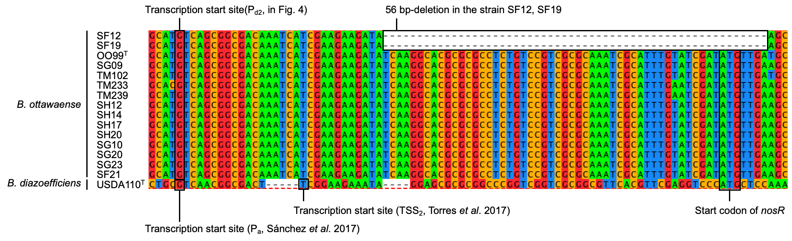

Supplementary Fig. 6. Homology of nos gene cluster amino acid (a) and nucleotide sequences (b). The pink arrow indicates gene configuration, and the colors among these genes indicate the homology between the upper and lower strains. Nucleotide sequence upstream of nosR and the 56 bp deletion site (c).
Supplementary Fig. 7. Electrophoresis images of 5′ RACE analysis in Bradyrhizobium ottawaense SG09, OO99^{T}, and B. diazoefficiens USDA110^{T}. The “N₂O” and “NO₃” lanes indicate samples obtained under N₂O- and NO₃-reducing conditions. Lane M is a size maker (FastGene 100 bp DNA Marker; Nippon Genetics, Tokyo, Japan). Red arrows indicate bands for which the sequence was determined.

Supplementary Table 1. Bacterial strains used in this study.
Strain | Accession no. | Reference for genome sequence
USDA110^{T}(R) | BA000040.2 | [3]
OO99^{T}(R) | CP029425.1 | [4]
SG09(R) | AP021854.1 | [5]
TM102(N) | AP021855.1 | [5]
TM233(N) | BTIG01000001-BTIG01000413 | [5]
TM239(N) | BTIR01000001-BTIR01000077 | [5]
SG10(R) | BTIQ01000001-BTIQ01000335 | This study
SG20(R) | BTIH01000001-BTIH01000340 | This study
SG23(R) | BTII01000001-BTII01000335 | This study
SF12(R) | BTIN01000001-BTIN01000328 | This study
SF19(R) | BTIO01000001-BTIO01000828 | This study
SF21(R) | BTIP01000001-BTIP01000318 | This study
SH12(R) | BTIJ01000001-BTIJ01000507 | This study
SH14(R) | BTIK01000001-BTIK01000358 | This study
SH17(R) | BTIL01000001-BTIL01000343 | This study
SH20(R) | BTIM01000001-BTIM01000619 | This study
Parentheses after the strain name indicate nodule-forming ability. R = nodule forming strain (rhizobia), N = non-nodulation and non-diazotroph.

Supplementary Table 2. Average nucleotide identity between Bradyrhizobium ottawaense isolates and type strain OO99^{T}
 | OO99^{T}(R) | SF12(R) | SF19(R) | SF21(R) | SG09(R) | SG10(R) | SG20(R) | SG23(R) | SH12(R) | SH14(R) | SH17(R) | SH20(R) | TM102(N) | TM233(N) | TM239(N)
OO99^{T}(R) |  | 99.04 | 99.01 | 99.07 | 99.08 | 99.05 | 99.07 | 99.07 | 99.07 | 99.05 | 99.05 | 99.07 | 98.99 | 95.30 | 95.29
SF12(R) | 99.04 |  | 99.95 | 99.93 | 99.92 | 99.99 | 99.94 | 99.95 | 99.94 | 99.93 | 99.92 | 99.94 | 99.15 | 95.33 | 95.27
SF19(R) | 99.01 | 99.95 |  | 99.92 | 99.90 | 99.96 | 99.93 | 99.92 | 99.91 | 99.91 | 99.90 | 99.89 | 99.13 | 95.35 | 95.26
SF21(R) | 99.07 | 99.93 | 99.92 |  | 99.96 | 99.94 | 99.96 | 99.96 | 99.96 | 99.96 | 99.97 | 99.95 | 99.09 | 95.36 | 95.25
SG09(R) | 99.08 | 99.92 | 99.90 | 99.96 |  | 99.92 | 99.94 | 99.94 | 99.94 | 99.95 | 99.95 | 99.93 | 99.10 | 95.35 | 95.27
SG10(R) | 99.05 | 99.99 | 99.96 | 99.94 | 99.92 |  | 99.95 | 99.95 | 99.94 | 99.94 | 99.93 | 99.94 | 99.14 | 95.37 | 95.28
SG20(R) | 99.07 | 99.94 | 99.93 | 99.96 | 99.94 | 99.95 |  | 99.98 | 99.97 | 99.95 | 99.96 | 99.96 | 99.12 | 95.43 | 95.30
SG23(R) | 99.07 | 99.95 | 99.92 | 99.96 | 99.94 | 99.95 | 99.98 |  | 99.99 | 99.95 | 99.95 | 99.99 | 99.11 | 95.45 | 95.30
SH12(R) | 99.07 | 99.94 | 99.91 | 99.96 | 99.94 | 99.94 | 99.97 | 99.99 |  | 99.95 | 99.96 | 99.98 | 99.10 | 95.45 | 95.29
SH14(R) | 99.05 | 99.93 | 99.91 | 99.96 | 99.95 | 99.94 | 99.95 | 99.95 | 99.95 |  | 99.99 | 99.94 | 99.08 | 95.34 | 95.25
SH17(R) | 99.05 | 99.92 | 99.90 | 99.97 | 99.95 | 99.93 | 99.96 | 99.95 | 99.96 | 99.99 |  | 99.95 | 99.10 | 95.35 | 95.29
SH20(R) | 99.07 | 99.94 | 99.89 | 99.95 | 99.93 | 99.94 | 99.96 | 99.99 | 99.98 | 99.94 | 99.95 |  | 99.10 | 95.47 | 95.30
TM102(N) | 98.99 | 99.15 | 99.13 | 99.09 | 99.10 | 99.14 | 99.12 | 99.11 | 99.10 | 99.08 | 99.10 | 99.10 |  | 95.34 | 95.30
TM233(N) | 95.30 | 95.33 | 95.35 | 95.36 | 95.35 | 95.37 | 95.43 | 95.45 | 95.45 | 95.34 | 95.35 | 95.47 | 95.34 |  | 98.90
TM239(N) | 95.29 | 95.27 | 95.26 | 95.25 | 95.27 | 95.28 | 95.30 | 95.30 | 95.29 | 95.25 | 95.29 | 95.30 | 95.30 | 98.90

Supplementary Table 3. Homology of nos-regulating genes between Bradyrhizobium ottawaense SG09 and B. diazoefficiens USDA110^{T}
 | FixL | FixJ | FixK₂ | FixK box | NasS | NasT | nosR upstream* | RegS | RegR
nucleotide | 88% | 92% | 92% | SG09 ATGCGCTAGCGCAA  USDA110:TTGATCCAGCGCAA | 88% | 96% | 48% | 93% | 93%
amino acid | 91% | 96% | 93% | - | 90% | 99% | - | 97% | 99%
*The sequence between the nosR gene and the upstream hypothetical gene (reverse oriented) was compared (see Supplementary Fig. 5).

Supplementary Table 4. Primers used in this study.
Primer mane | purpose | sequence (5′→3′) | Reference
nosZ_qPCR_F | qPCR | ACCCGCGAATTCCTCAAGAA | This study
nosZ_qPCR_R | qPCR | CTGTTGGCCTTGTCGTTCATG | This study
sigAf | qPCR | GAGAACCAGATGTCGCTTGC | [6]
sigAr | qPCR | TGGATGTCCTGCTCCTGAAG | [6]
Bo_nasSdel_F1 | nasS deletion | TCGAGCTCGGTACCCCGGAATCCACCAATGCCTTG | This study
Bo_nasSdel_R1 | nasS deletion | GCAGCTCCGAATCAGGCCTTGTTGGACCAGGACACCTCG | This study
Bo_nasSdel_F2 | nasS deletion | CGAGGTGTCCTGGTCCAACAAGGCCTGATTCGGAGCTGC | This study
Bo_nasSdel_R2 | nasS deletion | CTCTAGAGGATCCCCGGTCCTGGATACCCTCGATC | This study
aadA_F_IF | nasS deletion | CAGGGGATCAAGATCGTGGACATAAGCCTGTTCGG | This study
aadA_R_IF | nasS deletion | GCAGGCATCGCCATGAGTGCATCTAACGCTTGAGT | This study
56del_F1 | 56 bp deletion | TCGAGCTCGGTACCCGTCGAGGTAGCCGTCGACCA | This study
56del_R1 | 56 bp deletion | GGTATCGTCATCCGGTCGCTTATCTTCTTCGATGATTTGTCGCCG | This study
56del_F2 | 56 bp deletion | CGGCGACAAATCATCGAAGAAGATAAGCGACCGGATGACGATACC | This study
56del_R2 | 56 bp deletion | CTCTAGAGGATCCCCCGGCTTCAGGCTGTCCTTCA | This study
SG09_nos-1F | nosZ deletion | CTCGAATTCCGCTGATCTTCATTCTGTGG | This study
SG09_nos-1R | nosZ deletion | CAGATCGTCCCCGGGCGCTCGAGAAGAACACGTAG | This study
SG09_nos-2F | nosZ deletion | TCTCGAGCGCCCGGGGACGATCTGTTCGACGACAA | This study
SG09_nos-2R | nosZ deletion | CTCAAGCTTCGGAAACATGCGTAAGAGAA | This study
Bw_SP1 | 5' RACE | GAGGAAGATGAATCCCTGGAGCTG | This study
Bw_SP2 | 5' RACE | GCGGTACACTGGTACGATGG | This study
Bw_SP3 | 5' RACE | GGCGTAATCTTCGGCAGGTAT | This study
R_SP1 | 5' RACE | CAGGTACACGAAGCCCTGCAATTG | [7]
R_SP2 | 5' RACE | GCGATAGGCCGGTATGATAG | [7]
R_SP3 | 5' RACE | GGGCAATCTTCGACAGGTAA | [7]

References
1 Stecher, G., Tamura, K. & Kumar, S. Molecular evolutionary genetics analysis (MEGA) for macOS. Mol. Biol. Evol. 37, 1237-1239 (2020).
2 Ohtsubo, Y., Ikeda-Ohtsubo, W, Nagata, Y. & Tsuda, M. GenomeMatcher: A graphical user interface for DNA sequence comparison. BMC Bioinformatics. 9, 376 (2008)
3 Kaneko et al. Complete genomic sequence of nitrogen-fixing symbiotic bacterium Bradyrhizobium japonicum USDA110. DNA Res. 31; 189-197 (2002).
4 Nguyen, H.D.T., Cloutier, S. & Bromfield, E.S.P. Complete Genome Sequence of Bradyrhizobium ottawaense OO99^{T}, an Efficient Nitrogen-Fixing Symbiont of Soybean. Microbiol. Resour. Announc. 7, e01477-18 (2018).
5 Wasai-Hara, S. et al. Diversity of Bradyrhizobium in non-leguminous sorghum plants: B. ottawaense isolates unique in genes for N₂O reductase and lack of the type VI secretion system. Microbes Environ. 35, ME19102 (2020).
6 Itakura, M. et al. Mitigation of nitrous oxide emissions from soils by Bradyrhizobium japonicum inoculation, Nature Clim. Change 3, 208–212 (2013).
7 Sánchez, C., Mitsui, H. & Minamisawa, K. Regulation of nitrous oxide reductase genes by NasT-mediated transcription antitermination in Bradyrhizobium diazoefficiens. Environ Microbiol Rep. 9, 389-396 (2017).

