A polyphagous chewing herbivore induces positive plant-soil feedbacks of two legumes in soil with prolonged drought legacies
Kamrul Hassan^{1,2*}, Premchand Maisnam, Yolima Carrillo¹ and Uffe N. Nielsen¹
¹Hawkesbury Institute for the Environment, Western Sydney University, Penrith, New South Wales, Australia.
²Department of Entomology, Sylhet Agricultural University, Sylhet- 3100, Bangladesh.
*Corresponding author: khassan.entom@sau.ac.bd

Table S1 (%) Foliar C, and soil C, N and nodule/pot of Lucerne and white clover at different treatment combination.

Lucerne
 | With herbivore |  |  |  |  |  |  | Without herbivore
 | Ambient rainfall legacies |  |  |  | Drought legacies |  |  | Ambient rainfall legacies |  |  |  | Drought legacies
Response | Home | Away | Sterile |  | Home | Away | Sterile |  | Home | Away | Sterile |  | Home | Away | Sterile
Foliar C | 40.56±0.95 | 42.05±0.62 | 39.33±0.42 |  | 43.49±0.68 | 41.91±0.56 | 42.81±0.41 |  | 40.42±0.50 | 41.98±0.59 | 40.59±0.54 |  | 39.97±0.65 | 41.02±0.55 | 40.67±0.54
Soil C | 1.50±0.26 | 1.32±0.09 | 1.14±0.12 |  | 1.25±0.06 | 1.19±0.02 | 1.38±0.04 |  | 1.34±0.05 | 1.32±0.07 | 1.33±0.03 |  | 1.30±0.06 | 1.33±0.08 | 1.37±0.09
Soil N | 0.10±0.01a | 0.09±0.00ab | 0.07±0.00b |  | 0.10±0.00 | 0.09±0.00 | 0.10±0.00 |  | 0.10±0.00 | 0.09±0.00 | 0.10±0.00 |  | 0.09±0.00 | 0.09±0.00 | 0.10±0.00
Soil CN ratio | 14.15±0.82 | 13.30±0.09 | 15.85±0.82 |  | 12.30±1.04 | 13.03±0.25 | 13.15±0.49 |  | 13.36±0.27 | 13.58±0.29 | 13.19±0.11 |  | 13.56±0.40 | 13.61±0.34 | 13.51±0.23
Soil moisture | 2.73±0.48 | 4.12±3.33 | 2.27±0.22 |  | 1.84±0.71 | 1.25±0.59 | 0.84±0.26 |  | 2.02±0.80 | 2.16±0.62 | 1.63±0.15 |  | 1.52±0.18 | 1.47±0.35 | 1.04±0.17
Nodule/pot | 14.50±4.69a | 2.00±1.26b | 0.00±0.00c |  | 11.66±1.22a | 6.00±2.19b | 0.50±0.50c |  | 9.66±3.37a | 14.66±7.46a | 2.16±0.98b |  | 14.50±3.18a | 1.83±1.22b | 2.16±0.83b
White clover
Foliar C | 42.90±0.78 | 42.69±0.42 | 43.86±0.82 |  | 43.04±0.94 | 41.85±0.73 | 43.92±1.46 |  | 43.04±0.5 | 44.01±0.88 | 42.28±0.27 |  | 42.51±0.42 | 43.54±0.8 | 43.43±0.64
Total soil C | 1.23±0.11 | 1.42±0.00 | 1.15±0.04 |  | 1.56±0.32 | 1.31±0.02 | 1.56±0.05 |  | 1.28±0.02 | 1.13±0.03 | 1.45±0.07 |  | 1.22±0.03 | 1.45±0.09 | 1.34±0.20
Soil N | 0.09±0.00 | 0.09±0.00 | 0.09±0.00 |  | 0.10±0.02 | 0.09±0.00 | 0.10±0.00 |  | 0.09±0.00 | 0.08±0.00 | 0.10±0.00 |  | 0.09±0.00 | 0.10±0.00 | 0.09±0.01
Soil CN ratio | 12.99±0.21a | 15.74±0.00b | 12.76±0.35a |  | 14.33±0.27a | 13.40±0.10b | 15.46±0.06c |  | 13.34±0.34 | 13.03±0.47 | 13.80±0.51 |  | 13.38±0.09 | 14.43±0.35 | 14.39±0.25
Soil moisture | 1.86±1.03 | 3.72±0.00 | 1.80±0.23 |  | 1.28±0.44 | 1.48±0.66 | 1.90±0.24 |  | 1.32±0.46 | 1.72±0.72 | 3.13±2.12 |  | 1.70±0.00 | 1.61±0.24 | 1.72±0.08
Nodule/pot | 6.66±1.58a | 5.16±2.40a | 1.00±0.63b |  | 2.16±2.16b | 11.16±3.72a | 0.00±0.00c |  | 4.83±2.05 | 2.33±1.05 | 2.16±1.51 |  | 2.33±1.66b | 14.00±0.77a | 0.00±0.00b
Mean ± s.e. reported. Different lower-case letters within row indicate differences in foliar C, total soil N, soil CN ratio, and nodule/pot among soil conditioning (‘home’, ‘away’, and ‘sterile’) within similar rainfall legacies with or without herbivore treatment. Significance at p = 0.05 level.

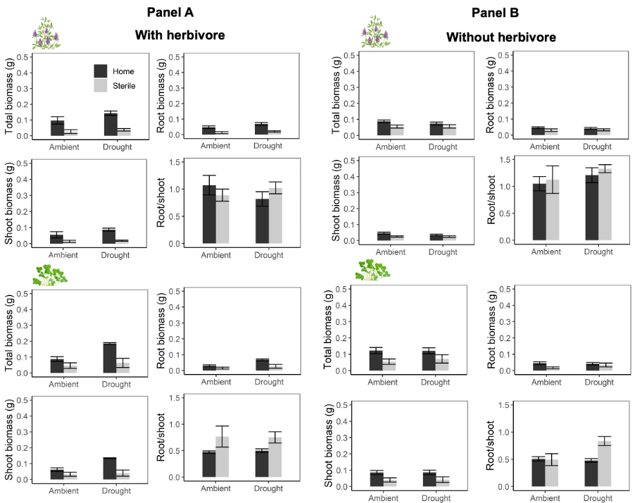

Fig. S1 Mean (±s.e.) total, shoot and root biomass, and root/shoot ratio, of M. sativa and T. repens in monoculture when comparing ‘home’ and ‘sterile’ conditioning with herbivore present (Panel A) and absent (Panel B) in soils with prolonged ambient and drought legacies (n=6).

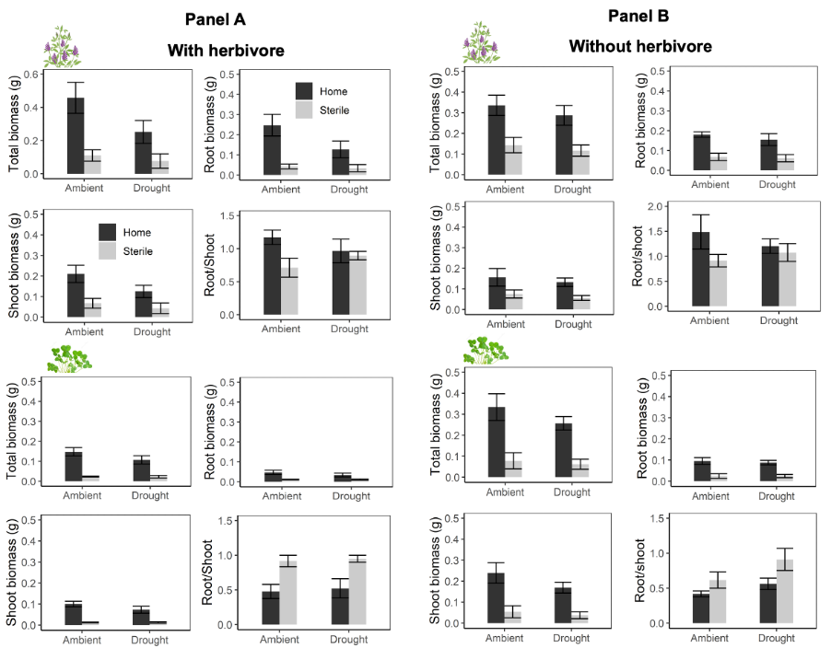

Fig. S2 Mean (±s.e.) total, shoot and root biomass, and root/shoot ratio, of M. sativa and T. repens in mixture when comparing ‘home’ and ‘sterile’ conditioning with herbivore present (Panel A) and absent (Panel B) in soils with prolonged ambient and drought legacies (n=6).

