Table 1 Physical properties of reactive dyes
Dye | Molecular  formula | MW  (g/mol) | λ_{max}  (nm) | Number of chemical group
 |  |  |  | -SO₃Na | -OH | -NH₂
RB 171 | C₄₀H₂₃Cl₂N₁₅Na₆O₁₉S₆ | 1418.9 | 610 | 6 | 1 | 1 | 4 | 1
RR195 | C₃₁H₁₉ClN₇Na₅O₂₁S₆ | 1168.3 | 540 | 5 | - | - | 1 | 2
RY184 | C₁₉H₁₈N₄Na₂O₁₁S₃ | 620.54 | 420 | 2 | - | - | 2 | -

Table 2 Effect of DADMAC concentration on dyes adsorption
DADMAC concentration (%) | Red | Blue | Yellow
0 (Untreated cotton fabric) | 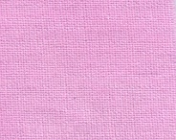 | 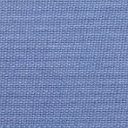
10 |  | 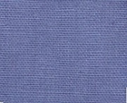
20 | 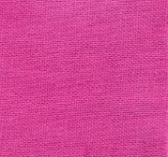 | 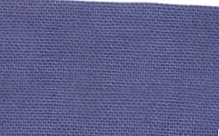
30 | 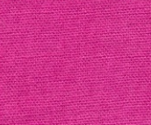 | 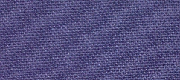
40 | 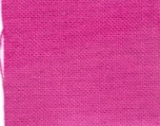 | 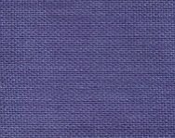
50 | 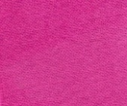 | 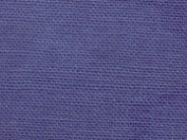
60 | 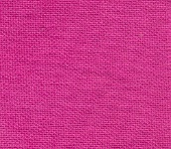 | 