1. Reaction between TMEDA and potassium persulphate to form free radical
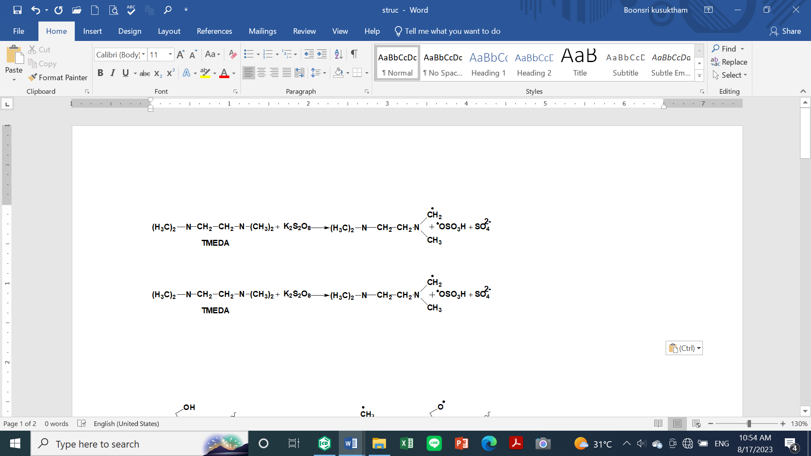
2. Reaction between cellulose and free radical to form cellulose radical
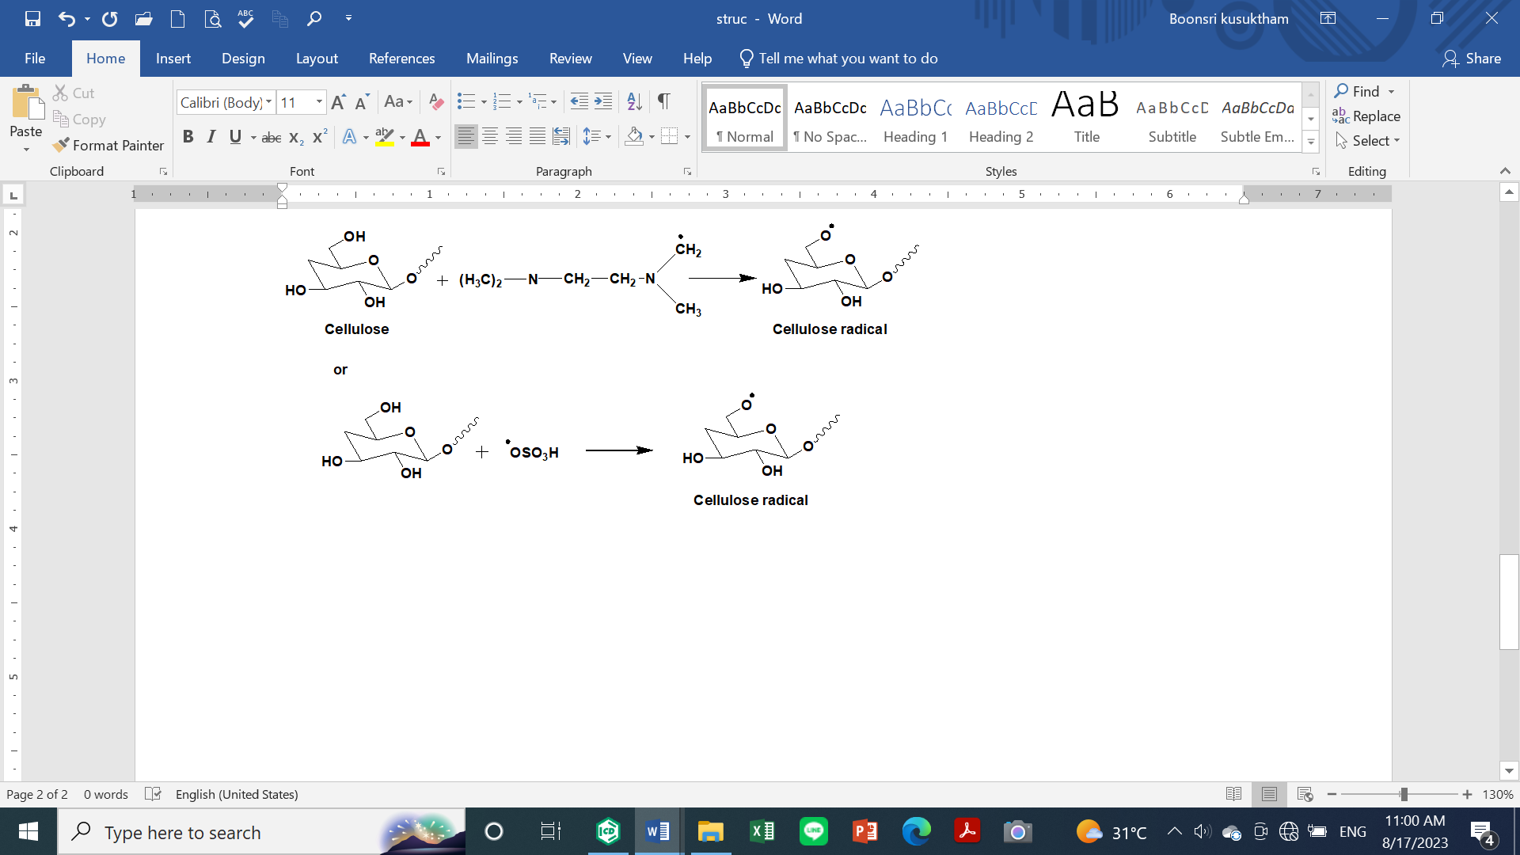
3. Reaction between cellulose radical and DADMAC to form grafting cellulose with poly(DADMAC)
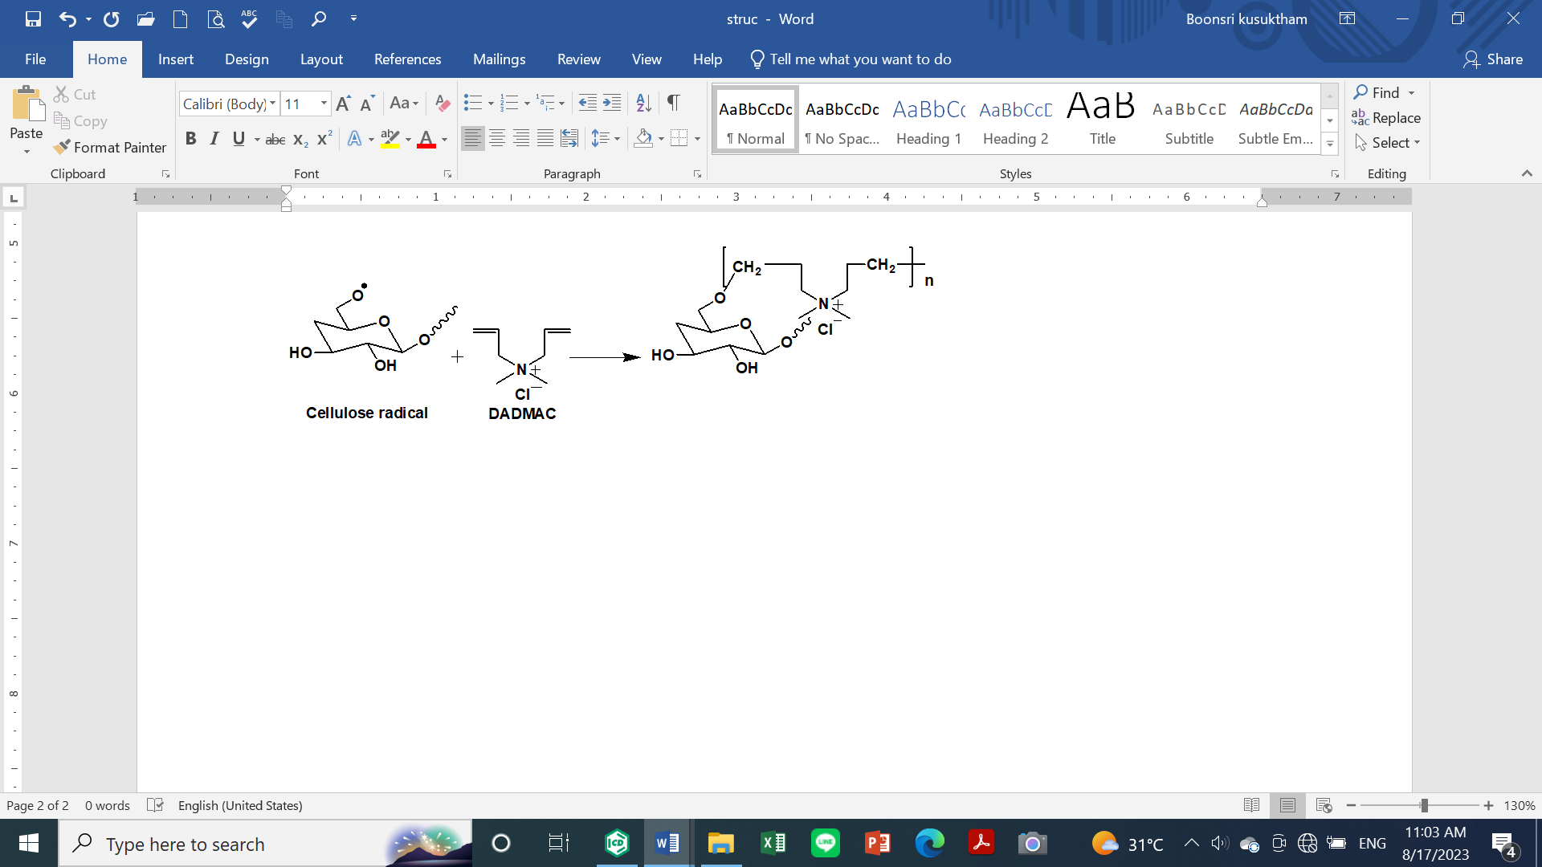
Scheme 1 Schematic representation of the grafting of cotton fabric with DADMAC

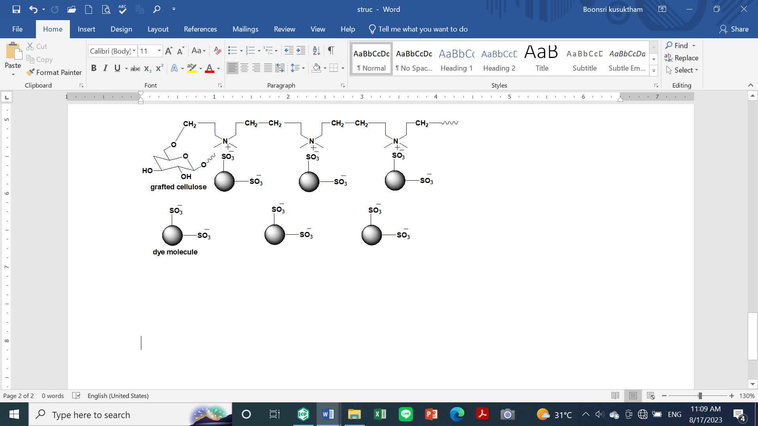
Scheme 2 Schematic representation of the reactive dye adsorption on the grafted cotton fabric with the poly(DADMAC)

