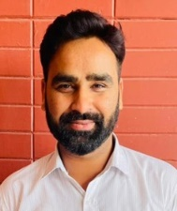
Dr. Abhishek Kumar is Doctorate in computer science from University of Madras and done M.tech in Computer Sci. & Engineering from Government engineering college Ajmer, Rajasthan Technical University, Kota India. He has total Academic teaching experience of more than 7 years with more than 80 publications in reputed, peer reviewed National and International Journals, books & Conferences. He has guided more than 20 M.Tech Projects and Thesis and guiding 2 PhD Scholar. His research area includes- Artificial intelligence, Image processing, Computer Vision, Data Mining, Machine Learning. He has been Session chair and keynote Speaker of many International conferences, webinars in India and Abroad. He has been the reviewer for IEEE and Inderscience Journal. He has authored/Co-Authored 6 books published internationally and edited 16 books (Published & ongoing with Elsevier, Wiley, IGI GLOBAL Springer, Apple Academic Press, De-Grueter and CRC etc. He has been member of various National and International professional societies in the field of engineering & research like Senior Member of IEEE, IAENG (International Association of Engineers), Associate Member of IRED (Institute of Research Engineers and Doctors), He has got Sir CV Raman National award for 2018 in young researcher and faculty Category from IJRP Group. He is Editor of Special issue in the Journal Computer materials and continua [SCI and SCOPUS.IF- 4.98] and Intelligent Automation and Soft Computing [SCI, SCOPUS, IF-1.276] Cognitive Neurodynamics, Springer [SCI, SCOPUS, IF-3.925].

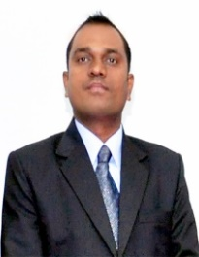
Dr. Ashutosh Kumar Dubey is currently in the department of Computer Science and Engineering, Chitkara University School of Engineering and Technology, Chitkara University, Himachal Pradesh, India. He received his PhD degree in Computer Science and Engineering from JK Lakshmipat University, Jaipur, Rajasthan, India. He is the Senior Member of IEEE and ACM. He has more than 14 years of teaching experience. He has authored a book name Database Management Concepts. He has been associated with many international and national conferences as the Technical Program Committee member. He is also associated as the Editor/Editorial Board Member/ Reviewer of many peer-reviewed journals. His research areas are Data Mining, Health Informatics, Optimization, Machine Learning, Cloud Computing, Artificial Intelligence and Object-Oriented Programming.

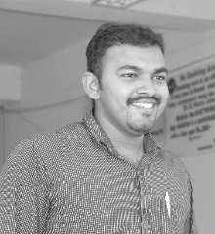
Dr. T.Ananth kumar received Bachelor’s degree in Electronics and communication engineering from Anna University, Chennai and Master’s degree in VLSI Design from Easwari engineering College affiliated to Anna University. He received his Ph.D. degree in VLSI Design from Manonmaniam Sundaranar University, Tirunelveli. He became an Associate Professor in IFET college of Engineering. He has presented papers in various National and International Conferences and Journals. His fields of interest are Networks on Chips, Computer Architecture and ASIC design. He is the recipient of the Best Paper Award at INCODS 2017. He has written many Book chapters in IET press, Elsevier, Springer, Taylor & Francis and Wiley press.

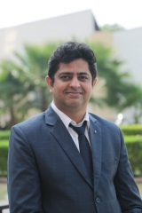
Dr Sachin Ahuja is presentl serving as Executive Director Engineering at Chandigarh University. He has extensive research and academic experience. He has served at key academic positions at various reputed higher education institutes. He has guided several ME and PhD scholars in areas like Artificial Intelligence, Machine learning, data mining etc


Vishal Dutt is currently working as a technical trainer at Chandigarh University, Mohali, Punjab, India with a strong background in academia and industry. He is engaged in cutting-edge research in the field of computer engineering. He is a renowned freelance trainer specializing in Research and Development since 2016. With over 7 years of teaching and Research experience, he has authored 50+ publications in reputable national and international journals, conferences, and book chapters (Springer, Wiley etc.), including SCI and Scopus journals. He has contributed to the editorial process of two books and is currently working on three more publications with Wiley. He has served as a keynote speaker and resource for numerous workshops and webinars in India. He has provided peer review services for esteemed publishers such as Elsevier, Springer, and IEEE Access. Vishal has also served as a program committee member and reviewer for the International Conference on Computational Intelligence and Emerging Power Systems (ICCIPS 2021). His research interests encompass Data Science, Data Mining, Machine Learning, and Deep Learning. Additionally, Mr. Vishal possesses extensive experience in data analytics using Rapid Miner, Tableau, and WEKA, along with over 6 years of expertise in Java and Android development.

