Supplementary Information

Table S1 The land use/land cover classification system of China (China LULC)
Level 1 |  | Level 2 |  | Descriptions
Code | Name | Code | Name | Descriptions
1 | Cropland | 11 | Paddy land | Cropland that has enough water supply and irrigation facilities for planting paddy rice, lotus etc., including rotation land for paddy rice and dry farming crops.
1 | Cropland | 12 | Dry land | Cropland for cultivation without water supply and irrigating facilities; cropland that has water supply and irrigation facilities and planting dry farming crops; cropland planting vegetables; fallow land.
2 | Woodland | 21 | Forest | Natural or planted forests with canopy cover greater than 30%.
2 | Woodland | 22 | Shrub | Lands covered by trees less than 2 m high, the canopy cover >40%.
2 | Woodland | 23 | Woods | Lands covered by trees with canopy cover between 10–30%.
2 | Woodland | 24 | Other woodland | Lands such as tea-garden, orchards, groves and nurseries.
3 | Grassland | 31 | Dense grass | Grassland with canopy coverage greater than 50%.
3 | Grassland | 32 | Moderate grass | Grassland with canopy coverage between 20% and 50%.
3 | Grassland | 33 | Sparse grass | Grassland with canopy cover between 5% and 20%.
4 | Water body | 41 | Stream and rivers | Lands covered by rivers including canals.
4 | Water body | 42 | Lakes | Lands covered by lakes.
4 | Water body | 43 | Reservoir and ponds | Man-made facilities for water reservation.
4 | Water body | 44 | Permanent ice and snow | Lands covered by perennial snowfields and glaciers.
4 | Water body | 45 | Beach and shore | Lands between high tide level and low tide level.
4 | Water body | 46 | Bottomland | Lands between normal water level and flood level.
5 | Built-up land | 51 | Urban built-up | Lands used for urban
5 | Built-up land | 52 | Rural settlements | Lands used for settlements in villages
5 | Built-up land | 53 | Other built-up land | Lands used for factories, quarries, mining, oil-field slattern outside cities and lands for special uses such as transportation and airport
6 | Unused land | 61 | Sandy land | Sandy land covered with less than 5% vegetation cover
6 | Unused land | 62 | Gobi | Gravel covered land with less than 5% vegetation cover.
6 | Unused land | 63 | Salina | Lands with salina accumulation and sparse vegetation
6 | Unused land | 64 | Swampland | Lands with a permanent mixture of water and herbaceous or woody vegetation that cover extensive areas
6 | Unused land | 65 | Bare soil | Bare exposed soil with less than 5% vegetation cover
6 | Unused land | 66 | Bare rock | Bare exposed rock with less than 5% vegetation cover
6 | Unused land | 67 | Other unused land | Other lands such as alpine desert and tundra

Table S2 The land use/land cover classification system of Europe (CORINE)
Level 1 |  | Level 2 |  | Level 3 |  | Descriptions
Code | Name | Code | Name | Code | Name | Descriptions
1 | Artificial surfaces | 11 | Urban fabric (structure) | 111 | Continuous urban fabric | Artificial urban surfaces > 80%
 |  |  |  | 112 | Discontinuous urban fabric | Artificial urban surfaces 30–80%
1 | Artificial surfaces | 12 | Industrial,  commercial and transport units | 121 | Industrial or commercial units | Industrial and commercial surfaces
 |  |  |  | 122 | Road and rail networks and associated land | Rail and road network – min. width ≥ 100 m
 |  |  |  | 123 | Port areas | Infrastructure of port area (sea, river and lake)
 |  |  |  | 124 | Airports | Infrastructure of airport
1 | Artificial surfaces | 13 | Mine, dump and construction | 131 | Mineral extraction sites | Open-pit extraction of materials and minerals
 |  |  |  | 132 | Dump sites | Public or industrial dump sites (materials)
 |  |  |  | 133 | Construction sites | Sites under construction development
1 | Artificial surfaces | 14 | Artificial non-agricultural vegetated areas | 141 | Green urban areas | Vegetation within urban fabric
 |  |  |  | 142 | Sport and leisure facilities | Sport and leisure facilities
2 | Agricultural areas | 21 | Arable land | 211 | Non-irrigated arable land | Non-irrigated arable land with annual crops (75% and more of land is under a rotation system)
 |  |  |  | 212 | Permanently irrigated land | Permanently irrigated land (annual and permanent crops)
 |  |  |  | 213 | Rice fields | Rice fields (land cultivated for rice)
2 | Agricultural areas | 22 | Permanent crops | 221 | Vineyards | Vineyards (its parcels exceed 50% of the land)
 |  |  |  | 222 | Fruit trees and berry plantations | Fruit trees and berry plantations (their parcels exceed 50% of the area)
 |  |  |  | 223 | Olive groves | Olive trees (its parcels exceed 50% of the area)
2 | Agricultural areas | 23 | Pastures | 231 | Pastures | Agricultural grasslands
2 | Agricultural areas | 24 | Heterogeneous agricultural areas | 241 | Annual crops associated with permanent crops | Patterns of annual and permanent crops on the same parcel
 |  |  |  | 242 | Complex cultivation patterns | Patterns of parcels (< 25 ha) annual and permanent crops (< 25 ha)
 |  |  |  | 243 | Land principally occupied by agriculture, with significant areas of natural vegetation | Patterns of agro-natural areas (both < 25 ha)
 |  |  |  | 244 | Agro-forestry areas | Patterns of agro-forest areas
3 | Forests and semi-natural areas | 31 | Forests | 311 | Broad-leaved forest | Deciduous trees > 75%
 |  |  |  | 312 | Coniferous forest | Coniferous trees > 75%
 |  |  |  | 313 | Mixed forest | Mixed species (does not exceed 25% in the canopy closure)
3 | Forests and semi-natural areas | 32 | Shrub and/or herbaceous vegetation | 321 | Natural grassland | Natural grasslands
 |  |  |  | 322 | Moors and heathland | Shrub formations (climax stage of development) in humid conditions
 |  |  |  | 323 | Sclerophyllous vegetation | Shrub formations (climax stage of development) in arid conditions
 |  |  |  | 324 | Transitional woodland/shrub | Bushy formation (woodland degradation or forest regeneration)
3 | Forests and semi-natural areas | 33 | Open spaces with little or no vegatation | 331 | Beaches, dunes, sands | Sand or gravel areas developed under fluvial or aeolian processes
 |  |  |  | 332 | Bare rock | Bare rocks
 |  |  |  | 333 | Sparsely vegetated areas | Sparse vegetation (10% < vegetation < 50%, 50% < ground cover < 90%)
 |  |  |  | 334 | Burnt areas | Burnt forest areas (rests of recent fire)
 |  |  |  | 335 | Glaciers and perpetual snow | Glaciers and perpetual snow
4 | Wetlands | 41 | Inland wetlands | 411 | Inland marshes | Non-forested wetland areas flooded by river or ground water
 |  |  |  | 412 | Peatbogs | Decomposed vegetation matter covered by sphagnum or other acidophilus plants (exploited or unexploited)
4 | Wetlands | 42 | Coastal wetlands | 421 | Salt marshes | Halophytic plants flooded by sea water
 |  |  |  | 422 | Salines | Salt-pans
 |  |  |  | 423 | Intertidal flats | Unvegetated mud, sand or rock areas between high and low sea water marks
5 | Water bodies | 51 | Inland waters | 511 | Water courses | Natural or artificial water courses (width ≥100 m)
 |  |  |  | 512 | Water bodies | Natural or artificial water bodies
5 | Water bodies | 52 | Marine waters | 521 | Coastal lagoons | Brackish water in coastal areas
 |  |  |  | 522 | Estuaries | Mouths of rivers affected by sea water
 |  |  |  | 523 | Sea and ocean | Sea and ocean water

Table S3 Transformation of the legends of CORINE into the legends of China LULC
China LULC |  | CORINE
Level 2 |  | Level 3
Code | Name | Code | Name
11 | Paddy land | 212 | Permanently irrigated land
11 | Paddy land | 213 | Rice fields
12 | Dry land | 211 | Non-irrigated arable land
12 | Dry land | 241 | Annual crops associated with permanent crops
12 | Dry land | 242 | Complex cultivation patterns
12 | Dry land | 243 | Land principally occupied by agriculture, with significant areas of natural vegetation
12 | Dry land | 244 | Agro-forestry areas
21 | Forest | 311 | Broad-leaved forest
21 | Forest | 312 | Coniferous forest
21 | Forest | 313 | Mixed forest
22 | Shrub | 322 | Moors and heathland
22 | Shrub | 323 | Sclerophyllous vegetation
23 | Woods | 324 | Transitional woodland/shrub
24 | Other woodland | 221 | Vineyards
24 | Other woodland | 222 | Fruit trees and berry plantations
24 | Other woodland | 223 | Olive groves
31 | Dense grass | 321 | Natural grassland
32 | Moderate grass | 231 | Pastures
33 | Sparse grass | 333 | Sparsely vegetated areas
41 | Stream and rivers | 511 | Water courses
42 | Lakes | 512 | Water bodies
43 | Reservoir and ponds | 512 | Water bodies
44 | Permanent ice and snow | 335 | Glaciers and perpetual snow
45 | Beach and shore | 423 | Intertidal flats
45 | Beach and shore | 521 | Coastal lagoons
45 | Beach and shore | 522 | Estuaries
46 | Bottomland | 411 | Inland marshes
51 | Urban built-up | 111 | Continuous urban fabric
52 | Rural settlements | 112 | Discontinuous urban fabric
53 | Other built-up land | 122 | Road and rail networks and associated land
53 | Other built-up land | 123 | Port areas
53 | Other built-up land | 124 | Airports
53 | Other built-up land | 131 | Mineral extraction sites
53 | Other built-up land | 132 | Dump sites
53 | Other built-up land | 133 | Construction sites
53 | Other built-up land | 142 | Sport and leisure facilities
53 | Other built-up land | 141 | Green urban areas
53 | Other built-up land | 121 | Industrial or commercial units
61 | Sandy land | 331 | Beaches, dunes, sands
62 | Gobi | 332 | Bare rock
63 | Salina | 422 | Salines
64 | Swampland | 411 | Inland marshes
64 | Swampland | 412 | Peatbogs
64 | Swampland | 421 | Salt marshes
65 | Bare soil | 334 | Burnt areas
66 | Bare rock | 332 | Bare rock
67 | Other unused land | 333 | Sparsely vegetated areas

Table S4 The proportions of the variation in the ecosystem services explained by the non-collinear drivers (variance inflation factor < 5) in the Yangtze River Economic Belt (YREB).
City (number) | ES | Socioeconomic factors (SOE) |  | Climatic factors (CLI) |  | Topographic factors (TOP) |  | Land use and land cover factors (LULC) |  | Total explained proportions | P
City (number) | ES | VIF < 5 | Explained proportions | VIF < 5 | Explained proportions | VIF < 5 | Explained proportions | VIF < 5 | Explained proportions | Total explained proportions | P
All cities (130) | ES supply | UR, PD, pGDP | 18.4% | MI, AR, aaT10 | 26.9% | SL | 16.6% | CL, WL,  WB, BL, UL | 30.5% | 43.5% | ***
All cities (130) | ES demand | UR, PD, pGDP | 43.3% | MI, AR, aaT10 | 24.5% | SL | 49.6% | CL, WL,  WB, BL, UL | 54.4% | 67.2% | ***
All cities (130) | ES balance | UR, PD, pGDP | 32.6% | MI, AR, aaT10 | 28.2% | SL | 36.3% | CL, WL,  WB, BL, UL | 47.0% | 59.7% | ***
Oversupply  cities (97) | ES supply | UR, PD, pGDP | 13.7% | MI, AR, aaT10 | 15.8% | SL | 0.1% | CL, WL,  WB, BL, UL | 27.3% | 31.1% | ***
Oversupply  cities (97) | ES demand | UR, PD, pGDP | 43.9% | MI, AR, aaT10 | 19.0% | SL | 42.5% | CL, WL,  WB, BL, UL | 49.8% | 59.9% | ***
Oversupply  cities (97) | ES balance | UR, PD, pGDP | 24.3% | MI, AR, aaT10 | 17.6% | SL | 14.0% | CL, WL,  WB, BL, UL | 40.6% | 46.6% | ***
Undersupply cities (33) | ES supply | UR, PD | 41.7% | AR, aaT10 | 11.5% | EL | 8.4% | CL, GL,  WB, UL | 5.6% | 44.4% | **
Undersupply cities (33) | ES demand | UR, PD | 34.5% | AR, aaT10 | 0.2% | EL | 0.1% | CL, GL,  WB, UL | 0.5% | 28.3% | *
Undersupply cities (33) | ES balance | UR, PD | 40.8% | AR, aaT10 | 1.7% | EL | 2.3% | CL, GL,  WB, UL | 0.2% | 36.1% | *
Note: *: P < 0.05; **: P < 0.01; ***: P < 0.001. UR: Urbanization rate; PD: Population density; pGDP: per capita GDP; MI: Moisture index; AR: Aridity; aaT10: Accumulated temperature >10℃; EL: Elevation; SL: Slope; CL: cropland; WL: woodland; WB: water body; BL: built-up land; UL: unused land.
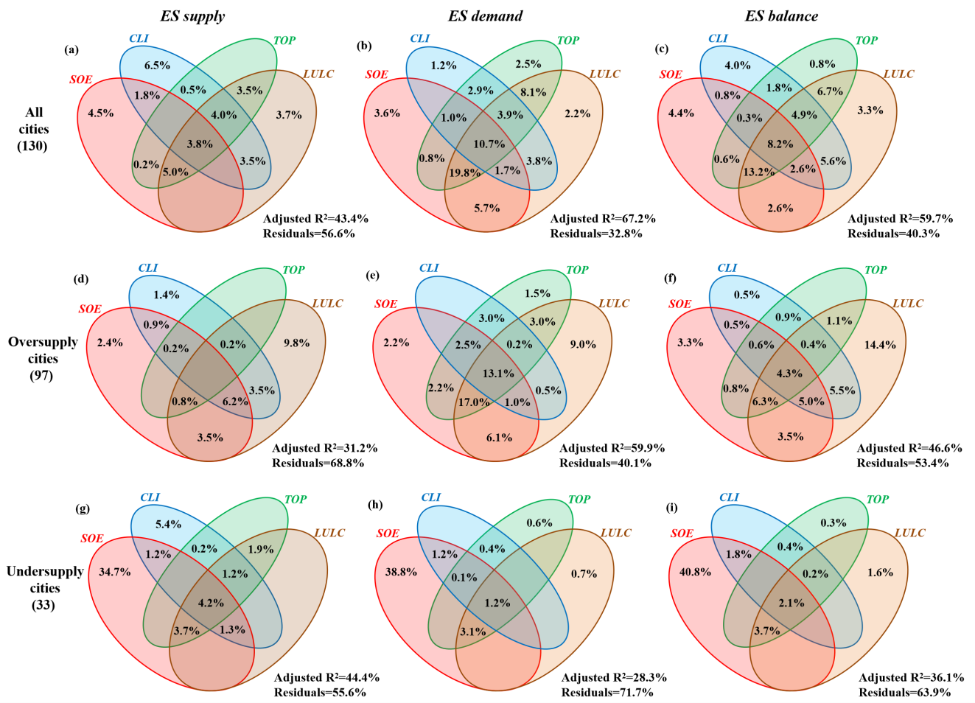
Fig. S1 Results of variation partitioning analysis, illustrating the contributions of the non-collinear drivers (VIF < 5) to the ES supply (a, d, and g), demand (b, e, and h) and balance (c, f, and i). Three types of spatial units, namely, all cities (a, b, and c), oversupply cities (d, e, and f) and undersupply cities (g, h and i) were used to the proportions of the variation in the ESs explained by the isolated and combined influences of the essential driving factors, respectively. SOE: Socioeconomic factors; CLI: Climatic factors; TOP: Topographic factors; LULC: Land use and land cover factors. Negative values are not shown. The explained variation is based on adjusted R² values.

