The shell proteome of the deep-sea barnacle Bathylasma hirsutum and the convergency in barnacle and molluscan shell proteins.

Yu-Tao Xuª, James Taylor^{b}, Hao-Cheng Liuª, Niklas Dreyer^{c}, Qian-Qian Cho^{d}, Yu Zhang^{d}, Shi-Feng Guo^{e}, Saskia Brix^{b}, Yue Him Wong^{a*}

ª Institute for Advance Studies, Shenzhen University, Guangdong, China
^{b} German Centre for Marine Biodiversity Research (DZMB), Senckenberg am Meer, c/o Biozentrum Grindel, Universität Hamburg, Martin-Luther-King-Platz 3, 20146 Hamburg, Germany
^{c} Museum of Comparative Zoology, Harvard University, Cambridge, 02138 MA, USA
^{d} College of Life Science and Oceanography, Shenzhen University, Guangdong, China
^{e} Shenzhen Institute of Advanced Technology, Chinese Academy of Sciences, 518055 Guangdong, China

*Corresponding author
Email: timwong@szu.edu.cn

Supplementary materials
Figure S1. Phylogeny of all carbonic anhydrase recovered from B. hirsutum shell proteome. The phylogenetic tree was constructed by Maximum Likelihood method, with 1000 bootstrap replicate. Chionoecetes opilio carbonic anhydrase (acc. no.: KAG0720076) was used as outgroup carbonic anhydrase sequences. Abbreviations: Aamph – Amphibalanus amphitrite; Owar – Octolasmis waririi; Ggigas - Glyptelasma gigas; Ctest - Chelonibia. Testudinaria; Nmar - Neolepas marisindica; Majex - Megabalanus ajex; Tform - Tetraclita formosana; Ppoll – Pollicipes pollicipes.
Figure S2. The primary structure of peroxidase recovered from B. hirsutum shell proteome (Bh-POX). a. a schematic showing the distribution of different low complexity regions and peroxidase domain of Bh-POX. b. the amino acid sequence of Bh-POX, with different low complexity regions color highlighted according to the schematic plot shown in a.
Figure S3. Phylogeny of all c-type lectin sequences recovered from the translated protein database derived from B. hirsutum transcriptome. The phylogenetic tree was constructed by Maximum Likelihood method, with 1000 bootstrap replicates. All B. hirsutum c-type lectin were colored in red. Bh-BSP_Clectin was specifically indicated in the tree. Note that Bra-2 and -3 from Megabalanus rosa, two proteins suggested to be involved in biomineralization of the species, were also indicated by bold words.

Table S1. nr-BLASTP hit for phylostratography gene age estimation.
Table S2. Amino acid composition of Bh-BSSPs.
Table S3. RLCD sequences in Bh-BSPs and Bh-BSSPs.
Figure S1
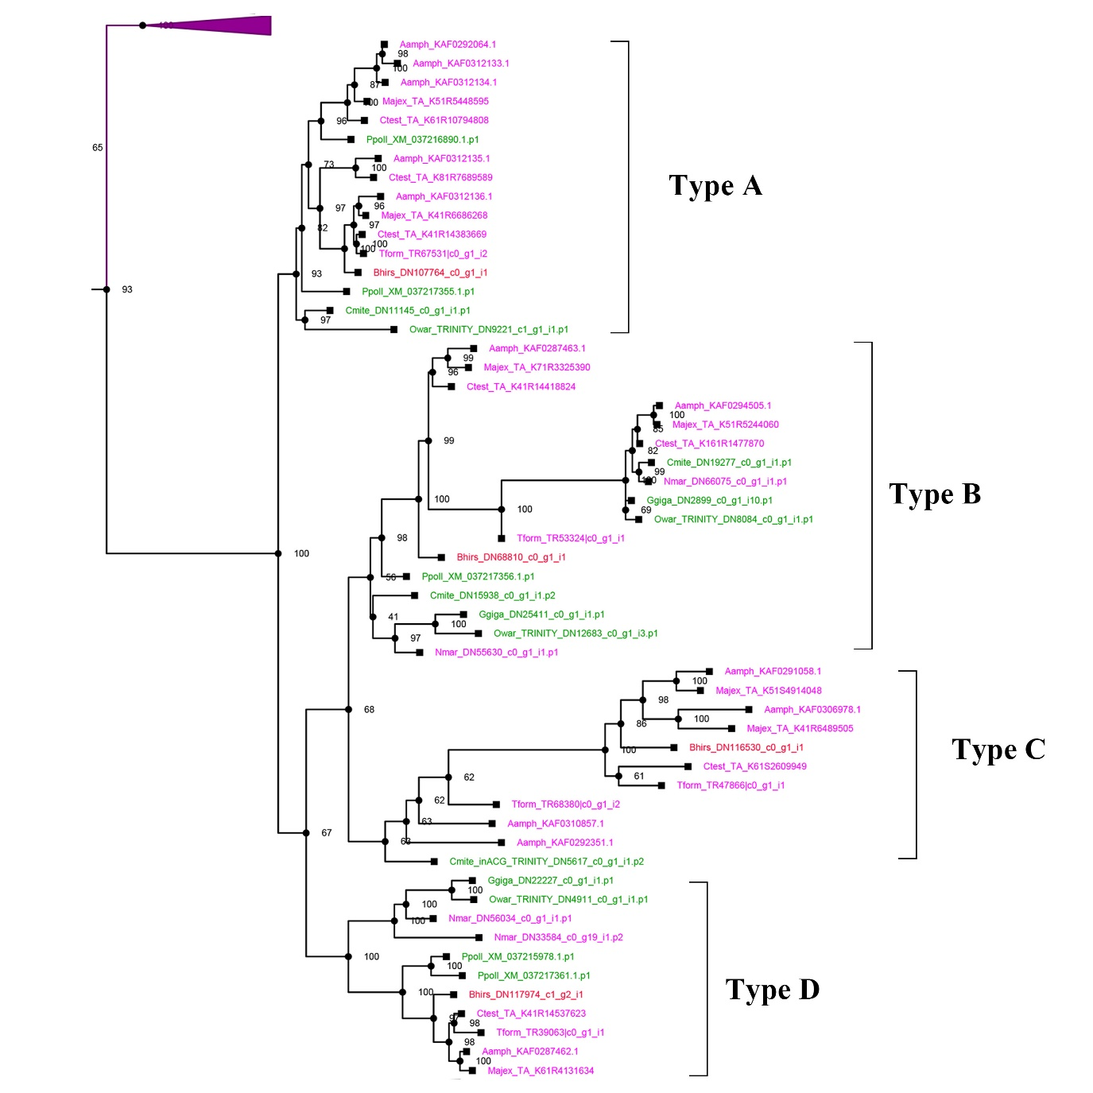

Figure S2
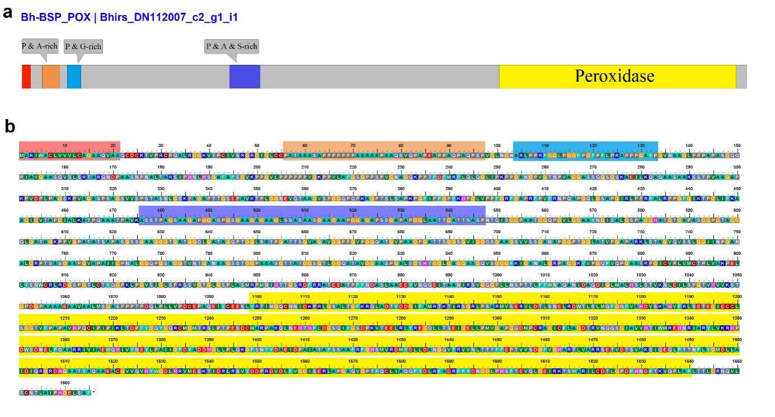

Figure S3
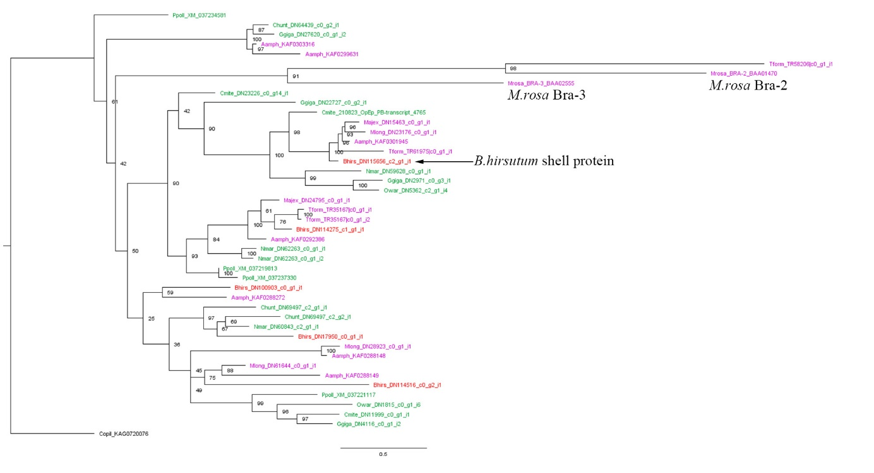

Table S1. Phylostratum assignment of Bh-BSPs based on BLASTP against nr result
Cement Protein name | BSP/BSSP | Annotation | Blast_hit | Evalue | acc | Taxa | PS level
Bhirs_DN101626_c1_g1_i1 | Bh_BSSP | LOC122393488 | uncharacterized protein LOC122393488 | 1E-32 | XP_043245474.1 | Cirripedia | 11
Bhirs_DN102860_c1_g1_i1 | Bh_BSSP | Asp-Ser repeat containing F-like | hypothetical protein FJT64_022155 | 6E-18 | KAF0306278.1 | Cirripedia | 11
Bhirs_DN107764_c0_g1_i1 | Bh_BSP | Carbonic anhydrase | carbonic anhydrase 2-like | 0 | XP_043209549.1 | Eumetazoa | 5
Bhirs_DN107933_c0_g1_i1 | Bh_BSSP | FJT64_007420_homolog | hypothetical protein FJT64_007420 | 0.003 | KAF0294983.1 | Cirripedia | 11
Bhirs_DN108902_c0_g2_i1 | Bh_BSSP | FJT64_008003_homolog | hypothetical protein FJT64_008003 [Cirripedia] | 2E-115 | KAF0294304.1 | Cirripedia | 11
Bhirs_DN109748_c0_g1_i1 | Bh_BSSP | FJT64_008002_homolog | hypothetical protein FJT64_008002 [Cirripedia] | 1E-107 | KAF0294303.1 | Cirripedia | 11
Bhirs_DN112007_c2_g1_i1 | Bh_BSP | POX | peroxidase-like isoform X2 | 0 | XP_043224303.1 | Pancrustacea | 10
Bhirs_DN113120_c2_g2_i2 | Bh_BSSP | Asp-Ser repeat containing F-like | serine-aspartate repeat-containing protein F-like | 0.036 | XP_043226407.1 | Cirripedia | 11
Bhirs_DN113476_c6_g1_i1 | Bh_BSP | Serine_Protease | Serine protease easter | 1E-153 | KAF0305686.1 | cellular organisms | 1
Bhirs_DN115464_c0_g2_i1 | Bh_BSP | collagen alpha-1(III) chain-like | collagen alpha-1(III) chain-like | 4E-94 | XP_043224125.1 | Pancrustacea | 10
Bhirs_DN115559_c2_g1_i2 | Bh_BSP | Annexin-B10 | Annexin B10 [Protostomia] | 0 | KAF0305229.1 | Protostomia | 7
Bhirs_DN115656_c2_g1_i1 | Bh_BSP | CLECT | C-type lectin lectoxin-Lio2-like | 3E-42 | XP_037075708.1 | Pancrustacea | 10
Bhirs_DN115958_c0_g1_i1 | Bh_BSP | Collectin-like isoform X1 | collectin-10-like isoform X1 | 3E-11 | XP_035692282.1 | Eumetazoa | 5
Bhirs_DN116530_c0_g1_i1 | Bh_BSP | Carbonic anhydrase | carbonic anhydrase 12-like | 6E-72 | XP_043193035.1 | Eumetazoa | 5
Bhirs_DN116703_c6_g2_i1 | Bh_BSSP | FJT64_001459_homolog | hypothetical protein FJT64_001459 | 6E-17 | KAF0287525.1 | Cirripedia | 11
Bhirs_DN117275_c0_g2_i2 | Bh_BSSP | FJT64_008005_homolog | hypothetical protein FJT64_008005 | 3E-117 | KAF0294306.1 | Cirripedia | 11
Bhirs_DN117974_c1_g2_i1 | Bh_BSP | Carbonic anhydrase | carbonic anhydrase 1-like | 2E-165 | XP_043196971.1 | Bilateria | 6
Bhirs_DN120109_c0_g2_i9 | Bh_BSP | EGF/FOLN_domain_containing | uncharacterized protein LOC122383893 isoform X9 | 0 | XP_043226683.1 | Pancrustacea | 10
Bhirs_DN177080_c1_g1_i1 | Bh_BSSP | novel | novel | novel | novel | Target species | 12
Bhirs_DN22363_c0_g1_i1 | Bh_BSP | chitin deacetylase 1-like | chitin deacetylase 1-like | 0 | XP_043233856.1 | cellular organisms | 1
Bhirs_DN40976_c0_g1_i1 | Bh_BSP | novel | novel | novel | novel | Target species | 12
Bhirs_DN60548_c0_g1_i1 | Bh_BSSP | novel | novel | novel | novel | Target species | 12
Bhirs_DN61156_c0_g3_i1 | Bh_BSSP | novel | novel | novel | novel | Target species | 12
Bhirs_DN64114_c0_g1_i1 | Bh_BSSP | novel | mucin-1-like | 1E-19 | XP_052258942.1 | cellular organisms | 1
Bhirs_DN68810_c0_g1_i1 | Bh_BSP | Carbonic anhydrase | carbonic anhydrase 1-like | 2E-150 | XP_037073251.1 | Bilateria | 6
Bhirs_DN69553_c0_g1_i1 | Bh_BSP | Fibropellin-like | fibropellin-1-like isoform X2 | 0 | XP_043214271.1 | Pancrustacea | 10
Bhirs_DN80141_c1_g1_i1 | Bh_BSP | Cuticle-like | pro-resilin-like | 2E-16 | XP_043204547.1 | Pancrustacea | 10
Bhirs_DN84923_c1_g31_i1 | Bh_BSP | AchReceptor-like | Acetylcholine receptor subunit alpha-type acr-16 | 9E-61 | KAF0300376.1 | Bilateria | 6
Bhirs_DN92775_c0_g1_i5 | Bh_BSSP | Pro-rich 36-like | peroxisome proliferator-activated receptor gamma coactivator-related protein 1 | 3E-07 | XP_041065244.1 | cellular organisms | 1
Bhirs_DN94351_c1_g4_i1 | Bh_BSSP | novel | novel | novel | novel | Target species | 12
Bhirs_DN96994_c0_g1_i1 | Bh_BSSP | novel | novel[Target species] | novel | novel | Target species | 12
Table S2. Amino acid composition of Bh-BSSPs
Protein name | A | R | N | D | C | Q | E | G | H | I | L | K | M | F | P | S | T | W | Y | V
Bh-BSSP_DRYrich | 4.27% | 21.35% | 2.85% | 17.44% | 1.42% | 1.78% | 2.14% | 7.83% | 2.49% | 2.14% | 4.27% | 1.78% | 2.14% | 2.85% | 1.78% | 5.34% | 2.14% | 1.07% | 11.03% | 3.91%
Bh-BSSP_DSGrich_iso1 | 3.59% | 4.04% | 2.24% | 18.39% | 0.45% | 2.24% | 9.87% | 13.00% | 0.90% | 0.45% | 4.93% | 5.83% | 0.45% | 2.24% | 1.35% | 17.94% | 4.93% | 0.00% | 1.35% | 5.83%
Bh-BSSP_FJT64_007420_homolog | 4.72% | 7.55% | 1.89% | 9.43% | 0.94% | 2.83% | 3.77% | 7.55% | 5.66% | 1.89% | 5.66% | 5.66% | 0.94% | 2.83% | 8.49% | 9.43% | 0.94% | 2.83% | 12.26% | 4.72%
Bh-BSSP_FJT64_008003_homolog | 8.00% | 4.50% | 4.00% | 6.00% | 2.50% | 2.00% | 4.00% | 8.00% | 1.00% | 5.00% | 14.00% | 3.50% | 2.00% | 4.00% | 6.00% | 6.50% | 7.50% | 1.50% | 1.00% | 9.00%
Bh-BSSP_FJT64_008002_homolog | 5.36% | 5.80% | 2.23% | 6.25% | 1.34% | 1.34% | 4.91% | 12.95% | 0.89% | 5.80% | 11.61% | 4.02% | 2.68% | 5.80% | 4.91% | 5.36% | 4.91% | 4.46% | 0.89% | 8.48%
Bh-BSSP_DSGrich_iso2 | 2.48% | 1.86% | 4.97% | 22.11% | 0.12% | 1.12% | 7.70% | 14.16% | 1.37% | 0.50% | 1.49% | 3.23% | 0.12% | 0.99% | 2.86% | 29.07% | 2.24% | 0.00% | 0.87% | 2.73%
Bh-BSP_collagen alpha-1(III) chain-like | 10.82% | 9.02% | 1.80% | 8.25% | 1.55% | 10.05% | 2.84% | 12.11% | 1.29% | 2.06% | 5.15% | 2.58% | 0.52% | 5.93% | 9.02% | 9.02% | 2.58% | 0.26% | 1.80% | 3.35%
Bh-BSSP_FJT64_001459_homolog | 18.53% | 1.27% | 2.28% | 3.30% | 0.00% | 1.27% | 0.76% | 15.23% | 0.51% | 1.02% | 8.12% | 1.78% | 0.25% | 2.54% | 18.02% | 14.47% | 4.57% | 0.25% | 0.51% | 5.33%
Bh-BSSP_FJT64_008005_homolog | 8.06% | 3.32% | 6.16% | 6.16% | 0.95% | 3.79% | 3.79% | 8.06% | 0.47% | 2.84% | 12.32% | 4.74% | 3.79% | 5.21% | 9.48% | 5.69% | 6.16% | 1.42% | 0.47% | 7.11%
Bh-BSSP_APrich_type3 | 27.32% | 3.28% | 5.46% | 1.09% | 0.00% | 6.01% | 2.19% | 7.65% | 0.55% | 1.09% | 6.01% | 0.55% | 0.00% | 2.19% | 13.11% | 3.28% | 7.10% | 0.00% | 4.92% | 8.20%
Bh-BSSP_GSrich_type2 | 11.59% | 6.83% | 0.41% | 2.90% | 0.00% | 9.32% | 0.83% | 25.26% | 1.04% | 1.04% | 2.69% | 0.83% | 0.21% | 9.73% | 7.25% | 14.49% | 3.31% | 0.00% | 0.21% | 2.07%
Bh-BSSP_APrich_type4 | 26.18% | 1.26% | 0.95% | 3.47% | 0.32% | 1.26% | 5.68% | 8.83% | 0.63% | 0.32% | 5.68% | 0.63% | 0.63% | 1.89% | 20.50% | 1.89% | 5.68% | 0.00% | 2.21% | 11.99%
Bh-BSSP_QAPrich_type1 | 16.84% | 1.03% | 0.52% | 1.89% | 0.34% | 29.04% | 1.89% | 2.75% | 3.09% | 0.69% | 5.84% | 1.55% | 0.17% | 1.37% | 14.78% | 2.58% | 4.98% | 0.69% | 3.09% | 6.87%
Bh-BSSP_EPrich | 13.57% | 10.05% | 1.51% | 1.76% | 0.50% | 6.03% | 15.83% | 4.02% | 0.00% | 0.50% | 2.76% | 7.79% | 0.50% | 0.50% | 20.60% | 6.53% | 3.27% | 1.76% | 0.50% | 2.01%
Bh-BSSP_QAPrich_type2 | 22.52% | 1.24% | 1.03% | 1.86% | 0.62% | 27.69% | 2.07% | 1.24% | 2.07% | 0.41% | 5.58% | 1.24% | 0.21% | 2.69% | 12.40% | 2.48% | 6.40% | 0.00% | 3.10% | 5.17%
Bh-BSSP_APrich_type1 | 25.22% | 1.60% | 0.18% | 1.24% | 0.36% | 6.75% | 3.73% | 11.01% | 0.89% | 0.53% | 6.04% | 1.78% | 0.36% | 1.95% | 20.60% | 9.06% | 4.62% | 0.18% | 0.89% | 3.02%
Bh-BSSP_GSrich_type1 | 11.58% | 6.95% | 0.42% | 2.95% | 0.00% | 9.05% | 0.84% | 25.05% | 1.05% | 1.05% | 2.74% | 0.84% | 0.21% | 9.68% | 7.37% | 14.53% | 3.37% | 0.00% | 0.21% | 2.11%

Table S3. RLCDs in Bh-BSPs/Bh-BSSPs
Protein name | Protein length | RLCD sequences* | RLCD type | No. of repeat | T-REKs Psim score | start
Bh-BSSP_DSGrich_iso1 | 223 | EKSDTDD | tandem repeat | 2 | 0.85 | 96 to 109
 |  | GENSKSDDSDSNSG-----DSDSDSDSG | tandem repeat | 2 | 0.63 | 224 to 587
Bh-BSSP_DSGrich_iso2 | 805 | GENSKSDDSDSNSG-----DSDSDSDSG | tandem repeat | 22 | 0.63 | 224 to 587
 |  | EPAVE | tandem repeat | 3 | 0.8 | 728 to 742
 |  | EKSDTDD | tandem repeat | 2 | 0.85 | 96 to 109
Bh-BSSP_DRYrich | 281 | DYDDRRRG(R/Y) | tandem repeat | 2 | 0.89 | 112 to 129
 |  | DRRDD | tandem repeat | 3 | 0.8 | 155 to 169
Bh-BSSP_APrich_type1 | 317 | PAVE | tandem repeats | 26 | 0.7-0.78 | 51 to 202
 |  | PTEAPAGP | tandem repeats | 6 | 0.75 | 242 to 289
Bh-BSSP_APrich_type2_Cter | 183 | PGTAVN | tandem repeat | 7 | 0.71 | 1 to 42
Bh-BSSP_QAPrich_type1 | 484 | AQQQ | tandem repeats | 14 | 0.84 | 76 to 127
 |  | Q(A/T)Q | tandem repeats | 19 | 0.87, 0.7 | 191 to 223, 231 to 254
 |  | (Q/H)PAPVA | tandem repeats | 11 | 0.84 | 362 to 427
 |  | PSGPAAGT | tandem repeats | 7 | 0.85 | 477 to 532
Bh-BSSP_QAPrich_type2 | 582 | QPV-PH- | tandem repeats | 18 | 0.84 | 99 to 188
 |  | Q | Single amino acid stretch* | NA | NA | 267 to 366
 |  | QLQQ | tandem repeats | 4 | 0.81 | 394 to 409
 |  | APATY | tandem repeats | 6 | 0.75 | 469 to 498
Bh-BSSP_Prich_Nter | 563 | QPGPASAEP | tandem repeats | 11 | 0.88, 0.94 | 133 to 159, 161 to 232
 |  | A | single amino acid stretch | NA | NA | 348 to 365
Bh-BSSP_Prich_Cter | 394 | GPASGTSS | tandem repeats | 6 | 0.79 | 1 to 53
 |  | KPDSPLAGVVAGL(M/T) | tandem repeats | 2 | 0.92 | 173 to 200
Bh-BSSP_EPrich | 398 | AEARAAE | tandem repeats | 4 | 0.78 | 92 to 119
 |  | EPKP | tandem repeats | 30 | 0.92, 0.78 | 223-282, 286 to 345
Bh-BSSP_GSrich_iso2 | 483 | RAGS | tandem repeats | 4 | 0.875 | 30 to 45
 |  | GQQGFPG | tandem repeats | 18 | 0.71 | 273 to 401
Bh-BSSP_GSrich_iso1 | 475 | RAGS | tandem repeats | 4 | 0.875 | 30 to 45
 |  | GQQGFPG | tandem repeats | 8 | 0.85, 0.76 | 289 to 323, 350 to 370
Bh-annexin | 1624 | SRSG | tandem repeats | 11 | 0.7
 |  | GAPGGH | tandem repeats | 8 | 0.68
 |  | LGEDGAGQRRR | tandem repeats | 6 | 0.93 | 850
Bh-BSSP_collagen_like | 388 | FGGPRGGPAD-Q | tandem repeat | 4 | 0.92 | 153 to 196
Bh-BSP_CA-b | 352 | GSEG | tandem repeat | 5 | 1 | 328 to 347

