Table 3 Molecular docking diagram of active compounds of HYCA with KT1 and TP53
active compounds | CAS number | binding energy with AKT1（kJ/mol） | binding energy with TP53（kJ/mol） | molecular structure
Kaempferol | 520-18-3 | -26.2 | -20.5 | 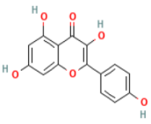
Quercetin | 117-39-5 | -32.4 | -21.1 | 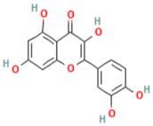
Beta-sitosterol | 83-46-5 | -32.3 | -28.5 | 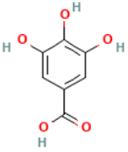
Luteolin | 491-70-3 | -26.2 | -20.5 | 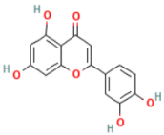
Formononetin | 485-72-3 | -29.1 | -23.7 | 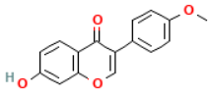
Stigmasterol | 83-48-7 | -36.2 | -28.9 | 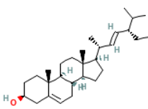
 | 465-99-6 | -30.8 | -29.8 | 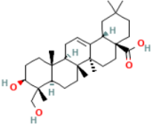
  Hederagenin Hederagenin Hederagenin（hederagenin）
7-O-  Methylisomucronulato | ------ | -26.9 | -20.9 | 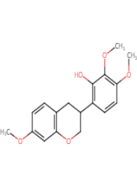
Anhydroicaritin | 118525-40-9 | -26.8 | -25.5 | 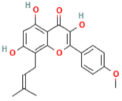
Kumatakenin | 3301-49-3 | -27.3 | -23.2 | 