Scheme 1.
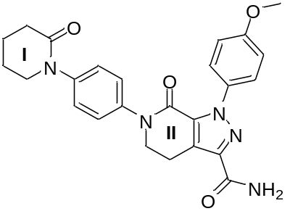

Scheme 2
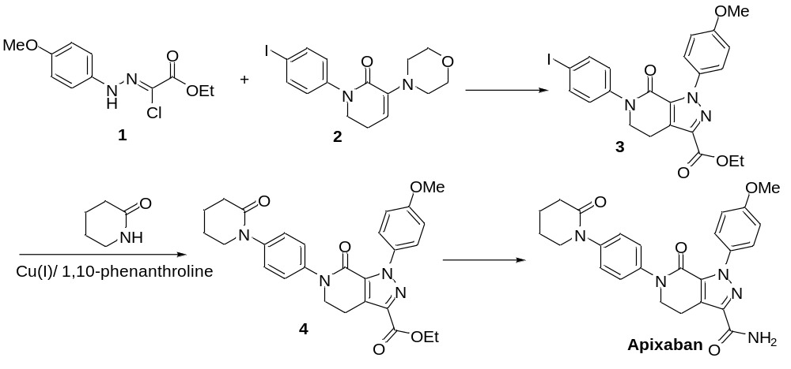

Scheme 3
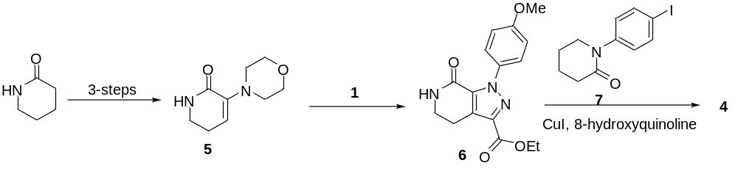

Scheme 4

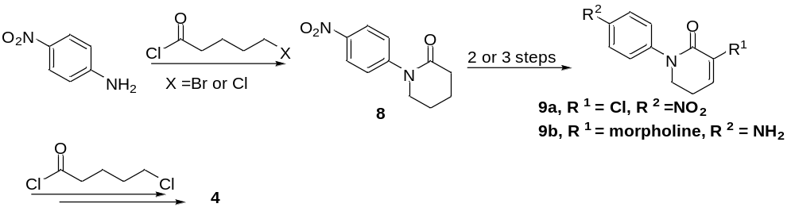

Scheme 5
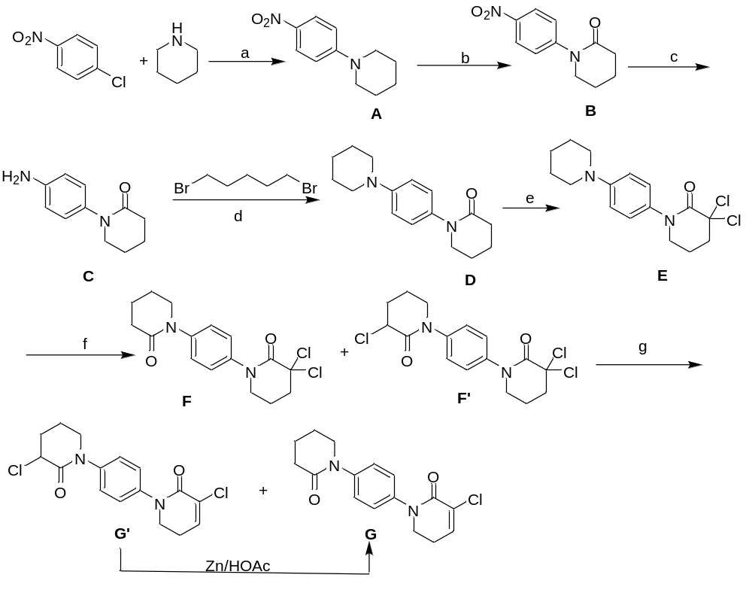
Reaction conditions: a) piperidine (1 mol), 4-chloro nitrobenzene (0.5 mol), Na₂CO₃ (1 mol), 100 °C, 3 h; b) NaClO₂ (3 eq), CO₂ balloon; c) FeCl₃/Charcoal (15 mol %), aq. hydrazine (5 eq), reflux; d) 1,5-dibromopentane (1.2 eq), K₂CO₃ powder (1.5 eq); e) PCl₅ (3 eq); f) NaClO₂ (3 eq), CO₂ balloon; g) Li₂CO₃/LiCl

Scheme 6
