Table 1. The chemical features and docking scores between CD26-Caveolin-1 and selected compounds.
Molecule Name | Molecule Structure | Molecular Weight | Docking Score  (kcal/mol)
Crocin | 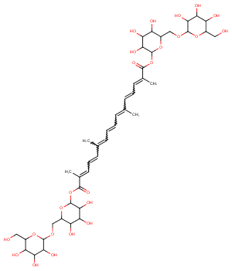 | 976.97 | -14.18
Poliumoside | 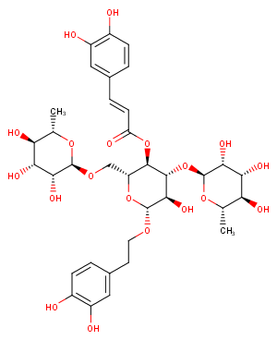 | 770.73 | -13.70
Canagliflozin | 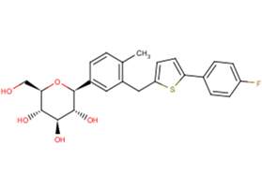 | 444.52 | -9.78

