Extended data figures and tables

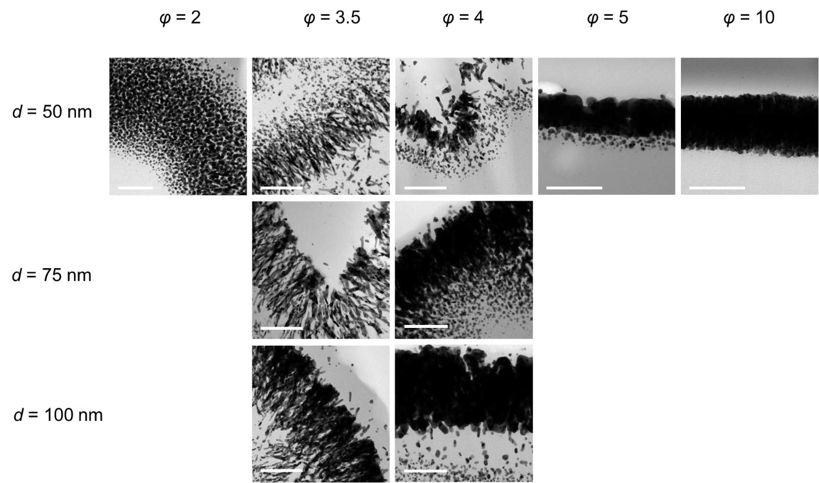

Extended Data Figure 1. Cross-section HRTEM images of Au-PDMS nanophases with various φ and deposition thickness of Au. Structural variety from particles, elongated nanoparticles, needles, to films was observed.

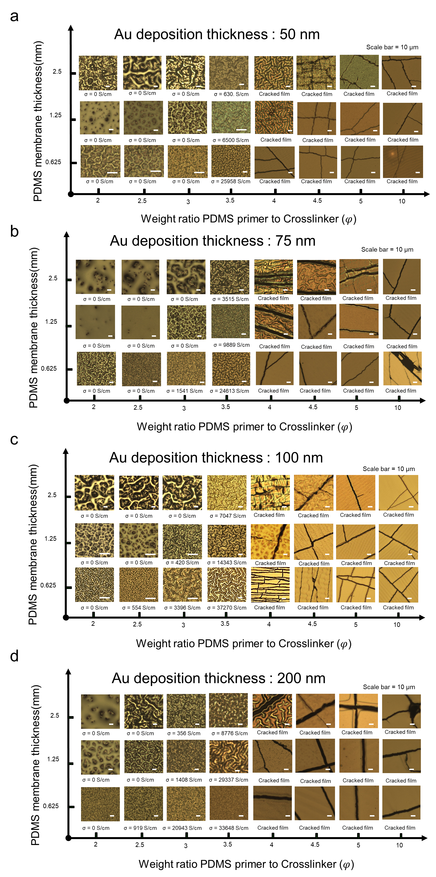
Extended Data Figure 2. Surface morphology changes and electrical conductivity of PDMS membranes with deposited Au vary based on the mixing ratios (φ) of the base PDMS polymer to the curing agent in the elastomer substrate, as well as different membrane thicknesses and metal deposition thicknesses: (a) 50 nm, (b) 75 nm, (c) 100 nm, and (d) 200 nm. The corresponding electrical conductivity, measured using the four-point probe method, also reveals distinct features.

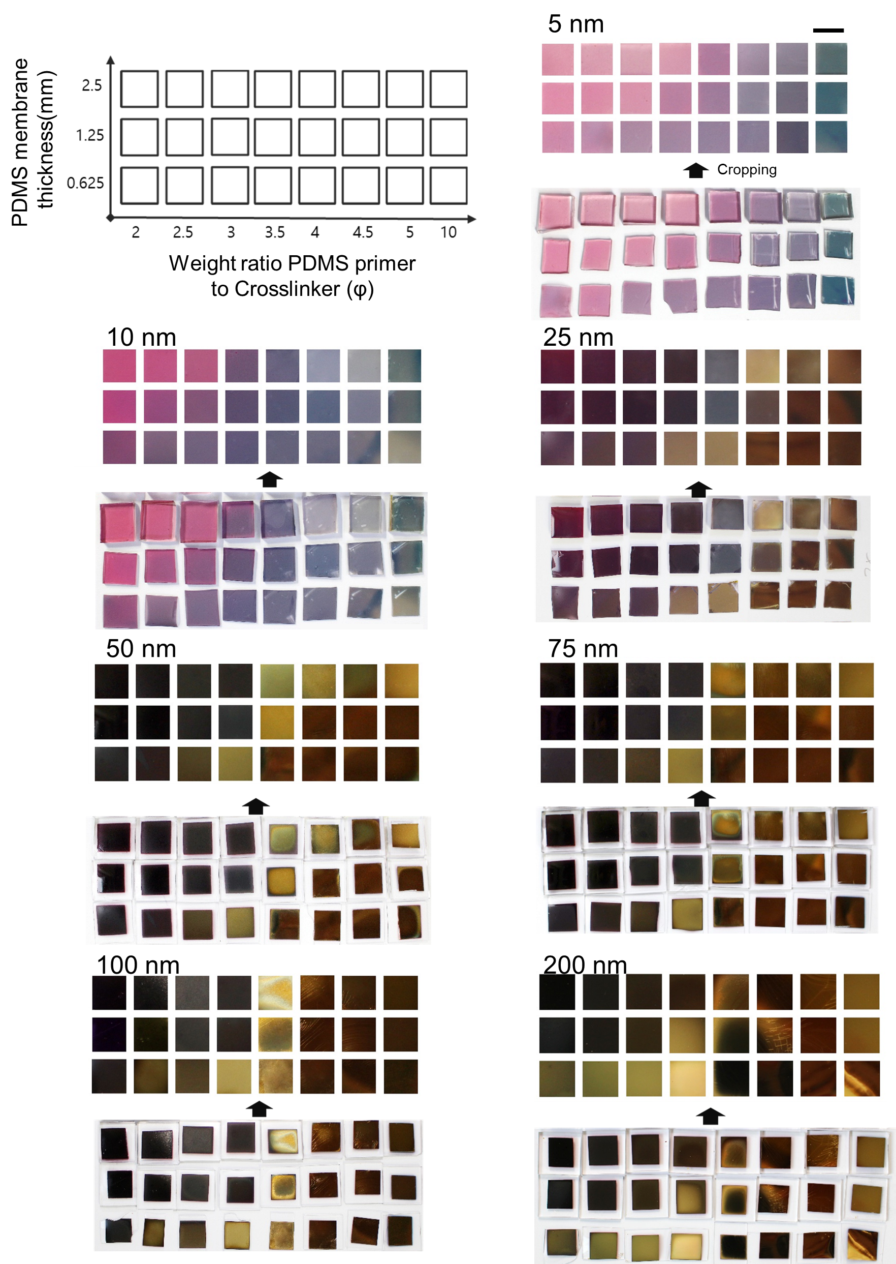
Extended Data Figure 3. Variations in Au–PDMS membrane. Photographs showing various colors of Au-deposited PDMS samples with various mixing ratio (φ) of base PDMS polymer to curing agent in the elastomer substrate, those membrane thickness, and deposition thickness of the metal. Scale bars denote 1 cm.
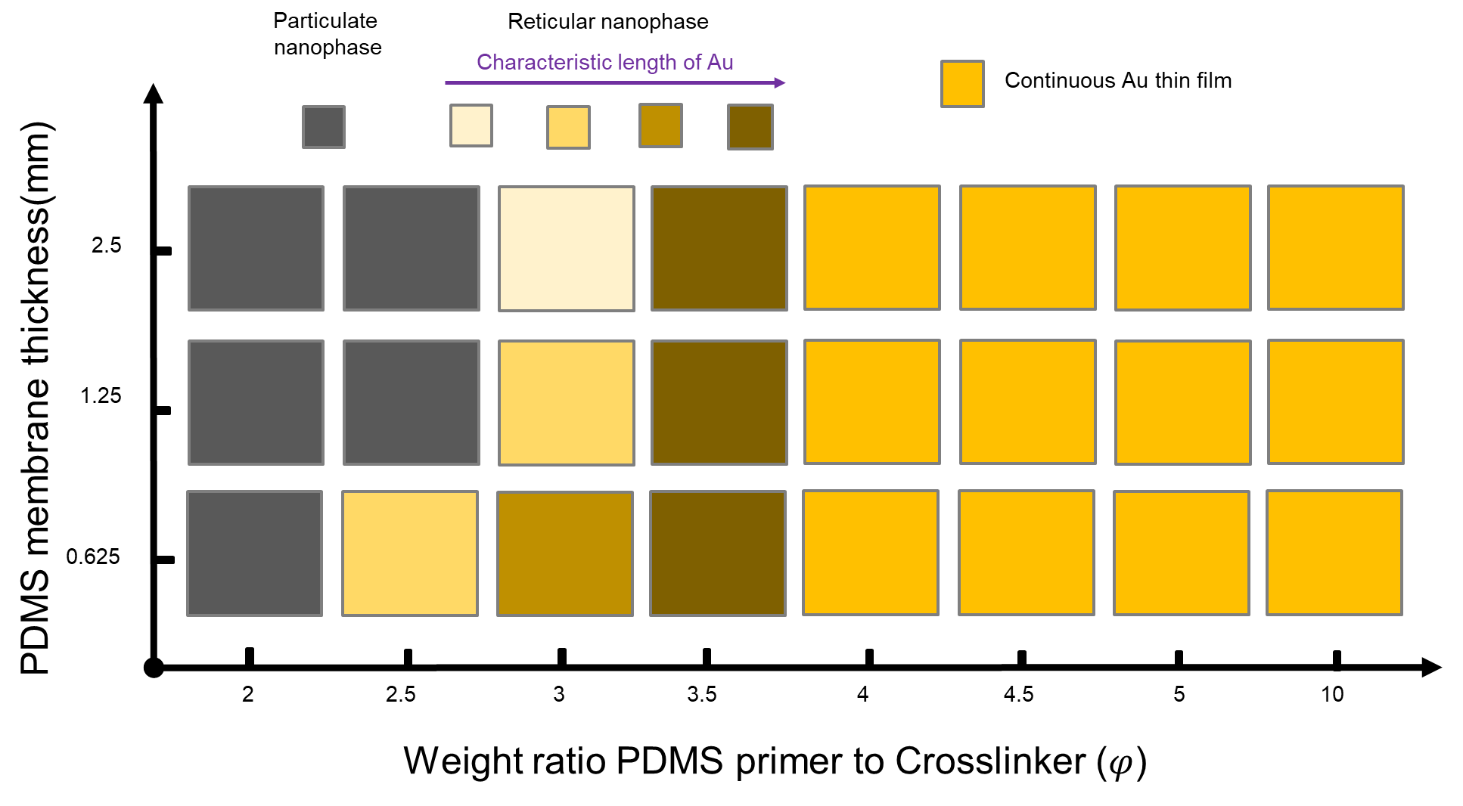
Extended Data Figure 4. Classification table of Au-PDMS nanophases based on the process variables; membrane thickness and φ at 100 nm of deposition thickness. Conditions in which electrical conductivity could not be measured were classified as having particulate nanophases, and conditions in which electrical conductivity was measured were classified as reticular nanophase.

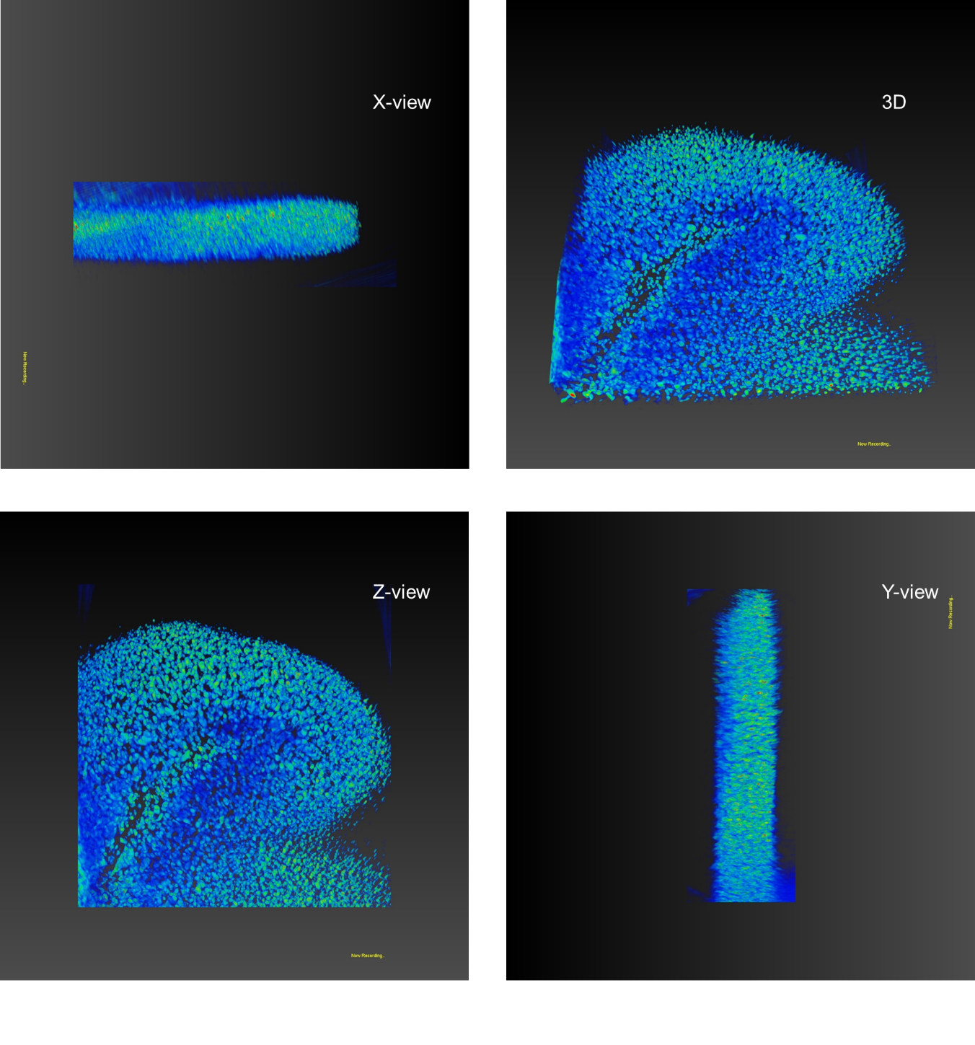
Extended Data Figure 5. 3D TEM tomography images of Au 100 nm-thick deposited on the PDMS membrane (φ = 3.5), showing the interconnected and interpenetrated gyrified metal-elastomer nanophase. The brightness in the tomography images indicates 3D density of Au in the PDMS matrix. Scale bar = 300 nm.

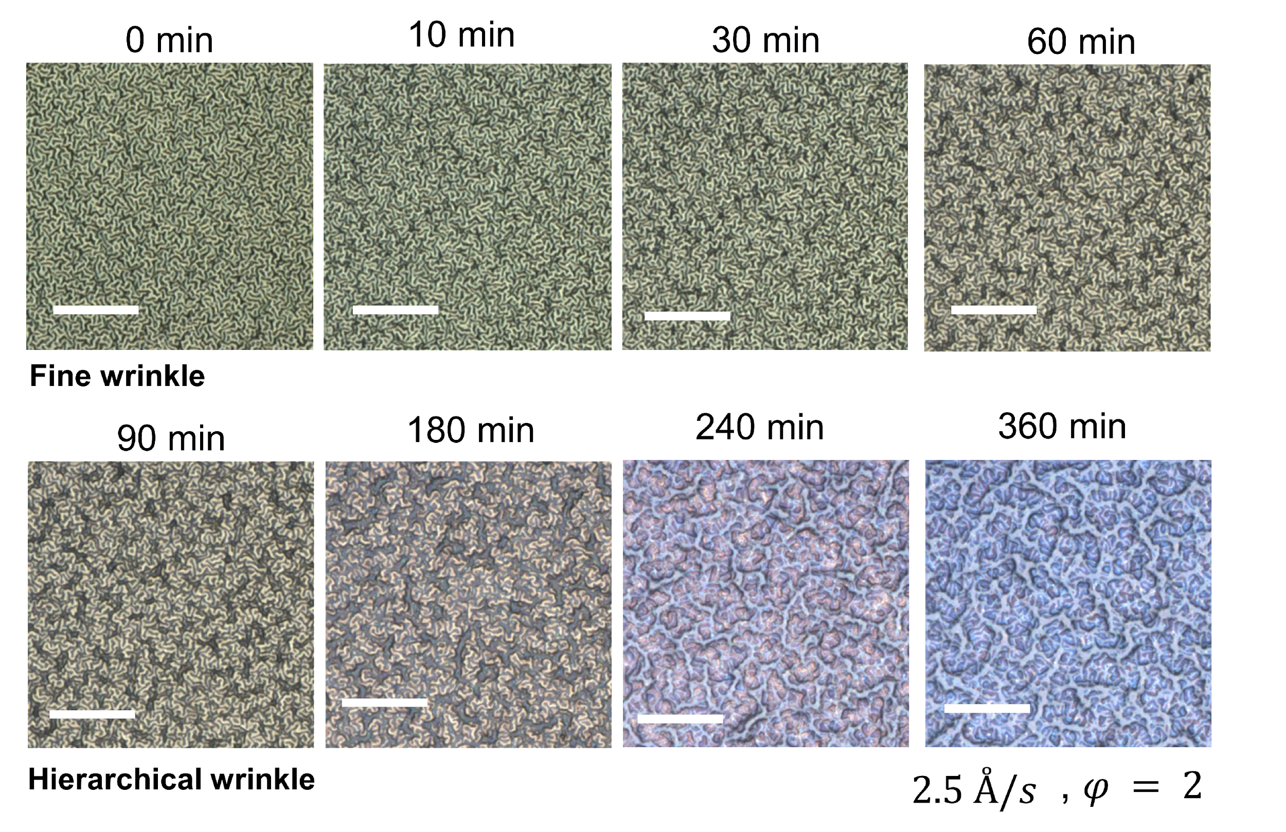
Extended Data Figure 6. LSM images of gyrification of Au-PDMS nanophases at φ = 2.0 and 2.5 Å/s. The evolution of gyrification at φ = 2.0 occurs more rapidly compared to that at φ = 3.5 resulting in distinct morphologies (as depicted in Fig. 3a). The scale bar corresponds to 10 μm.

