Supplementary Information for

Kinetically Controlled Three-dimensional Complex of Reticular Metal–Elastomer Nanophase

Soosang Chae, Won Jin Choi*, Lisa Julia Nebel, Chang Hee Cho, Quinn A. Besford, André Knapp, Oliver Sander, Pavlo Makushko, Yevhen Zabila, Oleksandr Pylypovskyi, Min Woo Jeong, Stanislav Avdoshenko, Denys Makarov, Yoon Jang Chung, Andreas Fery, Jin Young Oh* and Tae Il Lee*

Correspondence to:
Won Jin Choi, email: choi21@llnl.gov,
Tae Il Lee, email: t2.lee77@gachon.ac.kr,
Jin Young Oh, email: jyoh@khu.ac.kr

This PDF file includes:

Supplementary Note 1 to 7
Additional reference
Figs. S1 to S19
Tables S1 to S3
Captions for Video S1 to S6

Other Supplementary Information for this manuscript include the following:

Videos S1 to S6

Supplementary Note 1.
Analytical mechanics of gyrification
The gyrification index (GI) is a metric used to quantify the level of gyrification of a surface, and we have adopted this concept here to compare our structural features of 3D complex of nanophase with other wrinkles/buckles. We have specifically focused on two parameters: the amplitude of wrinkles and the number of wrinkles per 100 µm. As one might expect, higher GI values are achieved with greater numbers and larger amplitudes of wrinkles. We denote the amplitude as "x" and the number per 100 µm as "y," with examples represented as (x, y) (Supplementary Figs. S1a–d).
However, attaining a high GI value is not a straightforward task due to the trade-off correlation between wrinkle amplitudes and their density. This negative correlation becomes evident when examining the equations for wavelength (λ) and amplitude (A) of wrinkles, as outlined below:

$λ=2πh{(\overline{E_{p}}/3\overline{E_{m}})}^{1/3} (1)$
$A = h\sqrt{ε/ε_{c}-1}$ (2)
where $h$ is the film thickness, $\overline{E}=E/(1-ν^{2})$ is the plane-strain elastic modulus, $E$ is the elastic modulus, $ν$ is the Poisson’s ratio, $ε_{c}=\frac{1}{4}{(3\overline{E_{m}}/\overline{E_{p}})}^{2/3}$ is the critical wrinkling strain, $ε$ is the compressive strain¹.
Here, the subscripts “p” and “m” indicate PDMS substrate and metallic thin film, respectively. We found that both $λ$ and A are proportional to $\overline{E_{p}}/3\overline{E_{m}}$; thus, the number of wrinkles per 100 µm (y) is inversely proportional to this value as plotted in Supplementary Fig. S1e. Here, the ratio $\overline{E_{p}}/3\overline{E_{m}}$ essentially reflects the elastic modulus relationship between the metal film and PDMS substrate. It directly suggests that, in order to achieve a high GI value, the value of $\overline{E_{p}}/3\overline{E_{m}}$ should be approximately 10, as shown in Supplementary Fig. S1e. However, achieving this desired value is challenging since it requires the elastic modulus of the metallic film to be comparable to that of PDMS. In the case of conventional metallic films like Au, which have a modulus of around tens of GPa, and PDMS with a modulus of several MPa, obtaining the necessary GI value becomes unfeasible due to the substantial difference in elastic modulus^{2,3}.

Supplementary Note 2.
Optical analysis of Au-PDMS nanophase
The nanophase starts to grow with Au nanoparticles close to spheres at the beginning of deposition and thickens with Au nanoneedles as deposition progresses. An electromagnetic (EM) study of the nanosphere and nanoneedle provides further insight on the broadening of the absorbance spectrum. The results indicate that when the shape of a particle is a sphere, the peak positions are not changed by the radius until it grows from 1 nm to 20 nm (Supplementary Figs. S2c–e). Only the amplitudes of peaks increase by a factor of 5. Because the ratio between peaks and baseline is also changed by the radius, color change possibly occurs with the growth of the nanosphere; however, according to HRTEM analysis, the structure of Au nanostructures changes from spheres to needles for reticular formation. This may be a well-known phenomenon, but an EM study was conducted based on the dimensions of nanoneedles obtained from the TEM analysis (Supplementary Figs. 2f–h). As the shape of Au nanostructures changed from nanosphere and nanorod to nanoneedle, the main LSPR peaks exhibit a red shift (Supplementary Fig. 2g). LSPR depends strongly on the length (l) of the nanostructure, and in general, the peak of resonance is proportional to the l of the Au structures based on the lumped circuit model. The resonance peak can be defined as f = 1/2π(LC)^{1/2}, where L and C are the inductance and capacitance of the Au nanostructure. Since both of L and C are proportional to the l of Au nanoneedle, then f is inversely proportional to l; thus, the wavelength of LSPR is proportional to l. Similar to the case in nanospheres, the magnitude of s for Au nanoneedles increases as l increases (Supplementary Figs. 2h).

Supplementary Note 3.
Formation Mechanism of Au-PDMS nanophases.
While Au deposition on PDMS with φ = 10 results in typical thin-films of Au layers, PDMS with φ < 10 no longer provides a conducive surface for the free diffusion of Au atoms. This is due to the interaction between Si-H groups in the excess crosslinker and Au atoms, leading to the formation of Si-Au chemical bonds. Excess crosslinkers are distributed in an equilibrium concentration throughout the volume and surface of PDMS when prepared under φ < 10 conditions. As φ decreases, the absolute concentration of these excess linkers increases.
When Au nucleates on the PDMS surface and forms small nanoparticles, the crosslinkers occupy the interface between Au nanoparticles and PDMS, resulting in the formation of Si-Au bonds. This phenomenon can be understood in terms of surface energy: the introduction of an Au nanoparticle onto PDMS replaces the original PDMS/vacuum interface with new PDMS/Au and Au/vacuum interfaces. Given that the interfacial energy of PDMS/vacuum (19.00 mN/m) is lower than that of Au/vacuum (1,500 mN/m), the system seeks to minimize the overall surface energy. Consequently, the system favors the presence of the Au/vacuum interface over that of the PDMS/vacuum interface.
Driven by this energy minimization principle, the excess crosslinkers spontaneously migrate to the surface of the Au nanoparticle, leading to the creation of Si-Au bonds. As illustrated schematically in Supplementary Fig. S3a, the migration of crosslinkers can be visualized as occurring upward along the surface of the Au nanoparticle from the triple junction involving Au, PDMS, and vacuum.
Here, let's consider a scenario where the deposition of Au is ongoing while the crosslinker is undergoing migration. When Au atoms are introduced onto the substrate, they do not adhere to the regions already occupied by the crosslinker. Instead, they settle onto the surfaces of Au nanoparticles that have not yet been covered by the migrating crosslinkers. This process facilitates the growth of the Au nanoparticles.
In cases where the migration flux of the crosslinker is significantly faster than the deposition flux of Au, the Au nanoparticle becomes completely enveloped by the crosslinker, preventing further growth. As a result, any additional incoming Au atoms can only lead to the nucleation and growth of secondary Au nanoparticles on other sites of the PDMS surface. These secondary Au nanoparticles quickly become coated with crosslinkers once again (Supplementary Fig. S3b). This mechanism elucidates the formation process of particulate nanophases.
However, when the deposition flux of Au is comparable to the migration flux of the crosslinker, continuous growth of Au occurs near the upper surface of the Au nanoparticle that remains unoccupied by the crosslinker. Concurrently, the crosslinkers continue their migration along the newly grown Au surface (Supplementary Fig. S3c). This mechanism corresponds to the formation process of the reticular nanophase.
To validate the nanophase formation mechanisms discussed above, we conducted observations of microstructures in nanophases based on varying deposition fluxes of Au, as presented in Supplementary Fig. S4. As the deposition flux increases, a nanophase consisting of progressively longer Au nanoneedles emerges, providing support for our proposed reticular nanophase formation mechanism.
Drawing upon our experimental findings, we have formulated a concise summary of the mechanism underlying nanophase formation as follows: (I) Under conditions where the migration rate of the excess crosslinker significantly exceeds the deposition rate of Au, the resulting nanophase takes on the form of discrete particles; (II) When these two rates are approximately equal, a nanophase characterized by a reticular structure is generated; and (III) In cases where the deposition rate greatly surpasses the migration rate of the excess crosslinker, the outcome is a straightforward deposition of a metal thin film, devoid of nanophase formation.

Supplementary Note 4.
Plain PDMS membrane mechanical characterization for simulation
To get simulations of labyrinth 3D complex, a simulation model based on real hyperelastic substrate behavior was necessary. This simulation required a more detailed determination of stress-strain behavior. The PDMS system (Sylgard 184, Dow Corning) allows the modification of the mechanical parameters by changes of the component ratio and by different curing procedures. The characterization was done with uniaxial tensile tests for different component ratios with 5-6 single specimens to get the stress-strain relationship. Every tensile raw data file includes the measured specimen geometry and measured tensile force $F_{t}$ [N] in combination with the elongation way $s_{e}$ [mm]. A precise raw data processing was required to get an averaged master stress-strain curve from all specimens for each tested variant of component ratio and curing temperature. This was done with a Python 3.7 script that averaged all single stress-strain curves by stack processing to one averaged master stress-strain curve, which was then used as the basis for mechanical characterization.
The averaging process itself was made between the maximum single start strain value and the mean fracture strain value for all single tests of one variant. This process requires a uniform strain interval, which was not naturally given in the result files. Therefore, all measured points had to be interpolated between existing points to get a global strain interval which is valid for all single test results. The averaging process was done up to the point of the fracture of the first specimen by simple averaging of force values. After that point the first single stress-strain curve ends and a further simple averaging of force values with the remaining stress-strain curves leads mostly to undesired sharp changes in the master stress-strain curve. To avoid exactly this problem, a modified averaging process continued from this point. For the fractured single curve, the force values continually were interpolated with the last slope of this curve before the fracture up to the mean facture strain of all single curves. Values of single strain curves, whose fracture was higher than the mean fracture strain, were ignored for the master stress-strain curve calculation. The complete averaging process is shown in Supplementary Fig. S6.
These resulting master force vs. elongation curves had to be transformed to stress vs. strain curves. Therefore, the initial cross-section area was extracted from the single specimens, averaged, and used for the calculation of the engineering stress, which means that the stress curve was calculated only with the initial cross-section area for the complete elongation range. But every elongated material shows, in reality, a reduced cross-section area depending on the applied force, which underestimate the real stress in the material. By assuming a constant volume of the specimen, the true stress could be calculated with Eq.(3)⁴.

$$A*L=A_{0}*L_{0}⇒ σ= \frac{F}{A}=\frac{F*L}{A_{0}*L_{0}}=σ_{E}\left(1+ε_{E}\right)$$ | (3)

The result is a set of master stress-strain curves, which first enabled an easy extraction of the fracture strain, fracture stress and Young’s modulus for every component ratio and curing regime. The Young’s modulus is defined for linear elastic material behavior but depends in the case of hyperplastic material behavior directly on the current strain value.
The hyperelastic constants C_{ij} for the selected Mooney-Rivlin-model as hyperelastic material model were done with the FEM software ANSYS 2021R1. For that the different component ratios were implemented in the material data base. By curve fitting of the uniaxial stress-strain curves with the selected material model the hyperelastic constants C_{ij} could be extracted. The results are summarized in Supplementary Table S1.

Supplementary Note 5.
Computational calculation of 3D complex
For the numerical finite element simulation, we considered the three layers separately: plain Au layer, Au-PDMS intermediate layer and plain PDMS layer. We modeled the plain PDMS layer as an elastic rectangular block of dimensions of 24µm x 24µm x 20µm in x-, y- and z-direction. We used a hyperelastic Mooney-Rivlin material⁵ (Sylgard 184, φ = 3.5) with parameters derived from uniaxial tensile tests (see table S1 for the uniaxial tensile tests for Sylgard 184, φ = 3.5). For the plain Au layer and the Au-PDMS layer, we used two geometrically exact Cosserat shells as described in the literature⁶. While the shell model is two-dimensional, the thickness of each layer h_{gold}, h_{intermediate} appears as a material parameter. This thickness parameter and the stiffness parameters µ_{gold}, λ_{gold}, µ_{intermediate}, λ_{intermediate} of each of the two Cosserat shells determine the elastic behavior of the plain Au layer and the Au-PDMS layer. To model the swelling ratio, we attached a swollen plain Au layer and a swollen Au-PDMS layer to a stretched-out plain PDMS layer. After releasing the stretch on the plain PDMS layer, 3D complex formed due to the stress mismatch. Throughout all simulations, we chose the same maximum penetration depth of Au atoms as in the HRTEM images (Figure 2a). There was almost no dependence on the deposition thickness in the case of φ = 3.5 used in our experiments. Knowing the Young’s modulus for the plain components (plain Au and plain PDMS layer), we conducted different simulations resulting in different surface morphologies with various Young’s moduli (E_{Y}), swelling ratios of the intermediate layer (Q) and various thickness values of plain Au layer (d). We suppose both the stiffness (Young’s modulus) of the intermediate layer and the thickness of the plain Au layer to increase when increasing the deposition thickness. Accordingly, we suppose that the swelling ratio of intermediate layer increases along with the stiffening, when increasing the deposition thickness. Under these assumptions, the simulated morphologies matched the experimental 3D complex quite well. We discretized the model using second-order (27-nodes) Lagrange finite elements for the substrate, and second-order (9-nodes) geodesic finite elements for the two shells⁷. As shown experimentally in the literature⁸, no locking occurs for this type of shell discretization. The grid for the substrate is manually graded, with a high resolution in the vicinity of the shells. In total, the substrate grid had 8802 vertices and 64859 degrees of freedom. The attached shell models were discretized on the two-dimensional restriction of the substrate grid to the upper boundary in z-direction, which had 2401 vertices. The calculations were done using the DUNE libraries for C++ for solving partial differential equations (PDEs) with grid-based methods⁹.

Supplementary Note 6.
Resistance changes of ideal elastomer and Au-PDMS nanophase conductors on strain
1) Calculation of the resistance change of an ideal elastic conductor under an applied uniaxial strain. For the one-dimensional deformation of a rectangular-shaped two-terminal electrode pad, the width and thickness are reduced by the Poisson's ratio of the pad during tensile elongation in the longitudinal direction. Even for an ideal elastic conductor that undergoes no change in electrical conductivity under any situation, this shape change results in an increase in the two-terminal resistance of the pad. With the assumption of a perfectly incompressible isotropic material with a Poisson's ratio of 0.5, the two-terminal resistance change in the one-dimensional deformation for the ideal elastic conductor was derived as shown in the Figure 4c as an olive solid line (ideal). The detailed arithmetic derivation process is shown in the upper part of Supplementary Fig. S11.
2) Calculation of resistance change of ideal elastic conductor under an applied areal strain. The result is shown in the lower part of Figure 4c as an orange solid line. The calculation of areal strain for an ideal elastic conductor of a circular disk-shaped pad was derived through computational calculations (see the lower of Supplementary Fig. S11). We assume that the pad consists of a perfectly incompressible isotropic material with a Poisson's ratio of 0.5. As shown in the figure, the resistance across both ends was calculated using the voltage formed on the pad under the condition that a current of 1 A flows at both ends of the diameter.

Supplementary Note 7.
Environmentally resilient performance
Supplementary Table S2 and S3 show a performance comparison of the 3D complex of Au–PDMS nanophases with a comprehensive survey of previously reported stretchable conductors, which could be categorized in five; 1) carbon and 2) metal nanomaterials embedded in elastomer, such as blending nanomaterials with elastomeric matrix, intrinsically stretchable and electrically conductive 3) liquid metal and 4) organic polymer, and 5) mechanically-guided structural designs on elastomer. Various sets of such materials and methods have been studied for soft electronics and stretchable conducting membranes, which have been mainly focused on achieving high conductivity and mechanical stretchability (Supplementary Table S2). For the practical application of the stretchable conducting membrane into soft electronics, sensors, and actuators, the materials should possess not only strain-invariant high conductivity and mechanical robustness, but also thermal and chemical stability simultaneously (Supplementary Table S3). In general, materials have trade-offs between stabilities against chemicals. Polymers are weak against non-polar organic solvents and could be degraded but are stable under basic and acidic (a wide range of pH) conditions, and vice versa for metals. Meanwhile, mechanically guided structural designs with noble metal can provide chemical stability; however, they are delicate and fragile against mechanical abrasion. The pH stability (primarily within a moderate pH range of 4 – 8) of stretchable electrodes have been addressed in stretchable pH or glucose sensors and mostly relying on encapsulation with silicone or epoxy. The thermal stability of stretchable conductors has been discussed with the potential of stretchable thermal heaters within the operation range of less than 200 °C. Achieving stretchable conductor materials while obtaining multimodal stability simultaneously (including pH, thermal, chemical, and mechanical) remains challenging. As a stretchable conducting membrane, the 3D composite of Au–PDMS nanophases in this study can provide outstanding robustness against various destructive conditions, including a pH range of 2–13, temperatures up to 250 °C, solvents (including water, ethanol, acetone, c-benzene, and toluene), mechanical abrasion (up to adhesive of 32 N/cm and eraser test), and washing by a laundry machine (20 cycles for each 15 min with detergent) as shown in Fig. 5a and 5c. This stability against different environments is attributed to the strongly anchored nanophase inside the elastomer, along with the chemical inertness of the two components, gold and PDMS. This durability allowed us to use the material in practically applicable and reusable hand-motion e-skin devices.

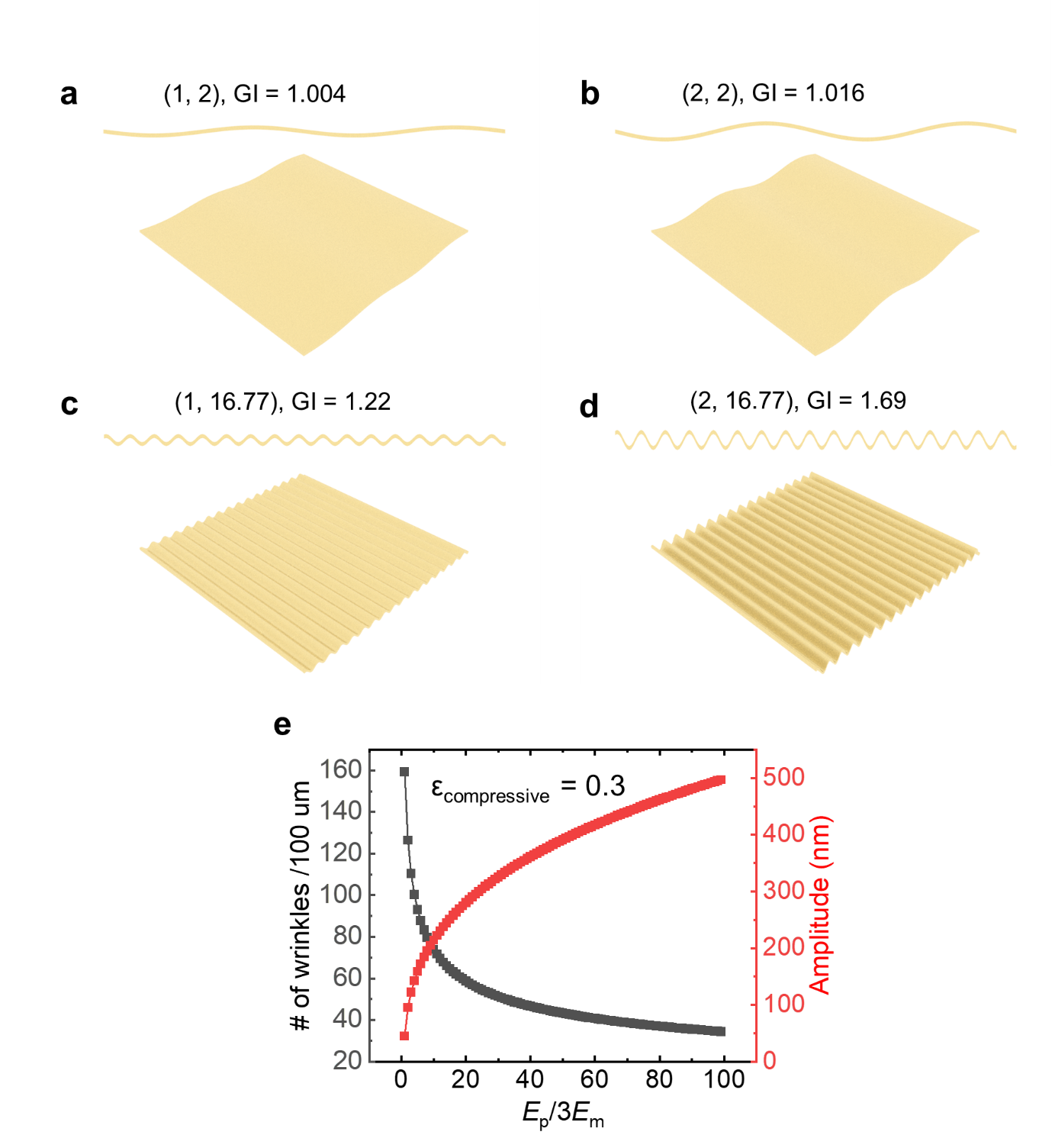
Figure S1. (a-d) Examples of wrinkles for coordinated points (1,2), (2,2), (1,16.77), and (2,16.77) in the GI map. (e) The number of wrinkles per 100 µm and amplitude of wrinkle as a function of elastic modulus ratio between the metal film and PDMS substrate to show its trade-off behavior.

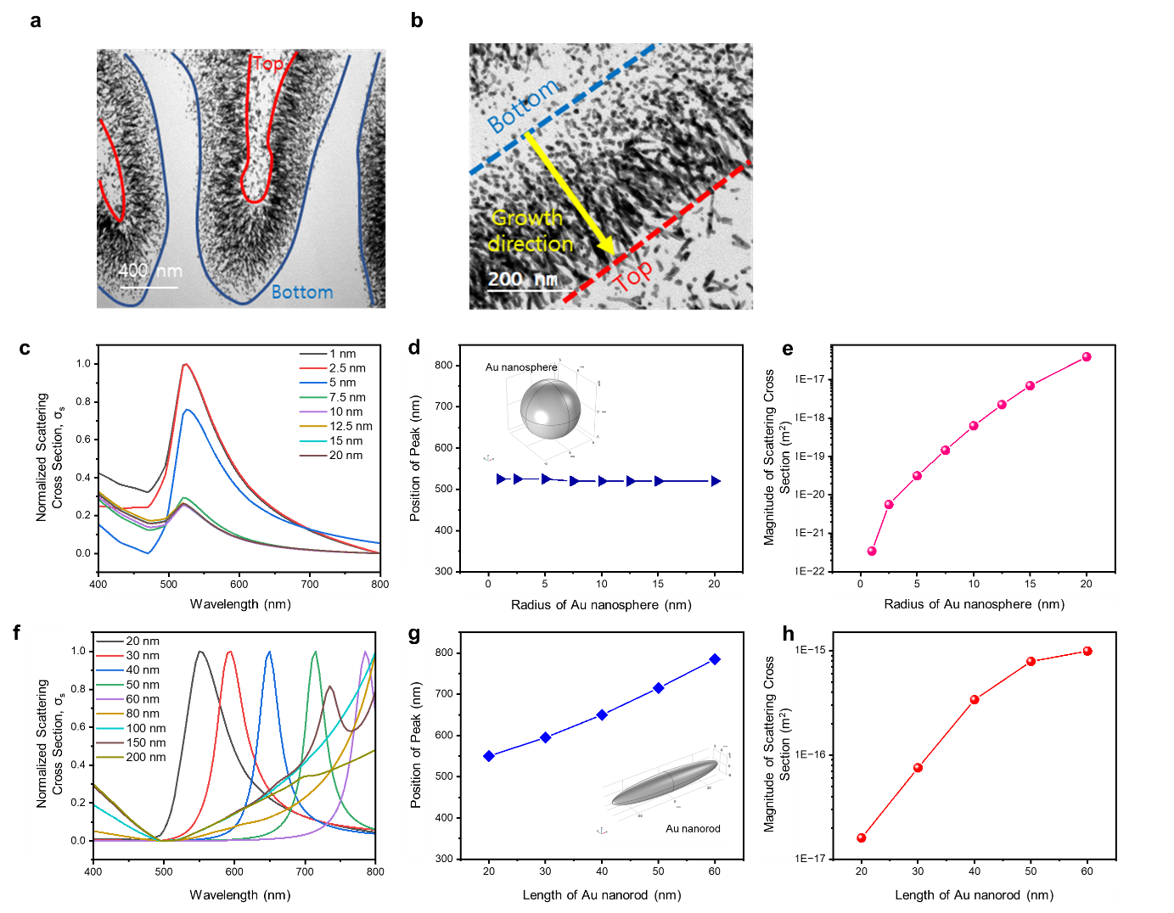
Figure S2. Optical analysis of Au-PDMS nanophase. (a) and (b) Cross-sectional HRTEM images of a sample (50 nm deposited under the condition of PDMS φ=3.5 and 2.5 Å/s) (c) Calculated normalized scattering cross section as a function of incident electromagnetic wave wavelength, (d) positions of LSPR peak, and (e) magnitude of scattering cross section of Au nanospheres with different radiuses. (f) Calculated normalized scattering cross section as a function of incident electromagnetic wave wavelength, (g) positions of LSPR peak, and (h) magnitude of scattering cross section of Au nanorods with different lengths. The spectral changes are caused by change of the Au nanostructures, which indicates spherical Au nanoparticles formed at the beginning of nanophase and growth into Au nanoneedles as deposition thickness increases. The origin of the observed peak broadening was well interpreted with the assistance of theoretical electromagnetic calculations. Initially, the LSPR spectrum of the Au nanosphere only appeared at a deposition of 5 nm thickness. As deposition thickness increases (t > 7.5 nm thickness), red-shift of LSPR peak was observed due to the superimposition of spectra of Au nanoneedles in addition to those of nanospheres. The TEM images show the length of Au nanoneedles almost linearly increases with respect to the t, and the corresponding LSPR spectrum with broad absorbance peak is observed accordingly (t = 10 and 20 nm thickness).

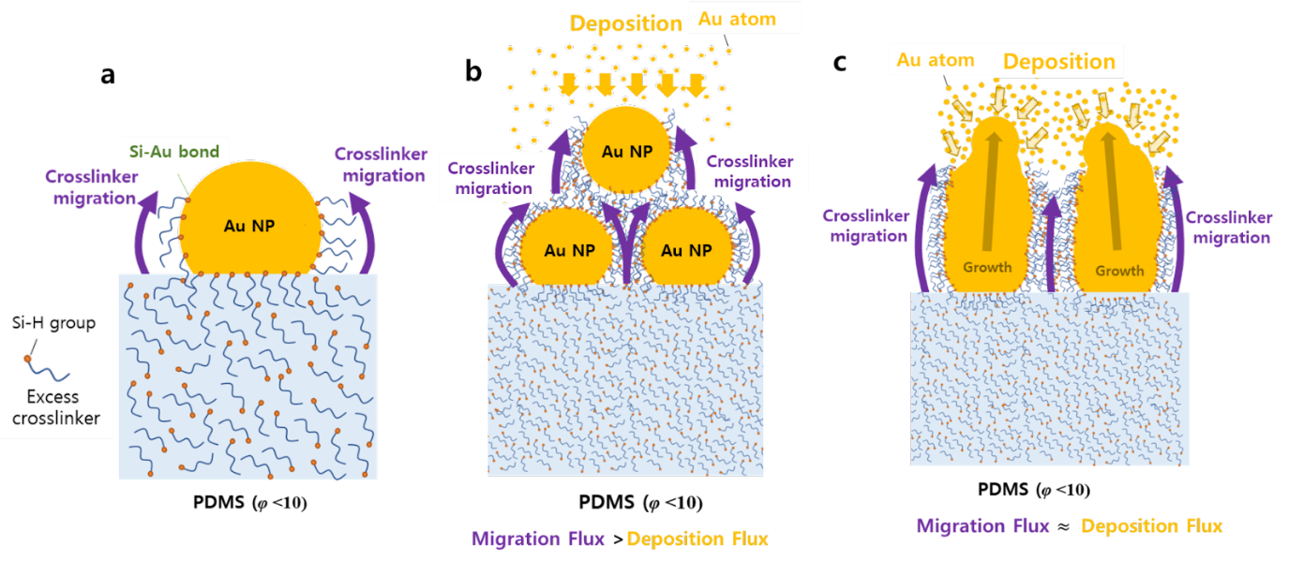
Figure S3. Schemes of growth mechanism on Au-PDMS reticular nanophase (a) Upward migration of the cross-linkers along the surface of the Au nanoparticle. (b) Particulate nanophase formation process. (c) Reticular nanophase formation process.
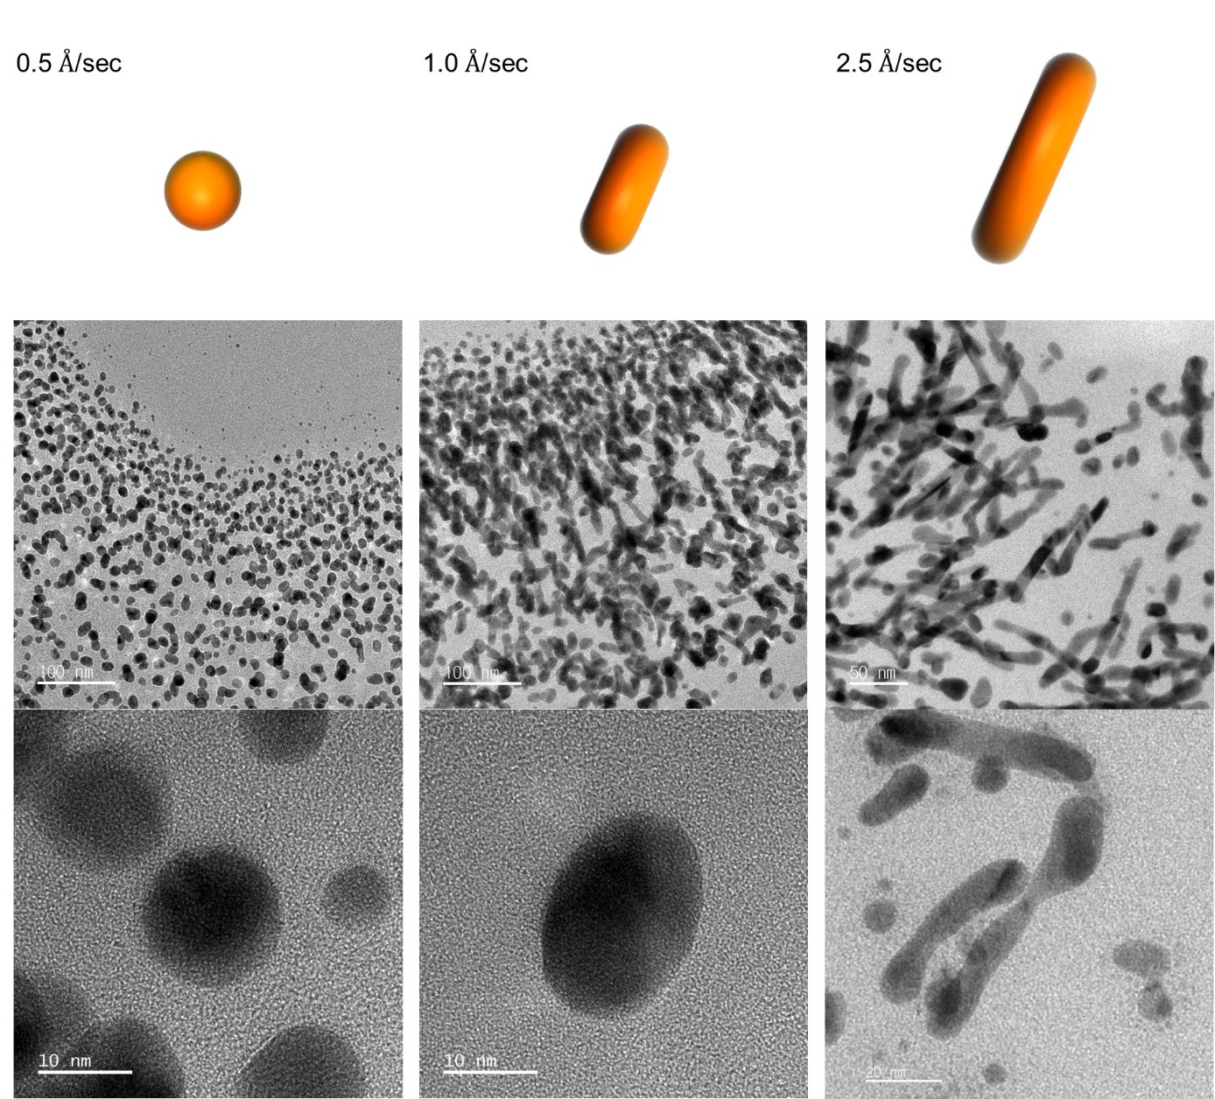
Figure S4. Morphologies of Au-PDMS nanophases were investigated with various Au deposition rates (0.5, 1, 2.5 Å/sec) at a fixed φ of 3.5. The PDMS thickness for Au deposition was set at 1.25 mm and 100 µm, respectively.

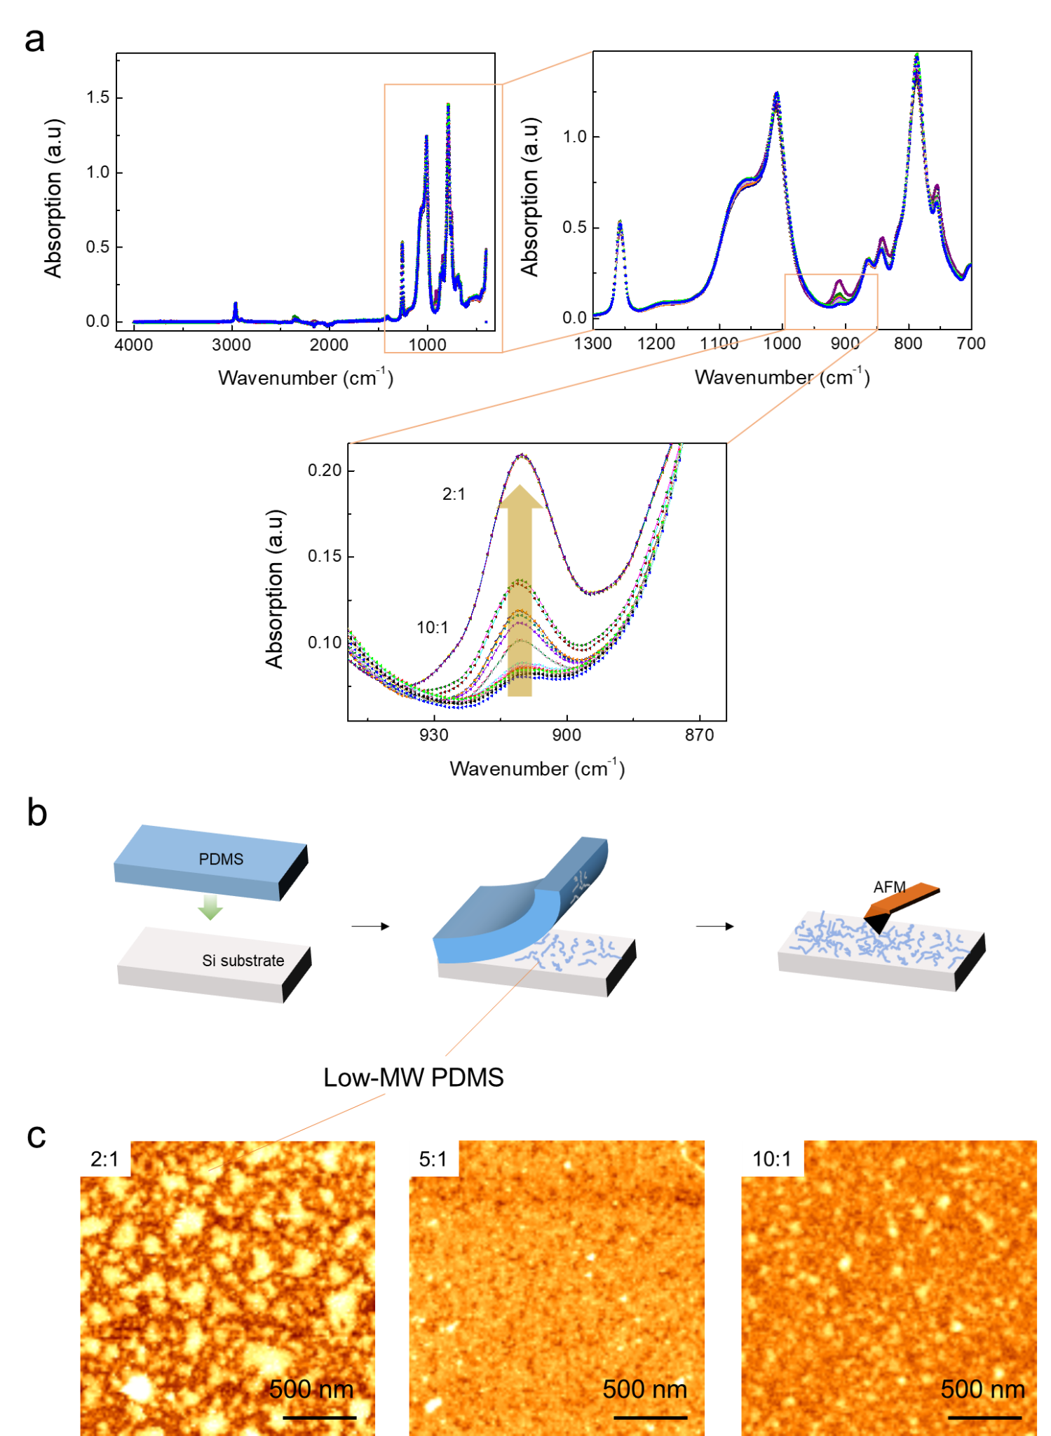

Figure S5. (a) FT-IR analysis of plain PDMS membranes with various curing ratio, φ. (b) Surface uncrosslinked low-molecular weight PDMS and excess PDMS crosslinker was contact printed on Si wafer for 30 min for all PDMS slabs. (c) AFM images of the contact printed PDMS with various curing ratios.

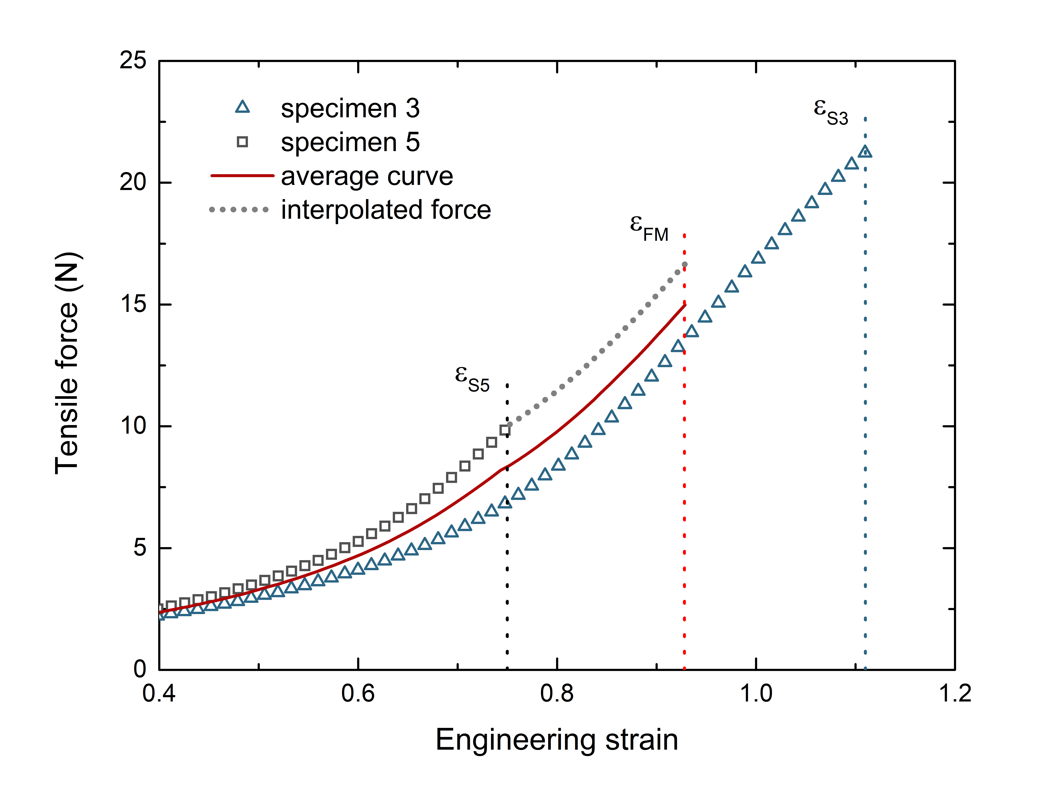

Figure S6. Visualization of the averaging process with an example of two single force-strain curves with different fracture strains. ε_{S3} represents the fracture strain for specimen 3 and ε_{S5} for specimen 5. Missing force values of single curves are interpolated up to the calculated fracture strain ε_{FM} of all used specimens. The averaging process end with a mean force-strain curve (red line) ends also with the mean fracture strain ε_{FM}.

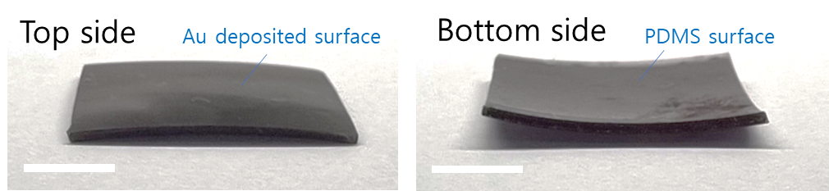

Figure S7. Differential tangential expansion of Au-PDMS nanophase. Digital photos of the Au deposited PDMS (φ = 3.5) membrane after the gyrification for 6 hr. The top side shows a convex shape where the Au deposited surface is facing up, and the bottom side shows a concave shape where the PDMS surface is facing up. The PDMS membrane was 1.25 mm in thick, 3 cm in width and 2.5 cm in height, and the Au deposition rate was 2.5 Å/s. The images show the convex appearances of a sample that was aged over 6 h on a PDMS pad (length 3 cm, width 2.5 cm, and thickness 1.25 mm). The convex shape is due to the expansion of the deposited surface. Scale bar is 1 cm.

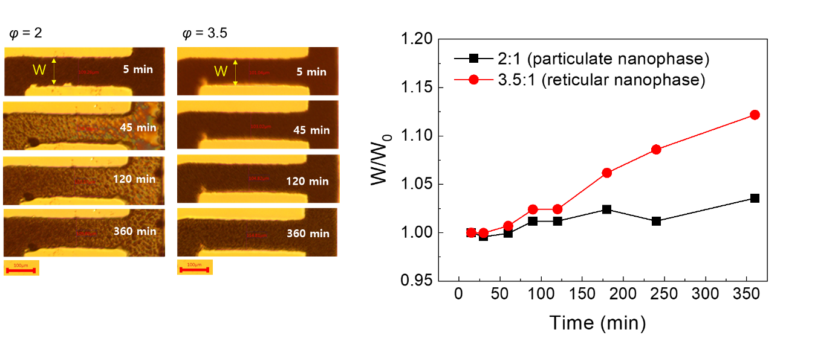

Figure S8. Differential tangential expansion of Au-PDMS nanophase with various φ. Optical microscopy images (left) and relative change of pattern width (right) over time (e.g., gyrification) for particulate (φ = 2) and reticular nanophase (φ = 3.5). Using the metal shadow mask, 100 nm of gold at a rate of 2.5 Å/s was deposited on PDMS (φ = 3.5). The line width of the metal mask was 100 µm, and the line width of the obtained electrode pattern was 140 µm.

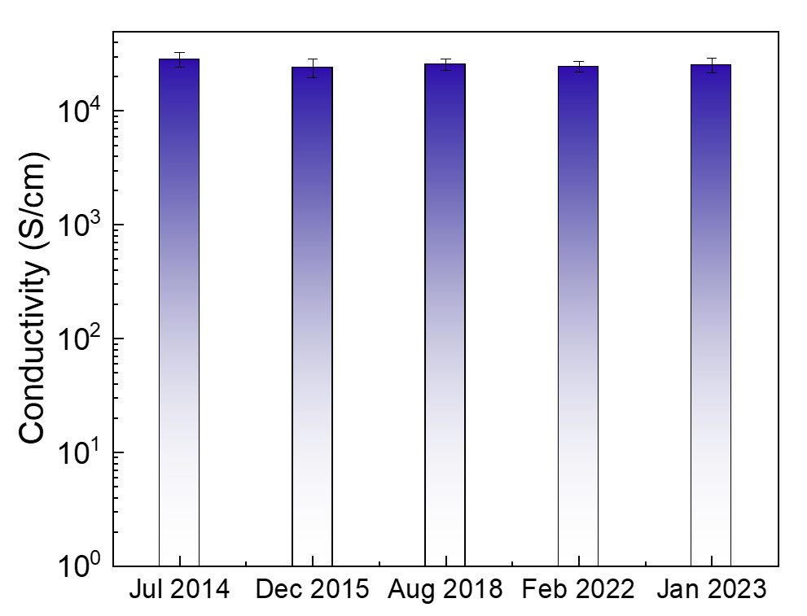

Figure S9. Long-term stability of the gyrified Au-PDMS nanophase sample for years.

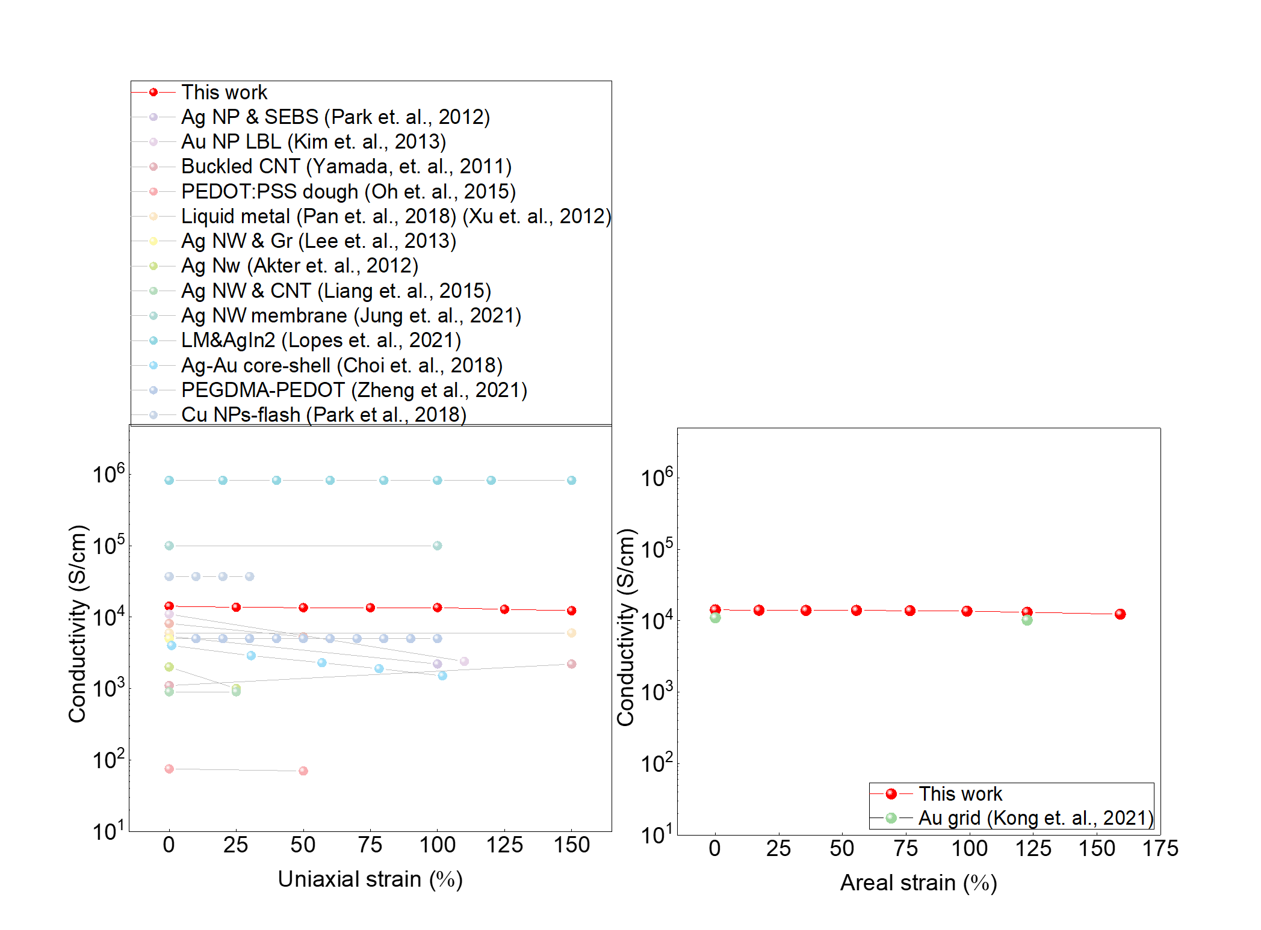
Figure S10. Compared strain-dependent conductivity (left for uniaxial- and right for areal-) of the gyrified Au-PDMS nanophases across the stretchable conductors previously reported (Supplementary Table S2 and S3).

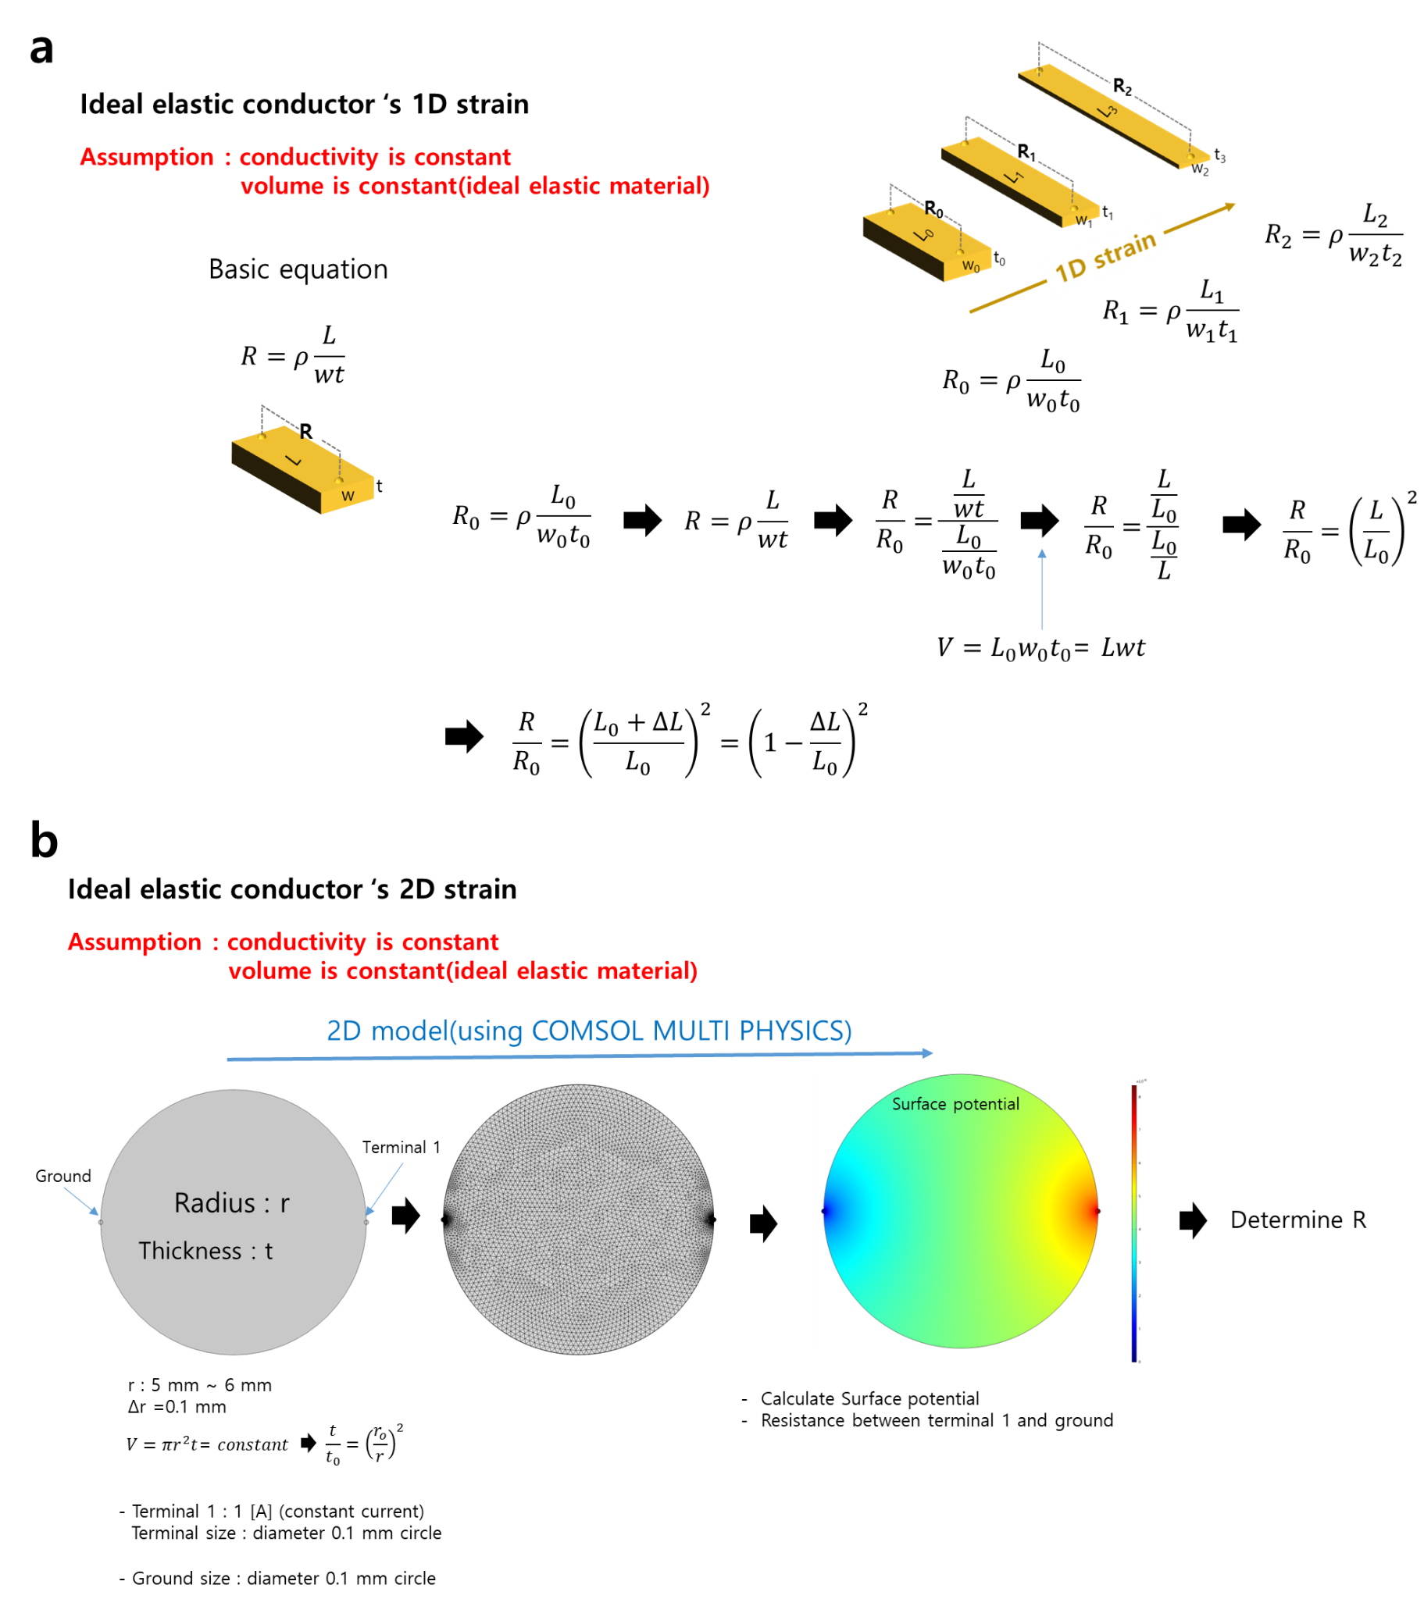

Figure S11. Calculation of ideal elastic conductor upon (a) uniaxial and (b) areal strain.

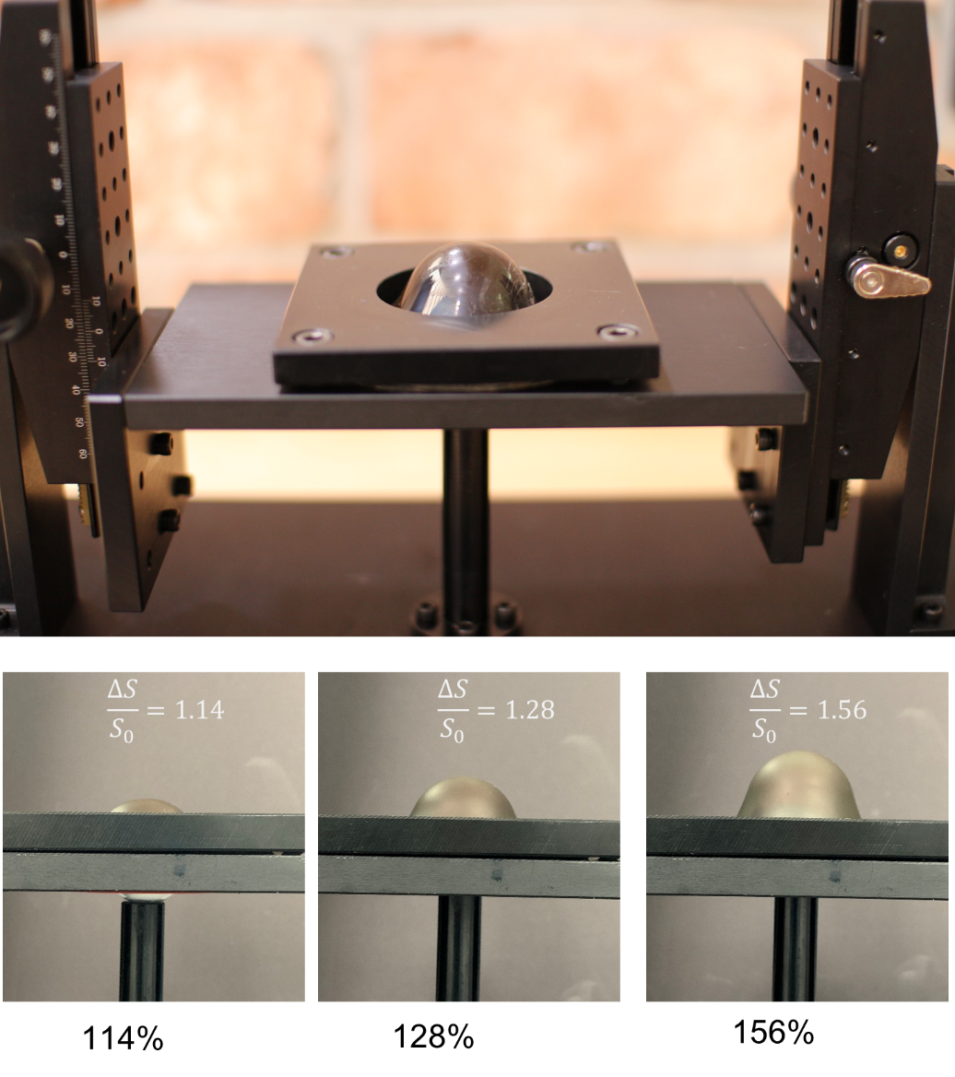
Figure S12. Characterization of the Au-PDMS nanophase upon area strain by custom made bulge test equipment. (top) Digital photos of the equipment. (bottom) Calculation of area strain of Au-PDMS nanophase.

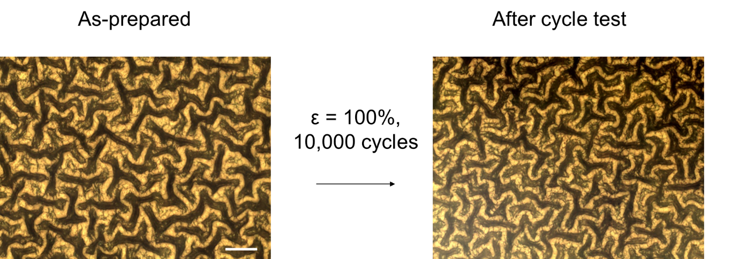
Figure S13. Mechanical stability of the gyrified Au-PDMS reticular nanophase sample. Up to 10,000 times of stretching cycle for 100% strain, the surface morphology of the stretchable Au-PDMS nanophase showed no change, implying that the wrinkle has remarkable durable and stable mechanical stability (no delamination, no crack formation). Scale bar denotes 10 μm.

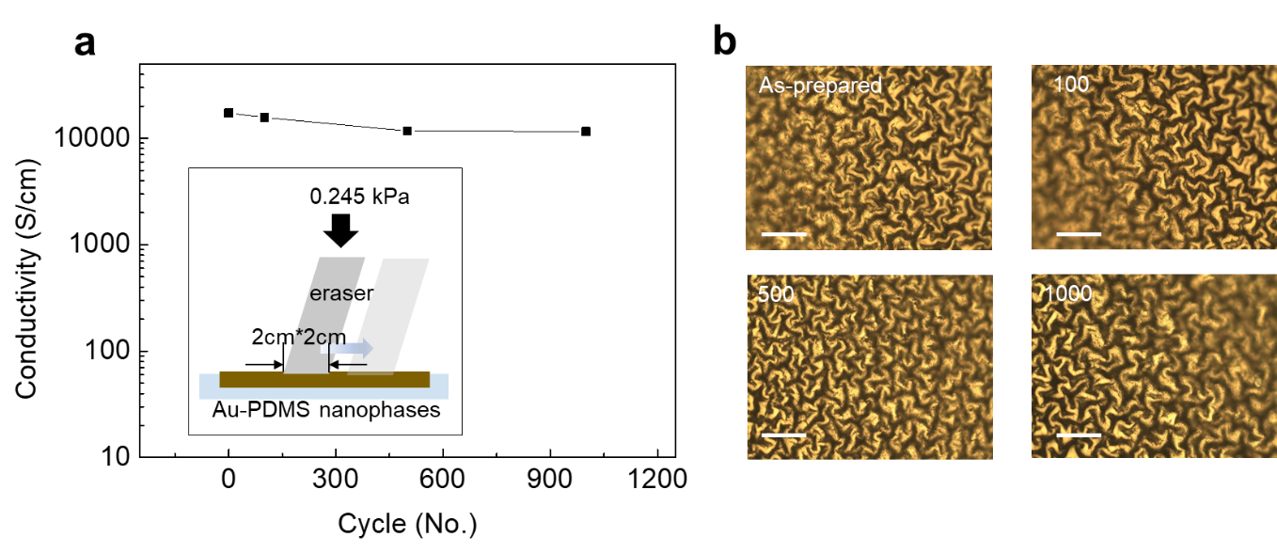
Figure S14. (a) Abrasion test by cyclic eraser, showing highly durable conductivity of the sample. (b) Optical microscopy images after each cyclic eraser test. Scale bar denotes 20 μm.

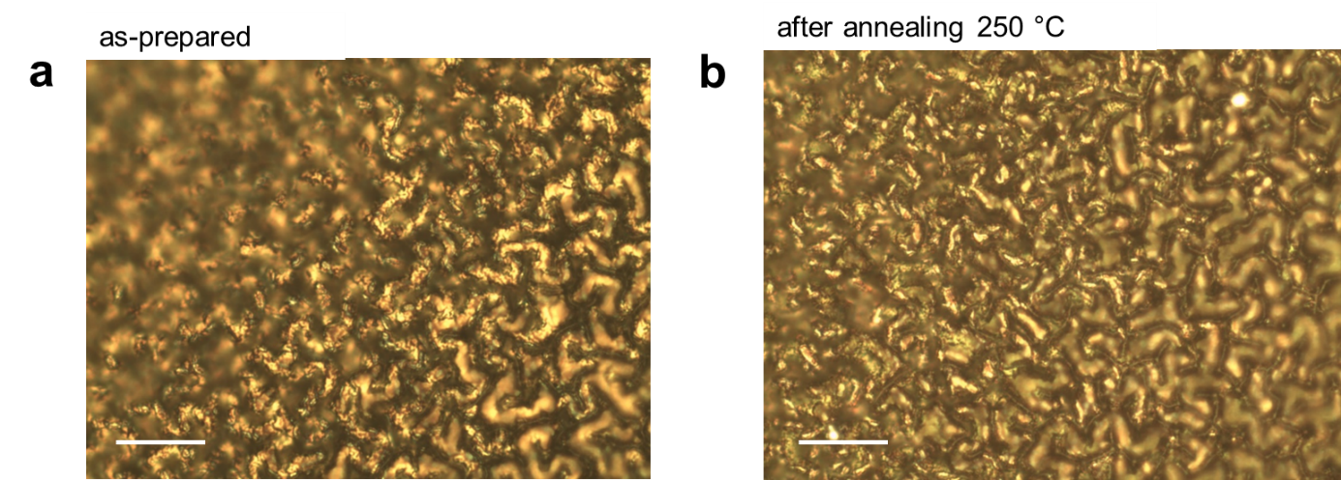

Figure S15. Thermal stability of the gyrified Au-PDMS nanophases. Optical microscopy images of the sample before (a) and after (b) annealing at 250 °C for 2 hrs.

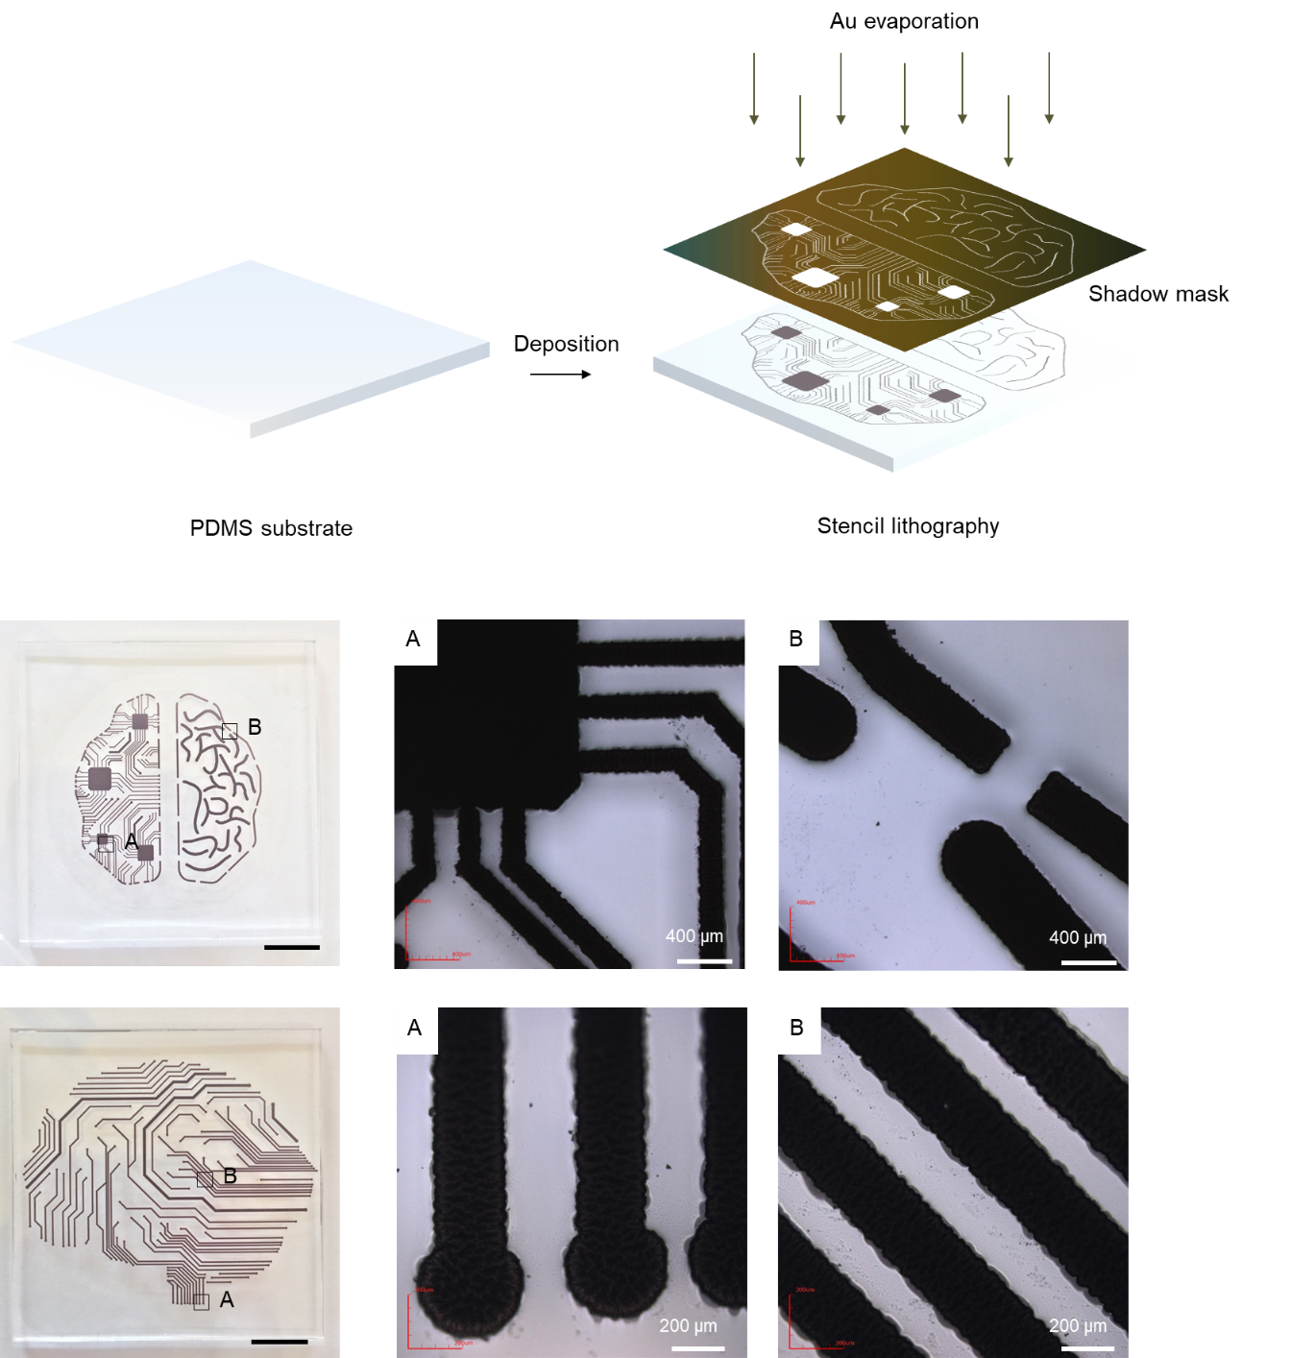

Figure S16. Stencil mask lithography. Stencil mask lithography of the gyrified Au-PDMS reticular nanophases sample, displaying ability of high-resolution pattering of the soft conductor. Scale bar denotes 0.5 cm.
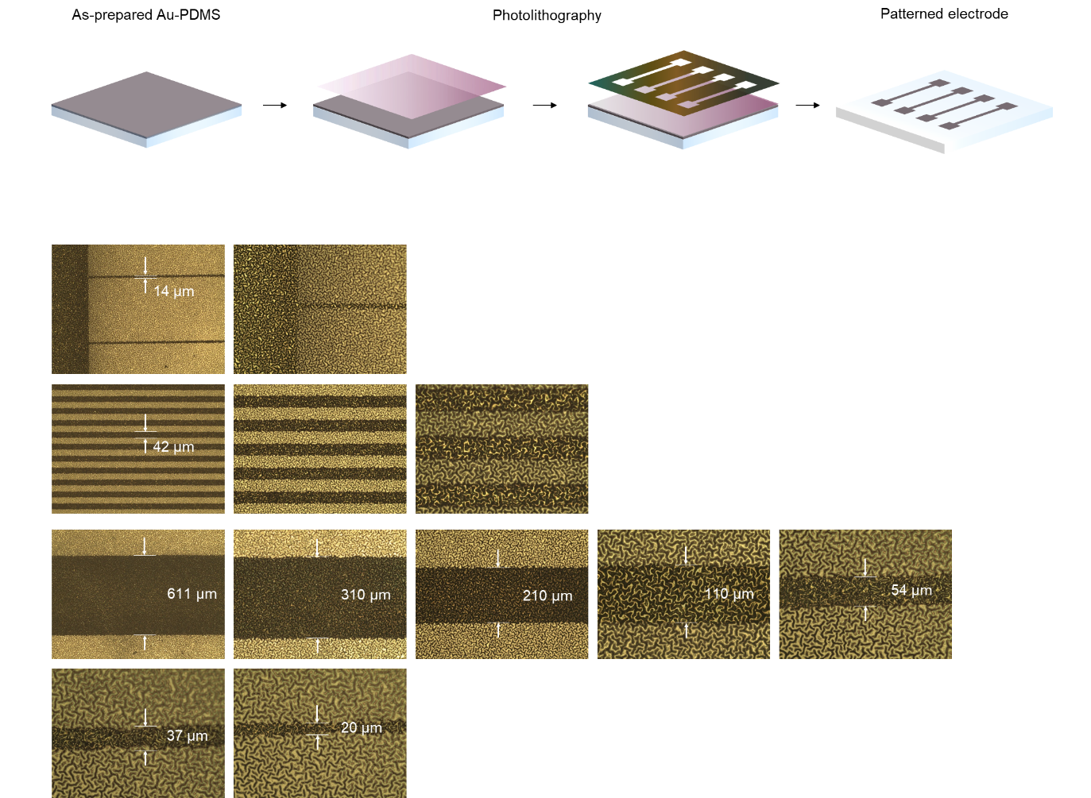

Figure S17. Photolithography of gyrified Au-PDMS reticular nanophase. The chemical and mechanical durability of the 3D complex of Au-PDMS nanophases sample enables us to create patterns for stretchable conductors using conventional techniques.

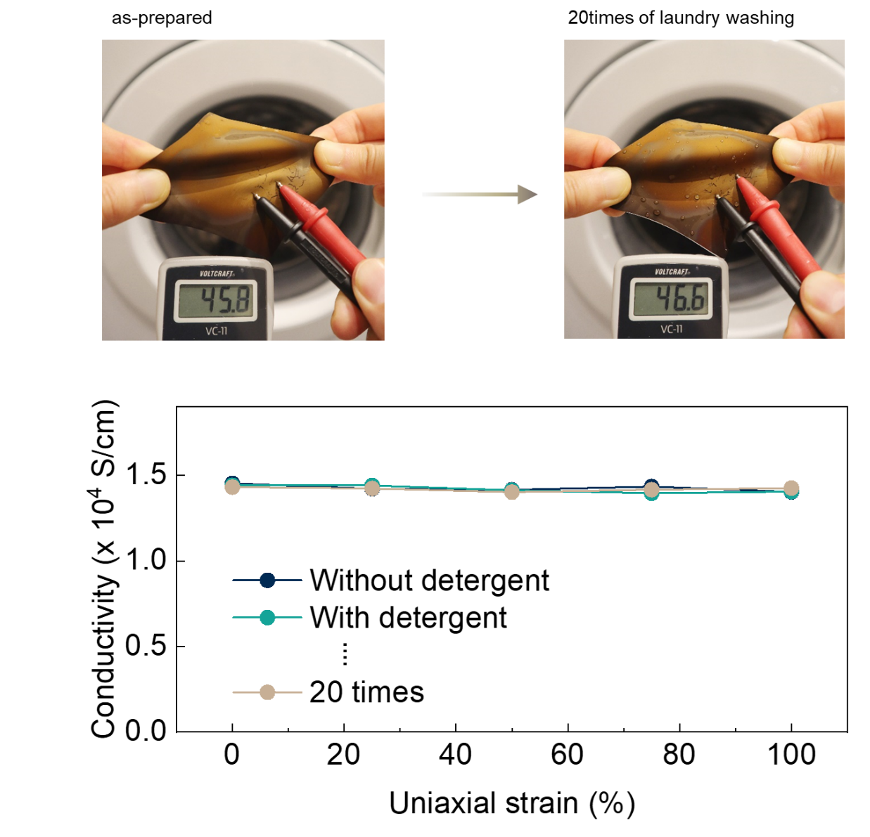

Figure S18. Laundry machine washable test (see Supplementary Mov. 3). Up to 20 times of washing (for each 15 min.) by laundry machine, the stretchable conductivity (up to 100 % of uniaxial strain) showed no change, implying that the wrinkle sample could be used for durable and washable e-skin device even without any encapsulation.

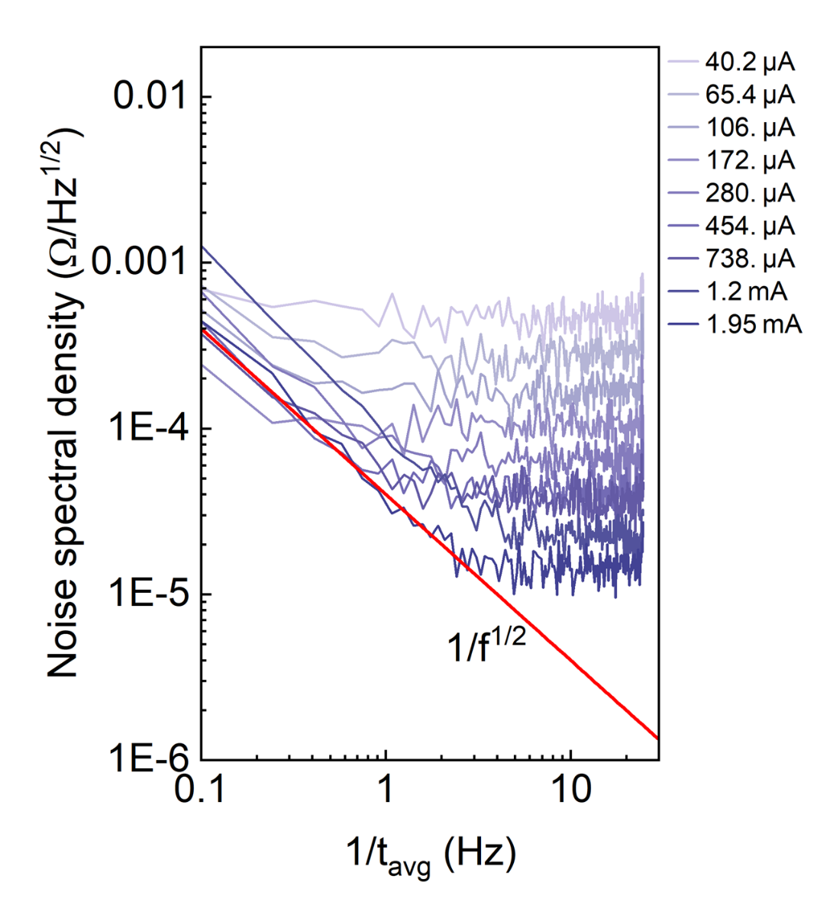
Figure S19. Electrical noise characterization of the Au-PDMS nanophase. A set of noise spectral density plots measured for Au-PDMS nanophase wrinkled sample at different driving currents. The noise spectra show clear 1/√𝑓 trend with base noise density of 20 Ω / √Hz and cutoff frequency of 2.8 Hz.

Table S1. Hyperelastic constants C_{ij} of plain PDMS membrane of φ = 3.5 and 10, obtained by the strain-stress curve.

Component ratio | C₁₀ (Pa) | C₀₁ (Pa) | C₂₀ (Pa) | C₀₂ (Pa) | 77₁₁ (Pa)
3.5:1 | -6,30E+06 | 7,12E+06 | 8,48E+06 | 2,27E+07 | -2,56E+07
10:1 | -5,58E+06 | 6,49E+06 | 6,71E+06 | 1,74E+07 | -1,95E+07

Table S2. Comparison table of various stretchable conductors with various material types (Carbons, Metals, Liquid Metals, and Mechanically-guided structural designs) previously reported in literature, mainly focusing on a greater stretchability and conductivity (Supplementary Fig. S1).

Type | Materials | Stretchability |  | Conducting property (S,Ω) |  | Reference
Type | Materials | 1D | 2D |  |  | Reference
Carbon | SWNT | 70% | - | 10 S/cm | Science 2008, 321, 1468−1472.
Carbon | SWNT | 405% | - | - | Soft Matter 2005, 1, 386.
Carbon | MWNT | 638% | - | - | Soft Matter 2005, 1, 386.
Carbon | CNT | 60% | - | ~ 10 Ω/sq | Sci. Rep. 2018, 8, 1375.
Carbon | PDA-CNT | 700% | - | 8.2 S/m | Adv. Funct. Mater. 2018, 28, 1704195.
Carbon | c-MWCNT | 2761% | - | ~1 S/m | J. Mater. Chem. B 2019, 7, 4638−4648.
Carbon | N-MWCNT | 100% | - | - | Adv. Funct. Mater. 2021, 31, 2008355.
Carbon | Carbon fibers | - | - | 20,000 S/m | Sci. Rep. 2018, 8, 12313.
Carbon | Carbon fibers | 7.9% | - | - | ACS Sustainable Chem. Eng. 2020, 8, 11162−11170.
Carbon | GO | 40% | - | 1,660 Ω/cm | Appl. Mater. Today 2019, 16, 482−492.
Carbon | Carbon fibers | 6.10% | - | 3.6 S/cm | Composites, Part A 2004, 35, 417−421.
Carbon | SWCNT | 3.10% | - | 300 S/cm | J. Mater. Chem. C 2016, 4, 526−532.
Carbon | CNT/Graphene | 100% | - | 0.01 S/cm | ACS Nano 2016, 10, 4770−4778.
Carbon | CNT | 70% | - | 1 MΩ @ 5 Hz | J. Neural Eng. 2014, 11, 046014.
Carbon | PDA-pGO | 1700% | - | 0.08 S/cm | Adv. Mater. 2016, 28, 6359−6364.
Carbon | CNT | - | - | 0.0672 S/m | ACS Nano 2020, 14, 664−675.
Carbon | CNT | 100% | - | 1.7 Ω/sq | Adv. Funct. Mater. 2017, 27, 1704353.
Carbon | Aligned-CNT ribbon/PDMS | 100% | - | 18.8 kΩ | Adv. Mater. 2010, 22, 3027.
Carbon | Double-layer graphene | 36.2% | - | - | Nanoscale 2014, 6, 6057.
Carbon | Graphene–AgNWs hybrid | 80% | - | 1 Ω/sq | Nano Lett. 2014, 14, 6322.
Carbon | Graphite-PDMS | 0.71% | - | 1.8 S/cm | Composites 22 211–8
Carbon | MWCNT-PDMS | 45% | - | 0.1 S/cm | IEEE Trans. Biomed. Eng. 59 1472–9
Carbon | MWCNT-PDMS | 50% | - | 10⁻³ S/cm | Compos. Sci. Technol. 72 1257–63
Carbon | MWCNT-PDMS | 40% | - | 6.5×10⁻² S/cm | J. Micromech. Microeng. 19 085019
Carbon | Graphene Nanoplatelets/PDMS | 450% | - | 1.72×10⁻⁵ S/cm | Compos. Part B 67 434–40
Carbon | Graphene–AgNWs hybrid | 100% | - | 33 Ω/sq | Nano Lett. 2013, 13, 2814.
Carbon | SWCNTs/fluorinated copolymer composite | >100% | - | ~100 S/cm | Nat. Mater. 2009, 8, 494.
Carbon | CNT–PMIA core–shell | 150% | - | 109 S/cm | ACS Nano 2015, 9, 10252.
Carbon | Carbon-black/styrene butadiene composite | 200% | - | 40 S/cm | J. Phys. Chem. C 2015, 119, 21723.
Carbon | CNT/R-GO/porous PDMS | 50% | - | 27 S/m | Adv. Funct. Mater. 2014, 24, 7548.
Carbon | R-GO microtubes/PDMS | 50% | - | - | ACS Appl. Mater. Interfaces 2015, 7, 27432.
Carbon | R-GO/nanocellulose | 100% | - | - | Adv. Mater. 2014, 26, 2022.
Carbon | GNP-w-CNT | 150% | - | 132 S/m | Adv. Funct. Mater.2021, 31, 2107082

Type | Materials | Stretchability |  | Conductivity |  | Reference
Type | Materials | 1D | 2D |  |  | Reference
Metal | AgNW | 40% | - | - | Adv. Funct. Mater. 2017, 27, 1700845.
Metal | AgNW | 400% | - | 100 Ω/sq | Adv. Funct. Mater. 2014, 24, 5671−5678.
Metal | AuNP | 40% | - | - | Adv. Mater. 2016, 28, 6359−6364.
Metal | Au-TiO₂NW | 150% | - | 16,000 S/cm, 10 kΩ @ 1 kHz | Adv. Mater. 2018, 30, 1706520.
Metal | AuNW-AgF | 1900% | - | 70 S/cm | Adv. Mater. 2021, 33, 2007346.
Metal | AgNW | 90% | - | 11,210 S/cm | Sci. Transl. Med. 2016, 8, 344ra86.
Metal | AgNW | 25% | - | 1.9 Ω/sq | npj Flex. Electron. 2019, 3,13.
Metal | AgNWs | 20% | - | 35 Ω/sq | ACS Appl. Mater. Interfaces 2012, 4, 1855.
Metal | CuNWs | 17% | - | 220 Ω/sq | J. Mater. Chem. C 2014, 2, 5309.
Metal | AgNWs/PDMS | 50% | - | 7.5 Ω/sq | Nanotechnology 2012, 23, 344002.
Metal | AgNWs/PDMS | 20% | - | 9 Ω/sq | J. Mater. Chem. C 2014, 2, 10369.
Metal | AgNWs/PUU/PDMS | 50% | - | 5 – 425 Ω/sq | ACS Appl. Mater. Interfaces 2015, 7, 15214.
Metal | AgNWs/PDMS | 30% | - | 26.1 Ω/sq | J. Mater. Chem. C 2015, 3, 8241.
Metal | AgNWs/PDMS | 50% | - | - | Nanoscale 2014, 6, 2345.
Metal | Silver salt/polystyrene-block-polyisoprene-block-polystyrene | 200% | - | 0.8 Ω/sq | ACS Nano 2015, 10, 396.
Metal | Ni/PDMS composite | 100% | - | 20 Ω | Adv. Mater. 2014, 26, 3094.
Metal | Ni electroplated onto porous PDMS surface | 80% | - | - | Nat. Commun. 2012, 3, 977.
Metal | AgNP/SWCNT/PU composite | 90% | - | 620 S/cm | ACS Macro Lett. 2015, 4, 769.
Metal | AgNWs/PEDOT:PSS/PU | 130% | - | 36 Ω/sq | ACS Nano 2015, 9, 8801.
Metal | AgNW/TPU | 600% | - | 5,000 S/cm | ACS Materials Lett. 2021, 3, 7, 912–920
Metal | AgNW | 50% | - | 8130 S/cm | Adv. Mater. 2012, 24, 5117−5122.
Metal | Ag flake | 400% | - | 6168 S/cm | Nat. Mater. 2017, 16, 834−840.
Metal | Au atom | 130% | - | ~50 Ω | Adv. Mater. 2019, 31, 1901360.
Metal | AgF | 250% | - | 374 S/cm | Nat. Electron. 2021, 4, 185−192.
Metal | AuNP | 486% | - | 6800 S/cm | Nature 2013, 500, 59−63.
Metal | AgNP | 1000% | - | 0.05 S/cm | Adv. Sci. 2019, 6, 1901229.
Metal | AgNW | 100% | - | ~0.8 Ω | ACS Nano 2015, 9, 6626−6633.
Metal | Ag-AuNW | 840% | - | 72,600 S/cm | Nat. Nanotechnol. 2018, 13, 1048−1056.
Metal | CuNW | - | - | ~54 Ω/sq | Nano Res. 2017, 10, 3077−3091.
Metal | AgNS | 50% | - | - | Nano Energy 2017, 42,300−306.
Metal | AgF | 300% | - | 500 S/cm | Sci. Rep. 2015, 4, 7254.
Metal | AgF | 1780% | - | 501 Ω | Adv. Mater. 2018, 30, 1800109.
Metal | Ag-AuNW | 720% | - | 29,500 S/cm, 112 Ω (@ 1kHz) | Adv. Mater. Technol. 2020, 5, 1900768.
Metal | Ag flakes-PU | 600% | - | 3.6×10³ S/cm | IEEE Electron Device  Lett. 32 1424–6
Metal | AgNW-PUA | 70% | - | 4.5×10⁴ S/cm | Adv. Mater. 28  5986–96
Metal | AgNW-PDMS | 100% | - | 9.97×10³ S/cm | ACS Appl. Mater. Interfaces 7 13467–75
Metal | AgNW-PDMS | 15% | - | 8.13×10³ S/cm | ACS Appl. Mater. Interfaces 6 4248–53
Metal | Ag flakes-PU | 74% | - | 4.31×10⁴ S/cm | Scientific Reports volume 6, Article number: 25784 (2016)

Type | Materials | Stretchability |  | Conductivity |  | Reference
Type | Materials | 1D | 2D |  |  | Reference
Liquid Metal | EGaIn/PDMS | 500% | - | 2,316 S/cm | iScience 4, 302–311, June 29, 2018
Liquid Metal | EGaIn/PDMS | 50% | - | 1370 S/cm | Nature Materials volume 17, pages 618–624 (2018)
Liquid Metal | EGaIn | 400% | - | ~1 Ω | J. Mater. Chem. C, 2022,10, 1039-1047
Liquid Metal | Biphasic Ga-In | 1,000% | - | 2.06 × 10⁶ S/m | Nature Materials volume 20, pages 851–858 (2021)
Liquid Metal | EGaIn/polyphenols | 70% | - | 1.6 × 10⁶ S/m | Adv. Funct. Mater.2021, 31, 2007336
Liquid Metal | EGaIn/SEBS | 250% | - | 46 Ω/sq | Adv. Funct. Mater.2021, 31, 2006711
Liquid Metal | EGaIn/LAPONITE® | 150% | - | ~ 10⁵ S/m | J. Mater. Chem. C, 2021, 9, 3070-3080
Liquid Metal | EGaIn | 100% | - | 64 Ω | Adv. Funct.Mater.2014, 24, 3501–3507
Liquid Metal | EGaIn | 680% | - | 0.05 Ω | Adv.Mater.2019, 31, 1901337
Liquid Metal | EGaIn/SEBS | 800% | - | 3.4 × 10⁴ S/cm | Adv. Funct.Mater.2013, 23, 2308–2314
Liquid Metal | GaInSn | 50% | - | - | Adv. Funct.Mater.2015, 25, 3806–3813

Type | Materials | Stretchability |  | Conductivity |  | Reference
Type | Materials | 1D | 2D |  |  | Reference
Mechanically-guided  structural designs | GaAs/Si | 100% | - | - | Nature Nanotechnology volume 1, pages 201–207 (2006)
Mechanically-guided  structural designs | SWNT | 30% | - | - | Adv. Mater.2009,21, 4793–4797
Mechanically-guided  structural designs | Si | 15% | - | - | PNAS October 2, 2007 104 (40) 15607-15612
Mechanically-guided  structural designs | Si | 140% | - | - | PNAS December 2, 2008 105 (48) 18675-18680
Mechanically-guided  structural designs | Si | 4% | - | - | Nano Lett. 2007, 7, 1655.
Mechanically-guided  structural designs | Au | 14.2% | - | - | Adv. Mater. 2004, 16, 393.
Mechanically-guided  structural designs | Si | 100% | - | - | Adv. Mater.2009,21,3703–3707
*Hyphen (-) means that the reference has no information about the factors

Table S3. Comparison of durability performance of the Au-PDMS nanophases with previously reported stretchable conductors (Supplementary Note 8)

Materials | Electrical property | Stretchability |  | Durability |  |  |  | Ref.
Materials | Electrical property | Uniaxial (1D) strain | Areal (2D) strain | pH | Thermal | Solvent | Washing | Ref.
Au nanophase-3D complex | 14200 S/cm | 12290 S/cm @150%  (F/I:98%) | 12140S/cm @156% | 2 - 13 | up to 250 °C | Water, Ethanol, Acetone,  Chlorobenzene, Toluene | Laundry machine (20 × 15 min) with detergent | This work
Cu Zr metallic glasses | 3.8 Ω/sq | 4.94 Ω/sq  @70% | - | - | 180 °C | - | - | Nano Lett. 2016, 16, 1, 471-478
PAA, PDMAPS, IL | 0.01 S/cm | -  @1000% | - | 7 | 100 °C | - | - | Nat. Comm. 10, 3429 (2019)
Ag, MWCNT, PDMS | 6450 S/cm | 3745 S/cm  @120% | - | - | - | - | Laundry machine  (10 s) | ACS Appl. Mater. Interfaces 2019, 11, 37043-37050
MWCNTs, m-PDMS | 86.33 Ω/sq | -  @30% | - | 0 - 13 | - | Ethanol | - | ACS Appl. Mater. Interfaces 2018, 10, 30, 25697-25705
Ag/AgCl ink | 7.45 Ω | 9.61 Ω  @40% | - | - | 49 °C | - | AATCC 61-2a | IEEE Sensors Journal 16.22 (2016): 7967-7976.
Cu/Pu fiber | 10⁵ S/cm | ~10⁵ S/cm  @200% | - | - | 20 °C | Water | Ultrasonic  (100 min) | Adv. Mater. 2020, 1907495
Cu/Ecoflex | 0.4 Ω | -  @100% | - | - | - | Water | Laundry machine  (30 min with detergent) | Adv. Healthcare Mater. 2021, 10, 2100221
rGO/PEDOT:PSS | 153 Ω/sq | -  @60% | - | - | 80 °C | - | Hand washing  (15 cycles, 30 min at 45 °C, drying 10 min at 80 °C) | J. Mater. Chem. C, 2020,8, 16204-16215
Ag NWs/TPU | 5114 S/cm | 50.89 S/cm  @ 600% | - | - | 120 °C | - | Simulated laundry washing  (10 min, drying at 60 °C for 30 min) | ACS Materials Lett. 2021, 3, 7, 912–920
AgMFs | 0.2 Ω/sq | 6.6 Ω/sq  @160% | - | - | 209.4 °C | - | - | Journal of Alloys and Compounds 790 (2019) 1127e1136
Ag NPs | 24.8 Ω | ~50 Ω  @50% | - | 2 - 12 | 118.7 °C | Water | - | Cellulose (2021) 28:7483–7495
PEDOT/Mxene | 3.6 Ω/sq | - | - | - | 193.1 °C | - | - | Nanoscale, 2021,13, 1832-1841
rGO | 24.7 Ω/sq | 148.2 Ω/sq  @20% | - | - | 138 °C | - | - | Applied Surface Science 454 (2018): 218-226.
PEDOT:PSS/EG | 74 S/cm | -  @10% | - | - | - | -- | Laundry machine (15 cycles, 40 min at 30 °C with detergent) | Adv.Mater. Technol.2018, 3, 1800251
Au coated fabric | 1.07 Ω/sq | 0.214 Ω/sq  @160% | - | 0.9 g/L NaCl, 0.2 g/L KCl | - | - | Stirring for 1h, drying at 60 °C overnight | Adv. Mater. Technol. 2018, 3, 1700292
Au-PI | - | @53% | - | 5 - 9 | - | Sweat equivalent solution | - | Biosensors and Bioelectronics 107 (2018) 192–202
Au-PI (TiSi₂) | 2.5 Ω/sq | - | - | 7.4 (PBS)  for 10 days | 96 °C | - | - | ACS Nano 2019, 13, 660−670
PANI-EB/Laser carbonized PI | 0.065 Ω/cm | 0.13 Ω/cm  @144% | - | 4 - 10 | - | PBS | - | ACS Appl. Mater. Interfaces 2017, 9, 10, 9015–9023
Au NS | 1.4 Ω/sq | 1.554 Ω/sq  @50% | - | 4 - 8 | - | - | - | ACS Appl. Mater. Interfaces 2018, 10, 13729−13740
Nanoporous Au | - | @30% | - | 5 – 7 | - | - | - | ACS Appl. Mater. Interfaces 2019, 11, 14567−14575
*Hyphen (-) means that the reference has no information about the factors
*F/I means a ratio of final electrical property and initial electrical property

Video S1. In-situ gyrification of 3D complex of Au-PDMS nanophases by Au 100 nm thick deposition on the PDMS (φ = 3.5) membrane. Scale bar denotes 30 μm.
Video S2. 3D TEM tomography movie of Au-PDMS nanophase, showing the interconnected and interpenetrated Au-PDMS nanophase and microscale surface 3D complex.
Video S3. Eraser test of 3D complex of Au-PDMS nanophases sample
Video S4. In-situ thermal annealing test, showing superior thermal durability of the 3D complex of Au-PDMS nanophases sample up to 250 °C.
Video S5. Washing test by laundry machine with detergent.
Video S6. Virtual reality (VR) demonstration by 3D complex of Au-PDMS nanophases.

References
1. Cheng, X. et al. Controlled fabrication of nanoscale wrinkle structure by fluorocarbon plasma for highly transparent triboelectric nanogenerator. Microsyst Nanoeng 3, 16074 (2017).
2. Kim, M., Moon, B. U. & Hidrovo, C. H. Enhancement of the thermo-mechanical properties of PDMS molds for the hot embossing of PMMA microfluidic devices. Journal of Micromechanics and Microengineering 23, (2013).
3. Matei, A., Ţucureanu, V. & Popescu, M. Synthesis and characterization of various surfactants for stabilized CuO powder. Powder Metallurgy and Advanced Materials 8, 52–60 (2018).
4. Khanafer, K., Duprey, A., Schlicht, M. & Berguer, R. Effects of strain rate, mixing ratio, and stress–strain definition on the mechanical behavior of the polydimethylsiloxane (PDMS) material as related to its biological applications. Biomed Microdevices 11, 503–508 (2009).
5. Seghir, R. & Arscott, S. Extended PDMS stiffness range for flexible systems. Sens Actuators A Phys 230, 33–39 (2015).
6. Bîrsan, M., Ghiba, I.-D., Martin, R. J. & Neff, P. Refined dimensional reduction for isotropic elastic Cosserat shells with initial curvature. Mathematics and Mechanics of Solids 24, 4000–4019 (2019).
7. Sander, O. Geodesic finite elements of higher order. IMA Journal of Numerical Analysis drv016 (2015) doi:10.1093/imanum/drv016.
8. Sander, O., Neff, P. & Bîrsan, M. Numerical treatment of a geometrically nonlinear planar Cosserat shell model. Comput Mech 57, 817–841 (2016).
9. Sander, O. DUNE — The Distributed and Unified Numerics Environment. vol. 140 (Springer International Publishing, 2020).

