Supplemental information for:

Forest thinning and prescribed burning treatments reduce wildfire severity and buffer the impacts of severe fire weather
Emily G. Brodie^{1,2}, Eric E. Knapp¹, Wesley Brooks³, Stacy A. Drury¹, Martin W. Ritchie¹

¹Pacific Southwest Research Station, USDA Forest Service, Redding, California 96006, USA
²Oak Ridge Institute for Science and Education, Oak Ridge, Tennessee 37831, USA
³Data Lab, University of California, Davis, California 95616, USA

Submitted to: Fire Ecology

Correspondence: egbrodie@ucdavis.edu

This appendix includes:
Figures S1 – S3
Tables S1 – S8

Supplemental figures

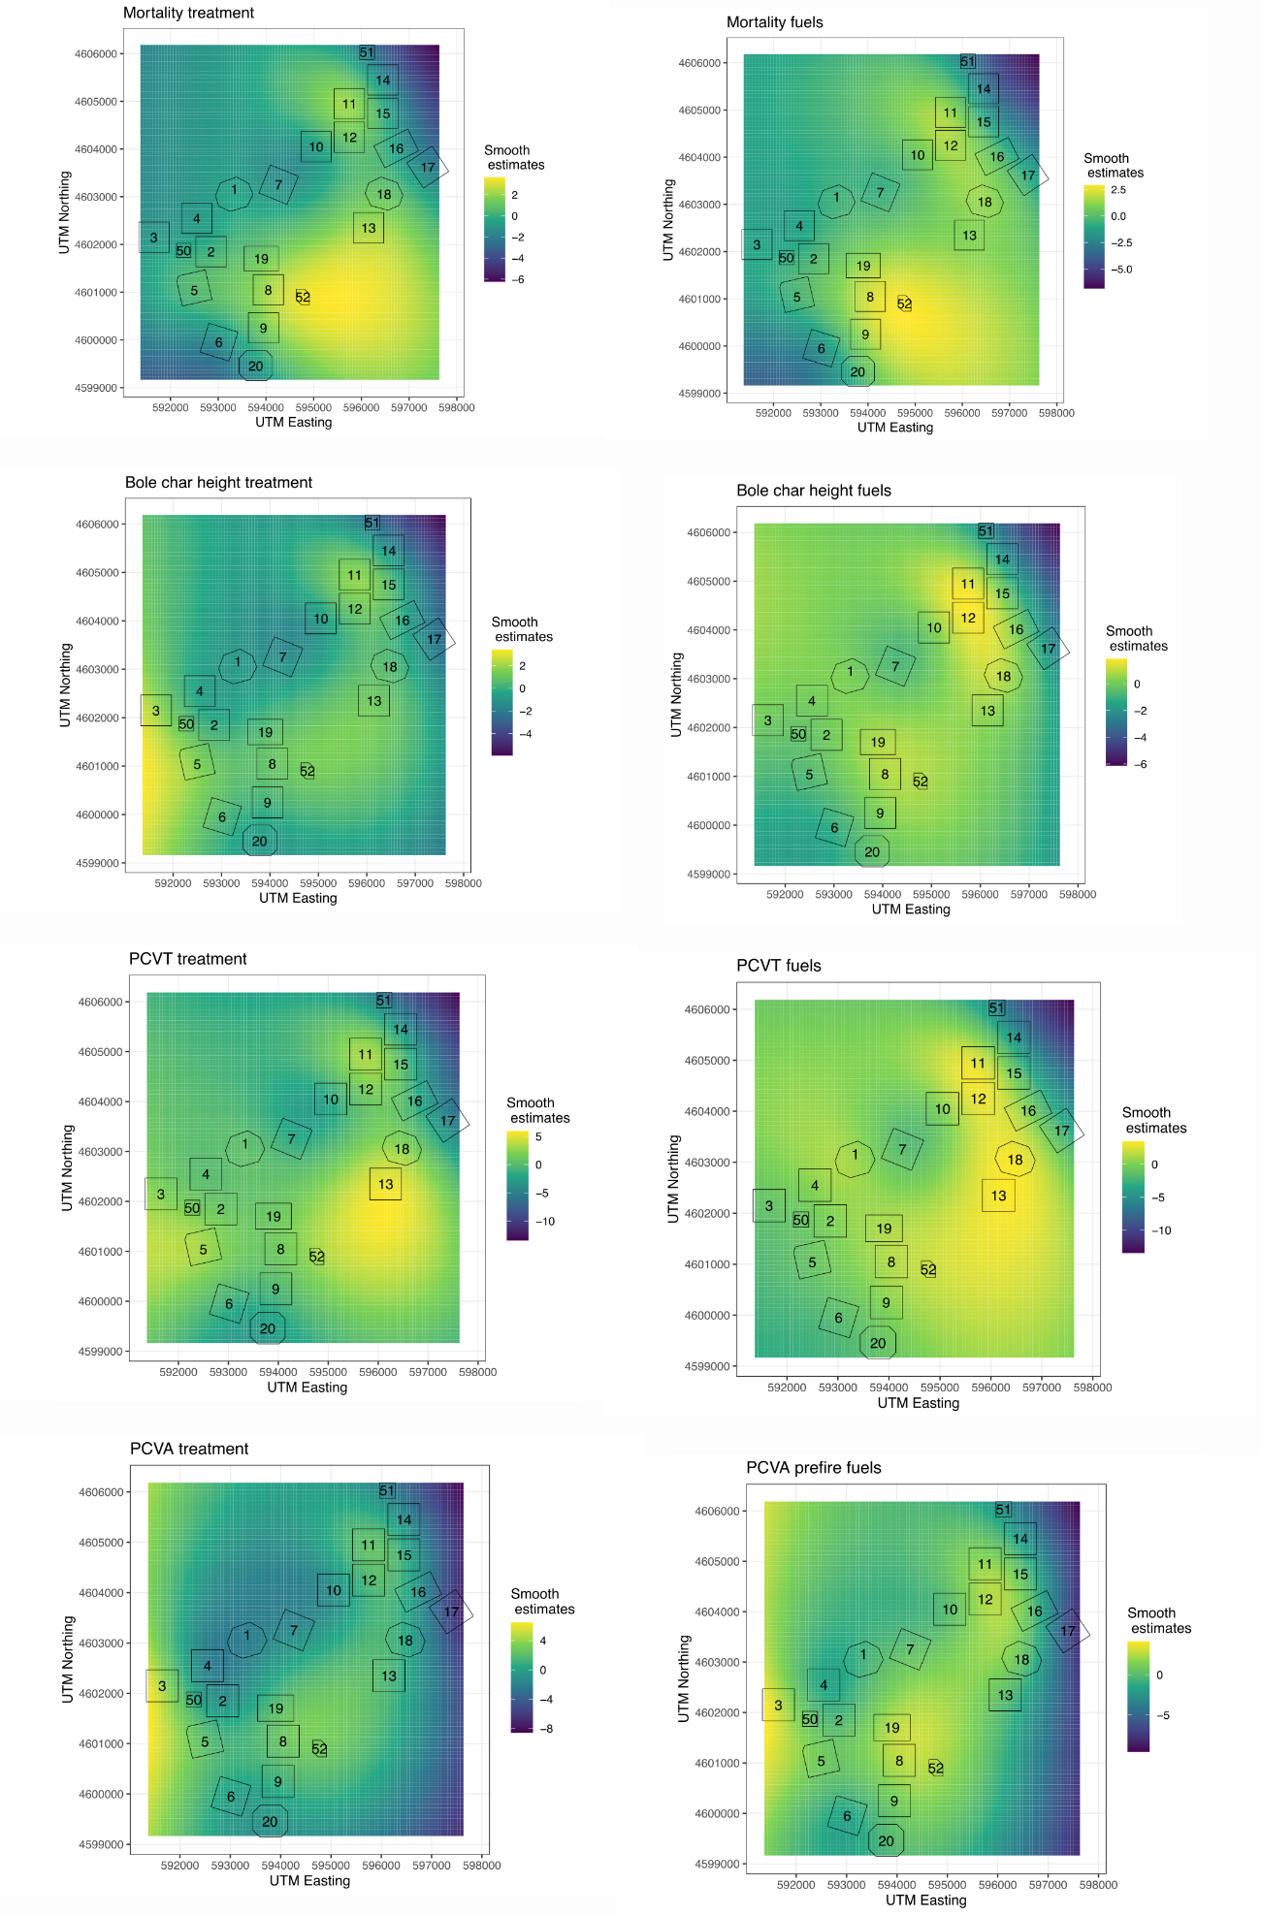
Figure S1. Smooth surfaces representing underlying spatial autocorrelation in fire severity for models in Tables S1-S8. Numbered treatment units displayed for reference.

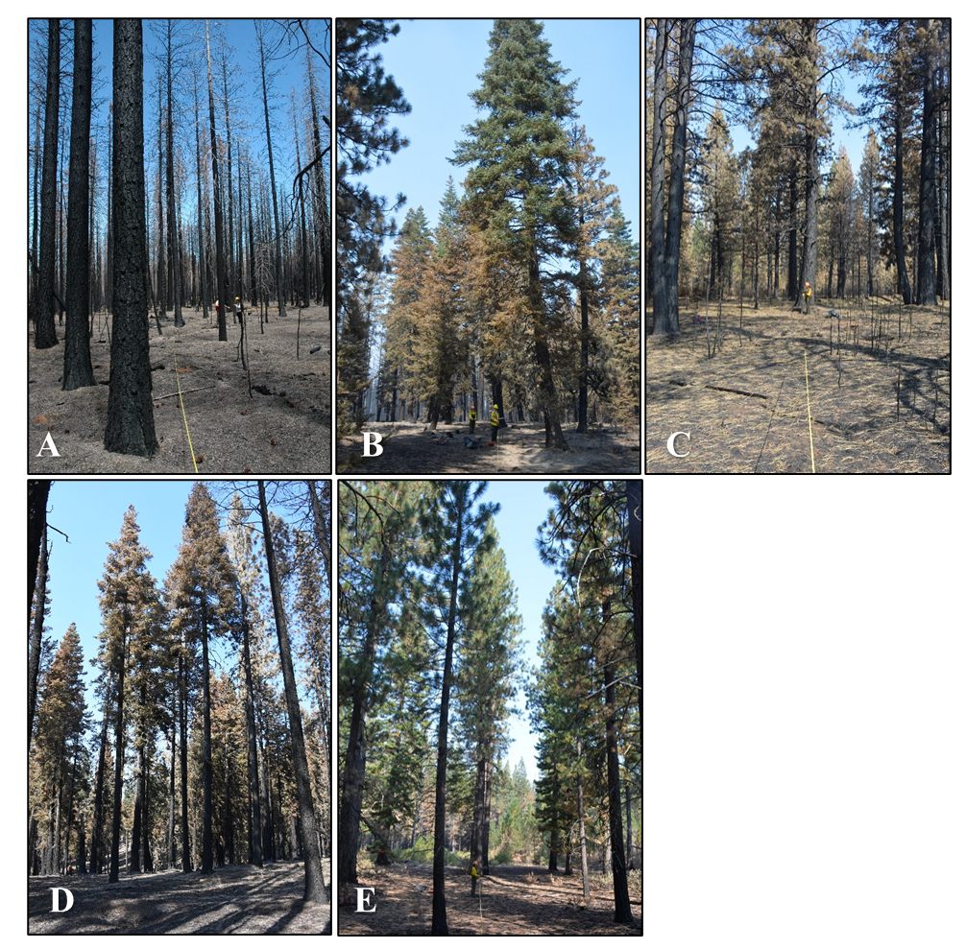
Figure S2. Representative photos of treatments after the 2021 Atelope fire for Control (a), Thin-BT (b), Thin-P (c), Fire-only (d), and Thin-P-fire (e). Fire severity outcomes were extremely variable within treatments and photos were selected such that ocular estimates of percent crown volume affected matched the mean observed value for each treatment type as closely as possible, with torching most evident in the control: 0.81 for Control, 0.66 for Thin-BT, 0.88 for Thin-P, 0.74 for Fire-only, and 0.30 for Thin-P-fire.

Supplemental tables

Table S1. Prefire tree density and basal area median and interquartile range shown by treatment and tree size.
Treatment | Tree size | Density (trees ha1) | Basal area (m2 ha1)
Control | pole | 444.6 [ 197.6 , 543.4 ] | 10.27 [ 4.32 , 16.25 ]
Control | sawtimber | 247 [ 197.6 , 305.66 ] | 41.76 [ 33.11 , 50.44 ]
Thin-BT | pole | 0 [ 0 , 49.4 ] | 0 [ 0 , 0.72 ]
Thin-BT | sawtimber | 111.15 [ 86.45 , 148.2 ] | 26.63 [ 20.97 , 32.56 ]
Thin-P | pole | 0 [ 0 , 49.4 ] | 0 [ 0 , 2.21 ]
Thin-P | sawtimber | 123.5 [ 86.45 , 148.2 ] | 27.72 [ 21.02 , 35.42 ]
Fire-only | pole | 518.7 [ 358.15 , 815.1 ] | 19.41 [ 12.28 , 26.72 ]
Fire-only | sawtimber | 135.85 [ 101.89 , 160.55 ] | 17.49 [ 12.26 , 26.06 ]
Thin-P-fire | pole | 0 [ 0 , 49.4 ] | 0 [ 0 , 1.45 ]
Thin-P-fire | sawtimber | 98.8 [ 49.4 , 135.85 ] | 23.66 [ 14.44 , 31.31 ]

Table S2. Prefire surface fuel mass, canopy bulk density, and shrub cover median and interquartile range show by treatment.
Treatment | Surface fuel mass (Kg m2) | Canopy bulk density (Kg m3) | Shrub cover (%)
Control | 8.41 [ 6.66 , 11.09 ] | 0.15 [ 0.11 , 0.2 ] | 0 [ 0 , 0 ]
Thin-BT | 6.51 [ 5.42 , 8.13 ] | 0.05 [ 0.03 , 0.06 ] | 5 [ 2 , 10 ]
Thin-P | 7.19 [ 5.81 , 9.21 ] | 0.05 [ 0.04 , 0.06 ] | 5 [ 2 , 20 ]
Fire-only | 6.28 [ 5.04 , 7.4 ] | 0.12 [ 0.08 , 0.15 ] | 0.5 [ 0 , 1 ]
Thin-P-fire | 5.04 [ 3.81 , 6.04 ] | 0.04 [ 0.02 , 0.05 ] | 37.47 [ 10 , 60 ]

Table S3. Summary for mortality model with treatment effects.
Variable | Estimate | Est.Error | l-95% CI | u-95% CI | Rhat | Bulk_ESS | Tail_ESS
Intercept | 1.9 | 0.12 | 1.67 | 2.14 | 1.00 | 1970 | 2523
treatmentbig_tree | -2.19 | 0.23 | -2.65 | -1.74 | 1.00 | 1848 | 2227
treatmentpine_emphasis | -1.03 | 0.2 | -1.43 | -0.63 | 1.00 | 1880 | 2379
treatmentfire | -2.3 | 0.27 | -2.83 | -1.78 | 1.00 | 2117 | 2853
treatmentpine_emphasis_fire | -3.05 | 0.25 | -3.52 | -2.56 | 1.00 | 2134 | 2747
bi_max | 1.37 | 0.14 | 1.09 | 1.65 | 1.00 | 2189 | 2539
dbh | -0.51 | 0.04 | -0.6 | -0.43 | 1.00 | 5866 | 2795
shrub | -0.47 | 0.06 | -0.59 | -0.35 | 1.00 | 3450 | 3268
speciesABMA | -0.22 | 0.69 | -1.53 | 1.16 | 1.00 | 5984 | 2895
speciesCADE | 0.3 | 0.25 | -0.19 | 0.8 | 1.00 | 4289 | 2770
speciesPILA | 0.53 | 0.34 | -0.1 | 1.22 | 1.00 | 5785 | 2825
speciesPIPO | -0.43 | 0.08 | -0.59 | -0.28 | 1.00 | 5539 | 3115
treatmentbig_tree:bi_max | -1.1 | 0.15 | -1.39 | -0.82 | 1.00 | 2374 | 2751
treatmentpine_emphasis:bi_max | -1.27 | 0.18 | -1.62 | -0.94 | 1.00 | 2164 | 2440
treatmentfire:bi_max | -0.43 | 0.19 | -0.8 | -0.05 | 1.00 | 2251 | 2664
treatmentpine_emphasis_fire:bi_max | 0.07 | 0.22 | -0.36 | 0.5 | 1.00 | 2166 | 2402
sutm_nutm_e_1 | 4.52 | 0.85 | 2.85 | 6.17 | 1.00 | 4508 | 3160
sutm_nutm_e_2 | -5 | 0.95 | -6.82 | -3.2 | 1.00 | 4961 | 2897

Table S4. Summary for bole char height model with treatment effects.
Variable | Estimate | Est.Error | l-95% CI | u-95% CI | Rhat | Bulk_ESS | Tail_ESS
Intercept | 3.35 | 0.04 | 3.26 | 3.43 | 1.00 | 1993 | 2639
treatmentbig_tree | -0.89 | 0.09 | -1.06 | -0.71 | 1.00 | 1963 | 2314
treatmentpine_emphasis | -0.93 | 0.08 | -1.08 | -0.76 | 1.00 | 2134 | 2877
treatmentfire | -0.72 | 0.1 | -0.93 | -0.52 | 1.00 | 2072 | 2689
treatmentpine_emphasis_fire | -2.71 | 0.09 | -2.88 | -2.54 | 1.00 | 2231 | 2516
bi_max | 0.99 | 0.06 | 0.87 | 1.1 | 1.00 | 2132 | 2487
dbh | 0.36 | 0.01 | 0.33 | 0.38 | 1.00 | 4146 | 2860
shrub | -0.24 | 0.02 | -0.28 | -0.2 | 1.00 | 2965 | 3086
speciesABMA | 0.17 | 0.34 | -0.49 | 0.85 | 1.00 | 4302 | 2710
speciesCADE | 0.18 | 0.1 | -0.02 | 0.38 | 1.00 | 4266 | 2695
speciesPILA | 0.29 | 0.14 | 0.01 | 0.55 | 1.00 | 4632 | 2876
speciesPIPO | 0.28 | 0.03 | 0.22 | 0.33 | 1.00 | 4354 | 2672
treatmentbig_tree:bi_max | -0.77 | 0.06 | -0.88 | -0.66 | 1.00 | 2152 | 2918
treatmentpine_emphasis:bi_max | -1.29 | 0.07 | -1.43 | -1.15 | 1.00 | 2592 | 2959
treatmentfire:bi_max | -0.92 | 0.08 | -1.07 | -0.77 | 1.00 | 2379 | 2987
treatmentpine_emphasis_fire:bi_max | -1 | 0.07 | -1.14 | -0.86 | 1.00 | 2189 | 2512
sutm_eutm_n_1 | -15.34 | 0.86 | -17.06 | -13.69 | 1.00 | 2536 | 2565
sutm_eutm_n_2 | -3.03 | 0.6 | -4.15 | -1.82 | 1.00 | 2090 | 2680

Table S5. Summary for model of percent crown volume torched with treatment effects.
Variable | Estimate | Est.Error | l-95% CI | u-95% CI | Rhat | Bulk_ESS | Tail_ESS
treatmentnone | 1.4 | 0.15 | 1.11 | 1.7 | 1.00 | 2492 | 2563
treatmentbig_tree | -2.45 | 0.22 | -2.9 | -2.01 | 1.00 | 2673 | 2773
treatmentpine_emphasis | -1.94 | 0.19 | -2.32 | -1.58 | 1.00 | 2862 | 2990
treatmentfire | -1.14 | 0.35 | -1.84 | -0.48 | 1.00 | 2419 | 2689
treatmentpine_emphasis_fire | -7.46 | 0.71 | -8.94 | -6.19 | 1.00 | 2832 | 2674
bi_max | 0.68 | 0.21 | 0.28 | 1.09 | 1.00 | 2383 | 2937
shrub | -0.25 | 0.09 | -0.43 | -0.09 | 1.00 | 3691 | 3145
speciesABMA | -0.77 | 1.19 | -2.98 | 1.66 | 1.00 | 5680 | 3047
speciesCADE | 0.58 | 0.32 | -0.07 | 1.19 | 1.00 | 5321 | 2970
speciesPILA | 0.14 | 0.35 | -0.53 | 0.82 | 1.00 | 5834 | 2861
speciesPIPO | -0.02 | 0.09 | -0.2 | 0.16 | 1.00 | 4191 | 2801
dbh | -0.39 | 0.05 | -0.49 | -0.3 | 1.00 | 5321 | 2508
treatmentbig_tree:bi_max | -0.43 | 0.19 | -0.81 | -0.06 | 1.00 | 2133 | 2774
treatmentpine_emphasis:bi_max | -1.82 | 0.25 | -2.3 | -1.32 | 1.00 | 2308 | 2656
treatmentfire:bi_max | -1.7 | 0.28 | -2.24 | -1.14 | 1.00 | 2051 | 2513
treatmentpine_emphasis_fire:bi_max | 0.96 | 0.58 | -0.14 | 2.14 | 1.00 | 2047 | 2814
sutm_eutm_n_1 | -31.39 | 3.22 | -38.13 | -25.43 | 1.00 | 3300 | 2764
sutm_eutm_n_2 | 12.47 | 2.93 | 6.6 | 18.08 | 1.00 | 2772 | 2895

Table S6. Summary for model of percent crown volume affected with treatment effects.
Variable | Estimate | Est.Error | l-95% CI | u-95% CI | Rhat | Bulk_ESS | Tail_ESS
treatmentnone | 3.21 | 0.18 | 2.86 | 3.58 | 1.00 | 2088 | 2414
treatmentbig_tree | 1.65 | 0.2 | 1.25 | 2.04 | 1.00 | 2533 | 3027
treatmentpine_emphasis | 2.06 | 0.2 | 1.69 | 2.45 | 1.00 | 3407 | 3111
treatmentfire | 0.27 | 0.29 | -0.29 | 0.86 | 1.00 | 2607 | 2895
treatmentpine_emphasis_fire | -1.09 | 0.21 | -1.5 | -0.68 | 1.00 | 3319 | 3134
bi_max | 1.89 | 0.18 | 1.54 | 2.24 | 1.00 | 1899 | 2375
shrub | -0.57 | 0.07 | -0.71 | -0.43 | 1.00 | 4531 | 2842
speciesABMA | 0.34 | 1.06 | -1.72 | 2.5 | 1.00 | 6697 | 2852
speciesCADE | -0.08 | 0.28 | -0.63 | 0.47 | 1.00 | 6299 | 2821
speciesPILA | 0.2 | 0.45 | -0.64 | 1.09 | 1.00 | 5578 | 2757
speciesPIPO | -0.44 | 0.09 | -0.63 | -0.26 | 1.00 | 4980 | 2960
dbh | -0.42 | 0.05 | -0.51 | -0.32 | 1.00 | 6323 | 3070
treatmentbig_tree:bi_max | -1.45 | 0.19 | -1.83 | -1.09 | 1.00 | 2035 | 2338
treatmentpine_emphasis:bi_max | -2.84 | 0.23 | -3.3 | -2.4 | 1.00 | 1795 | 2200
treatmentfire:bi_max | -0.89 | 0.31 | -1.47 | -0.27 | 1.00 | 2065 | 2788
treatmentpine_emphasis_fire:bi_max | -1.86 | 0.27 | -2.4 | -1.31 | 1.00 | 2074 | 2442
sutm_eutm_n_1 | -25.16 | 2.21 | -29.49 | -20.78 | 1.00 | 2633 | 2420
sutm_eutm_n_2 | 27.27 | 2.47 | 22.49 | 32.1 | 1.00 | 3806 | 3189

Table S7. Summary for mortality model with prefire fuels.
Variable | Estimate | Est.Error | l-95% CI | u-95% CI | Rhat | Bulk_ESS | Tail_ESS
Intercept | 0.62 | 0.06 | 0.51 | 0.73 | 1.00 | 5828 | 3031
cbd | 0.58 | 0.06 | 0.47 | 0.7 | 1.00 | 3744 | 3220
bi_max | 0.99 | 0.1 | 0.81 | 1.18 | 1.00 | 2856 | 2748
surface_fuel | 0.09 | 0.05 | 0 | 0.18 | 1.00 | 4967 | 3178
dbh | -0.47 | 0.04 | -0.55 | -0.39 | 1.00 | 6356 | 3116
shrub | -0.53 | 0.05 | -0.62 | -0.43 | 1.00 | 4671 | 3309
speciesABMA | -0.07 | 0.67 | -1.35 | 1.27 | 1.00 | 7163 | 3052
speciesCADE | 0.35 | 0.26 | -0.15 | 0.85 | 1.00 | 5924 | 2702
speciesPILA | 0.63 | 0.33 | 0 | 1.29 | 1.00 | 6428 | 2819
speciesPIPO | -0.19 | 0.08 | -0.34 | -0.04 | 1.00 | 5174 | 2801
cbd:bi_max | 0.45 | 0.06 | 0.34 | 0.56 | 1.00 | 3702 | 3137
bi_max:surface_fuel | -0.05 | 0.05 | -0.15 | 0.06 | 1.00 | 5104 | 3163
sutm_eutm_n_1 | -1.99 | 0.73 | -3.45 | -0.54 | 1.00 | 4548 | 3048
sutm_eutm_n_2 | -7.55 | 0.87 | -9.21 | -5.82 | 1.00 | 4949 | 2899

Table S8. Summary for bole char height model with prefire fuels.
Variable | Estimate | Est.Error | l-95% CI | u-95% CI | Rhat | Bulk_ESS | Tail_ESS
Intercept | 2.54 | 0.02 | 2.49 | 2.58 | 1.00 | 5097 | 3259
cbd | 0.31 | 0.02 | 0.26 | 0.35 | 1.00 | 4168 | 3037
bi_max | 0.51 | 0.05 | 0.43 | 0.6 | 1.00 | 3150 | 2617
surface_fuel | 0.1 | 0.02 | 0.07 | 0.14 | 1.00 | 4900 | 2815
dbh | 0.33 | 0.02 | 0.3 | 0.36 | 1.00 | 4879 | 2850
shrub | -0.49 | 0.02 | -0.53 | -0.46 | 1.00 | 4597 | 2833
speciesABMA | 0.31 | 0.36 | -0.43 | 1.02 | 1.00 | 5725 | 2961
speciesCADE | 0.22 | 0.11 | 0.01 | 0.44 | 1.00 | 5234 | 2844
speciesPILA | 0.3 | 0.15 | 0 | 0.6 | 1.00 | 5860 | 2918
speciesPIPO | 0.32 | 0.03 | 0.26 | 0.38 | 1.00 | 4989 | 3115
cbd:bi_max | 0.27 | 0.02 | 0.23 | 0.31 | 1.00 | 4340 | 3221
bi_max:surface_fuel | -0.04 | 0.02 | -0.09 | 0 | 1.00 | 5396 | 3018
sutm_eutm_n_1 | -8.13 | 0.64 | -9.39 | -6.88 | 1.00 | 3775 | 2924
sutm_eutm_n_2 | -1.58 | 0.49 | -2.53 | -0.63 | 1.00 | 3485 | 2625

Table S9. Summary for model of percent crown volume torched with prefire fuels.
Variable | Estimate | Est.Error | l-95% CI | u-95% CI | Rhat | Bulk_ESS | Tail_ESS
cbd | 0.75 | 0.06 | 0.63 | 0.88 | 1.00 | 4320 | 2787
bi_max | 0.59 | 0.13 | 0.33 | 0.84 | 1.00 | 3784 | 3060
surface_fuel | 0.03 | 0.05 | -0.06 | 0.12 | 1.00 | 5358 | 3384
shrub | -1.04 | 0.07 | -1.19 | -0.9 | 1.00 | 4838 | 2758
speciesABCO | -1.12 | 0.08 | -1.27 | -0.97 | 1.00 | 3565 | 3038
speciesABMA | -1.36 | 1.07 | -3.41 | 0.8 | 1.00 | 6930 | 2874
speciesCADE | -0.55 | 0.34 | -1.22 | 0.1 | 1.00 | 6656 | 2870
speciesPILA | -1.03 | 0.33 | -1.67 | -0.38 | 1.00 | 5998 | 2944
speciesPIPO | -0.99 | 0.07 | -1.14 | -0.85 | 1.00 | 3535 | 2994
dbh | -0.47 | 0.05 | -0.56 | -0.38 | 1.00 | 6654 | 2906
cbd:bi_max | 0.21 | 0.06 | 0.09 | 0.33 | 1.00 | 4607 | 3381
bi_max:surface_fuel | -0.02 | 0.06 | -0.14 | 0.1 | 1.00 | 5588 | 2919
sutm_eutm_n_1 | 3.72 | 1.84 | 0.19 | 7.32 | 1.00 | 2550 | 3015
sutm_eutm_n_2 | 27.13 | 3.14 | 21.33 | 33.58 | 1.00 | 2800 | 2839

Table S10. Summary for model of percent crown volume affected with prefire fuels.
Variable | Estimate | Est.Error | l-95% CI | u-95% CI | Rhat | Bulk_ESS | Tail_ESS
cbd | 0.89 | 0.09 | 0.72 | 1.07 | 1.00 | 3200 | 2993
bi_max | 1.04 | 0.12 | 0.81 | 1.27 | 1.00 | 3444 | 2850
surface_fuel | 0.46 | 0.06 | 0.34 | 0.58 | 1.00 | 3389 | 2909
shrub | -0.65 | 0.06 | -0.77 | -0.53 | 1.00 | 4199 | 3144
speciesABCO | 1.87 | 0.08 | 1.72 | 2.03 | 1.00 | 3965 | 3139
speciesABMA | 2.64 | 1.01 | 0.72 | 4.70 | 1.00 | 5857 | 2676
speciesCADE | 1.73 | 0.26 | 1.24 | 2.24 | 1.00 | 4967 | 3031
speciesPILA | 2.06 | 0.42 | 1.26 | 2.94 | 1.00 | 5560 | 2698
speciesPIPO | 1.57 | 0.07 | 1.43 | 1.72 | 1.00 | 3965 | 3372
dbh | -0.33 | 0.04 | -0.42 | -0.24 | 1.00 | 5055 | 2738
cbd:bi_max | 0.91 | 0.08 | 0.75 | 1.08 | 1.00 | 3178 | 3244
bi_max:surface_fuel | 0.23 | 0.07 | 0.09 | 0.36 | 1.00 | 3274 | 2850
sutm_eutm_n_1 | 21.99 | 1.82 | 18.48 | 25.57 | 1.00 | 3321 | 2952
sutm_eutm_n_2 | 28.24 | 1.73 | 24.97 | 31.70 | 1.00 | 3531 | 2713

