9. Appendices

Appendix A: Questionnaire


Welcome to our research study!

As hurricanes regularly threaten Florida and pose significant risks to life and property, we are conducting this research to study people’s intentions for hurricane preparedness within institutions of higher education in Florida. The survey should take around 15 minutes to complete, and responses will be kept confidential. The survey feedback will help universities prepare and stay safe during the upcoming hurricane seasons. Your participation in this online survey is crucial and highly appreciated.

There will be three $150 visa gift cards, and they will be awarded to the 5th, 50th, and 500th completed surveys. If you want to have the chance to win one of the three visa gift cards, you will have to follow the link at the end of the survey and leave us your email address, knowing that your responses will not be associated with your email address.

For the three winners:
Any payment for your participation in this research study will be handled through the University of Florida’s Research Participant Payment (RPP) Program. Your information which will include your name, address, and date of birth, is protected. Access to the RPP Program site is limited to certain staff with the assigned security role. You will be randomly assigned a specific identification (ID) number to protect your identity.

By clicking the button below, you acknowledge:
-You are currently living in Florida.
-Your participation in the study is voluntary.
-You are aware that you may choose to terminate your participation at any time for any reason.
- I consent, begin the study
- I do not consent, I do not wish to participate

At which university do you work/study?
- Edward Waters University
- College of Central Florida
- Florida International University
- Florida State University
- University of Florida

What is your status at your current university?
- Undergraduate Student
- Graduate Student or Professional Degree Student

Section#1: Hurricane preparedness
Please answer the questions below based on your current primary place of residence. Some questions will be asking about your current Dwelling, and some questions will be asking about your current Building. A dwelling is a home — where someone lives, such as a house, apartment, condo, etc. A building can have multiple dwellings (e.g. multiple apartments in one residential building).
Please note that if you live in a house, your dwelling and your building are the same thing. If you live in a dorm, your dwelling is your dorm floor, and NOT the entire dorm building. (You will be reminded of this definition multiple times throughout the survey)

 | (Very low) |  |  |  | (Very high)
 | 1 | 2 | 3 | 4 | 5
I believe that the possibility of a hurricane passing by or through my city/town in any given year is...
I believe that the severity of the damage that a hurricane can cause in my city/town is…
-
 | (Very low) |  |  |  | (Very high)
 | 1 | 2 | 3 | 4 | 5
I believe that the possibility of winds causing damage to my dwelling during a hurricane is…
I believe that the possibility of my dwelling flooding during a hurricane is…

 | (Very low) |  |  |  | (Very high)
 | 1 | 2 | 3 | 4 | 5
I believe that the severity of the damage that a hurricane can cause to the following elements is:
- Roof of my dwelling
- Exterior glass (such as windows and exterior glass doors) of my dwelling
- Exterior walls of my building
- Interior of my dwelling
- Foundations of my building
-
 | (Very Low) |  |  |  | (Very High)
 | 1 | 2 | 3 | 4 | 5
I believe that the possibility of a hurricane starting an electrical/gas fire at my dwelling is…
-
 | (Very low) |  |  |  | (Very high)
 | 1 | 2 | 3 | 4
I believe that the possibility of a hurricane causing a power/electricity outage at my dwelling is…
-
 | (Very Short) |  |  |  | (Very Long)
 | 1 | 2 | 3 | 4
How long do you believe a power/electricity outage will last due to a hurricane at your dwelling?
-
 | (Very low) |  |  |  | (Very high)
 | 1 | 2 | 3 | 4 | 5
I believe that the possibility of the residents of my dwelling (including me) getting physically harmed during a hurricane is…
I believe that the severity of the physical harm that a hurricane can cause the residents of my dwelling (including me) is…
-

Hurricane protective behaviors
The following questions will be asking about three hurricane preparedness behaviors: 1) preparing an emergency supply kit, 2) preparing an evacuation plan, and 3) preparing a communication plan.
Before you answer any question, please read the definitions of these hurricane preparedness behaviors below.

Preparing an emergency supply kit. A basic emergency supply kit includes a minimum of 3 days’ worth of the following supplies: Water, Pantry/Shelf-Stable Food (food that does not need to be refrigerated, such as canned food), Manual Can Opener, Battery-Powered Radio, Flashlight, Batteries, First-Aid Supplies, Toiletries/Hygiene Items, Important Documents, Cash, Pet Care Items, and any other items to keep you comfortable, like a pillow or a blanket.

Preparing an evacuation plan. Having an evacuation plan means you need to: 1) become familiar with the evacuation routes and locations of hurricane shelters near you, 2) know when you are supposed to evacuate your dwelling, 3) know what means of transportation you might use to reach any of the nearby safe shelters, 4) communicate your plan with your roommates, family, and friends, and 5) practice going to a nearby hurricane shelter.

Preparing a communication plan. A communication plan refers to making a list with contact information, and procedures for when, how, and whom to communicate with in case of a hurricane. A communication plan is also used to check on the welfare of family and friends during a hurricane. In a communication plan, you have to keep important numbers (hospital, veterinarian, pharmacy, etc.) written down in a reachable safe place, not just on your phone. You should also keep an out-of-town emergency contact updated with your situation during the hurricane.

 | Not at all |  |  |  | Very Likely
How likely is it that you will be able to prepare each of the following? | 1 | 2 | 3 | 4 | 5
- An emergency supply kit
- An evacuation plan
- A communication plan
-
 | (Little time) |  |  |  | (A lot of time)
How much time do you believe it would take you to prepare each of the following? | 1 | 2 | 3 | 4 | 5
- An emergency supply kit
- An evacuation plan
- A communication plan
-
 | (Little effort) |  |  |  | (A lot of effort)
How much effort do you believe it would take you to prepare each of the following? | 1 | 2 | 3 | 4 | 5
- An emergency supply kit
- An evacuation plan
- A communication plan
-
 | Not at all |  |  |  | (Very Overwhelmed)
How overwhelmed would you be if you were to prepare each of the following? | 1 | 2 | 3 | 4 | 5
- An emergency supply kit
- An evacuation plan
- A communication plan
-
 | Not at all |  |  |  | Very Likely
 | 1 | 2 | 3 | 4 | 5
How likely is it that you will be able to secure/obtain all the items in an emergency supply kit?
-
 | Not at all |  |  |  | Very Sufficient
 | 1 | 2 | 3 | 4 | 5
When it comes to storing the items in an emergency supply kit, how sufficient is the space at your dwelling?
-
 | Not at all |  |  |  | Very Likely
 | 1 | 2 | 3 | 4 | 5
Most emergency supply kits cost on average around $190 to assemble if you do not already own these items. If you were to prepare an emergency supply kit, how likely is it that you will be able to afford it?

 | (Very unnecessary) |  |  |  | (Very necessary)
During a hurricane, how necessary do you believe having each of the following would be at your dwelling? | 1 | 2 | 3 | 4 | 5
- An emergency supply kit
- An evacuation plan
- A communication plan
-
 | (Very unbeneficial) |  |  |  | (Very beneficial)
During a hurricane, how beneficial do you believe having each of the following would be at your dwelling? | 1 | 2 | 3 | 4 | 5
- An emergency supply kit
- An evacuation plan
- A communication plan
-
 | (Very ineffective) |  |  |  | (Very effective)
When it comes to saving lives and reducing the physical harm of hurricanes on the residents of your dwelling (including you), how effective do you believe having each of the following would be? | 1 | 2 | 3 | 4 | 5
- An emergency supply kit
- An evacuation plan
- A communication plan

 | Not at all |  |  |  |  | Maybe |  |  |  |  | Very Likely
During the next hurricane season, how likely is it that you will have the following? | 0 | 1 | 2 | 3 | 4 | 5 | 6 | 7 | 8 | 9 | 10
- An emergency supply kit
- An evacuation plan
- A communication plan
-

 | Not at all |  |  |  | Very Likely
For the next hurricane season, how likely is it that you will prepare the following for someone else? | 1 | 2 | 3 | 4 | 5
- An emergency supply kit
- An evacuation plan
- A communication plan
-
 | Not at all |  |  |  | Very Likely
For the next hurricane season, how likely is it that someone else will prepare the following for you? | 1 | 2 | 3 | 4 | 5
- An emergency supply kit
- An evacuation plan
- A communication plan
-
During the hurricane season, how many people around you do you believe have the following? | (No one) |  |  |  | (Everyone)
- Emergency supply kits
- Evacuation plans
- Communication plan
-
How many of your friends and family members think you should have the following during the hurricane season? | (No one) |  |  |  | (Everyone)
- An emergency supply kit
- An evacuation plan
- A communication plan
-
 | Not at all |  |  |  | Very Likely
During the hurricane season, how likely is it that you will be motivated to have the following, if people around you have one? | 1 | 2 | 3 | 4 | 5
- Emergency supply kits
- Evacuation plans
- Communication plan
-

 | (No responsibility) |  |  |  | (Full responsibility)
If your household was to prepare following items for the hurricane season at your dwelling, what level of responsibility would you have in preparing it? | 1 | 2 | 3 | 4 | 5
- An emergency supply kit
- An evacuation plan
- A communication plan
-
 | (No input) |  |  |  | (A lot of input)
If your household was to prepare the following for the hurricane season at your dwelling, what level of input/influence would you have in decision-making for preparing it? | 1 | 2 | 3 | 4 | 5
- An emergency supply kit
- An evacuation plan
- A communication plan


Complete the rest of the survey if you want to have the chance to win one of the three $150 visa gift cards!

How long have you lived in your current city?
- Less than 2 years
- 2 - 5 years
- 6 - 10 years
- More than 10 years

How long have you lived in Hurricane/Cyclone/Typhoon prone areas, whether in the US or overseas?
- Less than 2 years
- 2 - 5 years
- 6-10 years
- More than 10 years

Section#2: Demographics

Reminder of the Dwelling and Building definitions
Please answer the questions below based on your current primary place of residence. Some of the following questions ask about your current Dwelling and some ask about your current Building. A dwelling is a home — where someone lives, such as a house, apartment, condo, etc. A building can have multiple dwellings (e.g. multiple apartments in one residential building). Please note that if you live in a house, your dwelling and your building are the same thing. And if you live in a dorm, your dwelling is your dorm floor, and NOT the entire dorm building.
Which of the following best describes the type of your dwelling?
- Student Dorm or Residence Hall
- Fraternity/Sorority house
- Apartment/Condo
- Townhouse
- Duplex
- Mobile or Manufactured home
- Single-family home, not a Mobile or Manufactured home
- Hotel/Motel
- Trailer, Boat, RV, Car, or Van
- Other (specify)

-How old are you? (………. years)

-What is your gender identity?
- Female
- Male
- Non-binary
- Choose not to respond

-What is your race/ethnicity? (Select all that apply)
- Hispanic or Latino
- White
- Black or African American
- American Indian and Alaska Native
- Asian
- South Asian
- Native Hawaiian and Other Pacific Islander
- Middle Eastern
- Some Other Race
-What is your student status?
- Domestic student
- International student

Do you have any other comments or feedback about this survey that you would like our team to know?

We thank you for your time spent taking this survey.
Your response has been recorded.
Please enter your email address below if you want to have the chance to win one of the three $150 visa gift cards:

Thank You!
Your response has been recorded.

Appendix B: Statistical Analyses

Table B-1: Reliability checks for survey questions
Behavioral Construct | Cronbach's Alpha
Risk Perception | 0.91
Threat Possibility | 0.74
Threat Severity | 0.87
Efficacy | 0.85
Self-Efficacy | 0.86
Response Efficacy | 0.91
Intention | 0.82
Responsibility | 0.83
Subjective Norms | 0.85
-Cronbach’s Alpha: Unacceptable (< 0.5), Poor (> 0.5), Questionable (> 0.6), Acceptable (> 0.7), Good (> 0.8), Excellent (> 0.9)

Table B-2: Multicollinearity (Emergency Supply Kit Model)
Model | TOL | VIF | Distribution of Residuum
Threat Possibility | 0.38 | 2.66 | 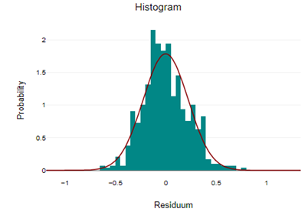
Threat Severity | 0.36 | 2.79
Self-Efficacy (Emergency Kit) | 0.88 | 1.14
Response Efficacy (Emergency Kit) | 0.69 | 1.46
Subjective Norms (Emergency Kit) | 0.7 | 1.43
Responsibility (Emergency Kit) | 0.82 | 1.22
-Note: Multicollinearity is problematic if TOL < 0.10 or VIF > 10

Table B-3: Multi Linear Regression (Emergency Supply Kit)
Model |  | B |  | Beta | Standard error |  | t |  | p |  | 95% confidence interval for B
 |  |  |  |  |  |  |  |  |  |  | lower bound |  | upper bound
(Constant) |  | -0.42 |  | - | 0.06 |  | -7.64 |  | <.001 |  | -0.53 |  | -0.32
Threat Possibility |  | 0.06 |  | 0.04 | 0.09 |  | 0.76 |  | 0.45* |  | -0.1 |  | 0.23
Threat Severity |  | 0 |  | 0 | 0.1 |  | 0.04 |  | 0.96* |  | -0.19 |  | 0.2
Self-Efficacy (Emergency Kit) |  | 0.58 |  | 0.33 | 0.06 |  | 10.08 |  | <.001 |  | 0.46 |  | 0.69
Response Efficacy (Emergency Kit) |  | 0.28 |  | 0.2 | 0.05 |  | 5.21 |  | <.001 |  | 0.17 |  | 0.39
Subjective Norms (Emergency Kit) |  | 0.5 |  | 0.34 | 0.05 |  | 9.11 |  | <.001 |  | 0.39 |  | 0.61
Responsibility (Emergency Kit) |  | 0.15 |  | 0.09 | 0.06 |  | 2.52 |  | 0.012 |  | 0.03 |  | 0.27
Intention (Emergency Kit) = -0.42 +0.06 · Threat Possibility +0 · Threat Severity +0.58 · Self-Efficacy (Emergency Kit) +0.28 · Response Efficacy (Emergency Kit) +0.5 · Subjective Norms (Emergency Kit) +0.15 · Responsibility (Emergency Kit)
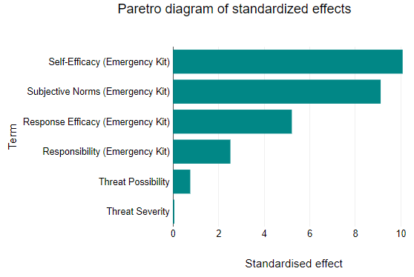
Model | df |  | F |  | p | R |  | R² |  | Adjusted R² |  | Standard error of the estimate
Regression | 6 |  | 77.99 |  | <.001 | 0.67 |  | 0.45 |  | 0.44 |  | 0.23
-Insignificant: p value > 0.05

Table B-4: Logistic Regression (Emergency Supply Kit Model)
Model |  | Coefficient B |  | Standard error |  | z | p |  | Odds Ratio | 95% conf. interval
Threat Possibility |  | -0.75 |  | 1.36 |  | 0.55 | 0.584* |  | 0.47 | 0.03 - 6.86
Threat Severity |  | 1.04 |  | 1.53 |  | 0.68 | 0.496* |  | 2.84 | 0.14 - 57.17
Self-Efficacy (Emergency Kit) |  | 5.92 |  | 0.94 |  | 6.27 | <.001 |  | 372.26 | 58.48 - 2369.73
Response Efficacy (Emergency Kit) |  | 3.6 |  | 0.89 |  | 4.06 | <.001 |  | 36.47 | 6.43 - 207.07
Subjective Norms (Emergency Kit) |  | 5.06 |  | 0.91 |  | 5.54 | <.001 |  | 156.88 | 26.22 - 938.73
Responsibility (Emergency Kit) |  | 1.7 |  | 0.92 |  | 1.86 | 0.063* |  | 5.48 | 0.91 - 32.97
Constant |  | -10.13 |  | 1.12 |  | 9.01 | <.001 |  | - | -
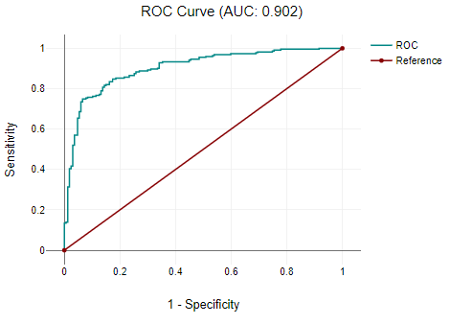
Chi2 | df |  | p |  | -2 Log-Likelihood |  |  | Nagelkerke R²
223.46 | 6 |  | <.001 |  | 309.12 |  |  | 0.59
-Insignificant: p value > 0.05

Table B-5: Multicollinearity (Evacuation Plan Model)
Model | TOL | VIF | Distribution of Residuum
Threat Possibility | 0.37 | 2.70 | 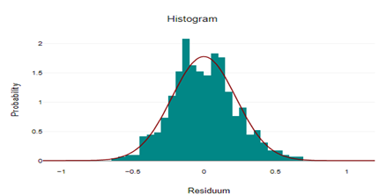
Threat Severity | 0.37 | 2.72
Self-Efficacy (Evacuation Plan) | 0.94 | 1.07
Response Efficacy (Evacuation Plan) | 0.72 | 1.38
Subjective Norms (Evacuation Plan) | 0.78 | 1.28
Responsibility (Evacuation Plan) | 0.89 | 1.12
Note: Multicollinearity is problematic if TOL < 0.10 or VIF > 10

Table B-6: Multi Linear Regression (Evacuation Plan Model)
Model | B | Beta | Standard error |  | t |  | p |  | 95% confidence interval for B
 |  |  |  |  |  |  |  |  | lower bound |  | upper bound
(Constant) | -0.35 | - | 0.05 |  | -6.38 |  | <.001 |  | -0.45 |  | -0.24
Threat Possibility | 0.03 | 0.02 | 0.09 |  | 0.39 |  | 0.698* |  | -0.14 |  | 0.2
Threat Severity | 0.03 | 0.02 | 0.1 |  | 0.33 |  | 0.739* |  | -0.16 |  | 0.22
Self-Efficacy (Evacuation Plan) | 0.34 | 0.25 | 0.05 |  | 7.5 |  | <.001 |  | 0.25 |  | 0.43
Response Efficacy (Evacuation Plan) | 0.31 | 0.23 | 0.05 |  | 6.11 |  | <.001 |  | 0.21 |  | 0.41
Subjective Norms (Evacuation Plan) | 0.62 | 0.42 | 0.05 |  | 11.59 |  | <.001 |  | 0.51 |  | 0.72
Responsibility (Evacuation Plan) | 0.14 | 0.08 | 0.06 |  | 2.44 |  | 0.015 |  | 0.03 |  | 0.25
Intention (Evacuation Plan) = -0.35 +0.03 · Threat Possibility +0.03 · Threat Severity +0.34 · Self-Efficacy (Evacuation Plan) +0.31 · Response Efficacy (Evacuation Plan) +0.62 · Subjective Norms (Evacuation Plan) +0.14 · Responsibility (Evacuation Plan)
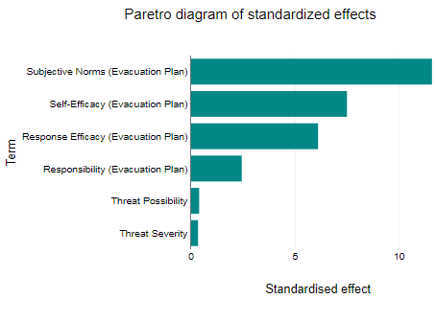
Model | df | F | p | R |  | R² |  | Adjusted R² |  | Standard error of the estimate
Regression | 6 | 68.07 | <.001 | 0.65 |  | 0.42 |  | 0.41 |  | 0.23
-Insignificant: p value > 0.05

Table B-7: Logistic Regression (Evacuation Plan Model)
Model |  | Coefficient B |  | Standard error |  | z | p |  | Odds Ratio | 95% conf. interval
Threat Possibility |  | -0.98 |  | 1.29 |  | 0.76 | 0.445* |  | 0.37 | 0.03 - 4.67
Threat Severity |  | 1.47 |  | 1.41 |  | 1.04 | 0.299* |  | 4.34 | 0.27 - 68.89
Self-Efficacy (Evacuation Plan) |  | 3.68 |  | 0.73 |  | 5.07 | <.001 |  | 39.82 | 9.59 - 165.34
Response Efficacy (Evacuation Plan) |  | 3.75 |  | 0.83 |  | 4.51 | <.001 |  | 42.58 | 8.35 - 217.09
Subjective Norms (Evacuation Plan) |  | 6.86 |  | 0.94 |  | 7.29 | <.001 |  | 958 | 151.23 - 6068.7
Responsibility (Evacuation Plan) |  | 1.42 |  | 0.91 |  | 1.57 | 0.117* |  | 4.13 | 0.7 - 24.34
Constant |  | -9.51 |  | 1.13 |  | 8.4 | <.001 |  | - | -
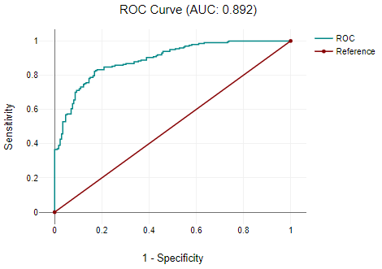
Chi2 | df |  | p |  | -2 Log-Likelihood |  |  | Nagelkerke R²
206.83 | 6 |  | <.001 |  | 303.02 |  |  | 0.57
-Insignificant: p value > 0.05

Table B-8: Multicollinearity (Communication Plan Model)
Modell | TOL | VIF | Distribution of Residuum
Threat Possibility | 0.37 | 2.71 | 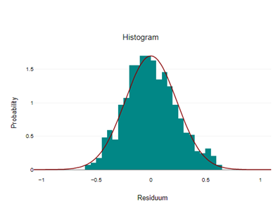
Threat Severity | 0.37 | 2.74
Self-Efficacy (Communication Plan) | 0.93 | 1.08
Response Efficacy (Communication Plan) | 0.74 | 1.35
Subjective Norms (Communication Plan) | 0.75 | 1.33
Responsibility (Communication Plan) | 0.89 | 1.12
Note: Multicollinearity is problematic if TOL < 0.10 or VIF > 10

Table B-9: Multi Linear Regression (Communication Plan Model)
Model | B | Beta | Standard error |  | t |  | p |  | 95% confidence interval for B
 |  |  |  |  |  |  |  |  | lower bound |  | upper bound
(Constant) | -0.26 | - | 0.06 |  | -4.49 |  | <.001 |  | -0.37 |  | -0.14
Threat Possibility | 0.03 | 0.02 | 0.09 |  | 0.34 |  | 0.733* |  | -0.15 |  | 0.21
Threat Severity | -0.01 | 0 | 0.1 |  | -0.07 |  | 0.947* |  | -0.21 |  | 0.19
Self-Efficacy (Communication Plan) | 0.29 | 0.2 | 0.05 |  | 5.82 |  | <.001 |  | 0.19 |  | 0.39
Response Efficacy (Communication Plan) | 0.3 | 0.22 | 0.05 |  | 5.71 |  | <.001 |  | 0.2 |  | 0.4
Subjective Norms (Communication Plan) | 0.59 | 0.4 | 0.06 |  | 10.62 |  | <.001 |  | 0.48 |  | 0.7
Responsibility (Communication Plan) | 0.14 | 0.08 | 0.06 |  | 2.34 |  | 0.02 |  | 0.02 |  | 0.25
Intention (Communication Plan) = -0.35 +0.01 · Threat Possibility -0.02 · Threat Severity +0.33 · Self-Efficacy (Communication Plan) +0.36 · Response Efficacy (Communication Plan) +0.62 · Subjective Norms (Communication Plan) +0.18 · Responsibility (Communication Plan)
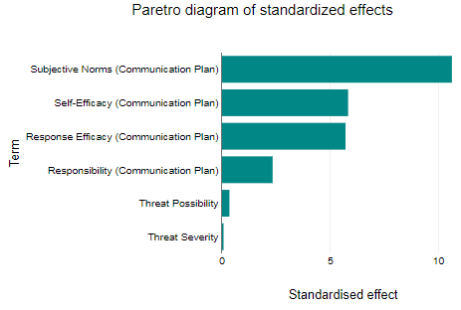
Model | df | F | p | R |  | R² |  | Adjusted R² |  | Standard error of the estimate
Regression | 6 | 58.88 | <.001 | 0.62 |  | 0.38 |  | 0.38 |  | 0.24
-Insignificant: p value > 0.05

Table B-10: Logistic Regression (Communication Plan Model)
Model | Coefficient B | Standard error | z | p | Odds Ratio |  | 95% conf. interval
Threat Possibility | -0.52 | 1.21 | 0.43 | 0.667* | 0.59 |  | 0.06 - 6.4
Threat Severity | 0.76 | 1.37 | 0.56 | 0.577* | 2.14 |  | 0.15 - 31.17
Self-Efficacy (Communication Plan) | 2.93 | 0.7 | 4.17 | <.001 | 18.65 |  | 4.72 - 73.74
Response Efficacy (Communication Plan) | 3.24 | 0.76 | 4.25 | <.001 | 25.5 |  | 5.73 - 113.55
Subjective Norms (Communication Plan) | 6.34 | 0.88 | 7.19 | <.001 | 566.24 |  | 100.68 - 3184.72
Responsibility (Communication Plan) | 1.47 | 0.83 | 1.77 | 0.076* | 4.36 |  | 0.86 - 22.24
Constant | -8.24 | 1.04 | 7.91 | <.001 | - |  | -
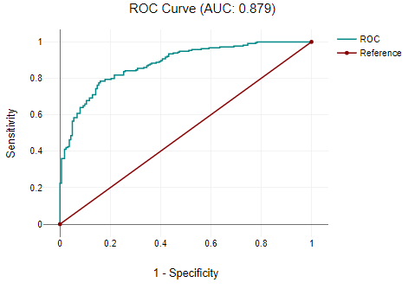
Chi2 | df | p | -2 Log-Likelihood |  |  | Nagelkerke R²
191.25 | 6 | <.001 | 322.78 |  |  | 0.54
-Insignificant: p value > 0.05

