“Follow your heart”: Heart-to-Brain-driven interplay relates to self-congruency.

SUPPLEMENTARY INFORMATION
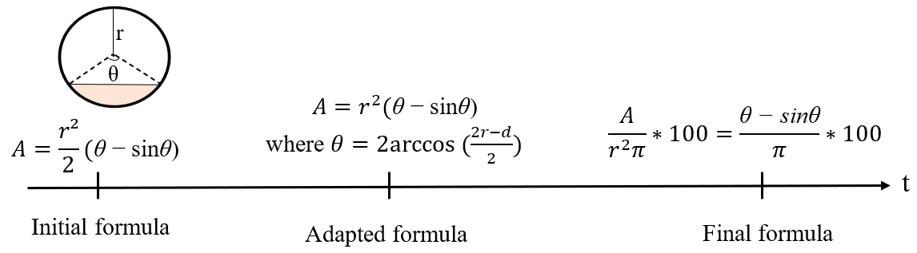
Supplementary A – Schematic illustration of self-congruency assessment.

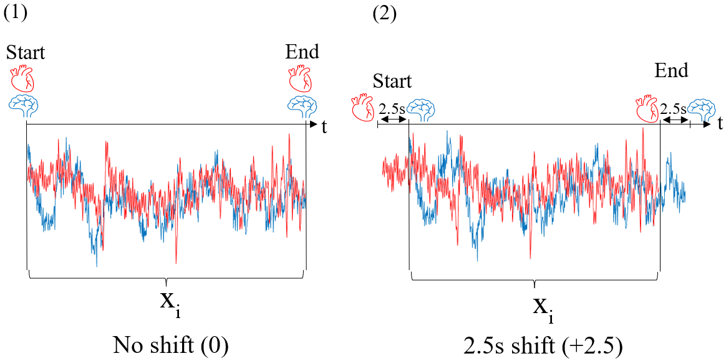
Supplementary B – Schematic illustration of cross-covariance analyses. The shifts represented depict the analyses done when both signals were perfectly overlayed (illustrated on the left), and when the IBI signal was shifted from 0.5 to 2.5 seconds before the BOLD signal (illustrated for the 2.5 seconds shift; on the right).

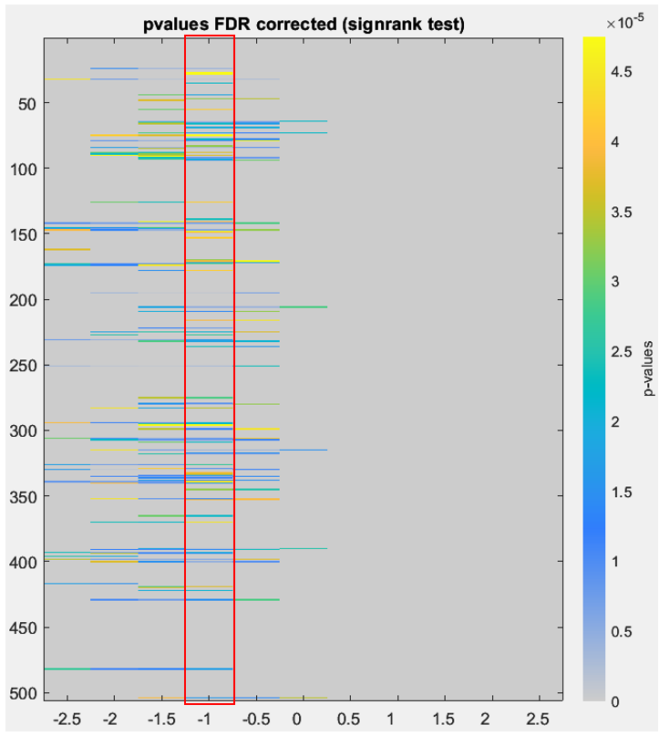
Supplementary C – The global relation between the BOLD and the IBI signals at all shifts. The red frame shows the results presented in Fig. 3. The color scale represents p-values. Regions are significant at p<0.001 FDR-corrected.

Brain regions
rh | lh |  | rh | lh
n° | n° | Name | n° | n° | Name
24,27,28,32,35 | 275,279,280,283 | ctx-rostralmiddlefrontal | 153 |  | ctx-pericalcarine
44,47 | 294,295,296,299 | ctx-superiorfrontal | 170,171,172 | 419,422 | ctx-lingual
55 | 306,307,309 | ctx-caudalmiddlefrontal | 173,178 | 429 | ctx-fusiform
64,65,66,69,73 | 315,317,318 | ctx-precentral | 195 |  | ctx-middletemporal
75,78,79 | 326,329,330 | ctx-paracentral | 206,209 |  | ctx-superiortemporal
 | 332,333 | ctx-rostralanteriorcingulate | 216 |  | ctx-transversetemporal
83,84 | 334,335,336 | ctx-caudalanteriorcingulate | 222 |  | ctx-insula
88 | 338,339,340 | ctx-posteriorcingulate | 225 |  | thal-anterior
90 |  | ctx-isthmuscingulate | 227 |  | thal-ventral_latero_dorsal
92,93,94 | 345,352,353 | ctx-postcentral | 231 | 482 | subc-caudate
 | 365, 370 | ctx-superiorparietal | 232 |  | subc-putamen
126 |  | ctx-inferiorparietal | 236 |  | subc-hippocampus
139,141,142,147 | 390,391,393,394,398 | ctx-precuneus | 251 |  | cer-cerebellum
148,149 | 400 | ctx-cuneus | 504 |  | brain-stem-pons
Supplementary D – Table summarizing the eighty-eight brain regions correlated to the heart signal at the shift presented in Fig. 3, and framed in red in Supplementary C.

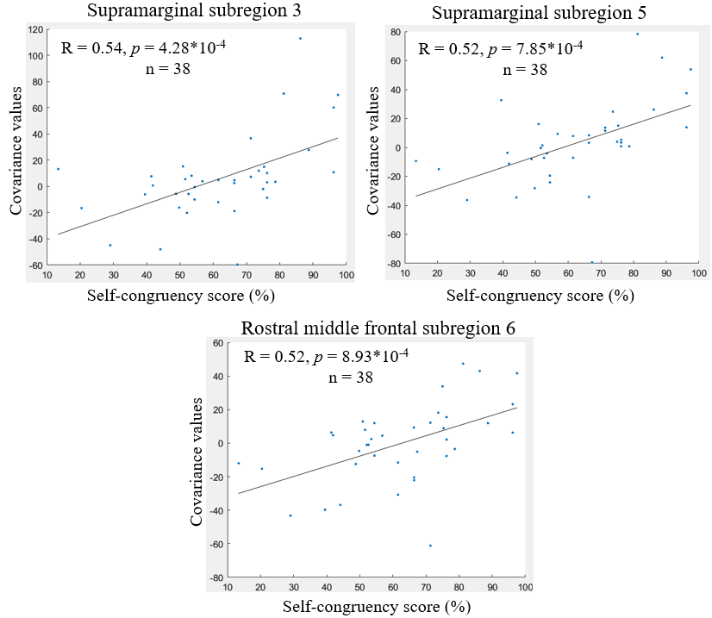
Supplementary E – Correlation results between self-congruency and heart-brain covariance. Results for supramarginal subregion 3 (top left panel), supramarginal subregion 5 (top right panel), and rostral middle frontal subregion 6 (bottom panel).

