Holding in the stream – convergent evolution of suckermouth structures in Loricariidae (Siluriformes)

Wencke Krings^{1,2,3,4*}, Daniel Konn-Vetterlein¹, Stanislav N. Gorb¹

¹ Department of Functional Morphology and Biomechanics, Zoological Institute, Christian-Albrechts-Universität zu Kiel, Am Botanischen Garten 1–9, 24118 Kiel, Germany
² Department of Cariology, Endodontology and Periodontology, Universität Leipzig, Liebigstraße 12, 04103 Leipzig, Germany
³ Department of Mammalogy and Palaeoanthropology, Leibniz Institute for the Analysis of Biodiversity Change, Martin-Luther-King-Platz 3, 20146 Hamburg, Germany
⁴ Department of Electron Microscopy, Institute of Cell and Systems Biology of Animals, Universität Hamburg, Martin-Luther-King-Platz 3, 20146 Hamburg, Germany

*corresponding author: wencke.krings@uni-hamburg.de

Supplementary Material

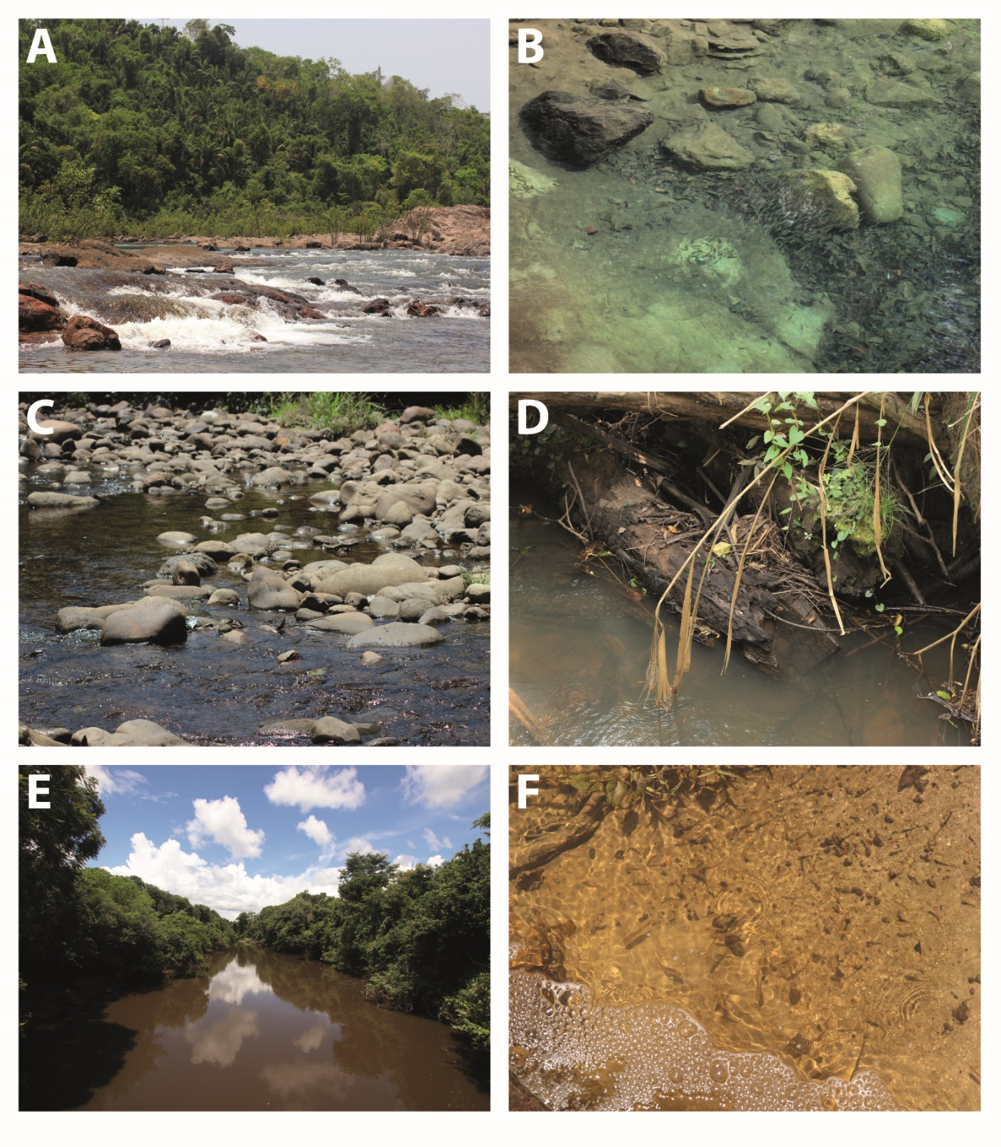
Supplementary Figure 1. Different habitats and preferred substrate. A. Strong current (Rio Xingu, Brazil). B. Stone substrate (Río Carrasco, Bolivia). C. Medium current (Río El Fuerte, Bolivia). D. Wood substrate (Río Tucavaca, Bolivia). E. Slow current (Río Tucavaca, Bolivia). F. Sandy substrate (Río Curicha, Bolivia).

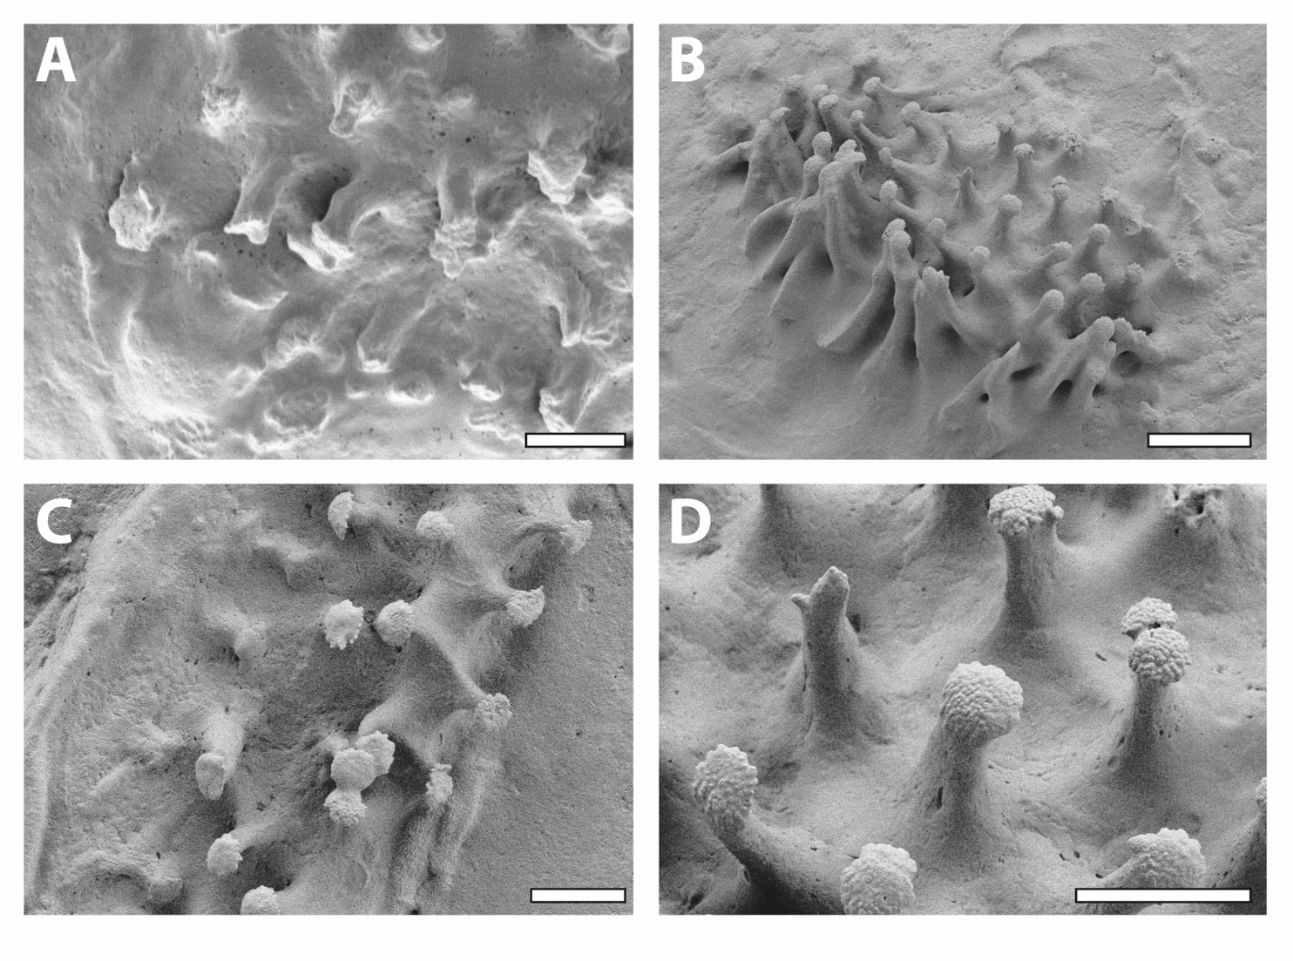Supplementary Figure 2. Unculi (mushrooms) of the four documented specimens of Ancistrus sp. L519. Each image comes from one specimen. Scale bars: A, C, D, 10 µm; 20 µm.

Supplementary Table 1. For each species: ecological data (current and preferred substrate), results from morphological study (papillae and unculi types), inferred type of interaction between organism and substrate, and data on localities. N, quantity of specimens studied.
Group | Species | L number | Current | Substrate | Papillae | Unculi | Interaction type | Locality | GPS coordinates | N
Hypoptopomatinae | Hypoptopoma inexspectatum | LDA13 | Medium | Wood | Short | No data | No data | Río Paraguay, Argentina | 26°12'31.79"S,  58°7'27.86"W | 2
Hypoptopomatinae | Otocinclus cocama |  | Medium | Wood | Medium | Mushroom | Interlocking and adhesion | Río Ucayali, Peru | 4°55'S,  73°43'W | 1
Hypoptopomatinae | Rhinotocinclus isabelae |  | Medium | Wood | Medium | None | Interlocking | Río Nanay, Peru | 03°48'15"S,  73°23'53"W | 2
Hypostominae | Acanthicus adonis |  | Medium | Wood | Medium | Suction cup | Adhesion | Rio Tocantins, Brazil | 2°14'39.23"S,  49°29'55.44"W | 2
Hypostominae | Ancistomus cf. sabaji | L75 | Strong | Stone | Medium | No data | No data | Rio Xingu, Brazil | 3°44'18.40"S,  52°31'33.36"W | 2
Hypostominae | Ancistomus spilomma | L12 | Strong | Stone | Medium | No data | No data | Rio Xingu, Brazil | 3°44'18.40"S,  52°31'33.36"W | 2
Hypostominae | Ancistrus cirrhosus |  | No data | No data | Medium | Mushroom | Interlocking and adhesion | Río Paraguay drainage, Paraguay | 25°00'11"S,  57°36'58"W | 5
Hypostominae | Ancistrus claro | LDA008 | Strong | Stone | Long | Mushroom | Interlocking and adhesion | Rio Paraguay, Brazil | 15°27'49.13"S,  55°58'53.30"W | 2
Hypostominae | Ancistrus dolichopterus | L183 | Medium | Wood | Medium | No data | No data | Rio Negro, Brazil | 3°9'48.88"S,  60°3'1.05"W | 3
Hypostominae | Ancistrus luzia | L159 | Medium | Wood | Medium | Mushroom | Interlocking and adhesion | Rio Xingu, Brazil | 09°47’15"S,  54°57’33"W | 2
Hypostominae | Ancistrus megalostomus |  | Strong | Stone | Long | Honey-combed | Adhesion | Río Beni, Bolivia | 17°0'29.05"S,  65°27'21.45"W | 4
Hypostominae | Ancistrus ranunculus | L34 | Strong | Stone | Flat | None | Interlocking | Rio Xingu, Brazil | 3°44'18.40"S,  52°31'33.36"W | 3
Hypostominae | Ancistrus sp. | L107 | Medium | Wood | Medium | Mushroom | Interlocking and adhesion | Rio Negro, Brazil | 0°28'0.63"S,  62°54'58.69"W | 2
Hypostominae | Ancistrus sp. | L464 | Medium | Wood | Short | Hooks | Interlocking and adhesion | Río Mamoré, Bolivia | 17°23'27.36"S,  63°31'30.17"W | 4
Hypostominae | Ancistrus sp. | L519 | Medium | Wood | Medium | Mushroom | Interlocking and adhesion | Río Itenéz, Bolivia | 12°29'51.13"S  64°6'40.10"W | 4
Hypostominae | Aphanotorulus cf. emarginatus |  | Medium | Wood | Long | Folds | Interlocking | Río Beni, Bolivia | 16°54'3.50"S,  65°24'35.44"W | 1
Hypostominae | Baryancistrus aff. niveatus | L142 | Strong | Stone | Medium | Folds | Interlocking | Rio Tapajós, Brazil | 4°17'27.75"S,  55°59'8.89"W | 1
Hypostominae | Baryancistrus xanthellus | L177 | Strong | Stone | Medium | Folds | Interlocking | Rio Xingu, Brazil | 3°27'07"S,  51°41'53"W | 1
Hypostominae | Baryancistrus xanthellus | L81 | Strong | Stone | Medium | Folds | Interlocking | Rio Xingu, Brazil | 3°27'07"S,  51°41'53"W | 2
Hypostominae | Chaetostoma dorsale | L443 | Strong | Stone | Medium | Mushroom | Interlocking and adhesion | Río Orinoco, Venezuela | 8°35'18.85"N,  71°9'34.63"W | 2
Hypostominae | Chaetostoma formosae | L444 | Strong | Stone | Short | Mushroom | Interlocking and adhesion | Río Orinoco, Venezuela | 4°20'11.27"N,  72°45'53.96"W | 3
Hypostominae | Chaetostoma lineopunctatum | L276 | Strong | Stone | Medium | Mushroom | Interlocking and adhesion | Río Ucayali, Peru | 10°23'24.32"S,  74°54'5.40"W | 3
Hypostominae | Dekeyseria picta | L168 | Medium | Sand/Mudd | Medium | None | Interlocking | Río Atabapo, Colombia | 3°53'58.97"N,  67°40'13.47"W | 1
Hypostominae | Guyanancistrus brevispinis |  | Medium | Stone | Medium | No data | No data | Nickerie-River, Surinam | 05˚24'28.6"N  53˚34'53.6"W | 1
Hypostominae | Hypancistrus contradens |  | Medium | Stone | Medium | Small mushrooms | Interlocking and adhesion | Río Orinoco, Venezuela | 4°04'50"N  66°51'31"W | 2
Hypostominae | Hypancistrus inspector |  | Strong | Stone | Medium | No data | No data | Rio Negro, Brazil | 1°58'N,  67°05'W | 3
Hypostominae | Hypancistrus sp. | L333 | Strong | Stone | Long | Long filaments | Adhesion | Rio Xingu, Brazil | 1°52'7.18"S,  52°12'41.86"W | 3
Hypostominae | Hypancistrus sp. | L174 | Strong | Stone | Medium | None | Interlocking | Rio Xingu, Brazil | 3°9'2.41"S,  51°39'56.89"W | 2
Hypostominae | Hypancistrus zebra | L46 | Strong | Stone | Medium | None | Interlocking | Rio Xingu, Brazil | 3°44'18.40"S,  52°31'33.36"W | 2
Hypostominae | Hypostomus bolivianus |  | Medium | Wood | Long | Folds | Interlocking | Río Beni, Bolivia | 11°20'48.16"S,  66°14'4.53"W | 1
Hypostominae | Hypostomus cochliodon | LDA051 | Medium | Wood | Medium | No data | No data | Rio Tapajós, Brazil | 5°20'39.34"S,  56°18'31.21"W | 1
Hypostominae | Hypostomus laplatae |  | Medium | Wood | Long | Folds | Interlocking | Río de la Plata, Argentina | 34°51'14.45"S,  57°52'42.74"W | 1
Hypostominae | Leporacanthicus joselimai | L264 | Medium | Stone | Medium | None | Interlocking | Río Tapajós, Brazil | 4°17'27.75"S,  55°59'8.89"W | 2
Hypostominae | Leporacanthicus sp. | L240 | Medium | Stone | Medium | None | Interlocking | Río Orinoco, Venezuela | 5°36'4.53"N,  67°37'21.25"W | 2
Hypostominae | Oligancistrus immaculatus | L269 | Strong | Stone | Medium | None | Interlocking | Rio Tapajós, Brazil | 4°16’46.56"S,  55°59’5.77"W | 1
Hypostominae | Panaqolus sp. | L271 | Medium | Wood | Medium | Folds | Interlocking | Rio Tapajós, Brazil | 4°37'10.21"S,  56°17'31.81"W | 2
Hypostominae | Panaqolus sp. | L351 | Medium | Wood | Medium | Folds | Interlocking | Río Huallaga, Peru | 9°19'14.52"S,  76°0'5.06"W | 3
Hypostominae | Panaque nigrolineatus | L190 | Medium | Wood | Medium | Folds | Interlocking | Río Apure, Venezuela | 8°50'9.79"N,  67°26'48.12"W | 1
Hypostominae | Parancistrus aurantiacus |  | Strong | Stone | Long | None | Interlocking | Rio Tocantins, Brazil | 3°42'43.66"S,  49°39'47.72"W | 2
Hypostominae | Parancistrus nudiventris | L31 | Strong | Stone | Medium | None | Interlocking | Rio Xingu, Brazil | 3°23'19"S,  51°43'24"W | 1
Hypostominae | Parancistrus nudiventris | L258 | Strong | Stone | Medium | None | Interlocking | Rio Xingu, Brazil | 3°23'19"S,  51°43'24"W | 1
Hypostominae | Parancistrus nudiventris | L300 | Strong | Stone | Medium | None | Interlocking | Rio Xingu, Brazil | 3°23'19"S,  51°43'24"W | 1
Hypostominae | Peckoltia sp. | L76 | Medium | Stone | Long | Folds | Interlocking | Rio Amazonas, Brazil | 1°52'33.36"S,  50°52'21.44"W | 2
Hypostominae | Pseudacanthicus pitanga | L24 | Strong | Stone | Flat | Long filaments | Adhesion | Rio Araguaia, Brazil | 5°19'33.22"S,  49°0'4.64"W | 1
Hypostominae | Pseudacanthicus sp. | L97 | Medium | Stone | Medium | Long filaments | Adhesion | Rio Amazonas, Brazil | 2°52'25.69"S,  54°20'24.33"W | 2
Hypostominae | Pseudacanthicus sp. | L185 | Strong | Stone | Medium | Long filaments | Adhesion | Rio Xingu, Brazil | 3°2'0.49"S,  51°51'1.41"W | 1
Hypostominae | Pseudacanthicus sp. | L273 | Strong | Stone | Medium | Long filaments | Adhesion | Rio Tapajós, Brazil | 4°37'10.21"S,  56°17'31.81"W | 1
Hypostominae | Pseudacanthicus sp. | L65 | Medium | Stone | Medium | Long filaments | Adhesion | Rio Amazonas, Brazil | 3°12'25.47"S,  60°46'3.92"W | 1
Hypostominae | Pseudacanthicus spinosus | L160 | Strong | Stone | Medium | Long filaments | Adhesion | Rio Amazonas, Brazil | 1°33'18.58"S,  48°9'43.92"W | 1
Hypostominae | Pseudolithoxus dumus | L244 | Strong | Stone | Medium | No data | No data | Río Orinoco, Venezuela | 3°04'N,  66°28'W | 1
Hypostominae | Scobinancistrus aff. pariolispos | L48 | Strong | Stone | Medium | Folds | Interlocking | Rio Xingu, Brazil | 3°51'35.81"S,  52°50'24.96"W | 2
Hypostominae | Scobinancistrus aureatus | L14 | Strong | Stone | Short | Mushroom | Interlocking and adhesion | Rio Xingu, Brazil | 3°51'35.81"S,  52°50'24.96"W | 1
Hypostominae | Scobinancistrus sp. | L82 | Strong | Stone | Long | Mushroom | Interlocking and adhesion | Rio Xingu, Brazil | 3°44'18.40"S,  52°31'33.36"W | 2
Loricariinae | Crossoloricaria cephalaspis |  | Strong | Sand/Mudd | Flat | None | Interlocking | Río Magdalena, Colombia | 5°15'0.00"N,  74°49'60.00"W | 1
Loricariinae | Cteniloricaria platystoma |  | Strong | Stone | Medium | Mushroom | Interlocking and adhesion | Corantijn River, Suriname | 2°1'4.75"N,  56°7'39.69"W | 1
Loricariinae | Farlowella oxyrryncha |  | Medium | Wood | Medium | Mushroom | Interlocking and adhesion | Río Mamoré, Brazil | 11°27'51.23"S,  65°18'54.54"W | 1
Loricariinae | Farlowella platorynchus |  | Medium | Wood | Medium | Mushroom | Interlocking and adhesion | Río Ucayali, Peru | 8°23'S,  74°32'W | 1
Loricariinae | Hemiloricaria melini |  | Medium | Sand/Mudd | Short | Small mushrooms | Interlocking and adhesion | Rio Negro, Brazil | 3°9'48.88"S,  60°3'1.05"W | 2
Loricariinae | Hemiodontichthys acipenserinus |  | Medium | Sand/Mudd | Medium | Small mushrooms | Interlocking and adhesion | Rio Guaporé, Brazil | 12°29'38.55"S,  64°4'12.72"W | 3
Loricariinae | Lamontichthys filamentosus |  | Strong | Wood | Medium | Mushroom | Interlocking and adhesion | Rio Jurua, Brazil | 7°25'58.65"S,  70°2'44.42"W | 2
Loricariinae | Lamontichthys stibaros |  | Strong | Wood | Medium | Hooks | Interlocking and adhesion | Río Pastaza, Ecuador | 2°25'S,  76°38'W | 2
Loricariinae | Loricaria luciae |  | Medium | Sand/Mudd | Flat | None | Interlocking | Río Paraná, Argentina | 27°25’6.94"S,  58°45’27.47"W | 1
Loricariinae | Loricaria simillima |  | Medium | Sand/Mudd | Flat | None | Interlocking | Río Pastaza, Ecuador | 1°35'28.25"S,  77°44'29.05"W | 1
Loricariinae | Pseudohemiodon almendarizi |  | Strong | Sand/Mudd | Flat | None | Interlocking | Río Napo, Ecuador | 0°3'57.51"N,  76°51'13.05"W | 2
Loricariinae | Pterosturisoma microps |  | Strong | Wood | Flat | No data | No data | Río Amazonas, Peru | 3°43'20.36"S,  73°17'0.38"W | 2
Loricariinae | Spatuloricaria puganensis |  | Medium | Sand/Mudd | Flat | Small mushrooms | Interlocking and adhesion | Río Marañon, Peru | 5°3'28.75"S,  75°59'59.13"W | 2
Loricariinae | Sturisomatichthys aureus |  | Medium | Wood & Stone | Medium | Mushroom | Interlocking and adhesion | Río Magdalena, Colombia | 9°34'23.24"N,  73°19'24.62"W | 2
Loricariinae | Sturisomatichthys festivus |  | Medium | Wood & Stone | Medium | Long filaments | Adhesion | Río Maracaíbo, Venezuela | 9°39'8.55"N,  70°26'38.97"W | 2
Rhinelepinae | Pseudorinelepis cf. genibarbis | L152 | Slow | Wood | Long | Mushroom | Interlocking and adhesion | Rio Negro, Brazil | 3°9'48.88"S,  60°3'1.05"W | 1
Rhinelepinae | Pseudorinelepis cf. genibarbis | L95 | Slow | Wood | Long | Mushroom | Interlocking and adhesion | Rio Amazonas, Brazil | 3°4'46.78"S,  61°29'17.86"W | 1
Rhinelepinae | Rhinelepis aspera |  | Strong | Wood | Long | Long filaments | Adhesion | Rio São Francisco, Brazil | 15°29’37"S,  44°21’25"W | 2

Supplementary Table 2. Results from contingency analysis (quantity of species N, percentage of species with these constellations of parameters) for papillae, unculi, interaction type, substrate and current.
 | Current
 | Slow |  | Medium |  | Strong |  | No data |  | Sum
Papillae | N | % | N | % | N | % | N | % | N | %
Flat | 0 | 0.00 | 3 | 4.35 | 5 | 7.25 | 0 | 0.00 | 8 | 11.59
Short | 0 | 0.00 | 3 | 4.35 | 2 | 2.90 | 0 | 0.00 | 5 | 7.25
Medium | 0 | 0.00 | 23 | 33.33 | 20 | 28.99 | 1 | 1.45 | 44 | 63.77
Long | 2 | 2.90 | 4 | 5.80 | 6 | 8.70 | 0 | 0.00 | 12 | 17.39
Sum | 2 | 2.90 | 33 | 47.83 | 33 | 47.83 | 1 | 1.45 | 69 | 100
Unculi | N | % | N | % | N | % | N | % | N | %
Folds | 0 | 0.00 | 7 | 10.15 | 4 | 5.80 | 0 | 0.00 | 11 | 15.94
Honey-combed | 0 | 0.00 | 0 | 0.00 | 1 | 1.45 | 0 | 0.00 | 1 | 1.45
Hooks | 0 | 0.00 | 1 | 1.45 | 1 | 1.45 | 0 | 0.00 | 2 | 2.90
Long filaments | 0 | 0.00 | 3 | 4.35 | 6 | 8.70 | 0 | 0.00 | 20 | 28.99
Mushroom | 2 | 2.90 | 7 | 10.15 | 8 | 11.59 | 1 | 1.45 | 18 | 26.09
None | 0 | 0.00 | 6 | 8.70 | 8 | 11.59 | 0 | 0.00 | 14 | 20.29
Small mushrooms | 0 | 0.00 | 4 | 5.80 | 0 | 0.00 | 0 | 0.00 | 4 | 5.80
Suction cup | 0 | 0.00 | 1 | 1.45 | 0 | 0.00 | 0 | 0.00 | 1 | 1.45
No data | 0 | 0.00 | 4 | 5.80 | 5 | 7.25 | 0 | 0.00 | 9 | 13.04
Sum | 2 | 2.90 | 33 | 47.83 | 33 | 47.83 | 1 | 1.45 | 69 | 100
Interaction type | N | % | N | % | N | % | N | % | N | %
Adhesion | 0 | 0.00 | 4 | 5.80 | 7 | 10.15 | 0 | 0.00 | 11 | 15.94
Interlocking | 0 | 0.00 | 13 | 18.84 | 12 | 17.39 | 0 | 0.00 | 15 | 21.74
Both | 2 | 2.90 | 12 | 17.39 | 9 | 13.04 | 1 | 1.45 | 24 | 34.78
No data | 0 | 0.00 | 4 | 5.80 | 5 | 7.25 | 0 | 0.00 | 9 | 13.04
Sum | 2 | 2.90 | 33 | 47.83 | 33 | 47.83 | 1 | 1.45 | 69 | 100
Substrate | N | % | N | % | N | % | N | % | N | %
Sand | 0 | 0.00 | 6 | 8.70 | 2 | 2.90 | 0 | 0.00 | 8 | 11.59
Stone | 0 | 0.00 | 7 | 10.15 | 27 | 39.13 | 0 | 0.00 | 34 | 49.28
Wood | 2 | 2.90 | 18 | 26.09 | 4 | 5.80 | 0 | 0.00 | 24 | 34.78
Wood & stone | 0 | 0.00 | 2 | 2.90 | 0 | 0.00 | 0 | 0.00 | 2 | 2.90
No data | 0 | 0.00 | 0 | 0.00 | 0 | 0.00 | 1 | 1.45 | 1 | 1.45
Sum | 2 | 2.90 | 33 | 47.83 | 33 | 47.83 | 1 | 1.45 | 69 | 100

Supplementary Table 3. Results from contingency analysis (quantity of species N; percentage of species with these constellations of parameters) for papillae, unculi, interaction type and substrate.
 | Substrate
 | Sand |  | Stone |  | Wood |  | Wood  & stone |  | No data |  | Sum
Papillae | N | % | N | % | N | % | N | % | N | % | N | %
Flat | 5 | 7.25 | 2 | 2.90 | 1 | 1.45 | 0 | 0.00 | 0 | 0.00 | 8 | 11.59
Long | 0 | 0.00 | 6 | 8.70 | 6 | 8.70 | 0 | 0.00 | 0 | 0.00 | 12 | 17.39
Medium | 2 | 2.90 | 24 | 34.78 | 15 | 21.74 | 2 | 2.90 | 1 | 1.45 | 44 | 63.77
Short | 1 | 1.45 | 2 | 2.90 | 2 | 2.90 | 0 | 0.00 | 0 | 0.00 | 5 | 7.25
Sum | 8 | 11.59 | 34 | 49.28 | 24 | 34.78 | 2 | 2.90 | 1 | 1.45 | 69 | 100
Unculi | N | % | N | % | N | % | N | % | N | % | N | %
Folds | 0 | 0.00 | 5 | 7.25 | 6 | 8.70 | 0 | 0.00 | 0 | 0.00 | 11 | 15.94
Honey-combed | 0 | 0.00 | 1 | 1.45 | 0 | 0.00 | 0 | 0.00 | 0 | 0.00 | 1 | 1.45
Hooks | 0 | 0.00 | 0 | 0.00 | 2 | 2.90 | 0 | 0.00 | 0 | 0.00 | 2 | 2.90
Long filaments | 0 | 0.00 | 7 | 10.15 | 1 | 1.45 | 1 | 1.45 | 0 | 0.00 | 9 | 13.04
Mushroom | 0 | 0.00 | 7 | 10.15 | 9 | 13.04 | 1 | 1.45 | 1 | 1.45 | 18 | 26.09
None | 5 | 7.25 | 8 | 11.59 | 1 | 1.45 | 0 | 0.00 | 0 | 0.00 | 14 | 20.29
Small mushrooms | 3 | 4.35 | 1 | 1.45 | 0 | 0.00 | 0 | 0.00 | 0 | 0.00 | 4 | 5.80
Suction cup | 0 | 0.00 | 0 | 0.00 | 1 | 1.45 | 0 | 0.00 | 0 | 0.00 | 1 | 1.45
No data | 0 | 0.00 | 5 | 7.25 | 4 | 5.80 | 0 | 0.00 | 0 | 0.00 | 9 | 13.04
Sum | 8 | 11.59 | 34 | 49.28 | 24 | 34.78 | 2 | 2.90 | 1 | 1.45 | 69 | 100
Interaction type | N | % | N | % | N | % | N | % | N | % | N | %
Adhesion | 0 | 0.00 | 8 | 11.59 | 2 | 2.90 | 1 | 1.45 | 0 | 0.00 | 11 | 15.94
Interlocking | 5 | 7.25 | 13 | 18.84 | 7 | 10.15 | 0 | 0.00 | 0 | 0.00 | 25 | 36.23
Both | 3 | 4.35 | 8 | 11.59 | 11 | 15.94 | 1 | 1.45 | 1 | 1.45 | 24 | 34.78
No data | 0 | 0.00 | 5 | 7.25 | 4 | 5.80 | 0 | 0.00 | 0 | 0.00 | 9 | 13.04
Sum | 8 | 11.59 | 34 | 49.28 | 24 | 34.78 | 2 | 2.90 | 1 | 1.45 | 69 | 100
Current | N | % | N | % | N | % | N | % | N | % | N | %
Slow | 0 | 0.00 | 0 | 0.00 | 2 | 2.90 | 0 | 0.00 | 0 | 0.00 | 2 | 2.90
Medium | 6 | 8.70 | 7 | 10.15 | 18 | 26.09 | 2 | 2.90 | 0 | 0.00 | 33 | 47.83
Strong | 2 | 2.90 | 27 | 39.13 | 4 | 5.80 | 0 | 0.00 | 0 | 0.00 | 33 | 47.83
No data | 0 | 0.00 | 0 | 0.00 | 0 | 0.00 | 0 | 0.00 | 1 | 1.45 | 1 | 1.45
Sum | 8 | 11.59 | 34 | 49.28 | 24 | 34.78 | 2 | 2.90 | 1 | 1.45 | 69 | 100

