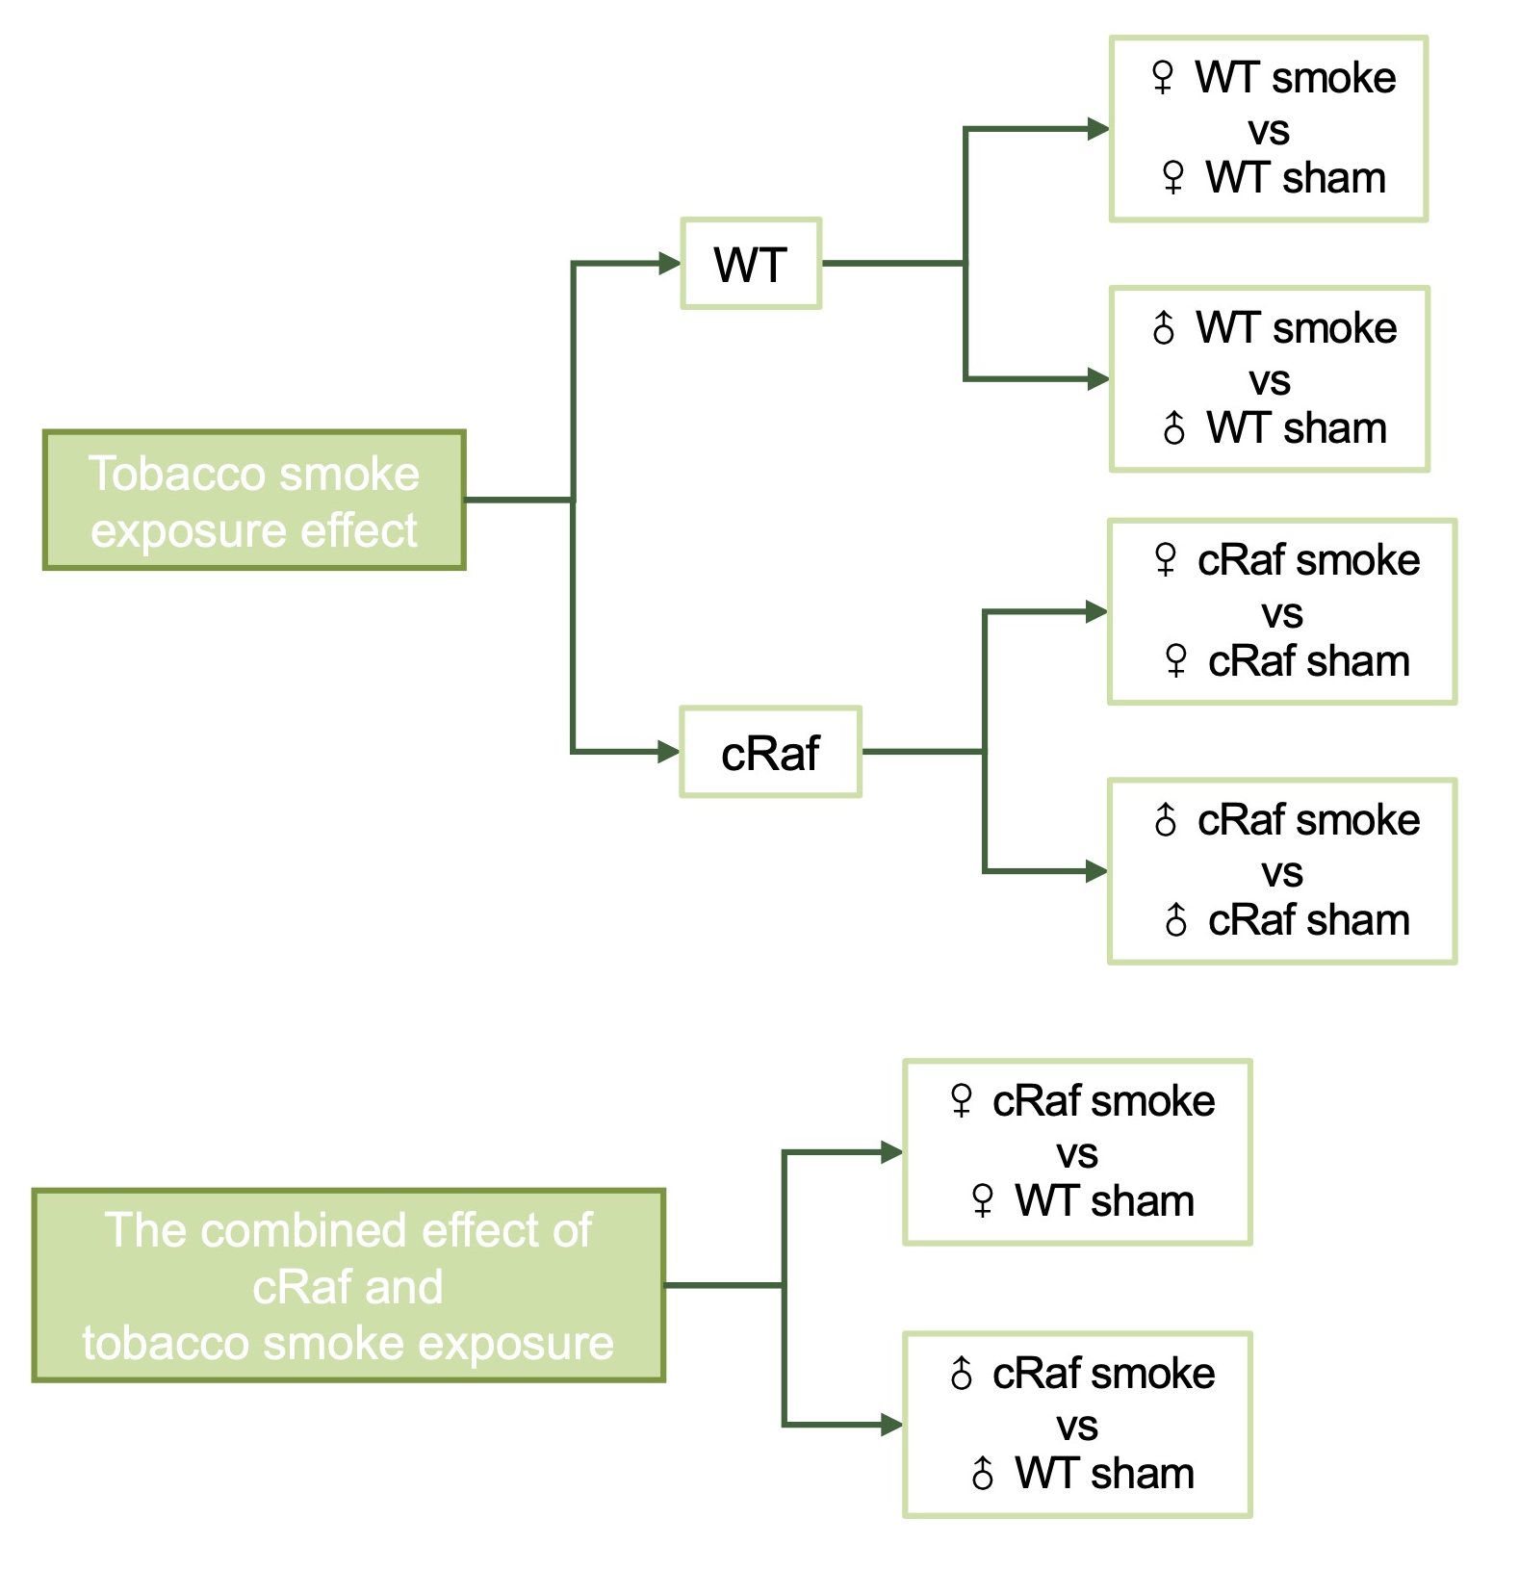
Supplementary Figure S1. The various comparisons of the study.

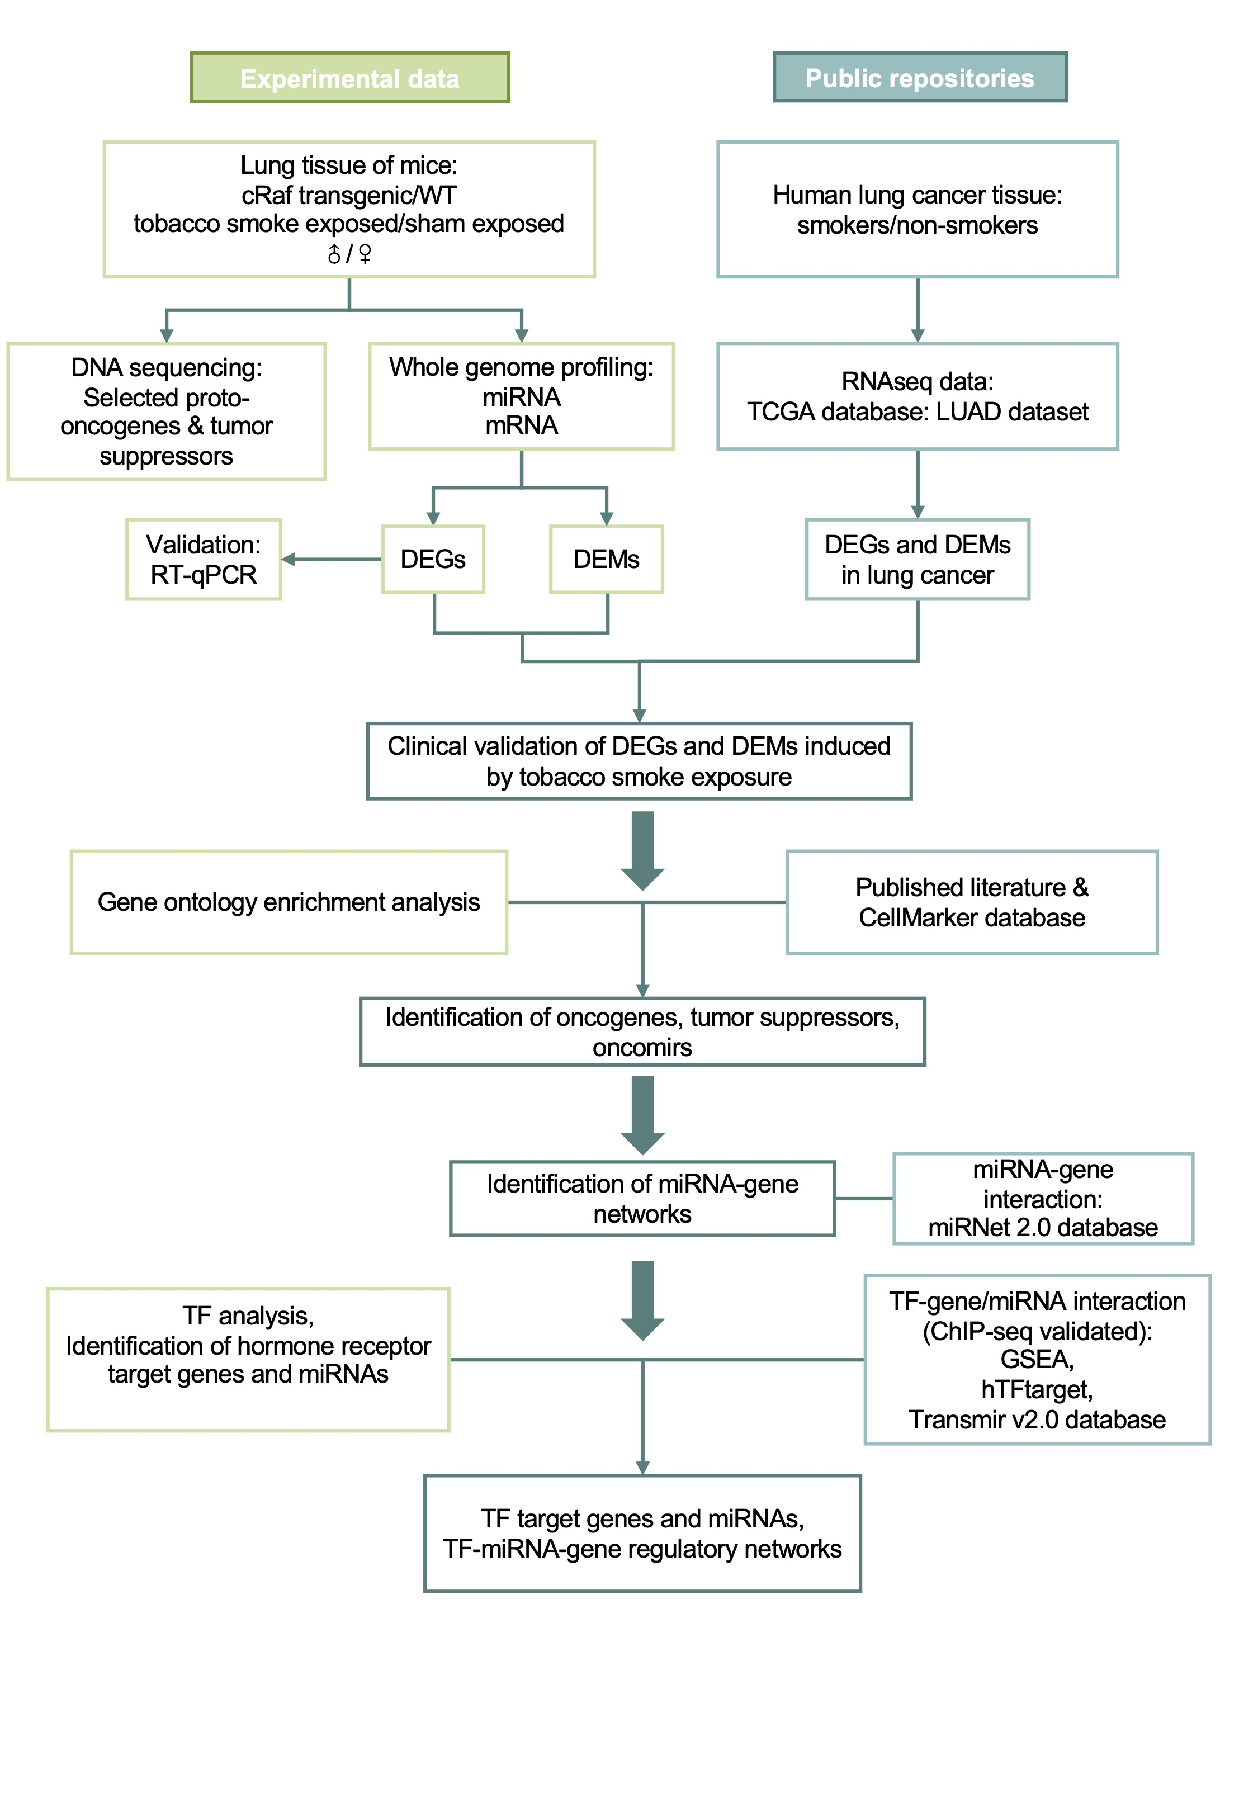
Supplementary Figure S2: The research strategy of the study.

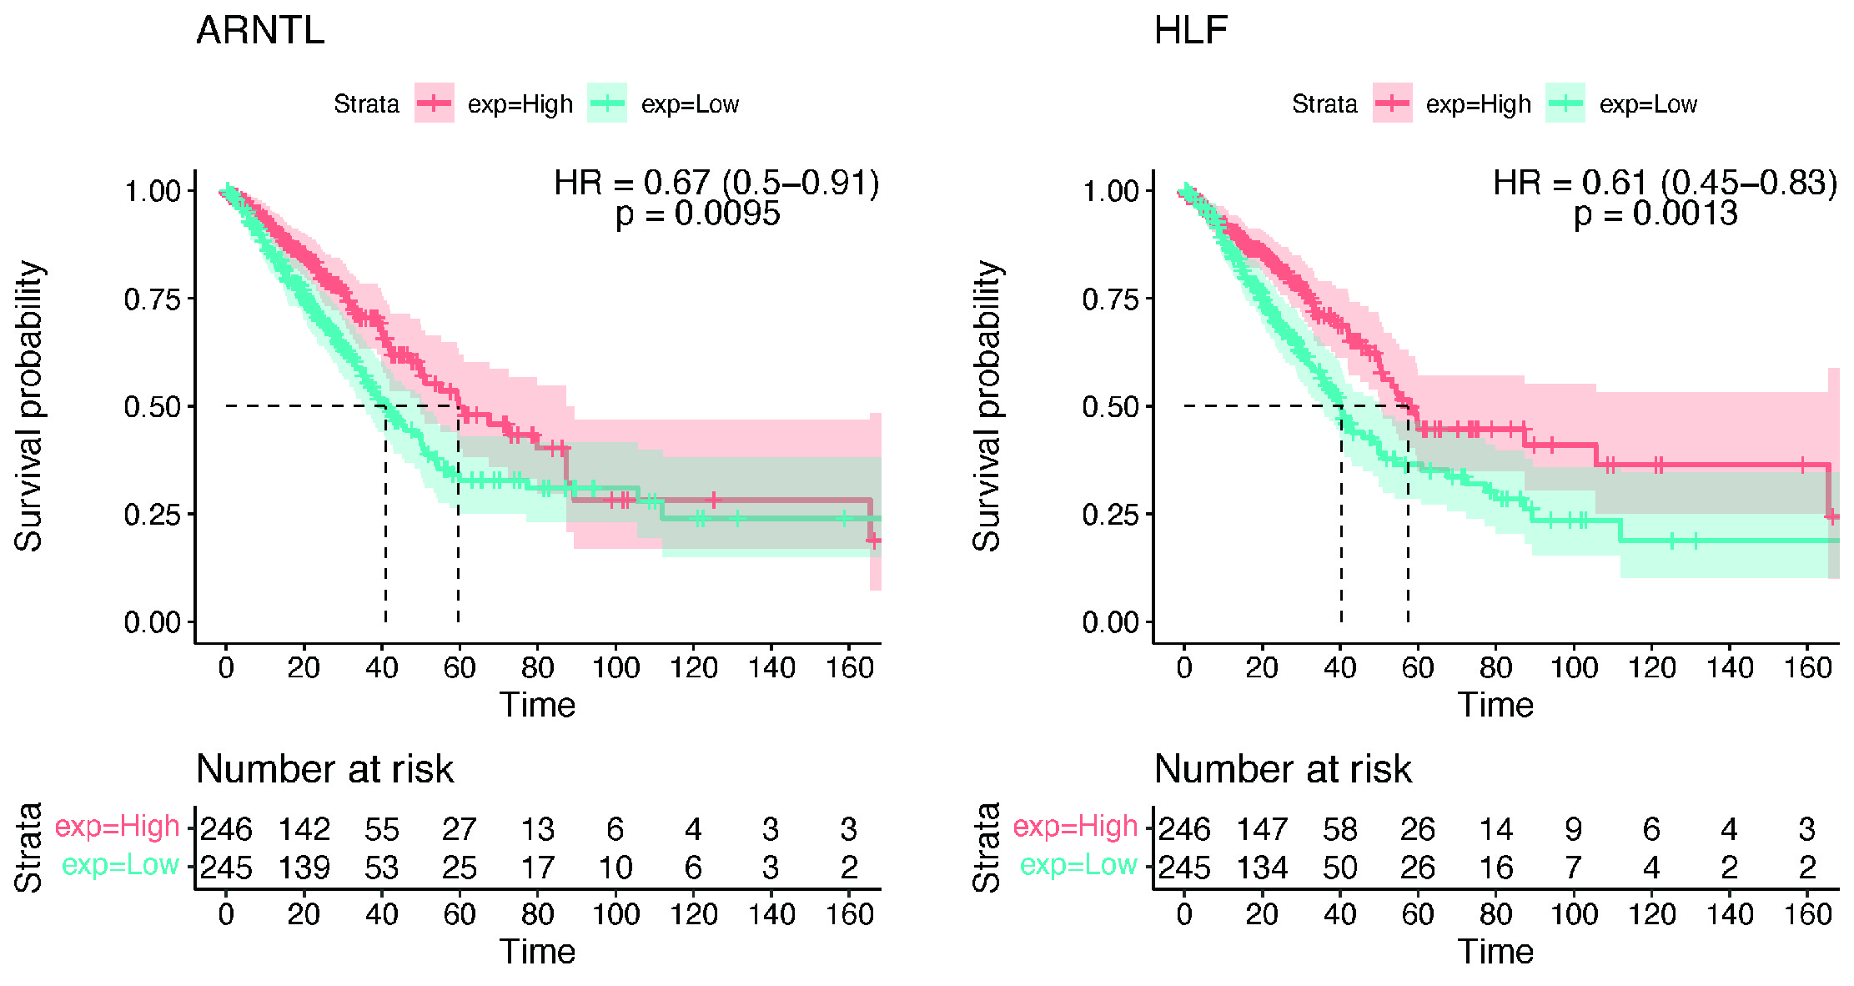
Supplementary Figure S3: Kaplan-Meier survival plots of ARNTL and HLF.

