Supplemental Material

Installation and Containers
OpenMS supports the three major Operating Systems (OS) Linux, Windows and macOS. Detailed installation guides for each OS are available via the OpenMS user documentation (https://openms.readthedocs.io/en/latest/openms-applications-and-tools/installation.html).
A detailed installation guide for PyOpenMS is available via the PyOpenMS user documentation (https://pyopenms.readthedocs.io/en/latest/user_guide/installation.html)

Pre-built binaries are available via:
GitHub: https://github.com/OpenMS/OpenMS/releases/tag/Release3.0.0
Conda: https://anaconda.org/bioconda/openms / https://anaconda.org/bioconda/pyopenms
(full releases) and https://anaconda.org/openms (OpenMS nightly builds)
PyOpenMS: pip install pyopenms (full releases) pip install --index-url https://pypi.cs.uni-tuebingen.de/simple/ pyopenms (PyOpenMS nightly)

Pre-built containers for OpenMS are available for:
Docker:
https://github.com/orgs/OpenMS/packages?repo_name=OpenMS (full releases, and nightly builds)
Singularity:
https://depot.galaxyproject.org/singularity/

To build custom containers, refer to https://github.com/OpenMS/dockerfiles and https://github.com/jcharkow/openmsSingularity

Workflow Engines
OpenMS enjoys support from major workflow systems such as KNIME, Nextflow, Galaxy, Snakemake via the work of community contributors. Users can freely build their own workflows, however, predefined pipelines are available on most systems (Table S1).

Table S1: selection of community workflows for different workflow systems
Workflow System | Example Workflows | Description
KNIME  Installation instructions:  https://openms.readthedocs.io/en/latest/run-workflows-with-openms-tools/knime/installation.html | KNIME workflows:  https://hub.knime.com/openms-team/spaces/Getting%20Started%20with%20OpenMS/latest/~weDqWoHT4hZzbrpH/  https://github.com/OpenMS/Tutorials/tree/master/Workflows  and https://hub.knime.com/search?q=openms&type=all&sort=best | - Simple Peptide / Protein identification and quantificaiton workflow  - multiple workflows, including LFQ, TMT, MSStats, QC, DIAMetAlyzer and more
Nextflow | 1. https://nf-co.re/mhcquant  2. https://nf-co.re/quantms  3. https://nf-co.re/metaboigniter | 1. HLA immunopeptidomics  2. proteomics label-free and isobaric labeling, quantification (DDA/DIA)  3. metabolomics identification and quantification
Galaxy  Installation instructions:  https://openms.readthedocs.io/en/latest/run-workflows-with-openms-tools/openms-on-galaxy.html | - https://training.galaxyproject.org/training-material/topics/proteomics/tutorials/protein-id-oms/tutorial.html  - https://training.galaxyproject.org/training-material/topics/proteomics/ | - peptide and protein identification workflow  - Additional workflows
Snakemake | https://github.com/biosustain/snakemake_UmetaFlow | untargeted metabolomics identification and quantification workflow
web deployment using pyOpenMS | - https://github.com/axelwalter/umetaflow-gui  - https://github.com/OpenMS/streamlit-template | - untargeted metabolomics workflow as web app  - streamlit template app

Softwipe Scoring

OpenMS has been evaluated using Softwipe to obtain a proxy metric for its code quality.
The overall absolute score of the current OpenMS 3.0 release is 6.9, which puts OpenMS in 7th place of 48 – see Table 1 in the Softwipe publication.
OpenMS 2.0 achieves a Softwipe score of 6.3, corresponding to place 13 of 48. Thus, by the Softwipe metric, the code quality was increased significantly.
Further details, which allow to reproduce the scores can be found here:
OpenMS 2.0: https://github.com/OpenMS/OpenMS/issues/6847
OpenMS 3.0: https://github.com/OpenMS/OpenMS/issues/6734

Documentation and Educational Material
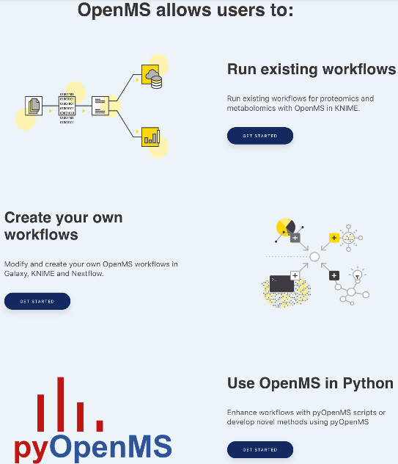 | 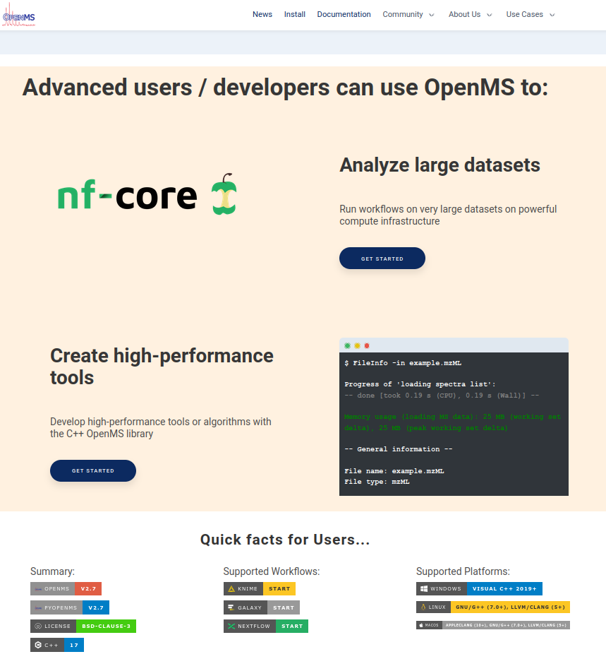
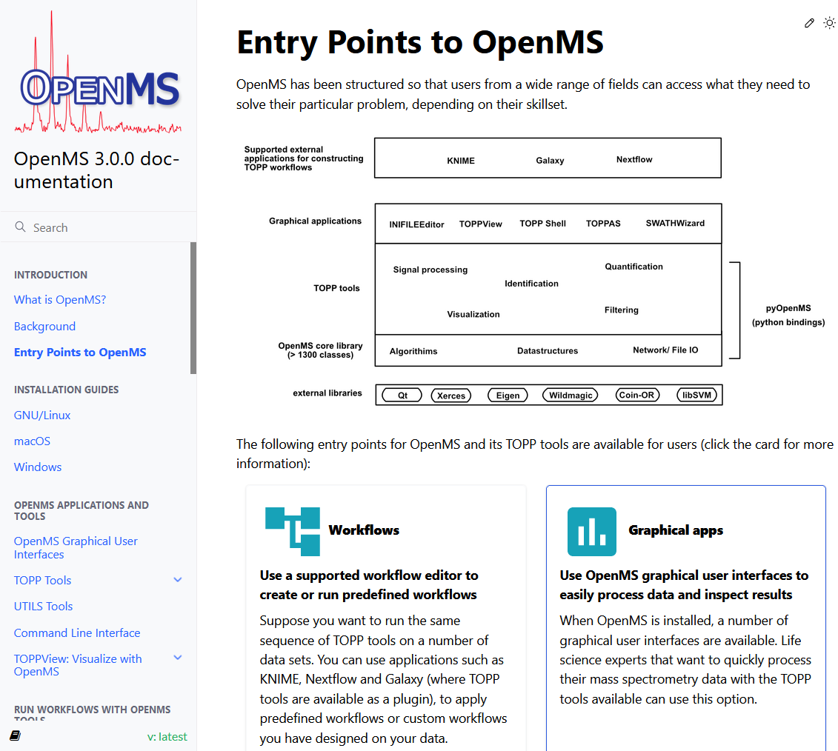 | 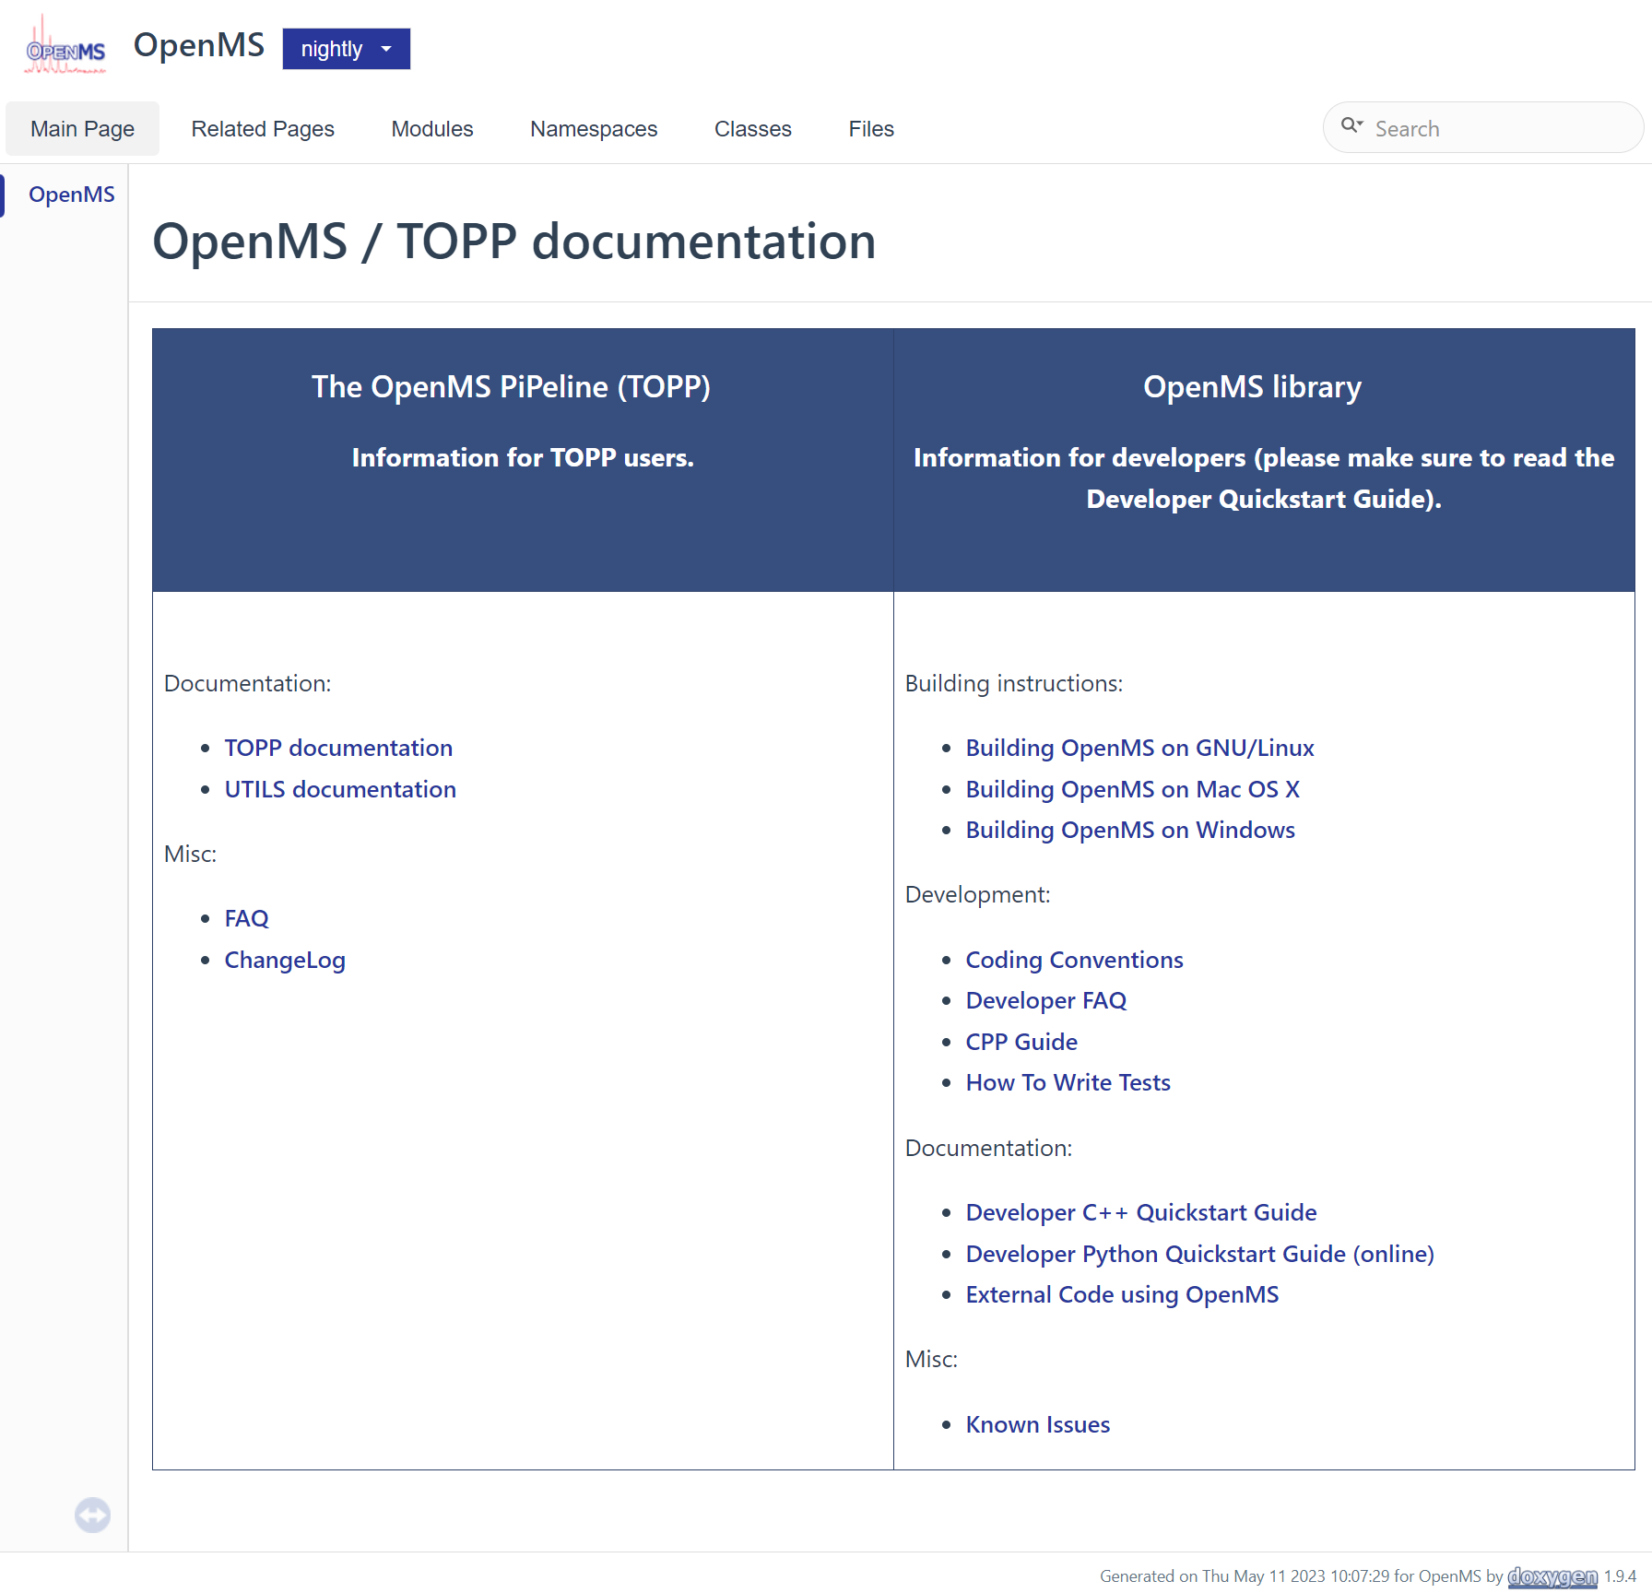
Figure S1: Top: revamped OpenMS webpage as entry point for users (left) and developers (right). Bottom left: user documentation (https://openms.readthedocs.io/). Bottom right: C++ Developer documentation (https://abibuilder.cs.uni-tuebingen.de/archive/openms/Documentation/nightly/html/index.html)

a)  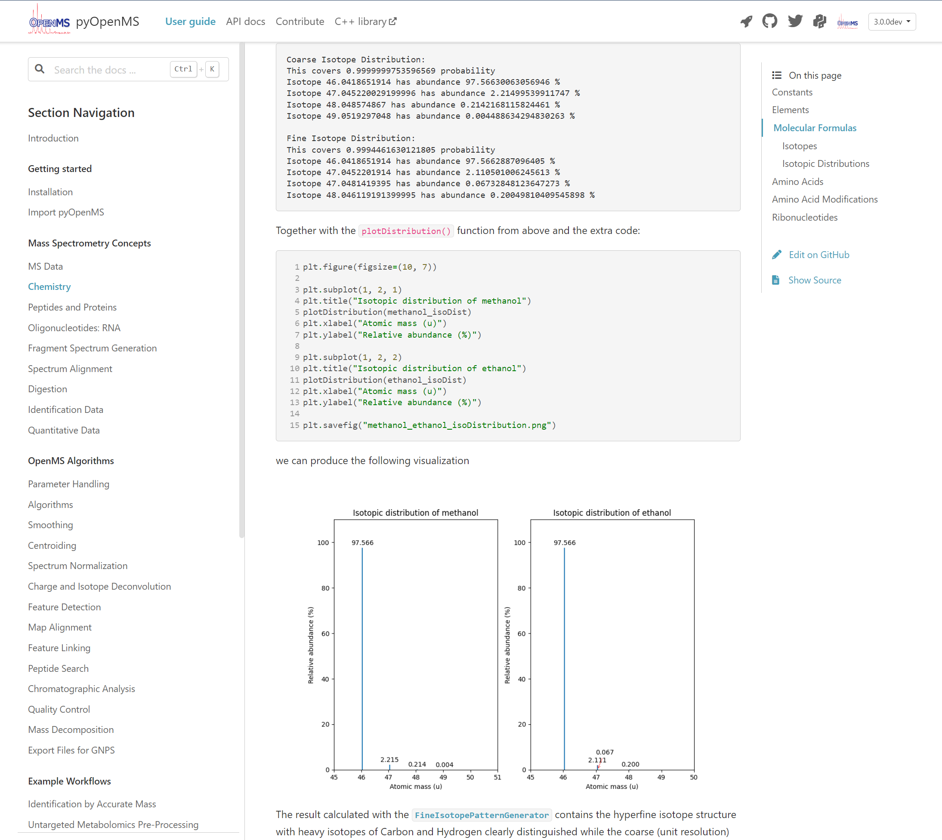 | b)  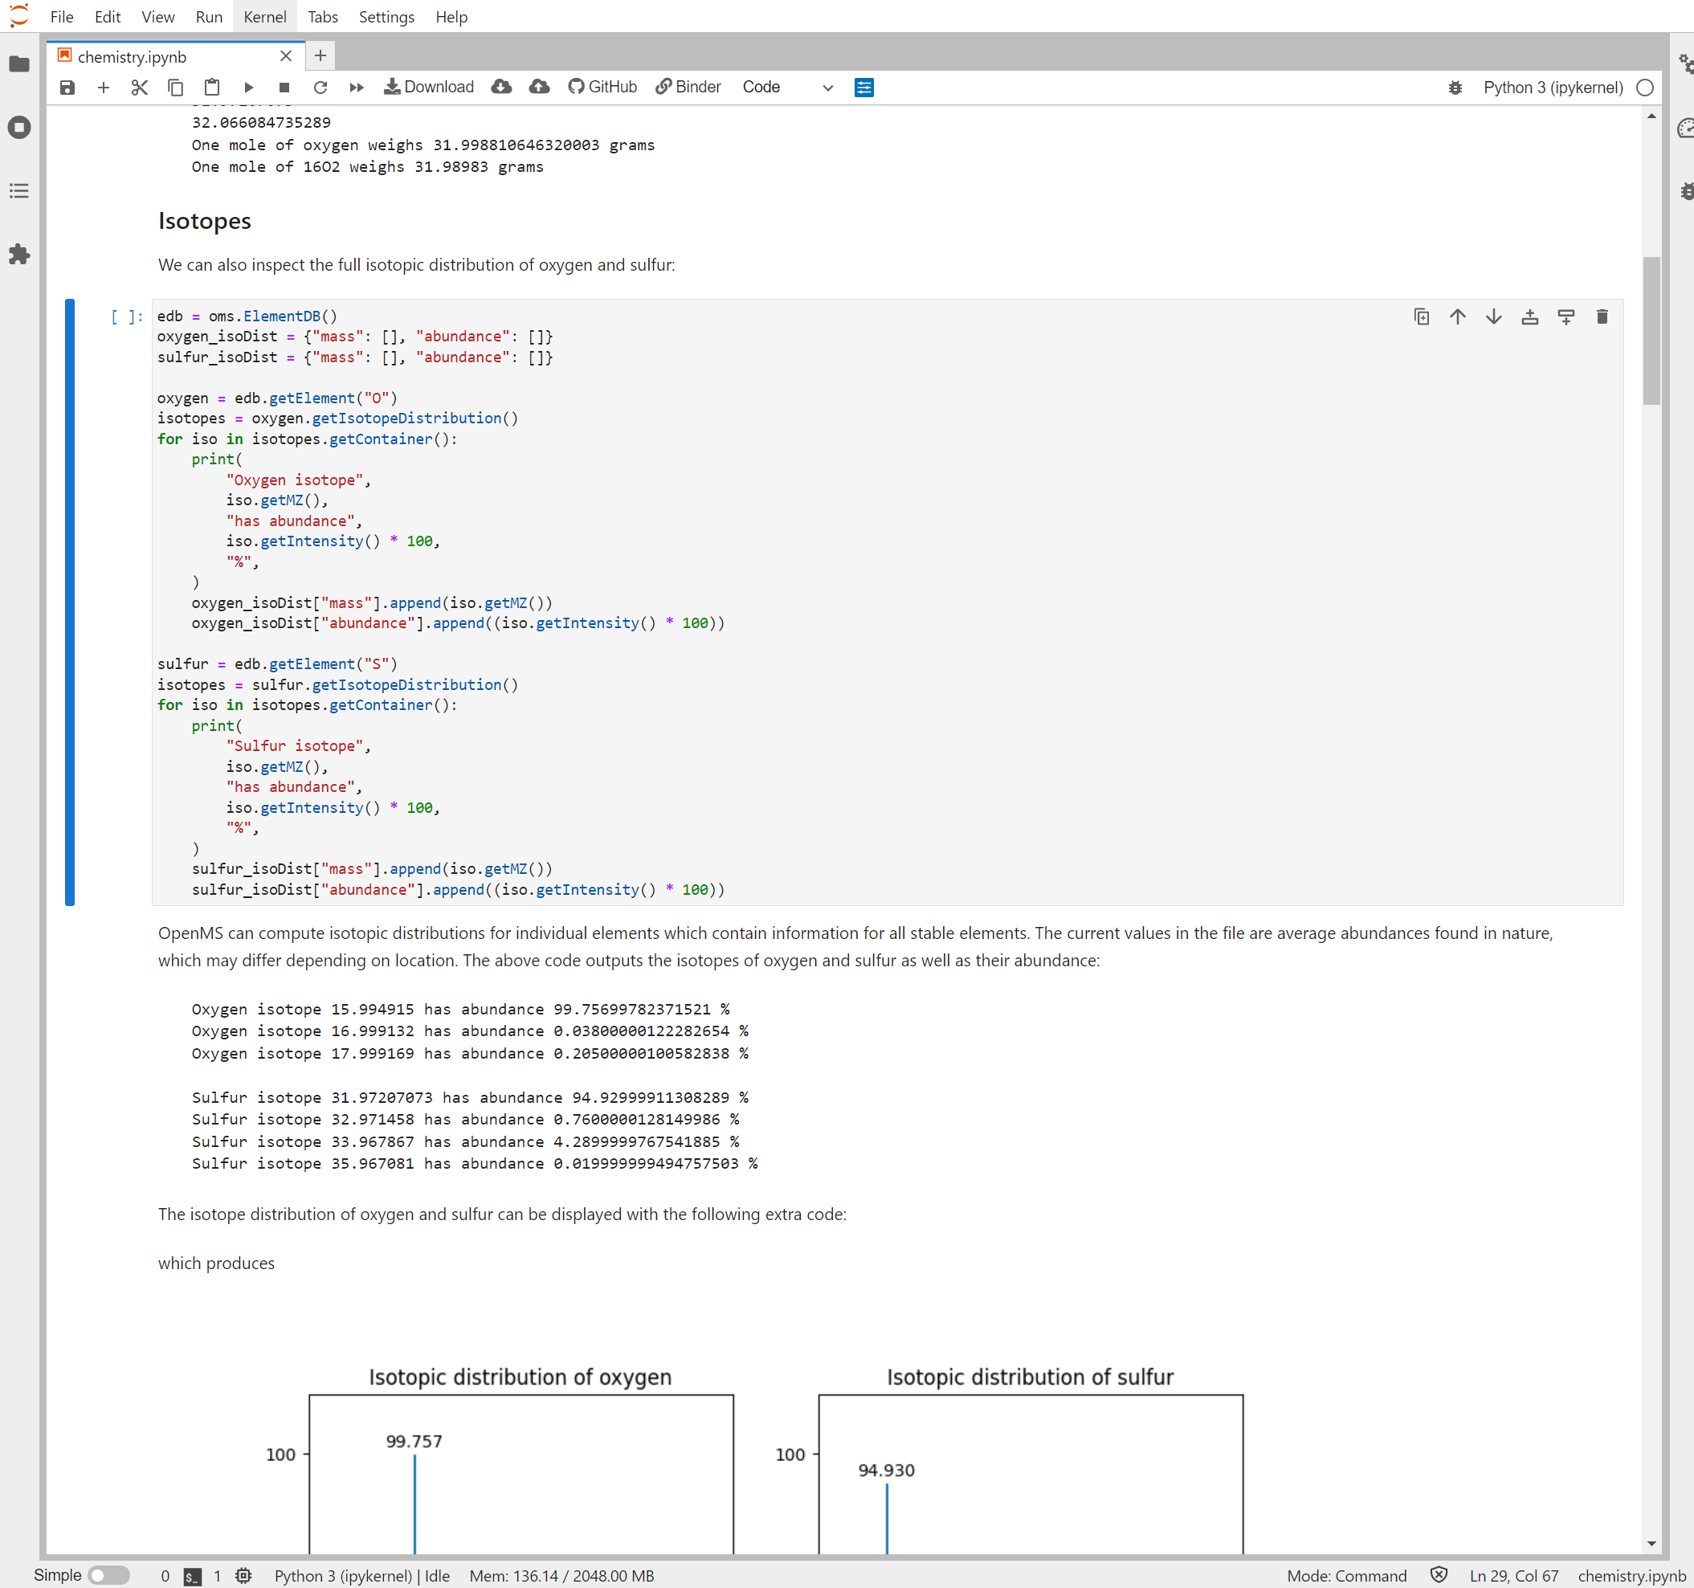
Figure S2: a): pyOpenMS documentation, tutorial, and API reference ( see https://pyopenms.readthedocs.io/en/latest/user_guide ).
b) Interactive, online execution of pyOpenMS tutorials as Jupyter Notebook using binder ( see https://pyopenms.readthedocs.io/en/latest/user_guide/installation.html#try-online ).

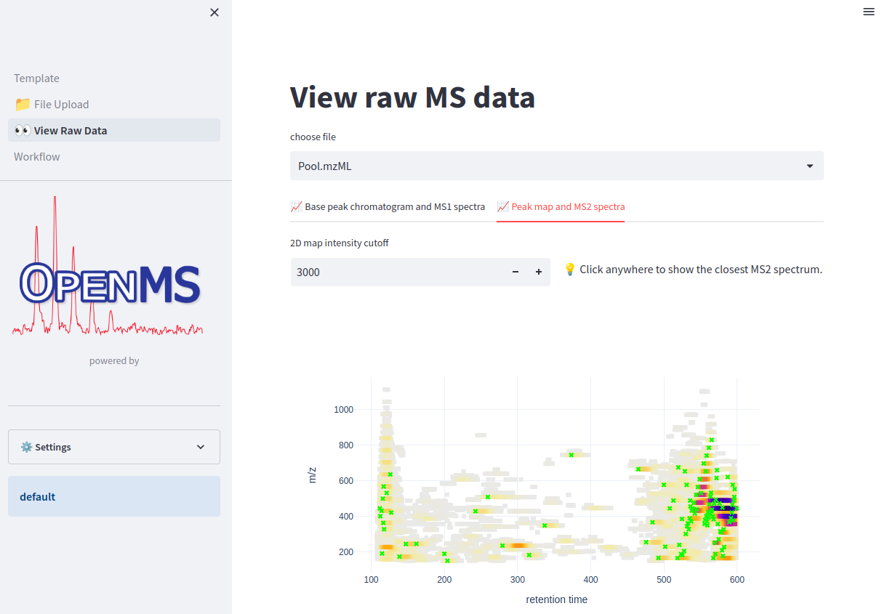
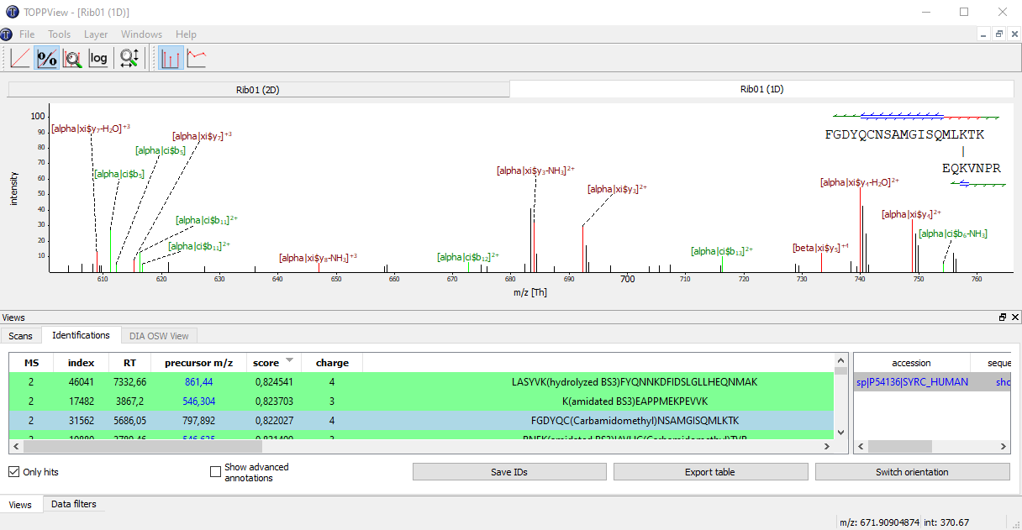
Figure S3: top: Visualization of raw MS data in a streamlit web application. bottom: Visualization of protein-protein cross-link spectrum matches in the desktop application TOPPView.

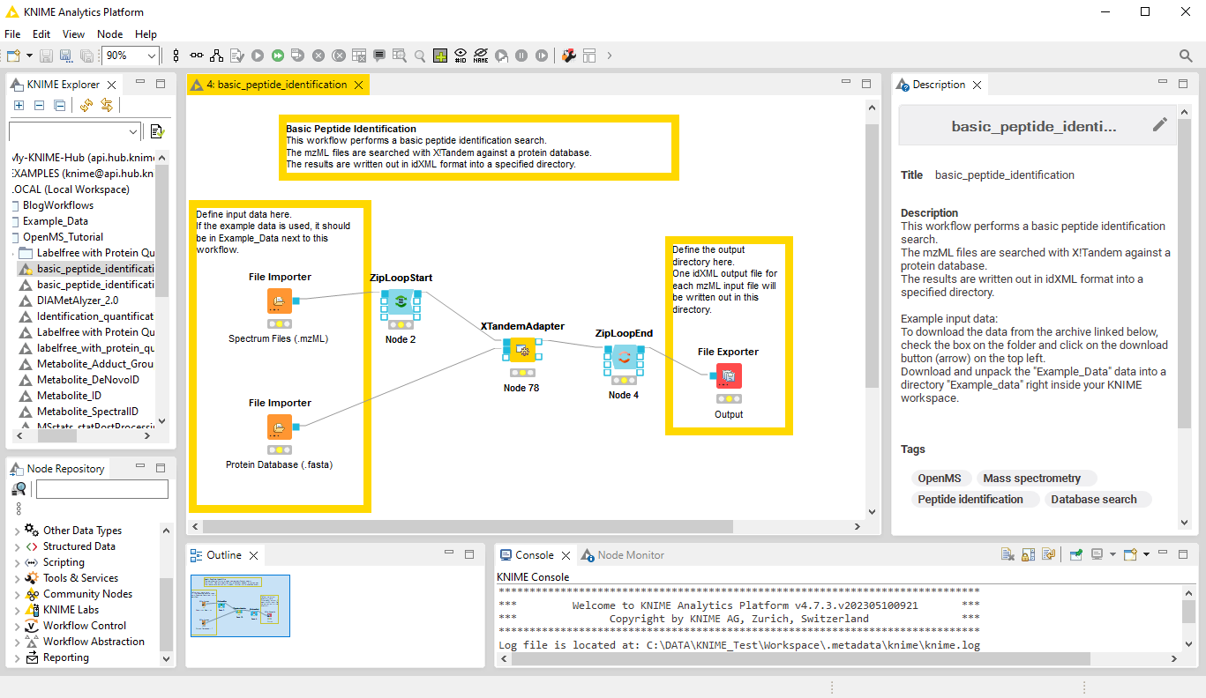
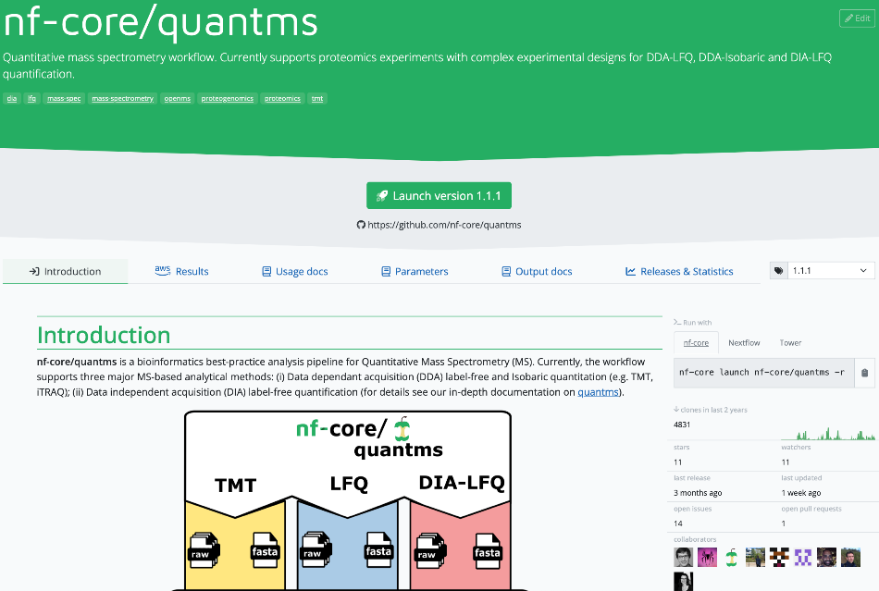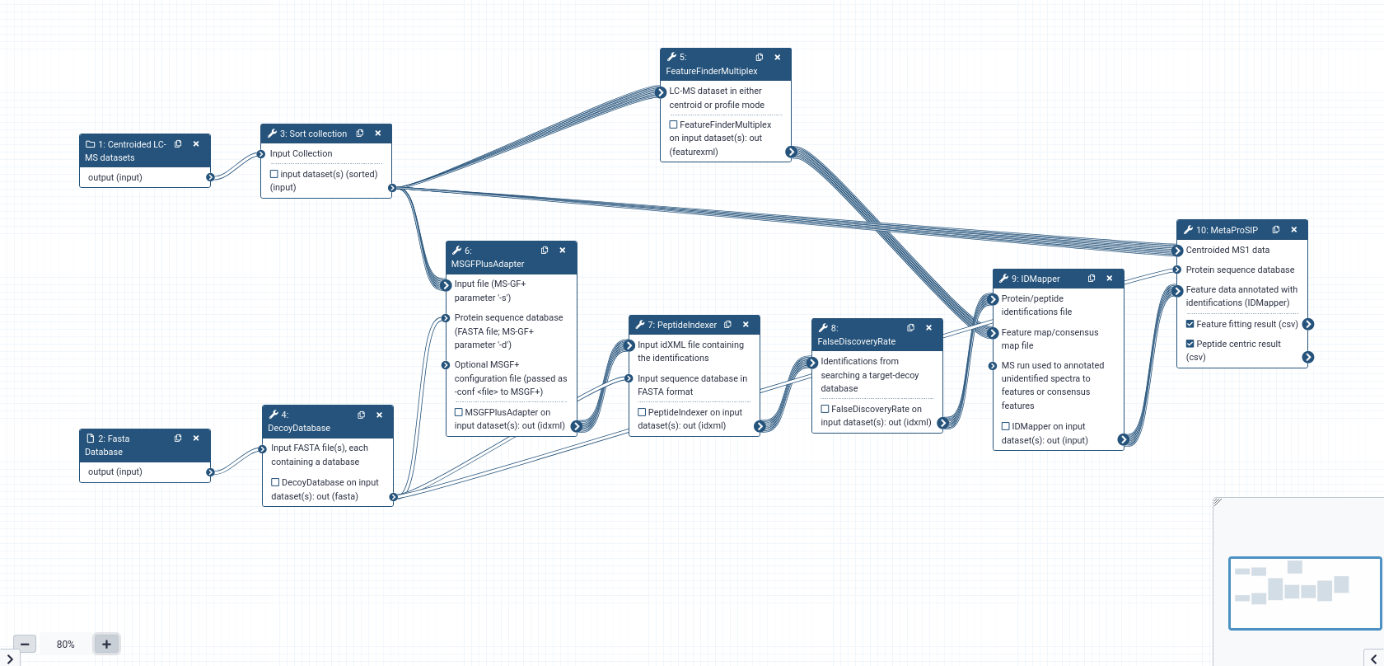
Figure S4: Screenshots of OpenMS exemplary workflows in three workflow systems, KNIME, NextFlow and Galaxy. Top: simple proteomics analysis in KNIME. Middle: QuantMS, an nf-core workflow for quantitative proteomics. Bottom: metaproteomics workflow (protein stable isotope probing) in Galaxy.

