Supplementary material
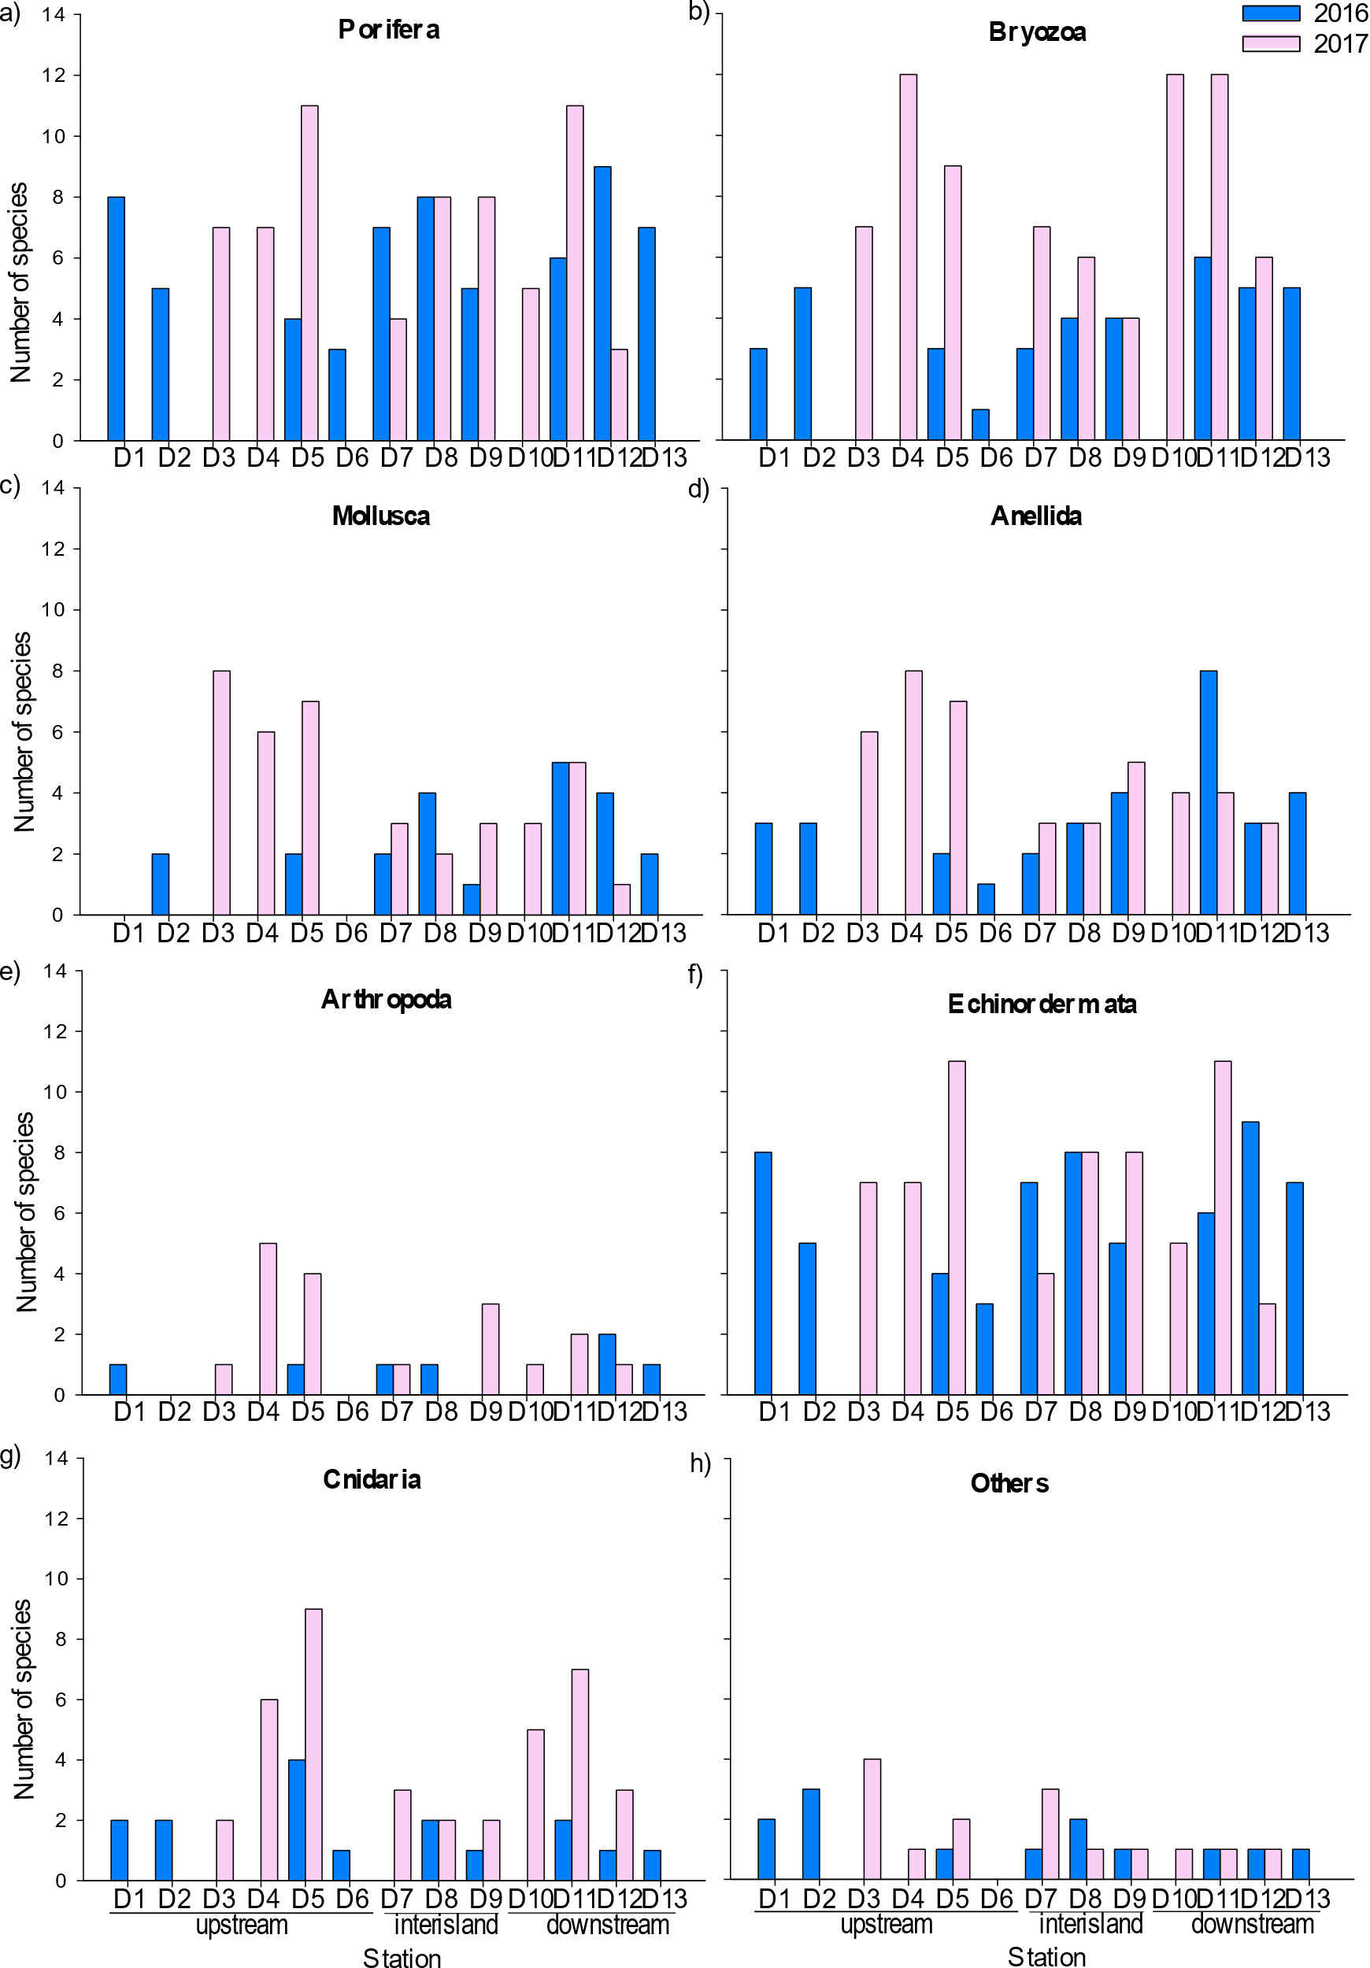
Fig S.1 Species richness of the most abundant phylum collected from stations located in the upstream, interisland and downstream regions of the Prince Edward Islands in 2016 and 2017. Values represent abundance for 500 m² of seafloor dredged. To note, stations D1, D2, D6 and D13 were sampled in 2016 only; while stations D3, D4 and D10 in 2017-only. a) Echinodermata, b) Porifera, c) Mollusca, d) Bryozoa, e) Annelida, f) Arthropoda, g) Cnidaria, h) Others.

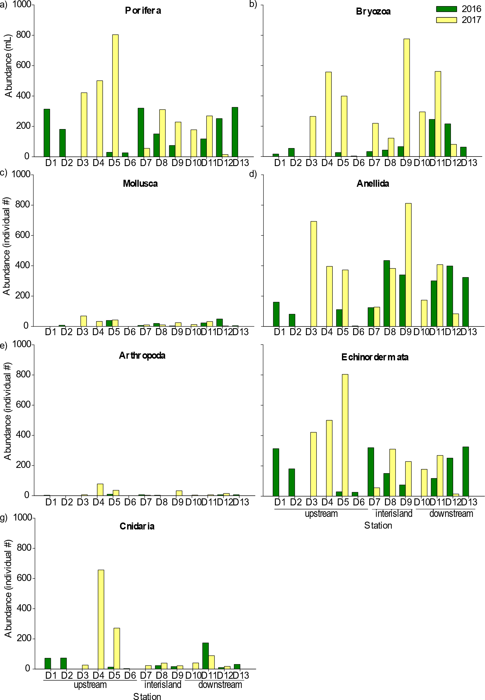
Fig S.2 Species abundance of the most common phylum collected from stations located in the upstream, interisland and downstream regions of the Prince Edward Islands in 2016 and 2017. Abundance is expressed by volume for the colonial phylum (Porifera and Bryozoa), while by number of individuals for the other phylum. Values represent abundance for 500 m² of seafloor dredged. To note, stations D1, D2, D6 and D13 were sampled in 2016 only; while stations D3, D4 and D10 in 2017-only. a) Echinodermata, b) Porifera, c) Mollusca, d) Bryozoa, e) Annelida, f) Arthropoda, g) Cnidaria.

