Supplementary information

Supplementary table 1. Antibodies used in this study
Antibody | Host | WB Dilution | IF Dilution | Sources | Catalog No.
Anti 3-NT | m |  | 1/50 | Santa-Cruz | #sc-32731
Anti 4-HNE | r |  | 1/200 | Abcam | #ab46545
Anti 8-OHdG | m |  | 1/200 | Abcam | #ab62623
Anti GPX4 | r | 1/5000 |  | Abcam | #ab125066
Anti xCT | m | 1/5000 |  | Abcam | #ab175186
Anti GFAP | m |  | 1/200 | Cell Signaling Technology | #3670
Anti Tomm20 | r |  | 1/300 | Abcam | #ab186734
Anti GAPDH | r | 1/6000 |  | Genetex | #GTX100118
Anti HO-1 | r | 1/1500 |  | Genetex | #GTX101147
Anti NOX4 | r |  | 1/50 | Proteintech | #14347-1-AP
Anti Nrf2 | m | 1/4000 |  | Proteintech | #66504-1-Ig
Anti Nrf2 | r |  | 1/200 | Proteintech | #16396-1-AP
Donkey anti-Mouse IgG (H+L) Alexa Fluor™ 488 | d |  | 1/200 | Thermo Fisher Scientific | #A21202
Donkey anti-Rabbit IgG (H+L) Alexa Fluor™546 | d |  | 1/200 | Thermo Fisher Scientific | #A10040
Goat anti-Mouse IgG (H+L) Cyanine3 | g |  | 1/200 | Thermo Fisher Scientific | #A10521
Goat anti-Mouse IgG (H+L) Secondary Antibody, HRP | g | 1/5000 |  | Thermo Fisher Scientific | #31430
Goat anti-Rabbit IgG (H+L) Secondary Antibody, HRP | g | 1/5000 |  | Thermo Fisher Scientific | #31460

3-NT, 3-nitrotyrosine; 4-HNE, 4-hydroxynonenal; 8-OHdG, 8-hydroxy-2’-deoxyguanosine; m, mouse; d, donkey; g, goat; GAPDH, glyceraldehyde 3-phosphate dehydrogenase; GFAP, glial fibrillary acidic protein; GPX4, glutathione peroxidase 4; HO-1, heme oxygenase-1; HRP, horseradish peroxidase; IF, immunofluorescence; NOX4, nicotinamide adenine dinucleotide phosphate oxidase 4; Nrf2, nuclear factor E2 related factor 2; r, rabbit; WB, western blot; xCT, cystine/glutamate antiporter SLC7A11.

Supplementary table 2. Reagents used in this study
Regents | Sources | Catalog No.
BIS-Tris gels | absin | #abs9391
Ferrostatin-1 | absin | #abs813072
Fetal Bovine Serum | Biological Industries | #C2820-0500HI
Nonfat Dried Milk | Coolaber | #CN7861
Dulbecco's Modified Eagle Medium | Gibco | #11965092
Penicillin‒streptomycin Solution | HyClone | #SV30010
Hydrophobic PVDF Transfer Membrane | Merck Millipore Billerica | #ISEQ00010
Immobilon Western HRP Chemiluminescent Substrate | Merck Millipore Billerica | #WBKLS0500
TBS | Servicebio | #G0001
3% glutaraldehyde | Solarbio | #P1126
Goat Serum | Solarbio | #SL038
PMSF | Solarbio | #P0100
Puromycin | Solarbio | #P8230
RIPA buffer (high) | Solarbio | #R0010
ROS assay kit | Solarbio | #CA1420
Triton X-100 | Solarbio | #T8200
Tween-20 | Solarbio | #T8220
Epon 812 | SPI | #1260804
DAPI | SouthernBiotech | #0100-20
Immunohistochemical Antigen Repair Buffer | ZSGB-BIO | #ZLI-9065

PVDF, polyvinylidene fluoride; TBS, Tris-buffered saline; PMSF, phenylmethylsulfonyl fluoride; RIPA, radioimmunoprecipitation assay; ROS, reactive oxygen species; DAPI, 4′,6-diamidino-2-phenylindole.

Supplementary Figure 1.

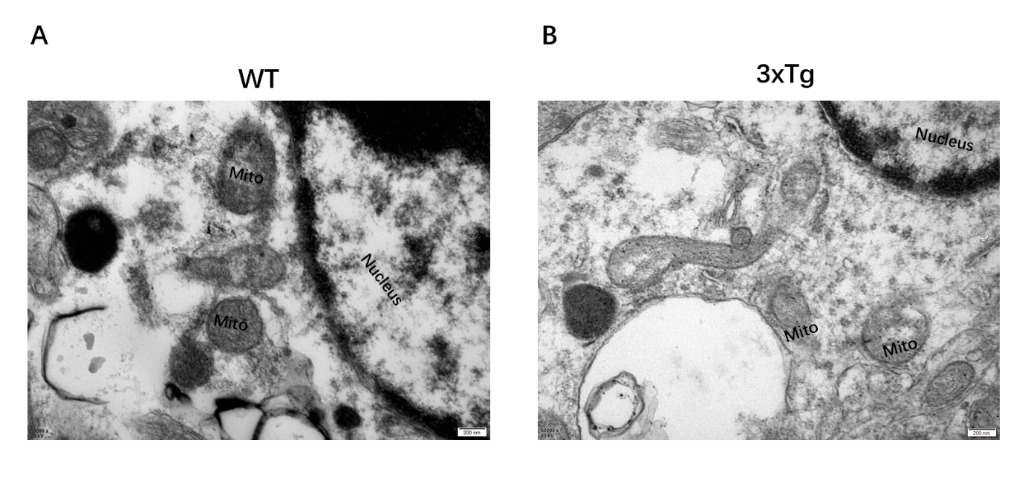

Supplementary Figure 1. Altered mitochondrial morphology in astrocytes from the hippocampus of WT and 3×Tg mice. Representative TEM images of mitochondrial structures in astrocytes from WT mice (A) and 3×Tg mice (B).

