Supporting Information
Dual-responsive smart nanoplatform targeting peptide modifications synergistically enhances multimodal therapy for liver cancer

Lin-Song Li, Xue-Jie Zhao, Peng-Wei Chen, Dong Cheng, Bang-Bang Liu, Mei-Xia Zhao*

Key Laboratory of Natural Medicine and Immune Engineering, Henan University, Kaifeng 475004, China; E-mail: zhaomeixia2011@henu.edu.cn

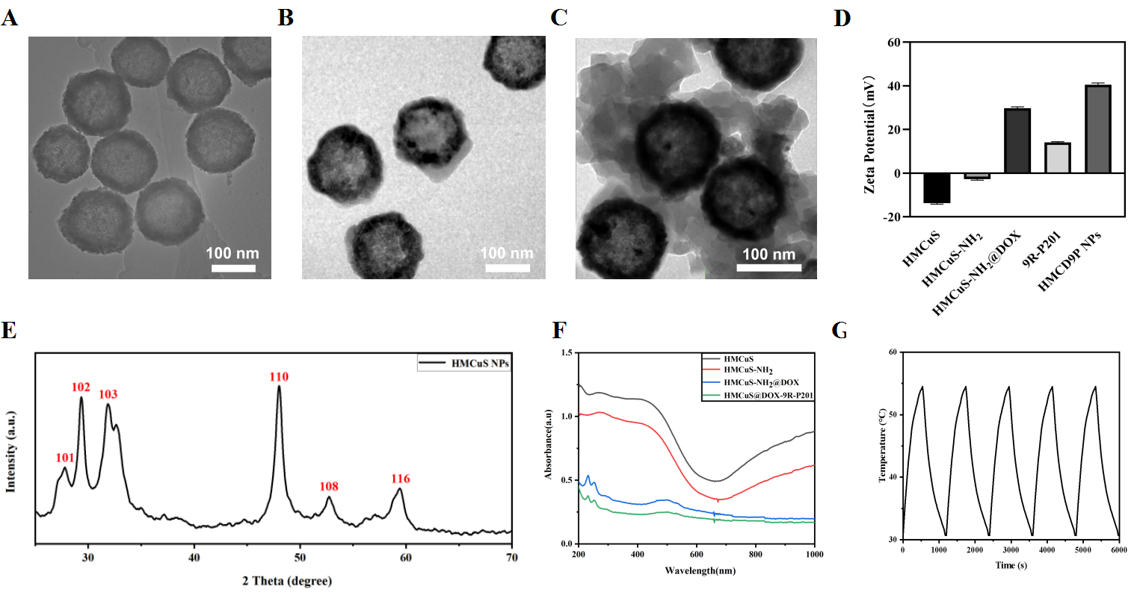
Figure S1. (A) TEM images of HMCuS NPs; (B) TEM images of HMCuS-NH₂@DOX NPs; (C) TEM images of HMCD9P NPs; (D) Zeta potential of HMCuS NPs and each component of the NPs; (E) X-ray diffraction (XRD) patterns of HMCuS NPs; (F) UV absorption spectra of HMCuS NPs and each component of the NPs; (G) Temperature distribution of the HMCD9P NPs solution (100 μg/mL) under 808-nm laser (1 W/cm²) irradiation for 5 laser on/off cycles.

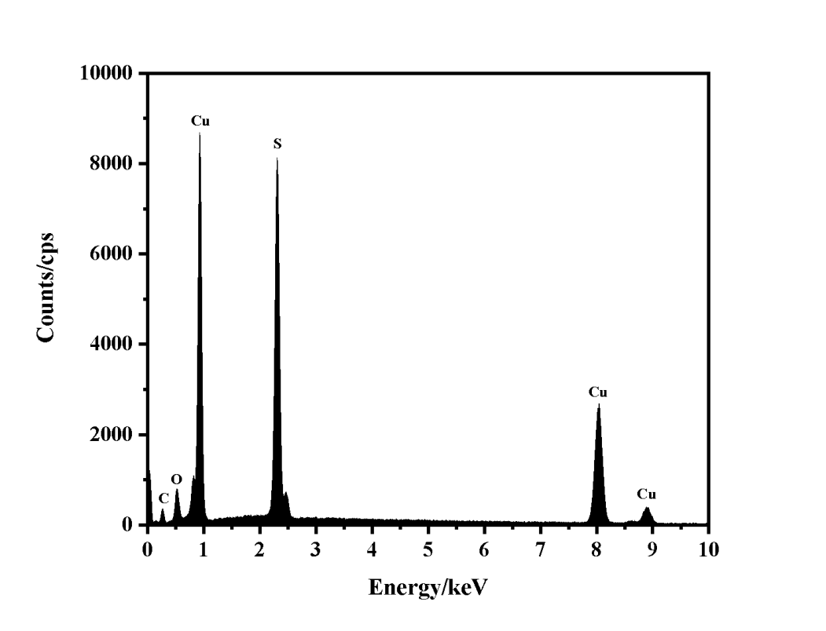
Figure S2. EDS pattern of HMCuS.

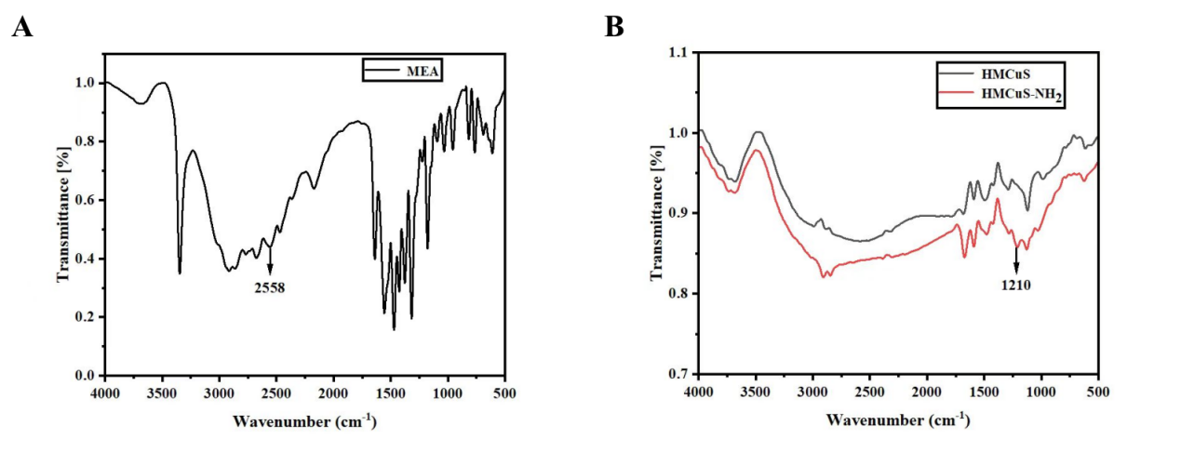
Figure S3. Sulfhydryl ethylamine (A) and (B) HMCuS and HMCuS-NH₂ IR spectra.

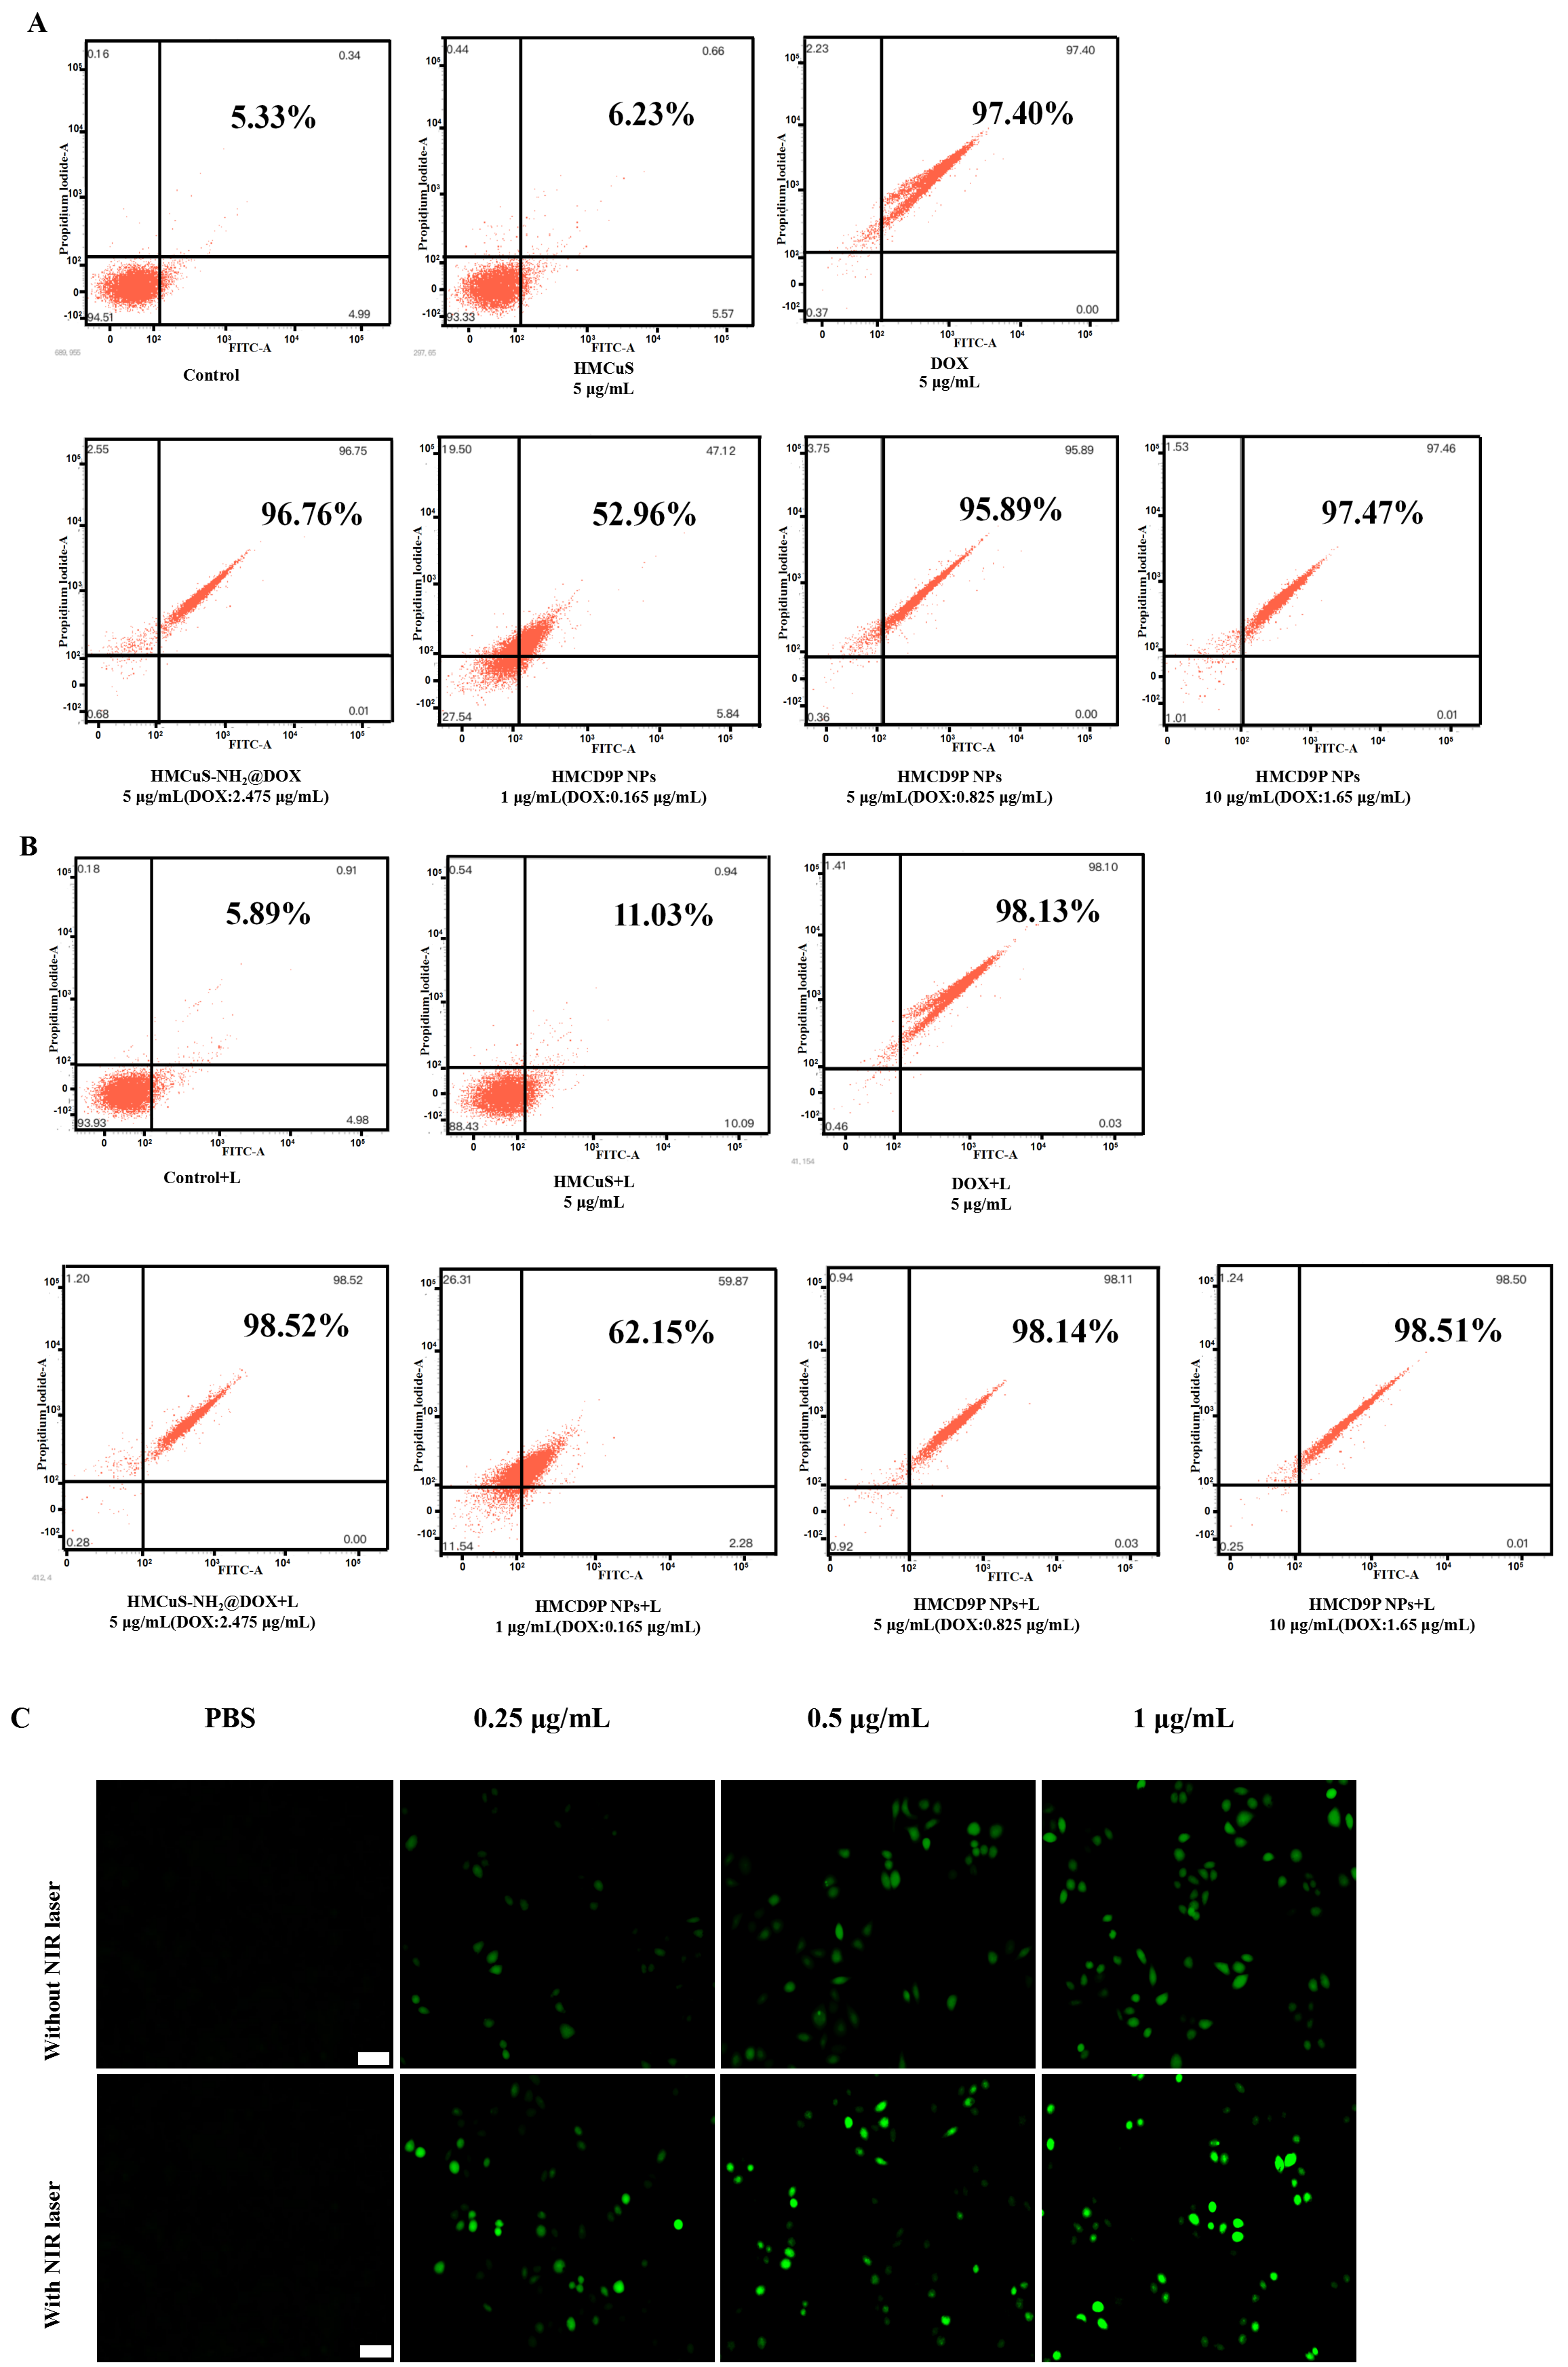
Figure S4. (A) Apoptosis analysis of HepG2 cells treated with HMCuS, DOX, HMCuS-NH₂@DOX, and HMCD9P NPs at 24 h without laser irradiation; (B) Apoptosis analysis of HepG2 cells treated with HMCuS, DOX, HMCuS-NH₂@DOX, and HMCD9P NPs at 24 h with laser irradiation; (C) Fluorescence plots of DCFH staining after incubation with different concentrations of HMCD9P NPs and treatment of HepG2 cells under different conditions. Scale bar: 100 μm.

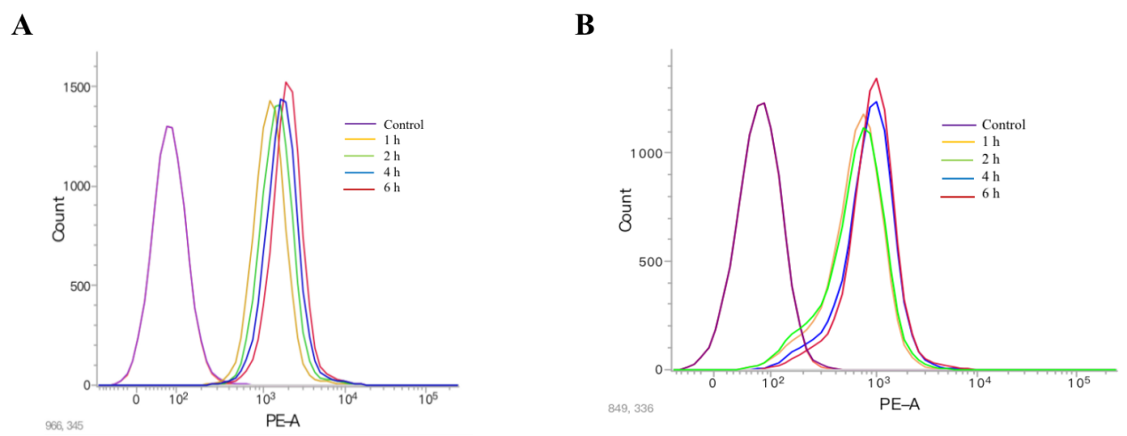
Figure S5. (A) Uptake of HMCD9P NPs (5 μg/mL) at different times of action without the addition of the competitive inhibitor 9R-P201 in A549 cells; (B) Uptake of HMCD9P NPs (5 μg/mL) at different times of action with the addition of the competitive inhibitor 9R-P201 in A549 cells.
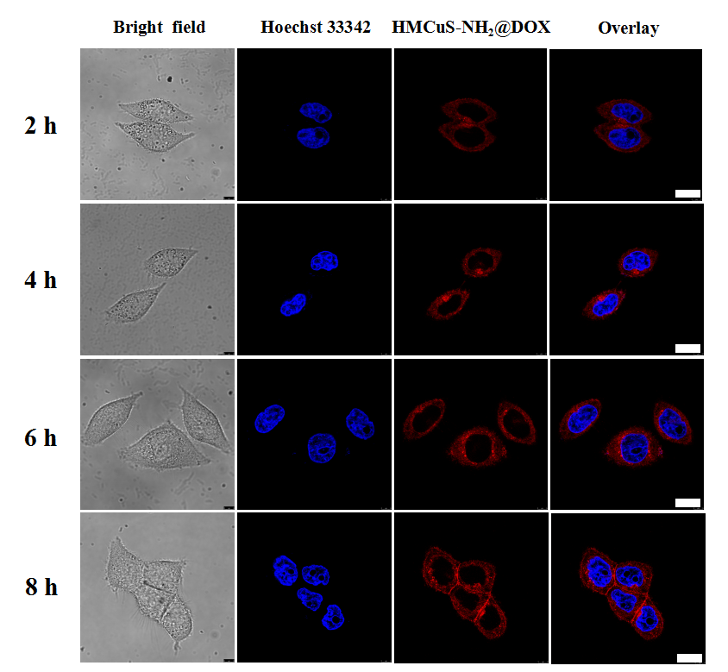
Figure S6. Uptake of HMCuS-NH2@DOX (5 μg/mL) in HepG2 cells at 2, 4, 6 and 8 h of action. (Scale bar: 50 μm).

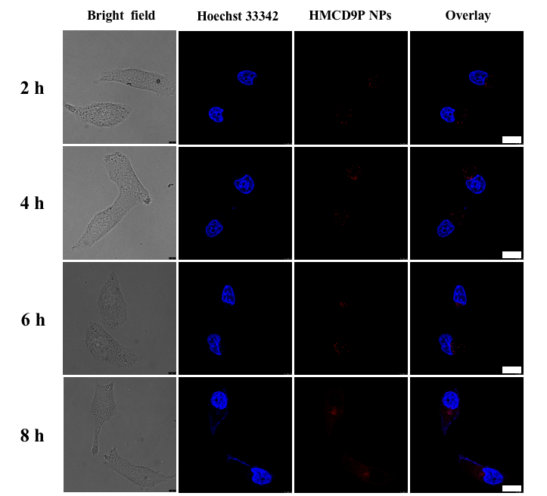
Figure S7. Uptake of HMCD9P NPs (5 μg/mL) in A549 cells at 2, 4, 6 and 8 h of action. (Scale bar: 50 μm).

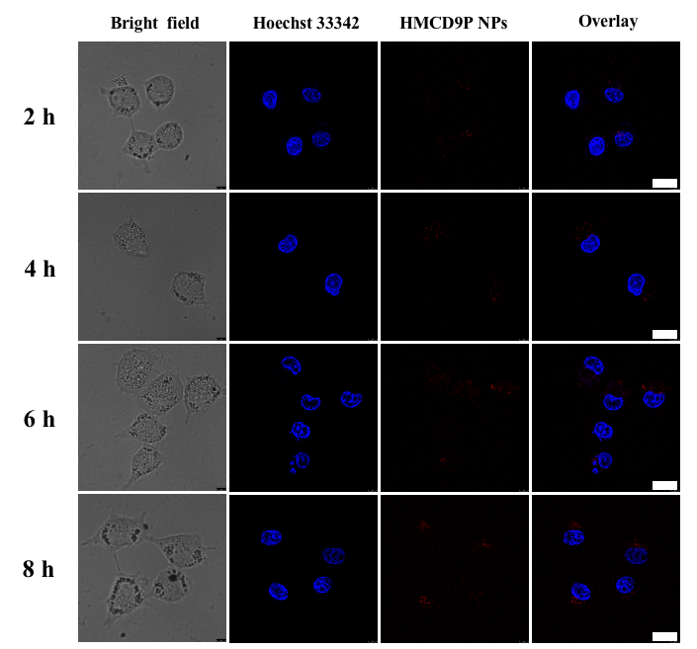
Figure S8. Uptake of HMCD9P NPs (5 μg/mL) in HL-7702 cells at 2, 4, 6 and 8 h of action. (Scale bar: 50 μm).

Table S1. IC₅₀ values of DOX, HMCuS, HMCuS-NH₂@DOX and HMCD9P NPs on HepG2 cells, SNU-739 cells, A549 cells and HL-7702 cells for 48 h.
Sample | IC₅₀ (μg/mL)
Sample | HepG2 | SNU-739 | A549 | HL-7702
DOX | 1.59±0.36 | 0.41±0.12 | 0.91±0.29 | 0.42 ±0.08
HMCuS | 279±2.65 | 131.29±1.57 | 318.85±3.58 | 135.47±2.53
HMCuS-NH₂@DOX | 4.56±0.61 | 3.28±1.5 | 5.44±0.36 | 3.86±0. 84
HMCD9P NPs | 0.8±0.17 | 1.01±0.14 | 2.68±0.18 | 7.69±0.28

