Supplementary Information

Boosting all-weather atmospheric water vapor harvesting with a solar-driven membrane system
Yong Jinª* and Noreddine Ghaffourª, ^{b}*
a Water Desalination and Reuse Center (WDRC), King Abdullah University of Science and Technology (KAUST), Thuwal 23955-6900, Saudi Arabia
b Environmental Science and Engineering Program, Biological and Environmental Science and Engineering (BESE) Division, King Abdullah University of Science and Technology (KAUST), Thuwal 23955-6900, Saudi Arabia
*Corresponding author: yong.jin@kaust.edu.sa or noreddine.ghaffour@kaust.edu.sa

Table of contents

S1. Membrane system simulation model establishment
S2. Experimental validation of the model
S3. Water vapor absorption device design
S4. Design of the channel and air gap frame
S5. Analysis of the deviation of experimental results from the theoretical calculations
S6. Thermodynamic properties of aqueous LiCl
S7. Solar tube design and position adjustment

S1. Membrane system simulation model establishment
All the governing equations were solved in Comsol Multiphysics. The laminar flow model, heat transfer in fluids model, and transport of concentrated species model were employed. The laminar flow and the heat transfer model were coupled with the non-isothermal flow multiphysics coupling interface. The laminar flow and the transport of the concentrated species model were coupled with the reacting flow multiphysics coupling interface. A stationary study was chosen.
Step 1: Build the geometry. 2-D geometry was built as shown below.
Step 2: Assign materials to different domains of the 2D geometry.
Step 3: Add physics and setting boundary conditions: The laminar flow model, heat transfer in fluids model, and transport of concentrated species model were employed.
The laminar flow model was assigned to the hot feed and coolant channel domains. Inlet velocities were set to be normal mass flow rates. Outlets were set to have 0 pressure.
The heat transfer in the fluid model was assigned to the whole domain of the built geometry. The inflow and outflow were imposed in the hot feed and coolant channel domains. A boundary heat source was set at the boundary between the fluid channel domains.
The transport of concentrated species model was assigned to the channel domain. At the boundaries of the domain, species concentrations were defined.
Step 4: Meshing. In this step, mapped meshing was chosen with a maximum size of 1 mm. Boundary layers were added to refine the meshes at the boundaries.
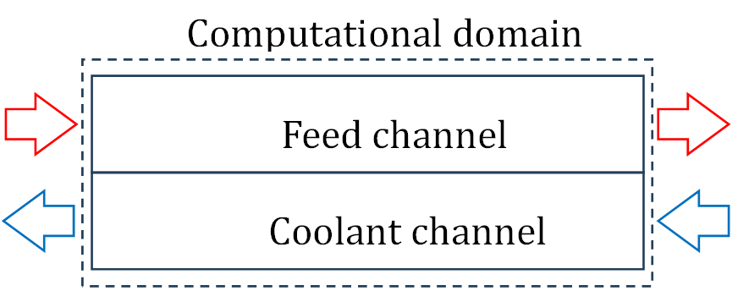
Figure S1. Computational domain consisting of the feed and coolant channels.

S2. Experimental validation of the model
The established model was validated with water as the working fluid, as the thermodynamic properties of water have been well established. A home-made membrane system with an active membrane area of 286 cm² (11 cm in width and 26 cm in length), 5 mm-thick fluid channels, and a 10 mm-thick air gap was used, as shown in Figure S2 a. A counterflow pattern was adopted in the experiment, whose temperatures were measured by thermocouples implemented at the inflow and outflow. The outlet of the coolant channel and the inlet of the feed channel were connected to the inlet and outlet of a heat exchanger correspondingly to ensure the same flow rate in both channels. The heat exchanger was immersed in a hot water bath whose temperature could be adjusted. A commercial PTFE membrane (100 µm) with an effective pore size of 1 µm was used as the tested membrane. Due to the stretchable nature of the polymeric membrane, a highly porous stainless steel support with a 1 mm thickness was employed to ensure a constant air gap thickness. The support’s thermal and mass transport resistance can be neglected due to its high porosity and small thickness.
Two independent experiments were performed. The mass flow rates in the experiments were 1.4 g/s and 4.5 g/s, respectively. Heat and mass transfer mainly occurred in the liquid domain in the channels and the diffusion domain in the air gap. The two parameters used to indicate the validity of the model were the coolant flow inlet and outlet temperature difference and the final permeate flux. The final permeate flux can characterize the diffusion domain, and the apparent temperatures of the liquid can characterize the heat and mass transfer processes in the liquid domain. Both domains are indeed coupled with each other. The coolant flow temperature was purposely set to be close to the ambient temperature (around 20 °C) in the experiments. Therefore, the temperature in the coolant flow was reliable in characterizing the real heat transfer rate. Figure S2 b shows the temperatures at the coolant flow inlet and outlet in the experiment (mass flow rate of 4.5 g/s). The average inlet temperature of the coolant flow was 19.37 °C. Due to the heat transfer from the hot feed, the outlet temperature of the coolant flow increased to 19.73 °C. Therefore, an average temperature difference of 0.36 °C between the inlet and outlet of the coolant flow was recorded. Meanwhile, the temperatures at the inlet and outlet of the feed flow were measured to be 31.76 °C and 31.06 °C, respectively (Figure S2 c). The temperature difference between the inlet and outlet of the feed flow was larger than that of the coolant flow due to the heat loss to the environment. However, this difference did not greatly impact the final permeate flux. The flux data is shown in Figure S2 d, corresponding to a permeate flux of 0.154 kg/m²/h. We ran a simulation with a mass flow rate of 4.5 g/s, a feed flow inlet temperature of 31.76 °C, and a coolant flow inlet temperature of 19.37 °C. The temperature distribution of the simulation is shown in Figure S2 e. The simulated coolant flow outlet temperature was 19.68 °C, and the average difference was 0.31 °C between the inlet and outlet. The permeate flux was calculated by averaging the line flux, which was 0.138 kg/m²/h. The simulated results showed around 10% variation from the experimental results.
A second experiment was performed with a lower mass flow rate (1.4 g/s) and similar inlet temperatures. As shown in Figure S2 f, the coolant flow's average inlet and outlet temperatures were 19.15 °C and 20.05 °C, respectively. Therefore, an average temperature difference of 0.9 °C between the inlet and outlet flows was recorded. As shown in Figure S2 g, the feed flow inlet and outlet temperatures were 32.13 °C and 30.4 °C, respectively. Similarly, the temperature difference between the feed flow inlet and outlet was larger than that of the coolant flow due to the heat loss to the environment. This difference also did not greatly impact the final permeate flux. The flux data is shown in Figure S2 h, corresponding to a permeate flux of 0.146 kg/m²/h. We ran a similar simulation with a mass flow rate of 1.4 g/s, a feed flow inlet temperature of 32.13 °C, and a coolant flow inlet temperature of 19.15 °C. The temperature distribution of the simulation is shown in Figure S2 i. The simulated outflow temperature of the coolant flow was 20.06 °C, with an average difference of 0.91 °C between the inlet and outlet. The permeate flux was calculated by averaging the line flux, which was 0.136 kg/m²/h. The simulated results also showed around 10% variation from the experimental results.
In the experiments, we found condensate on the stainless steel support, which is the reason for the relatively higher experimental permeate flux. Considering the experimental errors, we believe our model is robust enough to predict heat and mass transfer.

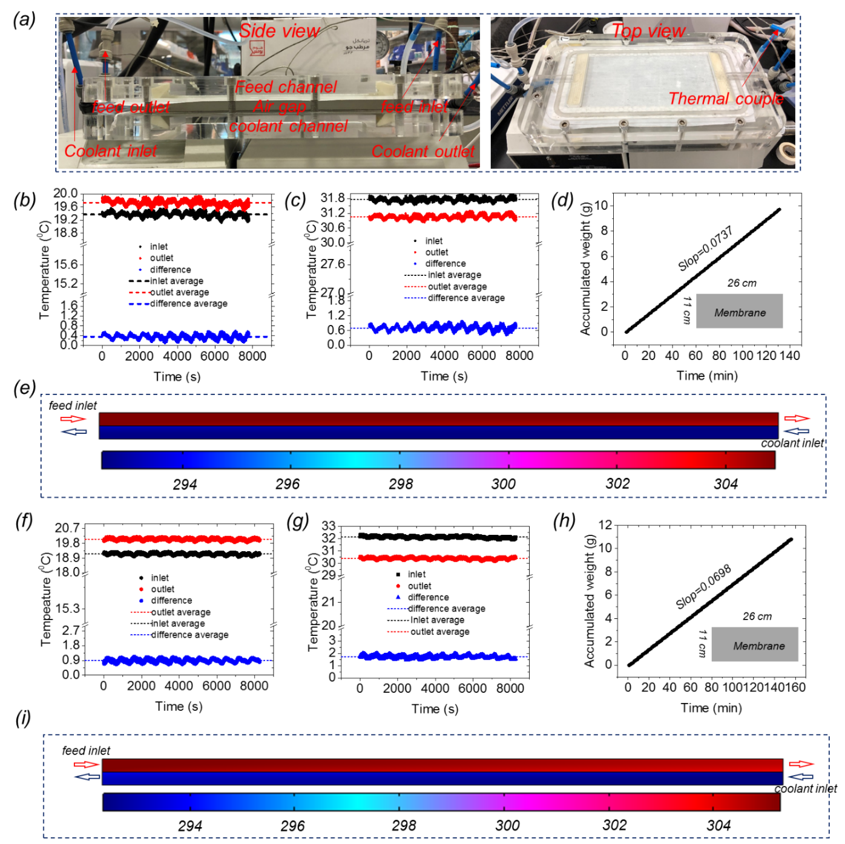
Figure S2. a, experimental setup for model validation; temperature profiles of inlet/outlet of coolant channel (b) and feed channel (c) of the first experiment (flow rate 4.5 g/s); d, water collection rate in the first experiment; e, temperature profile from the Comsol simulation for the first experiment (in the unit of K); temperature profiles of inlet/outlet of coolant channel (f) and feed channel (g) of the second experiment (flow rate 1.4 g/s); h, water collection rate in the second experiment; i, temperature profile from the Comsol simulation for the second experiment (in the unit of K).

S3. Water vapor absorption device design
The water vapor absorption device design consists of two channels (for the air stream and solution stream) separated by a hydrophobic membrane, as shown below (Figure S3). The two channels can be rolled into a compact spiral-wound module. The two streams flow in opposite directions. The channel depth is 0.5 mm, while the length is 600 mm. The 100-μm-thick membrane’s porosity and average pore size are assumed to be 0.9 and 100 nm, respectively. A multiphysics model was established to simulate the water vapor absorption process. The air stream and solution stream were simulated by numerically solving the following governing equations:
Continuity equation:
$$∇∙\left(ρu\right)=0 (S1)$$
Where ρ is the fluid density, and u is the velocity field of a fluid.
Momentum equation:
$$ρ\left(u∙∇\right)u=∇∙\left(-pI+K\right)+f (S2)$$
$$K=μ\left(∇u+{∇u}^{T}\right) (S3)$$
where p is the fluid pressure, I and K are the identity tensor and stress tensor, respectively, and f is the volume force.
Boundary condition of the momentum equation:
The hot feed and coolant channel inlet velocity is set to be a fixed average inlet velocity normal to the inlet, $u_{n}=u_{in}$. The pressure at the outlet of the channels is set to 0.
Energy equation:
$$ρC_{p}u∙∇T-k∆T=Q_{s}+Q_{vd}+Q_{p} (S4)$$
Where C_{p} is the specific heat capacity at constant pressure, T is the temperature (K), k is the thermal conductivity, Qs is the heat source term, Q_{vd} is the viscous dissipation tern, Q_{p} is the work done by pressure changes. It is the result of heating under adiabatic compression and some thermoacoustic effects.
Boundary condition of the energy equation: both channels’ inlets are set to have fixed inlet temperatures. At the membrane and solution interface, a boundary heat source is applied:
$$Q_{L}=J*H (S5)$$
Where Q_{L} is the latent heat released during vapor absorption, J is the vapor flux, which is calculated as:
$$J=-D_{mem}∇c (S6)$$
Where c is the vapor concentration in the membrane, which is solved in the membrane domain with the following governing equation:
$$∇∙J=0 (S7)$$
Concentration boundary conditions are set at the two interfaces of the membrane with the air stream and solution stream:
At the membrane-air stream interface, vapor concentrations are equal. The vapor concentration equals the solution’s saturated vapor concentration at the membrane-solution stream interface.
D_{mem} is the vapor diffusion coefficient in the membrane, which is expressed as:
$$D_{mem}={({(\frac{2εr}{3τ}\sqrt{\frac{8RT}{πM}})}^{-1}+{(\frac{ε}{τ}\frac{1.8951*{10}^{-5}T^{^2.072}}{P_{air}})}^{-1})}^{-1} (S8)$$
Where ε, τ, and r are the membrane’s porosity, tortuosity, and average pore size, respectively, P_{air is} the air pressure in the membrane, and the tortuosity is calculated as:
$$τ=\frac{{(2-ε)}^{2}}{ε} (S9)$$
H is the latent heat of vaporization of the solution. The rest of the walls of the channel are assumed to be adiabatic.
The concentrated species transport equation is solved in the solution channel:
$$∇∙j_{i}+ρ\left(u∙∇\right)w_{i}=R_{i} (S10)$$
$$j_{i}=-(ρD_{i}∇w_{i}+ w_{i}D_{i}\frac{∇M_{n}}{M_{n}}- w_{i}\sum_{1}^{N}{\frac{M_{i}}{M}∇x_{i}}) (S11)$$
$$M_{n}={\left(\sum{\frac{w_{i}}{M_{i}}}\right)}^{-1} (S12)$$
Where w_{i} is the mass fraction of species i; x_{i} is the mole fraction of species i; ρ is the fluid density; D_{i} is the multicomponent diffusion coefficient, which is the binary diffusion coefficient in our study; R_{i} is the reaction source term; M_{i} is the molar mass of species i and M is the average molar mass.
A flux boundary condition representing the evaporated water (J) is applied to the solution-membrane interface.
The diluted species transport equation is solved in the solution channel in the air stream:
$$∇∙\left(-D∇c+u*c\right)=R (S13)$$
Where u is the velocity field, R is the source term, and D is the binary vapor diffusion coefficient in the air, which is expressed as:
$$D=-2.775*{10}^{-6}+4.479*{10}^{-8}*T+1.656*{10}^{-10}*T^{2} (S14)$$
Conduction in the membrane domain is simulated by solving the following governing equation:
$$∇∙(-k_{mem}∇T)=0 (S15)$$
The membrane thermal conductivity (k_{mem}) is calculated to be:
$$k_{mem}=ε*k_{air}+\left(1-ε\right)*k_{PTFE} (S16)$$
Where k_{air} and k_{PTFE} are the thermal conductivity of air and PTFE, respectively.

Air stream
Solution stream
membrane

Figure S3. Schematic of the designed water vapor absorption device.

We simulated one water vapor absorption process with an air stream with a relative humidity of 65% at 20 °C (corresponding to a solution with a mass fraction of 0.215) and a solution with a mass fraction of 0.4. The flow rates of the air stream and solution were 4 m/s and 0.001 m/s, respectively. The simulated results showed that the mass fraction and temperature of the outgoing flow of the solution were 0.222 and 20 °C, respectively, which are almost in equilibrium with the ambient environment. The residence time of the solution in the device was 10 min, which means that the solution can reach equilibrium with the environment in 10 min, demonstrating the instant response to the changing environment. The width of the channel can be adjusted according to the total amount of the solution.

S4. Design of the channel and air gap frame
The design of the channel and air gap frame was done in SolidWorks. Figure S4 shows the design of the channel. The blue part is the effective channel section with dimensions of 103.6 mm⨯54.4 mm⨯0.5 mm. The whole piece’s thickness is 5 mm.
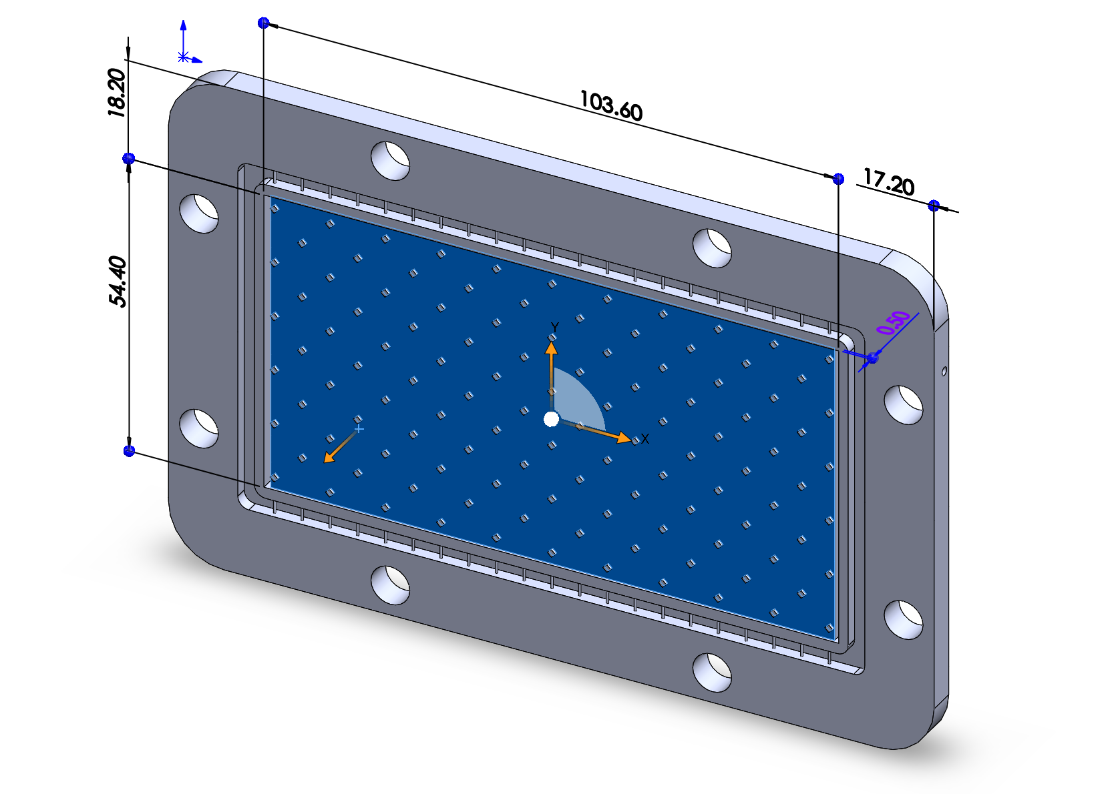
Fluid inlet/outlet
O-ring section
Hole for bolts

Figure S4. Channel design with dimensions.

The design of the air gap frame is shown in Figure S5. The area marked by the red rectangle is the air gap. The air gap thickness is the frame thickness. The air gap section is divided into smaller sections to avoid severe deformation of the polymeric PTFE membrane. The thickness of the air gap is also adjusted accordingly. We had four stages in the AVH-MS. The liquid pressure and temperature of the first two stages were high. Therefore, the thickness of the air gap in the first two stages was designed to be 1.9 mm, while the thickness of the air gap in the last two stages was designed to be 1.4 mm.
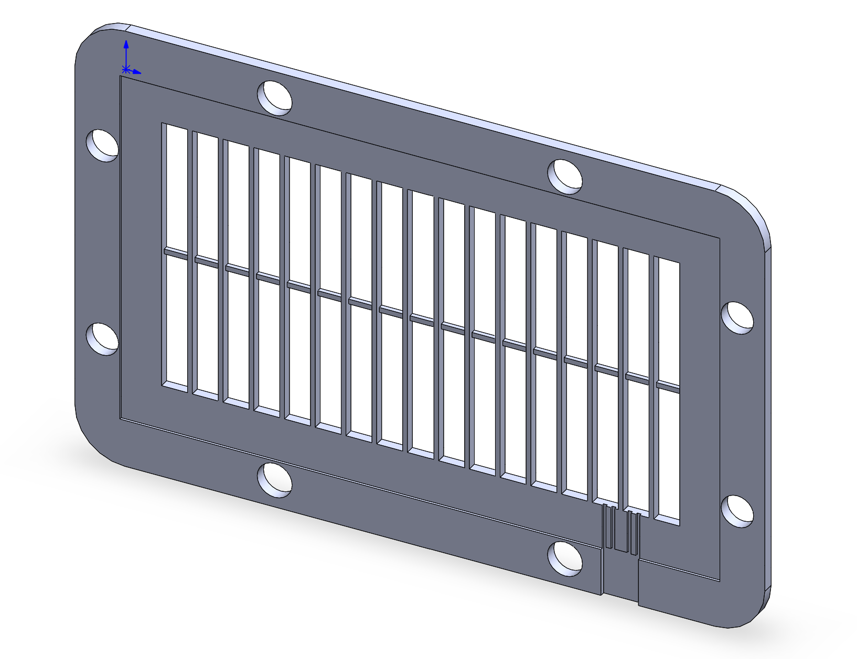
Condensed water drainage

Figure S5. Air gap frame design.
S5. Analysis of the deviation of experimental results from the theoretical calculations.
1. Steady versus unsteady state
Water collected (m_{c}) in the steady and unsteady states was not significantly different. What’s different is the coolant outlet’s temperature (T_{steady} and T_{unsteady}). Therefore, the difference in their water production capacity (∆WP) can be defined as:
$$∆WP=\frac{\frac{η_{steady}m_{c}}{\int_{T_{steady}}^{T_{boiling}}{MC_{p}dT}}-\frac{η_{unsteady}m_{c}}{\int_{T_{unsteady}}^{T_{boiling}}{MC_{p}dT}}}{\frac{η_{steady}m_{c}}{\int_{T_{unsteady}}^{T_{boiling}}{MC_{p}dT}}}=\frac{\int_{T_{unsteady}}^{T_{steady}}{C_{p}dT}}{\int_{T_{steady}}^{T_{boiling}}{C_{p}dT}} (S17)$$
Where η is the energy utilization efficiency, assumed constant for the steady and unsteady states; M is the total solution mass to be heated. If we further assume Cp is constant at that temperature range, then ∆WP is approximated as:
$$∆WP=\frac{T_{steady}-T_{unsteady}}{T_{boiling}-T_{steady}} (S18)$$
Therefore, if we operated continuously and steadily, the water production capacity could increase by around 20% to 50%.
2. Flow rate impact
Due to the small scale of lab experiments, the flow rates in our experiments were higher than those predicted by theories to minimize the temperature drop at the feed inlet. The theoretical predictions of SP at different flow rates in our fabricated AVH-MS are shown in Figure S6 for the solutions with a mass fraction of 0.2, 0.325, and 0.4, respectively. A lower mass concentration corresponds to a lower optimal flow rate, resulting in a larger deviation between the experiment and theory. Although SP with larger flow rates may impact the SP, we also need to consider the effect of heat loss on the environment. If the flow rate is low, the residence time of the solution in the AVH-MS is long, and more energy will be lost to the environment. Therefore, we will further consider the flow rate impact on the heat loss to the environment section.
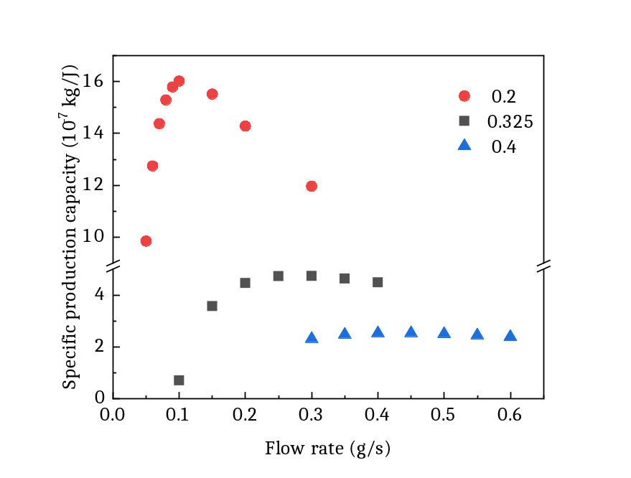
Figure S6. Effect of feed inlet flow rate on the SP.
3. Heat loss to the environment
Heat always moves from hot to cold. Therefore, it is important to pay attention to heat loss from the AVH-MS in daily operations. We individually applied a convective heat flux to the hot and coolant channel walls in the simulations. In order to achieve outlet temperatures that are comparable to those measured experimentally at the feed and coolant outlets, the heat transfer coefficient was set to 4 W/m2/K for the hot channel wall and 10 W/m2/K for the coolant channel wall. The feed inlet temperature was set to match the value recorded during the steady state in our experiments. The flow rate was also set to match the experimental flow rate. For solutions with various mass fractions, Figure S7 compares SP with heat loss (SP-exp) and SP without heat loss (SP-ideal). Due primarily to the flow rate deviation, the SP-exp for the solution with a mass fraction of 0.2 is almost half of the SP ideal, whereas it is only marginally less for the other two solutions.
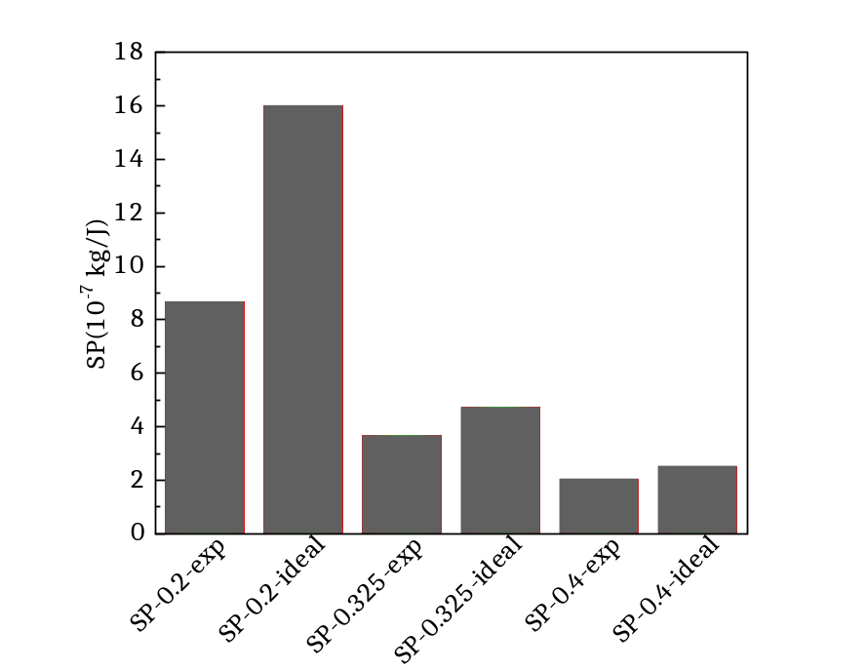
Figure S7. Comparison between SP with heat loss and without heat loss for solutions with different mass fractions.

4. Intermittency of the solar heating
When solar heating ends during the day, the temperature of the solution from the last cycle and the evacuated solar tube gradually decreases. On the second day, the solution and tube need heating to their original temperature. The energy required for heating is expressed as:
$$∆E=\frac{\int_{T_{initial}}^{T_{coolantoutlet}}{{(C}_{psolution}+C_{ptubbe})dT}}{η} (S19)$$
The ratio of ∆E to the total solar energy (E) is expressed as:
$$∆E/E=\frac{\int_{T_{initial}}^{T_{coolantoutlet}}{{(C}_{psolution}+C_{ptubbe})dT}}{η\int{I(t)dt}} (S20)$$
∆E/E is around 10% in our study. Therefore, we expect a 10% decrease in WP compared with theoretical predictions. However, the intermittent nature of solar heating is intrinsic unless the stored solar energy is supplied during the night.
5. Deformation of polymeric PTFE membrane
The liquid deforms the membrane at high temperatures, resulting in a larger feed channel depth. As theory predicts, a larger channel depth has a smaller SP. However, the deformation is not uniform. Therefore, it is hard to quantify the exact channel depth. We estimated from experience that the channel depth roughly increased by 1 mm on average. Therefore, the feed channel depth is 1.5 mm, while the coolant channel is still 0.5 mm. With this modification, the predicted SP is updated in Figure S8. These updated SPs are close to the real theoretical optimal SPs in our designed AVH-MS. Around 50% of these real theoretical SPs (due to the effects of unsteady operation and intermittent solar heating) are now close to the experimental SPs in our study.
The above analysis provides us with essential principles that can guide us toward better AVH-MS design to improve water production in the future.
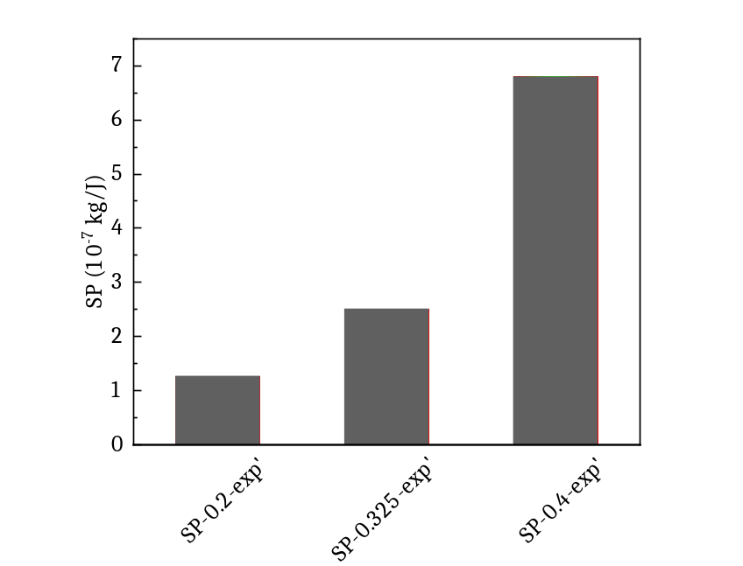
Figure S8. SP for deformed PTFE when heat loss is considered.

S6. Thermodynamic properties of aqueous LiCl
1. Density
$$ρ\left(w, T\right)=ρ_{water}\left(T\right)*(1+0.540966*\left(\frac{w}{1-w}\right)-0.303792*({\frac{w}{1-w})}^{2}+0.100791*{\left(\frac{w}{1-w}\right)}^{3}) (S21)$$

$$ρ_{water}\left(T\right)=ρ_{c, water}*(1+1.993771843*{\left(1-\frac{T}{647.096}\right)}^{\frac{1}{3}}+1.0985211604*{\left(1-\frac{T}{647.096}\right)}^{\frac{2}{3}}-0.5094492996*{\left(1-\frac{T}{647.096}\right)}^{\frac{5}{3}}-1.761912427*{\left(1-\frac{T}{647.096}\right)}^{\frac{16}{3}}-45.9005480267*{\left(1-\frac{T}{647.096}\right)}^{\frac{43}{3}}-723692.2618632*{\left(1-\frac{T}{647.096}\right)}^{\frac{110}{3}}) (S22)$$

$$ρ_{c, water}=322 kg/m^{3}$$
0<w<0.56
2. Dynamic viscosity
$$μ\left(w, T\right)=μ\left(water, T\right)*e^{(0.090481*{\frac{w}{{\left(1-w\right)}^{\frac{1}{0.6}}}}^{3.6}+1.390262*\frac{w}{{\left(1-w\right)}^{\frac{1}{0.6}}}+0.675875*\frac{647.096}{T}*\frac{w}{{\left(1-w\right)}^{\frac{1}{0.6}}}-0.583517*{\frac{w}{{\left(1-w\right)}^{\frac{1}{0.6}}}}^{2}) (S23)}$$

3. Heat Capacity:
$$C_{ps}\left(T,w\right)=C_{p water}\left(T\right)*(1-\left(1.4398*w-1.24317*w^{2}-0.1207*w^{3}\right)*(58.5225*{\left(\frac{T}{228}-1\right)}^{0.02}-105.6343*{\left(\frac{T}{228}-1\right)}^{0.04}+47.7948*{\left(\frac{T}{228}-1\right)}^{0.06}) (S24)$$
0<w<0.31
$$C_{ps}\left(T,w\right)=C_{p water}\left(T\right)*(1-\left(0.12825+0.62934*w\right)*(58.5225*{\left(\frac{T}{228}-1\right)}^{0.02}-105.6343*{\left(\frac{T}{228}-1\right)}^{0.04}+47.7948*{\left(\frac{T}{228}-1\right)}^{0.06}) (S25)$$
w>0.31
4. Thermal conductivity:
$$k_{s}\left(T,w\right)=k_{water}\left(T\right)-\left(0.0108958-0.0117882*w\right)*\frac{w*ρ_{s}(T,w)}{42.5} (S26)$$

5. Vapor pressure:
$$P_{S}\left(T,w\right)=P_{water}\left(T\right)*\left(1-{\left(1+{\left(\frac{w}{0.362}\right)}^{-4.75}\right)}^{-0.4}-0.03*e^{\frac{{\left(w-0.1\right)}^{2}}{-0.005}}\right)*(2-{\left(1+{\left(\frac{w}{0.28}\right)}^{4.3}\right)}^{0.6}+\left({\left(1+{\left(\frac{w}{0.21}\right)}^{5.1}\right)}^{0.49}-1\right)*\frac{T}{647.096}) (S27)$$
$$P_{water}\left(T\right)={133.32*10}^{8.07131-\frac{1730.63}{233.426+T-273.15 }} (S28)$$

6. Enthalpy
$$H_{s}(T,w)=H_{water}+\left(169.105+457.85*\frac{T}{647.096}\right)*{\left(1+{\left(\frac{w}{\left(0.6-w\right)*0.845}\right)}^{-1.965}\right)}^{-2.265} (S29)$$

$$H_{water}=2500.82-2.358*\left(T-273.15\right) (S30)$$

7. Diffusion coefficient
$$D=\frac{0.11353*{10}^{-16}RTV_{c}^{2/3}}{μV_{L}}*(1-{\left(1+{\left(\frac{\sqrt{w}}{0.52}\right)}^{-4.92}\right)}^{-0.56}) (S31)$$
V_{c} molar volume of water at the critical point; V_{L} molar volume of water at T.
V_{c}=55.9*10^-6 m^3/mol; V_{L}=1000/ρ_{water}(T)/18
µ= µ_{water} (T)

S7. Solar tube design and position adjustment
The solar tube resembles a cylinder. Half of the surface facing the sun is the effective absorption area, while the other half can also absorb diffusely reflected solar energy from the surroundings. To ensure that only half of the tube receives solar energy, the other half of the tube is covered with aluminum foil (Figure S9). The pyranometer measures the direct and diffuse solar flux reflected off the surrounding environment. With time, the tube's position was altered to maximize solar energy.
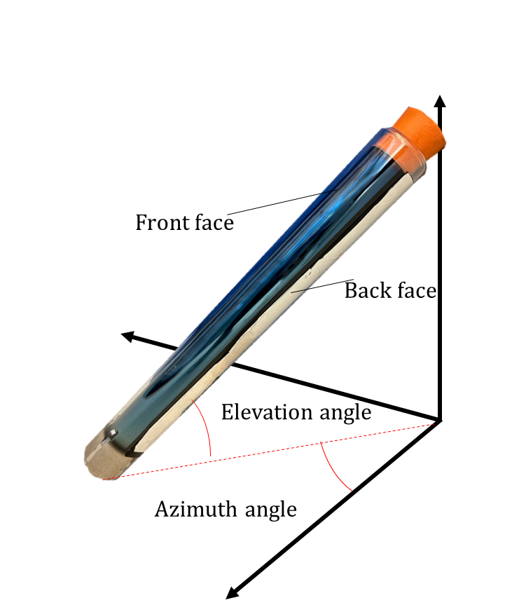
Figure S9. Position of the solar tube whose back face is covered with aluminum foil.

