Reducing pesticides in agriculture: Unveiling the impact of landscape features on natural pest control and farm income
Supplementary information
- Yield gap estimation and crop selection process
Yield gaps were only estimated for crops and regions if at least 16 yield observations in both organic and conventional farming within one region were reported in FADN. Subsequently, once a yield gap was estimated and attributed to a region, the contribution of LF-NPC potential was only investigated for a specific crop if more than ten regions had a yield gap estimation available. This selection process resulted in the estimation of yield gaps and LF-NPC contribution for eight crops: wheat, corn, barley, oats, potatoes, rye, fodder corn and legumes.

Table SI 1: Average yield gap between organic and conventional farming by crop (in %).

Figure SI 1: Distribution of p-value for all included farm-level variables by crop
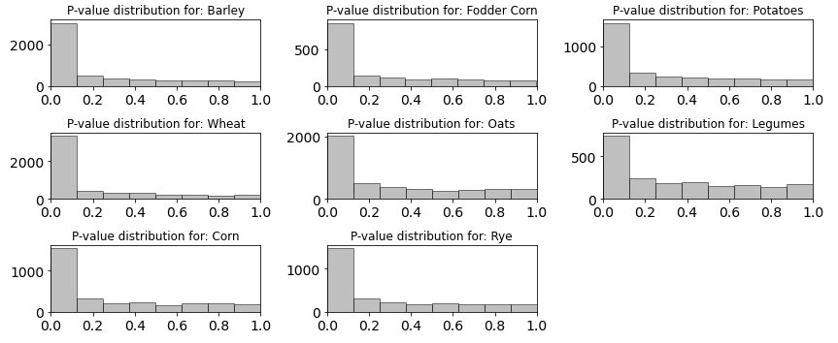

Figure SI 2: Distribution of model error (t/ha) per crop
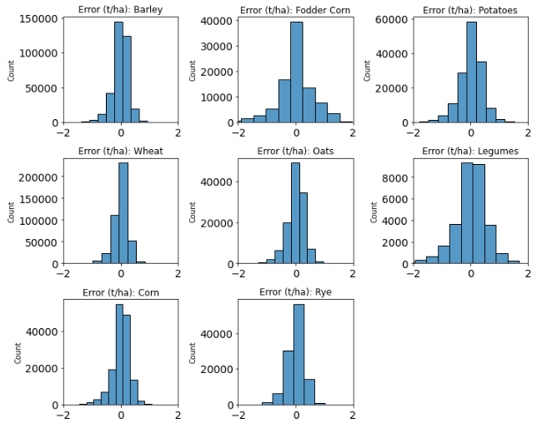

- Explanatory data analysis and mixed effect model
Table SI 2: Comparison of fit between yield gaps and LF-NPC. Option considered are LF-NPC without any changes, taking the log of LF-NPC and implementing a second degree polynomial.

Figure SI 3: Mixed Effect Results. Left estimate: Results obtained from only allowing the intercept to vary. Right estimate: Results obtained from allowing intercept and independent variable (LF-NPC) to vary.
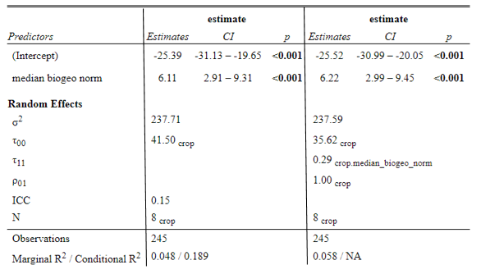
LF-NPC

- Simulation under the partial equilibrium model CAPRI:
For the economic evaluation of LF-NPC we simulated two scenarios: One scenario which does not consider feedbacks from trade and related price effects from global agri-food markets, and a second scenario where these price and market feedbacks are considered. Both scenarios show a positive relative contribution of LF-NPC potential to agricultural income. As our simulation mainly focuses on arable crops, the agricultural income analysed is the one of utilized agricultural area. In the scenario without international market and price feedback, a one-unit increase in the LF-NPC potential results in a 6.1% improvement in agricultural income per hectare (Figure SI 4). However, we observe that overall agricultural income decreases compared to the baseline (see y-axis of Figure SI 4) due to general lower yields as a consequence of reduced pesticides use. Only regions with a high LF-NPC potential are able to minimize the impact on income and stay close to what would have been their income under the business-as-usual baseline. These results are in line with the general logic of running a partial equilibrium model without allowing market feedback to increase prices as a result of lower production, i.e. constant prices and lower yields will lead to lower farm income. Running a scenario, where we allow for market feedback and price increase as a result of lower production, regions with a below-average LF-NPC potential are able to increase their income compared to the baseline. However, in our study we are not interested in the overall increase or decrease of income, but focus on the change in income related to a one-unit increase in LF-NPC.
Figure SI 4: LF-NPC potential (x-Axis) versus income changes in percentage (y-axis).
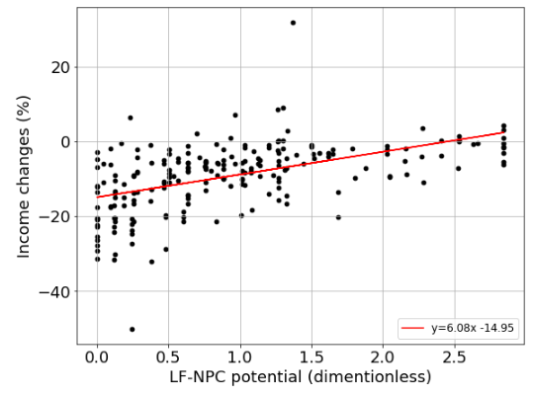
Furthermore, we focused here on the income of utilized agricultural area instead of looking at crop-specific income changes, as structural characteristics, such as the cost structure at regional level can introduce important variations in the income not related to the LF-NPC potential. This is expressed in the low R-square to the right from Table SI 3 and the relative higher explanatory power when only looking at revenue changes (see Table SI 3). When looking at the overall income from utilized agricultural area, the crop-specific cost structure are less important and hence allow for a more direct relation between LF-NPC and income changes expressed in percentage changes to the baseline scenario. Equally, it is worth to note, that when comparing yield changes to revenue changes, the impact was more
Table SI 3: Changes (%) in revenue and income due to a regions LF-NPC potential without international market and price feedback
*Legumes are not presented in the table, as data on revenue, cost and income are less robust compared to the other selected crops.

