Is it beneficial for patients with early breast cancer after mastectomy to receive internal mammary node irradiation? A propensity-matched analysis of a retrospective cohort

Yuxin Xie^{1,2,3, ∗}, Qiheng Gou^{4,∗}, Yingjie Zhang⁴

Short title: Internal mammary node irradiation in breast cancer

¹ Department of Medical Oncology, Cancer Center, West China Hospital, Sichuan University, Chengdu, China;
² Breast Center, West China Hospital, Sichuan University, Chengdu, China;
³ Laboratory of Molecular Diagnosis of Cancer, Clinical Research Center for Breast, West China Hospital, Sichuan University, Chengdu, China;
⁴ Department of radiation therapy, West China Hospital, Sichuan University, Chengdu, China.

∗Equal contribution to the work.

Correspondence to: Dr. Yuxin Xie, Department of Medical Oncology of Cancer Center, West China Hospital, Sichuan University, 37 Guoxue Xiang, Wuhou District, Chengdu 610041, China.
Tel: +86-28-85422685; Email: xieyuxin123@wchscu.cn (D. Xie)
Contents:
Page 3: Supporting Information Figure S1
Page 4-6: Supporting Information Table S1–TableS2
Figure. S1. Kaplan–Meier estimates of breast cancer-specific survival (A) and overall survival (B) after propensity score matching. IMNI indicates internal mammary node irradiation.
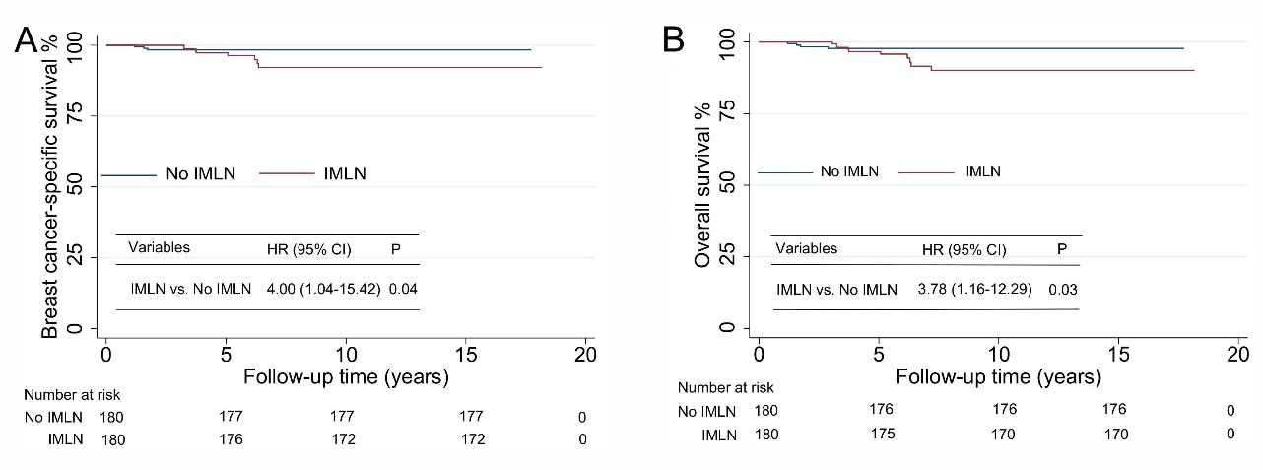
Table S1: Demographics and clinical characteristics of patients before propensity score matching.
Characteristics | All  (n=1,015) | IMNI  (n=189) | No IMNI  (n=826)
 | No.( %) | No.( %) | No.( %) | P
Age |  |  |  | 0.12
Median (IQR), y | 48 [43-54] | 48 [42-54] | 48 [43-54]
Calendar year at diagnosis |  |  |  | < 0.01
 | 152 (14.98) | 70 (37.04) | 82 (9.93)
  2003-2010
2011-2019 | 863 (85.02) | 119 (62.96) | 744 (90.07)
Residence |  |  |  | < 0.01
Rural | 299 (29.46) | 39 (20.63) | 260 (31.48)
Urban | 716 (70.54) | 150 (79.37) | 566 (68.52)
Menopausal status |  |  |  | 0.75
Premenopausal | 580 (57.14) | 106 (56.08) | 474 (57.38)
Postmenopausal | 435 (42.86) | 83 (43.92) | 352 (42.62)
Tumor laterality |  |  |  | 0.87
Left side | 510 (50.25) | 96 (50.79) | 414 (50.12)
Right side | 505 (49.75) | 93 (49.21) | 412 (49.88)
HR status |  |  |  | < 0.01
Negative | 35 (3.45) | 19 (10.05) | 16 (1.94)
Positive | 980 (96.55) | 170 (89.95) | 810 (98.06)
HER2 status |  |  |  | < 0.01
Negative | 587 (57.83) | 132 (69.84) | 455 (55.08)
Positive | 299 (29.46) | 41 (21.69) | 258 (31.23)
Unknown | 129 (12.71) | 16 (8.47) | 113 (13.68)
Clinical tumor size |  |  |  | 0.95
≤ 5cm | 793 (78.13) | 148 (78.31) | 645 (78.09)
> 5cm | 222 (21.87) | 41 (21.69) | 181 (21.91)
Clinical lymph nodal status |  |  |  | < 0.01
cN0-N1 | 516 (50.84) | 62 (32.80) | 454 (54.96)
cN2-N3 | 499 (49.16) | 127 (67.20) | 372 (45.04)
Number of pathological lymph nodes |  |  |  | < 0.01
≤ 3 | 559 (55.07) | 71 (37.57) | 488 (59.08)
> 3 | 456 (44.93) | 118 (62.43) | 338 (40.92)
Histological type |  |  |  | 0.68
Ductal | 982 (96.75) | 182 (96.30) | 800 (96.85)
Others | 33 (3.25) | 7 (3.70) | 26 (3.15)
Histological grade |  |  |  | < 0.01
I/II | 377 (37.14) | 56 (29.63) | 321 (38.86)
III | 425 (41.87) | 79 (41.80) | 346 (41.89)
Unknown | 213 (20.99) | 54 (28.57) | 159 (19.25)
Adjuvant chemotherapy |  |  |  | -
No | 0 (0.00) | 0 (0.00) | 0 (0.00)
Yes | 1,015 (100.00) | 189 (100.00) | 826 (100.00)
Adjuvant endocrine therapy |  |  |  | 0.03
No | 285 (28.08) | 65 (34.39) | 220 (26.63)
Yes | 730 (71.92) | 124 (65.61) | 606 (73.37)
Adjuvant HER2-targeted therapy |  |  |  | 0.09
No | 832 (81.97) | 163 (86.24) | 669 (80.99)
Yes | 183 (18.03) | 26 (13.76) | 157 (19.01)
Abbreviations: cm, centimeter; HR, hormone receptor; HER2, human epidermal growth factor receptor 2; IMNI, Internal mammary node irradiation; IQR, interquartile range; y, year.
Table S2: Associations of IMNI with risks of breast cancer-specific or overall mortality.
 | N of  patients | N of  events | Model A† |  | Model B‡ |  | Model C§
 | N of  patients | N of  events | HR (95% CI) | P | HR (95% CI) | P | HR (95% CI) | P
Breast cancer-specific mortality
No IMLN | 180 | 3 | 1.00 |  | 1.00 |  | 1.00
IMLN | 180 | 8 | 3.41 (0.84-13.77) | 0.08 | 3.01 (0.66-13.70) | 0.15 | 3.84 (0.75-19.73) | 0.11
Overall mortality
No IMLN | 180 | 4 | 1.00 |  | 1.00 |  | 1.00
IMLN | 180 | 10 | 2.89 (0.86-9.70) | 0.09 | 2.51 (0.71-8.82) | 0.15 | 3.17 (0.79-12.5) | 0.10
Abbreviations: N, number; HR, hazard ratio; CI, confidence interval.
† HRs were adjusted for age at diagnosis, calendar year at diagnosis (2003-2010 or 2011-2019), residence (rural or urban), and menopausal status (premenopausal or postmenopausal).
‡ HRs were additionally adjusted for tumor laterality (left side or right side), hormone receptor status (negative or positive), HER2 status (negative, positive, or unknown), clinical tumor size (≤ 5cm or > 5cm), clinical lymph nodal status (cN0-N1 or cN2-N3), number of pathological lymph nodes (≤ 3 or > 3) and histological grade (I/II, III, or unknown).
§ HRs were additionally adjusted for endocrine therapy (yes or no), and HER2-targeted therapy (yes or no).

