Fiber Mesoporous Spherical Ni(OH)₂ @ g-C₃N₄ Heterostructures with Amorphous Shell as Battery-type Capacitive Cathode Enable High-performance Hybrid Supercapacitor
Rui Wang ª, Won Young Jang ª, Mule Vijayalakshmi ª, Raghava Reddy Kakarla ^{b}, Jaesool Shim ^{a,*} Ch. Venkata Reddy ^{a,*}
ª School of Mechanical Engineering, Yeungnam University, Gyeongsan 712-749, Republic of Korea
^{b} School of Chemical and Biomolecular Engineering, The University of Sydney, NSW, 2006, Australia

_____________________________________________________________________
*Correspondence to: cvrphy@gmail.com (C. V. Reddy); jshim@ynu.ac.kr (J. Shim);

Calculation:
(1) The specific capacitance (C) of the prepared electrodes calculated from GCD (half-cell, three-electrode test) are obtained according to the following equation:
$$\begin{aligned}C= \frac{I∆t}{m∆V}\#\left(S-1\right)\end{aligned}$$
Where C is the specific capacitance of the half-cell, I is the discharge current, △t is the discharge time, m is the mass of the active material and △V is the potential window.
(2) The mass balance of cathode and anode active materials in the hybrid supercapacitor (HSC) satisfies the following formula:
$$\begin{aligned}\frac{m_{+}}{m_{-}}=\frac{C_{-}×{∆V}_{-}}{C_{+}×{∆V}_{+}}\#\left(S-2\right)\end{aligned}$$
In this formula, m means the mass, C means the capacitance, and △V is the potential window of cathode and anode materials.
(3) The specific capacitance of half-cell:
$$\begin{aligned}C_{h}= \frac{I∆t}{m∆V}\#\left(S-3\right)\end{aligned}$$
(4)The specific capacitance of the obtained HSC device (full-cell) can be calculated by the following equation^{[1]}:
$$\begin{aligned}C_{f}= \frac{4I∆t}{M∆V}\#\left(S-4\right)\end{aligned}$$
Herein the C_{h} and C_{f} stand for the gravimetric specific capacitance half-cell and full-cell, respectively, I is the discharge current, △t is the discharge time, m is the mass of active material on the single electrode, M is the mass of the total mass of the cathode and anode materials, and △V is the potential window.
(5) Methods to calculate the energy and power density of the HSC device^{[2]}
$$\begin{aligned}E= \frac{C×V^{2}}{2×3.6}\#\left(S-5\right)\end{aligned}$$
$$\begin{aligned}P= \frac{3600×E}{t}\#\left(S-6\right)\end{aligned}$$
Here, E presents energy density, C means specific capacitance of active material, V stands for the working potential window, P stands for power density, and t is the discharge duration.

Experimental section:
1.Synthesis and assembly
Synthesis of crystal g-C₃N₄ (GCN) and amorphous g-C₃N₄ (ACN) nano-sheets as the shell materials for core-shell heterostructure:
The GCN and CAN were synthesized by one-step thermal polymerization. Firstly, Weigh 5g of melamine and put it in a crucible. Secondly, put the sample in a furnace, then heat it at 450℃ for 5 h. Thirdly, the sample was ground into powder and was sonicated in DI water to eliminate the unexfoliated g-C₃N₄ and impurities. Finally, the solution was cleaned numerous times and then obtained GCN precipitation. The analogous process was used to synthesize the ACN nano-sheets, utilizing urea instead of melamine.
Synthesis of the fiber mesoporous spherical Ni(OH)₂ as the core materials for core-shell heterostructure:
Ni(OH)₂ was obtained by simple hydrothermal synthesis. In brief, Dissolve 3 mmol Ni(NO₃)₂ · 6H₂O and 6 mmol urea in 50ml deionized water with vigorous stirring. Then Add 0.05mmol trisodium citrate dihydrate to the obtained light green dispersion and stir thoroughly. After continuous stirring for 30 minutes, the obtained solution was transferred to the Teflon-lined stainless autoclave and kept at 150 °C for 24 h. The green precipitate was collected When the autoclave was restored to room temperature. Finally, the pure Ni(OH)₂ was obtained by drying at 80℃ for 12 hours after centrifugal washing with Di-water and ethanol several times.

Synthesis of the shell-core heterojunction Ni(OH)₂@GCN and Ni(OH)₂@ACN as the battery-type capacitive cathode:
The shell-core heterojunctions were synthesized by the solution self-assembly method. Firstly, the fiber hollow spheres Ni(OH)₂ and g-C₃N₄ nanosheets were added into absolute ethanol at a mass ratio of 7:3, and fully stirred to disperse. Then the dispersion was placed in the Teflon-lined stainless autoclave and kept at 120°C for 12 h. Finally, the specific heterojunction materials were obtained after the resulting precipitate for washing and drying. It should be noted that different types of core-shell spherical heterogeneous materials Ni(OH)₂@GCN and Ni(OH)₂@ACN can be obtained by changing the crystal form and amorphous g-C₃N₄.
Preparation of the electrodes:
All the working electrodes were prepared with the same procedure: 80% of active materials, 10% carbon black, and 10% polyvinylidene fluoride (PVDF) were ultrasonically dispersed for 45 minutes in N-Methylpyrrolidone solvent (NMP). Then evenly coated on the nickel foam current collector and dried at 120℃ for 12h under vacuum. Finally, the electrode sheet was obtained after the drying temperature was naturally cooled to room temperature.
Assembly of the HSC devices:
The HSC devices were assembled using Ni(OH)₂@ACN and commercialized carbon activated(CA) as the cathode and anode electrodes. The glass microfiber filter was employed as the separator, and the 1M KOH solutions as the electrolyte. It is worth mentioning that the mass ratio of anode and cathode materials satisfies the typical charge balance theorem (shown in formula S-2 for details).
2.Characterization
Materials Characterization:
FESEM (Hitachi, S-4800) and TEM (Tecnai G2 F20) were applied to research the prepared electrode materials' surface morphology and micro/nanostructure. The crystal structure and element valence of the materials were characterized by XRD (PANalytical X’Pert PRO diffractometer) with Cu-Kα radiations (λ between from 1.54059 to 1.544426 Å) and XPS (Thermo ESCALAB 250Xi) with Al-Kα (hv=1486.6 eV) excitation source, respectively. The N₂ adsorption/desorption isotherms and pore size distribution of the materials were recorded by a specific surface area analyzer (Micromeritics instrument).
Electrochemical measurements:
Cyclic voltammetry (CV), Galvanostatic charge and discharge (GCD), Electrochemical impedance spectroscopy (EIS), and Cycle performance were detected by an electrochemical workstation (Bio-Logic Sp-200) applied to the three-electrode and coin-cell test systems. The Pt sheet (1x1 cm), Hg/HgO, and 1M KOH solution were used as the counter electrode, reference electrode, and electrolyte, respectively, to construct a standard three-electrode system. Furthermore, the coin-cell test system was employed to detect the performance of HSC devices.

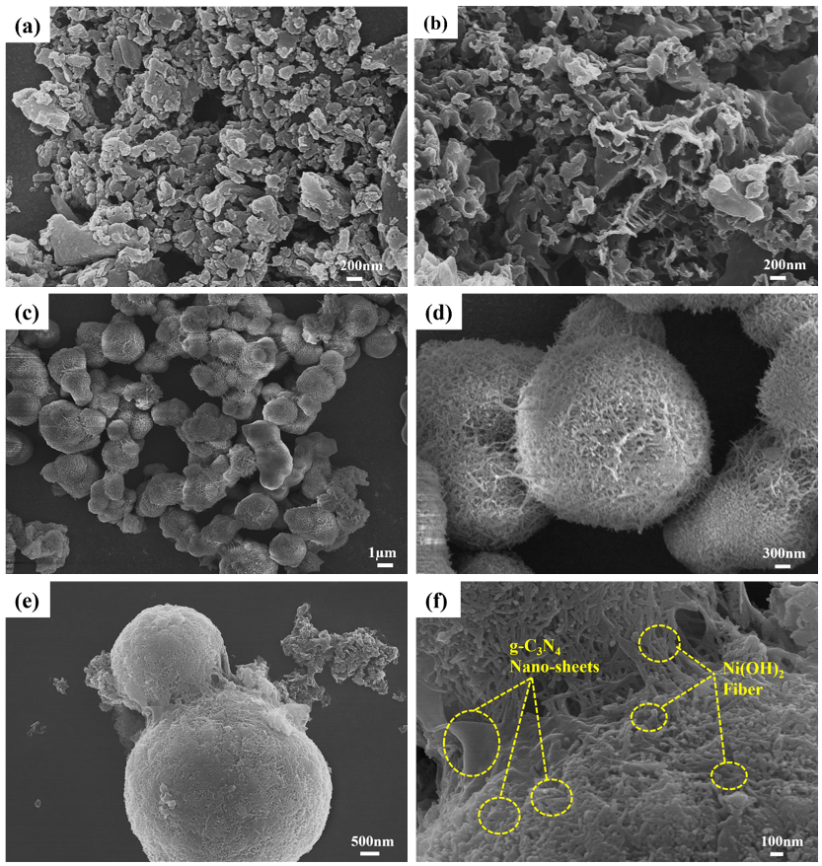
Figure S1. The morphologies of the materials. The SEM images, a) GCN nano-sheets, b) ACN nano-sheets, c-d) Fiber mesoporous spherical Ni(OH)₂, e-f) The bridging structure of Ni(OH)₂@GCN heterostructure. The TEM images, g-h) Ni(OH)₂@GCN composite materials, i) SAED image of Ni(OH)₂@GCN, j) elemental mapping of Ni(OH)₂@GCN.
Figure S2. TEM-EDS results for heterostructure materials, a) Ni(OH)₂@ACN and b) Ni(OH)₂@GCN.

Figure S3. a) The isotherms of the pristine materials and b) The pore size disposition plots of the pure materials.
Figure S4. The CV and GCD profiles of pure materials. a, b) GCN; c, d) ACN and e, f) Ni(OH)₂.

Figure S5. The electrochemical performance of the Ni(OH)₂@GCN material. a) The CV curves at diverse scan rates, b) the GCD profiles at serval current densities, c) the b-values, d) the distribution diagram displaying the capacity and diffusion contributions, e) the capacity contribution ratio at different scan rates and f) the cycling performance during 5000 cycles with corresponding periodic GCD curves.
Figure S6. The distribution diagram of Ni(OH)₂@ACN showing the capacity and diffusion contributions under the different scan rate. a) 1 mV s⁻¹, b) 5 mV s⁻¹, c) 30 mV s⁻¹ and d) 100 mV s⁻¹.

Figure S7. The distribution diagram of Ni(OH)₂@GCN showing the capacity and diffusion contributions under the different scan rate. a) 1 mV s⁻¹, b) 1 mV s⁻¹, c) 30 mV s⁻¹ and d) 100 mV s⁻¹.
Figure S8. The EIS profiles of the GCN, ACN and Ni(OH)₂ materials.

Table S1. The cycling stability comparison of the Ni(OH)₂@ACN with the other Ni(OH)₂-based materials
Materials | Cycling Condition | Cyclic Performance | Reference
Amorphous Ni(OH)₂ | 100 mV s⁻¹  1 M KOH | ~82% (after 5,000 cycles)  72% (after 10,000 cycles) |  | ^{[3]}
Ni(OH)₂@Ni | 100 mV s⁻¹  1 M KOH | ~30% (after 3,000 cycles) |  | ^{[4]}
Ni(OH)₂/Graphene Hydrogels | 4 A g⁻¹  2 M KOH | 95.2% (after 1,000 cycles) |  | ^{[5]}
Ni-Co-Al layered Hydroxides | 5 A g⁻¹  2 M NaOH | 82.2% (after 2,000 cycles) |  | ^{[6]}
Ni(OH)₂@Co(OH)₂ | 20 mA cm⁻²  1 M LiOH | 91% (after 10,000 cycles) |  | ^{[7]}
CoNi₂S₄-Ni(OH)₂ | 5 A g⁻¹  2 M KOH | 97.91% (after 5,000 cycles) |  | ^{[8]}
Co₃O₄@Ni(OH)₂ | 2.2 A g⁻¹  3 M KOH | ~90% (after 3,000 cycles) |  | ^{[9]}
rGO/Ni(OH)₂ nanoflakes | 2 A g⁻¹  6 M KOH | 172% (after 3,000 cycles) |  | ^{[10]}
rGO/Ni(OH)₂ sticks | 2 A g⁻¹  6 M KOH | 15% (after 3,000 cycles) |  | ^{[10]}
rGO/Ni(OH)₂ flowers | 2 A g⁻¹  6 M KOH | 90% (after 3,000 cycles) |  | ^{[10]}
Ni(OH)₂-3D mesoporous carbon | 5 A g⁻¹  6 M KOH | 96.4% (after 5,000 cycles) |  | ^{[11]}
Fe-Co-P@Ni(OH)₂ | 40 mA cm⁻²  2 M KOH | 90% (after 5,000 cycles) |  | ^{[12]}
Ni(OH)₂@Ni₁₂P₅ | 10 mA cm⁻²  2 M KOH | 76.39% (after 3,000 cycles) |  | ^{[13]}
g-C₃N₄@Ni(OH)₂ | 10 A g⁻¹  2 M KOH | ~84% (after 4,000 cycles) |  | ^{[14]}
Ni(OH)₂@ACN | 8 A g⁻¹  1 M KOH | 109.3% (after 5,000 cycles) |  | This work
Ni(OH)₂@GCN | 8 A g⁻¹  1 M KOH | 113.69% (after 5,000 cycles) |  | This work

Table S2. Impedance parameters derived using the corresponding equivalent circuit for materials.
Sample | Rs | Rct | CPE | Ws
GCN | 0.44 | 10.23 | 0.008 | 14.55
ACN | 0.20 | 0.87 | 0.138 | 1.37
Ni(OH)₂ | 0.28 | 59.49 | 0.018 | 8.06
Ni(OH)₂@ACN | 0.26 | 3.56 | 0.011 | 7.28
Ni(OH)₂@GCN | 0.69 | 18.18 | 0.008 | 19.62
CA | 0.63 | 3.91 | 0.44 | 0.44
Ni(OH)₂@ACN  //  CA | 1.22 | 26.69 | 0.002 | 0.009

Table S3. Comparisons of the HSC apparatuses' comprehensive properties with similar devices reported earlier.
Supercapacitors | Electrolyte | Potential  window  (V) | Specific  capacitance | Maximum  energy  density | Power  density | Retention (%)/Cycling number/Current density | Reference
Ni(OH)₂/Ni-Co LDH@CNT  //  APDC | 1M KOH | 1.7 | 315  F g⁻¹  (0.5 A g⁻¹) | 126.4  Wh kg⁻¹ | 424.1  W kg⁻¹ | 78.2% after 3,000 at 0.5 A g⁻¹ | ^{[2]}
β-Ni(OH)₂/Graphene //  β-Ni(OH)₂/Graphene | PVA/KOH | 1.2 | 61.7  mF cm⁻²  (5mA cm⁻²) | 17  μWh cm⁻² | 1.2  mW cm⁻² | 98% after 2,000 at 5 mA cm⁻² | ^{[15]}
P-Ni(OH)₂/NF  //  AC | LiOH/PVA | 1.6 | 365 C g⁻¹  (3.17 A g⁻¹) | 81.3  Wh kg⁻¹ | 635  W kg⁻¹ | No given | ^{[16]}
g-C₃N₄@Ni(OH)₂  //  Graphene | 6M KOH | 1.3 | 51  F g⁻¹  (0.8 A g⁻¹) | 43.1  Wh kg⁻¹ | 9162  W kg⁻¹ | 72% after 8,000 at 3A g⁻¹ | ^{[14]}
Ni(OH)₂/ Co(OH)₂/ Mg(OH)₂  //  AC | 6M KOH | 1.6 | 214 C g⁻¹  (1 A g⁻¹) | 55.3  Wh kg⁻¹ | 930.2  W kg⁻¹ | 86.6% after 5,000 at 8A g⁻¹ | ^{[17]}
NiC₂O₄/Ni(OH)₂  //  Porous biomass-derived carbon | 3M KOH | 1.7 | 134.2 C g⁻¹  (1 A g⁻¹) | 31.07  Wh kg⁻¹ | 833.47  W kg⁻¹ | 80% after 4,000 at 5A g⁻¹ | ^{[18]}
La-Ni(OH)₂  //  AC | 2M KOH | 1.5 | 151.9  F g⁻¹  (0.5 A g⁻¹) | 47.5  Wh kg⁻¹ | 375.0  W kg⁻¹ | 89.3% after 2,000 at 8A g⁻¹ | ^{[19]}
AC/ZnS-Ni₇S₆/Ni(OH)₂  //  AC | 2M KOH | 1.6 | 137.8  F g⁻¹  (1 A g⁻¹) | 48.99  Wh kg⁻¹ | 800.0  W kg⁻¹ | 90.6% after 3,000  At 10 A g⁻¹ | ^{[20]}
Ni(OH)₂@ACN  //  CA | 1M KOH | 1.5V | 311.83 F g⁻¹  (0.5 A g⁻¹) | 77.97  Wh kg⁻¹ | 1201  W kg⁻¹ | 84.3% after 10,000 at 6 A g⁻¹ | This work

[1] L. Cao, G. Tang, J. Mei, H. Liu, J. Power Sources 2017, 359, 262.
[2] J. Shen, X. Li, L. Wan, K. Liang, B. K. Tay, L. Kong, X. Yan, ACS Appl. Mater. \& Interfaces 2017, 9, 668.
[3] H. B. Li, M. H. Yu, F. X. Wang, P. Liu, Y. Liang, J. Xiao, C. X. Wang, Y. X. Tong, G. W. Yang, Nat. Commun. 2013, 4, 1894.
[4] Y.-Z. Su, K. Xiao, N. Li, Z.-Q. Liu, S.-Z. Qiao, J. Mater. Chem. A 2014, 2, 13845.
[5] R. Wang, A. Jayakumar, C. Xu, J.-M. Lee, ACS Sustain. Chem. \& Eng. 2016, 4, 3736.
[6] X. Wang, C. Yan, A. Sumboja, J. Yan, P. S. Lee, Adv. Energy Mater. 2014, 4.
[7] K. Li, B. Zhao, J. Bai, H. Ma, Z. Fang, X. Zhu, Y. Sun, Small 2020, 16, 2001974.
[8] A. K. Yedluri, D. K. Kulurumotlakatla, S. Sangaraju, I. M. Obaidat, H.-J. Kim, J. Energy Storage 2020, 31, 101623.
[9] X. Bai, Q. Liu, J. Liu, H. Zhang, Z. Li, X. Jing, P. Liu, J. Wang, R. Li, Chem. Eng. J. 2017, 315, 35.
[10] L. Lai, R. Li, S. Su, L. Zhang, Y. Cui, N. Guo, W. Shi, X. Zhu, J. Alloys Compd. 2020, 820, 153120.
[11] H. Chen, X. Yang, W. Yang, S. Zhang, X. Wang, B. Liu, C. Dai, J. Zhang, X. Ma, Carbon Resour. Convers. 2022, 5, 101.
[12] J. Chen, P. Bandyopadhyay, E. M. Jin, S. M. Jeong, Appl. Surf. Sci. 2022, 588, 152857.
[13] J. Liao, A. Ju, W. Jiang, Y. Ju, X. Liu, N. Hu, R. Xu, J. Wang, Electrochim. Acta 2022, 403, 139605.
[14] B. Dong, M. Li, S. Chen, D. Ding, W. Wei, G. Gao, S. Ding, ACS Appl. Mater. \& Interfaces 2017, 9, 17890.
[15] Y. Li, H. Ye, J. Chen, N. Wang, R. Sun, C.-P. Wong, J. Alloys Compd. 2018, 737, 731.
[16] K. Li, S. Li, F. Huang, Y. Lu, L. Wang, H. Chen, H. Zhang, Appl. Surf. Sci. 2018, 428, 250.
[17] C. Hao, Y. Guo, W. Ren, X. Wang, L. Zhu, X. Wang, J. Wu, Electrochim. Acta 2022, 412, 140135.
[18] X. Gao, X. Zhang, Q. Lu, E. Guo, C. Si, M. Wei, Y. Pang, Appl. Surf. Sci. 2022, 595, 153571.
[19] G. Wang, K. Qi, Z. Yan, L. Yue, Y. Ding, W. Li, Z. Xu, Appl. Surf. Sci. 2022, 592, 153293.
[20] H. Wu, M. Liu, J. Liu, Y. Song, B. Sun, C. Zhang, Y. Xu, Y. Cao, C. Chen, Electrochim. Acta 2023, 141821

