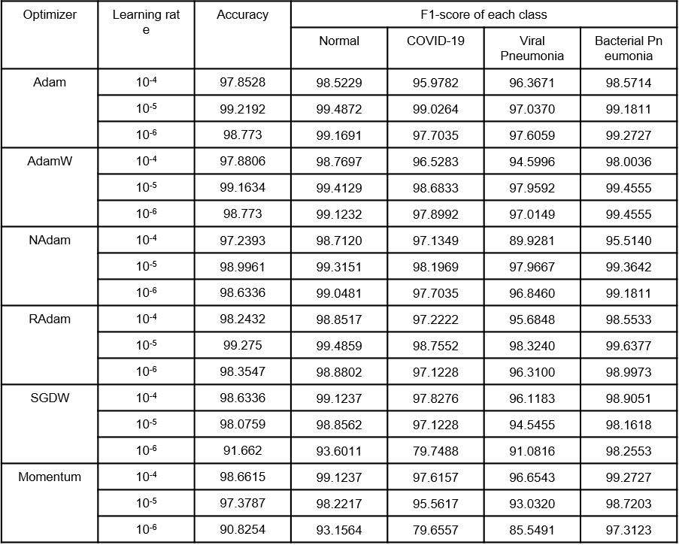
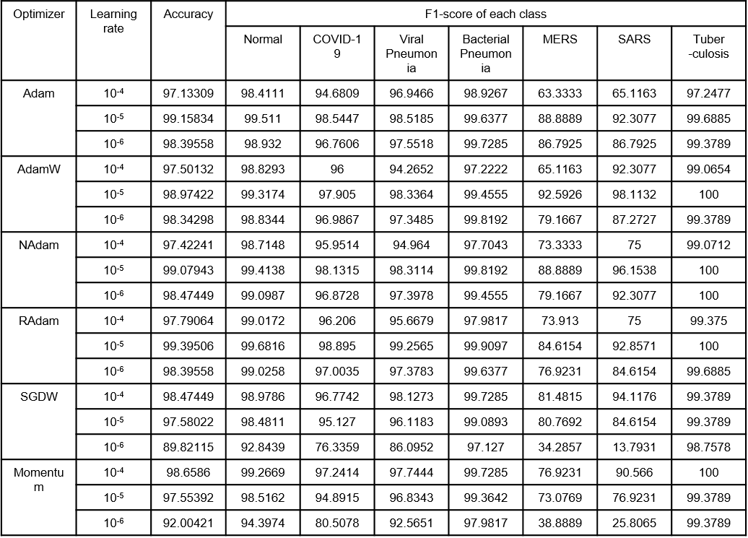
Supplementary Table 1.
b. 7 Class Dataset
a. 4 Class Dataset

