Fig S1. QQ plot for pleiotropy analysis.
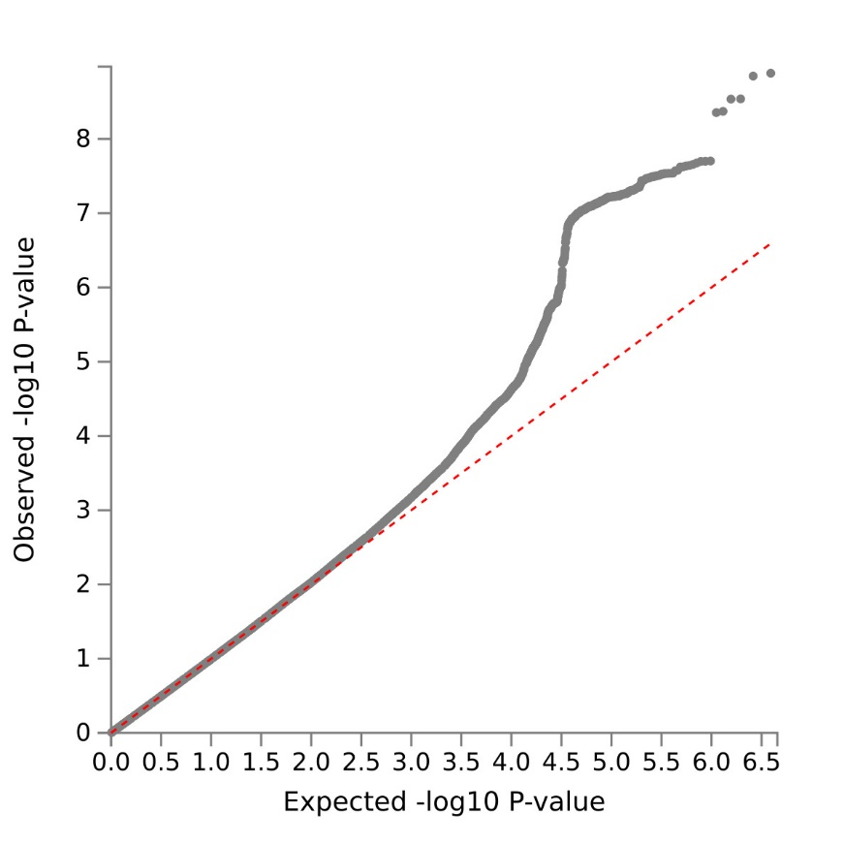

Fig S2. Summary of basic information for each genome risk locus.
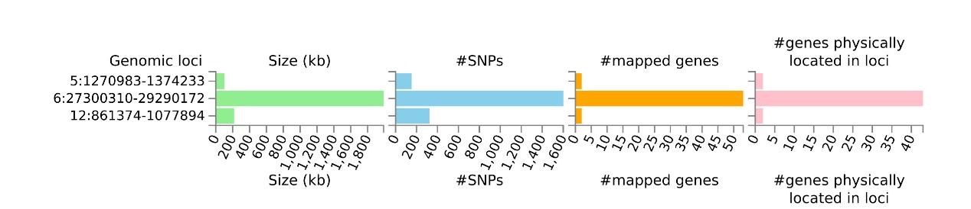

Fig S3. Functional impact of pleiotropic SNPs on genes.
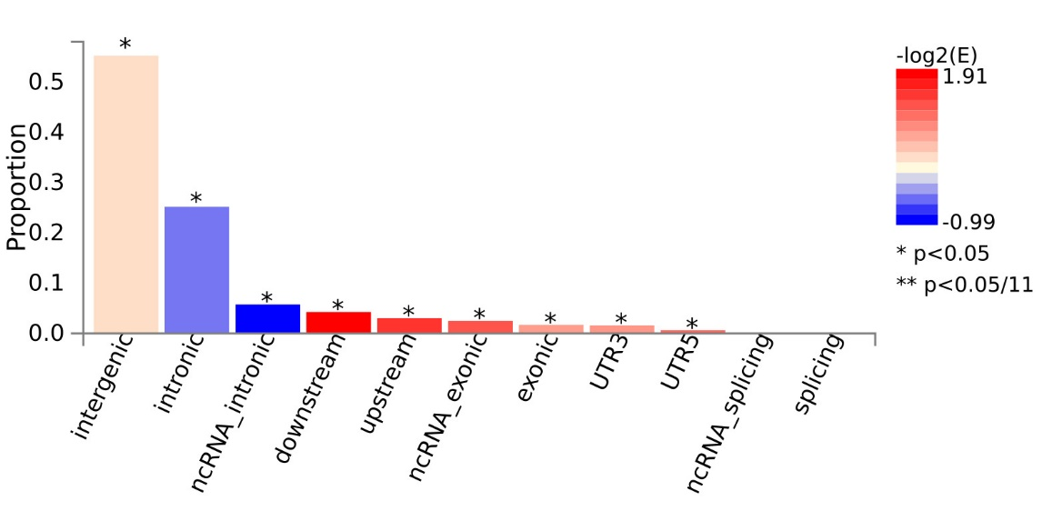

Fig S4. Regional plot for locus (5:1307910:A:G).
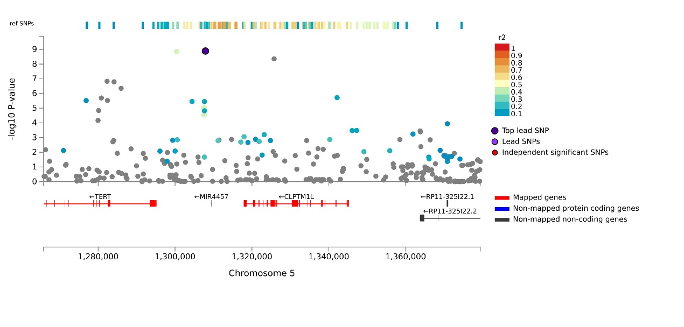

Fig S5. Regional plot for locus (6:28290328:G:T).
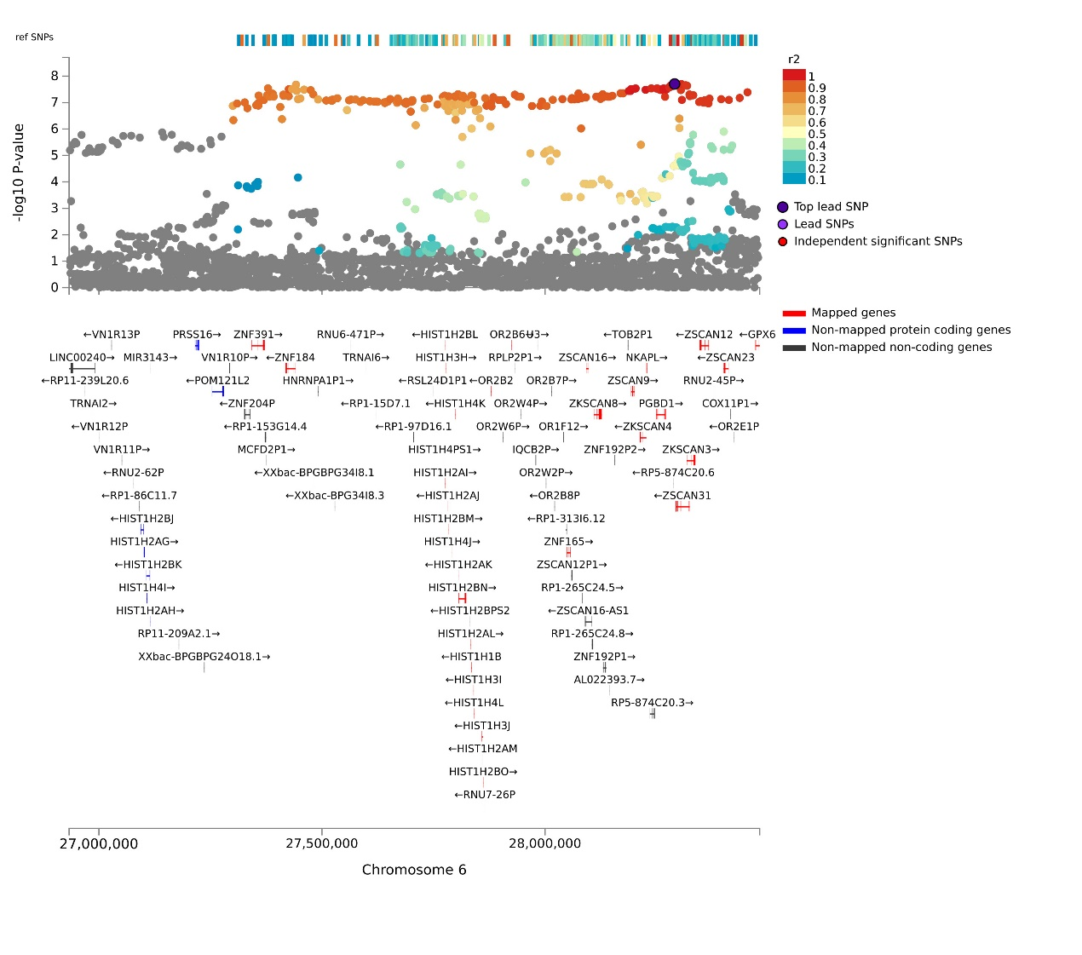

Fig S6. Regional plot for locus (12:1002857:C:T).
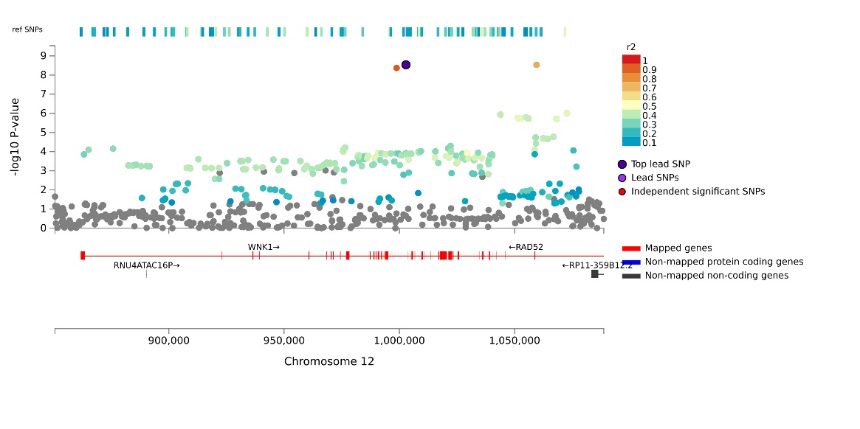Figure Fig S7. Manhattan plot for MAGMA gene analysis.
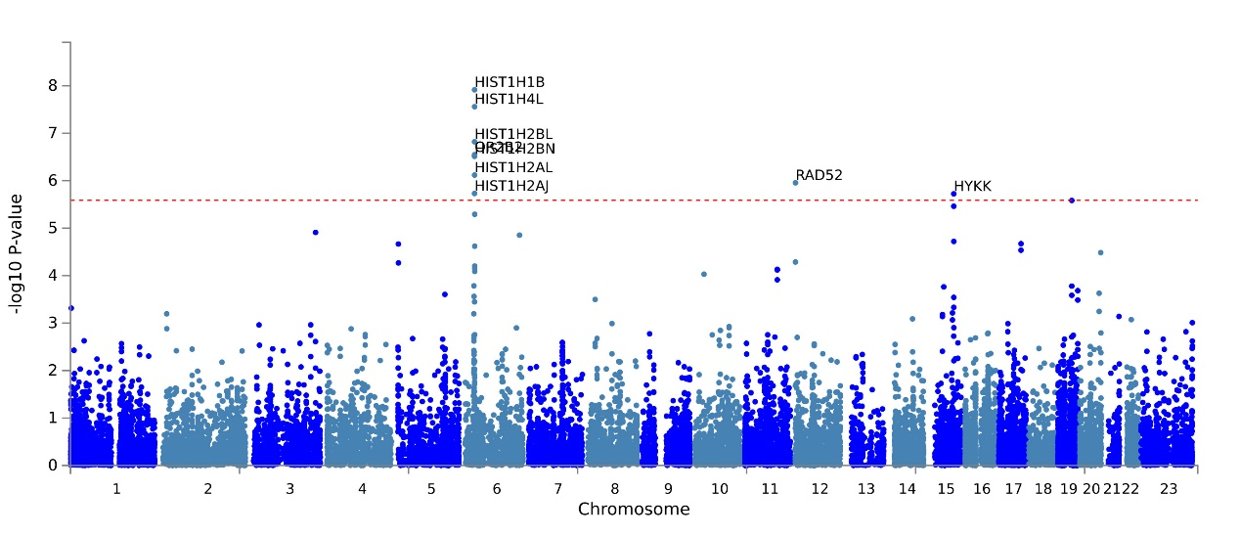
Fig S8. QQ plot for MAGMA gene analysis.
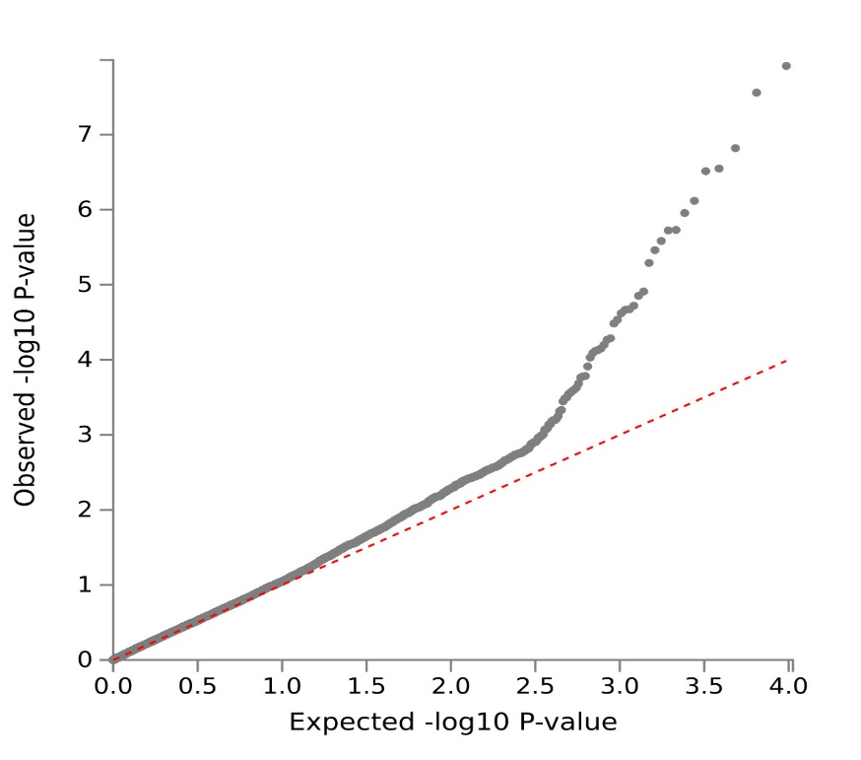
Fig S9. Expression profile of pleiotropic MAGMA genes in different tissues.
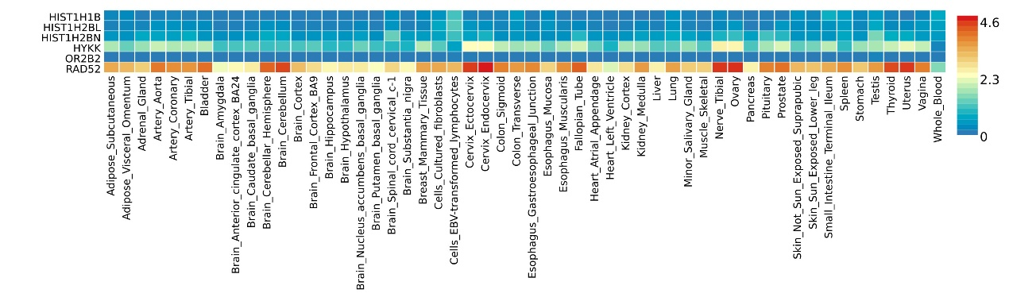

Fig S10. Pathway enrichment of pleiotropic MAGMA genes (GO:BP).
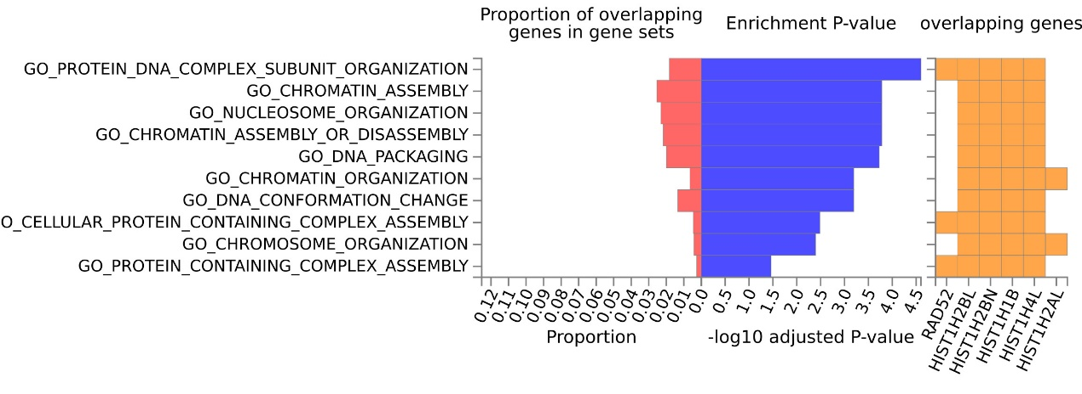

Fig S11. Pathway enrichment of pleiotropic MAGMA genes (GO:CC).
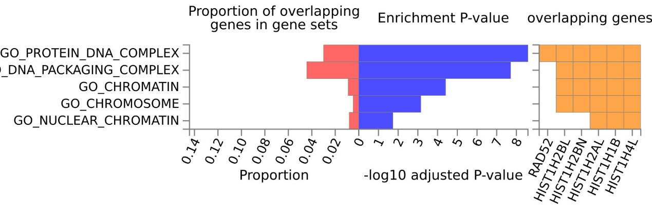

Fig S12. Pathway enrichment of pleiotropic MAGMA genes (GO:MF).
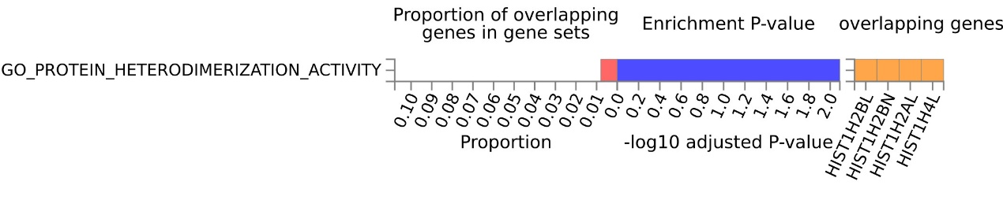

Fig S13. Pathway enrichment of pleiotropic MAGMA genes (immune-related pathways).
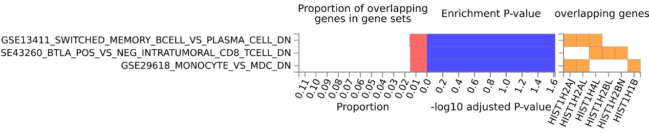
Fig S14. Expression profile of pleiotropic eQTL genes in different tissues.
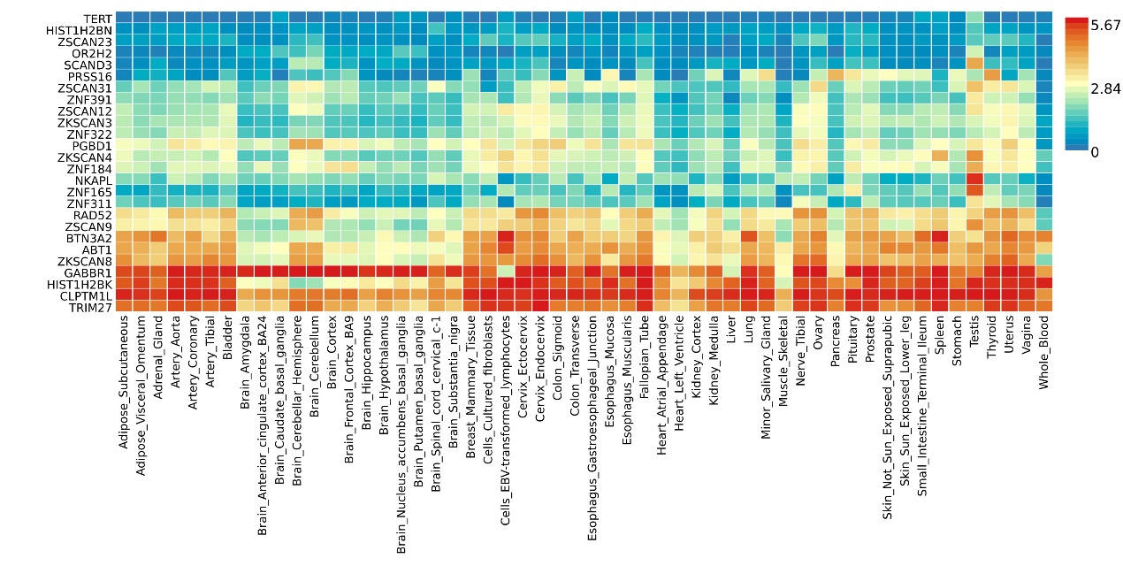

Fig S15. Tissue-specific enrichment analysis based on pleiotropic eQTL genes.
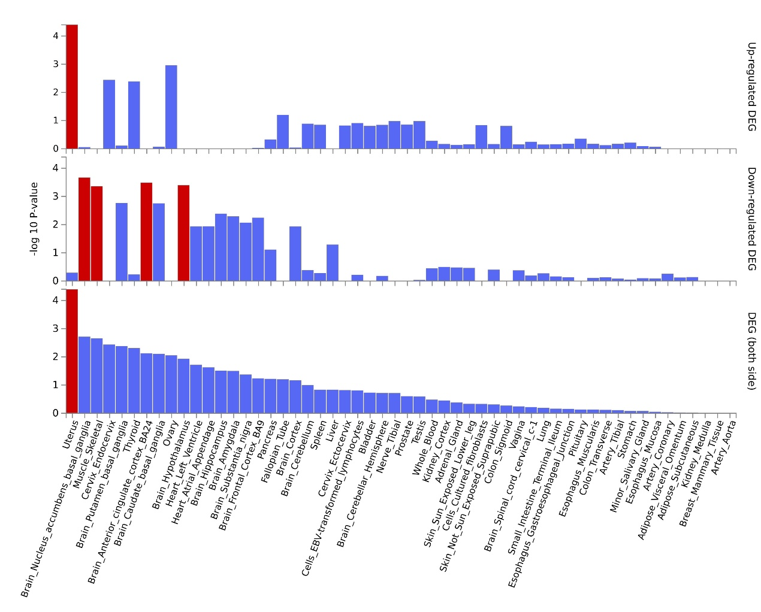
Fig S16. Pathway enrichment of pleiotropic eQTL genes.
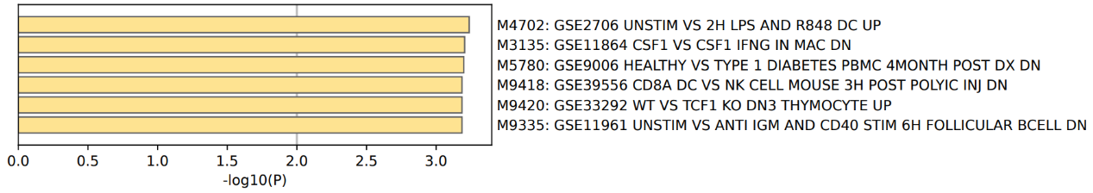

Fig S17. Protein-protein interaction (PPI) network analysis of pleiotropic eQTL genes.
Fig S18. Genetic Loci on Chromosomes.
Fig S19. ssGSEA on each KEGG pathway.

