Design on Modified Glass Fiber Separator by Ball-milled Tin Fluoride (SnF₂) particles for Zn Metal Anodes with High Reversibility
Huaijun Zhangª, Hengyu Yangª, Banghui Wuª, Yongle Liangª, Wentao Niª, Guobao Xu^{b}, Liwen Yang ^{a*}
ª School of Physics and Optoelectronics, Xiangtan University, Hunan, 411105, China
^{b} School of Materials Science and Engineering, Xiangtan University, Hunan, 411105,
China

Fig.S1 (a) SEM image of commercial SnF₂ powder; (b) SEM images of SnF₂@GF separator; (c) Digital image of GF separator (left) and SnF₂@GF separator (right).

Fig.S2 The electrochemical performance tests of Zn||Zn symmetric cells with different concentration loading (0 mg cm⁻², 0.5 mg cm⁻², 1 mg cm⁻² and 2 mg cm⁻²) after SnF₂ modifying at the working condition of 1 mA cm⁻² and 1mAh cm⁻².


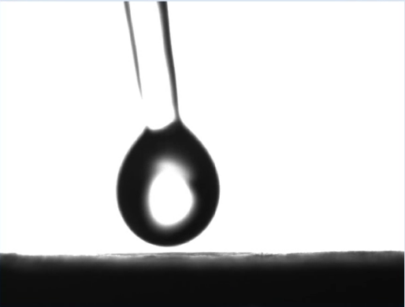


GF
SnF₂@GF

Fig.S3 Digital photos about the contact angles test of water dropped over GF and SnF₂@GF separator.

Fig.S4 The SEM images of polished Zn anodes.

Fig.S5 XRD pattern of as-prepared MnO₂ cathode material.

Fig.S6 The corresponding charge/discharge curves of GF separators recorded at different current densities.

Table S1. The comparison of our results with the reported separators modified by
different materials.

Zn anode | Current density  (mA cm⁻²) | Areal  capacity  (mAh cm⁻²) | Cycle  life (h) | Ref.
VG | 1 | 1 | 250 | ^{[1]}
VG | 5 | 5 | 80 | ^{[1]}
g-C₃N₄/GF separators | 1 | 1 | 600 | ^{[2]}
g-C₃N₄/GF separators | 5 | 1 | 870 | ^{[2]}
MXene | 1 | 1 | 1180 | ^{[3]}
MXene | 5 | 1 | 1200 | ^{[3]}
Zn@ZnF₂-Sn | 1 | 1 | 700 | ^{[4]}
Zn@ZnF₂-Sn | 5 | 1 | 700 | ^{[4]}
g-C₃N₄/cellulose fiber separator | 3 | 1 | 590 | ^{[5]}
g-C₃N₄/cellulose fiber separator | 5 | 1 | 320 | ^{[5]}
SnF₂@GF | 1 | 1 | 1400 | This work
SnF₂@GF | 5 | 1 | 1000 | This work

Supporting References

[1] D. Han, S. Wu, S. Zhang, Y. Deng, C. Cui, L. Zhang, Y. Long, H. Li, Y. Tao, Z. Weng, Q. H. Yang, F. Kang, Small 2020, 16, 2001736.
[2] L. S. Wu, Y. Zhang, P. Shang, Y. F. Dong, Z. S. Wu, Journal of Materials Chemistry A 2021, 9, 27408-27414.
[3] Y. W. Su, B. Z. Liu, Q. H. Zhang, J. Peng, C. H. Wei, S. Li, W. P. Li, Z. K. Xue, X. Z. Yang, J. Y. Sun, Advanced Functional Materials 2022, 32, 2204306.
[4] C.-L. Xu, J.-H. Li, Y.-H. Feng, B. Yuan, J. Liu, M. Liu, F. Shen, P.-F. Wang, X. Han, Journal of Power Sources 2022, 548, 232044.
[5] Y. Yang, T. Chen, B. Yu, M. Zhu, F. Meng, W. Shi, M. Zhang, Z. Qi, K. Zeng, J. Xue, Chemical Engineering Journal 2022, 433, 134077.

