Supplementary materials A
Table A1: Linear models summarising the effect of fishing intensity on Carbon and Nitrogen isotope ratios of plasma and scale in H. curtus and H. schistosus
Species | Tissue type | Isotope | Parameter | Coefficient | Standard Error | T | p | r_{adj}²
Hydrophis curtus | Plasma | δN¹⁵ | Intercept | 13.866 | 0.234
Hydrophis curtus | Plasma | δN¹⁵ | Fishing intensity | -0.003 | 0.003 | -0.835 | 0.418 | -0.021
Hydrophis curtus | Plasma | δC¹³ | Intercept | -15.665 | 0.404
Hydrophis curtus | Plasma | δC¹³ | Fishing intensity | -0.017 | 0.006 | -3.149 | 0.007 | 0.373
Hydrophis curtus | Scales | δN¹⁵ | Intercept | 14.331 | 0.295
Hydrophis curtus | Scales | δN¹⁵ | Fishing intensity | 0.000 | 0.003 | -0.018 | 0.986 | -0.048
Hydrophis curtus | Scales | δC¹³ | Intercept | -15.010 | 0.324
Hydrophis curtus | Scales | δC¹³ | Fishing intensity | 0.003 | 0.004 | 0.958 | 0.349 | -0.004
Hydrophis schistosus | Plasma | δN¹⁵ | Intercept | 14.684 | 0.260
Hydrophis schistosus | Plasma | δN¹⁵ | Fishing intensity | 0.001 | 0.004 | 0.195 | 0.846 | -0.025
Hydrophis schistosus | Plasma | δC¹³ | Intercept | -16.577 | 0.256
Hydrophis schistosus | Plasma | δC¹³ | Fishing intensity | -0.001 | 0.004 | -0.294 | 0.770 | -0.024
Hydrophis schistosus | Scales | δN¹⁵ | Intercept | 14.864 | 0.363
Hydrophis schistosus | Scales | δN¹⁵ | Fishing intensity | 0.000 | 0.006 | -0.075 | 0.940 | -0.029
Hydrophis schistosus | Scales | δC¹³ | Intercept | -14.079 | 0.377
Hydrophis schistosus | Scales | δC¹³ | Fishing intensity | -0.009 | 0.006 | -1.347 | 0.187 | 0.023

Supplementary Materials B
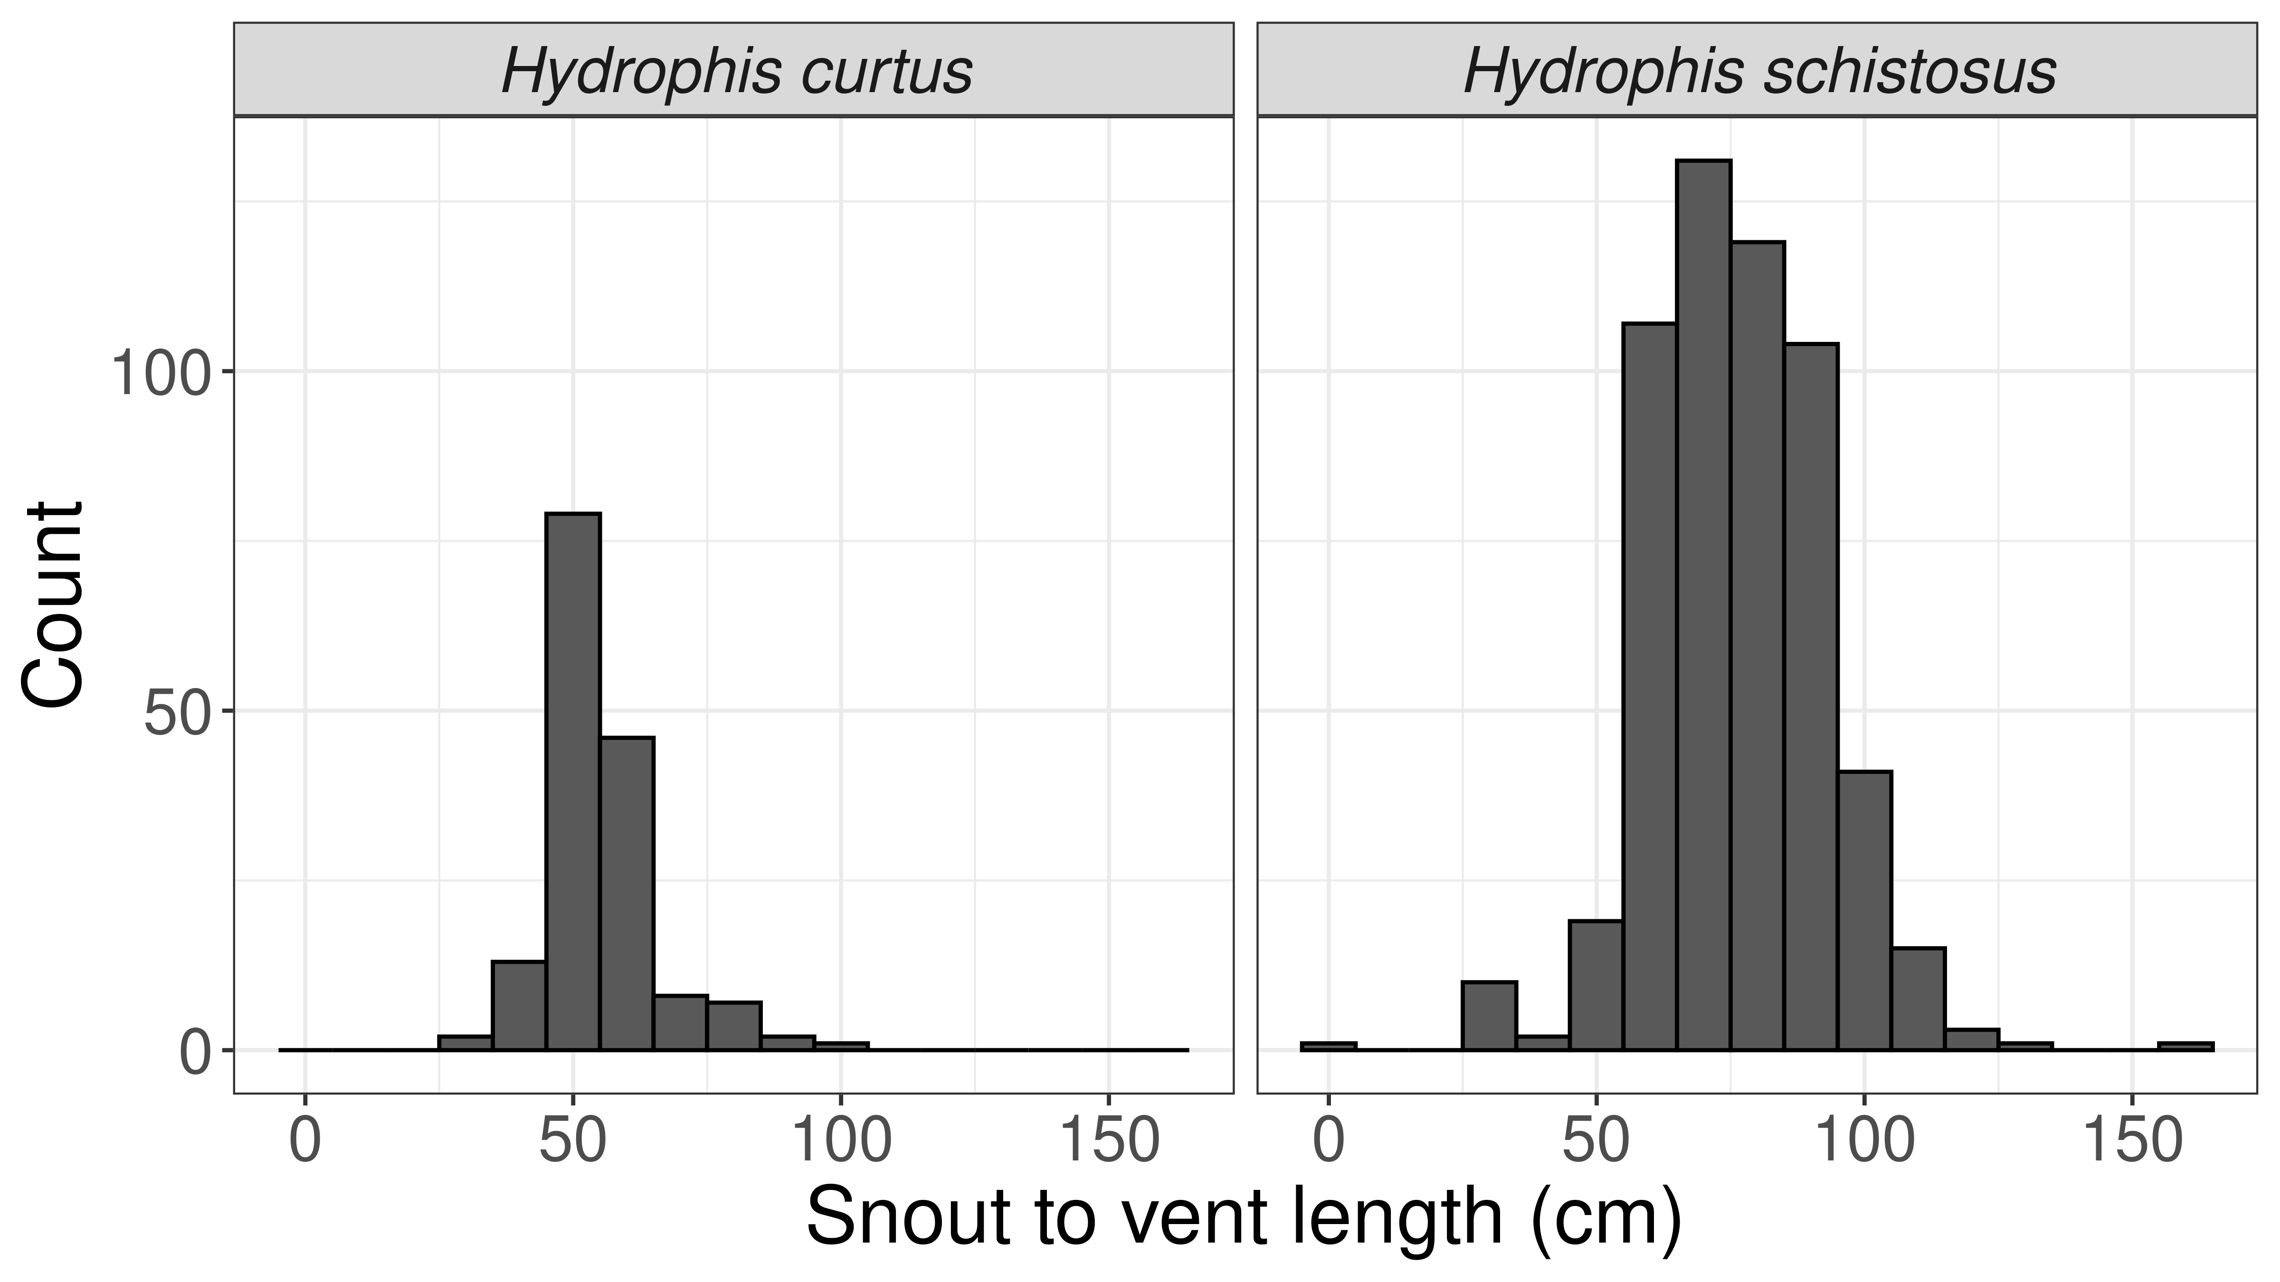
Fig B1: Snout to vent length (cm) distribution of sampled sea snakes.

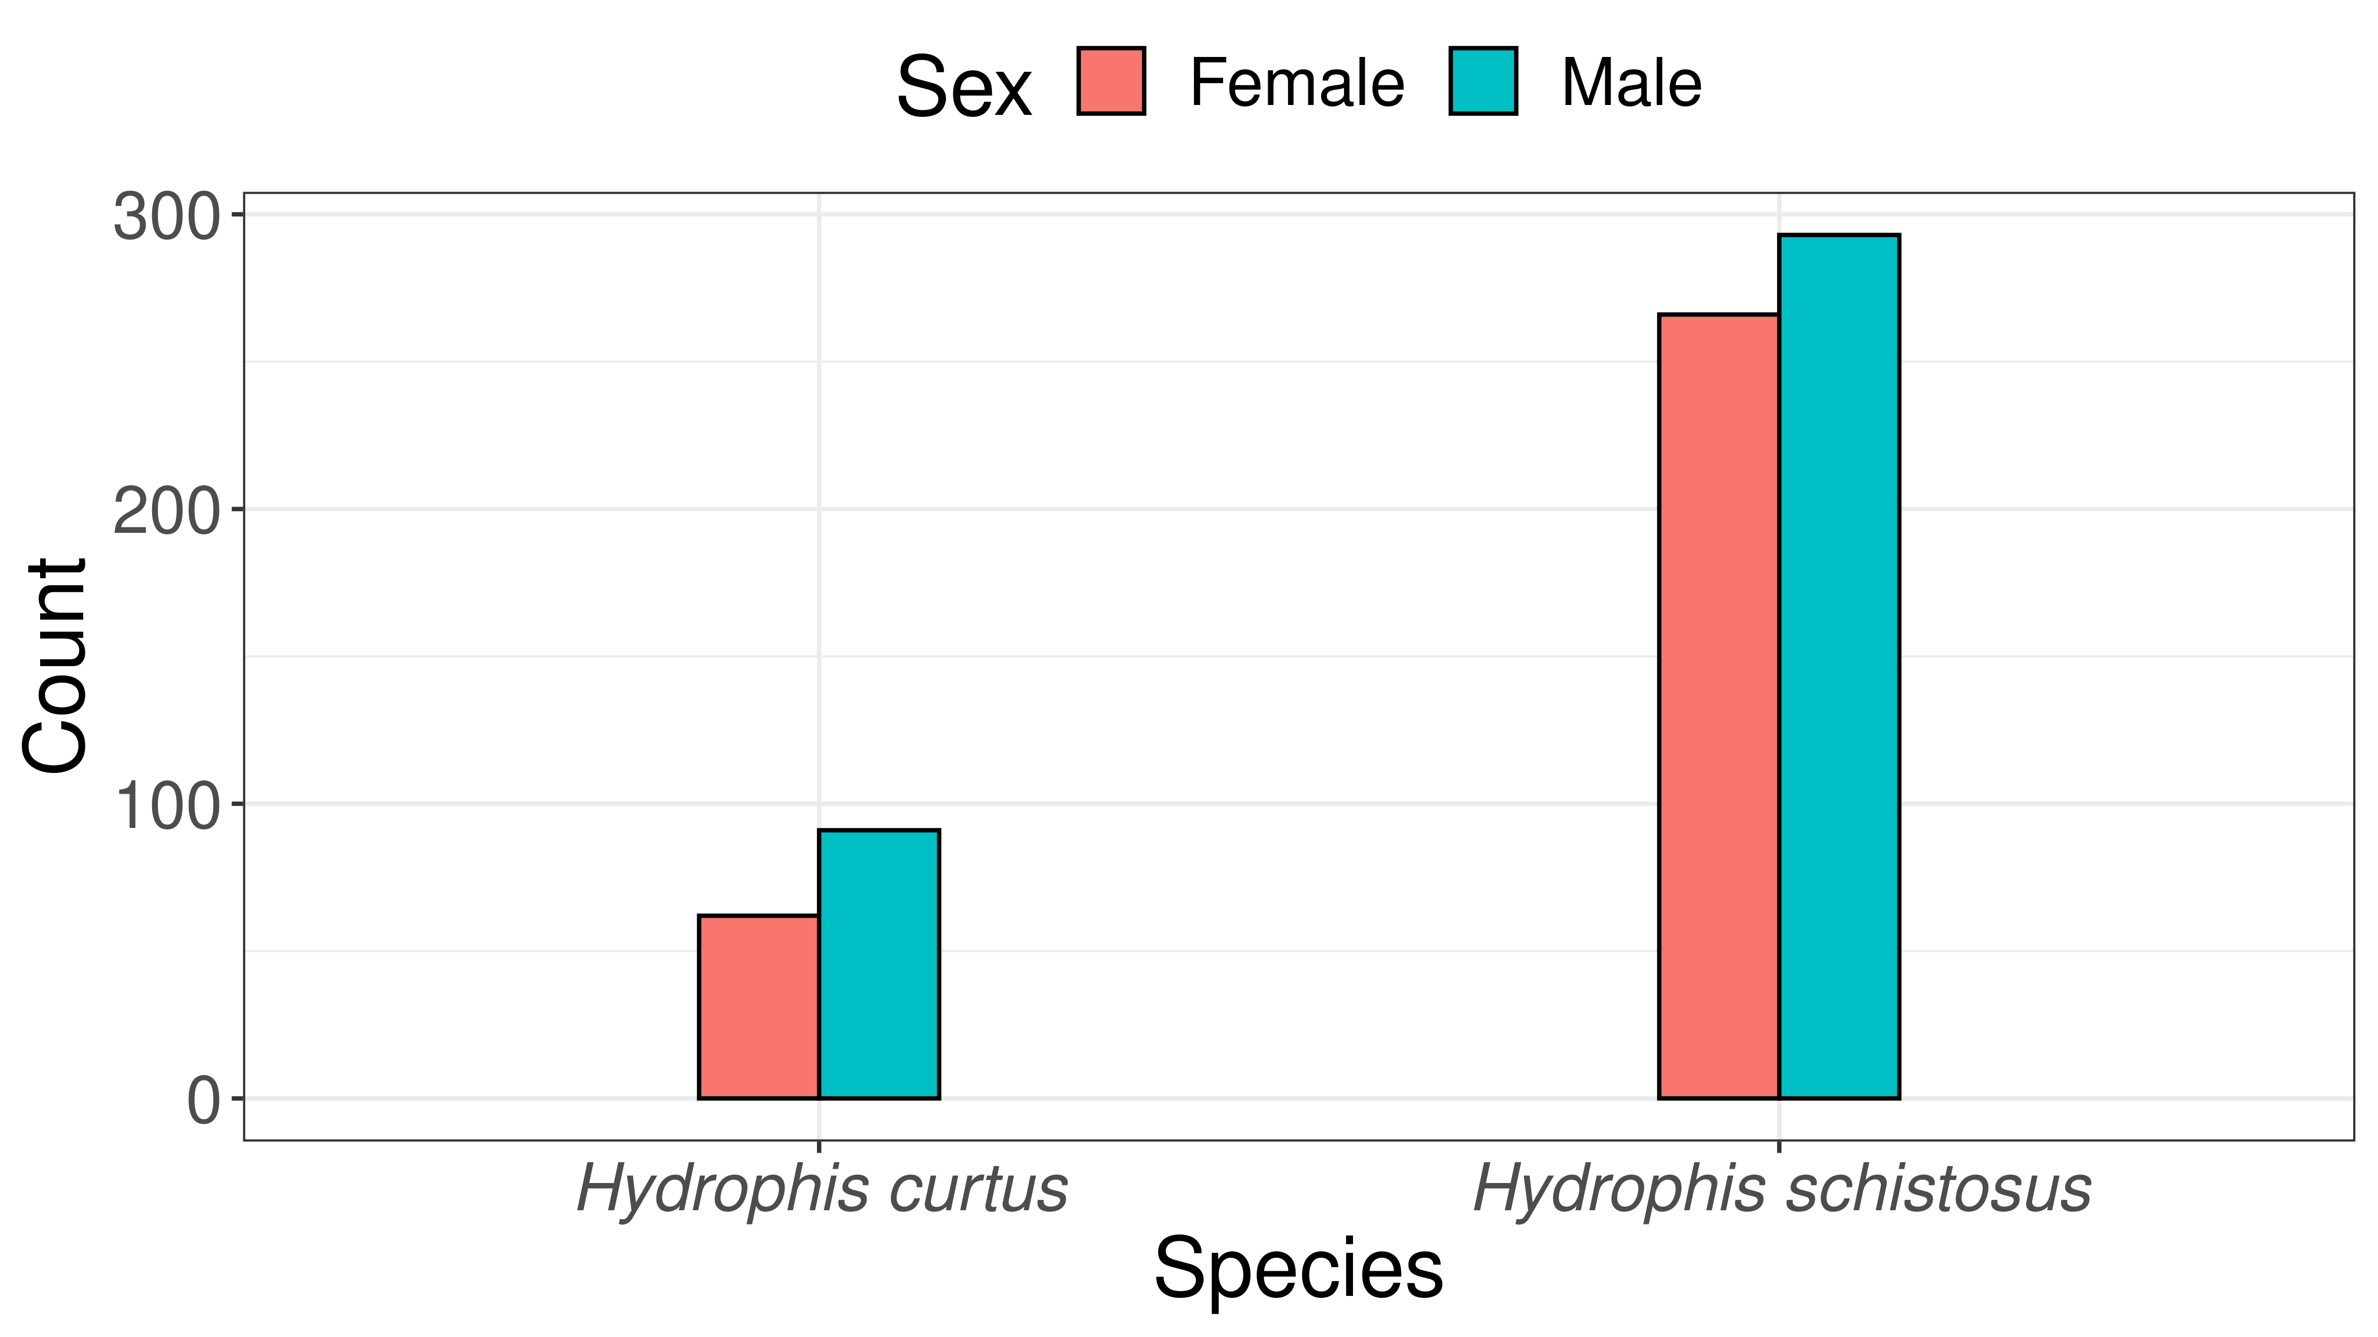
Fig B2: Distribution of males and females among sampled sea snake species.
Supplementary Materials C
We compared prey preference and overlap across sexes in Hydrophis curtus and H. schistosus. Sample sizes (number of prey specimens) were too small for further analysis.
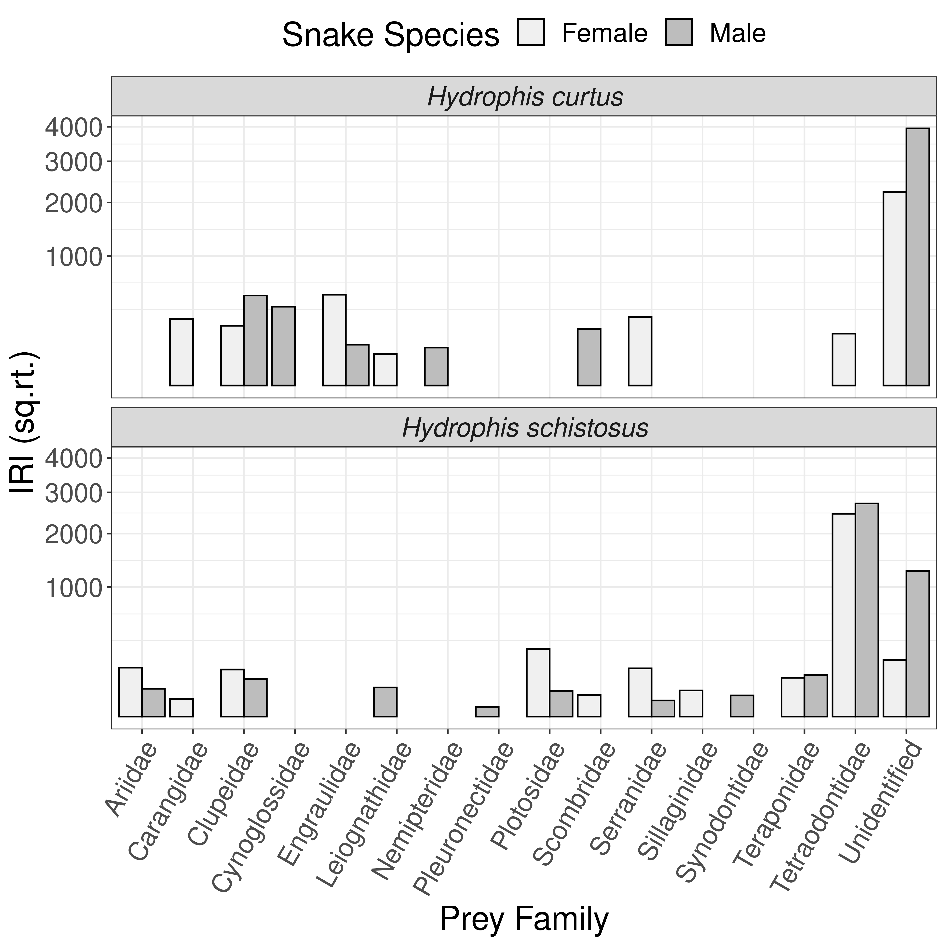
Fig C1: Preferences among males and females of Hydrophis curtus and H. schistosus.
Table C1: Richness of prey species and prey families taken by males and females of sampled sea snake species.
Snake Species | Sex | Prey Species | Prey Families | Overlap
Hydrophis curtus | Female | 6 | 6 | 2
Hydrophis curtus | Male | 4 | 5 | 2
Hydrophis schistosus | Female | 12 | 9 | 6
Hydrophis schistosus | Male | 10 | 9 | 6

Supplementary Materials D
A comparison of gut content data across locations using data collated by Sherratt et al. (2018) from Malaysia (Voris and Voris, 1983) and Australia (Fry et al., 2001).
Table D1: Richness of prey families found in sea snake guts in current and previous studies.
Snake species | Location | Reference | Richness | Sample size
Hydrophis curtus | Australia | Fry et al. (2001) | 18 | 118
Hydrophis curtus | Malaysia | Voris and Voris (1983) | 33 | 130
Hydrophis curtus | India | Dsouza et al. (Current) | 9 | 35
Hydrophis schistosus | Malaysia | Voris and Voris (1983) | 9 | 172
Hydrophis schistosus | India | Dsouza et al. (Current) | 12 | 89

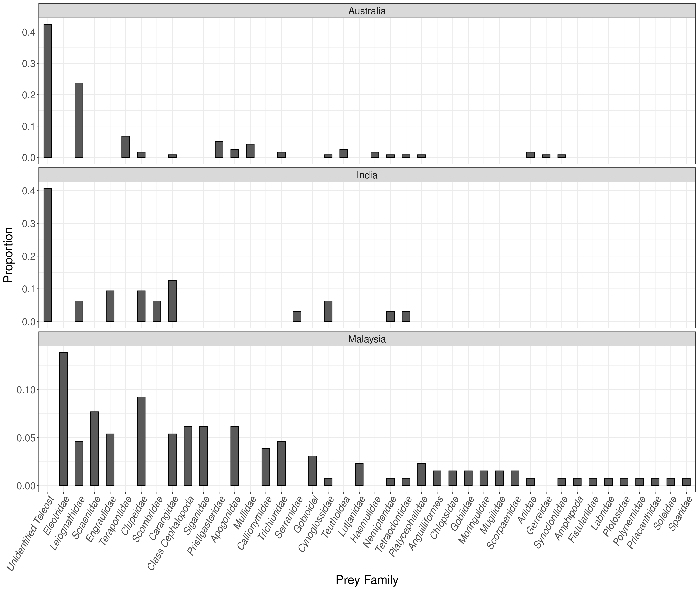
Fig D1: Relative proportions of prey families in Hydrophis curtus gut content as reported in the current study (India), Fry et al. (2001, Australia) and Voris and Voris (1983, Malaysia).
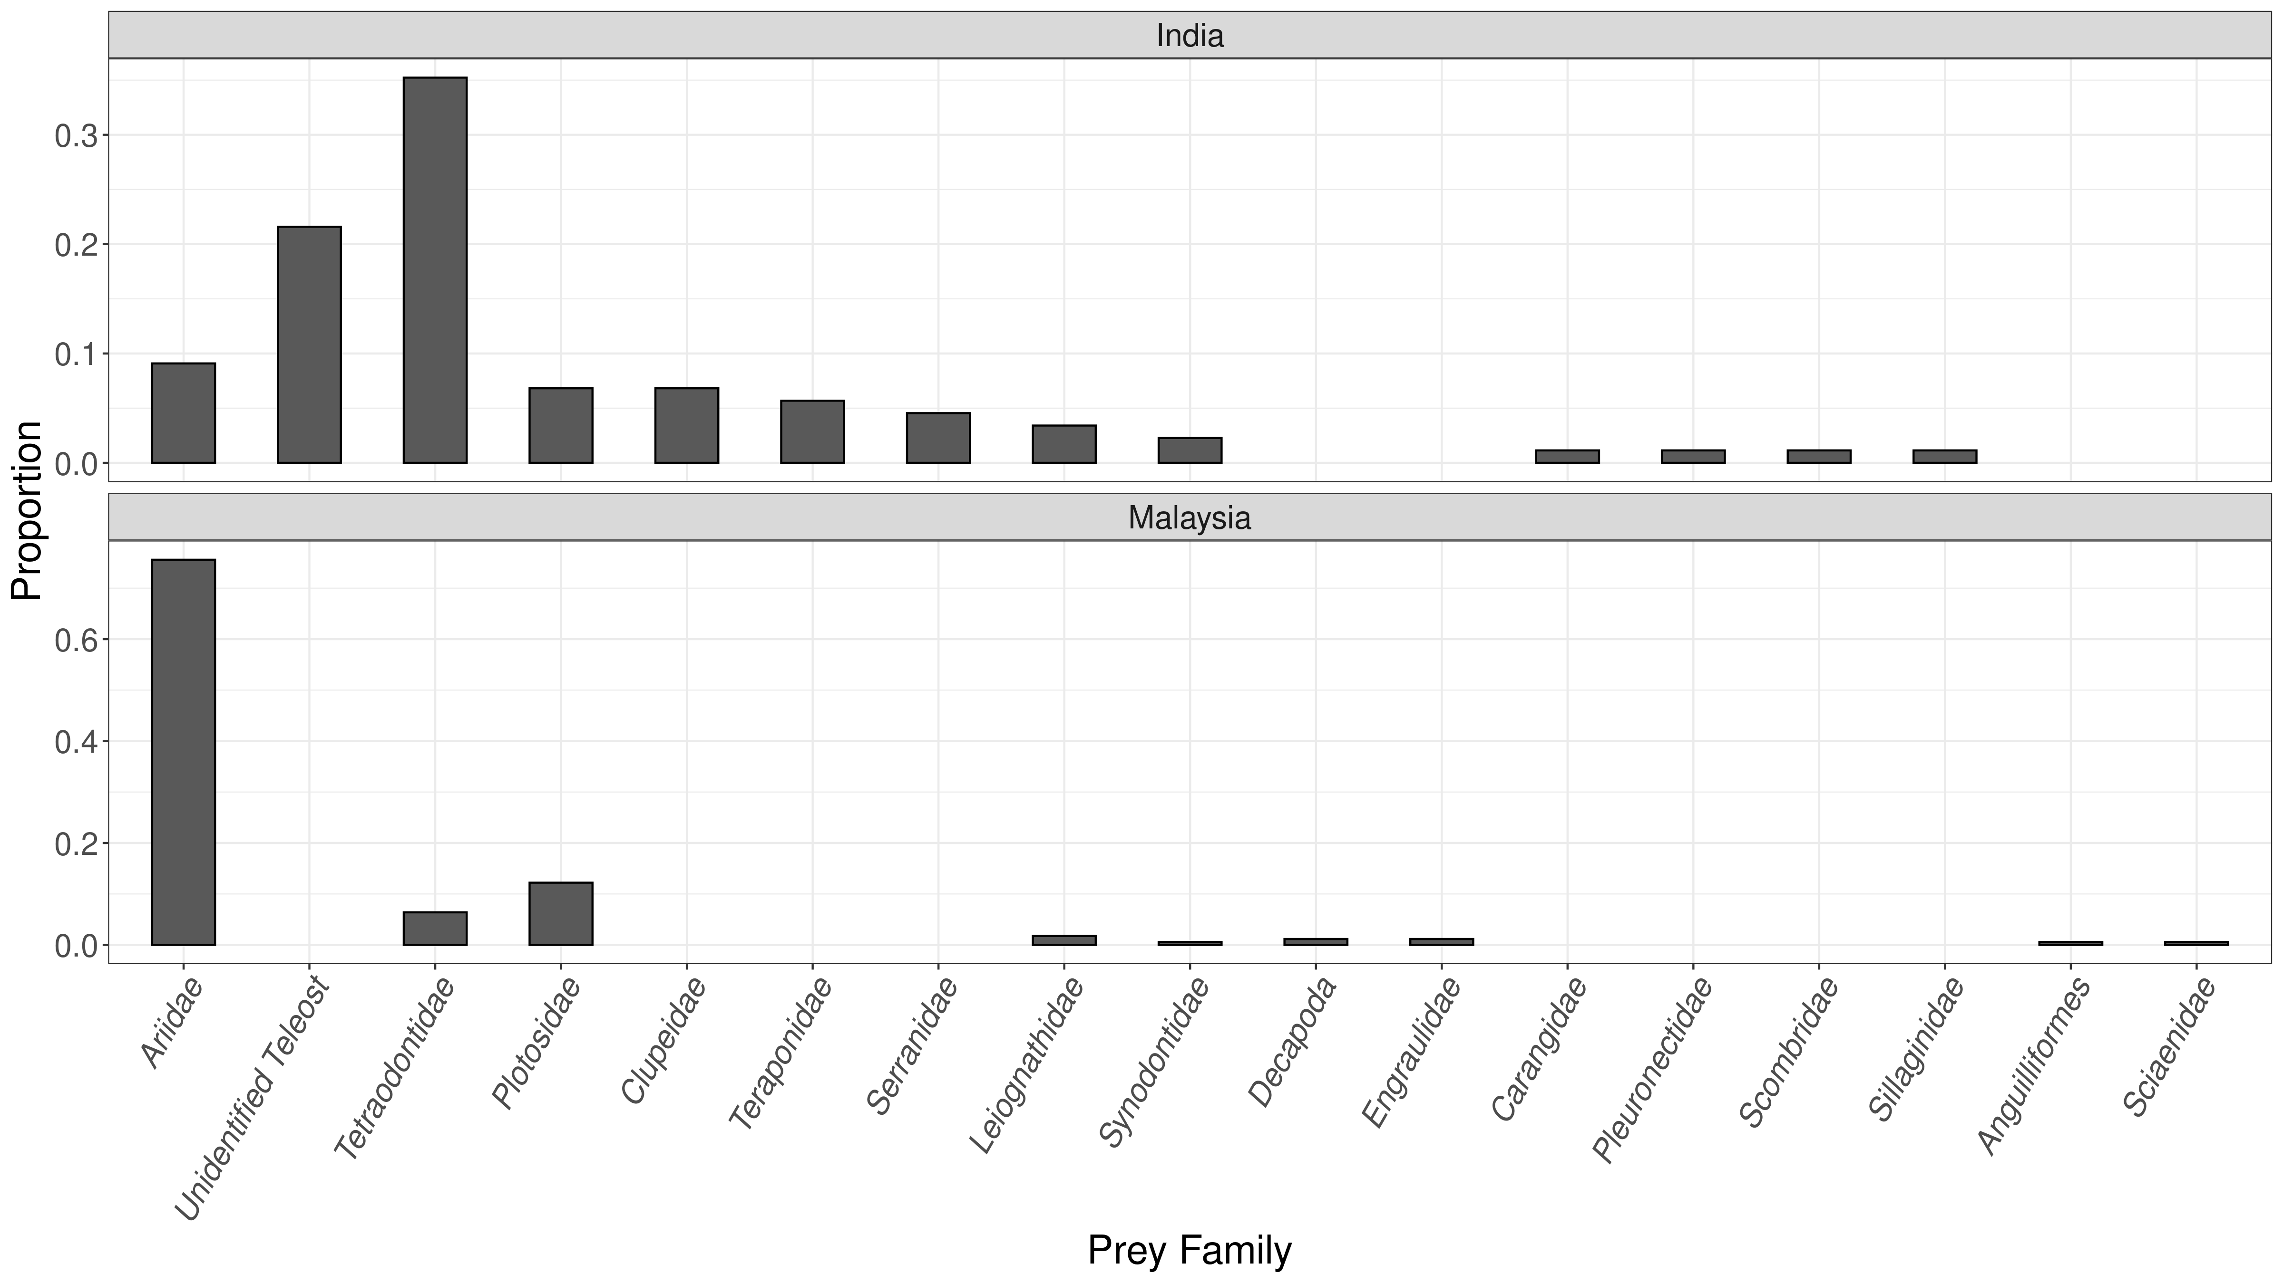
Fig D2: Relative proportions of prey families in Hydrophis schistosus gut content as reported in the current study (India) and Voris and Voris (1983, Malaysia).

