SUPPLEMENTAL MATERIAL

Definitions
STEMI was defined as persistent chest pain that lasted at least 30 minutes, arrival at the hospital within 12 hours from symptom onset, 12-lead electrocardiogram changes (ST-segment elevation of >0.1 mV in continuous leads or new-onset left bundle branch block), and elevation of cardiac biomarkers (creatine kinase-MB or troponin T/I) [1]. DM was identified by a combination of strategies including patients reporting a history of diabetes mellitus, hemoglobin A1c (HbA1c) ≥6.5%, , and/or fasting blood glucose ≥126 mg/dL, and/or the use of diabetes medication [2-5]. Hypertension was defined as systolic BP of 140 mm Hg or greater, diastolic BP of 90 mm Hg or greater, or use of antihypertensive medications [6]. Kidney disease was defined as an eGFR less than 60 mL/min/1.73 m² on at least 2 consecutive visits, microalbuminuria (AER 30 mg per 24 hours on 2 consecutive visits), or macroalbuminuria (AER 300 mg per 24 hours) [7].
Cardiac death was defined as death from myocardial infarction, cardiac perforation or pericardial tamponade, arrhythmia or conduction abnormalities, procedural complications, or any death in which a cardiac cause could not be excluded. Ischemia-driven revascularization was defined as either repeat percutaneous or surgical revascularization with ischemic symptoms for the target lesion identified at index procedure or non-target lesions. Scheduled revascularization for lesions that were identified in the index coronary angiograms was not considered as an adverse event. UAP were evaluated according to Braunwald Unstable Angina Classification. Non-fatal MI was diagnosed by the detection of raise and fall of cardiac biomarkers (preferably troponin) above the 99th centile of the upper reference limit, together with evidence of myocardial ischemia with at least one of the following criteria: ischemic symptoms; ECG changes indicative of new ischemia (new ST-T changes or new left bundle branch block); development of pathological Q waves in the ECG; and imaging evidence of new loss of viable myocardium or new regional wall motion abnormalities [8].

References
- Fang C, Yin Y, Jiang S, Zhang S, Wang J, Wang Y, et al. Increased Vulnerability and Distinct Layered Phenotype at Culprit and Nonculprit Lesions in STEMI Versus NSTEMI. JACC Cardiovasc Imaging. 2022;15:672-681. https://doi:10.1016 /j.jcmg.2021.07. 022
- Hamid A, Yimer WK, Oshunbade AA, Kamimura D, Clark D 3rd, Fox ER, et al. Impact of Diabetes and Hypertension on Left Ventricular Structure and Function: The Jackson Heart Study. J Am Heart Assoc. 2023;12:e026463. https://doi:10.1161 /JAHA.122. 026463
- Wang L, Li X, Wang Z, Bancks MP, Carnethon MR, Greenland P, et al. Trends in Prevalence of Diabetes and Control of Risk Factors in Diabetes Among US Adults, 1999-2018. JAMA. 2021;326(8):1-13. https://doi: 10.1001/jama.2021.9883.
- Li N, Zhou J, Chen R, Zhao X, Li J, Zhou P, Liu C, Chen Y, Wang Y, Song L, Yan S, Zhao H, Yan H. Prognostic impacts of diabetes status and lipoprotein(a) levels in patients with ST-segment elevation myocardial infarction: a prospective cohort study. Cardiovasc Diabetol. 2023;22(1):151. https://doi: 10.1186/s12933-023 -01881-w.
- Song L, Zhao X, Chen R, Li J, Zhou J, Liu C, et al. Association of PCSK9 with inflammation and platelet activation markers and recurrent cardiovascular risks in STEMI patients undergoing primary PCI with or without diabetes. Cardiovasc Diabetol. 2022;21(1):80. https://doi: 10.1186/s12933-022-01519-3.
- Castañer O, Pintó X, Subirana I, Amor AJ, Ros E, Hernáez Á, et al. Remnant Cholesterol, Not LDL Cholesterol, Is Associated With Incident Cardiovascular Disease. J Am Coll Cardiol. 2020;76(23):2712-2724. https://doi: 10.1016/j.jacc.2020.10.008.
- Braffett BH, Bebu I, El Ghormli L, Cowie CC, Sivitz WI, Pop-Busui R, et al. Cardiometabolic Risk Factors and Incident Cardiovascular Disease Events in Women vs Men With Type 1 Diabetes. JAMA Netw Open. 2022;5(9):e2230710. https://doi: 10.1001/jamanetworkopen.2022.30710.
- Fang C, Yin Y, Jiang S, Zhang S, Wang J, Wang Y, et al. Increased Vulnerability and Distinct Layered Phenotype at Culprit and Nonculprit Lesions in STEMI Versus NSTEMI. JACC Cardiovasc Imaging. 2022;15(4):672-681. https://doi: 10.1016/j.jcmg.2021.07.022.

Supplemental Figure 1
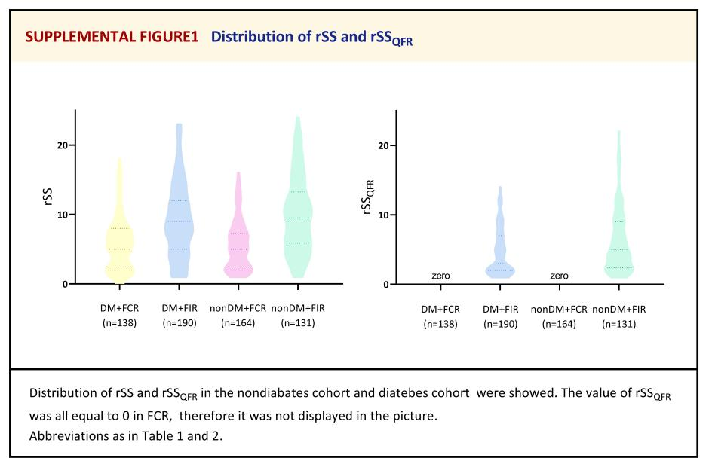

Supplemental Figure 2
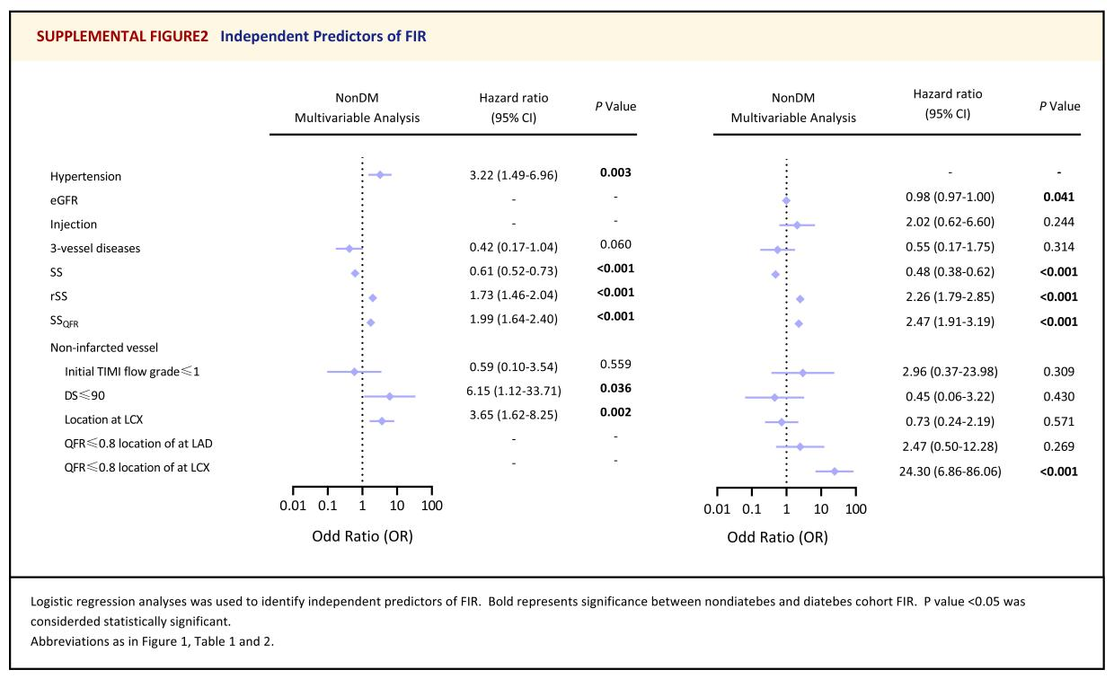

Supplemental Figure 3
