Extended Data Figures

Extended Data Figure 1. Selected provinces (i.e., those where we collected survey data or leaf samples; in red) for assessing K deficiencies in rice-maize systems in Indonesia: North Sumatra (NSU), South Sumatra (SSU), Lampung (LAM), West Java (WJA), Central Java (CJA), East Java (EJA), South Kalimantan (SKA), South Sulawesi (SUL), Gorontalo (GOR), and West Nusa Tenggara (WNT). Locations where survey data were collected are shown with green circles (n = 1147 field-years); included among them there is a subset of fields where crop nutrient status was determined via analysis of leaf nutrient concentration (n = 335 field-years). Triangles show location of on-farm fertility trials for rice (blue) and maize (yellow) whereas location of the rice long-term fertility experiment in WJA is shown with a star. Inset shows rice (green), maize (yellow), and overlapping of both crops area (red) as reported by SPAM2010 (IFPRI, 2019).

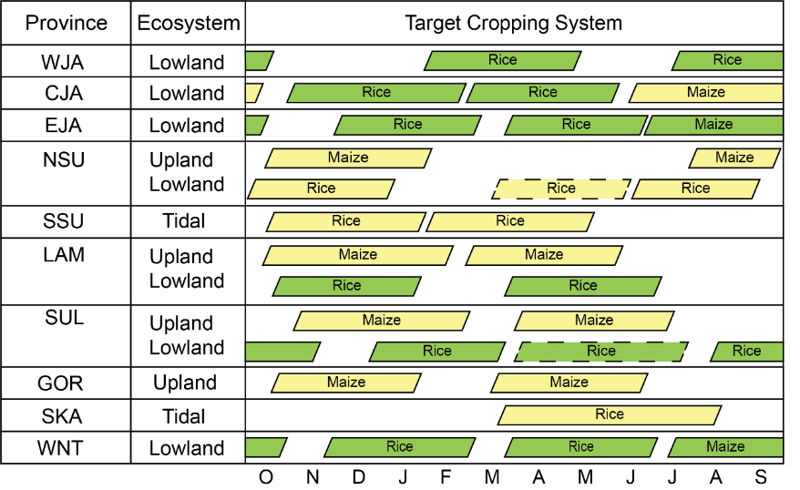

Extended Data Figure 2. Selected 13 rice-maize cropping systems in each province. Color indicates water regime: irrigated (green), and rainfed (yellow). In some double-rice crop systems, an additional third rice crop was planted in some fields (dashed boxes). See Figure 1 for full province names and geographical location.

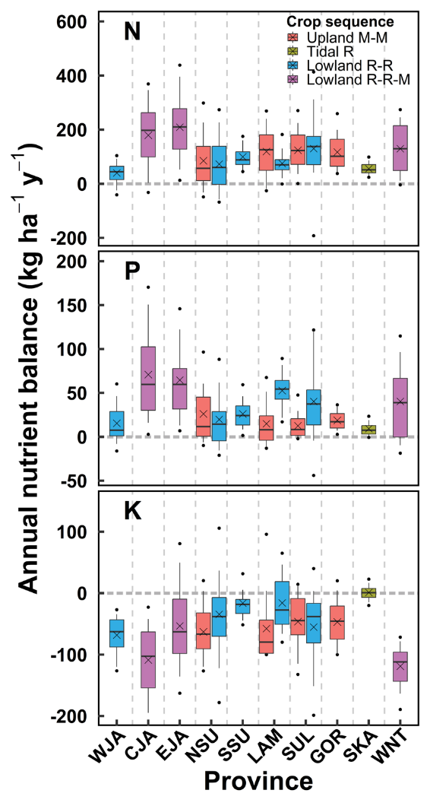
Extended Data Figure 3. Annual nitrogen (N), phosphorus (P), and potassium (K) balances by cropping sequence in Indonesia. The dominant crop systems in each province are shown, as determined by the environments (upland, lowland, tidal) and crop intensity (single, double, triple cropping) for rice (R) and maize (M). Boxes delimit first and third quartiles. Solid line inside the box indicates the median, while the cross represents the mean. The upper and lower end of vertical lines represents the 10 and 90th percentiles. The upper and lower points represent the 5 and 95th percentiles. Horizontal dashed line represents a zero-nutrient balance and is shown as a reference. See Extended Data Figure 1-2 for a map showing location of each province, associated full name, and dominant crop sequence.

Supplementary Information for Rizzo et al.

Section S1. Calculation of nutrient removal and losses………………………………………. 2
Section S2. Assessing strategies to increase K fertilizer rates…………………….………….. 3
Supplementary Table S1 …………………………….……………………………..………….. 5
Supplementary Table S2 …………………………….………………….………….………….. 6
Additional references associated with Supplementary Information…….………………….. 7

S1. Calculation of nutrient removal and losses

Nutrient removal with harvested grain per hectare was determined for each crop based on the grain dry matter (GDM) and associated nutrient concentration (GNC) as follows:

$H=GDM×GNC$ Eq. 4
The GNC used for rice were 0.0106 kg N per kg of GDM, 0.0021 kg P per kg of GDM, and 0.0027 kg K per kg of GDM¹. In the case of maize, the GNC used were 0.0106 kg N per kg of GDM, 0.0021 kg P per kg of GDM, and 0.0045 kg K per kg of GDM². We note that grain N removal depends mostly on yield rather than GNC; hence, variation in GNC will have a minor impact on our nutrient balances^{1,3}. Nutrient removal with straw was estimated based on grain yield and straw management, and published data on straw nutrient concentration (SNC) as follows:

$S=\left(\frac{GDM}{HI}–GDM\right)×SNC×FSL$ Eq. 5
where HI is grain harvest index (kg of grain per kg of total above-ground dry matter), SNC is the nutrient concentration in straw expressed in kg nutrient per kg of straw dry matter, and FSL is the fraction of total crop residue that is withdrawn from the field during harvest. We assumed an average HI of 0.5 (rice) and 0.45 (maize) based on Dobermann and Fairhurst¹ and Setiyono et al.². For rice, we assumed SNC to be 0.0063 kg N, 0.001 kg P, and 0.0139 kg K per kg of straw dry matter following Dobermann and Fairhurst¹. In the case of maize, we assumed 0.0059 kg N, 0.0006 kg, and 0.0143 kg K per kg of straw dry matter based on Setiyono et al.². Finally, we assumed FSL to be 0.9 when farmer reported straw removal from the field, and 0.5 when farmer reported that the straw was left in the field⁴. We note that even if straw is left in the field after harvest, a substantial fraction is lost due to animal feed, burning, and harvesting for other losses.

Following Dobermann et al.⁴, losses via leaching or burning of straw retained in the field were estimated based on the farmer-reported straw management:

$L=\left(\frac{GDM}{HI}–GDM\right)×SNC×\left(1-FSL\right)×FLB$ Eq. 6
where FLB is the fraction of nutrient loss via leaching or burning. When farmer reported straw burning, we assumed that 90%, 10% and 20% of the N, P, and K in straw remaining in the field was lost. If the straw that remained in the field was not burned, we assumed that only 10% of N and K would be lost and no P losses would occur⁴. Finally, based on our re-analysis of Pampolino et al.⁵ and Pasuquin et al.⁶ data, we assumed G to represent 40% (rice) and 22.5% (maize) of total N input via fertilizer and manure, which is consistent with data on N volatilization for rice and maize reported in the literature^{2,6,7}.

S2. Assessing strategies to increase K fertilizer rates

Fields exhibiting a nutrient balance >25 kg N and/or >5 kg P per ha per crop, were considered as fields with large N and/or P surplus(es). For this subset of fields, we estimated the cost saving (US$ per ha per crop) of reducing their N and/or P surpluses to their respective (i.e., 25 kg N and 5 kg P per ha per crop) as follows:

$Cost saving=(Nbal-25)×FNP+(Pbal-5)×FPP$ Eq. (7)
where Nbal and Pbal refers to the estimated N and P balances, respectively, and FNP is the average fertilizer N price (US$ per kg of elemental N), and FPP is the average fertilizer P price (US$ per kg of elemental P). In the case of fertilizer prices, we assumed a cost of 0.29 (N) and 0.94 (P) US$ per kg of elemental nutrient⁸. The amount of K fertilizer (kg K per ha per crop) that could be applied if the cost saving from reducing N and P surpluses would be reinvested into K fertilizer was calculated as follows:

$Additional K fertilizer=\frac{Cost saving}{FKP}$ Eq. (8)

where FKP is the price of K fertilizer (0.7 US$ per kg elemental K)⁸. We note that domestic prices for N and P are lower than international prices because the subsidy program includes urea and SP36, while MOP is not subsidized.

Following this ‘reinvestment’ strategy, based on reducing N and P surpluses and reinvesting the costs saving on K fertilizer, this subset of fields would have an average cost saving of US$ 23 per ha for both rice and maize. Reinvesting those savings in K fertilizer would allow those farmers to increase K fertilizer rates from current 33 and 39 kg K ha⁻¹ crop⁻¹ up to 65 and 72 kg K ha⁻¹ crop⁻¹ for rice and maize, respectively. In the short term, this strategy would change the K balance of those fields from -14 and -29 kg K ha⁻¹ crop⁻¹ to an average K balance of 19 and 3 kg K ha⁻¹ crop⁻¹ for rice and maize.

Finally, we also quantify the economic impact of doubling current K fertilizer rates via subsidies. To do so, we estimate the associated cost of MOP and current harvested rice and maize area.
Supplementary Table S1. Average nutrients inputs and nutrient removal per crop for each of the 13 cropping systems included in our study. Parenthetical values show the associated interquartile ranges. Nutrient input includes synthetic fertilizer and organic amendments. Overall averages across provinces are weighted based on their relative contribution of each province to the national harvested area of each crop. See Extended Data Figure 1 for province location and names, and Extended Data Figure 2 for description of the dominant cropping system in each province.

Province | Ecosystem | Crop | Yield  (t ha⁻¹ crop⁻¹) | Input  (kg ha⁻¹ crop⁻¹) |  |  | Removal  (kg ha⁻¹ crop⁻¹)
 |  |  |  | N | P | K | N | P | K
WJA | lowland | rice | 6.7  (2.6) | 142  (53) | 23  (15) | 26  (18) | 95  (39) | 16  (6) | 60  (26)
CJA | lowland | rice | 5.9  (2.1) | 180  (88) | 41  (29) | 36  (17) | 80  (27) | 14  (5) | 63  (24)
CJA | lowland | maize | 5.6  (2) | 187  (99) | 31  (22) | 36  (13) | 82  (29) | 13  (5) | 90  (42)
EJA | lowland | rice | 5.6  (2.5) | 188  (94) | 36  (24) | 56  (39) | 74  (29) | 14  (5) | 60  (27)
EJA | lowland | maize | 7.3  (2.5) | 220  (156) | 37  (25) | 57  (35) | 99  (38) | 16  (6) | 102  (42)
NSU | upland | maize | 5  (1.9) | 148  (81) | 24  (22) | 33  (24) | 72  (26) | 11  (4) | 64  (24)
NSU | lowland | rice | 5.6  (2.5) | 134  (101) | 22  (16) | 41  (30) | 77  (34) | 13  (6) | 57  (28)
SSU | tidal | rice | 3.3  (2.6) | 103  (52) | 21  (13) | 20  (13) | 42  (31) | 7  (6) | 28  (22)
LAM | upland | maize | 6.6  (3.1) | 188  (105) | 21  (14) | 42  (28) | 86  (40) | 14  (7) | 71  (19)
LAM | lowland | rice | 5  (2.1) | 123  (39) | 38  (12) | 37  (24) | 66  (29) | 12  (5) | 45  (20)
SUL | upland | maize | 3.6  (2.3) | 142  (94) | 14  (8) | 23  (13) | 48  (34) | 8  (5) | 46  (33)
SUL | lowland | rice | 4.9  (3.7) | 136  (117) | 27  (22) | 21  (16) | 62  (50) | 11  (9) | 42  (33)
GOR | upland | maize | 4.7  (2.6) | 165  (85) | 20  (10) | 37  (20) | 69  (39) | 10  (6) | 61  (34)
SKA | tidal | rice | 2.3  (1.4) | 91  (53) | 15  (11) | 22  (14) | 29  (20) | 5  (4) | 21  (16)
WNT | lowland | rice | 5.9  (1.9) | 159  (79) | 30  (28) | 22  (12) | 83  (29) | 14  (5) | 52  (17)
WNT | lowland | maize | 7  (2.1) | 183  (76) | 22  (18) | 28  (20) | 97  (21) | 15  (4) | 87  (23)
Overall average |  | rice | 5.5 | 151 | 30 | 35 | 74 | 13 | 53
 |  | maize | 6.3 | 194 | 29 | 44 | 86 | 14 | 85
Supplementary Table S2. Critical nutrient concentrations (%) for nitrogen (N), phosphorus (P), and potassium (K) reported in the literature for rice and maize based on measured nutrient concentration in flag leaf (rice) and ear leaf (maize) in early anthesis and silking, respectively. Also shown are the averages and interquartile range (IRQ) for each nutrient, which were used in the present study to diagnose nutrient deficiencies.

Crop | Nutrient concentration (%) |  |  | Reference
 | N | P | K
Rice | 2.2 | 0.20 | 1.4 | Dobermann and Fairhurst, 2000¹
 |  | 0.17 | 1.2 | Dobermann et al., 1998⁹
 |  |  | 1.4 | Gruener et al., 2022¹⁰
 |  |  | 1.2 | Linquist et al., 2022¹¹
 | 2.7 | 0.18 | 1.3 | de Mello Prado, 2021¹²
 | 2.8 | 0.08 | 1.2 | Westfall et al., 1990¹³
Average (IQR) | 2.6 (0.3) | 0.16 (0.04) | 1.3 (0.2)
Maize | 3.1 | 0.23 | 2.4 | Agboola, 1972¹⁴
 | 2.9 |  |  | Asghari and Hanson, 1984¹⁵
 | 2.4 |  |  | Baird et al., 1962¹⁶
 | 2.7 | 0.20 | 1.7 | Bennett, 1993¹⁷
 | 2.8 | 0.25 | 1.8 | Campbell and Plank, 2013¹⁸
 |  |  | 1.0 | Clover and Mallarino, 2013¹⁹
 |  |  | 1.5 | Csathó, 1998²⁰
 | 2.5 |  |  | Dara et al., 1992²¹
 | 2.5 |  |  | Dickson et al., 1993²²
 | 2.7 | 0.28 |  | Dumenil et al., 1961²³
 | 3.0 |  |  | Greub et al., 2018²⁴
 |  | 0.29 | 1.5 | Hanway, 1962²⁵
 | 2.6 |  |  | Li et al., 2019²⁶
 |  | 0.23 |  | Mallarino, 1995²⁷
 |  |  | 1.2 | Mallarino and Higashi, 2009²⁸
 | 2.7 | 0.25 | 2.1 | de Mello Prado, 2021¹²
 | 2.7 | 0.25 | 1.7 | Mills and Jones, 1991²⁹
 | 2.7 | 0.27 | 2.1 | Powell and Webb, 1972³⁰
 |  |  | 1.4 | Rehm, 1995³¹
 |  | 0.22 |  | Rehm et al., 1983³²
 |  | 0.18 |  | Smyth and Cravo, 1990³³
 |  | 0.25 | 1.1 | Stammer and Mallarino, 2018³⁴
 | 2.9 | 0.30 | 1.9 | Vitosh et al., 1995³⁵
 |  | 0.28 | 1.5 | Voss et al., 1970³⁶
 |  | 0.25 |  | Zhang et al., 2022³⁷
Average (IQR) | 2.7 (0.2) | 0.25 (0.05) | 1.6 (0.4)

Additional references associated with Supplementary Information

1. Dobermann, A. & Fairhurst, T. Rice: nutrient disorders & nutrient management. (Potash & Phosphate Institute [u.a.], 2000).
2. Setiyono, T. D., Walters, D. T., Cassman, K. G., Witt, C. & Dobermann, A. Estimating maize nutrient uptake requirements. Field Crops Research 118, 158–168 (2010).
3. Tenorio, F. A. M. et al. Assessing variation in maize grain nitrogen concentration and its implications for estimating nitrogen balance in the US North Central region. Field Crops Research 240, 185–193 (2019).
4. Dobermann, A. et al. Increasing productivity of intensive rice systems through site-specific nutrient management. (International Rice Research Institute, 2004).
5. Pampolino, M. F. et al. Environmental impact and economic benefits of site-specific nutrient management (SSNM) in irrigated rice systems. Agricultural Systems 93, 1–24 (2007).
6. Pasuquin, J. M. et al. Closing yield gaps in maize production in Southeast Asia through site-specific nutrient management. Field Crops Research 156, 219–230 (2014).
7. Buresh, R. j., Ramesh Reddy, K. & van Kessel, C. Nitrogen Transformations in Submerged Soils. in Nitrogen in Agricultural Systems 401–436 (John Wiley & Sons, Ltd, 2008). doi:10.2134/agronmonogr49.c11.
8. BPK. Database Peraturan | JDIH BPK. Database Peraturan | JDIH BPK http://peraturan.bpk.go.id/ (2023).
9. Dobermann, A., Cassman, K. G., Mamaril, C. P. & Sheehy, J. E. Management of phosphorus, potassium, and sulfur in intensive, irrigated lowland rice. Field Crops Research 56, 113–138 (1998).
10. Gruener, C. E. et al. Determination of critical Y-leaf potassium concentrations in pure-line and hybrid rice. Agrosystems, Geosciences & Environment 5, e20248 (2022).
11. Linquist, B. A., Campbell, J. C. & Southard, R. J. Assessment of potassium soil balances and availability in high yielding rice systems. Nutr Cycl Agroecosyst 122, 255–271 (2022).
12. de Mello Prado, R. Visual and Leaf Diagnosis. in Mineral nutrition of tropical plants (ed. de Mello Prado, R.) 279–312 (Springer International Publishing, 2021). doi:10.1007/978-3-030-71262-4_19.
13. Westfall, D. G., Whitney, D. A. & Brandon, D. M. Plant Analysis as an Aid in Fertilizing Small Grains. in Soil Testing and Plant Analysis 495–519 (John Wiley & Sons, Ltd, 1990). doi:10.2136/sssabookser3.3ed.c19.
14. Adeoye, G. O. & Agboola, A. A. Critical levels for soil pH, available P, K, Zn and Mn and maize ear-leaf content of P, Cu and Mn in sedimentary soils of South-Western Nigeria. Fertilizer Research 6, 65–71 (1985).
15. Asghari, M. & Hanson, R. G. Climate, Management, and N Effect on Corn Leaf N, Yield, and Grain N1. Agronomy Journal 76, 911–916 (1984).
16. Baird, B. L., Fitts, J. W. & Mason, D. D. The Relationship of Nitrogen in Corn Leaves to Yield. Soil Science Society of America Journal 26, 378–381 (1962).
17. Bennett, W. F. Nutrient Deficiencies & Toxicities in Crop Plants. (Amer Phytopathological Society, 1993).
18. Campbell, C. R. & Plank, C. O. Corn. in Reference sufficiency ranges for plant analysis in the southern region of the United States.
19. Clover, M. W. & Mallarino, A. P. Corn and Soybean Tissue Potassium Content Responses to Potassium Fertilization and Relationships with Grain Yield. Soil Science Society of America Journal 77, 630–642 (2013).
20. Csathó, P. Correlations between two soil extractants and corn leaf potassium contents from Hungarian field trials. Communications in Soil Science and Plant Analysis 29, 2149–2160 (1998).
21. Dara, S. T., Fixen, P. E. & Gelderman, R. H. Sufficiency Level and Diagnosis and Recommendation Integrated System Approaches for Evaluating the Nitrogen Status of Corn. Agronomy Journal 84, 1006–1010 (1992).
22. Dickson, T., Aitken, R. & Dwyer, J. Prediction of nitrogen fertiliser requirements of maize in subtropical Queensland. Aust. J. Exp. Agric. 33, 53 (1993).
23. Dumenil, L. Nitrogen and Phosphorus Composition of Corn Leaves and Corn Yields in Relation to Critical Levels and Nutrient Balance. Soil Science Society of America Journal 25, 295–298 (1961).
24. Greub, C. E., Roberts, T. L., Slaton, N. A., Kelley, J. P. & Gbur, E. E. Evaluating Tissue Tests to Improve Nitrogen Management in Furrow-Irrigated Mid-South Corn Production. Agronomy Journal 110, 1580–1588 (2018).
25. Hanway, J. J. Corn Growth and Composition in Relation to Soil Fertility: II. Uptake of N, P, and K and Their Distribution in Different Plant Parts during the Growing Season1. Agronomy Journal 54, 217–222 (1962).
26. Li, N. et al. Combined effects of nitrogen and sulfur fertilization on maize growth, physiological traits, N and S uptake, and their diagnosis. Field Crops Research 242, 107593 (2019).
27. Mallarino, A. P. Evaluation of Excess Soil Phosphorus Supply for Corn by the Ear-Leaf Test. Agronomy Journal 87, 687–691 (1995).
28. Mallarino, A. P. & Higashi, S. L. Assessment of Potassium Supply for Corn by Analysis of Plant Parts. Soil Sci. Soc. Am. J. 73, 2177–2183 (2009).
29. Mills, H. A. & Jones, J. B. Plant Analysis Handbook II. A Practical Sampling, Preparation, Analysis, and Interpretation Guide. (Micromacro Publ, 1996).
30. Powell, R. D. & Webb, J. R. Effect of High Rates of N, P, K Fertilizer on Corn (Zea mays L.)1. Agronomy Journal 64, 653–656 (1972).
31. Rehm, G. W. Impact of banded potassium for corn and soybean production in a ridge‐till planting system. Communications in Soil Science and Plant Analysis 26, 2725–2738 (1995).
32. Rehm, G. W., Sorensen, R. C. & Wiese, R. A. Application of Phosphorus, Potassium, and Zinc to Corn Grown for Grain or Silage: Nutrient Concentration and Uptake. Soil Science Society of America Journal 47, 697–700 (1983).
33. Smyth, T. J. & Cravo, M. S. Critical Phosphorus Levels for Corn and Cowpea in a Brazilian Amazon Oxisol. Agronomy Journal 82, 309–312 (1990).
34. Stammer, A. J. & Mallarino, A. P. Plant Tissue Analysis to Assess Phosphorus and Potassium Nutritional Status of Corn and Soybean. Soil Science Society of America Journal 82, 260–270 (2018).
35. Vitosh, M. L., Johnson, J. W. & Mengel, D. B. Tri-state fertilizer recommendations for corn, soybeans, wheat and alfalfa. Archive. lib. msu. edu (1995).
36. Voss, R. E., Hanway, J. J. & Dumenil, L. C. Relationship Between Grain Yield and Leaf N, P, and K Concentrations for Corn (Zea mays L.) and the Factors that Influence this Relationship1. Agronomy Journal 62, 726–728 (1970).
37. Zhang, J. et al. Potassium Deficiency in Rice Aggravates Sarocladium oryzae Infection and Ultimately Leads to Alterations in Endophyte Communities and Suppression of Nutrient Uptake. Frontiers in Plant Science 13, (2022).

