Title: Enhancing students’ agency in learning anatomy vocabulary with a formative intervention design.
Journal name: Advances in Health Science Education

Authors: Helen E Ritchie¹, Hongzhi Yang², Elizabeth M Hegedus¹
¹School of Medical Sciences (Education Innovation), Faculty of Medicine and Health, The University of Sydney, Sydney, Australia
²Sydney School of Education and Social Work, The University of Sydney, Sydney, NSW, 2006, Australia
Correspondence to: helen.ritchie@sydney.edu.au

‘How To Learn Anatomy’ Workshop Identification Tasks
Name ten (10) parts of the mandible
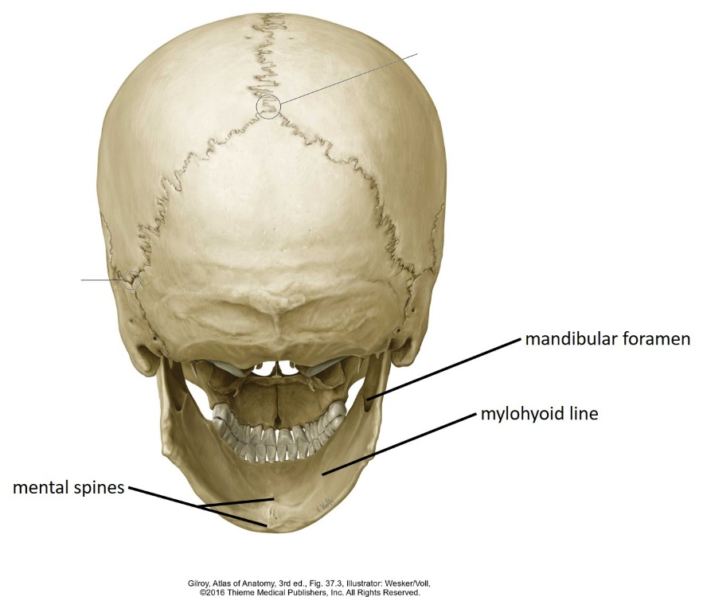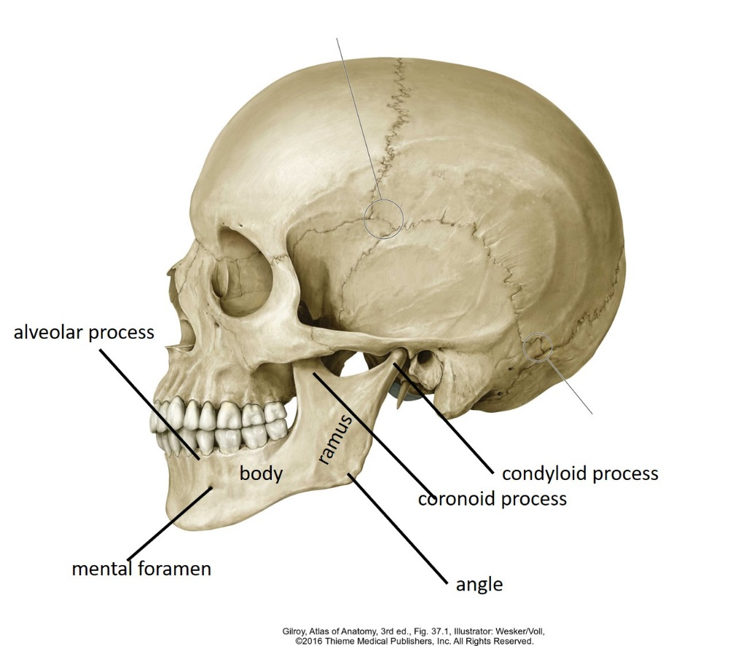

‘How To Learn Anatomy’ Workshop Stations
- Watch and Listen [passive]
WATCH and LISTEN to the video which will show you the structures on the MANDIBLE. No writing involved.
- Flip cards [passive]
Use the FLIPCARD method to label the structures on the MANDIBLE.
- Look, Cover, Label, Check [active]
Using the LOOK, COVER, LABEL, CHECK method, learn the vocabulary.
- Hotspots [passive]
Use the HOTSPOT method to label the structures on the MANDIBLE.
- Drawing [active]
Learn to DRAW and LABEL the structures of the MANDIBLE.
- Drag and Drop [moderately active]
Using the DRAG and DROP method to label the structures on the MANDIBLE.

Pre-Workshop Survey (5 minutes to complete)
- Have you learnt a foreign language before?
[Yes/No]
- If you have learnt another language, what language(s) have you learnt?
- What is your level of fluency?
[I haven’t learnt another language/Basic level /Intermediate level/Advanced level]
- In what context have you studied that language?
[I haven’t learnt another language/Language class in high school/Home language/Language course outside of school]
- Have you learnt human anatomy before?
[Yes/No]
- At what level did you learn anatomy?
[I haven’t learnt anatomy before/High school/TAFE College/University]
- What do you think are the challenging aspects in learning anatomy?
- Do you think you will find SPELLING new words:
[The least challenging/Medium challenging/The most challenging]
- Do you think you will find learning NEW words:
[The least challenging/Medium challenging/The most challenging]
- Do you think you will find learning LATIN words:
[The least challenging/Medium challenging/The most challenging]
- Do you think you will find learning a large NUMBER of new words:
[The least challenging/Medium challenging/The most challenging]
- Do you think you will find learning anatomy stressful?
[Yes/No]
- What other challenges do you think you will face learning anatomy? [blank]
Pre-Workshop Quiz (5 minutes to complete)
- I am on station:
[Drawing/Watch & Listen/Drag & Drop/Hotspots/Flip cards/Look, Cover, Label, Check]
- Followed by 10 multiple choice questions, for example:
Which of the following is incorrectly labelled?
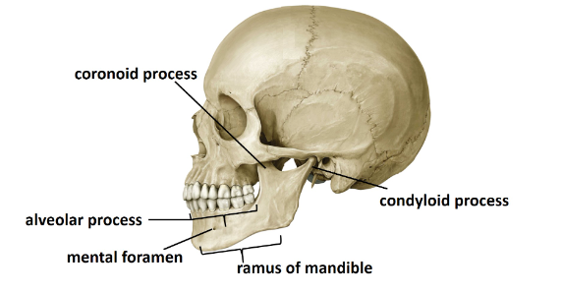
- ramus of mandible
- coronoid process
- condyloid process
- alveolar process
- mental foramen

Post-Workshop Quiz and Survey 1 (5 minutes to complete)
I completed station:
[Drawing/Watch & Listen/Drag & Drop/Hotspots/Flip cards/Look, Cover, Label, Check]
- What did you think of your station? Please rate your agreement with the following statements:
- I think this method of learning will be useful. [SA, A, D, SD]
- I liked this method of learning. [SA, A, D, SD]
- I will use this method of learning. [SA, A, D, SD]
- I thought the method of learning was fun. [SA, A, D, SD]
- Followed by 10 multiple choice questions.

Post-Workshop Survey 2 (5 minutes to complete)
- My favorite station was:
[Drawing/Watch & Listen/Drag & Drop/Hotspots/Flip cards/Look, Cover, Label, Check]
- I am going to use station ____ in my study.
[Drawing/Watch & Listen/Drag & Drop/Hotspots/Flip cards/Look, Cover, Label, Check]

Discussion Group Questions:
Students met online via Zoom (zoom.us, San Jose, CA) in groups of 4-6.

Key points of the discussion
- Introductory comments
- Why are strategies important?
- Why is it necessary to have more than one strategy?
- Thinking about the activities you did in the ‘How to learn Anatomy’ workshop, which activities did you find useful in learning anatomy vocabulary? And which were not as useful?
- Which aspect of the workshop do you want to adapt for your learning of anatomy?
- Brainstorm some ideas on how to develop or find resources to use in learning anatomy vocabulary?
- What resource do you plan to develop for your learning?
- I intend to develop the following learning resource.
[blank]

