Extended data figures & tables

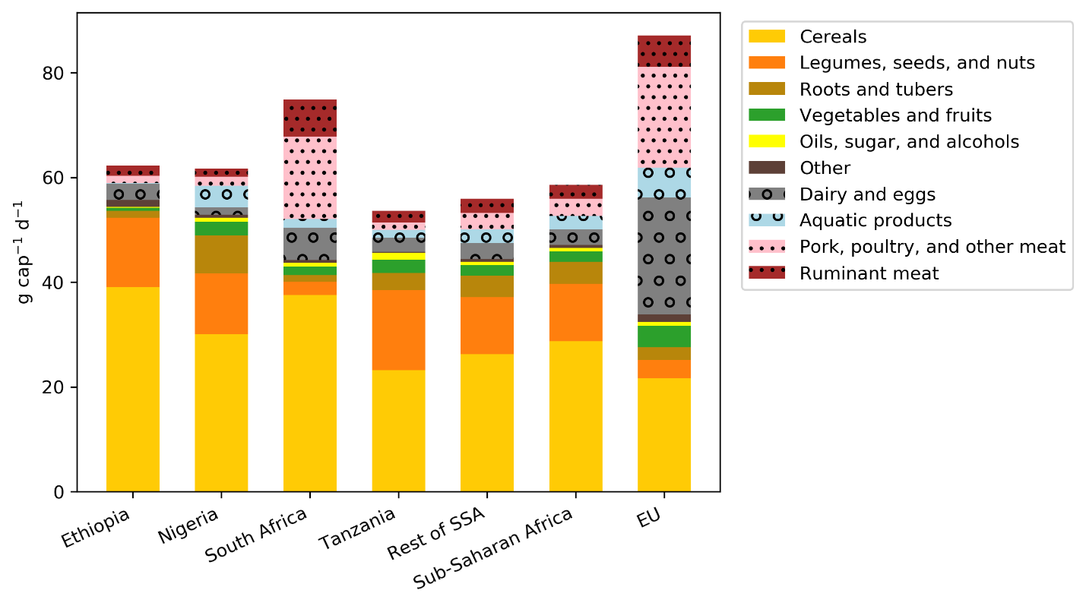
Extended Data Figure 1. Present diets in food protein consumption per capita. Source: Authors’ calculations based on FAO data.

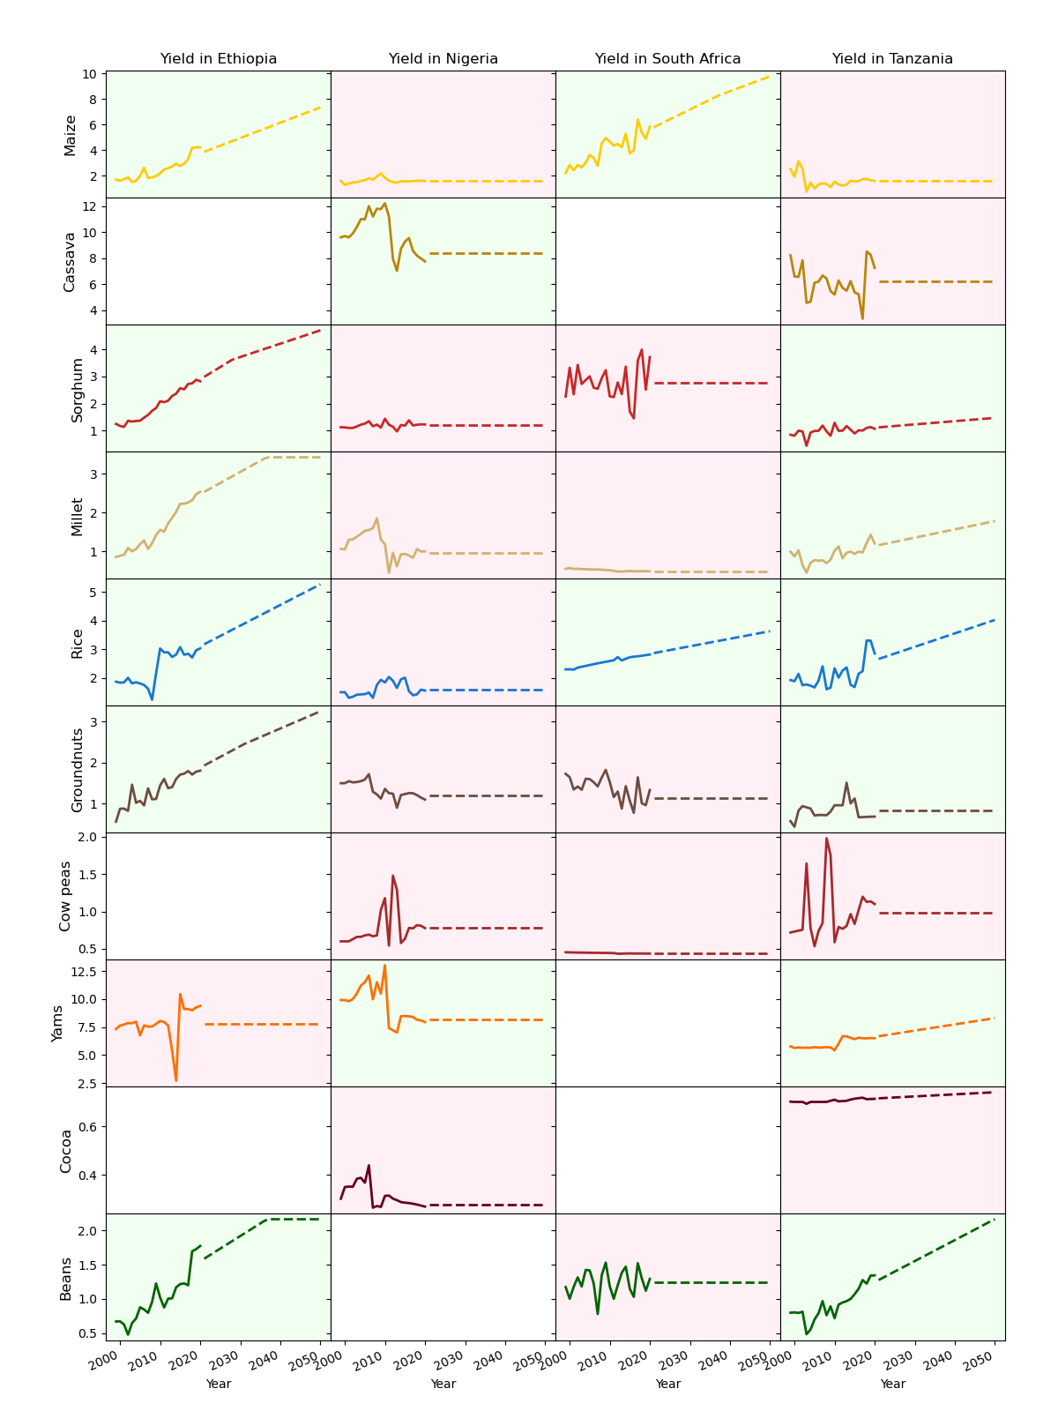
Extended Data Figure 2. Historical yield changes and future trends for the most grown crops in selected countries. Solid line is based on FAO data; dotted line represents projection. Tons of crop are measured in harvested crops at typical moisture contents.
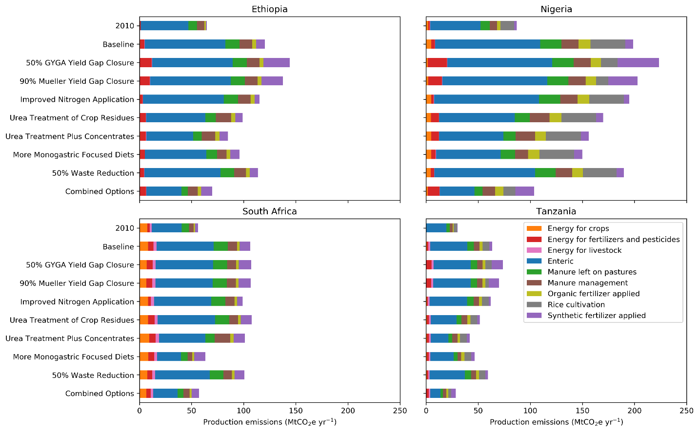
Extended Data Figure 3. Production emissions for four SSA countries in 2010 and for all scenarios in 2050.

Extended Data Table 1. Annual harvested areas and yields of the 10 most widely grown crops in SSA.

 | Average Harvested Area (2016-2020), Mha | Area Share | Average Yield (2016-2020), t ha⁻¹
Maize | 39.8 | 17% | 1.92
Cassava | 21.0 | 9% | 8.64
Sorghum | 20.3 | 9% | 1.12
Millet | 17.0 | 7% | 0.74
Rice | 16.1 | 7% | 1.88
Groundnuts | 13.5 | 6% | 0.97
Cow peas | 13.2 | 6% | 0.57
Yams | 8.5 | 4% | 8.54
Cocoa | 8.1 | 3% | 0.45
Beans | 7.4 | 3% | 0.86

Note: Harvested area and yields are computed using the average of 2016-2020. The crops are sorted by harvested area. Tons of crop are measured in harvested crops at typical moisture contents.
Source: FAOSTAT Food Balances 2021

Extended Data Table 2. Yield gains in the Baseline and Yield Gap Closure scenarios for 10 common crops.
Crop | 2010 | Baseline | % increase | 50% GYGA Yield Gap Closure | % increase | 90% Mueller Yield Gap Closure | % increase
Maize | 1.82 | 2.73 | 50% | 5.63 | 209% | 4.95 | 171%
Cassava | 9.66 | 11.23 | 16% | 20.78 | 115% | 28.79 | 198%
Sorghum | 1.13 | 1.44 | 28% | 8.18 | 623% | 4.95 | 338%
Millet | 0.74 | 0.93 | 27% | 3.48 | 371% | 2.61 | 253%
Rice | 2.07 | 2.94 | 42% | 4.55 | 120% | 5.60 | 171%
Groundnuts | 0.96 | 1.14 | 19% | 4.83 | 405% | 4.06 | 325%
Cow peas | 0.61 | 0.96 | 56% | 4.88 | 698% | 1.62 | 165%
Yams | 9.78 | 10.64 | 9% | 17.84 | 82% | 29.00 | 196%
Cocoa | 0.45 | 0.56 | 22% | 0.83 | 83% | 0.83 | 83%
Beans | 0.76 | 1.11 | 47% | 5.39 | 613% | 1.98 | 162%

Extended Data Table 3. Average NUE for 2010 and 2050 Baseline and Improved Nitrogen Application scenarios.
Region/Country | 2010 | Baseline | Improved Nitrogen Application
Sub-Saharan Africa | 0.70 | 0.55 | 0.76
Ethiopia | 0.80 | 0.61 | 0.81
Nigeria | 0.71 | 0.70 | 0.81
South Africa | 0.54 | 0.31 | 0.56
Tanzania | 0.83 | 0.76 | 0.90
Extended Data Table 4. Methane emissions of SSA by categories for 2010 and 2050 mitigation pathways.
 | Enteric | Rice  cultivation | Manure  management | Energy for crops | Energy for livestock | Total
 | 2010 CH₄ Emissions (MtCO₂e)
 | 437.78 | 55.09 | 22.14 | 0.77 | 0.09 | 515.88
Scenarios | 2050 CH₄ Emissions (MtCO₂e)
Baseline | 724.75 | 105.37 | 42.73 | 1.43 | 0.18 | 874.45
50% GYGA Yield Gap Closure | 724.75 | 65.13 | 42.73 | 0.73 | 0.18 | 833.51
90% Mueller Yield Gap Closure | 724.75 | 53.87 | 42.73 | 0.72 | 0.18 | 822.25
Improved Nitrogen Application | 724.75 | 105.37 | 42.73 | 1.43 | 0.18 | 874.45
Urea Treatment of Crop Residues | 556.29 | 104.40 | 40.27 | 1.41 | 0.18 | 702.56
Urea Treatment Plus Concentrates | 482.07 | 104.01 | 38.77 | 1.55 | 0.18 | 626.58
More Monogastric Focused Diets | 402.02 | 107.77 | 29.80 | 1.55 | 0.17 | 541.30
50% Waste Reduction | 693.49 | 101.17 | 40.73 | 1.31 | 0.17 | 836.87
Combined Options | 214.41 | 52.98 | 23.77 | 0.74 | 0.17 | 292.07

