Supplementary Information
Salting out, non-idealities and Synergism: how the Complex Chemical Composition of Atmospheric Aerosols Enhances Surfactant Efficiency
Manuella El haber¹, Corinne Ferronato¹, Anne Giroir-Fendler,¹
Ludovic Fine¹, and Barbara Noziére^{2*}
¹Université Claude Bernard Lyon 1, CNRS, IRCELYON, F-69626, Villeurbanne, France
²KTH Royal Institute of Technology SE-100 44, Stockholm, Sweden
*corresponding author: noziere@kth.se

Contents
S1. List of experiments performed 2
S2. Experimental work 3
S3. Adsorption isotherms for surfactant and inorganic salt mixtures 4
3.1 TritonX100 + NaCl 4
3.2 TritonX100 + (NH₄)₂SO₄ 5
3.3 Brij35 + (NH₄)₂SO₄ 6
S4. Adsorption isotherms for organic acid and inorganic salt mixtures 8
4.1 Glutaric acid + (NH₄)₂SO₄ 8
4.2 Glutaric acid + NaCl 9
S5. Adsorption isotherms for amphiphilic surfactant and organic acid mixtures 11
5.1 TritonX100 + Glutaric acid 11
5.2 Brij35 + Glutaric acid 15
5.3 TritonX114 + Glutaric acid 18
5.4 TritonX100 + Oxalic acid 19
5.5 Brij35 + Oxalic acid 22
S6. Adsorption isotherms for mixtures of two amphiphilic surfactants 25
6.1 SDS + CTAC 25
6.2 TritonX114 + SDS 27
S7. Adsorption isotherms for two organic acids mixtures 30
7.1 Glutaric acid + Oxalic acid 30
Figure S8. Effects of inorganic salts on the surface tension of glutaric acid 32
S9. Effects of organic acids on the CMC of amphiphilic surfactants 33
S10. Evolution of the surface tension for two amphiphilic surfactant mixtures 34
Figure S11. Evolution of the surface tension for Glutaric and Oxalic acid mixtures 35

S1. List of experiments performed
Table S1: List of experiments performed
Mixture. n. | Compound 1 | Compound 2 | Initial concentrations
Amphiphilic surfactant + inorganic salt
1 | TritonX100 | NaCl | TritonX100 0.1 M + 0, 0.4, 0.8, 1.6 M NaCl
2 | TritonX100 | (NH₄)₂SO₄ | TritonX100 0.1 M + 0, 0.7 M (NH4)2SO4
3 | Brij35 | (NH₄)₂SO₄ | Brij35 0.02 M + 0, 0.7 M (NH4)2SO4
Organic acid + inorganic salt
4 | Glutaric acid | (NH₄)₂SO₄ | Glutaric acid 3 M + 0, 0.7, 1.5 M
5 | Glutaric acid | NaCl | Glutaric acid 3 M + 0, 0.4, 1.7, 2.5 M
Amphiphilic surfactant + organic acid
6 | TritonX100 | Glutaric acid | TritonX100 0.1 M + x = 0, 0.87, 0.984, 0.99833, 0.99985, 1 GA*
7 | TritonX100 | Glutaric acid | TritonX100 0.1 M + 0, 0.0065, 0.65, 2.7 M GA*
8 | Brij35 | Glutaric acid | Brij35 0.02 M + x = 0, 0.87, 0.986, 0.9985, 0.99986, 1 GA*
9 | Brij35 | Glutaric acid | Brij35 0.02 M + 0, 0.65, 02 M GA*
10 | TritonX114 | Glutaric acid | TritonX114 0.01 M + 0, 0.6, 2 M GA*
11 | TritonX100 | Oxalic acid | TritonX100 0.1 M + x = 0, 0.9, 0.99, 0.9989, 0.99953, 0.99987, 1 OA**
12 | Brij35 | Oxalic acid | Brij35 + x = 0, 0.909, 0.9901, 0.998899, 0.99982, 1 OA**
Two different amphiphilic surfactants
13 | SDS | CTAC | SDS 0.1 M + x = 0, 0.33, 0.5, 0.66, 1 CTAC
14 | TritonX114 | SDS | TritonX114 0.01 M + x = 0. 0.1, 0.33, 0.5, 0.66, 1 SDS
Two different organic acids
15 | Oxalic acid | Glutaric acid | Oxalic acid 1 M + x = 0, 0.25, 0.4, 0.57, 1 GA*
*GA= glutaric acid; **OA= oxalic acid

S2. Experimental work
Principle binary solutions of surfactants, acids and salts listed in Table S2 of this Supplementary Information, were prepared in 60 mL glass bottles with deionized water (18.2 MΩ). In order to ensure its homogeneity, all solutions were placed on a magnetic stirrer for an hour. Afterwards, the ternary mixtures listed in Table S1 were prepared in deionized water for tensiometry and their surface tension was measured by the pendant drop method using a Dataphysics OCA 15EC tensiometer and Dataphysics SCA software for OCA version 4 - 4.1. The tensiometer was calibrated with ultrapure water and the measurements were carried out at 24 (± 2) °C; the SFT of pure water was in the range of 72.5–73.5 mN/m. Each measurement was repeated three times, and the reproducibility between the results was ± (1 - 3) %. The overall uncertainties on each surface tension measurement were ± (0.3 - 1.0) mN/m.
Table S2: List of the compounds used in this study
Compound | Formula | MW (g/mol) | CAS no. | Purity (%)
TritonX100 | C₁₄H₂₂O(C₂H₄O)_{n} | 647 | 9036-19-5 | 100
TritonX114 | C₁₄H₂₂O(C₂H₄O)_{n} | 537 | 9036-19-5 | 100
Brij35 | C₁₂H₂₆O(C₂H₄O)_{n} | 1199.54 | 9002-92-0 | 100
CetylTrimethyl Ammonium Chloride, “CTAC” | C₁₉H₄₂NCl | 320 | 112-02-7 | 25
Sodium Dodecyl Sulfate, “SDS” | C₁₂H₂₅OSO₂ONa | 288.37 | 151-21-3 | 100
Ethanedioic acid, “oxalic acid” | C₂H₂O₄ | 90.03 | 144-62-7 | 100
Pentanedioic acid, “glutaric acid” | C₅H₈O₄ | 132.12 | 110-94-1 | 100
Sodium chloride | NaCl | 58.44 | 111072-31-2 | ≥ 99.5
Ammonium sulfate | (NH₄)₂SO₄ | 132.14 | 7783-20-2 | ≥ 99

S3. Adsorption isotherms for surfactant and inorganic salt mixtures

TritonX100 + NaCl
With α = molar fraction of compounds in water.
Table S3.1: TritonX100 solutions
[TritonX100] (M) | σ (mN/m) | [TritonX100] (M) | σ (mN/m)
9.7E-03 | 32.37 | 1.6E-04 | 37.55
5.0E-03 | 32.38 | 1.1E-04 | 41.38
2.1E-03 | 31.75 | 5.5E-05 | 47.40
1.0E-03 | 31.80 | 4.9E-05 | 48.83
6.9E-04 | 31.90 | 4.4E-05 | 50.10
5.1E-04 | 31.52 | 3.3E-05 | 53.33
3.3E-04 | 32.60 | 8.0E-06 | 71.44
2.6E-04 | 33.67 | 2.9E-06 | 73.10
2.2E-04 | 36.40 | 0.0E+00 | 73.53
Table S3.2: TritonX100 + 0.4 M NaCl mixtures
∝ TritonX100 | ∝ NaCl | [TritonX100] (M) | [NaCl] (M) | σ (mN/m)
1.55E-05 | 8.62E-03 | 8.6E-04 | 4.8E-01 | 31.04
1.27E-05 | 7.28E-03 | 7.0E-04 | 4.0E-01 | 31.05
7.89E-06 | 7.30E-03 | 4.4E-04 | 4.0E-01 | 31.12
6.43E-06 | 6.91E-03 | 3.6E-04 | 3.8E-01 | 30.95
4.78E-06 | 6.84E-03 | 2.6E-04 | 3.8E-01 | 30.97
3.17E-06 | 6.89E-03 | 1.8E-04 | 3.8E-01 | 33.31
1.62E-06 | 6.99E-03 | 9.0E-05 | 3.9E-01 | 39.77
1.35E-06 | 6.89E-03 | 7.5E-05 | 3.8E-01 | 41.88
8.47E-07 | 7.24E-03 | 4.7E-05 | 4.0E-01 | 46.58
6.95E-07 | 6.84E-03 | 3.8E-05 | 3.8E-01 | 48.63
2.35E-07 | 6.67E-03 | 1.3E-05 | 3.7E-01 | 60.30
2.13E-07 | 7.32E-03 | 1.2E-05 | 4.1E-01 | 65.68
1.07E-07 | 6.98E-03 | 5.9E-06 | 3.9E-01 | 71.97
0.00E+00 | 6.93E-03 | 0.0E+00 | 3.8E-01 | 72.08
Table S3.3: TritonX100 + 0.8 M NaCl mixtures
∝ TritonX100 | ∝ NaCl | [TritonX100] (M) | [NaCl] (M) | σ (mN/m)
1.64E-05 | 1.41E-02 | 9.1E-04 | 7.8E-01 | 30.53
8.27E-06 | 1.39E-02 | 4.6E-04 | 7.7E-01 | 30.50
5.32E-06 | 1.41E-02 | 2.9E-04 | 7.8E-01 | 30.54
3.29E-06 | 1.42E-02 | 1.8E-04 | 7.8E-01 | 30.65
1.70E-06 | 1.39E-02 | 9.4E-05 | 7.7E-01 | 36.18
1.31E-06 | 1.40E-02 | 7.3E-05 | 7.7E-01 | 38.20
8.44E-07 | 1.40E-02 | 4.7E-05 | 7.7E-01 | 42.89
5.12E-07 | 1.41E-02 | 2.8E-05 | 7.8E-01 | 47.16
1.79E-07 | 1.40E-02 | 9.9E-06 | 7.7E-01 | 60.92
1.27E-07 | 1.44E-02 | 7.0E-06 | 8.0E-01 | 70.02
1.00E-07 | 1.37E-02 | 5.5E-06 | 7.5E-01 | 69.96
7.87E-08 | 1.34E-02 | 4.3E-06 | 7.4E-01 | 70.50
0.00E+00 | 1.40E-02 | 0.0E+00 | 7.7E-01 | 71.91

Table S3.4: TritonX100 + 1.6 M NaCl mixtures
∝ TritonX100 | ∝ NaCl | [TritonX100] (M) | [NaCl] (M) | σ (mN/m)
1.68E-05 | 2.94E-02 | 9.2E-04 | 1.6E+00 | 29.46
8.57E-06 | 2.97E-02 | 4.7E-04 | 1.6E+00 | 29.49
5.15E-06 | 2.98E-02 | 2.8E-04 | 1.6E+00 | 29.60
3.28E-06 | 2.91E-02 | 1.8E-04 | 1.6E+00 | 29.38
1.83E-06 | 2.92E-02 | 1.0E-04 | 1.6E+00 | 31.00
1.42E-06 | 2.91E-02 | 7.8E-05 | 1.6E+00 | 33.18
9.14E-07 | 2.91E-02 | 5.0E-05 | 1.6E+00 | 37.44
3.97E-07 | 2.87E-02 | 2.2E-05 | 1.6E+00 | 46.45
2.27E-07 | 2.97E-02 | 1.3E-05 | 1.6E+00 | 57.81
1.86E-07 | 2.95E-02 | 1.0E-05 | 1.6E+00 | 61.05
1.56E-07 | 3.03E-02 | 8.6E-06 | 1.7E+00 | 69.65
1.35E-07 | 3.05E-02 | 7.4E-06 | 1.7E+00 | 70.89
0.00E+00 | 2.93E-02 | 0.0E+00 | 1.6E+00 | 70.97
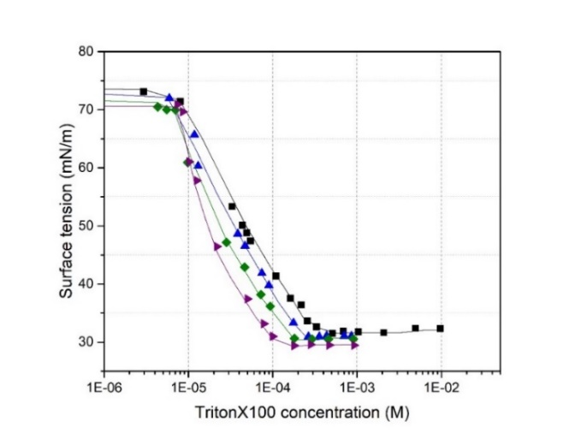
Figure S3.1: Adsorption isotherms for TritonX100 + NaCl mixtures: () black curve: TritonX100; () blue curve: TritonX100 + 0.4 M NaCl; () green curve: TritonX100 + 0.8 M NaCl and () purple curve: TritonX100 + 1.6 M NaCl.

TritonX100 + (NH₄)₂SO₄
Table S3.5: TritonX100 + 0.7 M (NH₄)₂SO₄ mixtures
∝ TritonX100 | ∝ AS | [TritonX100] (M) | [AS] (M) | σ (mN/m)
1.90E-05 | 1.24E-02 | 1.0E-03 | 6.6E-01 | 29.88
9.92E-06 | 1.25E-02 | 5.3E-04 | 6.7E-01 | 30.05
5.75E-06 | 1.27E-02 | 3.1E-04 | 6.8E-01 | 30.08
4.06E-06 | 1.23E-02 | 2.2E-04 | 6.6E-01 | 30.31
1.93E-06 | 1.24E-02 | 1.0E-04 | 6.6E-01 | 31.24
1.46E-06 | 1.28E-02 | 7.8E-05 | 6.8E-01 | 33.96
1.01E-06 | 1.24E-02 | 5.4E-05 | 6.6E-01 | 38.29
5.86E-07 | 1.25E-02 | 3.1E-05 | 6.7E-01 | 46.25
3.94E-07 | 1.25E-02 | 2.1E-05 | 6.7E-01 | 49.55
1.19E-07 | 1.26E-02 | 6.4E-06 | 6.7E-01 | 69.85
5.42E-08 | 1.26E-02 | 2.9E-06 | 6.8E-01 | 71.38
0.00E+00 | 1.22E-02 | 0.0E+00 | 6.5E-01 | 71.75
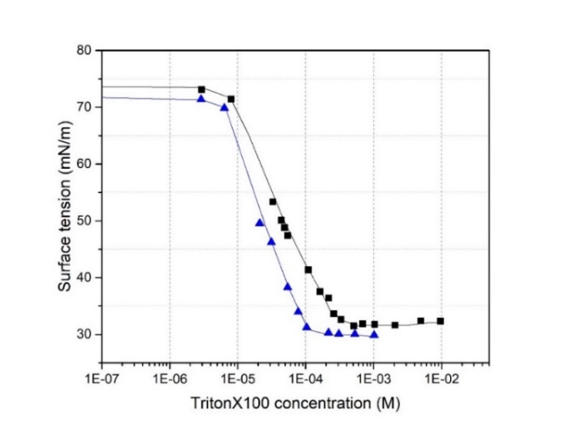
Figure S3.2: Adsorption isotherms for TritonX100 + (NH₄)₂SO₄ mixtures: () black curve: TritonX100 and () blue curve: TritonX100 + 0.7 M (NH₄)₂SO₄.

Brij35 + (NH₄)₂SO₄
Table S3.6: Brij35 solutions
[Brij35] (M) | σ (mN/m) | [Brij35] (M) | σ (mN/m)
2.06E-02 | 44.91 | 1.08E-04 | 47.80
1.04E-02 | 45.30 | 8.62E-05 | 49.35
7.76E-03 | 45.22 | 6.41E-05 | 50.40
4.95E-03 | 45.13 | 4.59E-05 | 53.32
1.03E-03 | 45.34 | 3.43E-05 | 53.73
7.58E-04 | 44.87 | 2.44E-05 | 56.79
5.59E-04 | 45.42 | 5.23E-06 | 71.88
3.85E-04 | 45.66 | 0.00E+00 | 73.30
2.00E-04 | 45.66
Table S3.7: Brij35 + 0.7 M (NH₄)₂SO₄ mixtures
∝ Brij35 | ∝ AS | [Brij35] (M) | [AS] (M) | σ (mN/m)
1.84E-04 | 1.19E-02 | 9.9E-03 | 6.4E-01 | 40.89
9.44E-05 | 1.29E-02 | 5.0E-03 | 6.9E-01 | 40.81
1.88E-05 | 1.22E-02 | 1.0E-03 | 6.5E-01 | 40.94
1.53E-05 | 1.21E-02 | 8.2E-04 | 6.5E-01 | 40.99
1.15E-05 | 1.20E-02 | 6.2E-04 | 6.4E-01 | 41.45
7.83E-06 | 1.21E-02 | 4.2E-04 | 6.5E-01 | 41.42
3.86E-06 | 1.23E-02 | 2.1E-04 | 6.6E-01 | 41.85
1.98E-06 | 1.23E-02 | 1.1E-04 | 6.6E-01 | 42.01
1.52E-06 | 1.23E-02 | 8.1E-05 | 6.6E-01 | 42.68
1.08E-06 | 1.23E-02 | 5.8E-05 | 6.6E-01 | 43.47
8.58E-07 | 1.23E-02 | 4.6E-05 | 6.6E-01 | 44.00
6.26E-07 | 1.25E-02 | 3.4E-05 | 6.7E-01 | 45.49
4.78E-07 | 1.22E-02 | 2.6E-05 | 6.5E-01 | 49.29
2.78E-07 | 1.21E-02 | 1.5E-05 | 6.5E-01 | 54.13
1.92E-07 | 1.23E-02 | 1.0E-05 | 6.6E-01 | 59.85
1.01E-07 | 1.24E-02 | 5.4E-06 | 6.6E-01 | 65.48
0.00E+00 | 1.21E-02 | 0.0E+00 | 6.5E-01 | 71.51
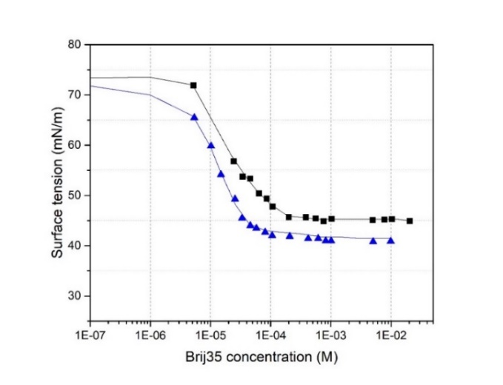
Figure S3.3: Adsorption isotherms for Brij35 + (NH₄)₂SO₄ mixtures: () black curve: Brij35 and () blue curve: Brij35 + 0.7 M (NH₄)₂SO₄.

S4. Adsorption isotherms for organic acid and inorganic salt mixtures

Glutaric acid + (NH₄)₂SO₄
Table S4.1: Glutaric acid solutions
[Glutaric acid] (M) | σ (mN/m) | [Glutaric acid] (M) | σ (mN/m)
3.0E+00 | 53.28 | 4.7E-02 | 72.27
2.2E+00 | 54.82 | 2.6E-02 | 72.18
1.4E+00 | 58.05 | 1.9E-02 | 72.89
7.1E-01 | 62.08 | 1.8E-02 | 72.31
5.5E-01 | 64.18 | 7.7E-03 | 73.23
2.8E-01 | 66.00 | 3.2E-03 | 73.52
7.4E-02 | 70.92 | 0.0E+00 | 73.78
5.9E-02 | 71.28
Table S4.2: Glutaric acid + 0.7 M (NH₄)₂SO₄ mixtures
∝ Glutaric acid | ∝ AS | [Glutaric acid] (M) | [AS] (M) | σ (mN/m)
2.98E-02 | 1.45E-02 | 1.5E+00 | 7.3E-01 | 55.95
1.37E-02 | 1.36E-02 | 7.3E-01 | 7.2E-01 | 59.55
1.09E-02 | 1.32E-02 | 5.8E-01 | 7.1E-01 | 60.94
6.89E-03 | 1.30E-02 | 3.8E-01 | 7.1E-01 | 62.57
3.86E-03 | 1.29E-02 | 2.1E-01 | 7.1E-01 | 64.87
1.33E-03 | 1.26E-02 | 7.4E-02 | 7.1E-01 | 68.69
1.14E-03 | 1.27E-02 | 6.4E-02 | 7.1E-01 | 68.76
6.74E-04 | 1.25E-02 | 3.8E-02 | 7.0E-01 | 68.96
3.44E-04 | 1.25E-02 | 1.9E-02 | 7.0E-01 | 69.68
1.16E-04 | 1.25E-02 | 6.5E-03 | 7.1E-01 | 70.16
5.39E-05 | 1.25E-02 | 3.0E-03 | 7.0E-01 | 70.86
0.00E+00 | 1.25E-02 | 0.0E+00 | 7.0E-01 | 71.34
Table S4.3: Glutaric acid + 1.5 M (NH₄)₂SO₄ mixtures
∝ Glutaric acid | ∝ AS | [Glutaric acid] (M) | [AS] (M) | σ (mN/m)
3.32E-02 | 3.28E-02 | 1.7E+00 | 1.6E+00 | 53.16
1.62E-02 | 2.87E-02 | 8.7E-01 | 1.5E+00 | 55.32
1.19E-02 | 2.92E-02 | 6.5E-01 | 1.6E+00 | 57.87
7.28E-03 | 2.84E-02 | 4.0E-01 | 1.6E+00 | 60.16
4.25E-03 | 2.82E-02 | 2.4E-01 | 1.6E+00 | 61.75
1.39E-03 | 2.68E-02 | 7.9E-02 | 1.5E+00 | 66.19
1.24E-03 | 2.73E-02 | 7.0E-02 | 1.6E+00 | 66.20
4.94E-04 | 2.71E-02 | 2.8E-02 | 1.5E+00 | 68.15
3.25E-04 | 2.74E-02 | 1.9E-02 | 1.6E+00 | 68.79
1.56E-04 | 2.64E-02 | 8.9E-03 | 1.5E+00 | 69.94
8.50E-05 | 2.69E-02 | 4.9E-03 | 1.5E+00 | 69.52
0.00E+00 | 2.67E-02 | 0.0E+00 | 1.5E+00 | 69.85
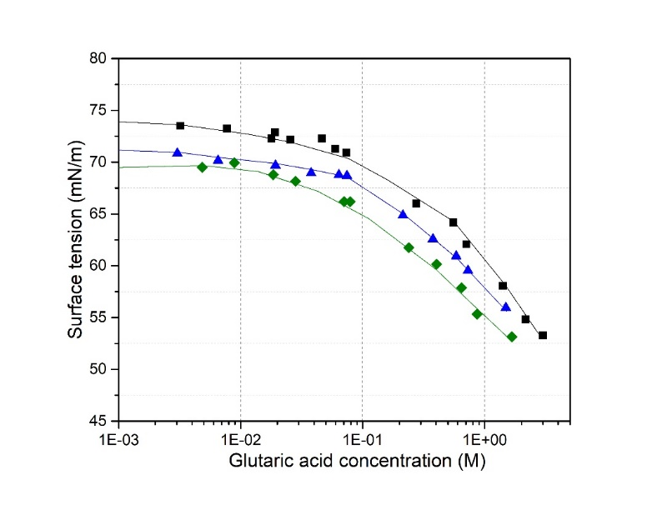
Figure S4.1: Adsorption isotherms for Glutaric acid + (NH₄)₂SO₄ mixtures: () black curve: Glutaric acid; () blue curve: Glutaric acid + 0.7 M (NH₄)₂SO₄; () green curve: Glutaric acid + 1.5 M (NH₄)₂SO₄.

Glutaric acid + NaCl
Table S4.4: Glutaric acid + 0.4 M NaCl mixtures
∝ Glutaric acid | ∝ NaCl | [Glutaric acid] (M) | [NaCl] (M) | σ (mN/m)
6.27E-02 | 9.88E-03 | 2.8E+00 | 4.4E-01 | 52.94
4.40E-02 | 8.83E-03 | 2.1E+00 | 4.2E-01 | 54.58
2.66E-02 | 8.38E-03 | 1.3E+00 | 4.2E-01 | 57.88
1.25E-02 | 7.64E-03 | 6.6E-01 | 4.1E-01 | 61.82
9.86E-03 | 7.28E-03 | 5.3E-01 | 3.9E-01 | 62.98
5.93E-03 | 7.27E-03 | 3.2E-01 | 4.0E-01 | 65.17
3.46E-03 | 7.35E-03 | 1.9E-01 | 4.1E-01 | 67.10
2.38E-03 | 6.77E-03 | 1.3E-01 | 3.7E-01 | 68.33
9.20E-04 | 6.95E-03 | 5.1E-02 | 3.9E-01 | 70.60
5.66E-04 | 6.93E-03 | 3.2E-02 | 3.9E-01 | 71.36
1.29E-04 | 6.91E-03 | 7.2E-03 | 3.9E-01 | 71.70
9.19E-05 | 6.71E-03 | 5.1E-03 | 3.8E-01 | 71.95
5.65E-05 | 6.78E-03 | 3.2E-03 | 3.8E-01 | 71.97
0.00E+00 | 6.78E-03 | 0.0E+00 | 3.8E-01 | 71.80

Table S4.5: Glutaric acid + 1.7 M NaCl mixtures
∝ Glutaric acid | ∝ NaCl | [Glutaric acid] (M) | [NaCl] (M) | σ (mN/m)
4.39E-02 | 3.68E-02 | 2.1E+00 | 1.8E+00 | 51.90
2.82E-02 | 3.44E-02 | 1.4E+00 | 1.8E+00 | 55.09
1.45E-02 | 3.04E-02 | 7.8E-01 | 1.6E+00 | 58.31
9.75E-03 | 3.06E-02 | 5.4E-01 | 1.7E+00 | 60.91
6.35E-03 | 3.14E-02 | 3.5E-01 | 1.8E+00 | 62.21
3.91E-03 | 2.98E-02 | 2.2E-01 | 1.7E+00 | 64.37
1.35E-03 | 2.96E-02 | 7.7E-02 | 1.7E+00 | 67.87
1.01E-03 | 2.93E-02 | 5.8E-02 | 1.7E+00 | 68.03
6.40E-04 | 2.93E-02 | 3.7E-02 | 1.7E+00 | 68.99
2.99E-04 | 3.00E-02 | 1.7E-02 | 1.7E+00 | 70.01
1.13E-04 | 2.94E-02 | 6.4E-03 | 1.7E+00 | 70.55
7.29E-05 | 2.95E-02 | 4.2E-03 | 1.7E+00 | 70.24
0.00E+00 | 2.83E-02 | 0.0E+00 | 1.6E+00 | 71.15
Table S4.6: Glutaric acid + 2.5 M NaCl mixtures
∝ Glutaric acid | ∝ NaCl | [Glutaric acid] (M) | [NaCl] (M) | σ (mN/m)
3.00E-02 | 5.26E-02 | 1.6E+00 | 2.7E+00 | 53.36
1.35E-02 | 4.80E-02 | 7.5E-01 | 2.6E+00 | 57.75
1.06E-02 | 4.70E-02 | 5.9E-01 | 2.6E+00 | 58.71
7.20E-03 | 4.49E-02 | 4.1E-01 | 2.5E+00 | 60.68
4.19E-03 | 4.52E-02 | 2.4E-01 | 2.6E+00 | 63.07
1.34E-03 | 4.44E-02 | 7.7E-02 | 2.6E+00 | 66.63
1.05E-03 | 4.49E-02 | 6.1E-02 | 2.6E+00 | 66.81
6.21E-04 | 4.44E-02 | 3.6E-02 | 2.6E+00 | 68.55
1.50E-04 | 4.41E-02 | 8.7E-03 | 2.6E+00 | 69.41
1.03E-04 | 4.22E-02 | 5.9E-03 | 2.4E+00 | 69.80
6.72E-05 | 4.45E-02 | 3.9E-03 | 2.6E+00 | 69.58
0.00E+00 | 4.26E-02 | 0.0E+00 | 2.5E+00 | 70.50
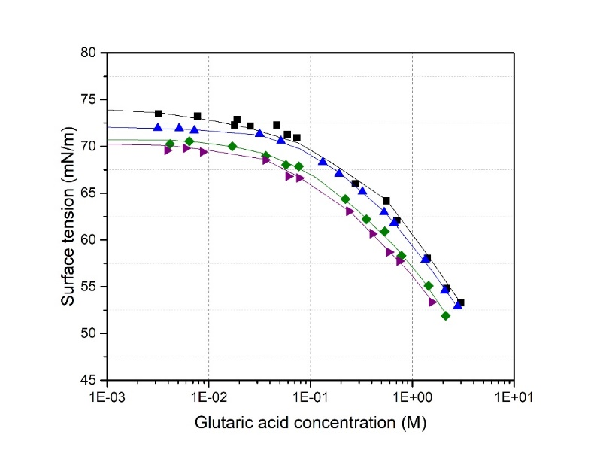
Figure S4.2: Adsorption isotherms for Glutaric acid + NaCl mixtures: () black curve: Glutaric acid; () blue curve: Glutaric acid + 0.4 M NaCl; () green curve: Glutaric acid + 1.7 M NaCl; () purple curve: Glutaric acid + 2.5 M NaCl.

S5. Adsorption isotherms for amphiphilic surfactant and organic acid mixtures

TritonX100 + Glutaric acid
Table S5.1: TritonX100 + Glutaric acid mixtures (x = 0.13)
$∝$Glutaric acid | ∝ TritonX100 | [Glutaric acid] (M) | [TritonX100] (M) | σ (mN/m)
6.41E-03 | 9.53E-04 | 3.4E-01 | 5.0E-02 | 33.24
1.21E-03 | 1.80E-04 | 6.8E-02 | 1.0E-02 | 32.85
7.24E-04 | 1.08E-04 | 4.0E-02 | 6.0E-03 | 32.67
3.59E-04 | 5.33E-05 | 2.0E-02 | 3.0E-03 | 32.56
1.26E-04 | 1.87E-05 | 7.0E-03 | 1.0E-03 | 31.83
1.01E-04 | 1.50E-05 | 5.6E-03 | 8.3E-04 | 32.20
6.58E-05 | 9.79E-06 | 3.7E-03 | 5.4E-04 | 31.94
4.41E-05 | 6.56E-06 | 2.4E-03 | 3.6E-04 | 31.98
1.92E-05 | 2.86E-06 | 1.1E-03 | 1.6E-04 | 38.20
1.20E-05 | 1.78E-06 | 6.6E-04 | 9.9E-05 | 43.25
7.16E-06 | 1.07E-06 | 4.0E-04 | 5.9E-05 | 48.02
3.54E-06 | 5.26E-07 | 2.0E-04 | 2.9E-05 | 54.43
1.15E-06 | 1.71E-07 | 6.4E-05 | 9.5E-06 | 67.27
6.93E-07 | 1.03E-07 | 3.8E-05 | 5.7E-06 | 71.61
3.46E-07 | 5.14E-08 | 1.9E-05 | 2.9E-06 | 72.69
0.00E+00 | 0.00E+00 | 0.0E+00 | 0.0E+00 | 73.40
Table S5.2: TritonX100 + Glutaric acid mixtures (x = 0.016)
∝ Glutaric acid | ∝ TritonX100 | [Glutaric acid] (M) | [TritonX100] (M) | σ (mN/m)
2.72E-02 | 4.50E-04 | 1.3E+00 | 2.2E-02 | 33.89
1.27E-02 | 2.07E-04 | 7.1E-01 | 1.2E-02 | 33.78
7.32E-03 | 1.20E-04 | 4.1E-01 | 6.7E-03 | 33.10
3.60E-03 | 5.92E-05 | 2.0E-01 | 3.3E-03 | 33.11
1.28E-03 | 2.12E-05 | 7.1E-02 | 1.2E-03 | 32.56
1.01E-03 | 1.66E-05 | 5.6E-02 | 9.2E-04 | 32.55
7.50E-04 | 1.24E-05 | 4.2E-02 | 6.9E-04 | 32.35
5.16E-04 | 8.52E-06 | 2.9E-02 | 4.7E-04 | 32.16
2.53E-04 | 4.18E-06 | 1.4E-02 | 2.3E-04 | 35.80
1.26E-04 | 2.08E-06 | 7.0E-03 | 1.2E-04 | 41.83
7.53E-05 | 1.24E-06 | 4.2E-03 | 6.9E-05 | 48.99
3.75E-05 | 6.20E-07 | 2.1E-03 | 3.4E-05 | 55.61
1.23E-05 | 2.03E-07 | 6.8E-04 | 1.1E-05 | 68.40
7.36E-06 | 1.22E-07 | 4.1E-04 | 6.8E-06 | 72.41
3.67E-06 | 6.07E-08 | 2.0E-04 | 3.4E-06 | 72.93
0.00E+00 | 0.00E+00 | 0.0E+00 | 0.0E+00 | 73.90

Table S5.3: TritonX100 + Glutaric acid mixtures (x = 0.00167)
∝ Glutaric acid | ∝ TritonX100 | [Glutaric acid] (M) | [TritonX100] (M) | σ (mN/m)
5.44E-02 | 8.99E-05 | 2.5E+00 | 4.1E-03 | 36.30
4.19E-02 | 6.65E-05 | 2.3E+00 | 3.8E-03 | 35.25
2.31E-02 | 3.73E-05 | 1.3E+00 | 2.1E-03 | 33.68
1.34E-02 | 2.19E-05 | 7.5E-01 | 1.2E-03 | 33.99
9.94E-03 | 1.63E-05 | 5.5E-01 | 9.1E-04 | 34.11
4.71E-03 | 7.74E-06 | 2.6E-01 | 4.3E-04 | 35.72
2.93E-03 | 4.83E-06 | 1.6E-01 | 2.7E-04 | 37.80
1.45E-03 | 2.40E-06 | 8.1E-02 | 1.3E-04 | 41.53
7.16E-04 | 1.18E-06 | 4.0E-02 | 6.6E-05 | 48.62
3.52E-04 | 5.82E-07 | 2.0E-02 | 3.2E-05 | 55.99
1.75E-04 | 2.88E-07 | 9.7E-03 | 1.6E-05 | 67.50
8.68E-05 | 1.43E-07 | 4.8E-03 | 8.0E-06 | 71.97
4.32E-05 | 7.13E-08 | 2.4E-03 | 4.0E-06 | 73.82
0.00E+00 | 0.00E+00 | 0.0E+00 | 0.0E+00 | 73.74
Table S5.4: TritonX100 + Glutaric acid mixtures (x = 0.00015)
∝ Glutaric acid | ∝ TritonX100 | [Glutaric acid] (M) | [TritonX100] (M) | σ (mN/m)
5.47E-02 | 8.26E-06 | 2.5E+00 | 3.7E-04 | 46.42
4.26E-02 | 6.17E-06 | 2.4E+00 | 3.6E-04 | 46.61
3.09E-02 | 4.52E-06 | 1.7E+00 | 2.6E-04 | 46.92
1.40E-02 | 2.08E-06 | 7.8E-01 | 1.2E-04 | 46.50
6.57E-03 | 9.85E-07 | 3.6E-01 | 5.5E-05 | 48.65
3.20E-03 | 4.81E-07 | 1.8E-01 | 2.7E-05 | 55.16
1.57E-03 | 2.37E-07 | 8.7E-02 | 1.3E-05 | 63.30
7.67E-04 | 1.16E-07 | 4.3E-02 | 6.4E-06 | 70.83
3.90E-04 | 5.88E-08 | 2.2E-02 | 3.3E-06 | 72.13
1.99E-04 | 3.00E-08 | 1.1E-02 | 1.7E-06 | 72.65
1.01E-04 | 1.53E-08 | 5.6E-03 | 8.5E-07 | 73.30
5.00E-05 | 7.55E-09 | 2.8E-03 | 4.2E-07 | 73.42
2.46E-05 | 3.71E-09 | 1.4E-03 | 2.1E-07 | 73.77
0.00E+00 | 0.00E+00 | 0.0E+00 | 0.0E+00 | 73.83
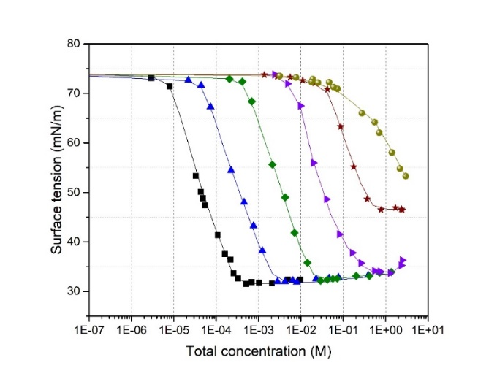
Figure S5.1: Adsorption isotherm for TritonX100 + Glutaric acid mixtures: () black curve TritonX100; () blue curve: x = 0.13; () green curve: x = 0.016; () violet curve: x = 0.00167; () wine curve: x = 0.00015 and () yellow curve: Glutaric acid; Total concentration = [TritonX100] + [Glutaric acid].
Table S5.5: TritonX100 + 0.065 M Glutaric acid mixtures
∝ Glutaric acid | ∝ TritonX100 | [Glutaric acid] (M) | [TritonX100] (M) | σ (mN/m)
1.43E-03 | 1.81E-04 | 7.9E-02 | 1.0E-02 | 32.67
1.20E-03 | 8.74E-05 | 6.7E-02 | 4.8E-03 | 32.60
1.21E-03 | 1.61E-05 | 6.7E-02 | 8.9E-04 | 32.63
1.18E-03 | 1.31E-05 | 6.5E-02 | 7.2E-04 | 32.50
1.19E-03 | 8.64E-06 | 6.6E-02 | 4.8E-04 | 33.75
1.16E-03 | 6.50E-06 | 6.4E-02 | 3.6E-04 | 35.02
1.15E-03 | 4.93E-06 | 6.4E-02 | 2.7E-04 | 35.40
1.16E-03 | 3.64E-06 | 6.4E-02 | 2.0E-04 | 36.92
1.21E-03 | 1.66E-06 | 6.7E-02 | 9.2E-05 | 43.88
1.11E-03 | 1.24E-06 | 6.2E-02 | 6.8E-05 | 45.63
1.16E-03 | 7.76E-07 | 6.4E-02 | 4.3E-05 | 49.65
1.14E-03 | 4.78E-07 | 6.3E-02 | 2.6E-05 | 54.75
1.16E-03 | 4.02E-07 | 6.4E-02 | 2.2E-05 | 56.04
1.15E-03 | 1.13E-07 | 6.4E-02 | 6.2E-06 | 67.50
1.22E-03 | 0.00E+00 | 6.7E-02 | 0.0E+00 | 70.57
Table S5.6: TritonX100 + 0.65 M Glutaric acid mixtures
∝ Glutaric acid | ∝ TritonX100 | [Glutaric acid] (M) | [TritonX100] (M) | σ (mN/m)
1.22E-02 | 1.93E-04 | 6.4E-01 | 1.0E-02 | 33.88
1.31E-02 | 9.70E-05 | 6.9E-01 | 5.1E-03 | 33.76
1.22E-02 | 1.73E-05 | 6.5E-01 | 9.1E-04 | 33.43
1.23E-02 | 1.37E-05 | 6.5E-01 | 7.3E-04 | 33.92
1.23E-02 | 8.80E-06 | 6.5E-01 | 4.7E-04 | 37.40
1.20E-02 | 7.23E-06 | 6.4E-01 | 3.8E-04 | 38.47
1.21E-02 | 5.23E-06 | 6.4E-01 | 2.8E-04 | 39.67
1.21E-02 | 3.98E-06 | 6.4E-01 | 2.1E-04 | 41.85
1.21E-02 | 2.45E-06 | 6.4E-01 | 1.3E-04 | 44.76
1.22E-02 | 1.34E-06 | 6.4E-01 | 7.1E-05 | 48.85
1.22E-02 | 1.13E-06 | 6.5E-01 | 6.0E-05 | 49.28
1.21E-02 | 8.40E-07 | 6.4E-01 | 4.4E-05 | 49.57
1.20E-02 | 4.25E-07 | 6.4E-01 | 2.2E-05 | 53.74
1.22E-02 | 3.91E-07 | 6.5E-01 | 2.1E-05 | 54.43
1.19E-02 | 1.25E-07 | 6.3E-01 | 6.6E-06 | 60.66
1.21E-02 | 0.00E+00 | 6.4E-01 | 0.0E+00 | 62.15

Table S5.7: TritonX100 + 2.7 M Glutaric acid mixtures
∝ Glutaric acid | ∝ TritonX100 | [Glutaric acid] (M) | [TritonX100] (M) | σ (mN/m)
5.56E-02 | 4.39E-04 | 2.5E+00 | 2.0E-02 | 34.34
6.26E-02 | 3.07E-04 | 2.8E+00 | 1.4E-02 | 33.85
5.67E-02 | 9.72E-05 | 2.6E+00 | 4.4E-03 | 36.62
6.43E-02 | 2.35E-05 | 2.8E+00 | 1.0E-03 | 44.30
6.20E-02 | 1.70E-05 | 2.7E+00 | 7.5E-04 | 44.38
6.36E-02 | 1.20E-05 | 2.8E+00 | 5.3E-04 | 46.50
6.10E-02 | 8.69E-06 | 2.7E+00 | 3.8E-04 | 47.60
6.11E-02 | 6.18E-06 | 2.7E+00 | 2.7E-04 | 48.80
6.28E-02 | 4.51E-06 | 2.8E+00 | 2.0E-04 | 49.90
6.24E-02 | 2.42E-06 | 2.7E+00 | 1.1E-04 | 50.60
6.38E-02 | 1.91E-06 | 2.8E+00 | 8.4E-05 | 50.60
6.30E-02 | 1.08E-06 | 2.8E+00 | 4.7E-05 | 51.70
6.30E-02 | 7.85E-07 | 2.8E+00 | 3.4E-05 | 52.20
6.34E-02 | 3.47E-07 | 2.8E+00 | 1.5E-05 | 52.40
6.48E-02 | 3.22E-07 | 2.8E+00 | 1.4E-05 | 52.10
6.11E-02 | 1.86E-07 | 2.7E+00 | 8.2E-06 | 53.51
6.24E-02 | 0.00E+00 | 2.7E+00 | 0.0E+00 | 53.73
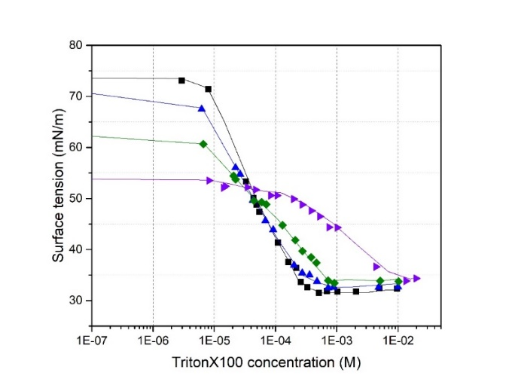
Figure S5.2: Adsorption isotherm for TritonX100 + Glutaric acid mixtures: () black curve: TritonX100; () blue curve: TritonX100 + 0.065 M glutaric acid; () green curve: TritonX100 + 0.65 M glutaric acid and () violet curve: TritonX100 + 2.7 M glutaric acid.

Brij35 + Glutaric acid
Table S5.8: Brij35 + Glutaric acid mixtures (x = 0.13)
∝ Glutaric acid | ∝ Brij35 | [Glutaric acid] (M) | [Brij35] (M) | σ (mN/m)
1.15E-03 | 1.75E-04 | 6.3E-02 | 9.6E-03 | 45.08
9.17E-04 | 1.39E-04 | 5.1E-02 | 7.7E-03 | 45.05
5.69E-04 | 8.62E-05 | 3.2E-02 | 4.8E-03 | 44.95
2.83E-04 | 4.29E-05 | 1.6E-02 | 2.4E-03 | 45.31
1.12E-04 | 1.69E-05 | 6.2E-03 | 9.4E-04 | 45.35
5.54E-05 | 8.40E-06 | 3.1E-03 | 4.7E-04 | 45.11
2.73E-05 | 4.14E-06 | 1.5E-03 | 2.3E-04 | 46.02
1.09E-05 | 1.65E-06 | 6.1E-04 | 9.2E-05 | 48.92
8.71E-06 | 1.32E-06 | 4.8E-04 | 7.3E-05 | 50.96
5.45E-06 | 8.27E-07 | 3.0E-04 | 4.6E-05 | 53.69
2.72E-06 | 4.13E-07 | 1.5E-04 | 2.3E-05 | 57.69
1.09E-06 | 1.65E-07 | 6.0E-05 | 9.2E-06 | 61.91
6.35E-07 | 9.64E-08 | 3.5E-05 | 5.4E-06 | 70.74
0.00E+00 | 0.00E+00 | 0.0E+00 | 0.0E+00 | 73.40
Table S5.9: Brij35 + Glutaric acid mixtures (x = 0.014)
∝ Glutaric acid | ∝ Brij35 | [Glutaric acid] (M) | [Brij35] (M) | σ (mN/m)
1.34E-02 | 1.86E-04 | 6.9E-01 | 9.7E-03 | 43.24
1.05E-02 | 1.46E-04 | 5.8E-01 | 8.2E-03 | 43.67
6.37E-03 | 8.91E-05 | 3.5E-01 | 5.0E-03 | 43.81
3.09E-03 | 4.33E-05 | 1.7E-01 | 2.4E-03 | 44.44
1.21E-03 | 1.70E-05 | 6.7E-02 | 9.5E-04 | 44.74
5.98E-04 | 8.41E-06 | 3.3E-02 | 4.7E-04 | 45.30
2.99E-04 | 4.21E-06 | 1.7E-02 | 2.3E-04 | 45.55
1.18E-04 | 1.66E-06 | 6.5E-03 | 9.2E-05 | 48.57
9.41E-05 | 1.32E-06 | 5.2E-03 | 7.4E-05 | 49.24
5.85E-05 | 8.23E-07 | 3.3E-03 | 4.6E-05 | 53.09
2.91E-05 | 4.09E-07 | 1.6E-03 | 2.3E-05 | 57.01
1.20E-05 | 1.69E-07 | 6.7E-04 | 9.4E-06 | 61.55
7.21E-06 | 1.01E-07 | 4.0E-04 | 5.6E-06 | 68.61
0.00E+00 | 0.00E+00 | 0.0E+00 | 0.0E+00 | 73.90

Table S5.10: Brij35 + Glutaric acid mixtures (x = 0.0015)
∝ Glutaric acid | ∝ Brij35 | [Glutaric acid] (M) | [Brij35] (M) | σ (mN/m)
4.52E-02 | 6.77E-05 | 2.1E+00 | 3.2E-03 | 40.45
3.51E-02 | 5.09E-05 | 2.0E+00 | 2.9E-03 | 41.90
1.99E-02 | 2.92E-05 | 1.1E+00 | 1.7E-03 | 42.77
9.41E-03 | 1.40E-05 | 5.2E-01 | 7.8E-04 | 43.47
3.31E-03 | 4.94E-06 | 1.8E-01 | 2.8E-04 | 43.86
1.62E-03 | 2.42E-06 | 9.0E-02 | 1.4E-04 | 47.31
7.96E-04 | 1.19E-06 | 4.4E-02 | 6.6E-05 | 52.60
2.91E-04 | 4.36E-07 | 1.6E-02 | 2.4E-05 | 56.87
1.46E-04 | 2.19E-07 | 8.1E-03 | 1.2E-05 | 62.70
9.07E-05 | 1.36E-07 | 5.0E-03 | 7.6E-06 | 66.77
4.52E-05 | 6.78E-08 | 2.5E-03 | 3.8E-06 | 73.73
2.23E-05 | 3.34E-08 | 1.2E-03 | 1.9E-06 | 73.90
1.09E-05 | 1.64E-08 | 6.1E-04 | 9.1E-07 | 74.05
0.00E+00 | 0.00E+00 | 0.0E+00 | 0.0E+00 | 73.74
Table S5.11: Adsorption isotherm for Brij35 + Glutaric acid (x = 0.00014)
∝ Glutaric acid | ∝ Brij35 | [Glutaric acid] (M) | [Brij35] (M) | σ (mN/m)
5.39E-02 | 7.54E-06 | 2.4E+00 | 3.4E-04 | 44.03
4.12E-02 | 5.55E-06 | 2.3E+00 | 3.2E-04 | 45.47
2.27E-02 | 3.10E-06 | 1.3E+00 | 1.8E-04 | 45.70
1.07E-02 | 1.48E-06 | 5.9E-01 | 8.3E-05 | 47.46
3.90E-03 | 5.45E-07 | 2.2E-01 | 3.0E-05 | 53.17
1.88E-03 | 2.63E-07 | 1.0E-01 | 1.5E-05 | 58.08
9.41E-04 | 1.32E-07 | 5.2E-02 | 7.3E-06 | 63.78
3.43E-04 | 4.81E-08 | 1.9E-02 | 2.7E-06 | 72.13
1.69E-04 | 2.36E-08 | 9.4E-03 | 1.3E-06 | 72.73
8.44E-05 | 1.18E-08 | 4.7E-03 | 6.6E-07 | 73.13
4.22E-05 | 5.91E-09 | 2.3E-03 | 3.3E-07 | 73.10
2.11E-05 | 2.95E-09 | 1.2E-03 | 1.6E-07 | 73.41
1.05E-05 | 1.48E-09 | 5.9E-04 | 8.2E-08 | 73.44
0.00E+00 | 0.00E+00 | 0.0E+00 | 0.0E+00 | 73.83
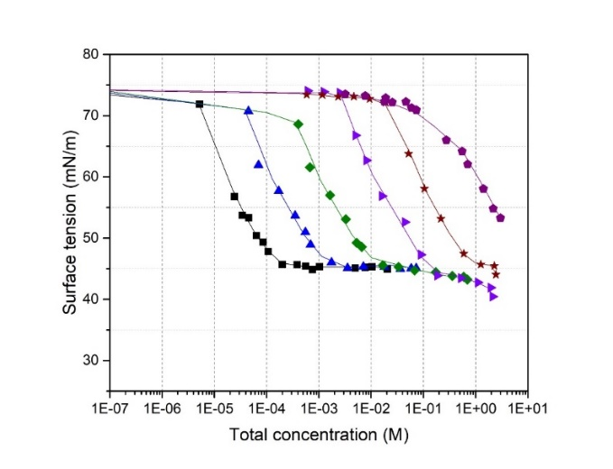
Figure S5.3: Adsorption isotherms for Brij35 + Glutaric acid mixtures: () black curve: Brij35; () blue curve: x = 0.13; () green curve: x = 0.014; () violet curve: x = 0.0015; () wine curve: x = 0.00014 and () purple curve: Glutaric acid solutions; Total concentration = [Brij35] + [Glutaric acid]

Table S5.12: Adsorption isotherm for Brij35 + 0.65 M Glutaric acid mixtures
∝ Glutaric acid | ∝ Brij35 | [Glutaric acid] (M) | [Brij35] (M) | σ (mN/m)
1.27E-02 | 1.87E-04 | 6.7E-01 | 9.9E-03 | 43.39
1.24E-02 | 1.49E-04 | 6.5E-01 | 7.9E-03 | 43.53
1.26E-02 | 9.56E-05 | 6.7E-01 | 5.1E-03 | 43.12
1.26E-02 | 1.90E-05 | 6.7E-01 | 1.0E-03 | 43.51
1.23E-02 | 1.50E-05 | 6.5E-01 | 7.9E-04 | 43.89
1.27E-02 | 9.61E-06 | 6.7E-01 | 5.1E-04 | 43.25
1.27E-02 | 6.59E-06 | 6.7E-01 | 3.5E-04 | 43.70
1.26E-02 | 2.07E-06 | 6.7E-01 | 1.1E-04 | 46.58
1.24E-02 | 1.53E-06 | 6.6E-01 | 8.1E-05 | 47.67
1.28E-02 | 1.17E-06 | 6.7E-01 | 6.2E-05 | 49.09
1.30E-02 | 7.52E-07 | 6.8E-01 | 4.0E-05 | 50.88
1.26E-02 | 4.18E-07 | 6.7E-01 | 2.2E-05 | 53.37
1.26E-02 | 3.75E-07 | 6.7E-01 | 2.0E-05 | 53.47
1.21E-02 | 2.34E-07 | 6.4E-01 | 1.2E-05 | 54.64
1.15E-02 | 1.15E-07 | 6.1E-01 | 6.1E-06 | 59.44
1.24E-02 | 0.00E+00 | 6.5E-01 | 0.0E+00 | 62.80
Table S5.13: Adsorption isotherm for Brij35 + 2 M Glutaric acid mixtures
∝ Glutaric acid | ∝ Brij35 | [Glutaric acid] (M) | [Brij35] (M) | σ (mN/m)
4.37E-02 | 1.17E-04 | 2.1E+00 | 5.5E-03 | 40.77
4.43E-02 | 2.33E-05 | 2.1E+00 | 1.1E-03 | 41.20
4.44E-02 | 1.86E-05 | 2.1E+00 | 8.8E-04 | 41.86
4.43E-02 | 1.17E-05 | 2.1E+00 | 5.5E-04 | 42.80
4.37E-02 | 8.24E-06 | 2.1E+00 | 3.9E-04 | 44.09
4.41E-02 | 3.37E-06 | 2.1E+00 | 1.6E-04 | 44.73
4.44E-02 | 1.86E-06 | 2.1E+00 | 8.8E-05 | 47.38
4.43E-02 | 1.31E-06 | 2.1E+00 | 6.1E-05 | 46.97
4.43E-02 | 9.58E-07 | 2.1E+00 | 4.5E-05 | 48.18
4.41E-02 | 4.95E-07 | 2.1E+00 | 2.3E-05 | 50.09
4.42E-02 | 2.94E-07 | 2.1E+00 | 1.4E-05 | 49.45
4.16E-02 | 2.56E-07 | 2.0E+00 | 1.2E-05 | 51.15
4.60E-02 | 1.16E-07 | 2.1E+00 | 5.4E-06 | 52.63
4.43E-02 | 0.00E+00 | 2.1E+00 | 0.0E+00 | 54.82

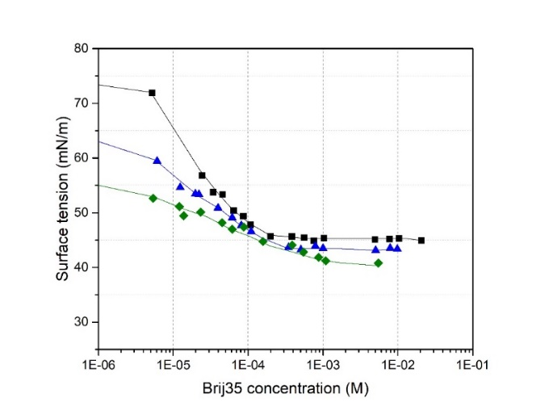
Figure S5.4: Adsorption isotherms for Brij35 + Glutaric acid mixtures: () black curve: Brij35; () blue curve: Brij35 + 0.65 M glutaric acid; () green curve: Brij35 + 2 M glutaric acid.

TritonX114 + Glutaric acid
Table S5.14: TritonX114 solutions
[TritonX114] (M) | σ (mN/m) | [TritonX114] (M) | σ (mN/m)
9.9E-03 | 30.14 | 9.5E-05 | 39.88
7.0E-03 | 30.16 | 4.7E-05 | 46.17
3.7E-03 | 29.67 | 2.2E-05 | 58.00
1.9E-03 | 29.83 | 9.1E-06 | 69.32
9.1E-04 | 29.63 | 4.0E-06 | 72.71
4.5E-04 | 29.48 | 0.0E+00 | 73.51
2.2E-04 | 31.54
Table S5.15: TritonX114 + 0.6 M Glutaric acid mixtures
∝ Glutaric acid | ∝ TritonX114 | [Glutaric acid] (M) | [TritonX114] (M) | σ (mN/m)
1.25E-02 | 8.79E-05 | 6.6E-01 | 4.6E-03 | 30.80
1.27E-02 | 2.60E-05 | 6.7E-01 | 1.4E-03 | 30.56
1.29E-02 | 1.40E-05 | 6.8E-01 | 7.4E-04 | 31.16
1.27E-02 | 1.01E-05 | 6.7E-01 | 5.3E-04 | 33.02
1.27E-02 | 6.62E-06 | 6.7E-01 | 3.5E-04 | 35.11
1.24E-02 | 4.06E-06 | 6.6E-01 | 2.1E-04 | 38.36
1.26E-02 | 1.79E-06 | 6.6E-01 | 9.4E-05 | 45.68
1.23E-02 | 8.65E-07 | 6.5E-01 | 4.6E-05 | 51.01
1.24E-02 | 4.37E-07 | 6.6E-01 | 2.3E-05 | 56.53
1.25E-02 | 2.09E-07 | 6.6E-01 | 1.1E-05 | 58.64
1.19E-02 | 1.65E-07 | 6.3E-01 | 8.7E-06 | 59.15
1.14E-02 | 1.32E-07 | 6.1E-01 | 7.0E-06 | 59.55
1.29E-02 | 0.0E+00 | 6.8E-01 | 0.0E+00 | 62.08

Table S5.16: TritonX114 + 2 M Glutaric acid mixtures
∝ Glutaric acid | ∝ TritonX114 | [Glutaric acid] (M) | [TritonX114] (M) | σ (mN/m)
4.05E-02 | 9.17E-04 | 1.9E+00 | 4.4E-02 | 31.76
4.02E-02 | 2.80E-04 | 1.9E+00 | 1.3E-02 | 31.83
4.68E-02 | 1.40E-04 | 2.2E+00 | 6.5E-03 | 31.30
4.53E-02 | 6.23E-05 | 2.1E+00 | 2.9E-03 | 33.00
4.42E-02 | 3.07E-05 | 2.1E+00 | 1.4E-03 | 37.01
4.52E-02 | 1.69E-05 | 2.1E+00 | 7.9E-04 | 40.21
4.52E-02 | 1.13E-05 | 2.1E+00 | 5.3E-04 | 42.83
4.44E-02 | 8.27E-06 | 2.1E+00 | 3.9E-04 | 44.24
4.42E-02 | 5.05E-06 | 2.1E+00 | 2.4E-04 | 44.86
4.48E-02 | 2.35E-06 | 2.1E+00 | 1.1E-04 | 48.45
4.45E-02 | 1.23E-06 | 2.1E+00 | 5.8E-05 | 48.83
4.61E-02 | 6.48E-07 | 2.1E+00 | 3.0E-05 | 50.13
4.45E-02 | 2.49E-07 | 2.1E+00 | 1.2E-05 | 51.05
4.38E-02 | 2.23E-07 | 2.1E+00 | 1.0E-05 | 50.42
4.13E-02 | 9.01E-08 | 2.0E+00 | 4.3E-06 | 53.63
4.68E-02 | 0.0E+00 | 2.2E+00 | 0.0E+00 | 54.82
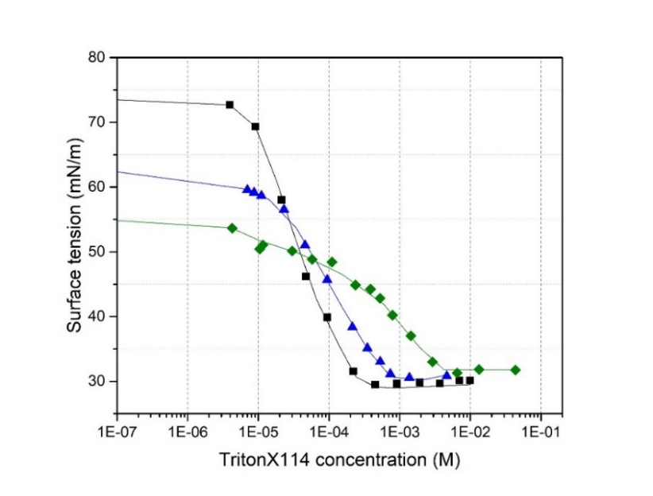
Figure S5.5: Adsorption isotherms for TritonX114 + Glutaric acid mixtures: () black curve: TritonX114; () blue curve: TritonX114 + 0.6 M glutaric acid; () green curve: TritonX114 + 2 M glutaric acid.

TritonX100 + Oxalic acid
Table S5.17: Oxalic acid solutions
[Oxalic acid] (M) | σ (mN/m) | [Oxalic acid] (M) | σ (mN/m)
9.2E-01 | 68.47 | 3.7E-02 | 72.88
7.6E-01 | 68.59 | 2.6E-02 | 72.92
5.7E-01 | 69.78 | 1.9E-02 | 73.53
3.8E-01 | 70.09 | 1.0E-02 | 72.98
1.9E-01 | 72.00 | 5.8E-03 | 73.54
1.2E-01 | 71.63 | 1.1E-03 | 73.25
7.6E-02 | 72.94 | 0.0E+00 | 73.87
5.7E-02 | 72.71

Table S5.18: TritonX100 + Oxalic acid mixtures (x = 0.1)
∝ Oxalic acid | ∝ TritonX100 | [Oxalic acid] (M) | [TritonX100] (M) | σ (mN/m)
1.43E-02 | 1.56E-03 | 7.4E-01 | 8.1E-02 | 31.43
1.06E-02 | 1.15E-03 | 5.9E-01 | 6.4E-02 | 31.87
5.09E-03 | 5.53E-04 | 2.8E-01 | 3.1E-02 | 32.16
2.53E-03 | 2.75E-04 | 1.4E-01 | 1.5E-02 | 32.35
1.25E-03 | 1.36E-04 | 6.9E-02 | 7.6E-03 | 32.45
6.24E-04 | 6.81E-05 | 3.5E-02 | 3.8E-03 | 32.43
3.14E-04 | 3.43E-05 | 1.7E-02 | 1.9E-03 | 32.08
1.57E-04 | 1.71E-05 | 8.7E-03 | 9.5E-04 | 32.07
7.89E-05 | 8.62E-06 | 4.4E-03 | 4.8E-04 | 31.83
3.99E-05 | 4.36E-06 | 2.2E-03 | 2.4E-04 | 33.50
2.01E-05 | 2.20E-06 | 1.1E-03 | 1.2E-04 | 41.80
9.80E-06 | 1.07E-06 | 5.4E-04 | 5.9E-05 | 47.93
4.92E-06 | 5.37E-07 | 2.7E-04 | 3.0E-05 | 56.80
2.45E-06 | 2.68E-07 | 1.4E-04 | 1.5E-05 | 65.28
6.20E-07 | 6.77E-08 | 3.4E-05 | 3.8E-06 | 73.01
0.00E+00 | 0.00E+00 | 0.0E+00 | 0.0E+00 | 73.58
Table S5.19: TritonX100 + Oxalic acid mixtures (x = 0.01)
∝ Oxalic acid | ∝ TritonX100 | [Oxalic acid] (M) | [TritonX100] (M) | σ (mN/m)
1.58E-02 | 1.73E-04 | 8.5E-01 | 9.0E-03 | 31.68
1.19E-02 | 1.28E-04 | 6.6E-01 | 7.2E-03 | 31.92
5.70E-03 | 6.21E-05 | 3.2E-01 | 3.5E-03 | 32.08
2.81E-03 | 3.08E-05 | 1.6E-01 | 1.7E-03 | 31.97
1.40E-03 | 1.53E-05 | 7.8E-02 | 8.5E-04 | 31.92
6.74E-04 | 7.38E-06 | 3.7E-02 | 4.1E-04 | 31.70
3.39E-04 | 3.71E-06 | 1.9E-02 | 2.1E-04 | 35.44
1.68E-04 | 1.84E-06 | 9.3E-03 | 1.0E-04 | 43.46
8.24E-05 | 9.04E-07 | 4.6E-03 | 5.0E-05 | 49.51
4.10E-05 | 4.50E-07 | 2.3E-03 | 2.5E-05 | 57.87
2.05E-05 | 2.25E-07 | 1.1E-03 | 1.3E-05 | 66.23
1.01E-05 | 1.11E-07 | 5.6E-04 | 6.2E-06 | 73.57
4.98E-06 | 5.46E-08 | 2.8E-04 | 3.0E-06 | 73.16
2.49E-06 | 2.73E-08 | 1.4E-04 | 1.5E-06 | 73.53
0.00E+00 | 0.00E+00 | 0.0E+00 | 0.0E+00 | 73.58

Table S5.20: TritonX100 + Oxalic acid mixtures (x = 0.0011)
∝ Oxalic acid | ∝ TritonX100 | [Oxalic acid] (M) | [TritonX100] (M) | σ (mN/m)
1.55E-02 | 1.67E-05 | 8.4E-01 | 9.0E-04 | 31.23
1.15E-02 | 1.22E-05 | 6.4E-01 | 6.9E-04 | 31.58
5.57E-03 | 5.96E-06 | 3.1E-01 | 3.3E-04 | 32.21
2.78E-03 | 2.98E-06 | 1.5E-01 | 1.7E-04 | 38.11
1.32E-03 | 1.42E-06 | 7.3E-02 | 7.9E-05 | 44.73
6.65E-04 | 7.16E-07 | 3.7E-02 | 4.0E-05 | 52.21
3.32E-04 | 3.57E-07 | 1.8E-02 | 2.0E-05 | 59.85
1.67E-04 | 1.80E-07 | 9.3E-03 | 1.0E-05 | 70.48
8.27E-05 | 8.90E-08 | 4.6E-03 | 4.9E-06 | 73.00
4.14E-05 | 4.46E-08 | 2.3E-03 | 2.5E-06 | 73.06
2.07E-05 | 2.23E-08 | 1.2E-03 | 1.2E-06 | 73.55
1.03E-05 | 1.11E-08 | 5.7E-04 | 6.2E-07 | 73.18
0.00E+00 | 0.00E+00 | 0.0E+00 | 0.0E+00 | 73.58
Table S5.21: TritonX100 + Oxalic acid mixtures (x = 0.00047)
∝ Oxalic acid | ∝ TritonX100 | [Oxalic acid] (M) | [TritonX100] (M) | σ (mN/m)
1.57E-02 | 7.41E-06 | 8.5E-01 | 4.0E-04 | 31.38
7.55E-03 | 3.55E-06 | 4.2E-01 | 2.0E-04 | 36.74
3.74E-03 | 1.76E-06 | 2.1E-01 | 9.8E-05 | 42.87
1.85E-03 | 8.73E-07 | 1.0E-01 | 4.9E-05 | 49.25
9.06E-04 | 4.28E-07 | 5.0E-02 | 2.4E-05 | 57.58
4.54E-04 | 2.15E-07 | 2.5E-02 | 1.2E-05 | 67.10
2.30E-04 | 1.09E-07 | 1.3E-02 | 6.0E-06 | 72.54
1.14E-04 | 5.40E-08 | 6.3E-03 | 3.0E-06 | 73.00
5.74E-05 | 2.71E-08 | 3.2E-03 | 1.5E-06 | 73.48
2.88E-05 | 1.36E-08 | 1.6E-03 | 7.6E-07 | 73.43
1.46E-05 | 6.88E-09 | 8.1E-04 | 3.8E-07 | 73.51
0.00E+00 | 0.00E+00 | 0.0E+00 | 0.0E+00 | 73.59
Table S5.22: TritonX100 + Oxalic acid mixtures (x = 0.00013)
∝ Oxalic acid | ∝ TritonX100 | [Oxalic acid] (M) | [TritonX100] (M) | σ (mN/m)
1.56E-02 | 2.01E-06 | 8.4E-01 | 1.1E-04 | 41.03
7.63E-03 | 9.77E-07 | 4.2E-01 | 5.5E-05 | 46.13
5.60E-03 | 7.18E-07 | 3.1E-01 | 4.0E-05 | 50.88
2.69E-03 | 3.45E-07 | 1.5E-01 | 1.9E-05 | 58.53
2.00E-03 | 2.57E-07 | 1.1E-01 | 1.4E-05 | 61.80
9.83E-04 | 1.27E-07 | 5.5E-02 | 7.0E-06 | 72.03
4.88E-04 | 6.29E-08 | 2.7E-02 | 3.5E-06 | 72.81
2.30E-04 | 2.96E-08 | 1.3E-02 | 1.6E-06 | 73.14
1.10E-04 | 1.42E-08 | 6.1E-03 | 7.9E-07 | 73.21
5.42E-05 | 6.99E-09 | 3.0E-03 | 3.9E-07 | 73.51
2.64E-05 | 3.41E-09 | 1.5E-03 | 1.9E-07 | 73.22
0.00E+00 | 0.00E+00 | 0.0E+00 | 0.0E+00 | 73.57
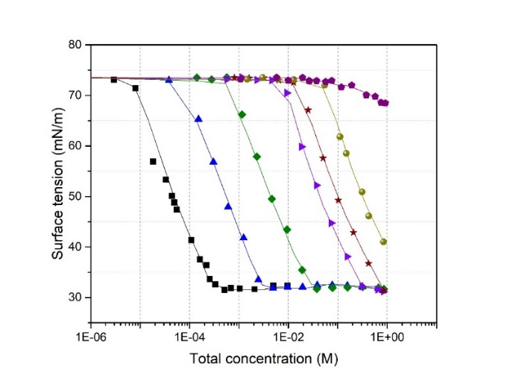
Figure S5.6: Adsorption isotherms for TritonX100 + oxalic acid mixtures: () black curve: TritonX100; () blue curve: x = 0.1; () green curve: x = 0.01; () violet curve: x = 0.0011; () wine curve: x = 0.00047; () yellow curve: x = 0.00013 and () purple curve: Oxalic acid; Total concentration = [TritonX100] + [Oxalic acid].

Brij35 + Oxalic acid
Table S5.23: Brij35 + Oxalic acid mixtures (x = 0.091)
∝ Oxalic acid | ∝ Brij35 | [Oxalic acid] (M) | [Brij35] (M) | σ (mN/m)
4.33E-03 | 4.51E-04 | 2.3E-01 | 2.4E-02 | 43.50
2.09E-03 | 2.17E-04 | 1.2E-01 | 1.2E-02 | 44.34
1.04E-03 | 1.08E-04 | 5.8E-02 | 6.0E-03 | 44.44
5.17E-04 | 5.38E-05 | 2.9E-02 | 3.0E-03 | 44.67
2.58E-04 | 2.68E-05 | 1.4E-02 | 1.5E-03 | 43.88
1.28E-04 | 1.33E-05 | 7.1E-03 | 7.4E-04 | 44.29
6.48E-05 | 6.74E-06 | 3.6E-03 | 3.7E-04 | 44.18
1.58E-05 | 1.64E-06 | 8.8E-04 | 9.1E-05 | 47.07
3.92E-06 | 4.07E-07 | 2.2E-04 | 2.3E-05 | 55.93
1.96E-06 | 2.04E-07 | 1.1E-04 | 1.1E-05 | 59.51
9.81E-07 | 1.02E-07 | 5.5E-05 | 5.7E-06 | 67.59
2.48E-07 | 2.58E-08 | 1.4E-05 | 1.4E-06 | 72.53
6.29E-08 | 6.54E-09 | 3.5E-06 | 3.6E-07 | 72.15
0.00E+00 | 0.00E+00 | 0.0E+00 | 0.0E+00 | 73.28

Table S5.24: Brij35 + Oxalic acid mixtures (x = 0.0099)
∝ Oxalic acid | ∝ Brij35 | [Oxalic acid] (M) | [Brij35] (M) | σ (mN/m)
1.32E-02 | 1.33E-04 | 7.1E-01 | 7.2E-03 | 42.72
9.72E-03 | 9.69E-05 | 5.4E-01 | 5.4E-03 | 43.08
7.19E-03 | 7.19E-05 | 4.0E-01 | 4.0E-03 | 43.34
5.37E-03 | 5.37E-05 | 3.0E-01 | 3.0E-03 | 43.81
2.66E-03 | 2.67E-05 | 1.5E-01 | 1.5E-03 | 44.10
1.32E-03 | 1.33E-05 | 7.3E-02 | 7.4E-04 | 44.50
6.58E-04 | 6.62E-06 | 3.7E-02 | 3.7E-04 | 44.58
1.63E-04 | 1.64E-06 | 9.0E-03 | 9.1E-05 | 48.06
4.09E-05 | 4.12E-07 | 2.3E-03 | 2.3E-05 | 55.44
2.04E-05 | 2.05E-07 | 1.1E-03 | 1.1E-05 | 59.85
1.03E-05 | 1.04E-07 | 5.7E-04 | 5.8E-06 | 68.54
2.13E-06 | 2.14E-08 | 1.2E-04 | 1.2E-06 | 73.12
1.07E-06 | 1.07E-08 | 5.9E-05 | 6.0E-07 | 73.30
0.00E+00 | 0.00E+00 | 0.0E+00 | 0.0E+00 | 73.27
Table S5.25: Brij35 + Oxalic acid mixtures (x = 0.00111)
∝ Oxalic acid | ∝ Brij35 | [Oxalic acid] (M) | [Brij35] (M) | σ (mN/m)
1.67E-02 | 1.84E-05 | 9.0E-01 | 1.0E-03 | 42.06
1.25E-02 | 1.36E-05 | 6.9E-01 | 7.6E-04 | 43.13
9.19E-03 | 1.01E-05 | 5.1E-01 | 5.6E-04 | 43.48
4.58E-03 | 5.05E-06 | 2.5E-01 | 2.8E-04 | 44.01
2.29E-03 | 2.53E-06 | 1.3E-01 | 1.4E-04 | 45.49
1.14E-03 | 1.26E-06 | 6.3E-02 | 7.0E-05 | 50.28
5.74E-04 | 6.34E-07 | 3.2E-02 | 3.5E-05 | 53.01
2.86E-04 | 3.17E-07 | 1.6E-02 | 1.8E-05 | 58.06
1.43E-04 | 1.58E-07 | 7.9E-03 | 8.8E-06 | 61.50
7.13E-05 | 7.89E-08 | 4.0E-03 | 4.4E-06 | 69.61
3.51E-05 | 3.88E-08 | 2.0E-03 | 2.2E-06 | 72.95
8.74E-06 | 9.66E-09 | 4.9E-04 | 5.4E-07 | 73.37
0.00E+00 | 0.00E+00 | 0.0E+00 | 0.0E+00 | 73.14
Table S5.26: Brij35 + Oxalic acid mixtures (x = 0.00018)
∝ Oxalic acid | ∝ Brij35 | [Oxalic acid] (M) | [Brij35] (M) | σ (mN/m)
1.68E-02 | 3.04E-06 | 9.1E-01 | 1.6E-04 | 42.00
1.26E-02 | 2.26E-06 | 7.0E-01 | 1.3E-04 | 44.89
9.30E-03 | 1.67E-06 | 5.2E-01 | 9.4E-05 | 47.21
6.95E-03 | 1.25E-06 | 3.9E-01 | 7.0E-05 | 49.41
3.42E-03 | 6.17E-07 | 1.9E-01 | 3.4E-05 | 53.62
1.70E-03 | 3.08E-07 | 9.5E-02 | 1.7E-05 | 58.51
8.45E-04 | 1.53E-07 | 4.7E-02 | 8.5E-06 | 63.93
4.21E-04 | 7.64E-08 | 2.3E-02 | 4.2E-06 | 70.73
2.11E-04 | 3.82E-08 | 1.2E-02 | 2.1E-06 | 73.18
1.05E-04 | 1.91E-08 | 5.8E-03 | 1.1E-06 | 72.89
5.23E-05 | 9.49E-09 | 2.9E-03 | 5.3E-07 | 72.92
0.00E+00 | 0.00E+00 | 0.0E+00 | 0.0E+00 | 73.14
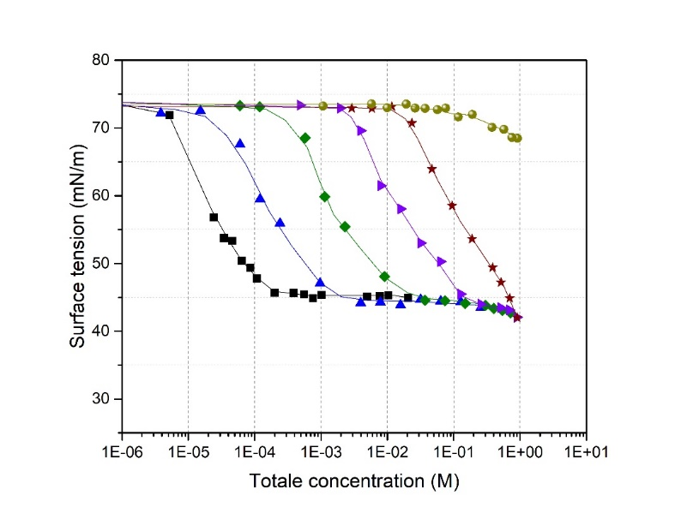
Figure S5.7: Adsorption isotherms for Brij35 + oxalic acid mixtures: () black curve: Brij35; () blue curve: x = 0.091; () green curve: x = 0.0099; () violet curve: x = 0.00111; () wine curve: x = 0.00018 and () yellow curve: Oxalic acid; Total concentration = [Brij35] + [Oxalic acid].

S6. Adsorption isotherms for mixtures of two amphiphilic surfactants

SDS + CTAC
Table S6.1: SDS solutions (x = 0)
[SDS] (M) | σ (mN/m)) | [SDS] (M) | σ (mN/m)
9.6E-02 | 34.06 | 9.9E-04 | 68.22
7.8E-02 | 34.21 | 7.7E-04 | 69.21
4.9E-02 | 34.76 | 5.1E-04 | 71.02
2.1E-02 | 35.18 | 2.7E-04 | 71.85
1.1E-02 | 34.29 | 8.3E-05 | 72.38
8.9E-03 | 33.44 | 4.1E-05 | 72.91
7.0E-03 | 37.58 | 0.0E+00 | 73.38
2.8E-03 | 55.69
Table S6.2: CTAC solutions (x = 1)
[CTAC] (M) | σ (mN/m) | [CTAC] (M) | σ (mN/m)
1.0E-01 | 38.82 | 5.4E-04 | 46.95
5.0E-02 | 39.22 | 2.7E-04 | 58.63
1.2E-02 | 40.22 | 6.6E-05 | 66.17
8.9E-03 | 39.72 | 1.5E-05 | 73.08
4.4E-03 | 39.21 | 3.7E-06 | 73.29
2.2E-03 | 38.61 | 1.8E-06 | 73.36
1.1E-03 | 38.71 | 0.0E+00 | 73.365
Table S6.3: SDS + CTAC mixtures (x = 0.33)
∝ SDS | ∝ CTAC | [SDS] (M) | [CTAC] (M) | σ (mN/m)
8.47E-04 | 1.97E-03 | 4.5E-02 | 1.0E-01 | 31.53
4.13E-04 | 9.61E-04 | 2.3E-02 | 5.3E-02 | 32.88
1.99E-04 | 4.64E-04 | 1.1E-02 | 2.6E-02 | 34.03
9.74E-05 | 2.27E-04 | 5.4E-03 | 1.3E-02 | 35.17
4.83E-05 | 1.13E-04 | 2.7E-03 | 6.3E-03 | 35.94
2.38E-05 | 5.53E-05 | 1.3E-03 | 3.1E-03 | 37.35
1.18E-05 | 2.76E-05 | 6.6E-04 | 1.5E-03 | 41.70
2.88E-06 | 6.71E-06 | 1.6E-04 | 3.7E-04 | 54.30
1.43E-06 | 3.32E-06 | 7.9E-05 | 1.8E-04 | 63.31
7.09E-07 | 1.65E-06 | 3.9E-05 | 9.2E-05 | 66.92
3.53E-07 | 8.22E-07 | 2.0E-05 | 4.6E-05 | 71.18
1.71E-07 | 3.99E-07 | 9.5E-06 | 2.2E-05 | 72.53
8.36E-08 | 1.95E-07 | 4.6E-06 | 1.1E-05 | 72.78
0.00E+00 | 0.00E+00 | 0.0E+00 | 0.0E+00 | 73.17

Table S6.4: SDS + CTAC mixtures (x = 0.5)
∝ SDS | ∝ CTAC | [SDS] (M) | [CTAC] (M) | σ (mN/m)
1.81E-03 | 1.98E-03 | 9.5E-02 | 1.0E-01 | 30.87
4.30E-04 | 4.78E-04 | 2.4E-02 | 2.6E-02 | 34.99
2.76E-04 | 3.08E-04 | 1.5E-02 | 1.7E-02 | 36.07
9.47E-05 | 1.07E-04 | 5.3E-03 | 5.9E-03 | 38.10
4.28E-05 | 4.85E-05 | 2.4E-03 | 2.7E-03 | 43.54
2.82E-05 | 3.12E-05 | 1.6E-03 | 1.7E-03 | 45.97
1.39E-05 | 1.54E-05 | 7.7E-04 | 8.6E-04 | 54.03
6.99E-06 | 7.73E-06 | 3.9E-04 | 4.3E-04 | 64.63
3.44E-06 | 3.81E-06 | 1.9E-04 | 2.1E-04 | 71.50
1.71E-06 | 1.89E-06 | 9.5E-05 | 1.1E-04 | 71.93
8.52E-07 | 9.43E-07 | 4.7E-05 | 5.2E-05 | 73.00
4.26E-07 | 4.72E-07 | 2.4E-05 | 2.6E-05 | 72.83
2.14E-07 | 2.37E-07 | 1.2E-05 | 1.3E-05 | 72.75
1.07E-07 | 1.19E-07 | 6.0E-06 | 6.6E-06 | 73.18
5.20E-08 | 5.75E-08 | 2.9E-06 | 3.2E-06 | 73.19
0.00E+00 | 0.00E+00 | 0.0E+00 | 0.0E+00 | 73.76
Table S6.5: SDS + CTAC mixtures (x = 0.66)
∝ SDS | ∝ CTAC | [SDS] (M) | [CTAC] (M) | σ (mN/m)
1.73E-03 | 9.48E-04 | 9.2E-02 | 5.1E-02 | 33.17
8.46E-04 | 4.64E-04 | 4.7E-02 | 2.6E-02 | 34.61
4.17E-04 | 2.29E-04 | 2.3E-02 | 1.3E-02 | 35.31
2.08E-04 | 1.14E-04 | 1.2E-02 | 6.4E-03 | 39.13
1.04E-04 | 5.73E-05 | 5.8E-03 | 3.2E-03 | 47.10
5.15E-05 | 2.83E-05 | 2.9E-03 | 1.6E-03 | 56.70
1.27E-05 | 6.99E-06 | 7.1E-04 | 3.9E-04 | 68.20
6.35E-06 | 3.48E-06 | 3.5E-04 | 1.9E-04 | 69.53
3.18E-06 | 1.74E-06 | 1.8E-04 | 9.7E-05 | 71.40
1.60E-06 | 8.79E-07 | 8.9E-05 | 4.9E-05 | 71.87
7.90E-07 | 4.33E-07 | 4.4E-05 | 2.4E-05 | 72.22
3.93E-07 | 2.15E-07 | 2.2E-05 | 1.2E-05 | 72.54
1.96E-07 | 1.08E-07 | 1.1E-05 | 6.0E-06 | 72.82
0.00E+00 | 0.00E+00 | 0.0E+00 | 0.0E+00 | 73.17

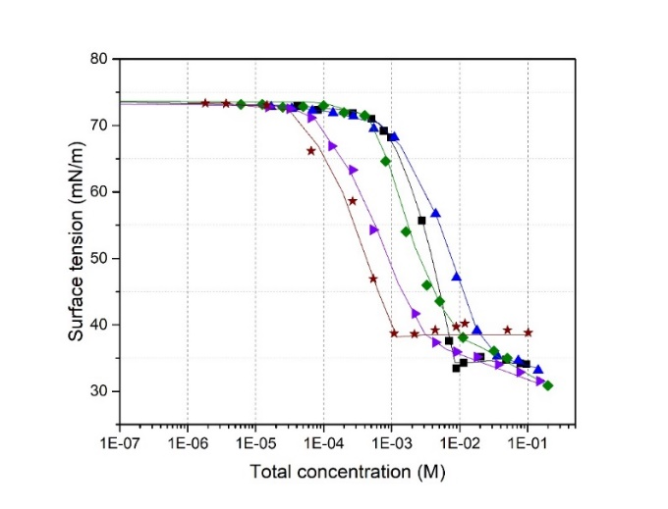
Figure S6.1: Adsorption isotherms for SDS + CTAC mixtures: () black curve: SDS; () blue curve: x = 0.66; () green curve: x = 0.5; () violet curve: x = 0.33 and () wine curve: CTAC; Total concentration = [SDS] + [CTAC].

TritonX114 + SDS
Table S6.6: TritonX114 + SDS mixtures (x = 0.1)
∝ SDS | ∝ TritonX114 | [SDS] (M) | [TritonX114] (M) | σ (mN/m)
1.06E-03 | 1.22E-04 | 5.8E-02 | 6.60E-03 | 32.34
5.22E-04 | 6.00E-05 | 2.9E-02 | 3.30E-03 | 33.06
1.74E-04 | 2.01E-05 | 9.7E-03 | 1.10E-03 | 32.69
1.39E-04 | 1.60E-05 | 7.7E-03 | 8.90E-04 | 32.84
1.03E-04 | 1.19E-05 | 5.7E-03 | 6.60E-04 | 32.73
5.18E-05 | 5.96E-06 | 2.9E-03 | 3.30E-04 | 32.61
1.75E-05 | 2.01E-06 | 9.7E-04 | 1.10E-04 | 33.99
1.39E-05 | 1.60E-06 | 7.7E-04 | 8.90E-05 | 37.20
1.03E-05 | 1.19E-06 | 5.7E-04 | 6.60E-05 | 41.62
5.28E-06 | 6.08E-07 | 2.9E-04 | 3.40E-05 | 49.60
1.77E-06 | 2.04E-07 | 9.9E-05 | 1.10E-05 | 68.38
1.42E-06 | 1.63E-07 | 7.9E-05 | 9.10E-06 | 70.24
1.03E-06 | 1.18E-07 | 5.7E-05 | 6.60E-06 | 72.31
5.52E-07 | 6.35E-08 | 3.1E-05 | 3.50E-06 | 72.90
1.65E-07 | 1.90E-08 | 9.2E-06 | 1.10E-06 | 73.26
0.00E+00 | 0.00E+00 | 0.0E+00 | 0.00E+00 | 73.69

Table S6.7: TritonX114 + SDS mixtures (x = 0.15)
∝ SDS | ∝ TritonX114 | [SDS] (M) | [TritonX114] (M) | σ (mN/m)
1.07E-03 | 2.20E-04 | 5.8E-02 | 1.2E-02 | 31.93
5.28E-04 | 1.09E-04 | 2.9E-02 | 6.0E-03 | 32.69
1.75E-04 | 3.62E-05 | 9.7E-03 | 2.0E-03 | 32.99
1.39E-04 | 2.87E-05 | 7.7E-03 | 1.6E-03 | 33.17
1.08E-04 | 2.22E-05 | 6.0E-03 | 1.2E-03 | 33.44
5.25E-05 | 1.08E-05 | 2.9E-03 | 6.0E-04 | 32.74
1.73E-05 | 3.57E-06 | 9.6E-04 | 2.0E-04 | 32.19
1.42E-05 | 2.93E-06 | 7.9E-04 | 1.6E-04 | 32.73
1.08E-05 | 2.22E-06 | 6.0E-04 | 1.2E-04 | 35.72
4.83E-06 | 9.96E-07 | 2.7E-04 | 5.5E-05 | 45.12
1.71E-06 | 3.52E-07 | 9.5E-05 | 2.0E-05 | 57.09
4.95E-07 | 1.02E-07 | 2.8E-05 | 5.7E-06 | 72.57
1.74E-07 | 3.59E-08 | 9.7E-06 | 2.0E-06 | 73.06
0.00E+00 | 0.00E+00 | 0.0E+00 | 0.0E+00 | 73.69
Table S6.8: TritonX114 + SDS mixtures (x = 0.33)
∝ SDS | ∝ TritonX114 | [SDS] (M) | [TritonX114] (M) | σ (mN/m)
1.08E-03 | 5.27E-04 | 5.8E-02 | 2.8E-02 | 30.92
6.43E-04 | 3.13E-04 | 3.6E-02 | 1.7E-02 | 31.71
2.19E-04 | 1.07E-04 | 1.2E-02 | 5.9E-03 | 32.43
1.52E-04 | 7.42E-05 | 8.5E-03 | 4.1E-03 | 32.68
1.05E-04 | 5.13E-05 | 5.8E-03 | 2.9E-03 | 32.75
6.32E-05 | 3.08E-05 | 3.5E-03 | 1.7E-03 | 32.37
2.17E-05 | 1.06E-05 | 1.2E-03 | 5.9E-04 | 32.03
1.55E-05 | 7.57E-06 | 8.6E-04 | 4.2E-04 | 31.82
1.06E-05 | 5.16E-06 | 5.9E-04 | 2.9E-04 | 31.48
6.37E-06 | 3.11E-06 | 3.5E-04 | 1.7E-04 | 32.46
2.18E-06 | 1.06E-06 | 1.2E-04 | 5.9E-05 | 44.04
1.59E-06 | 7.76E-07 | 8.8E-05 | 4.3E-05 | 47.76
1.07E-06 | 5.20E-07 | 5.9E-05 | 2.9E-05 | 52.99
2.19E-07 | 1.07E-07 | 1.2E-05 | 5.9E-06 | 72.82
1.10E-07 | 5.35E-08 | 6.1E-06 | 3.0E-06 | 73.44
0.00E+00 | 0.00E+00 | 0.0E+00 | 0.0E+00 | 73.99
Table S6.9: TritonX114 + SDS mixtures (x = 0.5)
∝ SDS | ∝ TritonX114 | [SDS] (M) | [TritonX114] (M) | σ (mN/m)
8.98E-04 | 8.74E-04 | 4.8E-02 | 4.7E-02 | 30.52
5.31E-04 | 5.17E-04 | 3.0E-02 | 2.9E-02 | 30.87
1.75E-04 | 1.71E-04 | 9.7E-03 | 9.5E-03 | 31.32
1.04E-04 | 1.01E-04 | 5.8E-03 | 5.6E-03 | 31.73
8.67E-05 | 8.44E-05 | 4.8E-03 | 4.7E-03 | 31.98
5.19E-05 | 5.05E-05 | 2.9E-03 | 2.8E-03 | 31.78
1.72E-05 | 1.67E-05 | 9.5E-04 | 9.3E-04 | 31.65
1.03E-05 | 1.00E-05 | 5.7E-04 | 5.6E-04 | 31.36
8.56E-06 | 8.34E-06 | 4.8E-04 | 4.6E-04 | 31.28
5.12E-06 | 4.99E-06 | 2.8E-04 | 2.8E-04 | 31.30
1.69E-06 | 1.65E-06 | 9.4E-05 | 9.2E-05 | 40.89
1.03E-06 | 1.00E-06 | 5.7E-05 | 5.6E-05 | 44.90
8.44E-07 | 8.21E-07 | 4.7E-05 | 4.6E-05 | 49.30
1.68E-07 | 1.63E-07 | 9.3E-06 | 9.1E-06 | 71.13
8.53E-08 | 8.30E-08 | 4.7E-06 | 4.6E-06 | 72.07
0.00E+00 | 0.00E+00 | 0.0E+00 | 0.0E+00 | 73.34
Table S6.10: TritonX114 + SDS mixtures (x = 0.66)
∝ SDS | ∝ TritonX114 | [SDS] (M) | [TritonX114] (M) | σ (mN/m)
5.43E-04 | 1.06E-03 | 2.9E-02 | 5.7E-02 | 30.26
3.22E-04 | 6.26E-04 | 1.8E-02 | 3.5E-02 | 30.67
1.06E-04 | 2.06E-04 | 5.9E-03 | 1.1E-02 | 31.02
7.30E-05 | 1.42E-04 | 4.1E-03 | 7.9E-03 | 31.24
5.23E-05 | 1.02E-04 | 2.9E-03 | 5.6E-03 | 31.43
3.18E-05 | 6.19E-05 | 1.8E-03 | 3.4E-03 | 31.32
1.06E-05 | 2.06E-05 | 5.9E-04 | 1.1E-03 | 31.04
7.26E-06 | 1.41E-05 | 4.0E-04 | 7.8E-04 | 31.19
5.26E-06 | 1.02E-05 | 2.9E-04 | 5.7E-04 | 31.06
3.22E-06 | 6.26E-06 | 1.8E-04 | 3.5E-04 | 30.77
1.05E-06 | 2.04E-06 | 5.8E-05 | 1.1E-04 | 38.15
7.31E-07 | 1.42E-06 | 4.1E-05 | 7.9E-05 | 41.74
5.24E-07 | 1.02E-06 | 2.9E-05 | 5.7E-05 | 45.49
1.07E-07 | 2.09E-07 | 6.0E-06 | 1.2E-05 | 68.59
5.34E-08 | 1.04E-07 | 3.0E-06 | 5.8E-06 | 73.45
0.00E+00 | 0.00E+00 | 0.0E+00 | 0.0E+00 | 73.51

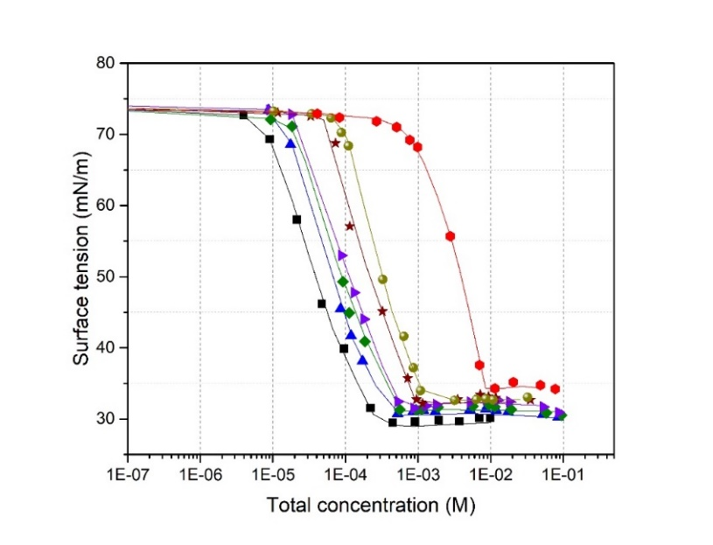
Figure S6.2: Adsorption isotherm for SDS + TritonX114 mixtures: () black curve: TritonX114; () blue curve: x = 0.66; () green curve: x = 0.5; () violet curve: x = 0.33; () wine curve: x = 0.15; () yellow curve: x = 0.1 and () red curve: SDS; Total concentration = [SDS] + [TritonX114].

S7. Adsorption isotherms for two organic acids mixtures

Glutaric acid + Oxalic acid
Table S7.1: Glutaric acid + Oxalic acid mixtures (x = 0.25)
∝ Glutaric acid | ∝ Oxalic acid | [Glutaric acid] (M) | [Oxalic acid] (M) | σ (mN/m)
5.15E-03 | 1.44E-02 | 2.7E-01 | 8.0E-01 | 64.34
3.69E-03 | 1.07E-02 | 2.0E-01 | 6.0E-01 | 66.65
2.67E-03 | 7.03E-03 | 1.4E-01 | 4.0E-01 | 68.31
1.81E-03 | 5.10E-03 | 1.0E-01 | 3.0E-01 | 69.29
1.26E-03 | 3.42E-03 | 6.9E-02 | 2.0E-01 | 70.39
9.36E-04 | 2.66E-03 | 5.0E-02 | 1.5E-01 | 70.82
7.42E-04 | 2.00E-03 | 4.0E-02 | 1.1E-01 | 71.34
5.00E-04 | 1.36E-03 | 2.7E-02 | 7.5E-02 | 72.23
3.58E-04 | 9.83E-04 | 2.0E-02 | 6.0E-02 | 72.43
2.21E-04 | 6.62E-04 | 1.2E-02 | 3.6E-02 | 72.63
1.17E-04 | 3.32E-04 | 6.5E-03 | 1.8E-02 | 72.93
7.32E-05 | 1.92E-04 | 4.0E-03 | 1.1E-02 | 72.88
4.47E-05 | 1.49E-04 | 2.5E-03 | 8.0E-03 | 73.08
0.00E+00 | 0.00E+00 | 0.0E+00 | 0.0E+00 | 73.29
Table S7.2: Glutaric acid + Oxalic acid mixtures (x = 0.4)
∝ Glutaric acid | ∝ Oxalic acid | [Glutaric acid] (M) | [Oxalic acid] (M) | σ (mN/m)
9.89E-03 | 1.37E-02 | 5.2E-01 | 7.2E-01 | 62.36
7.72E-03 | 1.08E-02 | 4.1E-01 | 5.7E-01 | 63.70
4.78E-03 | 7.24E-03 | 2.6E-01 | 3.9E-01 | 66.07
2.55E-03 | 3.44E-03 | 1.4E-01 | 1.9E-01 | 68.97
1.20E-03 | 1.74E-03 | 6.6E-02 | 9.6E-02 | 70.74
1.03E-03 | 1.33E-03 | 5.7E-02 | 7.3E-02 | 71.48
5.06E-04 | 7.09E-04 | 2.8E-02 | 3.9E-02 | 72.37
2.93E-04 | 3.42E-04 | 1.6E-02 | 1.9E-02 | 71.90
1.33E-04 | 1.87E-04 | 7.4E-03 | 1.0E-02 | 71.97
1.25E-04 | 1.76E-04 | 7.0E-03 | 9.8E-03 | 73.15
6.59E-05 | 1.17E-04 | 3.7E-03 | 6.5E-03 | 73.31
5.83E-05 | 8.35E-05 | 3.2E-03 | 4.6E-03 | 73.44
0.00E+00 | 0.00E+00 | 0.0E+00 | 0.0E+00 | 73.29

Table S7.3: Glutaric acid + Oxalic acid mixtures (x = 0.57)
∝ Glutaric acid | ∝ Oxalic acid | [Glutaric acid] (M) | [Oxalic acid] (M) | σ (mN/m)
1.56E-02 | 1.15E-02 | 8.0E-01 | 6.0E-01 | 60.35
1.29E-02 | 9.13E-03 | 7.0E-01 | 4.7E-01 | 62.19
1.04E-02 | 7.34E-03 | 5.5E-01 | 3.8E-01 | 63.31
7.33E-03 | 5.45E-03 | 3.9E-01 | 2.9E-01 | 64.87
4.98E-03 | 3.54E-03 | 2.7E-01 | 1.9E-01 | 66.58
2.65E-03 | 1.81E-03 | 1.5E-01 | 1.0E-01 | 68.24
1.92E-03 | 1.43E-03 | 1.1E-01 | 8.0E-02 | 69.59
1.40E-03 | 1.03E-03 | 7.7E-02 | 5.7E-02 | 70.84
9.40E-04 | 6.79E-04 | 5.2E-02 | 3.8E-02 | 71.21
7.52E-04 | 5.00E-04 | 4.2E-02 | 2.8E-02 | 72.03
4.69E-04 | 3.34E-04 | 2.6E-02 | 1.9E-02 | 72.56
2.50E-04 | 1.79E-04 | 1.4E-02 | 9.9E-03 | 72.73
1.90E-04 | 1.36E-04 | 1.1E-02 | 7.5E-03 | 72.94
1.34E-04 | 8.21E-05 | 7.5E-03 | 4.6E-03 | 72.54
0.00E+00 | 0.00E+00 | 0.0E+00 | 0.0E+00 | 73.29
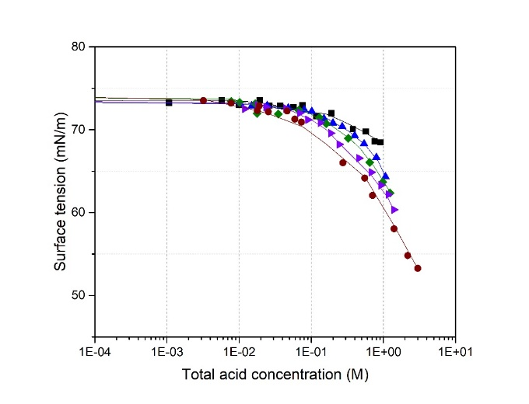
Figure S7.1: Adsorption isotherms for glutaric acid + oxalic acid mixtures: () Black curve: Oxalic acid; () blue curve: x = 0.25; () green curve: x = 0.4 () violet curve: x = 0.57 and () wine curve: Glutaric acid; Total acid concentration = [Glutaric acid] + [Oxalic acid].

Figure S8. Effects of inorganic salts on the surface tension of glutaric acid
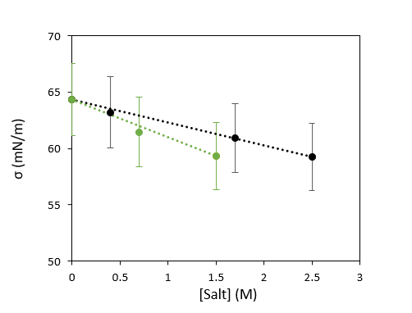
Figure S8: Effects of inorganic salts on the surface tension of glutaric acid. Variation of the surface tension for glutaric acid + salt mixtures, at [Glutaric acid] = 0.5 M: () with NaCl; () with (NH₄)₂SO₄.

S9. Effects of organic acids on the CMC of amphiphilic surfactants
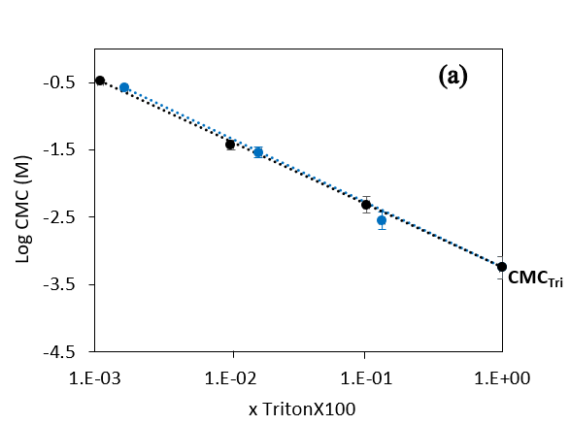
Figure S9.1: Evolution of the CMC for TritonX100 + organic acid mixtures. () TritonX100 + Glutaric acid and () TritonX100 + Oxalic acid (with x_{Triton}= molar fraction of TritonX100).
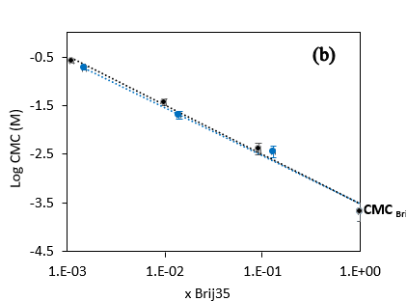
Figure S9.2: Evolution of the CMC for Brij35 + organic acid mixtures. () Brij35 + Glutaric acid and () Brij35 + Oxalic acid (x_{Brij} = molar fraction of Brij35).

S10. Evolution of the surface tension for two amphiphilic surfactant mixtures
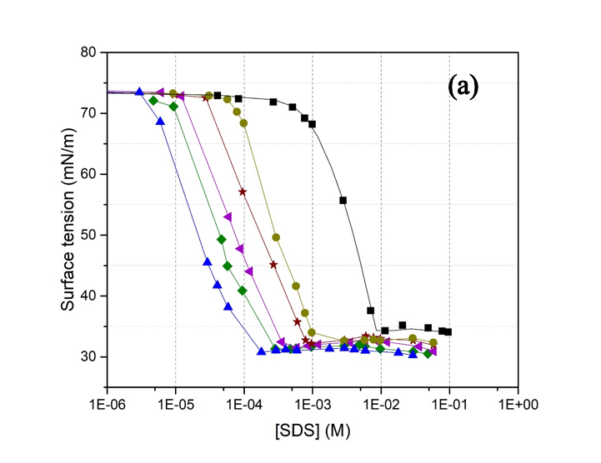
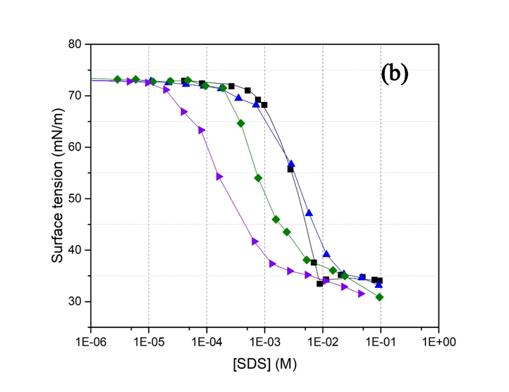
Figure S10.1: Evolution of the surface tension for mixtures of two amphiphilic surfactants with the concentration of SDS. (a) SDS + TritonX114: () black curve: SDS, () yellow curve: x = 0.9, () wine curve: x = 0.85, () violet curve: x = 0.66, () green curve: x = 0.5 and () blue curve: x = 0.33 and (b) SDS+ CTAC: () black curve: SDS; () blue curve: x = 0.66; () green curve: x = 0.5; () violet curve: x = 0.33 (with x the molar organic fraction of SDS).

Figure S11. Evolution of the surface tension for Glutaric and Oxalic acid mixtures
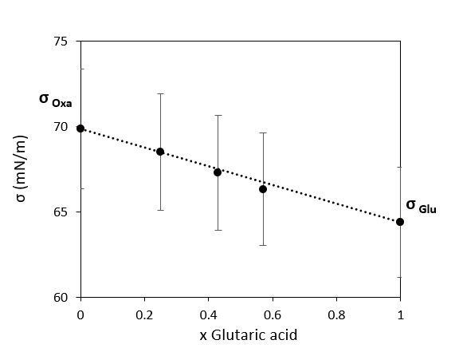
Figure S10: Evolution of the surface tension for glutaric + oxalic acid mixtures. Measured at [total acid] = 0.5 M. x_{Glutaric acid} = glutaric acid molar fraction.

