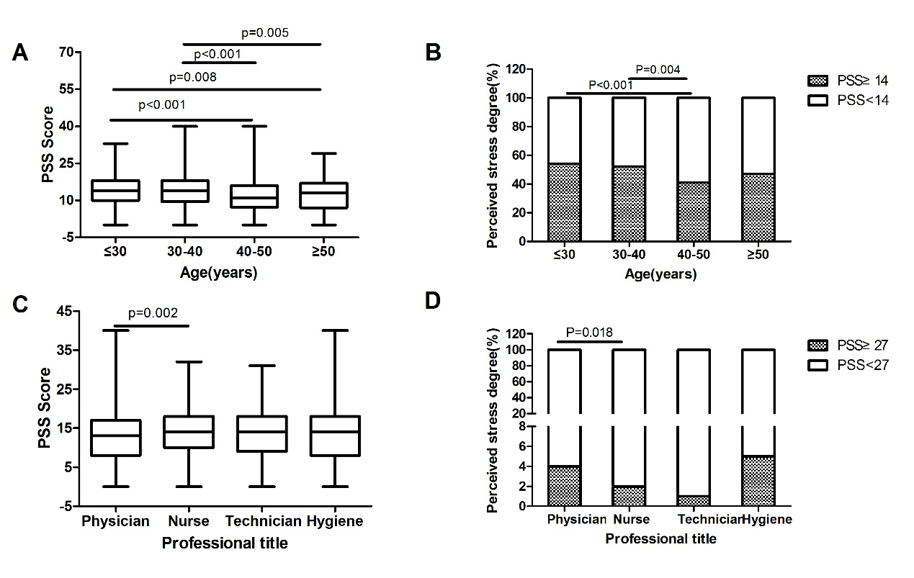

Figure S1: Pairwise comparison of perceived stress score and degree of health workers by age and professional title .A:Perceived stress score by age; B: perceived stress degree by age ;C： PSS:perceiver stress score by professional title;D: Perceived stress degree by professional title.

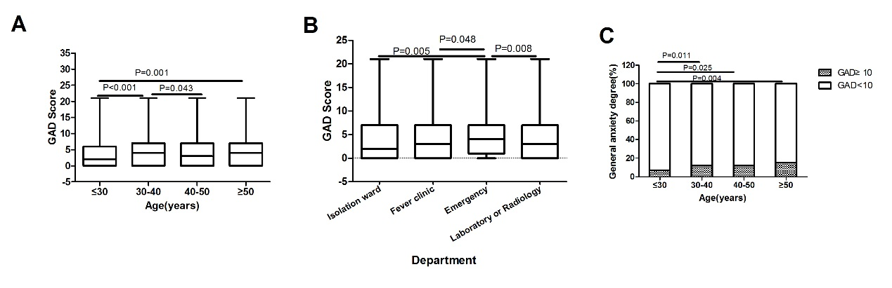
Figure S2: General anxiety status of HCWs by different demographic characteristics. A: GAD score by age; B: General anxiety degree by age; C: GAD score by workin department;

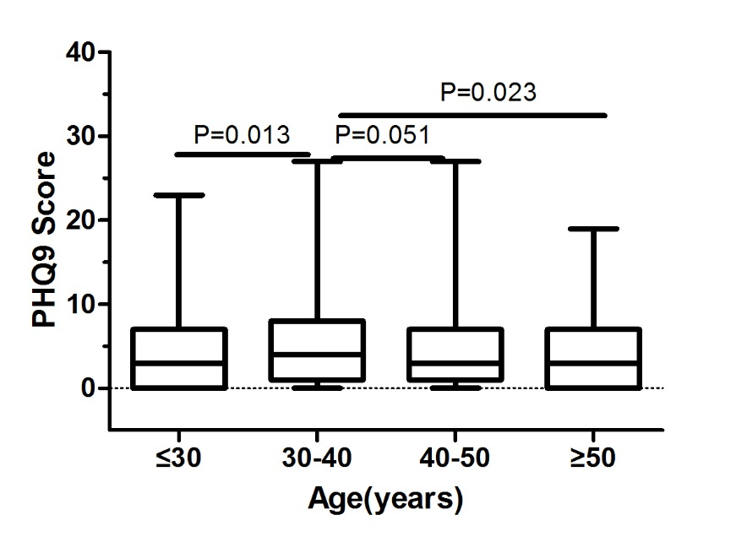
Figure S3: PHQ9 score of HCWs by age.

