The Goblet of Fluorescence: Calix[4]pyrrole’s Quest to Identify Ciprofloxacin Observed Through Experimental and Computational Approach
Jaymin Parikh ª, Keyur Bhatt ^{a*}, Krunal Modi ^{b*}, Nihal Patel ª, Ajay Desai ª , Chirag Patel ^{c}, Ravibhai Bhola ª
ª Department of Chemistry, Faculty of Science, Ganpat University, Kherva-384012, Mehsana, Gujarat, India.
^{b} Department of Humanity and Sciences, School of engineering, Indrashil university, Kadi, Mehsana-382740, Gujarat, India.
^{c} Biotechnology Research Center, Technology Innovation Institute, Abu Dhabi 9639, United Arab Emirates.
*Corresponding authors:
drkdbhatt@outlook.com (Keyur Bhatt) ORCID: 0000-0001-9301-576X
kmodi5033@gmail.com (Krunal Modi) ORCID:0000-0002-1151-1207

Scheme S1: Synthesis of meso-tetramethyl-meso-tetraaminophenyl calix[4]pyrrole (MMTCP)

Taking into account of the synthesis reported (Reference no 32). 4-aminoacetophenone (2.28 gm, 0.016 mol) and freshly distilled pyrrole (1.10 ml, 0.016 mol) were dissolved in methanol in RBF. To this mixture addition of methane sulphonic acid (2 ml) was carried out dropwise with constant stirring. Reaction mixture was stirred overnight, and reaction progress was monitored via TLC in methanol:DCM (2:8). After the completion of reaction, Triethyl amine was added dropwise to neutralize the acidic pH and orange precipitates were filtered off and thoroughly washed with methanol and pure product was eluted in 15% Methanol/DCM as eluent in column chromatography.
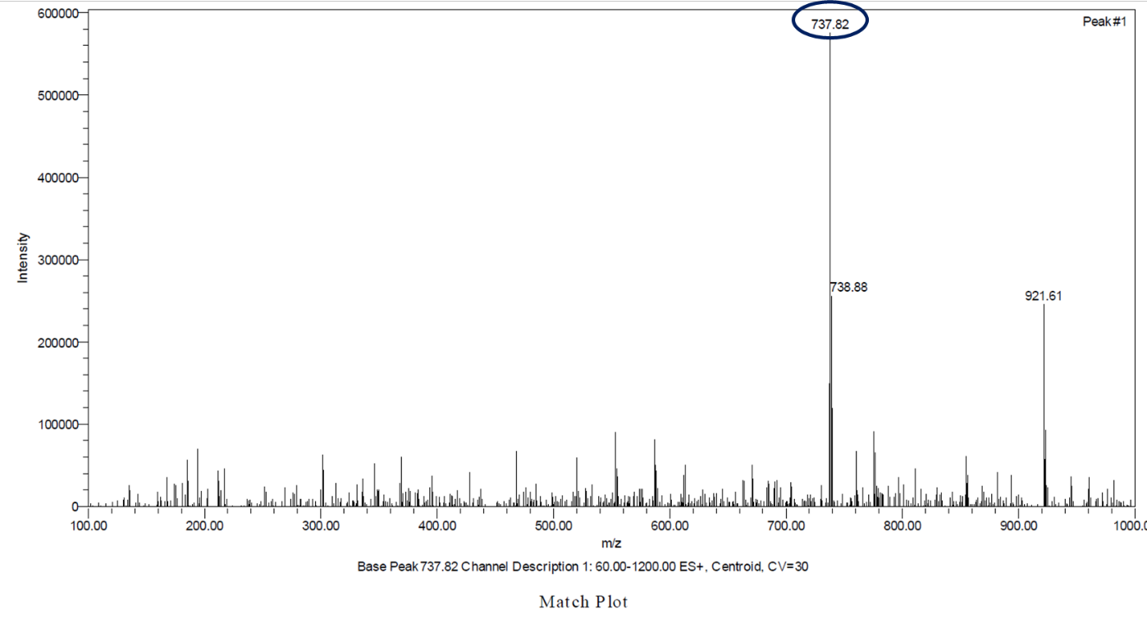
Figure S1: ESI-MS of Parent MMTCP
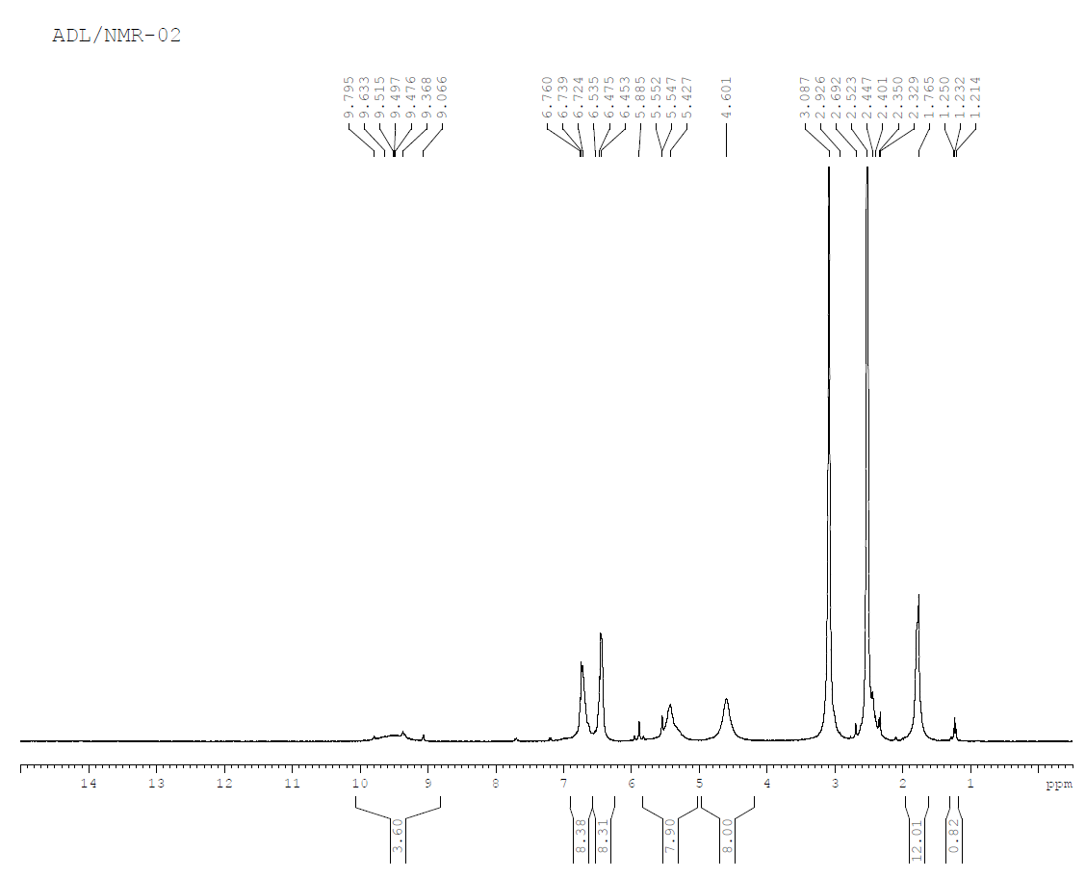
Figure S2: ¹H NMR of Parent MMTCP
Figure S3: FTIR Spectra of PCACP
Figure S4: Mass Spectra of PCACP
Figure S5: ¹H NMR of PCACP
Figure S6: FTIR of Ciprofloxacin
Figure S7: FTIR of PCACP_Ciprofloxacin complex

