Supplementary Information
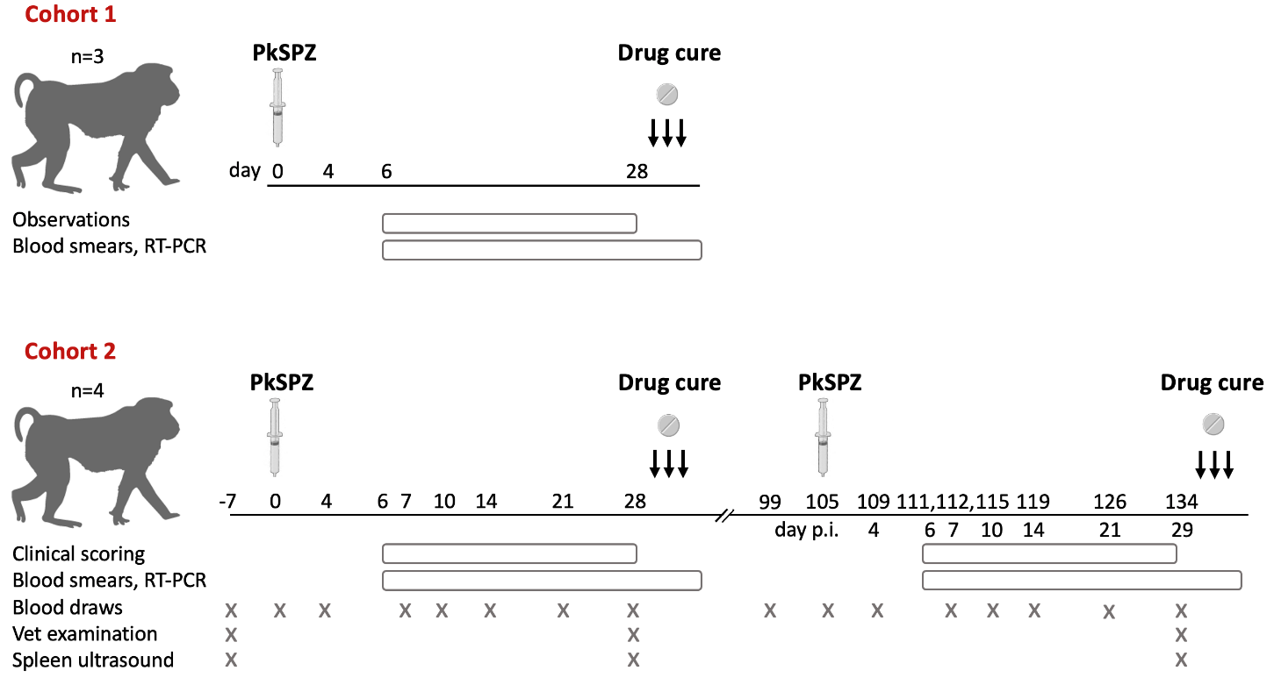
Supplementary Figure 1. Study design. The period of daily observations and blood collection for thin blood smears and Plasmodium 18S rRNA RT-PCR are indicated by bars beneath the study timeline. For cohort 2, the schedule for sedated blood draws and procedures are indicated by crosses beneath the study timeline. Animals in cohort 2 were rested for approximately two-months between the first and second PkSPZ challenge. The rest is indicated by a double slash in the timeline. Abbreviations: PkSPZ; Plasmodium knowlesi sporozoites; p.i., post-infection.

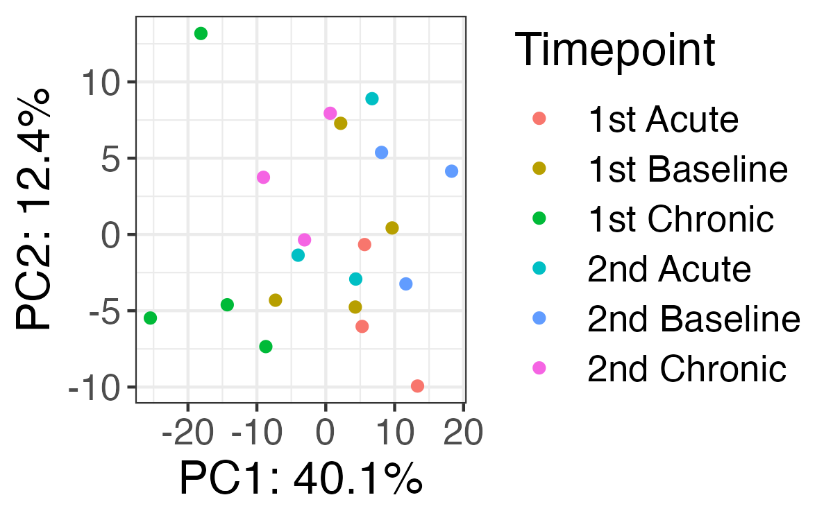
Supplementary Figure 2: Principal Component (PC) Analysis of whole blood gene expression data. Analysis performed for the most variably expressed genes (420 genes under an FDR <0.2 for at least one comparison).

